
Walking Plan
2014–17
Contents
Foreword 4
Executive Summary 5
The Walking City 6
The importance of walking in Melbourne 6
Achievements to date 11
Walking environment 11
Walk 21 Charter 11
Challenges for walking in Melbourne 13
Growth 13
Crowding and delay 13
Connecting to public transport 13
The walking network 16
Safety 16
Access for all 16
Attractive walking environments 16
Goals 19
Expand the pedestrian network 19
Plan for future growth 19
Reduce delay 19
Improve safety 19
Actions 20
Planning 21
A central city subregion walking plan 21
Use the planning scheme to improve the walking network 23
Principal pedestrian networks 24
Street management and operation 26
SmartRoads 26
Signal operation 29
Pedestrian street hierarchy 34
Investigate Streets as Places 36
Investigate new Walking Streets 39
Investigate High-Mobility Walking Streets 42
Create new shared zones 45
Make roads safer for pedestrians 49
Walking navigation 49
Stop lines 51
Travel behaviour change 55
Promote health 56
Capital Works 58
Addressing pedestrian crowding 58
Pedestrian crossings at intersections 61
Master plans 63
Access around stations 68
Tram and bus stops 74
Increasing the number of formal crossings 76
Making streets easier to cross 79
Technical notes 81
Walking Plan Actions 82
Appendices 84
Appendix 1 84
Appendix 2 86
Appendix 3 91
Appendix 4 92
Appendix 5 93
Appendix 6 94
Bibliography 97

Foreword
Melbourne is Victoria’s economic engine room and enjoys a vibrant social and cultural scene. Around 840,000 people pass through our city daily. This is likely to rise to more than 1.2 million by 2030. The City of Melbourne is responding to this growth with considered strategies for transport, land use and community services.
The City of Melbourne’s Walking Plan is part of an integrated approach to transport, outlined in the City of Melbourne Transport Strategy 2012. It links all modes and is coordinated with city development and urban renewal.
Melbourne is a walking city with most trips to, from and within the city starting or ending on foot. In 2010, 66 per cent of trips within the municipality were walking trips. This figure is even higher in the CBD with 86 per cent of trips being on foot.
And this figure is set to grow as the city does which will put increasing pressure on footpaths and public transport interchanges The safety of pedestrians is paramount and we constantly seek ways to improve this, whether through design, education or other strategies.
Walking makes economic sense: a 10 per cent increase in the connectivity of the pedestrian network in the City would add $2.1 billion to the City of Melbourne’s economy.
Our vision for Melbourne as a connected city means a place for people, a city with great streets linked by a well-designed transport system.
The Walking Plan includes strategies and actions that will ensure we keep a strong focus on the vital role that walking plays in the city and continue to improve the environment for walking.
Robert Doyle, Lord Mayor
Cathy Oke, Chair, Transport Portfolio

Executive Summary
Walking is the most important mode of transport for the City of Melbourne. It accounts for 66 per cent of all trips within the municipality and is part of trips by all other modes.
The purpose of the Walking Plan is to highlight the contribution that walking makes to the citymunicipality, while and laying out a practical plan to improve the city’s walking network and encourage more walking.
The walking plan aims to increase the number of walking trips in 2030 by 63 per cent from 2009 levels.
It establishes principles for planning walking in the city including priority access, safety, access for all abilities, planning for future growth, creating attractive walking environments, permeability and reducing delay to pedestrians.
The plan will help the City of Melbourne to work with the State Government to achieve the Plan Melbourne goal of transforming the transport system to support a more productive central city. In particular it supports improving pedestrian crossing times and reducing speed limits to improve pedestrian safety.
The actions in the plan are grouped in three streams.
Planning:
- amending the Melbourne Planning Scheme to improve the walking environment.
Street management:
- changing traffic signal operation to reduce delays to pedestrians;
- increasing the number of pedestrian streets and shared zones; and
- improving legibility and way finding.
Capital works:
- extensive master planning;
- access around tram and bus stops; and
- increasing the number of road crossings.

The Walking City

The importance of walking in Melbourne

Role of walking
Walking is our most fundamental mode of transport; almost everyone walks, and walking makes up part of every journey in the city.
Walking accounts for 66 per cent of all trips within the municipality. Council has a target for this to grow to 69 per cent by 2030 (CoM, 2012, p. 17). There will be many more people visiting and living in the City of Melbourne by 2030. The number of daily weekday city users is predicted to increase from around 840,000 today to over 1,200,000 (CoM, 2013a, p. 14). The number of walking trips is forecast to increase by 64 per cent over this same period (CoM, 2012, p. 15).

Commuting to work in Melbourne
Virtually every public transport trip begins and ends with a walking trip. The share of people commuting to work in Melbourne by public transport has increased by 11 per cent since 2001 (ABS 2001; 2011a). Over the same period, the share of individuals walking to work has increased by 76 per cent.
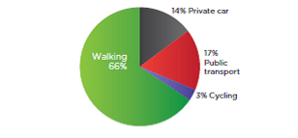
Figure 1 – Trips within the City of Melbourne by mode on the average weekday 2009/10: walking 66 per cent; private car 14 per cent; public transport 17 per cent; and cycling 3 per cent.
Melbourne’s public transport patronage grew at an average of 3.9 per cent a year from 2002 to 2012, and at 6.6 per cent a year between 2004 and 2008 (PTV, 2013, p. 4). Projections indicate that 2011 patronage will double by 2029, meaning that there will also be many more people walking to tram stops and train stations in Melbourne.
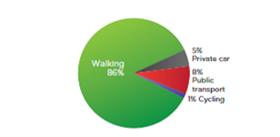
Figure 2 – Trips within the Hoddle Grid and Docklands by mode on the average weekday 2009/10: walking 86 per cent; private car 5 per cent; public transport 8 per cent; and cycling 1 per cent.
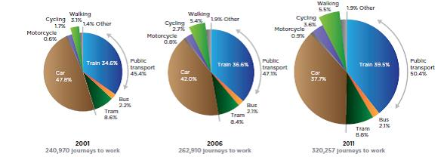
Figure 3 – Methods of travel to work in the City of Melbourne in 2001, 2006 and 2011.
In 2001 there were 240,970 journeys to work: 47.8 per cent by car; 1.7 per cent cycling; 3.1 per cent walking; 34.6 per cent train; 2.2 per cent bus and 8.6 per cent tram (total 45.4 per cent public transport) (ABS, 2001).
In 2006 there were 262,910 journeys to work: 42.0 per cent by car; 2.7 per cent cycling; 5.4 per cent walking; 36.6 per cent train; 2.1 per cent bus and 8.4 per cent tram (total 47.1 per cent public transport). (ABS, 2006).
In 2011 there were 320,257 journeys to work: 37.7 per cent by car; 3.6 per cent cycling; 5.5 per cent walking; 39.5 per cent train; 2.1 per cent bus and 8.8 per cent tram (total 50.4 per cent public transport). (ABS, 2011a).
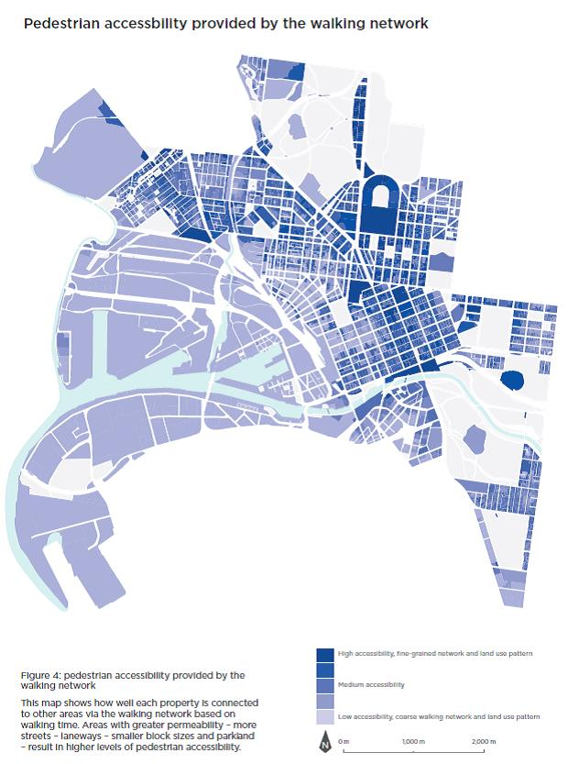
Figure 4: pedestrian accessibility provided by the walking network in the City of Melbourne
The above map shows how well each property is connected to other areas via the walking network, based on walking time. Areas with greater permeability – more streets, laneways, smaller block sizes and parkland – result in higher levels of pedestrian accessibility.
Hoddle’s Grid is mostly classified as highly accessible, except for the north-western corner which has medium-to-low accessibility. The northern part of the municipality, beyond Victoria Street, is mostly classified as medium-to-high accessibility. The western section of the municipality has medium-low to low accessibility.

The walking economy
Walking trips are important for the economy. About 63 per cent of trips made within the City of Melbourne for a work purpose are on foot (DoT, 2010). Walking is the primary mode for shopping, tourism and city visitors (DoT, 2010). Walking has also grown as more people have come to live in the municipality – 35 per cent of residents of the Hoddle Grid and 34 per cent of Southbank residents walk to work (ABS, 2011b).

Walking and agglomeration
Central business and retail precincts in large cities, such as in the Hoddle Grid and the expanded central city in Docklands and Southbank, foster connections within the central city community. These connections generate knowledge which circulates through both formal and informal links, and from this knowledge income is generated. Much of this knowledge transfer takes place face to face and is often the result of a walking trip within the central city. This is why dense city centres are so important to the economic prosperity of cities and nations. The large number of people located in close proximity to each other allows ideas to be quickly generated, refined into knowledge and put to work solving complex problems. There is a strong relationship between connectivity and productivity. This relationship is referred to as agglomeration economies.
Analysis of the impact of walking on agglomeration has found that if the walking connectivity within the Hoddle Grid was increased by 10 per cent, the value of the economy of the Hoddle Grid would be increased by up to $2.1 billion per annum. This represents a 6.6 per cent increase in the value of the current economy (SGS, 2013, p. 2).
Agglomeration can be measured using Effective Job Density (EJD). Figure 4 shows the EJD provided by the walking network; that connectivity across the walking network contributes to the economy of the City of Melbourne. Areas with darker colours represent both a richer walking network and a higher concentration of employment and economic activity. This measure of EJD is based on the number of jobs (working people) that can be reached within 30 minutes by walking on the pedestrian network (scaled by the time it takes to reach them).
Walking connectivity contributes to EJD by supporting knowledge transfer. The connectivity of the walking network across the City of Melbourne is shown in Figure 7, demonstrating how well each land parcel is connected to other land parcels. It shows the amount of land that can be reached by a 30-minute walk, divided by how long it takes to reach each of the land parcels within the 30-minute catchment.

Attractive streetscapes enhance the city experience
A high-quality walking environment is key to delivering on the vision of the city’s retail and hospitality strategies. Walking is low cost, environmentally sustainable and promotes physical and mental health. As a mode of transport, walking is also the main mode of transport for tourists and visitors for events. However, one of the main problems reported by visitors to Melbourne is the difficulty of walking around the city due to narrow footpaths or delays at signals (Destination Melbourne, 2010, p. 60).

Policy background
There is a significant policy background supporting the goals of this plan including documents from the Commonwealth and State governments as well as the City of Melbourne. Details of these documents are available in Appendix 1.
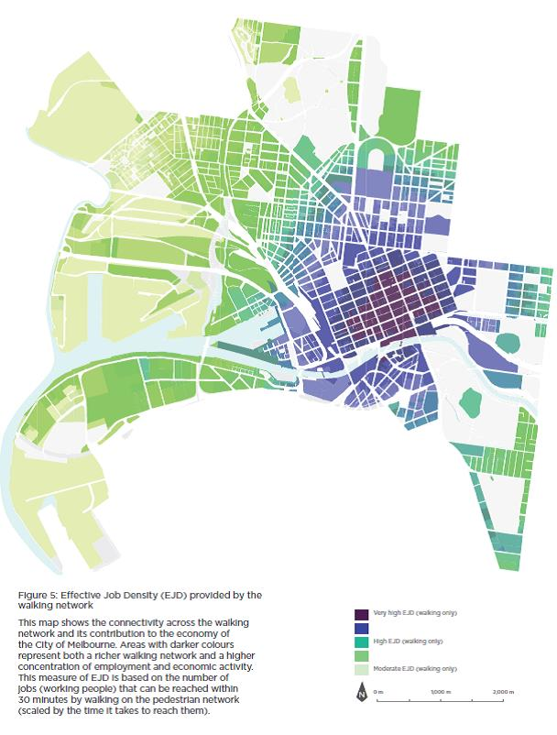
Figure 5: Effective Job Density (EJD) provided by the walking network in the City of Melbourne
The above map shows the connectivity across the walking network and its contribution to the economy of the City of Melbourne. Areas with darker colours represent both a richer walking network and a higher concentration of employment and economic activity. This measure of EJD is based on the number of jobs (working people) that can be reached within 30 minutes by walking on the pedestrian network (scaled by the time it takes to reach them).
Hoddle’s Grid has a very high EJD, as does Southbank and the Docklands. This fades out to a moderate-high EJD in the rest of the municipality.

Achievements to date

Walking environment
For more than 30 years the City of Melbourne has been transforming the municipality’s walking environment. Melbourne’s iconic Bourke Street Mall opened officially in 1983. Guided by the Places for People studies in 1994 and 2005, the City of Melbourne has widened footpaths, laid high quality pavements, encouraged outdoor dining and reduced traffic signal cycle times to support improvements to public transport to make Melbourne a more attractive place to be.
The city has increased pedestrian safety and level of service with:
- Widened footpaths, especially in areas of high pedestrian use, such as approaching train stations;
- Pedestrianisation of Bourke Street Mall and transformation of Swanston Street into a pre-eminent civic space;
- High-quality pedestrian environments including bluestone paving, trees and street furniture;
- Level access trams stops;
- Signalised pedestrian and zebra crossings;
- Safe staging points for pedestrians to cross busy roads;
- Reductions in traffic signal waiting times especially in the central city;
- Extending the time that walk signals are displayed to give pedestrians a longer window in which to cross at signals;
- Shared zones with speed limits reduced to 10 km/h, which allow pedestrians and drivers to share the road and make more efficient use of space;
- 30 km/h and 40 km/h speed limits in key pedestrian streets;
- A speed limit in the central city of 40 km/h;
- Conversion of laneways to active uses including retail and hospitality;
- Negotiating laneways to be built in new developments;
- Conversion of underused road space to pedestrian use, such as removing slip lanes;
- Enhancement of existing public spaces, such as City Square in 2000 and the creation of new spaces such as Queensbridge Square in 2006;
- Signal cycle time reductions at Spencer and King Streets to reduce pedestrian wait times and crowding;
- Painted pedestrian medians on Toorak Road, Errol Street and Victoria Street; and
- Expanding the amount of footpath space by 160,000 square metres or nearly 15 per cent since 2007, from 1,107,627 square metres to 1,270,793 square metres in 2012.

Walk 21 Charter
In 2008 the City of Melbourne became a signatory to the Walk21 International Charter for Walking. This requires the city to ‘work with others to create a culture where people choose to walk’ (Walk21, 2006) through the following strategic principles:
- increased inclusive mobility;
- well-designed and well-managed spaces and places for people;
- improved integration of networks;
- supportive land-use and spatial planning;
- reduced road danger;
- less crime and fear of crime;
- more supportive authorities; and
- a culture of walking.

Challenges for walking in Melbourne

Growth
The City of Melbourne will experience significant increases in residential and employment populations which will result in more people walking in the municipality.
Some key footpaths in the city are already routinely overcrowded with people forced to walk on the roadway. The volume of pedestrian traffic in Melbourne will rise as the city grows from about 844,000 daily visitors in 2012 to 1.256 million per day in 2030 (CoM, 2013a, p. 14). The central city is expanding into urban renewal areas including Southbank, Docklands, Fishermans Bend, City North and Arden-Macaulay. Figure 7 shows where growth will be concentrated. These areas need to be designed to offer similar levels of walkability to that currently experienced in the central city.

Crowding and delay
Crowding is already a significant issue for the walking network in Melbourne and city growth will exacerbate this. Locations where crowding occurs include in and around public transport stops and stations and in areas of the retail core of the city, such as Swanston Street.
Crowding discourages people from walking, creates delays which waste time and money and undermines Melbourne’s international reputation for liveability. It can ‘squeeze out’ other normal functions of a footpath, such as socialising, window shopping or enjoying a space, and it can undermine retail and hospitality experiences. Overcrowding and delays that result from waiting at intersections can cause annoyance and discourage people from returning to the city.
Traffic congestion in Melbourne costs the city’s economy $3 billion a year. This is projected to rise to $6 billion by 2020 (BTRE, 2007, p. 13). A significant amount of traffic congestion experienced in Melbourne is suffered by people walking, especially through delays at traffic lights or other crossings.

Connecting to public transport
Public transport nodes attract the largest and most concentrated walking activity in the city. For example, 171,160 people use Flinders Street Station each weekday, 111,290 use Southern Cross and 47,360 use the Federation Square tram stop (PTV, 2011a, 2011b).
Public transport use has grown strongly in recent years and is expected to continue to grow based on central city job growth and new infrastructure such as Regional Rail Link. Providing an efficient walking network supports public transport operation.
Increases in tram patronage and crowding at tram stops will also require the conversion of some high-intensity tram stops to new designs that provide more space for people waiting, more permeable access from footpaths and potentially low-speed road space to increase opportunities for pedestrians to cross roads.
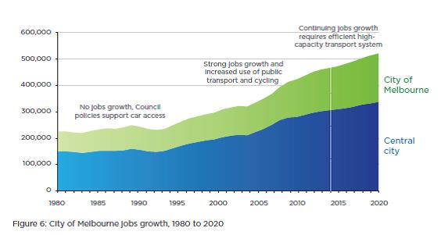
Figure 6: City of Melbourne jobs growth, 1980 to 2020
The above graph shows job growth for both the City of Melbourne and the central city from 1980 to 2020. The number of jobs in the City of Melbourne was roughly 23,000 in 1980 and rose to just over 450,000 in 2014. It is predicted to reach over 500,000 by 2020. For the central city the number of jobs was roughly 150,000 in 1980, rose to 300,000 in 2014 and is projected to reach approximately 320,000 in 2020.
Commentary accompanies the three stages in the graph: from 1980 to 1994 there was no job growth and Council policy supported car access; from 1995 to 2014 there was strong job growth and increased use of public transport and cycling; for the projected period between 2014 and 2020, continuing job growth will require a high-capacity transport system.
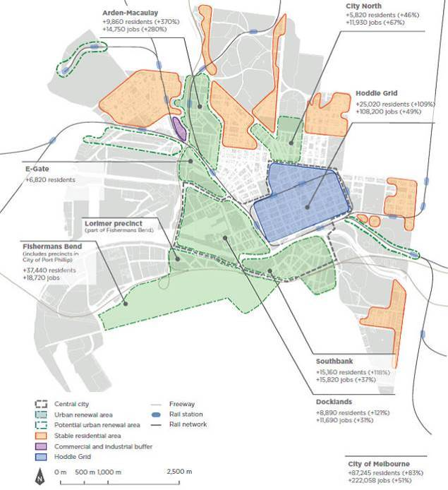
Figure 7: Growth in the City of Melbourne, 2012 –2031
The above map shows the projected resident and job growth in the City of Melbourne’s urban renewal areas and the Hoddle Grid to 2031. The projections are as follows:
- Arden–Macaulay will increase by 9,860 residents (370 per cent) and 14,750 jobs (280 per cent)
- E-Gate will increase by 6,820 residents
- Fishermans Bend will increase by 37,440 residents and 18,720 jobs
- Docklands will increase by 8,890 residents (121% per cent) and 11,690 jobs (31 per cent)
- Southbank will increase by 15,160 residents (118 per cent) and 15, 820 jobs (37 per cent)
- City North will increase by 5,820 residents (46 per cent) and 11,930 jobs (67 per cent)
- Hoddle’s Grid will increase by 250,020 residents (109 per cent) and 108,200 jobs (49 per cent)
Total increase in the City of Melbourne will be 87,245 residents (83 per cent) and 222,058 jobs (51 per cent).

The walking network
Increasing the number of pedestrian connections and ensuring new developments are permeable is a challenge for the future.
A rich walking network with many routes, links, crossings and connections provides more walking choices, spreads the pedestrian load, stimulates more walking, reduces walking times, creates more economic activity by bringing people into new spaces and reduces walking distances.
New developments must be able to provide new connections whilst remaining viable both in their own right and in order to deliver a net community benefit through the viability of the development yield and the pedestrian network overall.
Links may be footpaths, lanes, shared zones and formal or informal pedestrian crossings. They also include part-time links through arcades and other public connections through private property.
The walking network in the Hoddle Grid is relatively rich with many through-block connections, mid-block pedestrian crossings, laneways and little streets. There are still opportunities to add connections to this network. In urban renewal areas, however, the walking network is relatively less rich and will require significant improvement to achieve its development goals.

Safety
In the City of Melbourne, a pedestrian is killed or sustains a serious or other injury every two days. There were 956 pedestrians injured or killed in the five years to 2011 (VicRoads, 2011, p. 7). The City of Melbourne has the highest rates of pedestrian death and injury in the state.
The road safety approach in a people city is to reduce death and injury by addressing the road danger posed by vehicles while supporting the growth of walking and the expansion of the walking network. City of Melbourne’s Road Safety Plan 2013–2017, approved in July 2013, seeks to deliver an environment in which pedestrians are prioritised and supported by a safe, attractive and engaging urban environment.
People walking in Melbourne need to feel personally secure. A high level of personal security will encourage more people to walk more, including at night and in places with which they are not familiar. This encourages more economic activity. Passive surveillance is a key factor in creating a feeling of personal security.
Balanced transport priority
Walking is the most fundamental mode of travel in the City of Melbourne and decisions about the transport network and land use should reflect this priority. The walking network in Melbourne should be planned and managed to increase the priority given to walking to reduce delay and avoid overcrowding.

Access for all
Providing access for people of all abilities and ages is a key component of developing the walking network in Melbourne.

Attractive walking environments
The City of Melbourne will continue to strive to create attractive walking environments. This includes creating walking environments that encourage a variety of uses: places to pause or window-shop, space for kerbside dining, art, seating and expansion of the urban forest.
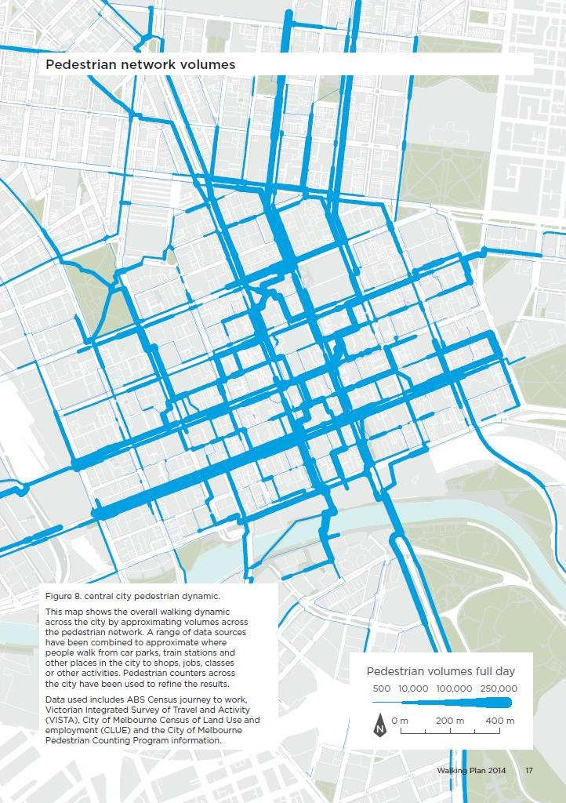
Figure 8: Central city pedestrian dynamic
This map shows the overall walking dynamic across the city by approximating volumes across the pedestrian network. A range of data sources have been combined to approximate where people walk from car parks, train stations and other places in the city to shops, jobs, classes or other activities.
Collins Street is the busiest pedestrian street in the central city, with high pedestrian volumes also recorded in the centre of the central city, on streets around Melbourne Central and on streets leading to The University of Melbourne.
Pedestrian counters across the city have been used to refine the results. Data used includes ABS Census journey to work, Victorian Integrated Survey of Travel and Activity (VISTA), City of Melbourne Census of Land Use and employment (CLUE) and the City of Melbourne Pedestrian Counting Program information.

Goals

Expand the pedestrian network
The City of Melbourne Council Plan 2013–17 has a four-year priority of expanding and prioritising a connected, safe and easy to access pedestrian network.
The City of Melbourne will create an excellent and safe walking environment for residents, workers and visitors, with seamless high-priority links between the city’s public spaces and the public transport system.

Plan for future growth
A key goal of this plan is to accommodate increasing amounts of walking in Melbourne. The city is experiencing significant growth. Figure 10 shows that walking will account for 30 per cent of all trips to, within and from the City of Melbourne in 2030, corresponding to over one million walking-only trips (on top of walking connections to public transport trips) on an average weekday. Decisions about the transport network and land use that affect pedestrians should take into account the likely future growth in numbers of people walking in Melbourne and plan accordingly.

Reduce delay
This plan will reduce delays to pedestrians through changes to the walking network, footpaths, intersections and traffic signals.

Improve safety
The safety of people walking in the City of Melbourne is very important. This includes personal safety and road safety. The City of Melbourne faces a significant challenge addressing the high numbers of people injured by vehicles while walking.
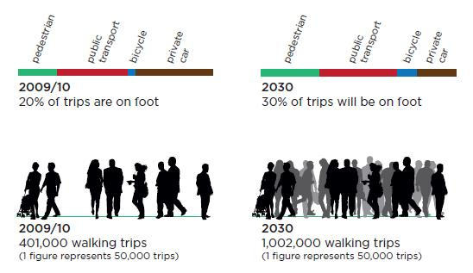
Figure 10: the above sliding bar graph shows that 20 per cent of trips in the City of Melbourne were on foot in 2009/10 with 401,000 walking trips. This is compared to another bar graph for 2030 which estimates that 30 per cent of trips will be on foot, accompanied by a reduction in private car trips. The 2030 estimates are for 1,002,000 walking trips.

Actions
Actions in this plan have been framed within the existing structure of the operations of the City of Melbourne and its stakeholders. This will ensure the effective implementation of these actions to achieve the strategy vision.
- Planning
  - A central city subregion walking plan
  - A central city subregion walking plan
  - Using the planning scheme to improve the walking network
  - Principal Pedestrian Networks
- Street Management and Operation
  - SmartRoads
  - Signal operation
  - Pedestrian street hierarchy
  - Investigate streets as places
  - Investigate new Walking Streets
  - High Mobility Streets
  - Create new shared zones
  - Making roads safer for pedestrians
  - Walking navigation
  - Stop lines
  - Travel behaviour change
  - Promoting health
- Capital Works
  - Addressing pedestrian crowding
  - Pedestrian crossings at intersections
  - Master plans
  - Access around stations
  - Tram and bus stops
  - Increasing the number of formal crossings
  - Making streets easier to cross
  - Technical notes

Planning

A central city sub-region walking plan
Work with the Metropolitan Planning Authority, the Departments of Transport, Planning and Local Infrastructure and Inner Melbourne Action Plan councils to deliver improvements to walking in Melbourne.

Objective
To ensure that planning for the central subregion of Melbourne provides for a high-quality pedestrian network.

Issue
Plan Melbourne identifies walking as a critical element in the economy of central Melbourne. It also proposes that the new Metropolitan Planning Authority facilitate work with subregional groups on shared priorities. Meanwhile, the Inner Melbourne Action Plan, which is made up of the same councils as the central subregion, will need to be reviewed and may be able to be incorporated in planning. Walking must be a high priority in planning for the central subregion.

Rationale
Plan Melbourne, the metropolitan planning strategy, is a framework which articulates a whole-of-government policy direction to integrate transport and land use strategic planning for an expanded central city in 2050. The framework provides a high-level central city transport narrative and strategic transport network corridors for Melbourne.
The framework will also provide guidance to urban renewal precincts, such as Arden-Macaulay, City North and Fishermans Bend. It will highlight potential transport connections in areas where people’s preferences for getting around may include walking, cycling and frequent public transport networks that connect destinations both across and within the expanded central city and Inner Melbourne neighbourhoods. This framework will assist short- and medium-term projects to incrementally contribute to the shared long-term vision for transport in the central city.

Implementation
- Work with the Metropolitan Planning Authority, the Department of Transport, Planning and Local Infrastructure and Inner Melbourne Action Plan councils to deliver improvements to walking in Melbourne, including capital works and planning scheme amendments to support the Plan Melbourne goal to create a more productive central city.
- Work with the Metropolitan Planning Authority to integrate the highest levels of walking, cycling and public transport use in the planning of urban renewal precincts.
- Work with the Metropolitan Planning Authority to integrate the City of Melbourne Walking Plan into master planning for urban renewal precincts.
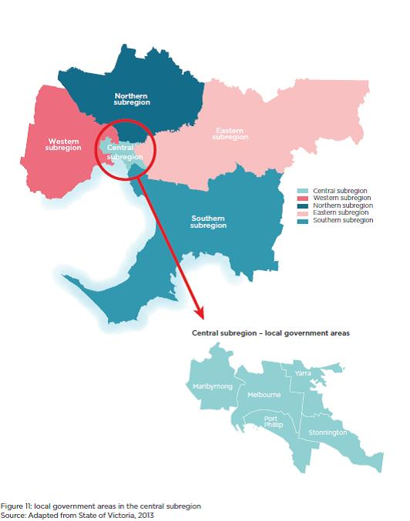
Figure 11: the above image consists of two maps; one is of the five subregions of Melbourne, and the other is of the central subregion showing the local government areas within it. This includes Maribrynong, Melbourne, Port Phillip, Stonnington and Yarra.

Use the planning scheme to improve the walking network
Establish a future fine-grained pedestrian network for the City of Melbourne for implementation in the Melbourne Planning Scheme.

Objective
To ensure that land is developed in Melbourne in a way that contributes to the development of a fine-grained walking network with short blocks and many routes, links and connections.

Issues
A fine-grained walking network reduces walking distances and travel times and has been a goal of the City of Melbourne for many years. It increases accessibility and boosts the city’s economy in a similar way to other transport infrastructure. Support for the concept is in the Municipal Strategic Statement as well as in structure plans for Southbank, Arden-Macaulay and City North. However, the fine-grained walking network is not clearly established in the Melbourne Planning Scheme. The planning scheme is the tool used to manage the development of private land. Creating a fine-grained network will require many new walking links on private land. It will also identify mid-block road crossing points.
Provisions already exist in the planning scheme (including Design and Development Overlays, Public Acquisition Overlays and Developer Contribution Plans) to require developers to provide through-block links, but these are not always effective or desirable. Developers often provide fine-grained pedestrian links in commercial developments (such as the QV Building at the corner of Lonsdale and Swanston streets), but they can be reluctant to do so for other land uses, particularly residential developments. In these situations, the mechanisms do not serve the broader strategic context of an overall plan for Melbourne’s walking network.
Also, previous attempts to establish a fine-grained pedestrian network in urban renewal areas through the planning scheme have not been justified to the satisfaction of planning panels.
Another issue is specifying the quality of through-block links, such as whether they are open to the air or attractive to pedestrians, levels of sunlight, width and whether they should provide clear sight lines through the block.
In the Southbank precinct (and currently proposed for City North), controls in the planning scheme require pedestrian through-block links to be provided where the average length of a street block exceeds 100 metres (DTPLI, 2014, p. 2). Research shows that the optimum spacing for pedestrian connections in city centre retail core areas may be 50 to 70 metres (Siksna, 1996). However, planning scheme provisions do not specify the exact location of the link and planners are merely obliged to negotiate the link placement with developers as each land parcel is developed. As a result, links may not be provided in the best location.
Work that is needed to support changes to the planning scheme includes:
- specifying a fine-grained pedestrian network that will be developed throughout the City of Melbourne including through-block links on private land;
- assessing the economic contribution and other benefits of a fine-grained walking network to the city’s economy ; and
- assessing the costs of developing the walking network, including impacts on landowners who would be required to provide the links.
This will involve expanding and improving the current pedestrian monitoring and counting program as well as pedestrian network modelling.

Rationale
The walking network in the City of Melbourne already has a significant impact on the city’s economy. Increasing the level of walking connectivity by 10 per cent – for example, by adding through-block links – would increase the value of the overall Hoddle Grid economy by $2.1 billion per annum or 6.6 per cent. This is because people would then be better connected, particularly to jobs and for work-related walking trips. (CoM & SGS, 2013d)
Through-block links add to the quality of the walking network by:
- shortening walking distances;
- increasing the amount of street frontage leading to business and job opportunities;
- creating more intersections and offering more route choices;
- providing alternatives to crowded routes;
- providing intimate and interesting spaces; and
- enhancing the city’s reputation for laneway experiences.

Implementation
- Continue to expand the pedestrian monitoring program to inform decisions about pedestrian planning.
- Develop a model of the walking network to test scenarios for improving the network such as the location of though-block links or predicting future crowding.
- Establish a future fine-grained pedestrian network for the City of Melbourne particularly in urban renewal areas for implementation in the Melbourne Planning Scheme.

Principal pedestrian networks
Define a principal pedestrian network in the Planning Policy Framework and SmartRoads to complement the fine-grained pedestrian network.

Objective
To ensure that land is developed in Melbourne in a way that contributes to the development of a fine-grained walking network with short blocks and many routes, links and connections.

Rationale
The State Government has been reviewing the State Planning Policy Framework. Part of this review has been to include in the planning system the principal networks for the main modes of travel: motor vehicles, trams, buses, bicycles and walking. One aim of the framework is to ensure that the planning system provides appropriate protection for the operation and enhancement of these principal routes when land is developed. This is a specific objective of the Transport Integration Act to integrate transport and land use planning.
A principal pedestrian network is a designated network of routes in a given area that supports walking trips into and around key destinations. These networks are being trialled and evaluated in four metropolitan municipalities. When this work is complete, City of Melbourne will have more information about how these would work in the central city. City of Melbourne’s planning scheme already provides some of the protections for the pedestrian environment that Principal Pedestrian Networks would consider, such as reducing the number of driveway crossovers in high-volume pedestrian areas.
The principal pedestrian network would be included as Pedestrian Priority Areas in VicRoads’ SmartRoads system (see Section 2.1).

Implementation
- Work with the Department of Transport, Planning and Local Infrastructure to define a principal pedestrian network in the Planning Policy Framework. This would complement the fine-grained pedestrian network and pedestrian priority areas as defined in SmartRoads.

Street management and operation

SmartRoads
Use SmartRoads to assess road space allocation in the City of Melbourne.

Objective
To ensure that the SmartRoads Network Operating Plan gives appropriate priority to pedestrians.

Rationale
The SmartRoads Network Operating Plan is VicRoads’ system for managing all modes of movement on the road network to deliver the greatest benefit to the community.
The plan allocates priorities for different modes on all roads (such as tram or pedestrian priority). Often a road will have several priority modes; Swanston Street, for example, prioritises pedestrians, cyclists and trams.
Network Fit Assessments gauge the extent to which proposals to change network operations fit with the strategy of the Network Operating Plan. This can include changing traffic signals to give more time to one road or another or removing a lane of traffic to add a bicycle lane or widen the footpath. In areas identified as having pedestrian priority, pedestrian movements are given greater weight in the Network Fit Assessment process.
The current Network Operating Plan prioritises pedestrians in the Hoddle Grid, areas of Carlton, some roads in Southbank and some shopping strips. Reflecting the role of walking in the capital city, pedestrian priority areas in the City of Melbourne need to be expanded to include many parts of Docklands and key streets in Southbank as identified in the Southbank Structure Plan, including City Road as well as parts of St Kilda Road. In the future, as the central city area expands, pedestrian priority will also need to be expanded to urban development areas such as Arden-Macaulay and the Lorimer precinct of Fishermans Bend.
As part of integrating transport land use and planning, the Principal Pedestrian Network, developed as part of the Planning Policy Framework, would become the Pedestrian Priority Area for the City of Melbourne in SmartRoads.

Implementation
- Work with VicRoads and State Government agencies to expand SmartRoads Pedestrian Priority Areas in the City of Melbourne to include City Road and other parts of Southbank, Docklands and other areas.
- Use SmartRoads to assess road space allocation in the City of Melbourne.

Increasing accuracy in measuring pedestrian congestion
The Network Operating Plan uses estimates when counting the numbers of people walking across intersections rather than actual numbers. As a result, accurate assessments of delay to pedestrians at intersections cannot be made.
- Work with VicRoads to continue to improve the knowledge of pedestrian volumes and movements, particularly at intersections, to ensure high-quality data is used in Network Fit Assessments. Explore the use of new technology, including de-identified mobile phone data, to reduce counting costs.

Develop a place-based approach in Smart Roads
SmartRoads provides a framework for making decisions about priority access on the road network, particularly at intersections. It assesses proposals on the basis of their contribution to the efficiency of the transport system. This may benefit pedestrians walking to destinations when travel time is important. However, it has been acknowledged that it does not take into account the concept of high-quality places in the same way. For example, proposals to widen footpaths to improve urban design, plant trees or address pedestrian crowding cannot currently be assessed properly by SmartRoads. The Department of Economic Development, Jobs, Transport and Resources (DEDJTR) has been working with VicRoads, City of Melbourne and others to develop a complementary place-based analysis to be incorporated into the SmartRoads framework. This would allow improvements to the quality of a place to be compared with or against improvements to improve the efficiency of the transport network.
- Continue to work with VicRoads, the DEDJTR and others to develop a place-based assessment to be integrated into SmartRoads.
- 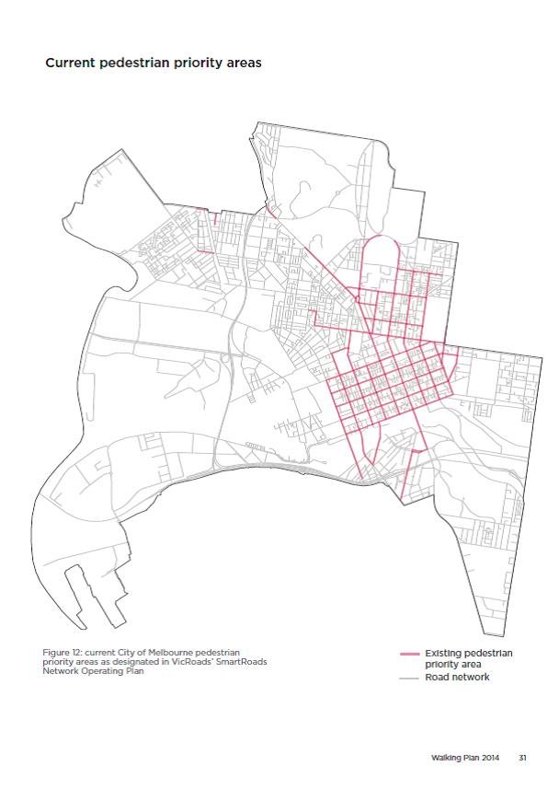
Figure 12: the above map shows the current City of Melbourne pedestrian priority areas as designated in VicRoads SmartRoads Network Operating Plan. Existing pedestrian priorities areas cover the whole of the Hoddle Grid and extend into Carlton via Swanston Street, Lygon Street, Elizabeth Street, Drummond Street and Rathdowne Street. The priority area extends up Flemington Road and also includes Pridham Street in Kensington, part of Racecourse Road and Errol Street. To the south of the Hoddle Grid, Sturt Street, Clarendon Street, Queens Bridge Street and part of Kings Way area also designated as pedestrian priority areas.
Signal operation
Assess pedestrian delay at intersections across the City of Melbourne and develop a prioritised list of projects to reduce pedestrian delay.

Objective
To improve traffic signal operation for pedestrians while balancing priority for all users.

Rationale
Delays to pedestrians contribute significantly to congestion and inefficiency in the City of Melbourne.

Reducing delay to pedestrians at crossings
Delays to pedestrians at traffic signals contribute significantly to traffic congestion costs. The cost of pedestrian congestion grows as the number of pedestrians increases.
The City of Melbourne works with VicRoads to review signal timing to maximise its efficiency and achieve the lowest overall delay across all types of road users. In September 2013, signal times on King and Spencer streets were reduced to bring them closer in alignment with other intersections in the Hoddle Grid, where most signals operate with a 90-second cycle during peak periods. Previously, King and Spencer streets operated at longer cycle times (110 and 120 seconds) during peak periods, and on King Street, north-south movements received a disproportionately high level of priority (72 per cent in the am peak and 66 per cent in the pm peak). This created significant delays for people crossing King Street. Only one third of people using King Street (in all modes of transport) are travelling north-south. Two thirds are travelling east-west, with many people walking to and from Southern Cross Station or travelling in trams and buses.
There are also other techniques for reducing delays including extending the time that the walk signal is displayed without affecting other uses at the signal.

Implementation
- Assess pedestrian delay at intersections across the City of Melbourne and develop a prioritised list of projects to reduce pedestrian delay, focusing on the intersections with the most pedestrians first.
- Reduce traffic signal cycle times on Spencer Street at Collins Street and at Flinders Street.

Auto-on pedestrian phase signals
At crowded intersections, or intersections through which many pedestrians move, the pedestrian phase should be automatically activated rather than pedestrians being required to press buttons to activate crossings.
These signals are called auto-on pedestrian phase traffic signals; they automatically activate the pedestrian signal when traffic lights turn green without needing someone to press a button. They reduce wait times for pedestrians as pedestrians do not miss an opportunity to cross if they reach the intersection after the time a walk phase could start. They give pedestrians a similar level of service to motorists, public transport vehicles and cyclists who do not need to manually activate lights.
The City of Melbourne will work with VicRoads within the current Council term (until 2017) to convert signalised intersections located in the proposed auto-on pedestrian phase areas shown. Traffic signals will be set up to automatically activate the walk signal between 6am and 9pm. After 9pm the noise of pedestrian signals may have a negative impact on residential areas. Beyond 2017, auto-on pedestrian phase signals will be further expanded as the city grows.

Implementation
- Expand the implementation of auto-on pedestrian phase signals at intersections in the area shown where compatible with prevailing signal timings.
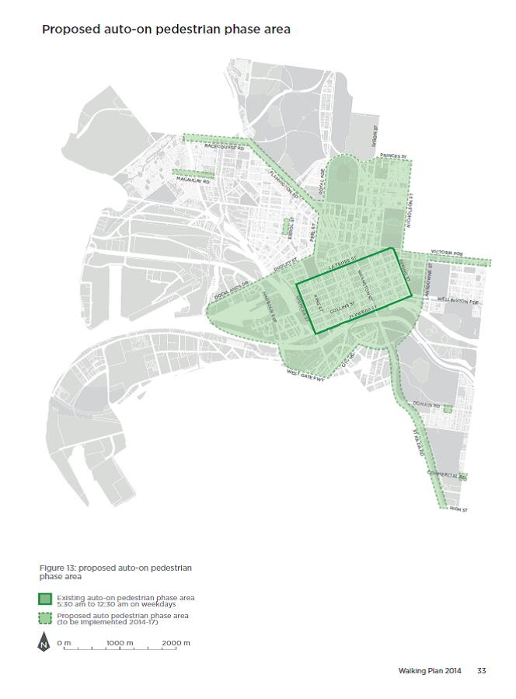
Figure 13: The above map shows the current and proposed auto-on pedestrian phase areas in the City of Melbourne in operation between 5:30 am and 12:30 am on weekdays. The current area covered is restricted to the Hoddle Grid. The proposal is to extend the boundaries of this area out to the Westgate Freeway, Docklands Drive, Dudley Street, Peel Street, Royal Parade, Princess Street, Nicholson Street, Lansdowne Street and City Road. It also extends along St Kilda Road, Victoria Parade and Flemington Road on to Racecourse Road. A section of Macaulay Road, Errol Street, Domain Road and Commercial road are also proposed auto-on pedestrian phase areas but are not physically connected to the other proposed areas.
Pedestrian lanterns at all Hoddle Grid signalised intersections
Some signals do not include pedestrian displays in all directions.
Many of the traffic signals on ‘little streets’ that run east-west in the Hoddle Grid between the major streets, such as Flinders Lane or Little Collins Street, do not have full pedestrian signals. This is a historical legacy reflecting when they were installed in the 1940s. However, this means that people with disabilities face significant difficulty when crossing these streets as they are not alerted when it is safe and appropriate to cross. The red traffic light for cars is often positioned such that pedestrians cannot see them clearly.
- Work with VicRoads to install pedestrian crossing lights, push buttons and audible devices at Hoddle Grid signalised intersections to create consistency across the Hoddle Grid and provide vision-impaired pedestrians with better guidance when walking around the city.
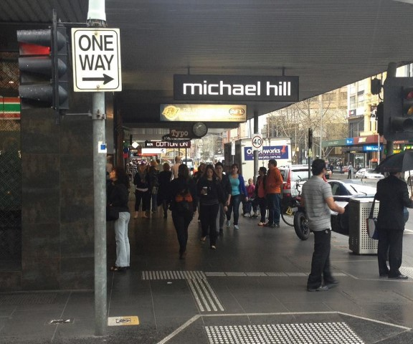

Scramble crossings
Pedestrian signals that allow crossing in all directions simultaneously are popular and do have some benefits. However, they also have adverse impacts on pedestrian delay, extending the waiting time between walking phases. They also increase delays to public transport, bicycles and other vehicles on the road as it takes longer for pedestrians to cross diagonally and signal timing must account for this. There are limited opportunities (such as at T-intersections) where these impacts can be reduced, though, and there may be some locations where they could be implemented.
- Scramble crossings will be considered at appropriate intersections to reduce crowding and delay where the adverse impacts on timing and other modes can be minimised.
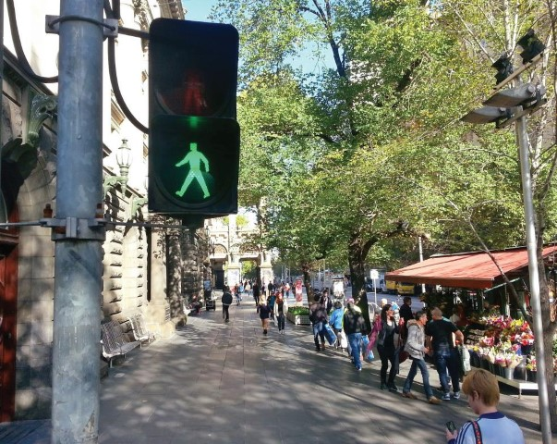
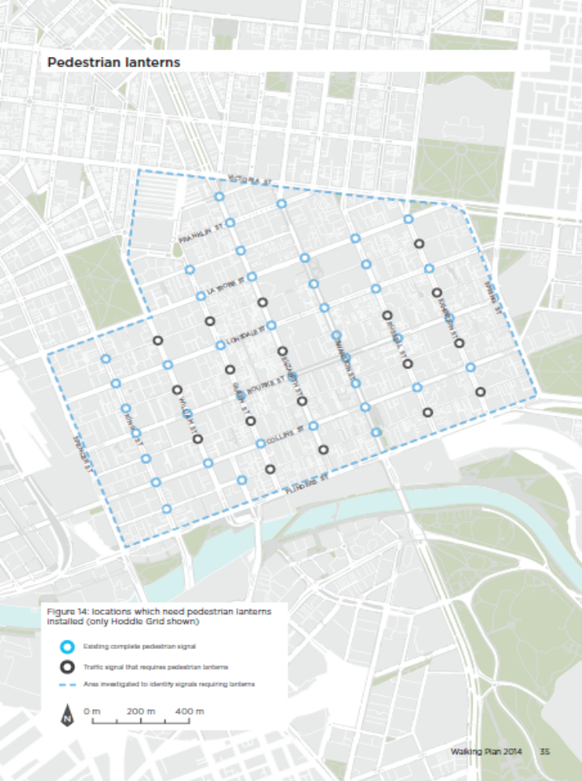
Figure 14: the above map shows the locations in the Hoddle Grid that need pedestrian lanterns installed. The locations are as follows; on the intersections of Flinders Lane with Queen Street, Elizabeth Street, Russell Street and Exhibition Street; on the intersections of Little Collins Street with William Street, Queen Street, Elizabeth Street, Russell Street and Exhibition Street; on the intersections of Little Bourke Street with William Street, Queen Street, Elizabeth Street, Russell Street and Exhibition Street; on the intersections of Little Lonsdale Street with William Street, Queen Street, Elizabeth Street and Exhibition Street.

Pedestrian street hierarchy
Adopt a pedestrian street hierarchy to provide direction for the operation of streets.

Objective
To define a pedestrian street hierarchy and provide direction for the design and operation of streets based on this hierarchy. To identify streets that should increase in function as pedestrian streets.

Rationale
Melbourne’s streets provide the connections between the places that people are and where they want to go, and allow for the delivery of goods. They also play many other roles, including providing a significant amount of the city’s open space, meeting places and views. The streets provide for movement by a variety of modes; as we create a city for people and as the numbers of people walking increase we must cater for that growth and be innovative in the way we use our streets.
There is an opportunity to provide safe and enjoyable places for children and families in the central city as the pedestrian street hierarchy is implemented.
One innovation is to develop a hierarchy of pedestrian streets ranging from those in which pedestrians can move freely across the full width of the street and vehicles – if present – travel slowly, through to arterial roads where pedestrians use sidewalks while trams, buses, bicycles and other vehicles use the street at higher speeds. This hierarchy allows each street or laneway to be assessed as to its position in the hierarchy based on factors such as current and future pedestrian demand or requirements for other modes (such as deliveries, providing access to car parks, etc.). Streets may operate differently at different times of day depending on demand for different modes.
As pedestrian numbers grow, more streets will have an increasing pedestrian function. This plan proposes a number of locations, mostly in the central city, where the pedestrian function of streets could increase.

Vehicle access
Maintaining access for deliveries and service vehicles, as well as to off-street car parks, is important for city commerce. The walking plan does not propose to remove motor vehicle access to off-street car parks nor to remove delivery, service or disabled access to properties.
The bicycle network identified in the City of Melbourne Bicycle Plan will also be considered when investigating proposals that change the layout or operation of a street in the City of Melbourne. Where there are high volumes of cyclists as well as pedestrians, separation will be considered.

Streetscape Framework
The pedestrian street hierarchy will be implemented in accordance with the Streetscape Framework Plan.
Any proposals that change the layout or operation of a street in the City of Melbourne would require thorough consultation with appropriate stakeholders including building owners, businesses and residents, to understand their access requirements.
The City of Melbourne introduced the Streetscape Framework in 2011 to work with businesses and the community to effectively respond to the changing needs of our streets.
The Streetscape Framework guides planning and implementation of new streetscapes, and involves the community in deciding on streetscape design and improvements.
The City of Melbourne is upgrading many of its streets as part of the Streetscape Improvements program, which aims to enhance streets and laneways through road- and footpath-works, landscaping and other improvements.
Pedestrian Street Hierarchy | Characteristics | Street management
Street as Place (Local Street) | - Pedestrians move freely over the street  - People linger in the street, at cafes, on public seating or to play  - Amenity increased by providing spaces for people to be in  - Low traffic function | - Can be used as a place permanently or during specific times (such as lunch times or in evenings)  - Can operate as a shared zone to provide traffic access  - Provide for deliveries, property servicing, cycling and access to off-street car parking.
Walking Street (Local Street) | - Pedestrians move freely over the street  - Key transport link for pedestrians  - Amenity and safety increased by reducing crowding  - Low through traffic function | - Can be used as a walking street permanently or during specific times (such as lunch times or in evenings)  - Can operate as a shared zone to provide traffic access  - Provide for deliveries, property servicing, cycling and access to off-street car parking.
High Mobility Walking Street (Public Transport Corridor) | - Streets shared by trams, buses, bikes and pedestrians  - High frequency public transport corridor  - Low traffic function  - Significant interchange between public transport and walking network | - Provide for deliveries, property servicing, cycling and access to off-street car parking.
High Mobility Street (Public Transport Corridor) | - Streets shared by trams, buses, private vehicles (including bikes) and pedestrians  - High frequency public transport corridor  - Traffic function | - Trams, buses and pedestrians have priority under SmartRoads  - Provide for deliveries, property servicing, cycling and access to off-street car parking.
Other streets used by pedestrians | - Streets shared by private vehicles (including bikes) and pedestrians  - Examples include shopping strips, local residential streets or arterial roads  - Traffic function | - Varies depending on use  - Provide for deliveries, property servicing, cycling and access to off-street car parking.

Investigate Streets as Places
Investigate the suitability of the proposed Streets as Places.

Characteristics
The characteristics of Streets as Places are that:
- pedestrians move freely over the street;
- people linger on the street at cafes, on public seating or to play;
- there is low traffic function; and
- amenity is increased as more space is provided for people to be in.

Street management
Streets as Places are managed to:
- be used as a place permanently or during specific times (such as during lunch times or in evenings);
- possibly operate as a shared zone to provide traffic access; and
- provide for deliveries, property servicing, cycling and access to off-street car parking.

Implementation
- Investigate the suitability of the proposed Streets as Places as indicated in ‘Figure 15: proposed Streets as Places’. This will include consideration of local access requirements.
- Investigate Market Street (at Collins Street) and Spring Street outside the Princes Theatre as shared zones.
- Investigate closing Dodds Street to through traffic between Grant Street and Southbank Boulevard to create an open-space plaza.
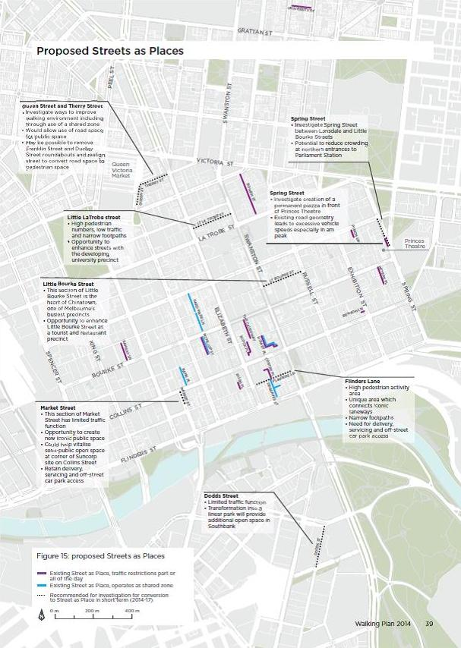
Figure 15: The above map highlights the proposed Streets as Places, which are as follows (part): Queen Street and Therry Street, Little La Trobe Street, Market Street, Flinders Lane, Little Bourke Street, Spring Street, Flinders Lane and Dodds Street. Each Street proposal is accompanied by a small description justifying their inclusion in the Streets as Places proposal. The descriptions are as follows:
Queen Street and Therry Street: Investigate ways to improve walking environment including through use of a shared zone; Would allow use of road space for public space; May be possible to remove Franklin Street and Dudley Street roundabouts and realign street to convert road space to pedestrian space.
Little LaTrobe street: high pedestrian numbers, low traffic and narrow footpaths; opportunity to enhance streets with the developing university precinct.
Little Bourke Street: this section of Little Bourke Street is the heart of Chinatown, one of Melbourne’s busiest precincts; opportunity to enhance Little Bourke Street as a tourist and restaurant precinct.
Market Street: this section of Market Street has limited traffic function; opportunity to create new iconic public space; could help vitalise semi-public open space at corner of Suncorp site on Collins Street; retain delivery, servicing and off-street car park access.
Dodds Street: limited traffic function; transformation into a linear park will provide additional open space in Southbank.
Flinders Lane: high pedestrian activity area; unique area which connects iconic laneways; narrow footpaths; need for delivery, servicing and off-street car park access.
Spring Street; investigate creation of a permanent piazza in front of Princes Theatre, existing road geometry leads to excessive vehicle speeds especially in am peak.
Spring Street: investigate Spring Street between Lonsdale and Little Bourke Streets; potential to reduce crowding at northern entrances to Parliament Station.
Investigate new Walking Streets
Investigate the suitability of the proposed Walking Streets.

Characteristics
The characteristics of Walking Streets are that:
- pedestrians move freely over the street;
- they provide a key transport link for pedestrians; and
- amenity and safety are increased by reducing crowding.
- Low through traffic function;

Street management
Walking Streets are managed to
- be used as a Walking Street permanently or during specific times (such as lunch times or evenings);
- operate as a shared zone if traffic access is needed;
- provide for deliveries, property servicing, cycling and access to off-street car parking.

Implementation
- Investigate the suitability of the proposed Walking Streets as indicated in ‘Figure 16: proposed walking streets’. This will include consideration of local access requirements.
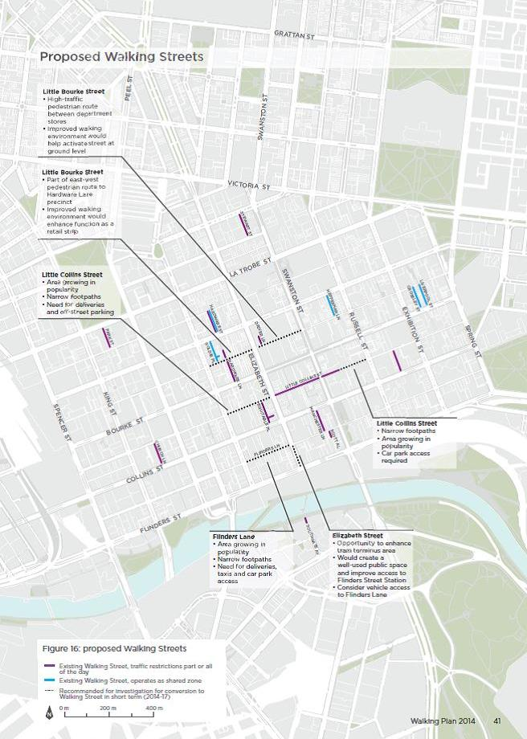
Figure 16: The above map highlights the proposed Walking Streets, which are as follows (part): Little Bourke Street, Little Collins Street, Flinders Lane, Elizabeth Street. Each Street proposal is accompanied by a small description justifying their inclusion in the Walking Streets proposal. The descriptions are as follows:
Little Bourke Street: high-traffic pedestrian route between department stores, improved walking environment would help activate street at ground level
Little Bourke Street: part of east-west pedestrian route to Hardware Lane precinct; improved walking environment would enhance function as a retail strip.
Little Collins Street: area growing in popularity; narrow footpaths; need for deliveries and off-street parking.
Flinders Lane: are growing in popularity; narrow footpaths; need for deliveries, taxis and car park access.
Elizabeth Street: opportunity to enhance tram terminus area; would create a well-used public space and improve access to Flinders Street Station; consider vehicle access to Flinders Lane.
Little Collins Street: narrow footpaths; area growing in popularity; car park access required.
Investigate High-Mobility Walking Streets
Investigate the suitability of the proposed High-Mobility Walking Streets.

Characteristics
Characteristics of High-Mobility Walking Streets are that:
- they are shared by trams, buses, bicycles and pedestrians;
- they provide a high-frequency public transport corridor;
- they have a low-traffic function; and
- there is significant interchange between the public transport and walking networks.

Street Management
High-Mobility Walking Streets are managed to
- provide appropriate priority to trams, buses, cyclists and pedestrians under SmartRoads; and
- provide for deliveries, property servicing, cycling and access to off-street car parking.

Implementation
- Investigate the suitability of the proposed High-Mobility Walking Streets as indicated in ‘Figure 17: proposed High Mobility Walking Streets’. This will include consideration of local access requirements.
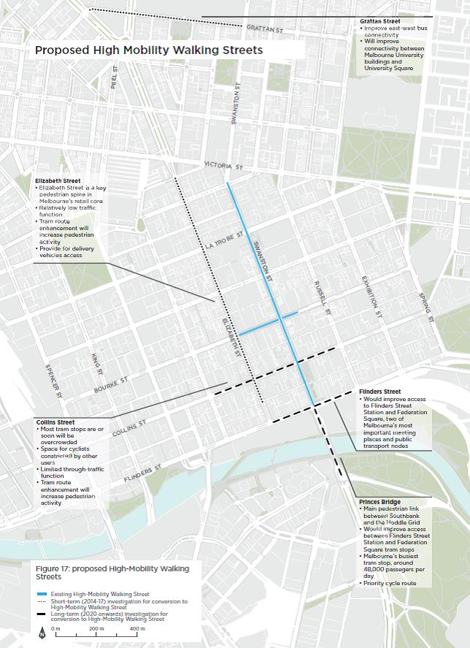
Figure 17: The above map highlights the proposed High-Mobility Walking Streets, which are as follows (part): Elizabeth Street, Collins Street, Princes Bridge, Flinders Street and Grattan Street. Each Street proposal is accompanied by a small description justifying their inclusion in the High-Mobility Walking Streets proposal.
The descriptions are as follows
Elizabeth Street: Elizabeth Street is a key pedestrian spine in Melbourne’s retail core; relatively low traffic function; tram route enhancement will increase pedestrian activity; provide for delivery vehicles access.
Collins Street: Most tram stops are or soon will be overcrowded; Space for cyclists constricted by other users; Limited through-traffic function; Tram route enhancement will increase pedestrian activity
Princes Bridge: main pedestrian link between Southbank and the Hoddle Grid; would improve access between Flinders Street Station and Federation Square tram stops, Melbourne’s busiest tram stop, around 48,000 passengers per day; priority cycle route.
Flinders Street: would improve access to Flinders Street Station and Federation Square, two of Melbourne’s most important meeting places and public transport nodes.
Grattan Street: improve east-west bus connectivity; will improve connectivity between Melbourne University buildings and University Square.
Create new shared zones
Extend the program of converting laneways, roads and other spaces into shared zones in line with VicRoads’ guidelines and the City of Melbourne Pedestrian Street Hierarchy.
Melbourne is renowned for its network of laneways. In the Hoddle Grid there are around 230 laneways. Laneways increase connectivity in urban renewal areas and established suburbs alike. Most are through-block links that allow pedestrians to take a more direct route to their destination rather than having to walk ‘around the block’.
In many lanes and narrow roads in the City of Melbourne there is not enough space for vehicles, pedestrians and cyclists to each have their own dedicated space. The default speed limit (40 km/h in the Hoddle Grid or 50 km/h in other areas) is not compatible with sharing space. In many cases, the most effective way to improve the walking network while still retaining access for vehicles is to convert the road into a shared zone with a speed limit of 10 km/h.
Shared zones can make it easier to introduce trees, landscaping and other uses, such as on-street dining, while allowing people to walk comfortably – perhaps two or three abreast. They can offer significant economic benefit with outdoor dining generating up to $25,000 in revenue per square metre per annum. The conversion of selected narrow streets into shared zones will make the city safer and legitimise pedestrians as users of narrow streets.
Shared zones are a specific type of speed limit under Victoria’s Road Safety Road Rules (2009). These zones provide for the sharing of spaces by vehicles, pedestrians and cyclists at low speeds. Using a pedestrian street hierarchy, shared zones could be Streets as Places or Walking Streets.

Implementation
- Extend the program of converting laneways into shared zones. Laneways that currently operate as shared zones and require only signage changes are shown in ‘Figure 18: laneway shared zones’.
- Convert roads and other spaces into shared zones in line with VicRoads’ guidelines and the City of Melbourne Pedestrian Street Hierarchy.
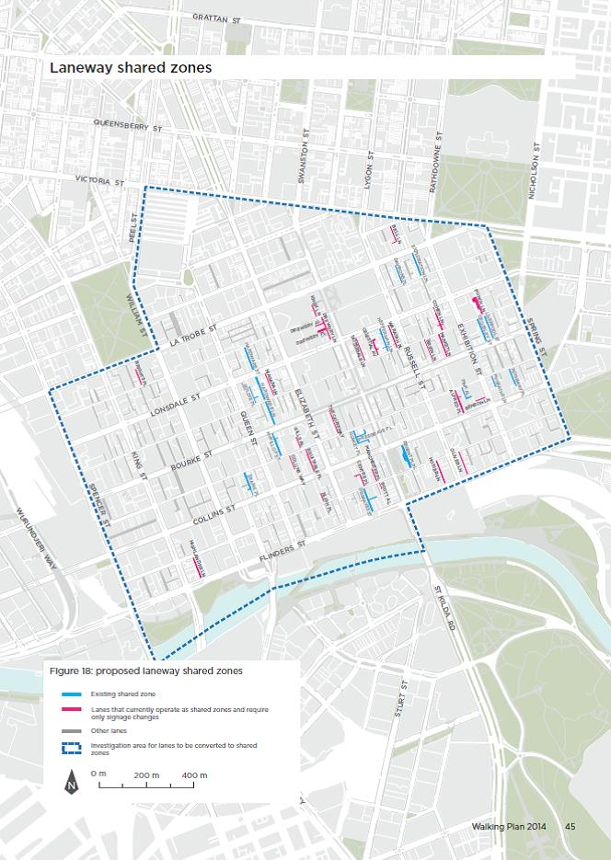
Figure 18: The above map highlights the proposed laneway shared zones - lanes that currently operate as shared zones and only require signage changes. These are as follows (part): Brights Place, Highlander Lane, Bligh Place, Collins way, Gills Alley, Equitable Place, Niagara Lane, Knox Lane, Drewery Alley, Drewery Place, Drewery Lane, The Causeway, Centre Place, Manchester Lane, Hosier Lane, Scott Alley, Oliver Lane, Tattersals lane, Celestial Avenue, Waratah Place, Brien Lane, Cohen Lane, Bell Lane, Market Lane, Alfred Place, Punch Lane.
The following streets are existing shared zones in the central city (part): Bank Place, McKillop Street, Goldie Place, Hardware Lane, Hardware Street, Degraves Street, Presgrave Place, Regent Place, Heffernan Lane, Davisons Place, Exploration Lane, Pink Alley, Liverpool Street, Crossley Street, Ridgeway Place and McGraths Lane.
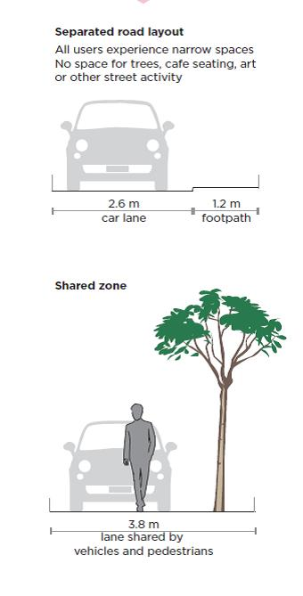
Figure 19: The above figure compares two diagrams; the first is of a separated road layout where the car lane is 2.6 metres wide and the single-sided footpath is 1.2 metres wide. In the separated road layout all users experience narrow spaces and their in no space for trees, café seating, art of other street activity. In the second diagram of a shared zone the vehicle and a pedestrian share a space 3.8m wide. A tree next to the car and pedestrian is also included in this diagram. The caption for the above two diagrams is as follows: shared zones improve the use of space by creating the conditions under which vehicles and pedestrians can share the same space rather than have separate areas. A key design criterion for shared zones is lower speeds, usually 10 km/h. A City of Melbourne example given of a separated layout is Corrs Lane and for a shared zone it is Hardware Street.
Make roads safer for pedestrians
Review existing lower speed limits and implement more on local and arterial roads where appropriate.

Objective
To achieve motor vehicle speeds in the City of Melbourne which are compatible with high levels of walking and a city for people while also being logical and easy for drivers to comply with.

Issues
Higher motor vehicle speeds can save time for motorists driving longer distances. However, they can also lead to greater road trauma, separation of land uses, reduced permeability (ability to cross streets) and reduced opportunities for streetscaping.

Rationale
The pedestrian street hierarchy recognises that pedestrians share many streets with private vehicles. Speed limits have a significant impact on how pedestrian-friendly a street is.
Lower speed limits increase the likelihood of surviving being hit by a vehicle and reduce the severity of injuries due to collision. Lower speeds also mean less need for expensive traffic controls, road safety barriers and expensive and disruptive traffic management for temporary works. Also, when speeds are lowered, more roadside furniture and trees can be installed. Lower speeds also allow for a more permeable city where pedestrians and drivers can make eye contact and allow for safe road crossing without delaying either party. Drivers travelling more slowly have greater opportunities to observe the city and see things that they might want to visit either during the current trip or later. In some countries lower speed limits have been introduced in urban areas alongside changes to traffic signals, which have together increased traffic throughput.
In 2012 the City of Melbourne reduced the speed limit in the Hoddle Grid to 40 km/h following approval by VicRoads. This is expected to save one life, nine serious injuries and 25 other injuries every year in the city. 40 km/h speed limits were introduced to local streets in Parkville in early 2014. Reducing motor vehicle speeds in areas of high pedestrian movement is a strategic objective of the City of Melbourne’s Road Safety Plan 2013 – 2017.

Implementation
- Review the performance of the 40 km/h zone in the central city considering road safety as well as other costs and benefits.
- Investigate speed limit reductions to 40 km/h on local streets throughout the City of Melbourne where appropriate.
- Investigate speed limit reductions on arterial roads in the City of Melbourne where significant numbers of pedestrians and vulnerable road users use the road now or are expected to in the future.

Walking navigation
Install a ‘heads-up’ mapping system in high-pedestrian areas and work to implement this system across Melbourne.

Objective
To help people navigate the city by making walking easier and more enjoyable while making it easy to transition from walking to using public transport.

Issue
The City of Melbourne can be difficult to navigate for people not familiar with its layout, such as visitors from other parts of Melbourne, out of town, interstate or overseas. There are currently many different way-finding signage systems carrying inconsistent messages, language and naming conventions.

‘Heads-up’ mapping
‘Heads-up’ mapping systems – which orient maps so the person reading them sees the view in front of them reflected in the map – make walking easier and more enjoyable and encourage more walking. ‘Heads-up’ maps orient people based on the direction they are facing and what is in their field of view. They have been successfully introduced in London, Bristol and New York City.
The City of Melbourne is developing a ‘heads-up’ mapping system to be deployed throughout the city beginning with the areas where the most walking occurs. These maps will assist way-finding by highlighting nearby destinations and public transport services that a person viewing a ‘heads-up’ map can easily access. The system will be extensively tested and regularly reviewed to ensure it is up-to-date and delivering on its objectives.

Implementation
- Install a ‘heads-up’ mapping system in high-pedestrian areas.
- Investigate the potential for the ‘heads-up’ mapping system to be applied across the central subregion as proposed in Plan Melbourne in collaboration with Public Transport Victoria, Yarra Trams and others.
- Investigate the potential for the system to be introduced at Melbourne’s visitor entry points (air, rail, roads and sea).
- Work with inner Melbourne councils and Victoria’s roads, public transport and tourism authorities to improve the consistency of way-finding systems that visitors rely on.
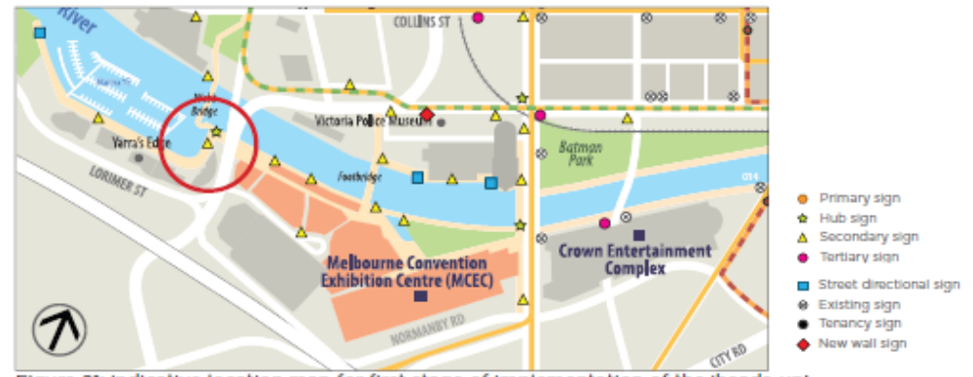
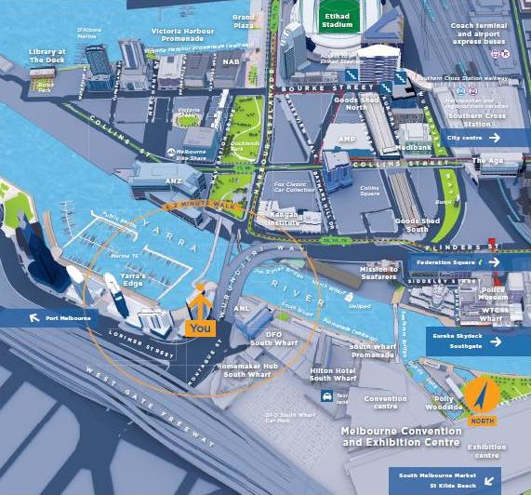

Stop lines
Progressively install stop lines on laneways at the building line rather than the intersection line along Bourke, Collins, Elizabeth and Flinders streets.

Objective
To improve the walking network in Melbourne by giving pedestrians priority at minor intersections and lanes.

Issues
A single motor vehicle exiting a minor road or lane can delay and inconvenience many pedestrians on a well-used footpath.

Rationale
On some streets in the city, stop lines have been installed so that drivers exiting minor laneways are required to give way to pedestrians on the footpath that the driver needs to cross. This reverses the usual convention where the stop line would be at the point where the two streets intersect. This means that a stopped motor vehicle would block the passage of pedestrians. In the central city many footpaths carry thousands of people per hour and it is appropriate that pedestrians have priority. The treatment allows pedestrians and motorists to make eye contact and negotiate to ensure drivers are not unreasonably delayed.
Pedestrians also need to be responsible for their own safety and ensure intersections are clear before proceeding. City of Melbourne will work VicRoads’ to ensure stop lines at the building line will not compromise the safety of pedestrians.

Implementation
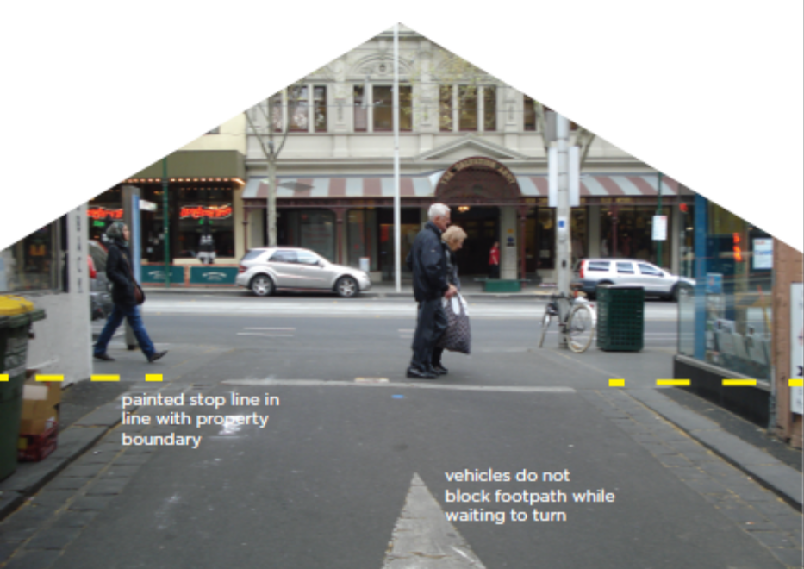
- Progressively install stop lines on laneways at the building line rather than the intersection line along Bourke, Collins, Elizabeth and Flinders streets.
Figure 23: The above image demonstrates how a painted stop line on Crossley Street is in line with the property line of the buildings on either side of the street. Because of this, vehicles do not block the footpath while waiting to turn.
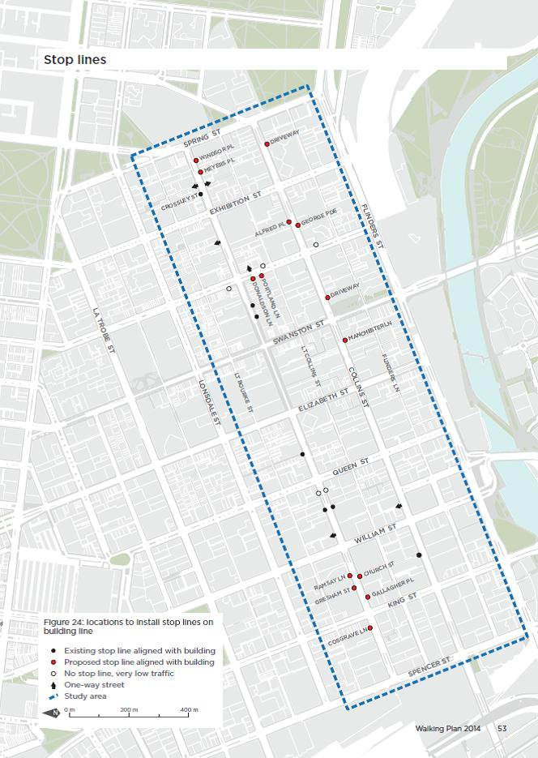
Figure 24: The above map shows the locations to install stop lines aligned with building lines. The following streets intersections are proposed: Bourke Street with Cosgrave Lane, Gallagher Place, Gresham Street, Church Street, Ramsay Street, Meyers Place and Windsor Place; Collins Street with Manchester Lane, two driveways, George Parade and Alfred Parade; and Russell Street with Portland Lane and Donaldson Lane.
Travel behaviour change
Continue to deliver the Share Our Streets multi-modal behaviour change program to improve safety and harmony amongst all road users.

Objective
To encourage everyone to use the roads collaboratively and respectfully to improve safety creating a more enjoyable road environment in the City of Melbourne and adjacent municipalities.

Issues
Respectful and cooperative behaviour by all road users can make the city safer and more efficient creating an environment that will encourage walking.

Rationale
The City of Melbourne has launched a travel behaviour change program called Share Our Streets as part of its Road Safety Plan. Many cities and jurisdictions around the world run behaviour change programs as a cost-effective way to improve the way road space is shared.
Pedestrians have much to gain from a program that delivers more considerate road behaviour. Benefits include drivers giving way appropriately, driving within the speed limit, allowing pedestrians to cross mid-block without creating delays and not using mobile devices while driving as well as cyclists slowing appropriately to allow pedestrians to get on trams and riding considerately in shared areas. Therefore, City of Melbourne will work with Victoria Police to enforce road rules in line with the Road Safety Plan to support the Share Our Streets Campaign.
Pedestrians also contribute to their own road safety as well as the safety of others. Share Our Streets promotes being considerate, observing road rules, not walking in bicycle lanes and paying attention when walking, particularly when using mobile devices. Keeping to the left on footpaths and crossings, especially in crowded areas, will also make the city easier to walk around.
Implementation
- Continue to deliver the Share Our Streets multi-modal behaviour change program to improve safety and harmony amongst all road users.
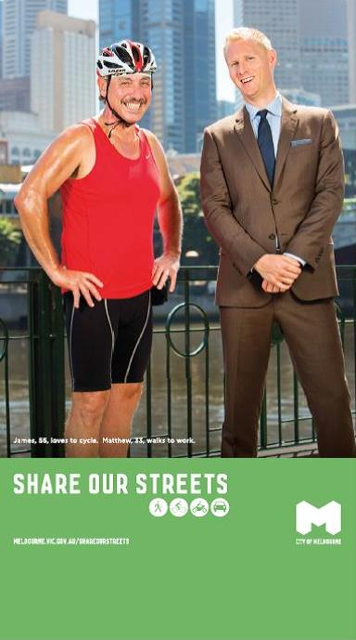

Promote health
Investigate the potential for encouraging walking to deliver health benefits in Melbourne including through the new Active Melbourne Strategy to be developed by the City of Melbourne.

Objective
To capitalise on the mental and physical health benefits and community benefits provided by walking.

Issues
Walking offers significant mental and physical health benefits. There is an opportunity to gain significant community benefit by promoting walking for health in the city, including getting exercise as a part of everyday travel.

Rationale
Promoting walking can be a cheap and simple way to improve the health of the community. Walking has been shown to address obesity, heart disease, blood pressure, arthritis, diabetes, anxiety, depression and other health issues.
Walking can be done on its own or in conjunction with public transport. For example, people who use public transport on a particular day also spend an average of 41 minutes walking or cycling as part of their travel, while those who did not use public transport spend only eight minutes walking or cycling as part of their travel (Bus Solutions, 2010, p. 3).
Victoria Walks promotes walking meetings, ‘exercise snacks’, workplace walks and local area mapping to encourage people to identify local walking destinations (www.victoriawalks.org.au). New York City has a campaign to ‘Make NYC Your Gym’. There are opportunities for the City of Melbourne to promote walking as a way to help the community to be healthier, potentially with a focus on the large number of employees who travel to the city each day.
The perception of a lack of safety and security can be a significant barrier to walking, particularly in relation to children walking to school or for trips that include public transport use. Initiatives should include the promotion of walking to school and addressing barriers to this behaviour, such as parental perceptions of risk.

Implementation
- Investigate the potential for encouraging walking to deliver health benefits in Melbourne including through the new Active Melbourne Strategy to be developed by the City of Melbourne.
- Investigate advocating for changes to the Planning and Environment Act 1987 to include health and wellbeing as an objective of planning.

Capital Works

Addressing pedestrian crowding
Develop a tool to assess and identify current and future crowding and develop measures to address these locations through a range of interventions.

Objective
To reduce pedestrian crowding through targeted actions at intersections, pedestrian crossings and footpaths.
To develop and adopt appropriate crowding standards for Melbourne to ensure footpaths are not subject to overcrowding now or in the future, including those under investigation for a pedestrian street hierarchy.

Issues
No guidance is available on what level of crowding is optimal in different environments.
In general higher crowding levels can be tolerated in the approach to busy public transport interchanges during peaks, however there is a limit to this tolerable level of crowding. Lower levels of crowding are appropriate in shopping areas and locations where people want to stand, be stationary or wander.
As pedestrian numbers have grown, pedestrians have been increasingly affected by a range of footpath obstructions, including infrastructure, construction, street furniture and both motorcycle and bicycle parking. Both motorcycle and bicycle use is growing int he City of Melbourne and allocating space for parking for these modes must be addressed with consideration of the needs of pedestrians.

Crowding standards and guidelines
The City of Melbourne can specify maximum numbers of people ideal for specific locations using various types of spaces to ensure that whether walking or waiting, people are comfortable and safe. Crowding standards and guidelines vary depending on locations; there are different crowding standards for places where people move along footpaths and where they wait at intersections.
Crowding standards are useful in maintaining pedestrian comfort when designing infrastructure (such as footpaths), managing street operations (such as signal timing) or placing street furniture.
London has a maximum pedestrian comfort level of 11 people per minute per metre of footpath width in mid-block locations (Atkins for TfL, 2010, p. 13). As an interim measure, the City of Melbourne will adopt Transport for London standards (which differ based on land use context and are shown in Appendix 6).
Further research will assess whether these are appropriate standards for Melbourne, develop crowding standards and pedestrian comfort levels for crossings and provide guidance on how to achieve these.
Crowding standards and guidelines can be used by City of Melbourne when designing infrastructure such as street upgrades as well as when reviewing proposals by developers that will have an impact on the pedestrian network in the public realm.

Implementation
- Develop a council tool to assess crowding in high pedestrian activity areas and develop measures to address overcrowding through a range of interventions.
- Identify current and future overcrowded areas and develop plans to address overcrowding in these locations.
- Plan future capital works in consideration of a crowding standard, taking into account likely future growth in pedestrian numbers.
- Identify current and future locations where footpath obstructions reduce the pedestrian comfort level below acceptable levels and take action to address this including relocation, education, regulation or enforcement.
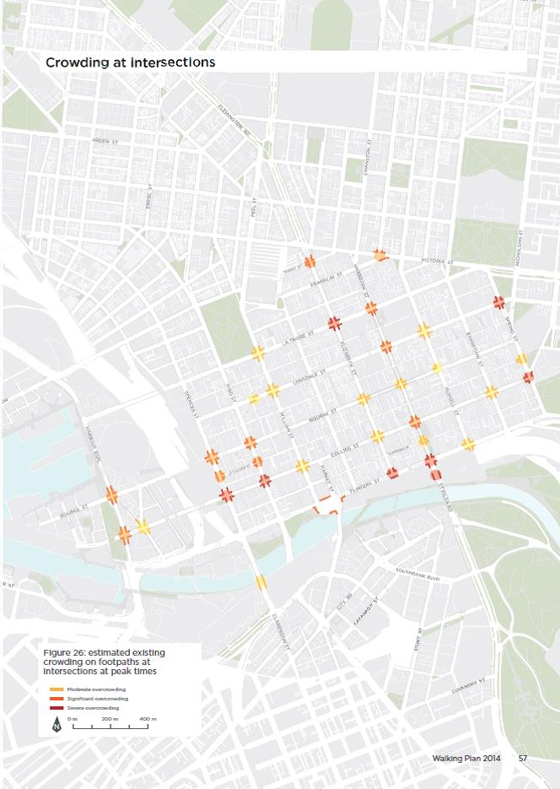
Figure 26: the above map displays three levels of estimated existing crowding on footpaths at intersections at peak times; moderate, significant and severe. The severe overcrowding is located at the following intersections; Collins Street with Spencer Street, Collins Street with King Street, La Trobe Street with Elizabeth Street, Flinders Street with La Trobe Street, Flinders Street with Swanston Street, The St Kilda Road tram stop opposite Federation square, Collins Street with Spring Street and Spring Street with Lonsdale Street. The significant overcrowding is located at the following intersections; Therry Street with Elizabeth Street, Franklin Street with Victoria Street, Flinders Street with Market Street and Williams Street, Swanston Street with La Trobe Street, Lonsdale Street and Collins Street, Bourke Street with King Street, Spencer Street and Harbour Esplanade and Collins Street with King Street, Spencer Street and Harbour Esplanade. Moderate overcrowding is located at the following intersections: Collins Street with Exhibition Street, Elizabeth Street, William Street and Batmans Hill Drive, Bourke Street with Elizabeth Street, Swanston Street and Russell Street, Lonsdale Street with William Street and Russell Street, La Trobe Street with William Street, Spring Street with Little Collins Street and Russell Street with Flinders Street. The Spence Street Bridge tram stop and the Lonsdale Street Tram stop between King Street and William Street are also locations of moderate overcrowding.
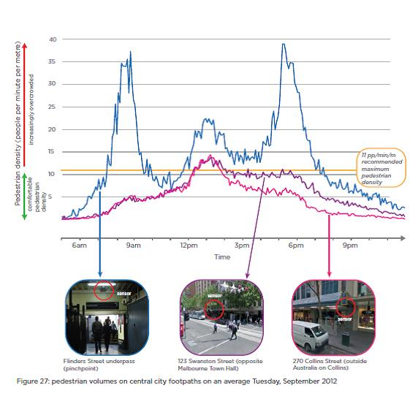
Figure 27: The above line graph charts pedestrian volumes in three central city locations on an average Tuesday, September 2012. The locations of pedestrian counters used are the Flinders Street underpass, 123 Swanston Street (opposite the Melbourne Town Hall) and 270 Collins Street (outside Australia on Collins). 11 people per minute per metres the recommended maximum pedestrian density. The Flinders Street underpass counter exceeds the recommended maximum density for most of the time between 8am and 7pm, with peaks of approximately 35 people per minute per metre at roughly 8:30 am and 5:30pm. The other two counters have similar morning trajectories to one another starting at 2-3 people per minute per metre at 6am, gradually rising to peak at 14 people per minute per metre at 1pm before both gradually falling back down. The Swanston Street counter maintains a longer stretch of higher pedestrian volumes with approximately 10 people per minute per metre between 2pm and 6pm.
Pedestrian crossings at intersections
Progressively widen, declutter, extend and protect pedestrian crossings through engineering, enforcement and design interventions.

Objective
Reduce crowding on and around pedestrians crossings.

Issues
Intersections can be crowded places where movement intensifies as people come together at safe crossing points. Crowding on corners makes it difficult for pedestrians heading for one crossing to get through the crowd waiting for the perpendicular crossing.
Given central city growth projections, more space and other improvements to the pedestrian network will be needed to avoid overcrowding.
In the Hoddle Grid, most older crosswalks in the central area are about three metres wide.
Wider crosswalks can reduce the problem of pedestrian crowding at intersections. They also minimise conflict between opposing pedestrians as they cross the road.
At some places where new tram stops have been constructed, crosswalks have been widened to cater for increased tram passenger volumes. The new pedestrian crossing at Elizabeth Street is more than eight metres wide. At other places the crosswalks are still quite narrow.
Generally, crosswalks should be made four metres wide across the central city and eight metres wide at busy tram stops or where pedestrian crowding is a problem. To provide for future increases in pedestrian numbers, it is worthwhile implementing wider crosswalks whenever opportunities arise with the installation of new tram stops or when road works are carried out.
Building out kerbs at intersections can shorten crossing distances and increase walk times. This can lead to improved traffic signal timings. Additional footpath space is more comfortable for waiting pedestrians and will help to reduce crowding at busy intersections.
Where pedestrian crowding is a problem now or in the future, the area near the crosswalk should be as clear as possible. This is important so that pedestrians with a visual disability do not walk into furniture. It also provides more space to avoid crowding. The clear area should be the full extension of the crosswalk lines, not just the area adjacent to the kerb ramp.

Implementation
- Progressively widen crosswalks within the Hoddle Grid that are less than four metres wide.
- Relocate footpath furniture and other infrastructure away from corners at busy intersections.
- Build kerb outstands at Hoddle Grid intersections where there is space to do so.

Blocked crossings and intersections
Vehicles blocking crossings and intersections because of queuing along a road add to pedestrian crowding and frustration while also causing operational delays to the tram network in certain locations. This is more significant for eastbound traffic in the pm peak.
Signs placed warning drivers to ‘Keep Intersection Clear’ are not effective and merely add to sign clutter. The road rules are quite clear that drivers must not block intersections or crossings.
Certain things can be done in terms of traffic engineering, signal timings and other techniques to minimise drivers blocking intersections or crossings, depending on the location. Enforcement, media coverage and traffic signal adjustments can deliver improvements to pedestrian and public transport movement in the most affected locations.

Implementation
- Work with Victoria Police to direct and inform enforcement activities in the City of Melbourne to achieve the transport and safety objectives of the City of Melbourne Transport Strategy 2012, Road Safety Plan 2013-17 and the Walking Plan.
- Work with Victoria Police, VicRoads and PTV to prevent vehicles from blocking intersections and crossings. This will include investigation of potential use of vehicle detector loops connected to traffic signals at certain intersections to prevent vehicles from blocking intersections.
- Assess the feasibility of trialling departure side detector loops at Elizabeth and Flinders streets to prevent queuing of southbound traffic on Flinders Street from blocking the intersection.

Master plans
Ensure master plans and precinct plans deliver an enhanced pedestrian network consistent with the principles of the Walking Plan.

Objective
To focus master planning and precinct planning efforts in the City of Melbourne on areas which will experience significant future growth in walking to ensure designs cater for that growth.

Issues
Rapidly increasing numbers of pedestrians are putting stress on existing infrastructure.

Rationale
Master planning and precinct planning are the appropriate tools to ensure that the city is well-adapted to changing demands such as significant growth in pedestrian numbers, major new public transport infrastructure and significant land use development particularly in growth and urban renewal areas.
Changes to the tram network and planning for future patronage of these services provides the impetus for new master plans. Other reasons include the need to change the operation of streets, such as City Road in Southbank, which were previously bypass routes but now run through busy, central city areas. (Figure 29 identifies future master plan projects, and more detail about the context of these projects is included in Appendix 2.)

Pedestrian Street Hierarchy
The Walking Plan establishes a Pedestrian Street Hierarchy to provide direction for the design and operation of streets. The hierarchy will be used to identify streets for short term investigation but will also be used in future development of Master Plans to ensure an enhanced pedestrian network consistent with the principles of the Walking Plan.
These plans will direct advanced streetscape designs and will lead to capital works delivery in accordance with the Streetscape Framework (2011).

Implementation
- Ensure master plans and precinct plans deliver an enhanced pedestrian network consistent with the principles of the Walking Plan.
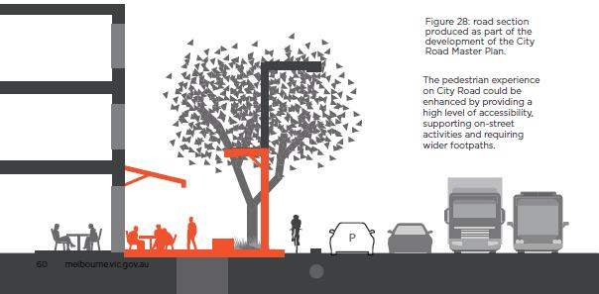
Figure 28: the above diagram shows how the pedestrian experience on City Road could be enhanced by providing a high level of accessibility, supporting on-street activities and requiring wider footpaths. The diagram highlights the addition of on street dining, seating and street lamps to light the footpath as well as the road space. A separated bike line protected by parked cars is also a feature of the diagram.
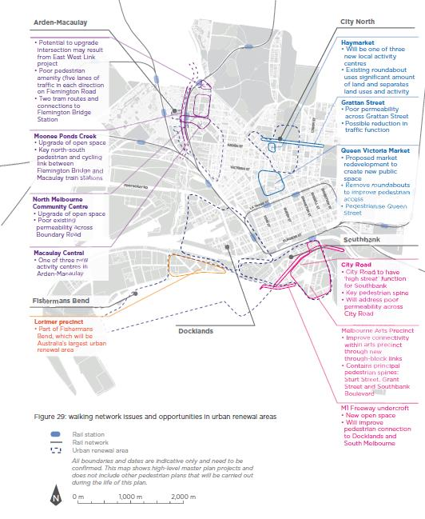
Figure 29: The above annotated map highlights walking network issues and opportunities in urban renewal areas. Arden-Macaulay, Fishermans Bend, City North and Southbank precincts are outlined on the map and broken down into key areas of concern. The map annotations are as follows:

Arden-Macaulay
Potential to upgrade intersection may result from East West Link project, poor pedestrian amenity (five lanes of traffic in each direction on Flemington Road, two tram routes and connections to Flemington Bridge Station. Moonee Ponds Creek: upgrade of open space, key north-south pedestrian and cycling link between Flemington Bridge and Macaulay train stations. North Melbourne Community Centre: upgrade of open space, poor existing permeability across Boundary Road. Macaulay Central: one of three new activity centres in Arden-Macaulay.

Fishermans Bend
Lorimer precinct: part of Fishermans Bend, which will be Australia’s largest urban renewal area

City North
Haymarket: will be one of three new local activity centres, existing roundabout uses significant amount of land and separates land uses and activity. Grattan Street: poor permeability across Grattan Street, possible reduction in traffic function. Queen Victoria Market: proposed market redevelopment to create new public space, remove roundabouts to improve pedestrian access, pedestrianise Queen Street.

Southbank
City Road: city Road to have ‘high street’ function for Southbank, key pedestrian spine, will address poor permeability across City Road. Melbourne Arts Precinct: improve connectivity within arts precinct through new through-block links, contains principal pedestrian spines: Sturt Street, Grant Street and Southbank Boulevard. M1 Freeway undercroft: new open space, will improve pedestrian connection to Docklands and South Melbourne.
Figure 30: The above annotated map highlights walking network issues and opportunities in future master plan areas. The issues and opportunities are as follows:
Melbourne University tram stop: likely future overcrowding, poor permeability across Swanston Street, possible opportunity to alter current fenced stop and tram turnaround. La Trobe Street: ink between west of Hoddle Grid and Docklands. Spencer Street: existing overcrowding, significant pedestrian growth forecast (Regional Rail Link, tram changes and increased development. Collins Street: significant pedestrian growth forecast, poor existing pedestrian environment, poor connection between Docklands and the city. Flinders Street (Northbank): existing poor connection to Docklands and rest of the city. William Street: existing crowding near Flagstaff Station, significant pedestrian growth forecast. Elizabeth Street: significant pedestrian growth forecast , new generation stops will be needed, island stops not adequate. Swanston Street: future tram network changes, significant future pedestrian growth. Collins Street: significant pedestrian growth forecast, most tram stops are or soon will be overcrowded, Collins Street has limited traffic function. Birrarung Mar: potential walking and cycling link will connect Birrarung Mar to the Alexandra Gardens. Wellington Parade: will improve permeability and connect parks to the north and south. Parliament Station: existing overcrowding at Spring, Lonsdale and north end of Collins streets. RMIT Precinct: significant future pedestrian growth. Cemetery Road East: will be impacted by East West Link, opportunity to reduce traffic function of Cemetery Road and improve pedestrian connection between Melbourne University and Princes Park.

Access around stations
Prepare pedestrian accessibility plans for train stations in the Hoddle Grid and in urban renewal areas.

Objective
To increase pedestrian safety and service around Melbourne’s public transport nodes by redesigning them to provide more links and improve amenity.

Issues
Footpaths around stations are frequently overcrowded and the problem is getting worse.

Rationale
Melbourne’s major stations are experiencing significant patronage growth which is expected to continue.
Public Transport Victoria and Metro Trains are continuing to adjust services to provide more capacity into and out of the city. Adjustments include rerouting and changing timetables to make the system more efficient. Major projects, such as Regional Rail Link, are also expected to have a significant impact.
Footpaths outside city loop train stations are currently experiencing significant crowding. Issues include people spilling onto the road because footpaths are not large enough for the number of people waiting, significant delays to pedestrians and crowded footpaths at midblock and crowded crossings. These problems are likely get worse given projected increases in patronage and nearby development which will attract more travellers.
Actions to address crowding around stations must allow for pedestrian permeability and not create barriers.

Implementation
- Work with the Department of Transport, Planning and Local Infrastructure, Public Transport Victoria and VicRoads to prepare pedestrian accessibility plans for the precincts around train stations in the Hoddle Grid.
- Prepare pedestrian accessibility plans for Spring Street and Collins Street at Parliament Station.
- Prepare pedestrian accessibility plans for Little Collins Street and King Street at Southern Cross Station.
- Work with the Department of Transport, Planning and Local Infrastructure, Public Transport Victoria and VicRoads to ensure high levels of pedestrian priority in planning for new train stations.
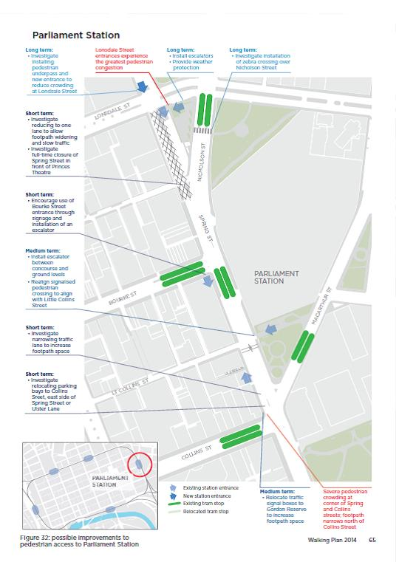
Figure 32: the above annotated map indicates points out possible long, medium and short term improvements to pedestrian access to Parliament Station. The suggested improvements are as follows: Lonsdale Street entrances experience the greatest pedestrian congestion. Long term: install escalators, provide weather protection; investigate installation of zebra crossing over Nicholson Street and investigate installing pedestrian underpass and new entrance to reduce crowding at Londsale Street. Short term (at the intersection of Spring Street and Bourke Street): investigate reducing to one lane to allow footpath widening and slow traffic; investigate full-time closure of Spring Street in front of Princes Theatre. Short term (at the southern corner of Spring Street and Bourke): encourage use of Bourke Street entrance through signage and installation of an escalator. Medium term (at the intersection Spring Street and Carpentaria Place): install escalator between concourse and ground levels; realign signalised pedestrian crossing to align with Little Collins Street. Short term (on Spring Street between Collins and Little Collins streets): investigate narrowing traffic lane to increase footpath space; investigate relocating parking bays to Collins Street, east side of Spring Street or Ulster Lane. Severe pedestrian crowding at corner of Spring and Collins streets; footpath narrows north of Collins Street. Medium term (at north eastern corner of Collins and Spring Street): relocate traffic signal boxes to Gordon Reserve to increase footpath space.
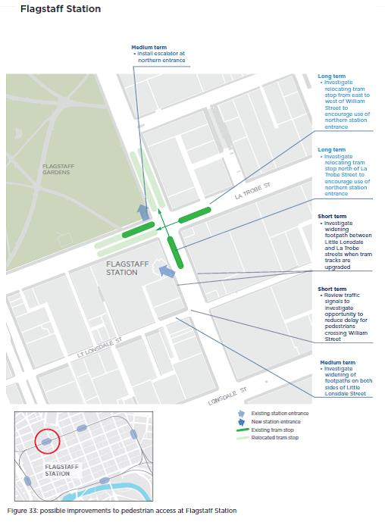
Figure 33: the above annotated map indicates points out possible long, medium and short term improvements to pedestrian access to Flagstaff Station. The suggested improvements are as follows: Medium term (at the Flag Staff Garden entrance): install escalator at northern entrance. Long term: investigate relocating tram stop from east to west of William Street to encourage use of northern station entrance; investigate relocating tram stop north of La Trobe Street to encourage use of northern station entrance. Short term: investigate widening footpath between Little Lonsdale and La Trobe streets when tram tracks are upgraded. Short term (at the corner of Little Lonsdale and William streets): review traffic signals to investigate opportunity to reduce delay for pedestrians crossing William Street. Medium term: investigate widening of footpaths on both sides of Little Lonsdale Street between King and William streets.
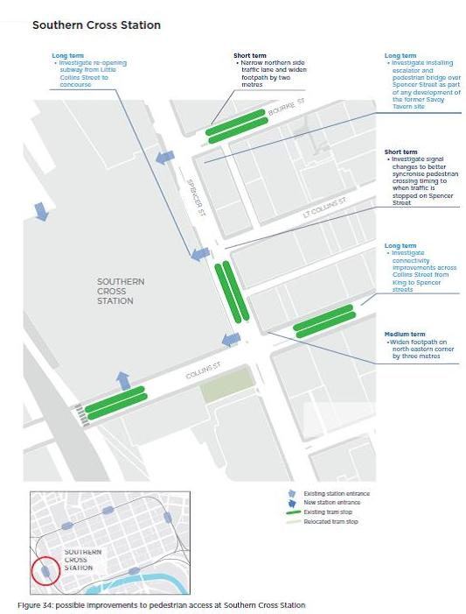
Figure 34: the above annotated map indicates points out possible long, medium and short term improvements to pedestrian access to Southern Cross Station. The suggested improvements are as follows: Long term: investigate re-opening subway from Little Collins Street to concourse. Short term (at Bourke Street near Southern Cross Station): narrow northern side traffic lane and widen footpath by two metres. Long term (between Little Collins and Bourke Street): investigate installing escalator and pedestrian bridge over Spencer Street as part of any development of the former Savoy Tavern site. Short term (at the end of Little Collins Street): investigate signal changes to better synchronise pedestrian crossing timing to when traffic is stopped on Spencer Street. Long term: investigate connectivity improvements across Collins Street from King to Spencer streets. Medium term (on Collins Street between Spencer Street and King Street): widen footpath on north eastern corner by three metres.
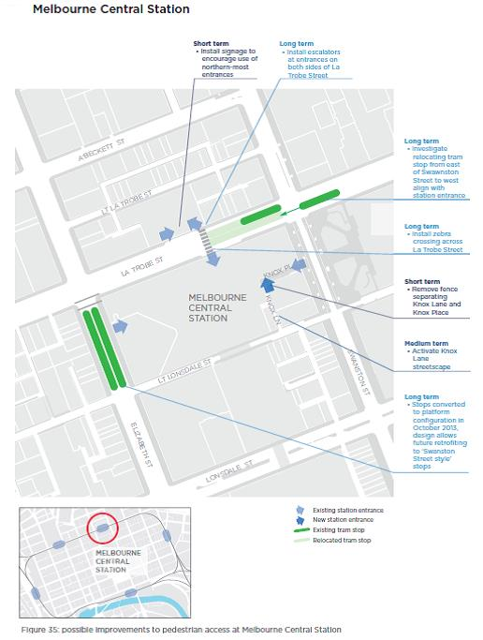
Figure 35: the above annotated map indicates points out possible long, medium and short term improvements to pedestrian access to Melbourne Central Station. The suggested improvements are as follows: Short term (at the La Trobe Street entrance on the northern side of the street): Install signage to encourage use of northern-most entrances. Long term: install escalators at entrances on both sides of La Trobe Street; install zebra crossing across La Trobe Street. Long term (La Trobe Street tram stop): investigate relocating tram stop from east of Swanston Street to west align with station entrance. Short term: remove fence separating Knox Lane and Knox Place to allow entrance to the station via Knox Lane. Medium term: activate Knox Lane streetscape. Long term (at Elizabeth Street/Melbourne Central tram stop): stops converted to platform configuration in October 2013, design allows future retrofitting to ‘Swanston Street style’ stops.
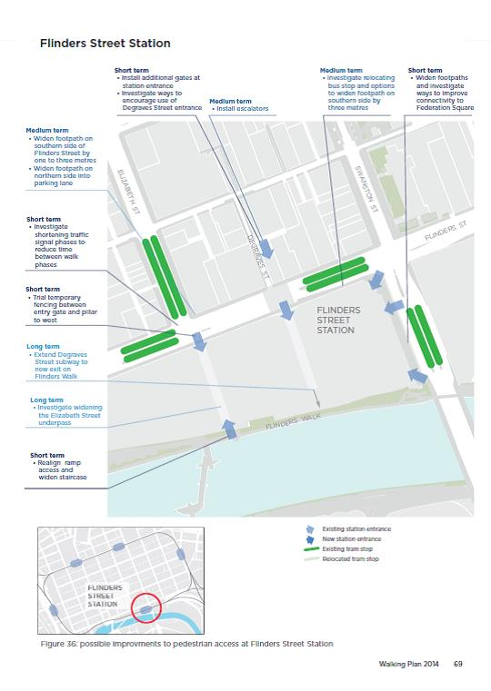
Figure 36: Short term (at the Flinders Walk entrance): realign ramp access and widen staircase. Long term investigate widening the Elizabeth Street underpass. Long term: extend Degraves Street subway to new exit on Flinders Walk. Short term (at Elizabeth Street station entrance): trial temporary fencing between entry gate and pillar to west. Short term (at the end of Elizabeth Street): investigate shortening traffic signal phases to reduce time between walk phases. Medium term (on Elizabeth Street between Flinders Street and Flinders Lane): widen footpath on southern side of Elizabeth Street by one to three metres; widen footpath on northern side into parking lane. Short term (Degraves Street station entrance): install additional gates at station entrance; investigate ways to encourage use of Degraves Street entrance. Medium term (Degraves Street station entrance): install escalators. Medium term: investigate relocating bus stop and options to widen footpath on southern side by three metres. Short term (St Kilda Road): widen footpaths and investigate ways to improve connectivity to Federation Square.
Tram and bus stops
Work with DTPLI, PTV and Yarra Trams to review current loadings, forecasts and location changes for tram and bus stops to Improve their design, account for better streetscape integration and future pedestrian volumes.

Objective
To develop designs for tram and bus stops which create a high level of amenity while reducing crowding and delays to passengers to integrate stops well with the walking network.

Issues
Some key tram stops are overcrowded and the problem is worsening as tram use rises. Access to some island tram stops is restricted by their width and small number of access points.

Rationale
Tram stops are key access points to the public transport network in Melbourne. The city has many tram stops that are busier than most suburban train stations. Around 47,360 people get on and off trams at the Federation Square tram stop on an average weekday (PTV, 2011b). At the stop on Collins Street just west of Swanston Street, more than 25,740 people get on and off trams on an average weekday (PTV, 2011b). Patronage on the tram network grew by 4.5 per cent in the year ending 30 June 2012 (DoT, 2012, p. 167). Overall growth across the public transport network is forecast to be 4.4 per cent per year to 2021, and 3.2 per cent between 2021 and 2031 (PTV, 2013; p. 4). If these growth rates apply to these individual stops, around 96,900 people will use the Federation Square tram stop, and 53,630 will use the Collins Street stop each day by 2031.
Many stops are already uncomfortably crowded during parts of the day; this is expected to worsen. Crowding at tram stops is a critical safety issue.
The stops provide level access (no step up) to the tram network and, in many cases, are island stops separated from the footpath by a traffic lane. Most of the platform stops are fewer than 10 years old but some have already reached capacity.
There are currently no crowding standards for the stops.
Tram stops in urban renewal areas need to be designed to cater for future growth.
Significant changes are expected for central Melbourne’s tram network. They include reducing overloading and tram congestion on Swanston Street by moving some routes to the west, as well as increasing the number of trams and passengers on most routes including Elizabeth Street.
- Work with the Department of Transport, Planning and Local Infrastructure, Public Transport Victoria and Yarra Trams to review the current loadings, forecasts and proposed location changes for tram and bus stops in consideration of the walking network around stops, prioritising tram stops that are currently over-crowded or forecasted to experience excessive crowding.
- Work with the Department of Transport, Planning and Local Infrastructure, Public Transport Victoria and Yarra Trams to adopt appropriate crowding and permeability standards for stops.
- Ensure master planning for Elizabeth Street takes into account significant future tram patronage growth and provides for highly accessible tram stops which are well-integrated with the footpath network.
- Improve the design of tram stops to account for better streetscape integration and higher pedestrian volumes in locations that already are or will be busy over the long term.
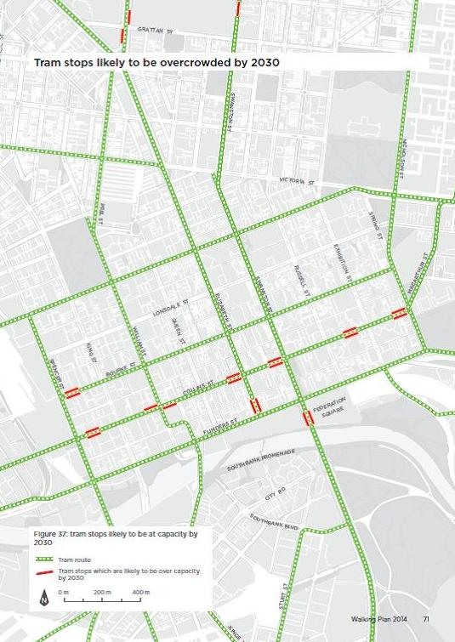
Figure 37: the above map shows trams stops likely to be at capacity by 2030. These tram stops are located: on Bourke Street between Spencer and King Streets, on Collins street between Spencer and King Streets, on Collins street on either side of William Street, on Collins Street Between Queen and Elizabeth Streets, on Collins Street between Elizabeth and Swanston Streets, on Collins Street between Russell and Exhibition Street, on Collins between Exhibition and Spring Street, at the Federation Square tram stop and at the tram stop at the junction of Flinders Street and Elizabeth Street.
Increasing the number of formal crossings
Develop a prioritised list of locations for new or improved pedestrian crossings where demand is high, crossing is difficult, including at roundabouts, and where distances between crossings are long.

Objective
Provide new pedestrian crossings to enable safe and easy pedestrian access.

Issues
A lack of pedestrian crossings or connections can make walking journeys unnecessarily long or create road safety hazards.

Rationale
Pedestrian crossings provide a safe way for people to walk from one side of the road to the other. They provide vital links in the walking network and reduce walking distances. There are locations in the City of Melbourne where new crossings are needed. Some are needed to deal with significant flows from stations (such as on Lonsdale Street at Crombie Street). Others are needed to connect developing areas to centres of activity (such as across City Road in Southbank) or to improve connections to key attractions such as the west side of the intersection of Flinders and Russell streets near Federation Square.
Walking north or south in the Hoddle Grid, formal pedestrian crossings are provided at a maximum spacing of every 100 metres. Walking east-west, formal pedestrian crossings are only every 200 metres. If a mid-block crossing is present this reduces to around 100 metres, assuming the crossing is in the middle of the block.
In some parts of the city, the distance between crossing points is extremely long. For example, the distance between crossing points on Alexandra Avenue between the Alexandra Gardens and the Queen Victoria Gardens is more than 630 metres (from the intersection at Linlithgow Avenue west to the pedestrian signals at Fanning Street on City Road). As the city grows, larger numbers of people walking will mean a need for more crossings.
Connections across the Yarra and other rivers must also be frequent enough to prevent the river being a barrier to pedestrian movement, especially in busy areas.
The City of Melbourne has been progressively installing mid-block signalised crossings on east-west streets in the Hoddle Grid similar to the well-used crossing on Collins Street between Swanston and Elizabeth streets.
Zebra crossings, which can be used on single-lane roads (in each direction) and work well in areas with lower vehicle speeds, are significantly cheaper to install than signalised crossings. They give a higher level of priority to pedestrians, who can cross them without having to wait for a signal.

Implementation
- Develop a prioritised list of locations for new pedestrian crossings and work with VicRoads to install them.
- Design and reconstruct the pedestrian bridge at the existing railway overpass at Arden Street.
- Construct a pedestrian refuge at Queensberry and Bouverie streets.
- Consider improved pedestrian connections across the Yarra River as part of the proposed Collins Street tram extension from Docklands to Fishermans Bend.
- Continue to install crossing points and meet VicRoads guidelines, prioritising locations where demand is high, crossing is difficult and distances between crossings are long.
- Review existing roundabouts on local streets and investigate the possibility of installing zebra crossings on pedestrian desire lines at these intersections.
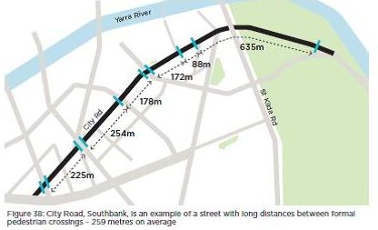
Figure 38: The above map uses a stretch of City Road in Southbank as an example of the long distances between formal crossings. On average this is 259 metres along City Road.
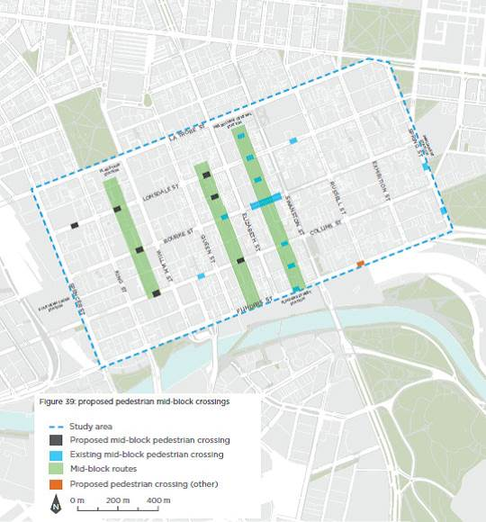
Figure 39: The proposed mid-block crossings in the above map are as follows: on Lonsdale Street between Spencer and King Streets, between Kind and William Streets and between Queen and Elizabeth Streets; on Bourke Street between King and William Streets; and on Collins Street between King and William Streets and between Queen and Elizabeth Streets. Another pedestrian crossing is also proposed at the intersection of Flinders Street and Russell Street. Existing mid-block crossings are located between Elizabeth and Swanson Street on Flinders Street, Flinders Lane, Collins Street, Bourke Street, Little Bourke Street, Lonsdale Street and Little Lonsdale Street; on Collins Street between William and Queen Streets; on Lonsdale Street between Swanston and Russell Streets; and on Spring Street between Bourke and Collins and between Collins and Flinders Streets.
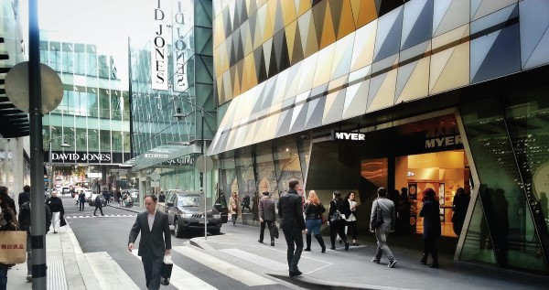
Making streets easier to cross
Investigate techniques to assist pedestrians to cross streets legally and safely at ‘non-crossing’ locations.

Objective
Make streets easier to cross safely, particularly mid-block.

Issues
A lack of crossings can make walking journeys unnecessarily long or create road safety hazards.
In addition to the installation of formalised crossings, there may be an opportunity to develop a program of low-cost painted medians and other infrastructure to help pedestrians cross the street safely and reach their destination more quickly.

Rationale
Pedestrian crossings create safe crossing points, mostly at intersections, by giving priority to people crossing the street. As previously described, zebra crossings require motorists to stop whenever a pedestrian wishes to cross. Signalised crossings require motorists to stop when signals turn red.
There are also many other places that pedestrians may wish to cross the street where formal crossings are not provided. It would be too expensive and inefficient for the operation of the street to provide crossings in all these locations. Under the road rules, pedestrians wishing to cross the road may do so anywhere except within 20 metres of a pedestrian crossing. Painted median islands have been used to assist people to cross in places where no crossing is provided. Allowing people to cross the street safely where they want to often reduces delay and walking distances. It can also promote business in shopping streets by allowing easier access between shops on different sides of the road.

Implementation
- Investigate techniques such as, medians, pedestrian refuges and raised thresholds to assist pedestrians to cross streets legally and safely at ‘non-crossing’ locations.
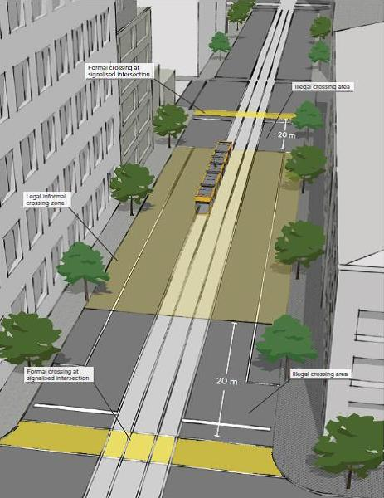
Figure 41: This 3D street diagram indicates where the legal and illegal crossing zones are in relation to the formal crossing intersections. The legal crossing zone begins 20 metres away from formal crossing areas.
Technical notes
Review Technical notes to ensure alignment with the Walking Plan.

Objective
To ensure that design and construction standards as well as standard drawings at City of Melbourne outline specifications which are aligned with Council’s Walking Plan.

Issues
City of Melbourne Technical Notes and Design and Construction Standards must continue to adapt in order to provide designs that cater for growing numbers of pedestrians and new types of walking infrastructure.

Rationale
Technical Notes and Design and Construction standards are provided by the City of Melbourne to developers and contractors to ensure that works in the public realm are of an appropriate standard. Much of the content of the standard drawings is aimed at creating a high-quality pedestrian environment. Compliance with the Docklands Design and Construction Standards is a requirement under the City of Melbourne’s Activities Local Law 2009.
The City of Melbourne is planning to extend the current Docklands Design and Construction Standards to cover the entire municipality. This provides the opportunity to ensure specifications provide for pedestrian ‘future-proofing’, for example setting footpath widths that are appropriate for the growing numbers of people walking in the city.

Implementation
- Review Technical notes to ensure alignment with the walking plan.

Walking Plan Actions
- Planning
  - A central city subregion walking plan – timeframe: 2014/15, 2015/16, 2016/17
Work with the Metropolitan Planning Authority, the Department of Economic Development, Jobs, Transport and Infrastructure and Inner Melbourne Action Plan councils to deliver improvements to walking in Melbourne.
  - Use the planning scheme to improve the walking network – timeframe: 2014/15, 2015/16, 2016/17
Establish a future fine-grained pedestrian network for the City of Melbourne for implementation in the Melbourne Planning Scheme.
  - Principal pedestrian networks – timeframe: 2015/16, 2016/17
Define a principal pedestrian network in the Planning Policy Framework and SmartRoads to complement the fine-grained pedestrian network.
- Street Management and Operation
  - SmartRoads – timeframe: 2014/15, 2015/16, 2016/17
Use SmartRoads to assess road space allocation in the City of Melbourne.
  - Signal operation – timeframe: 2014/15, 2015/16, 2016/17
Assess pedestrian delay at intersections across the City of Melbourne and develop a prioritised list of projects to reduce pedestrian delay.
  - Pedestrian street hierarchy – timeframe: 2014/15
Adopt a pedestrian street hierarchy to provide direction for the operation of streets.
  - Investigate Streets as Places – timeframe: 2014/15, 2015/16, 2016/17
Investigate the suitability of the proposed Streets as Places.
  - Investigate new Walking Streets – timeframe: 2014/15, 2015/16, 2016/17
Investigate the suitability of the proposed Walking Streets.
  - Investigate High-Mobility Streets – timeframe: 2014/15, 2015/16, 2016/17
Investigate the suitability of the proposed High-Mobility Walking Streets.
  - Create new shared zones – timeframe: 2014/15, 2015/16, 2016/17
Extend the program of converting laneways, roads and other spaces into shared zones in line with VicRoads’ guidelines and the City of Melbourne Pedestrian Street Hierarchy.
  - Make roads safer for pedestrians – timeframe: 2014/15, 2015/16
Review existing lower speed limits and implement more on local and arterial roads where appropriate.
  - Walking navigation – timeframe: 2014/15, 2015/16
Install a ‘heads-up’ mapping system in high pedestrian areas and work to implement this system across Melbourne.
  - Stop lines – timeframe: 2014/15, 2015/16, 2016/17
Progressively install stop lines on laneways at the building line rather than the intersection line along Bourke, Collins, Elizabeth and Flinders streets.
  - Travel behaviour change – timeframe: 2014/15, 2015/16, 2016/17
Continue to deliver the Share Our Streets multimodal behaviour change program to improve safety and harmony amongst all road users.
  - Promote health – timeframe: 2014/15
Investigate the potential for encouraging walking to deliver health benefits in Melbourne including through the new Active Melbourne Strategy to be developed by the City of Melbourne.
- Capital Works
  - Address pedestrian crowding – timeframe: 2014/15, 2015/16, 2016/17
Develop a tool to assess and identify current and future crowding and develop measures to address these locations through a range of interventions.
  - Pedestrian crossings at intersections – timeframe: 2014/15, 2015/16, 2016/17
Progressively widen, de-clutter, extend and protect pedestrian crossings through engineering, enforcement and design interventions.
  - Master plans – timeframe: 2014/15, 2015/16, 2016/17
Ensure master plans and precinct plans deliver an enhanced pedestrian network consistent with the principles of the walking plan.
  - Access around stations – timeframe: 2014/15, 2015/16
Prepare pedestrian accessibility plans for train stations in the Hoddle Grid and in urban renewal areas.
  - Tram and bus stops – timeframe: 2014/15, 2015/16
Work with the Department of Economic Development, Jobs, Transport and Resources, Public Transport Victoria and Yarra Trams to review current loadings, forecasts and location changes for tram and bus stops to improve their design and account for better streetscape integration and future pedestrian volumes.
  - Increase the number of formal crossings – timeframe: 2014/15, 2015/16, 2016/17
Develop a prioritised list of locations for new or improved pedestrian crossings where demand is high or crossing is difficult, including at roundabouts and distances between crossings are long.
  - Make streets easier to cross – timeframe: 2014/15, 2015/16, 2016/17
Investigate techniques to assist pedestrians to cross streets legally and safely at ‘non-crossing’ locations.
  - Technical notes – timeframe: 2014/15
Review technical notes

Appendices

Appendix 1

Information on actions not adopted in this plan

Pedestrian countdowns
Countdowns at traffic signals let road users know the amount of time remaining before a signal changes.
Most pedestrian countdowns begin at the end of the green walk phase and count down the time remaining during the flashing red walk phase. This type of pedestrian countdown was trialled in metropolitan Melbourne in 2010 and in Sydney in 2011. In both cities, the trial was not able to show improvement in pedestrian safety, and at some locations in Sydney non-compliance increased, with more people crossing after the end of the green walk phase (ARRB, 2010, p. 38; 2011, p. 56). A review of signal operation in Melbourne concluded that the benefits of ‘red walk countdown are likely to be limited and technical challenges may make installation costs high’. It may, however, be worth trialling them at a small number of sites where there are long crossing distances, such as the intersection of Elizabeth and Flinders streets.
An alternative pedestrian countdown displays the time pedestrians have to wait before they can begin to cross. This version has the potential to improve pedestrian safety while providing information to pedestrians about waiting times. Technology will need to be developed to implement this type of pedestrian countdown. Because traffic signals are linked as part of a coordinated system, the length of the ‘do not walk’ phase is not the same every light cycle and existing pedestrian countdown technology cannot accommodate the corresponding change in countdown length. It is also possible this type of countdown may encourage pedestrians to pre-empt the signal (as occurred with the Marshalite traffic signal clocks which operated up to the 1960s).
It is likely to be confusing if two different types of countdown timers operate in the same city.
Given the high cost, complexity and limited benefits, at this stage, the City of Melbourne does not intend to pursue pedestrian countdown signals.

Scramble crossing
Exclusive pedestrian phases are sometimes called a scramble crossing or a Barnes Dance. During this phase in the traffic signal cycle, pedestrians are allowed to walk diagonally across the intersection as well as parallel to the roads. An example is at the intersection of Flinders and Elizabeth streets.
Intuitively, it may seem that providing a scramble phase would improve pedestrian service, but this is demonstrably not the case in the great majority of typical intersections. A study of two typical Hoddle Grid intersections – Collins and Exhibition streets, and Spencer and Little Collins streets (Nash & Smith, 2010; John Piper Traffic Pty Ltd, 2008), found that implementing a scramble phase at each intersection would:
- result in slight increases in overall average pedestrian delay;
- markedly increase overall average vehicle delay; and
- increase average tram delay by at least double.
Though scramble phases free pedestrian movement by allowing them to cross in any direction, they also decrease the frequency of crossing opportunities by forcing pedestrians to wait through both the A and B traffic phases when vehicles pass through the intersection. Furthermore, within the scramble phase, pedestrian clearance time needs to be sufficient for an individual to clear the intersection diagonally rather than just straight across. For a typical Hoddle Grid intersection, the clearance interval would increase from about 16 seconds to 26 seconds, which is 10 seconds of additional lost time in the signal cycle. Running scramble phases would make it more difficult to achieve lower cycle times in light traffic conditions. The absolute minimum cycle time would be 65 seconds, made up of 15 seconds for each of A and B phases plus 35 seconds for the scramble phase, assuming all three phases run each cycle.

Pedestrian early starts
Pedestrian early starts provide an early introduction of the pedestrian ‘walk’ signal ahead of the parallel vehicle green at signalised intersections. This allows pedestrians to establish themselves on the crossing before left-turning traffic has a chance to reach the point of conflict with the pedestrians. The early start is generally in the order of two seconds. This type of operation is also called a ‘leading pedestrian interval’ in New York.
This measure provides pedestrians with no improvement to their level of service, as the timing of the lights for pedestrians remains unchanged. However, it provides a perceived priority because the parallel vehicle movement is delayed. This can easily be perceived to be an unnecessary penalty for motorists as it is actually achieved through a ‘late start’ for the vehicle green.
Unless there is clear evidence of a safety benefit, it could be difficult to get community support. A trial would probably need several years of operation before a reliable road safety evaluation would be possible as the road safety benefits, if any, would be marginal. A simple implementation of pedestrian early starts would adversely affect trams, buses and bicycles, as they are usually governed by the same green light as the general vehicular traffic. To overcome this, additional lanterns would have to be installed for the relevant vehicle types. This would add a level of complexity, expense and visual clutter that is unlikely to justify the small benefits of a two-second head start.
General vehicular traffic would be adversely affected by about one vehicle per lane per cycle. In congested conditions, this increases the likelihood of queues blocking an upstream intersection or crossing.
The main idea of pedestrian early starts is to overcome the situation where a left-turn driver makes their manoeuvre without looking for pedestrians. The delay for the vehicle drivers should get the pedestrian onto the crossing where the left-turn driver will see them. However, the benefit of this at intersections along Collins Street, for example, is questionable as drivers would have every expectation that they must give way to pedestrians, and driver compliance is good in Melbourne compared to many other cities. The pedestrian early start concept is more likely to have safety benefits where pedestrian presence is unexpected. That is certainly not the case along Collins Street.
When there are many pedestrians waiting to cross there is always someone who starts to walk quickly the moment the green man is displayed. In most cycles at Hoddle Grid intersections, the pedestrians are well established on the crosswalk before the first left-turn vehicle has a chance to reach the crosswalk. This is even more so as stop lines are set back through the installation of bicycle head-start boxes and wider crosswalks.
The effect of pedestrian early starts (vehicle late starts) on the operation and safety of hook turns would need to be examined carefully. According to Road Rule 34, a driver undertaking a hook turn must wait to complete the turn ‘until the traffic lights on the road that the driver is entering change to green’. However, many drivers would complete the turn from the propped position within the intersection as soon as the lights facing them turn to yellow. This disparity between expected behaviour and legal requirements could cause legal problems if any cases went to court. The extra all-red time between vehicle movements is likely to encourage more drivers per cycle to try to complete a hook turn, running the risk of interlocking hook turners.
Although pedestrian early starts provide a symbolic action showing priority for pedestrians over vehicles, the implementation is not supported for the following reasons:
- they provide no reduction in pedestrian delay;
- they adversely impact vehicular traffic;
- there is no evidence of a safety advantage, or any such benefit is likely to be small in locations where turning drivers expect to have to give way to pedestrians;
- to alleviate extra delays to bicycles, trams and buses, additional lanterns would have to be installed at considerable cost, adding to visual clutter; and
- they would create legal and operational problems at intersections with hook turns.

Appendix 2

Walking network improvements in urban renewal areas: policy context and detailed rationale
No. | Walking network improvement | Policy context | Rationale
1 | Intersection at Flemington, Racecourse and Boundary  roads | Arden-Macaulay Structure Plan | - Increase in pedestrian activity associated with forecast growth in Arden-Macaulay, around 10,900 jobs and 10,000 residents between 2011 and 2031.  - Intersection will be impacted by East West Link.  - Opportunity to reduce traffic function of Cemetery Road and improve pedestrian connection between Melbourne University and Princes Park.
2 | Moonee Ponds Creek | Arden-Macaulay Structure Plan | - Increase in pedestrian activity associated with forecast growth in Arden-Macaulay, around 10,900 jobs and 10,000 residents between 2011 and 2031.  - Upgrade of open space.  - Key north-south pedestrian and cycling link between Flemington Bridge and Macaulay stations.
3 | North Melbourne Community Centre | Arden-Macaulay Structure Plan | - Increase in pedestrian activity associated with forecast growth in Arden-Macaulay, around 10,900 jobs and 10,000 residents between 2011 and 2031.  - Upgrade of open space.  - Permeability improvement needed across Boundary Road.
4 | Macaulay Central | Arden-Macaulay Structure Plan | - Increase in pedestrian activity associated with forecast growth in Arden-Macaulay, around 10,900 jobs and 10,000 residents between 2011 and 2031.  - One of three new local activity centres.
5 | Lorimer precinct | Fishermans Bend, identified as an urban renewal precinct in Plan  Melbourne | x
6 | Haymarket | Haymarket | - Melbourne Metro and development in City North will result in more pedestrian activity.  - Forecast growth in City North – around 6,700 jobs and 5,400 residents between 2011 and 2031.  - Location of future Melbourne Metro station (Parkville), which will have around 16,000 morning peak commuters.  - Will be the centre of one of three local service hubs in City North.  - Existing roundabout uses significant amount of land
7 | Queen Victoria Market | City North Structure Plan | - Current overcrowding at Elizabeth Street tram stops.  - City North forecast to grow by around 6,700 jobs and 5,400 residents between 2011 and 2031.  - Hoddle Grid forecast to grow by around 120,340 jobs and 18,800 residents between 2011 and 2031.  - Currently Queen Victoria Market has more than 10 million annual visitors.  - Upgrade needed to ensure long-term market viability.  - Will build connections to and improve walking access within the market.
8 | City Road | Southbank Structure Plan | - Increase in pedestrian activity associated with forecast growth in Southbank, around 16,700 jobs and 13,400 residents between  - 2011 and 2031.  - City Road to be developed to have ‘High Street’ function for Southbank.  - One of the principal pedestrian spines for Southbank.  - Will address poor permeability across City Road and poor existing pedestrian amenities.
9 | M1 Freeway undercroft | Southbank Structure Plan | - Increase in pedestrian activity associated with forecast growth in Southbank, around 16,700 jobs and 13,400 residents between 2011 and 2031.  - Will improve pedestrian connection to South Melbourne and Docklands.  - New open space.
10 | Southbank arts precinct | Southbank Arts Precinct Blueprint | - Arts Victoria project in partnership with the City of Melbourne and the University of Melbourne.  - Funded in the 2011–12 Victorian State Budget and through additional funding by the Commonwealth Liveable Cities program.  - Will service local residents as well as local, regional, interstate and international visitors.  - Will improve connectivity within the arts precinct through new pedestrian through-block links.  - Area contains principal pedestrian spines – Sturt Street, Grant Street and Southbank Boulevard – as identified in Southbank Structure Plan.

Walking network improvements in future master plan areas: policy context and detailed rationale
 | Master Plan Project | Context | Rationale
11 | Wellington Parade | Open Space connections | - Permeability increase needed across Wellington Parade to connect parks.
12 | Cemetery Road | East West Link
13 | La Trobe Street | Central city growth
14 | Southern Cross Station | Central city growth | - Current pedestrian overcrowding on footpaths; crowding has been alleviated in the short term by reducing signal cycle timing and pedestrian waiting period.  - Regional Rail Link and development in the west of the Hoddle Grid will result in more pedestrian activity.  - Regional Rail Link will increase capacity of Southern Cross Station by 16 extra services (regional and metropolitan) in two-hour peak period, and is due for completion by early 2016. (State of Victoria, 2012, p. 15)  - Possible tram stop move on Collins Street from east of Spencer Street to west may alleviate some crowding.  - Possible opportunity for an air-bridge across Spencer Street, dependent on future development plans for former Savoy Tavern site at corner of Bourke and Spencer streets.
15 | Parliament Station | Central city growth | - Current pedestrian overcrowding on footpaths on Spring Street Lonsdale Street and north end of Collins and Little Collins streets.
16 | Flinders Street (Northbank) | Central city growth | - Development in the west of the Hoddle Grid, Northbank and surrounding urban renewal areas will result in more pedestrian journeys to trams and trains.  - Forecast growth in Northbank of around 17,000 jobs between 2011 and 2020. (DPCD, 2012)  - Existing poor pedestrian environment creating confl ict between pedestrians and cyclists.  - Existing poor connection to Docklands and the rest of the city.
17 | Flinders Street Station  at Federation Square tram stop | Central city growth | - Federation Square and Flinders Street Station are ‘Melbourne’s meeting place’.  - Busiest train station and tram stop in Melbourne. Flinders Street  - Station has around 171,000 people walking to and from the station each weekday, Federation Square tram stop has around 50,000. (PTV, 2012)
18 | Melbourne Central Station | Central city growth | - Significant future pedestrian growth and major interchange point.
19 | Collins Street | Central city growth | - Current overcrowding on most tram stops along Collins Street; most are already or will be unmanageable soon.  - Forecast pedestrian growth indicates more pedestrians will be accessing Collins Street tram stops and footpaths.  - Collins Street has limited traffic function.  - Pedestrian growth likely to lead to overcrowding.
20 | Grattan Street | City North | - Permeability increase needed across Grattan Street.  - Growth of university buildings south of Grattan Street will result in more pedestrians on Grattan Street.
21 | Elizabeth Street | Realignment of tram routes detailed in Public Transport Victoria’s forthcoming On Road Network Development Plan | - Elizabeth Street bookends the pedestrianised heart of Melbourne centred on the retail core.  - Future volumes of pedestrians accessing Elizabeth Street from two train stations and several tram lines will grow significantly and more footpath space will be needed.  - New-generation tram stops will be needed as island platforms will not be adequate.
22 | William Street | Realignment of tram routes as per On Road Network Development Plan | - Permeability increase needed across Swanston Street.  - Tram stop likely to be overcrowded in future.  - Possibility to alter current fenced arrangement and tram turnaround during realignment of tram routes.
23 | Melbourne University tram stop at Swanston Street | Realignment of tram routes as per On Road Network Development Plan | - Permeability increase needed across Swanston Street.  - Tram stop likely to be overcrowded in future.  - Possibility to alter current fenced arrangement and tram turnaround during realignment of tram routes.

Appendix 3
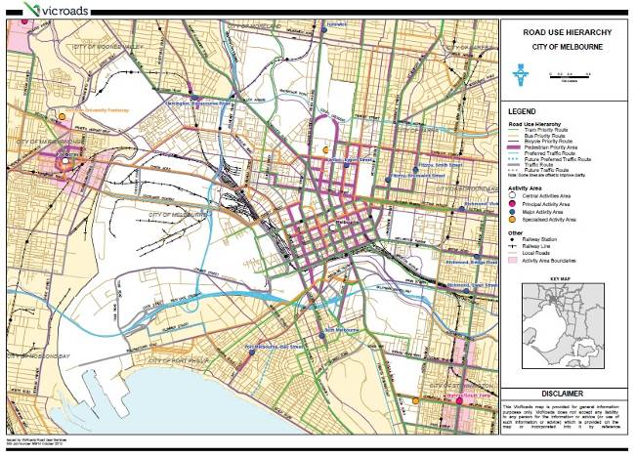

Current VicRoads Network Operating Plan, 2012
In the above map VicRoads has designated the entire Hoddle Grid as having a pedestrian priority. There are no preferred traffic routes or future preferred traffic routes running through the Hoddle Grid, though they do exist within the City of Melbourne municipality. In terms of the Hoddle Grid, trams are classified on having priority on all streets except for Russell, Exhibition, King and Lonsdale streets. The Hoddle Grid is classified as a Central Activities Area. Bus priorities are given on Lonsdale Street and Queen Street. Based on the map, bicycle priority routes are not evident in the central city.

Appendix 4

Policy background – list of Commonwealth, State and City of Melbourne policy documents
Plan Melbourne, 2014
w, Planning & Local Infrastructure
www.planmelbourne.vic.gov.au

SmartRoads framework
VicRoads
www.vicroads.vic.gov.au/Home/Traffi cAndRoadConditions/HowWeManageTraffi c/Smartroads/

Transport Integration Act, 2010
www.legislation.vic.gov.au

The Transport Integration Act sets out a vision for Victoria’s transport system that supports a city that
is inclusive, prosperous, safe and green, using careful planning to maximise opportunities and reduce risks.
The Act impacts on both the transport and placemaking function of roads. All Victorian transport planning and management needs to have regard for the six key objectives of the Act, which are: environmental sustainability, economic prosperity, safety, integration of land use and transport planning; and efficiency, coordination and reliability.

Transport Strategy, 2012
City of Melbourne
www.melbourne.vic.gov.au/futuregrowth

Council Plan, 2013-2017
City of Melbourne
www.melbourne.vic.gov.au/aboutcouncil/plansandpublications/councilplan

Road Safety Plan, 2013-2017
City of Melbourne
www.melbourne.vic.gov.au/roads

Active Melbourne Strategy, 2007
City of Melbourne
www.melbourne.vic.gov.au/ParksandActivities/ActiveMelbourne

Streetscapes Framework, 2011
City of Melbourne
https://www.melbourne.vic.gov.au/ParkingTransportandRoads/Roads/Documents/Streetscape_Framework.pdf

Melbourne for All People Strategy, 2014-2017
City of Melbourne
https://www.melbourne.vic.gov.au/CommunityServices/Pages/MelbourneForAllPeople.aspx

Bicycle Plan, 2012-2016
City of Melbourne
http://www.melbourne.vic.gov.au/AboutCouncil/PlansandPublications/strategies/Pages/Bikeplan.aspx

Appendix 5

Pedestrian Level of Service as defined in SmartRoads
Source: AITPM and VicRoads Seminar Training Manual: Application and Use of Network Fit Assessments
Transport type | LOS | Description
Pedestrian | A | Crossing opportunities within 25 metres of demand. Minimal delay in crossing.
Pedestrian | B | Crossing opportunities within 50 metres of demand. Average delay before being able to safely cross in less than 30 sec.
Pedestrian | C | Crossing opportunities within 100 metres of demand. Average delay before being able to safely cross in less than 45 sec.
Pedestrian | D | Crossing opportunities within 200 metres of demand. Average delay before being able to safely cross in less than 60 sec. Significant numbers of pedestrians start crossing illegally.
Pedestrian | E | Crossing opportunities within 400 metres of demand. Average delay before being able to safely cross in less than 90 sec.
Pedestrian | F | Crossing opportunities within 400 metres of demand. Average delay before being able to safely cross in more than 90 sec.
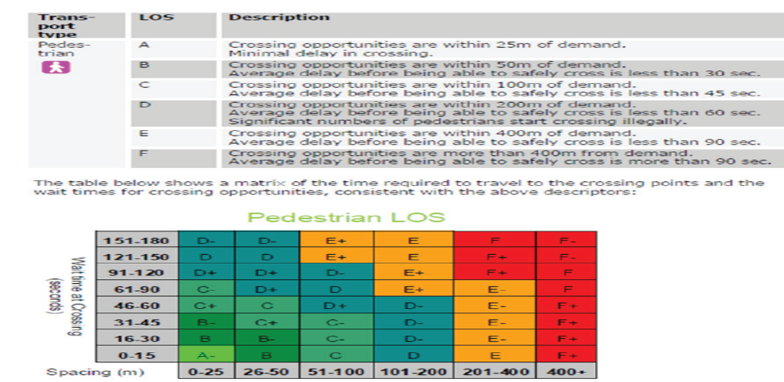
The above matrix has crossing wait times in seconds listed on the y axis and spacing in metres listed on the x axis. The only A- rating is given for a wait time of 0-15 seconds and spacing of 0-25 metres. Above the 61-90 second wait time and 51-100 metre spacing, all ratings are given as a D or lower.

Appendix 6
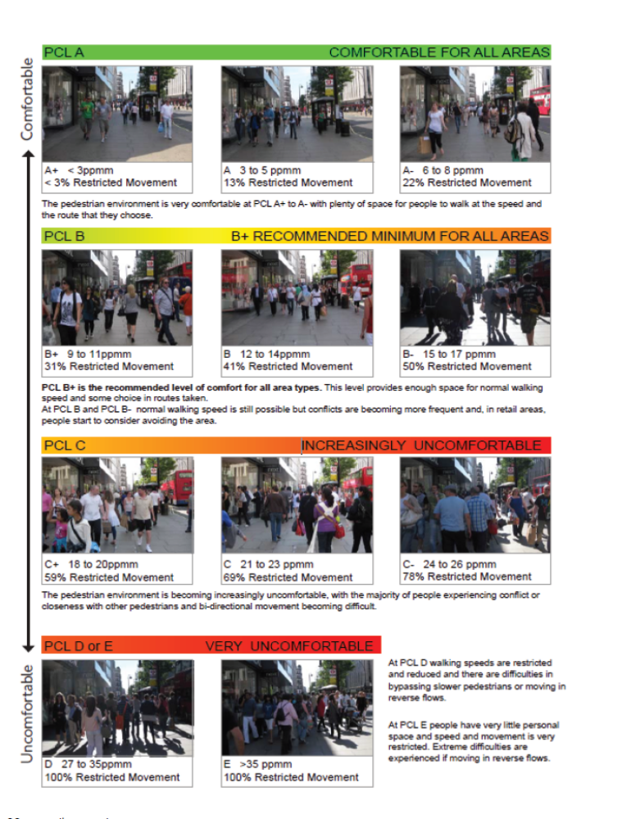
The above chart scales pedestrian comfort levels by letter ranking from comfortable to uncomfortable. The pedestrian environment is very comfortable at Pedestrian comfort level (PCL) A+ to A- with plenty of space for people to walk at the speed and the route that they chose. Here restricted movement is less than 22 per cent. PCL B is the recommended minimum for all area types. PCL B+ is the recommended level of comfort for all area types with 31 per cent restricted movement. This level provides enough space for normal walking speed and some choice in routes taken. At PCL B and PCL B- normal walking speed is still possible but conflicts are become more frequent and, in retail areas, people start to consider avoiding the areas. Restricted movement is between 41-50 per cent. At PCL C it is increasingly uncomfortable, with the majority of people experiencing conflict or closeness with other pedestrians and bi-directional movement becoming difficult. Restricted movement is 59 to 78 per cent. At PCL D walking speeds are restricted and reduced and there are difficulties in bypassing slower pedestrians or moving in reverse flows. At PCL E people have very little personal space and speed and movement is very restricted. Extreme difficulties are experienced if moving in reverse flows. PCL D and E are ranked as very uncomfortable.

Guidance on applying pedestrian comfort levels in different area types
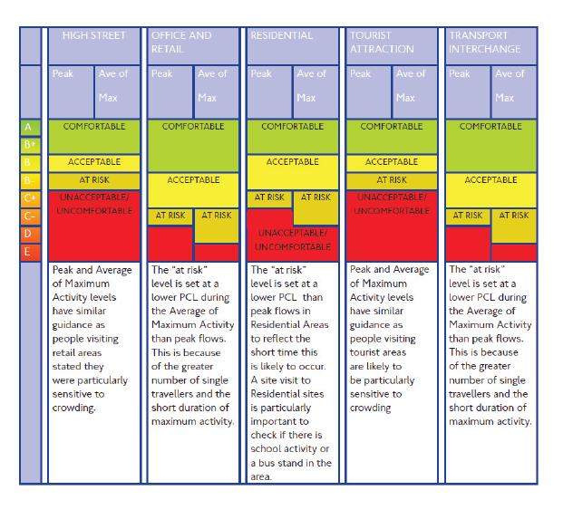
Source: Atkins for Transport for London, 2010, page 14
The above matrix measures street types according to pedestrian comfort levels. E is unacceptable/uncomfortable for all street types. The matrix classifications are as follows:
High street – A to B+ are ‘comfortable’, B is ‘acceptable’, B- is’ at risk’ and C+ to E is ‘unacceptable/uncomfortable’. Peak and Average of maximum activity levels had similar guidance as people visiting retail areas stated they were particularly sensitive to crowding.
Office and retail – A to B is ‘comfortable’, B- to C+ are ‘acceptable’, C- is ‘at risk, D is ‘at risk’ during ‘Average of Maximum’ and ‘uncomfortable’ during ‘peak’. The “at risk” level is set at a low PCL during the Average of Maximum Activity flows. This is because of the greater number of single travellers and the short duration of maximum activity.
Residential – A to B+ is ‘comfortable’, B to B- is ‘acceptable’, C+ is ‘at risk’, C- is ‘at risk’ during ‘Average of Maximum’ and ‘uncomfortable’ during ‘peak’. D is ‘unacceptable/uncomfortable’. The “at risk” level is set at a lower PCL than peak flows in residential areas to reflect the short time this is likely to occur. A site visit to residential sites is particularly important to check if there is school activity or a bus stand in the area.
Tourist attraction – A to B+ is ‘comfortable’, B is ‘acceptable’, B- is ‘at risk’, C to E is ‘unacceptable/uncomfortable’. Peak and ‘average of maximum’ activity levels have similar guidance as people visiting tourist areas are likely to be particularly sensitive to crowding.
Transport interchange – A to B is ‘comfortable’, B- to C+ is ‘acceptable’, C- is ‘at risk’, D is ‘at risk’ during ‘Average of Maximum’ and ‘unacceptable/uncomfortable’ during ‘peak’. The “at risk” level is set at a low PCL during the ‘average of maximum’ activity than peak flows. This is because of the number os single travellers and the short duration of maximum activity.

Bibliography
Atkins for Transport for London (TfL) 2010, ‘Pedestrian Comfort Level Guidance’, TfL website, accessed on 14 May 2014: www.tfl.gov.uk/assets/downloads/pedestrian-comfort-guidance-technical-guide.pdf
Australian Bureau of Statistics (ABS) 2001, ‘Table W19 Method of Travel to Work by Age, Working Population Profile (cat. no. 2006.0) (based on place of work, Melbourne (C) (LGA25600))’, ‘2001 Census Community Profiles’, ‘2001 Census of Population and Housing’, ABS website, accessed on 12 May 2014: www.censusdata.abs.gov.au/census_services/getproduct/census/2001/communityprofi le/LGA24600
Australian Bureau of Statistics (ABS) 2006, ‘Table W21 Method of Travel to Work by Age by Sex, Working Population Profile (cat. no. 2006.0) (based on place of employment, Melbourne (C) (LGA25600))’, ‘2006 Census Community Profiles’, ‘2006 Census of Population and Housing’, AB website, accessed on 12 May 2014: www.censusdata.abs.gov.au/census_services/getproduct/census/2006/communityprofile/LGA24600
Australian Bureau of Statistics (ABS) 2011a, ‘Table W22 Method of Travel to Work by Age by Sex, Working Population Profile (cat. no. 2006.0) (based on place of work, Melbourne (C) (LGA25600))’, ‘2011 Census Community Profiles’, ‘2011 Census of Population and Housing’, ABS website accessed on 12 May 2014: www.censusdata.abs.gov.au/census_services/getproduct/census/2011/communityprofile/LGA24600
Australian Bureau of Statistics (ABS) 2011b, ‘People – employment, Travel to work, top responses, 2011 Census QuickStats, (based on all people – usual residents, Southbank (SSC21241) and Melbourne (SSC20867)’, ABS website, accessed on 12 May 2014: www.abs.gov.au/websitedbs/censushome.nsf/home/quickstats
Cairney, P, Zivanovic, A, Pyta, V & Walsh, K (ARRB) 2009, ‘Contract Report: Trial of Countdown Timers – Pedestrian Behaviours and Perceptions’, VicRoads unpublished report.
Bureau of Transport and Regional Economics (BTRE) 2007, ‘Estimating urban traffic and congestion cost trends for Australian cities, Working paper 71, BTRE, Canberra ACT’, BITRE website, accessed on 12 May 2014: www.bitre.gov.au/publications/2007/files/wp_071.pdf
Bus Association of Victoria 2010, ‘Using public transport – a ticket to health’, Bus Solutions, issue 2, March 2010, Bus Association of Victoria website, accessed on 14 May 2014: www.busvic.asn.au/images/uploads/public/BusSolutions2-Mar2010.pdf
City of Melbourne (CoM) 2012, ‘Transport Strategy: Planning for Future Growth, Melbourne’, CoM website, accessed on 12 May 2014: www.melbourne.vic.gov.au/futuregrowth
City of Melbourne (CoM) 2013a, ‘City of Melbourne Daily Population Estimates and Forecasts’, CoM website, accessed on 12 May 2014: www.melbourne.vic.gov.au/AboutMelbourne/Statistics/Documents/Daily_population_model_2013_Report.pdf
City of Melbourne (CoM) 2013b, ‘Council Plan 2013–2017’, CoM website, accessed on 12 May 2014: www.melbourne.vic.gov.au/aboutcouncil/plansandpublications/councilplan
City of Melbourne (CoM) 2013c, ‘Road Safety Plan 2013–2017’, CoM website, accessed on 12 May 2014: www.melbourne.vic.gov.au/roads
Department of Planning and Community Development (DPCD) 2012, ‘Northbank Access and Mobility Study’, unpublished report.
Department of Transport (DoT) 2012, ‘Annual Report 2011–2012’, State Government of Victoria, Melbourne,
Department of Transport website, accessed on 14 May 2014: http://www.transport.vic.gov.au/__data/assets/pdf_file/0005/81383/DOT-Annual-Report-2011-2012.pdf
Department of Transport (DoT) 2010, ‘VISTA 2009/10 Customised report’.
Department of Transport, Planning and Local Infrastructure (DTPLI) 2014, ‘Clause 22.01: Urban Design within the Capital City Zone, Melbourne Planning Scheme’, DTPLI website, accessed on 12 May 2014: www.planningschemes.dpcd.vic.gov.au/schemes/Melbourne
Department of Transport, Planning & Local Infrastructure (DTPLI) 2013, ‘Plan Melbourne (draft)’,Plan Melbourne website, accessed on 12 May 2014: www.planmelbourne.vic.gov.au/Plan-Melbourne
Nash, D & Smith, W, 2010, ‘The Efficiency of Scramble Crossings’, unpublished report. AITPM Annual Conference Proceedings.
John Piper Traffic Pty Ltd. 2008, ‘Melbourne CBD Pedestrian only traffic signal phases feasibility analysis’, unpublished report.
Public Transport Victoria (PTV) 2013, ‘Estimated Station Entries at Metropolitan Stations 2008/09 to 2011/12’, PTV website, accessed on 12 May 2014: www.ptv.vic.gov.au/about-ptv/ptv-data-and-reports/research-and-statistics
SGS Economics and Planning 2013, ‘SGS Employment Forecasts, unpublished report. .
Siksna, A 1996, ‘The effects of block size and form in North American and Australian city centres’,
Urban Morphology, vol. 1, p. 19-33. See 8465483.
State of Victoria 2012, ‘Regional Rail Link: Benefits for all Victorians’, Regional Rail Link website, accessed on 14 May 2014: www.regionalraillink.vic.gov.au/__data/assets/pdf_file/0008/79514/RRL-benefits-for-Victorians.pdf
State of Victoria 2009, ‘Road Safety Road Rules 2009’, Victorian Legislation and Parliamentary Documents website, accessed on 12 May 2014: www.legislation.vic.gov.au
State of Victoria 2010, ‘Transport Integration Act, 2010’, Victorian Legislation and Parliamentary Documents website, accessed on 12 May 2014: www.legislation.vic.gov.au
ttchoice consulting for Destination Melbourne 2010, ‘A review of integrated visitor transport in Melbourne’, Destination Melbourne website, accessed on 12 May 2014: www.destinationmelbourne.com.au/cms/wp-content/uploads/2011/08/Integrated-Visitor-Transport-Report_LowRes.pdf
VicRoads 2011, ‘Road Safety Performance Information: Melbourne’, Local Roads: 2007-11 Data
Walk21 2006, ‘International Charter for Walking’, Walk21website, accessed on 14 May 2014: www.walk21.com/papers/International%20Charter%20for%20Walking.pdf

