Melbourne CBD North Edge Traffic Study
April 2015 Review
Movendo
Suite 3, 33 Chessell Street
South Melbourne 3205
Tel: 0433 058 833
information@movendo.com.au
ABN 15162173551

Table of Contents
Table of Contents i
1. Executive Summary 1
1.1. The 2011 Study 1
1.2. What Has Happened Since 2011 2
1.3. The Altered Traffic Environment 2
1.4. What Has Been Found 2
1.5. The 2015 Study Conclusions 3
2. Introduction 4
2.1. Study Purpose 4
2.2. Traffic Background 4
3. Existing Conditions 5
3.1. Route Overview 5
3.2. Roadway Configurations 5
4. Existing Traffic Patterns 12
4.1. 2015 Traffic Volumes 12
4.2. Peak Hour Traffic Patterns 18
4.3. Crash History 27
5. Re-Distribution of Traffic Volumes 29
5.1. New Alignment 29
5.2. Role of Existing Alignment 33
6. Franklin Street Re-Alignment and Reconfiguration 34
7. Consequences for La Trobe, Victoria & Peel Streets 37
8. Conclusion 38

Executive Summary

The 2011 Study
This study provides an update to the “Melbourne CBD North Edge Traffic Study” prepared by the City of Melbourne 4 years ago, in April 2011 (the “April 2011 Study”). It specifically sets out to understand and quantify the extent of any traffic flow changes that have occurred since April 2011 and to establish whether the findings and conclusions drawn in the April 2011 study are still valid.
Council undertook the April 2011 study in response to the intensification of development in the northern part of the CBD, as well as the anticipated major redevelopment forecast to occur to the immediate north and north/west of the CBD and in Docklands – in the area now known as the City North precinct. Subsequent to the April 2011 study, the City North Structure Plan prepared in 2012 identified the precinct as an urban renewal area that will accommodate significantly more residents and employment growth over the next 30 years. The Structure Plan provides a long term vision to guide the renewal of the area and fulfill the precinct’s potential as an extension of the central city.
The April 2011 study examined the traffic situation in the “Northern Edge” of the CBD and proposed a new framework for managing traffic flows in the CBD’s north. This framework capitalised on the opportunity to achieve a better balance in traffic flows and address the historic inconsistent amenity provided for vulnerable road users.
Within this context, Council’s desire, in 2011, was to focus on the transport function of three key east-west routes on the northern edge of the Melbourne CBD, in order to explore opportunities to enhance the amenity for pedestrians and cyclists, while retaining adequate levels of accessibility and mobility by car. The routes under review in the April 2011 study were:
- Victoria Street / Peel Street / Dudley Street
- Franklin Street
- La Trobe Street
The investigation presented in the April 2011 study focused on the potential role that a revised traffic function and/or realignment for Franklin Street could play – in helping to redistribute traffic flows in a more uniform manner across the CBD’s northern edge. The analysis revealed that it was possible to pursue more balanced treatments across all three routes.
More particularly, the April 2011 study found that it was feasible to adopt a uniformly consistent design for each of Franklin Street, La Trobe Street and Victoria Street (west of Elizabeth Street). The study recommended a package of operational arrangements and adoption of similar geometric cross-section for all 3 streets with a defined emphasis to enhance priority for pedestrians and cyclists.
Ultimately, the April 2011 study concluded that the adoption of a more direct alignment for Franklin Street (linking it to Dudley Street through the existing Queen Victoria Market carpark – via a new signalised intersection at Peel Street) would allow the following cross-sectional arrangements to be implemented on each of Victoria Street, Franklin Street and La Trobe Street:
- One mid-block traffic lane in each direction on each road (accompanied by the removal of clearways on La Trobe Street);
- An on-road bicycle lane in each direction on each road;
- Central median on Franklin Street to replace the current centre-of-road parking; and
- Retention of parallel parking on both sides of Franklin Street, as well as existing parking arrangements on Victoria Street and La Trobe Street.

What Has Happened Since 2011
In the 4 years since completion of the April 2011 study, traffic patterns in the precinct have altered in response to both the ongoing urban redevelopment (that had been predicted for both the northern and north-western parts of the central city and Docklands) as well as a number of recent road projects, including:
- Construction of physically separated bike lanes on La Trobe Street (which has involved implementation of design elements envisaged by the April 2011 study – such as the removal of clearways and reduction in the number of mid-block traffic lanes from two to one in each direction – in most blocks);
- Installation of painted bike lanes on William Street (this has also entailed the removal of clearways and the reduction in the number of mid-block traffic lanes from two to one in each direction); and
- Construction of new tram platform stops on Elizabeth Street and Swanston Street near RMIT (involving localised reductions in the number of traffic lanes at various intersections).
These projects have reduced vehicle traffic capacity on the affected streets, causing some traffic redistribution.

The Altered Traffic Environment
An essential first step in reviewing the April 2011 study has involved the collection of new traffic volume data on Franklin, La Trobe, Peel and Victoria Streets – necessary to quantify any changes on those streets. The key findings from the new traffic volume survey program (undertaken in March 2015) are summarised below:
- The introduction of the physically separated bike lanes on La Trobe Street (in 2013) has already reduced this route to one mid-block traffic lane in each direction (as envisaged in the April 2011 study) and caused daily traffic flows along La Trobe Street to reduce by approximately 23% from 24,000 to approximately 18,500 vehicles per average weekday (at Elizabeth Street). This represents a reduction of 5,500 vehicles per day travelling along La Trobe Street.
- Some of the La Trobe Street traffic may have redistributed to Franklin Street, which has experienced an 11% increase in daily traffic volumes (a rise of approximately 1,100 vehicles per day) since the April 2011 study. This 1,100 rise in traffic volume on Franklin Street is nonetheless significantly lower than the recorded 5,500 fall in the daily traffic volume on La Trobe Street.
- Interestingly, the recent traffic surveys also indicate that daily traffic volumes on Peel Street, between Victoria and Dudley Streets, have also dropped by approximately 8% (a reduction of approximately 3,000 vehicles per day).
- Finally, peak hour traffic counts on Victoria Street (west of Elizabeth Street) suggest that traffic volumes have not changed significantly since 2011. Thus, with virtually identical traffic volumes on Victoria Street and a small traffic volume reduction on Peel Street, it can be confidently concluded that traffic using the northern-most route (Victoria/Peel/ Dudley) for east-west travel has likely remained steady or, possibly, marginally decreased since 2011, despite the significant reduction of traffic using La Trobe Street since the separated bike lanes were installed – which has only partially rerouted to Franklin Street.

What Has Been Found
On the basis of the March 2015 traffic counts, it is evident that the overall volume of traffic using the east-west streets on the northern edge of the central city has reduced. On this basis alone, the broad conclusions drawn in the April 2011 Study are considered valid for 2015 – simply by virtue of the fact that the collective total traffic load on the three east-west routes under consideration has decreased markedly between 2011 and 2015. Importantly, whilst traffic volumes on La Trobe Street have reduced significantly (as a result of the reduction in traffic capacity associated with the installation of bike lanes in 2013) there is little evidence to suggest that this traffic has redistributed to other nearby east-west routes, other than a modest increase in daily traffic volume on Franklin Street.
In summary, the various traffic fluctuations recorded on La Trobe, Peel and Franklin Streets, would indicate that there has already been a partial re-balancing of traffic flows towards Franklin Street (despite the fact that the re-alignment of this route has not occurred to date). The redistribution that has occurred is thus primarily the result of the implementation of new separated bike lanes on La Trobe Street which have likely reduced the attractiveness of this route for some traffic.
The overall net reduction in east-west traffic flows in the northern part of the CBD is consistent with historic traffic data collected across the central area as a whole – which indicates sustained pattern of gradual and consistent reduction in weekday traffic volumes entering the CBD. This pattern has now been evident for at least a decade – and has occurred despite the ongoing development in the central area and the documented increase in the total number of visitors to central Melbourne. It can be concluded that the travel demand associated with much of the increased activity levels in central Melbourne is not being satisfied by the reduced traffic volumes being recorded and is thus likely being addressed to a mode shift to more sustainable transport options (such as walking, cycling and public transport). In fact, there is evidence of reduced reliance on private vehicle access to the central area and greater use of public transport and sustainable transport modes – captured across multiple dimensions, including:
- AM peak hour bike volumes on La Trobe Street between Swanston and Russell Streets have increased by 118% (more than doubled) since the bike lanes were installed in 2013 (an increase of approximately 225 two-way bikes per hour). PM peak hour bike volumes in this same location have more than tripled since the bike lanes were installed.
- Total bike volumes entering the central city precinct during the morning peak period (7 to 10 am) have increased by 57% since 2011 (up from 7,335 in 2011 to 11,519 in 2015 – measured at a number of Council’s permanent monitoring stations).
- The total daily traffic volume entering the CBD (as measured at a cordon of 22 sites on the central city perimeter) has reduced by approximately 12,000 vehicles per day (5% decrease) between February 2012 and February 2015.
- Total metropolitan public transport patronage has increased by 1.8% per annum (from 2008/09 to 2012/13). The increase represents approximately 38 million additional public transport boardings across the metropolitan network per annum.

The 2015 Study Conclusions
In considering the relevance of the 2011 recommendations for Victoria Street, Franklin Street and La Trobe Street, this 2015 study has taken into account t the altered traffic conditions in the northern part of the central city. The recorded reduction in access by car (and the strong and continued increase in the use of public transport and sustainable transport modes) supports retention of the 2011 vision for the creation of improved pedestrian and cyclist access on key streets in this area – to deliver enhanced amenity across the entire precinct. The suitability of the 2011 recommendations is thus confirmed in this 2015 analysis. In particular, this report concludes that the adoption of a more direct alignment for Franklin Street (linking it to Dudley Street through the existing Queen Victoria Market carpark via new signalised intersections at Peel Street and Queen Street) will allow the following cross-sectional arrangements to be implemented on Victoria Street and Franklin Street:
- One mid-block traffic lane on each road;
- On-road bicycle lane in each direction on each road;
- Potential for widened footpaths;
- Central median on Franklin Street to replace the current centre-of-road parking; and
- Retention of parallel parking on both sides of the road.
These same principles have already largely been delivered on La Trobe Street, since 2011.

Introduction

Study Purpose
This April 2015 study sets out to understand and quantify the extent of any changes that have occurred (since April 2011) in the traffic volumes using Franklin Street, La Trobe Street and the Victoria/Peel/Dudley Streets route. On the basis of the latest intelligence collected through traffic surveys in 2015, this study advises whether the original findings and conclusions drawn in the April 2011 study – in terms of traffic management and street design options – are still valid.
The April 2011 study specifically examined the likely consequences of reconfiguring and re-aligning Franklin Street to provide a more direct and functional east-west route servicing the Queen Victoria Market precinct. The 2011 study also concluded what impacts would arise on parallel east-west routes to the immediate north (Victoria Street) and south (La Trobe Street).
The 2011 study concluded that a re-alignment of Franklin Street (to provide a more direct and continuous link to Dudley Street, between Queen and Peel Streets) would likely cause in a redistribution of traffic towards Franklin Street and provide a better overall balance of traffic flows on the three east-west routes of La Trobe Street, Franklin Street and Victoria Street. Furthermore, the 2011 study concluded that the resultant traffic volumes on these three routes would likely allow the establishment of bicycle lanes, improved pedestrian amenity and reduction to one traffic lane in each direction on each street.

Traffic Background
The prevailing weekday daily traffic volume scenario in 2011 is summarised in Figure 1. It is evident that in 2011 there was a marked ‘imbalance’ in traffic volumes across the various east/west streets – with Franklin Street carrying less than 10,000 vehicles per day, whilst parallel east-west routes to the north and south carried over twice that daily traffic volume.
Figure 1: 2011 Study – Daily Traffic Volume Summary (average weekday)
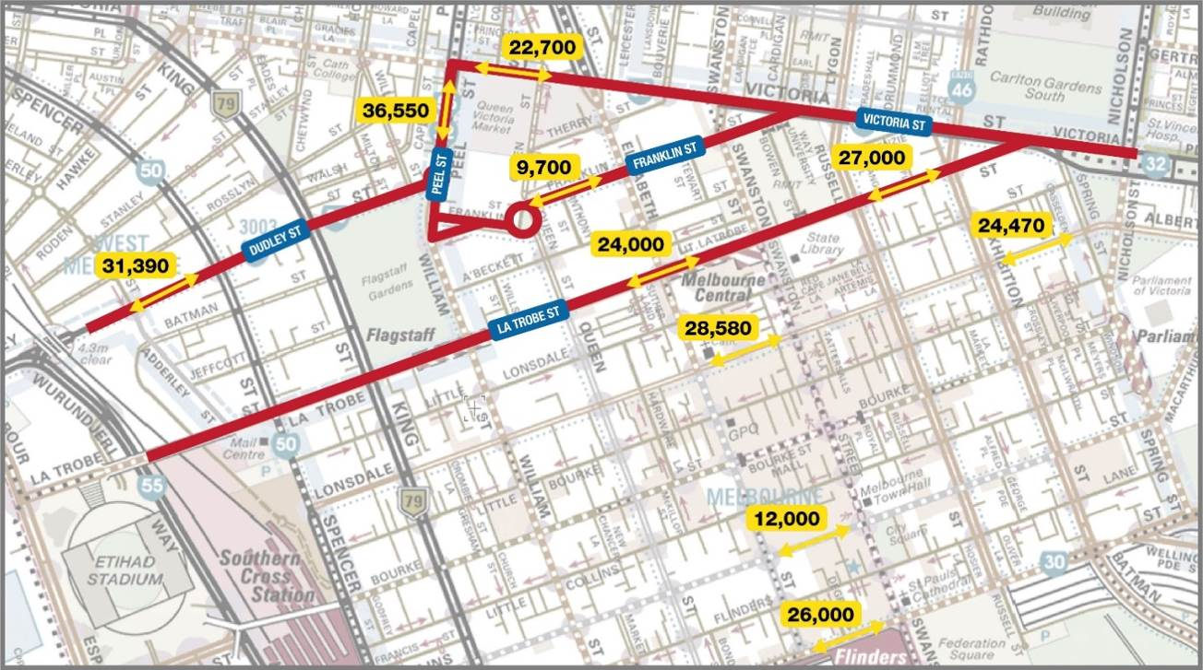

Existing Conditions

Route Overview
The existing alignment of Franklin Street and the alternate east-west routes (Franklin Street, Victoria Street and La Trobe Street) are shown in Figure 3 over the page.

Roadway Configurations

Franklin Street
Franklin Street typically features parallel kerbside parking, two mid-block traffic lanes in each direction and 90 degree centre-of-road parking. Short left turn traffic lanes are generally provided on the approach to intersections creating an intersection capacity of three ‘stand-up’ lanes. No bicycle lane facilities are currently provided on Franklin Street. Photographs of the typical roadway configuration of Franklin Street are presented in Figure 2.
Figure 2: Franklin Street – Examples of Roadway Configuration
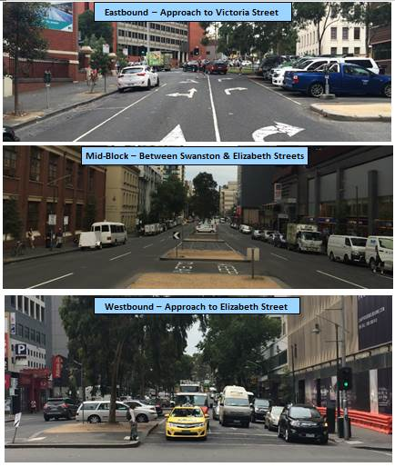
Figure 3: Existing Roadway Alignments
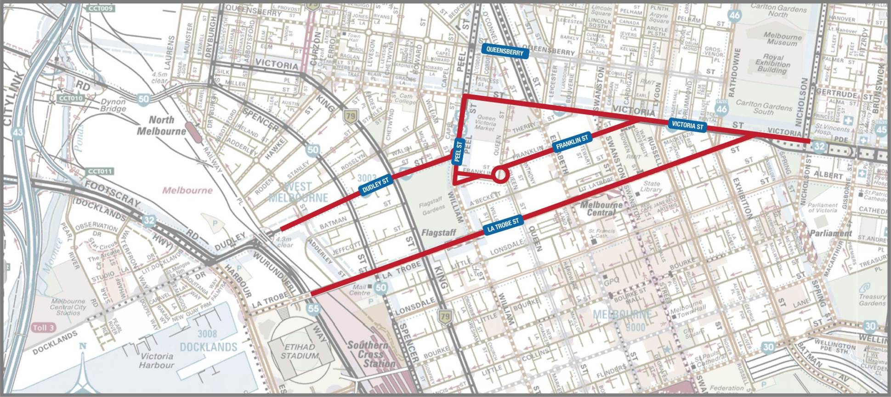

La Trobe Street
Physically separated kerbside bike lanes were constructed on La Trobe Street in 2013. This included the removal of the peak period clearways which previously operated on La Trobe Street.
Most sections of La Trobe Street now feature only a single mid-block traffic lane and two stand-up traffic lanes on the approach to intersections. However, in order to accommodate peak traffic demands at identified “squeeze points”, two mid-block traffic lanes have been maintained for an entire block at the following locations.
- Westbound: From William Street to King Street
- Eastbound: From Exhibition Street to Victoria Street
Some additional “No Stopping” areas are also provided on the eastbound approaches to Russell Street and Exhibition Street – to boost capacity.
Photographs of the various roadway configurations on La Trobe Street are presented in Figure 4.
Figure 4: La Trobe Street – Examples of Roadway Configuration
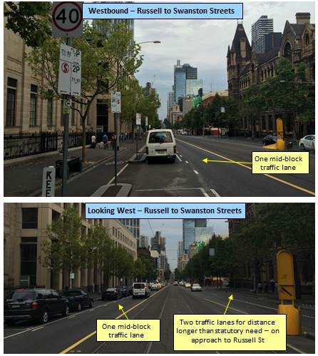
Figure 4 (continued): La Trobe Street – Examples of Roadway Configuration
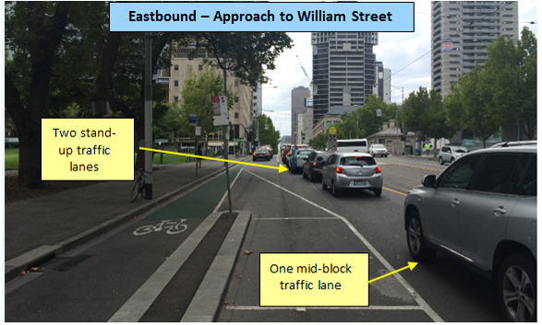
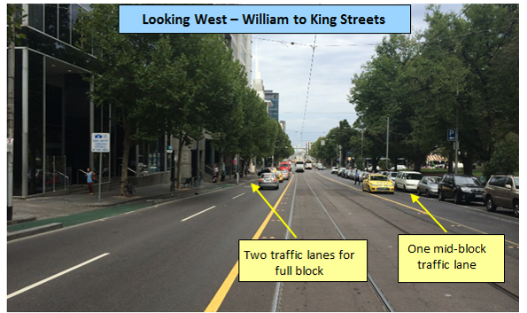
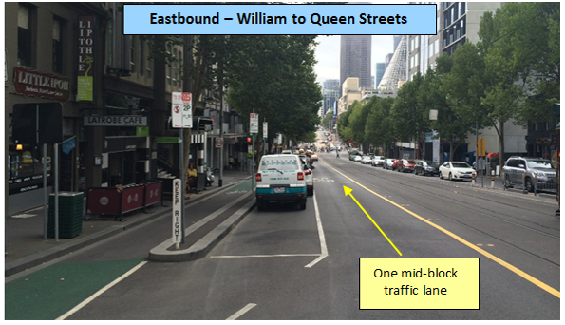

Victoria Street
The section of Victoria Street immediately adjacent to the Queen Victoria Market, between Elizabeth and Peel Streets provides two mid-block traffic lanes in the eastbound direction and parallel kerbside parking. The westbound carriageway initially provides two clearly defined traffic lanes and kerbside parallel parking on the departure side of Elizabeth Street, but then narrows to a single wide traffic lane adjacent to kerbside parallel parking before transitioning back to two traffic lanes on the approach to Peel Street. No bike lanes are provided in either direction in this section of Victoria Street.
To the west of Peel Street, the street features formal bike lanes in the form of a linemarked double-chevron separated bike lane design. The cross-section also features one mid-block traffic lane and kerbside parallel parking in each direction. Two stand-up traffic lanes are provided at most intersections.
To the east of Elizabeth Street, Victoria Street provides an arterial function, reflected by its geometry where the traffic capacity increases to generally feature three mid-block lanes during peak periods (through the operation of clearways) and up to four stand-up lanes at intersections. No bike lanes are provided on this arterial section of Victoria Street.
Photographs of the various roadway configurations on Victoria Street are presented in Figure 5.
Figure 5: Victoria Street – Examples of Roadway Configuration
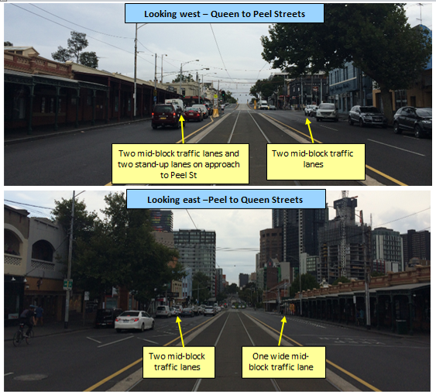
Figure 5 (continued): Victoria Street – Examples of Roadway Configuration
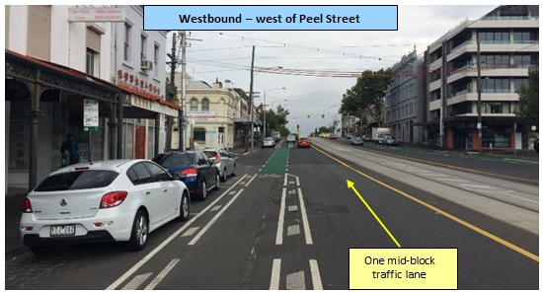
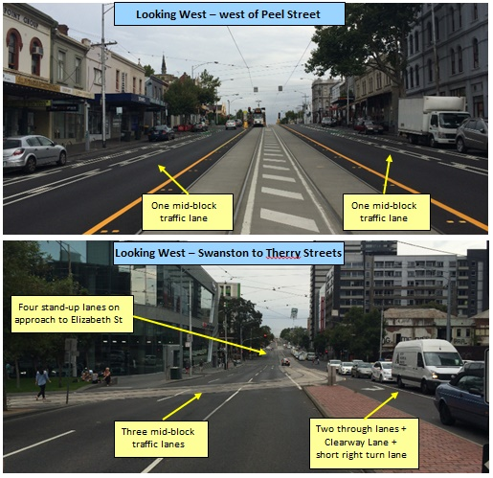

Existing Traffic Patterns

2015 Traffic Volumes
New traffic surveys were undertaken in 2015 (comprising a mix of 7-day ‘automatic tube’ traffic counts, counts obtained from signal sensors – known as SCATS counts – and manual counts). The new counts were undertaken in March 2015 at the following locations:
- Peel Street (between Victoria and Dudley Streets);
- Victoria Street (between Peel and Elizabeth Streets);
- Franklin Street (between Queen and Elizabeth Streets); and
- La Trobe Street (between Queen and Elizabeth Streets).
Historic traffic counts were also obtained from Council database sources for other locations, including Dudley Street and Lonsdale Street.
Overall, the analysis of the new 2015 traffic counts has revealed that since 2011:
- The introduction of the physically separated bike lanes on La Trobe Street (in 2013) has caused daily traffic flows to reduce by approximately 23% from 24,000 to approximately 18,500 vehicles per average weekday (measured as two-way flow in La Trobe Street at Elizabeth Street) between 2011 and 2015. This represents a reduction of 5,500 vehicles per day travelling along La Trobe Street.
- Franklin Street has experienced an 11% increase in daily traffic volumes (a rise of approximately 1,100 vehicles per day) since the April 2011 study. This 1,100 rise in traffic volume on Franklin Street is nonetheless significantly lower than the recorded 5,500 fall in the daily traffic volume on La Trobe Street.
- Daily traffic volumes on Peel Street, between Victoria and Dudley Streets, have also dropped by approximately 8% (a reduction of approximately 3,000 vehicles per day).
- Finally, peak period traffic counts on Victoria Street (west of Elizabeth Street – measured over intervals of 2 hours duration – between 7.30 to 9.30 am and 4.30 to 6.30 pm) have shown that traffic volumes have not changed significantly since 2011. The same daily traffic volume has therefore being adopted for 2015 on Victoria Street as per the 2011 volume.
The 2015 two-way total traffic volumes at each location are presented in greater detail for the following periods:
- 24 hour period (Figure 6)
- AM Peak Hour 8.00 to 9.00 am (Figure 7)
- PM Peak Hour 5.00 to 6.00 pm (Figure 8)
Directional two-way traffic volumes at each location are also presented diagrammatically for the peak hour periods as follows – AM Peak Hour (Figure 9) and PM Peak Hour (Figure 10).
Whilst the combined 2015 traffic volumes on Victoria Street, Franklin Street and La Trobe Street represent a lower overall east-west flow compared with 2011, the traffic volumes are still not evenly balanced amongst the 3 east-west routes. This imbalance can be clearly seen when comparing the daily traffic carried by Victoria Street, Franklin Street and La Trobe Street respectively. More specifically, the figures indicate that the daily traffic volume using Franklin Street is lower than the corresponding traffic using Victoria and La Trobe Streets. Interestingly though, the peak period re-balancing of traffic volumes that has occurred since 2011 is much more evident, with Franklin Street carrying comparable traffic volumes to the other routes during the busiest peak directional periods. Section 4.2 presents a more detailed examination of peak hour traffic patterns in order to determine the extent of any possible additional potential traffic redistribution – arising from the reconstruction of Franklin Street on a new, more direct alignment.
Figure 6: 24 Hour Two-Way Traffic Counts
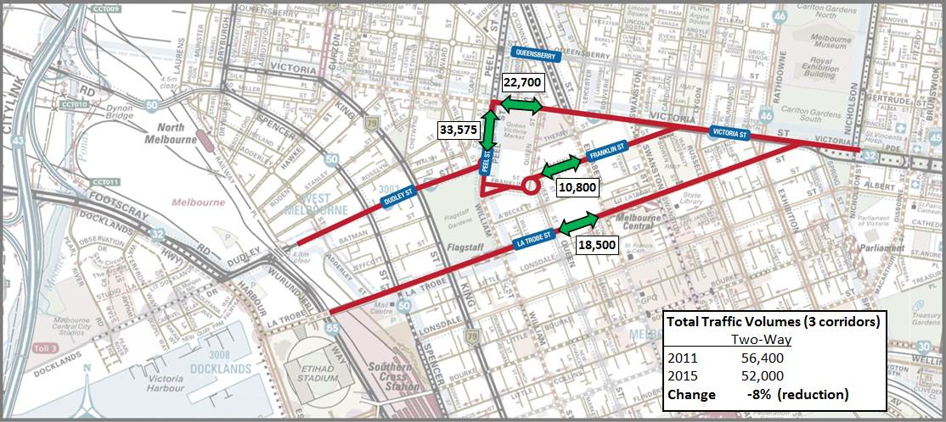
Total Traffic Volumes (3 corridors) | Two Way
2011 | 56,400
2015 | 52,000
Change | -8% (reduction)
Figure 7: AM Peak Hour (8 to 9 am): Two-Way Traffic Counts
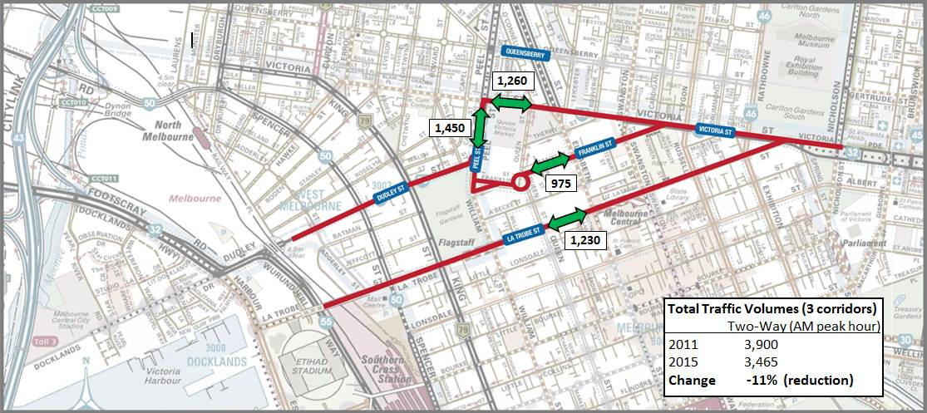
Total Traffic Volumes (3 corridors) | Two Way (AM Peak Hour)
2011 | 3,900
2015 | 3,465
Change | -11% (reduction)
Figure 8: PM Peak Hour (5 to 6 pm): Two-Way Traffic Counts
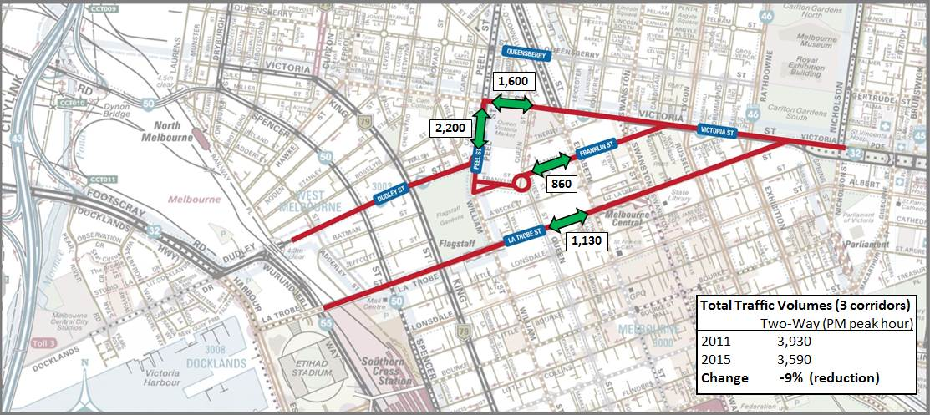
Total Traffic Volumes (3 corridors) | Two Way (PM Peak Hour)
2011 | 3,930
2015 | 3,590
Change | -9% (reduction)
Figure 9: AM Peak Hour (8 to 9 am): Directional Two-Way Traffic Counts
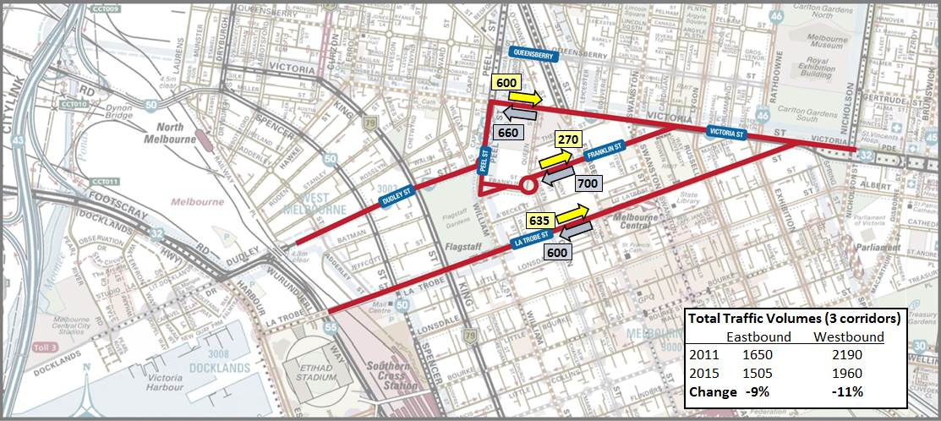
Total Traffic Volumes (3 corridors) | Eastbound | Westbound
2011 | 1,650 | 2,190
2015 | 1,505 | 1,960
Change | -9% (reduction) | -9% (reduction)
Figure 10: PM Peak Hour (5 to 6 pm): Directional Two-Way Traffic Counts
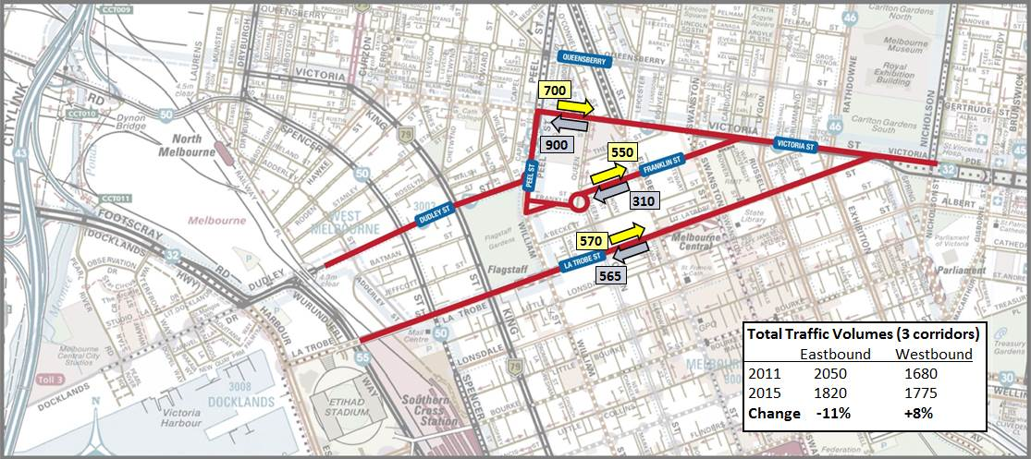
Total Traffic Volumes (3 corridors) | Eastbound | Westbound
2011 | 2,050 | 1,680
2015 | 1,820 | 1,775
Change | -11% (reduction) | +8% (increase)

Peak Hour Traffic Patterns

Victoria Street
Origin-destination surveys were undertaken in 2011 to determine the proportion of motorists travelling along the entire length of the Victoria Street-Peel Street-Dudley Street route (from east of Elizabeth Street to west of Peel Street) during the peak hours.
The traffic counts undertaken in 2011 (24 hour northbound and southbound flows on Peel Street, between Dudley and Victoria Streets) were also evaluated in order to determine the peak direction of flow. Figure 11 shows that the southbound movement is heaviest during the AM peak period and the northbound movement is heaviest during the PM peak period.
Figure 11: Peel Street (Victoria to Dudley): 2011 Weekday Traffic Volumes
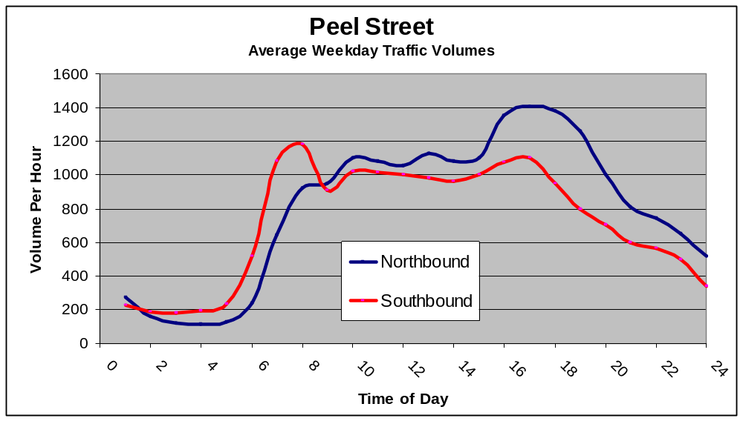
Accordingly, in 2011, the westbound flow of traffic was formally monitored in the AM peak and the eastbound flow in the PM peak (via full sampling of the respective traffic streams and number plate matching) in order to determine the number of vehicles using the route as a ‘through’ route. The results are presented diagrammatically in Figure 12 and Figure 13. The figures illustrate that a comparatively modest volume of ‘through’ traffic is currently using this route during the peak hours:
- 160 westbound trips during the AM peak hour (24% of 660 westbound vehicles crossing Elizabeth Street)
- 134 eastbound trips during the PM peak hour (16% of 820 eastbound vehicles on Dudley Street at Peel)
In 2015, a more limited origin-destination sampling of the westbound and eastbound traffic streams was undertaken (over half hourly periods in the respective peak hours and capturing white/silver/grey cars only). The subsequent analysis suggests that the total proportion (and thus volume) of through traffic in both the westbound and eastbound directions is virtually identical in 2015 as was recorded in 2011 in each direction. Therefore, for the purposes of the analysis in this study, the through traffic pattern and volume on Victoria Street will be assumed to be the same in 2015 as it was in 2011.
Figure 12: Victoria – Peel – Dudley: AM Peak Hour: Origin Destination Matches (2011 survey)
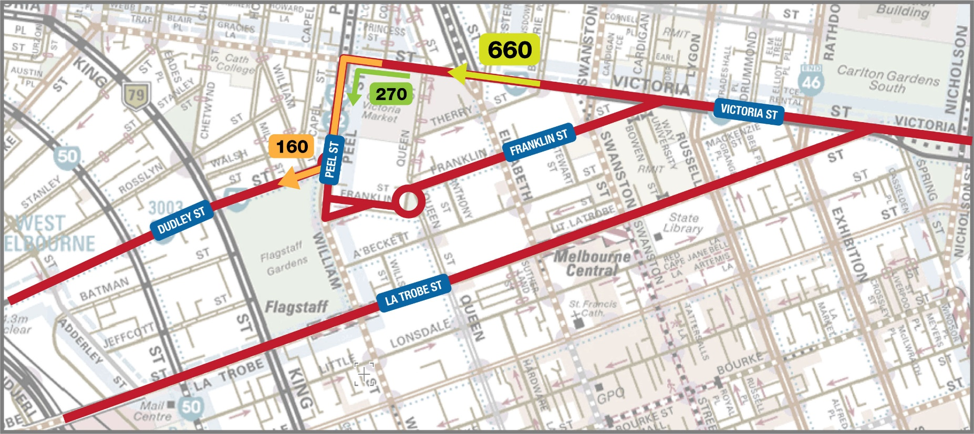
Key Statistics:
- 41% of westbound traffic on Victoria Street turns left into Peel Street (270 vehicles per hour)
- 24% of westbound traffic on Victoria Street (660 vehicles per hour) is destined for the arterial route along Peel Street and Dudley Street (160 vehicles per hour)
Figure 13: Dudley – Peel - Victoria: PM Peak Hour: Origin Destination Matches (2011 survey)
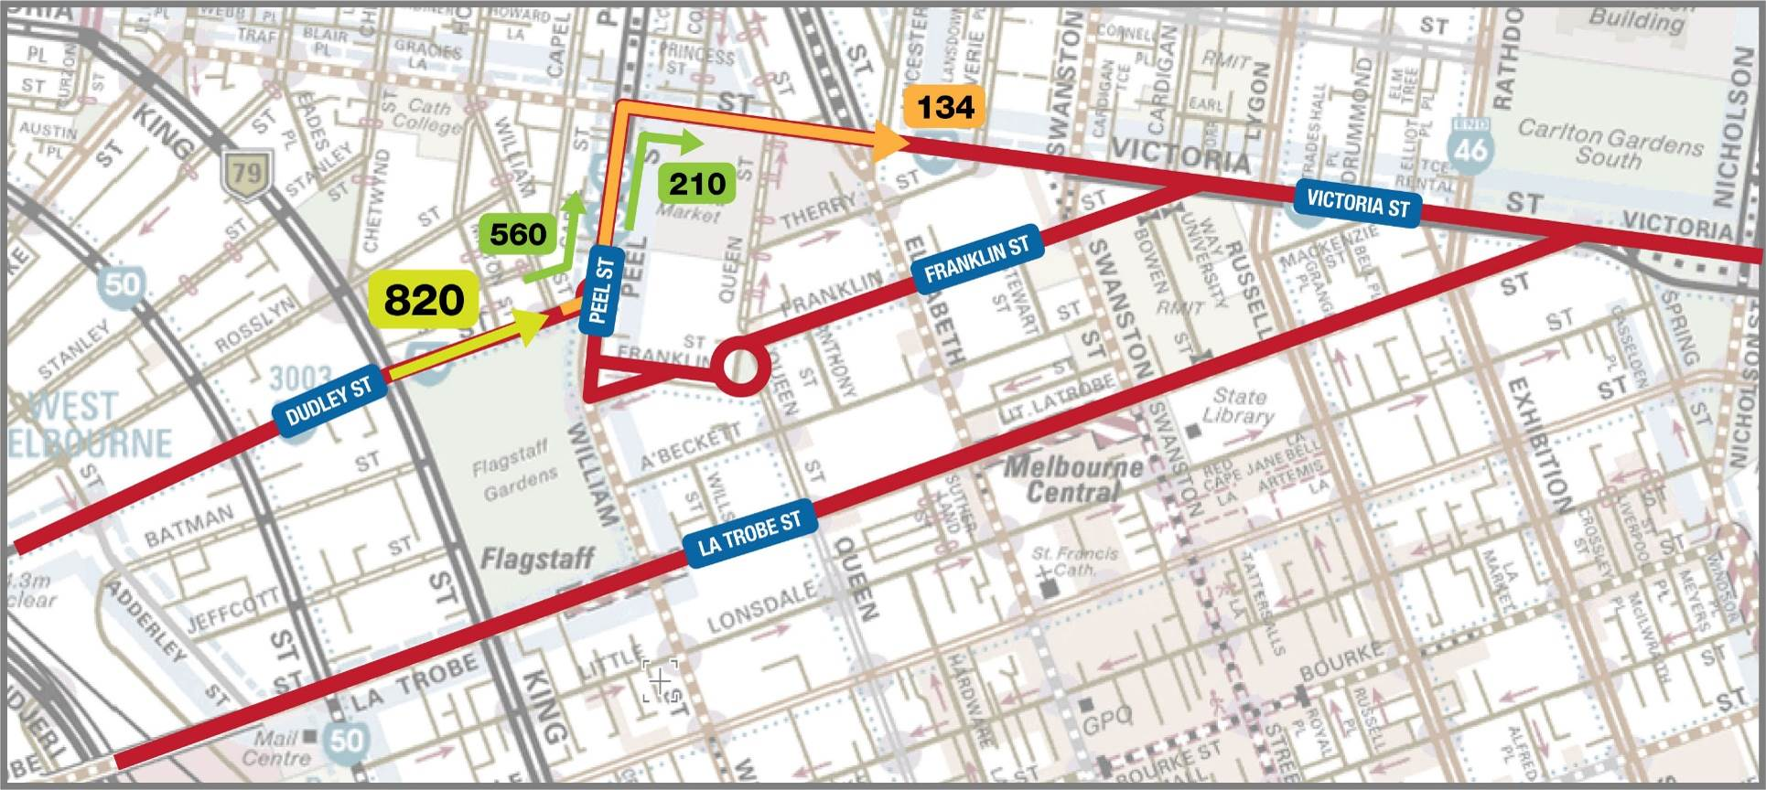
Key Statistics:
- 68% of eastbound traffic on Dudley Street turns left into Peel Street at the roundabout (560 vehicles per hour)
- 16% of eastbound traffic on Dudley Street (820 vehicles per hour) is destined for the arterial route along Peel Street and Victoria Street (134 vehicles per hour)

La Trobe Street – Through Traffic
A full new program of origin-destination surveys was undertaken in February 2015 to establish the volume and proportion of through traffic along La Trobe Street, particularly in light of the significant diminution that has occurred in the total traffic volume since 2011. The origin-destination surveys were undertaken in both directions during the AM and PM peak periods.
A summary of peak hour traffic volume entering and exiting the La Trobe Street at Victoria and Spencer Streets respectively and a summary of the volume of “through” traffic travelling along the full length of the street is presented diagrammatically in Figure 14 and Figure 15.
These figures illustrate that the volume of “through” traffic using La Trobe Street, during both the AM and PM peak hours, is comparatively modest.
AM Peak Hour (8 to 9 am)
- Westbound: 50 vehicles per hour (11% of traffic entering at Victoria Street)
- Eastbound: 15 vehicles per hour (7% of traffic entering at Spencer Street)
PM Peak Hour (5 to 6 pm)
- Westbound: 56 vehicles per hour (15% of traffic entering at Victoria Street)
- Eastbound: 24 vehicles per hour (11% of traffic entering at Spencer Street)
Figure 14: La Trobe Street: AM peak hour – Total and “Through” traffic volumes
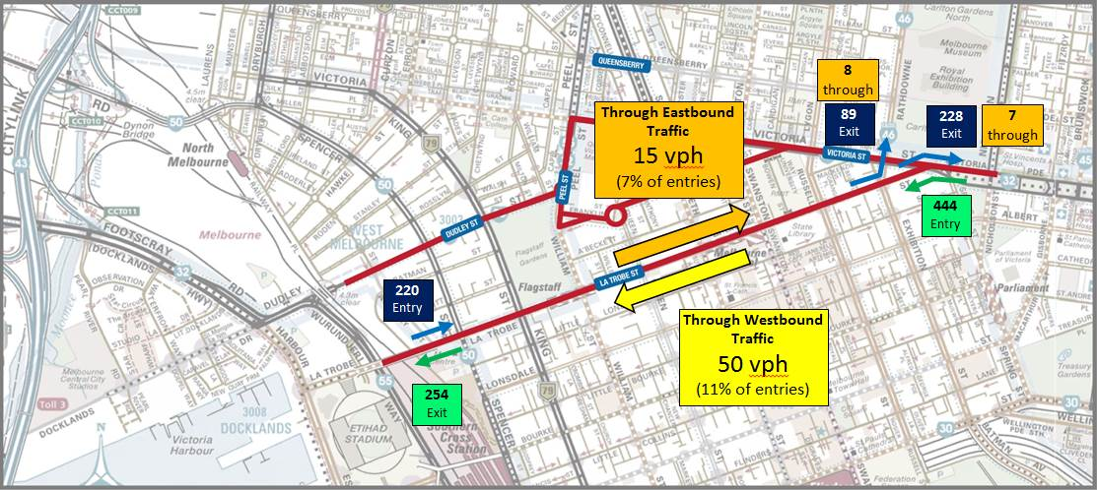
Figure 15: La Trobe Street: PM peak hour – Total and “Through” traffic volumes
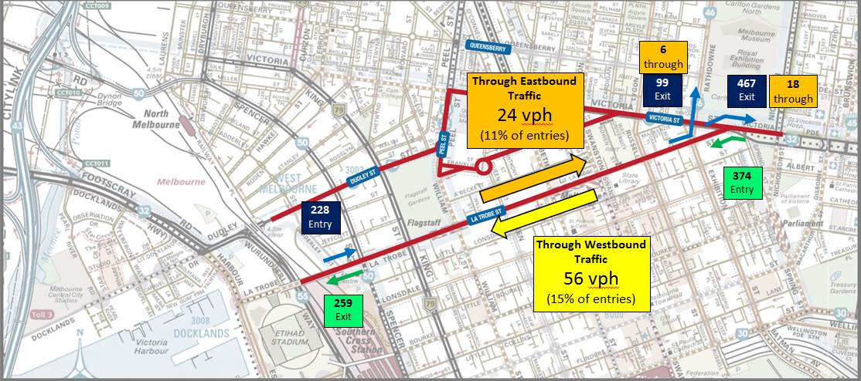

Franklin Street – Traffic
A full new program of origin-destination surveys was undertaken in February 2015 to establish the volume and proportion of through traffic along Franklin Street, particularly in light of the small increase in traffic that has occurred in the total traffic volume since 2011. The origin-destination surveys were undertaken in both directions during the AM and PM peak periods.
A summary of peak hour traffic volume entering and exiting Franklin Street at Victoria and Peel Streets respectively and a summary of the volume of “through” traffic travelling along the full length of the street is presented diagrammatically in Figure 16 and Figure 17. These figures illustrate that the volume of “through” traffic using Franklin Street, during both the AM and PM peak hours, is comparatively modest.
AM Peak Hour (8 to 9 am)
- Westbound: 48 vehicles per hour (8% of traffic entering at Victoria Street)
- Eastbound: 50 vehicles per hour (7% of traffic entering at Peel Street)
PM Peak Hour (5 to 6 pm)
- Westbound: 28 vehicles per hour (13% of traffic entering at Victoria Street)
- Eastbound: 84 vehicles per hour (17% of traffic entering at Peel Street)
During the AM peak hour, the movement of interest is the westbound traffic entering the CBD. Interestingly, a significant percentage (around 44%) of this traffic comes from Cardigan Street (instead of Victoria Street). Collectively, most of this traffic is bound for Queen Street (and destinations west thereof) – in all likelihood bound for the many carparks on the western side of the central city. Only 8% of the westbound traffic is considered “through” traffic (as it proceeds to and turns right into Peel Street to ultimately travel either northbound or westbound along Dudley Street).
During the PM peak hour, the movement of most interest is the eastbound traffic exiting the central city. A similar pattern occurs to the AM peak (in reverse) with 66% of eastbound traffic movements exiting Franklin Street destined for Cardigan Street (a local street) rather than Victoria Street (the arterial road). Observations suggest that this traffic pattern occurs due to the limited capacity of the right turn movement into Victoria Street (having to give way to steady southbound traffic flows and pedestrians crossing Victoria Street on the east leg of this intersection). Interestingly, the overall volume of 84 vehicles per hour that was regarded to be ‘through’ traffic on Franklin Street (having originated from Peel Street or Dudley Street) represents a significantly higher volume than the corresponding volume of through traffic deemed to be using La Trobe Street to travel eastbound during the PM peak hour (24 vehicles per hour). However, the eastbound through traffic volume of 134 vehicles per hour using Victoria Street is even greater than Franklin Street. Some of these motorists (currently using the Dudley-Peel-Victoria route) may potentially re-route to use a more continuous and direct Franklin Street route.
In summary, while Franklin Street still carries markedly less daily traffic than either of La Trobe Street or Victoria Street, it carries a greater volume of westbound traffic during the AM peak hour and a comparable volume of eastbound traffic during the PM peak hour. This indicates that there is a degree of attraction for motorists to use Franklin Street during periods when the alternate routes to the north and south are somewhat congested (despite Franklin Street’s current circuitous alignment). Within this context the potential exists for an additional transfer of traffic from Victoria and La Trobe Streets onto Franklin Street – particularly outside of peak hours – if the more direct alignment is constructed.
Figure 16: Franklin Street: AM peak hour – Total and “Through” traffic volumes
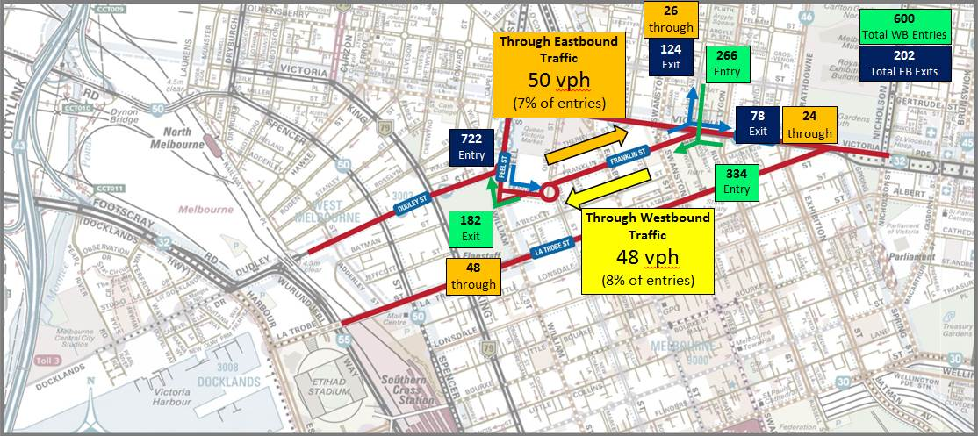
Figure 17: Franklin Street: PM peak hour – Total and “Through” traffic volumes
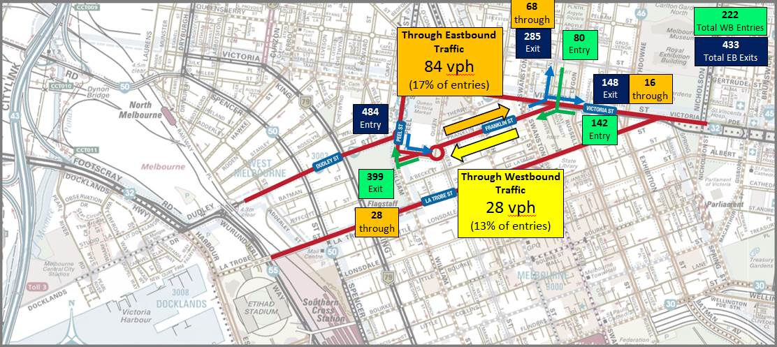

Crash History
The previous April 2011 report examined VicRoads ‘Crashstats’ data for the five-year period between 2005 to 2009 to determine the extent of pedestrian, cyclists and other crashes at the following locations:
- Victoria Street (Elizabeth to Peel Streets) 50 recorded crashes
- Peel Street (Victoria to William Streets) 47 recorded crashes
- Roundabout at Queen and Franklin Streets 7 recorded crashes
Since 2011, more recent data has been made available – between 2009 and 2013. Overall, for the same 3 sections of each road, there has been a small reduction in the number of crashes, as follows:
- Victoria Street 46 recorded crashes
- Peel Street (Victoria to William Streets) 43 recorded crashes
- Roundabout at Queen and Franklin Streets 3 recorded crashes
These marginal reductions (when comparing the 5-year periods pre-2009 and post-2009) are possibly attributable to the traffic redistribution that has occurred. The tables below provide a detailed comparison between the latest crash numbers and the previous reported statistics from 2011.
Table 1: Victoria Street (Elizabeth to Peel Streets) – Crash History Comparison
Location | Crashes Involving Pedestrians 2005 to 2009 | Crashes Involving Pedestrians 2009 to 2013 | Crashes Involving Cyclists 2005 to 2009 | Crashes Involving Cyclists 2009 to 2013 | Crashes Involving Only Vehicles 2005 to 2009 | Crashes Involving Only Vehicles 2009 to 2013
Intersection of Victoria and Peel | 1 | 2 | 1 | 2 | 27 | 22
Intersection of Victoria and Elizabeth | 5 | 3 | 3 | 3 | 3 | 7
Mid-Block (between Elizabeth and Peel) | 6 | 2 | 2 | 2 | 2 | 3
Total | 12 | 7 | 6 | 7 | 32 | 32
Table 2: Peel Street (Victoria to William Streets) – Crash History Comparison
Location | Crashes Involving Pedestrians 2005 to 2009 | Crashes Involving Pedestrians 2009 to 2013 | Crashes Involving Cyclists 2005 to 2009 | Crashes Involving Cyclists 2009 to 2013 | Crashes Involving Only Vehicles 2005 to 2009 | Crashes Involving Only Vehicles 2009 to 2013
Intersection of Peel and Victoria | 1 | 2 | 1 | 2 | 27 | 22
Intersection of Peel and Dudley | 0 | 2 | 4 | 1 | 7 | 6
Intersection of Peel and Franklin | 0 | 0 | 1 | 3 | 0 | 0
Intersection of William/Franklin/Peel | 0 | 0 | 0 | 0 | 0 | 1
Mid-Block (between Victoria and Dudley) | 3 | 1 | 1 | 2 | 2 | 2
Total | 4 | 5 | 7 | 8 | 36 | 31
Table 3: Roundabout at Queen and Franklin Streets – Crash History Comparison
Location | Crashes Involving Pedestrians 2005 to 2009 | Crashes Involving Pedestrians 2009 to 2013 | Crashes Involving Cyclists 2005 to 2009 | Crashes Involving Cyclists 2009 to 2013 | Crashes Involving Only Vehicles 2005 to 2009 | Crashes Involving Only Vehicles 2009 to 2013
Roundabout total – all approaches | 0 | 1 | 3 | 2 | 4 | 0
In addition to the comparison of crash data for the 5 year periods pre-2009 and post-2009, additional analysis of crash statistics has been undertaken for Franklin Street.
A total of 33 crashes were recorded on Franklin Street in the 5-year period between 2009 and 2013. The locations and the road users involved are presented below.
Table 4: Other Crash Statistics for Franklin Street – 2009 to 2013
Location | Crashes Involved Pedestrians | Crashes Involved Cyclists | Crashes Involved Only Vehicles
Franklin Street at Peel Street | 0 | 3 | 0
Franklin Street at Elizabeth Street | 2 | 4 | 4
Franklin Street at Swanston Street | 1 | 3 | 0
Franklin Street (between Swanston and Victoria) | 1 | 1 | 2
Franklin Street (between Elizabeth and Swanston) | 1 | 1 | 2
Franklin Street (between Queen and Elizabeth) | 4 | 0 | 1
Franklin Street (between Peel and Queen) | 0 | 0 | 3
Total | 9 | 12 | 12

Re-Distribution of Traffic Volumes

New Alignment
The realignment of Franklin Street to provide a more direct east-west route is likely to attract some proportion of traffic from La Trobe and Victoria Streets, thereby helping to achieve a more uniform distribution of daily traffic volumes across these three routes. For the purposes of this 2015 ‘update’ study, the following redistributions of traffic volumes are conservatively assumed:
- 70% of existing ‘through’ traffic on Victoria Street will redistribute to the realigned Franklin Street.
This represents a reduction from the 100% re-distribution value assumed in the 2011 study. This is due to the fact that peak hour traffic volumes have already increased on Franklin Street (since bike lanes were installed on La Trobe Street and other network changes implemented in the northern part of the central city). The various works implemented in recent years have already resulted in increased levels of vehicle use on Franklin Street – particularly in peak hours, as some motorists seek alternatives from other routes where traffic capacity has been constrained.
- 25% of ‘through’ traffic on La Trobe Street will redistribute to the realigned Franklin Street.
This represents a reduction from the 50% re-distribution value assumed in the 2011 study. The reduced inclination of motorists to ‘shift routes’ is justified by the fact that La Trobe Street’s ‘through’ motorists have already largely been displaced (since the separated bike lanes on La Trobe Street have reduced capacity to a single lane in each direction). Most of the remaining, and comparatively small, number of motorists that continue to use La Trobe Street as a through route (even during the congested peak periods) are likely to ‘stick-with-their-choice’ and continue to use La Trobe Street, given their willingness to do so since the implementation of the bike lanes and associated loss of traffic capacity that was recently experienced.
Thus, using these assumed redistribution proportions, the following additional peak hour traffic volumes are forecast to move to Franklin Street from Victoria Street and La Trobe Street respectively.
Victoria Street – Prediction of Traffic to be Redistributed to Franklin Street (70% of existing through traffic)
AM Peak Hour
- Westbound: 112 vehicles per hour
- Eastbound: 94 vehicles per hour
PM Peak Hour
- Westbound: 112 vehicles per hour
- Eastbound: 94 vehicles per hour
La Trobe Street – Prediction of Traffic to be Redistributed to Franklin Street (25% of existing through traffic)
AM Peak Hour
- Westbound: 12 vehicles per hour
- Eastbound: 4 vehicles per hour
PM Peak Hour
- Westbound: 6 vehicles per hour
- Eastbound: 14 vehicles per hour
Summaries of the proposed existing and future peak hour traffic volumes on Franklin, La Trobe and Victoria Streets in peak hours are provided in Figure 18 and Figure 19. Importantly, in all cases, the forecast peak hour traffic volumes are typically around 600 to 700 vehicles per hour in one direction along any of the three routes during the peak periods. This is consistent with the typical traffic capacity for single lanes in the Melbourne central area. The redistribution is there unlikely to create any undesirable congestion impacts but will contribute to a more even distribution of traffic flows along the three northern east-west routes in central Melbourne.
Figure 18: Franklin Street Re-Alignment: AM Peak Hour – Predicted Directional Traffic Volumes
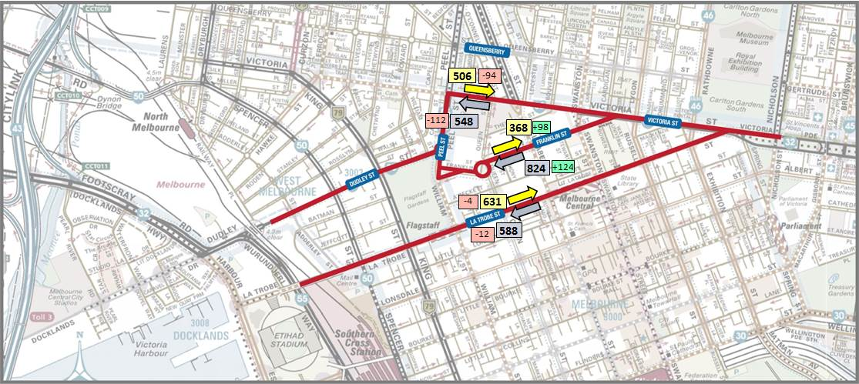
Figure 19: Franklin Street Re-Alignment: PM Peak Hour – Predicted Directional Traffic Volumes
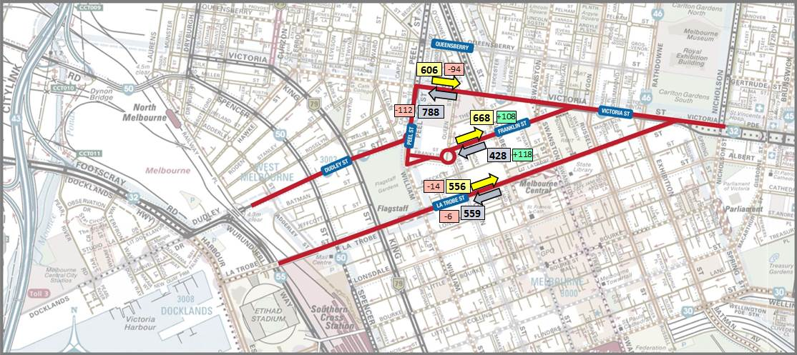

Role of Existing Alignment
The existing alignment of Franklin Street will be largely discontinued, except for a portion at the southern end, which (it is understood) will be narrowed to a width of between 10 to 12 metres – consistent with little streets in the central city. Its role will thus be to provide for a delivery / servicing function to those existing properties abutting the southern edge of Franklin Street. This proposed solution is considered appropriate – as the roadway will have no other traffic function to satisfy.
Given the anticipated ‘narrow’ width and intended delivery/service function, it is most likely that this remnant section of roadway on the old Franklin Street alignment will need to be managed as a one-way street, as it will effectively be a ‘laneway’ – Franklin Lane.
The schematic concept shown in Figure 20 (over the page) shows that access from Queen Street into Franklin Lane will be confined to a left turn – if the street is managed as one-way westbound. The extract below, from Figure 20, shows the preliminary concept treatment for Franklin Lane with a median on Queen Street restricting inbound movements to left turns only.
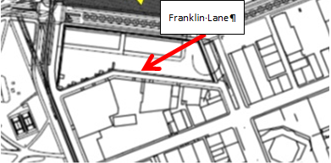
Adoption of a one-way westbound control on Franklin Lane is considered reasonable – given that it is the current arrangement utilised to service the existing properties along the south side of the street. The only issue that would need to be considered in the future is whether the exit onto William Street should allow for both left and right turns. Currently both are possible – under signalised control.
However, under a future realignment of Franklin Street (and new signalisation opposite Dudley Street) the existing traffic signals at the intersection of William Street with the current southern carriageway of Franklin Street would become unnecessary – as the traffic volume on the future Franklin Lane is likely to be exceptionally low. In this context, the ability for vehicles to exit via a right turn will be contingent on traffic flow conditions on Peel / William Street.
Existing peak hour flows in this section of William Street (northbound and southbound combined) are sufficiently high to constrain right turn opportunities from side streets without signal control. In the future, the installation of new signals at the intersection of the realigned Franklin Street with Peel Street is likely to create more frequent gaps in the southbound traffic flow but not necessarily the northbound flow. Thus, until the consequences of the new signalisation at Franklin/Peel/Dudley are fully understood – post construction, the ability to perform right turns out of Franklin Lane at William Street will be hard to predict – though it is likely to be a very low volume movement.
The likely low volume suggests that the retention of right turn movements is feasible and unlikely to cause adverse impacts. However the situation should be carefully monitored after ‘opening’ to gauge the safety and appropriateness of the new arrangements.

Franklin Street Re-Alignment and Reconfiguration
The existing alignment and proposed new Franklin Street configuration through the current Queen Victoria Market carpark are shown in Figure 20.
The photos in Figure 23 show the typical existing conditions on Franklin Street, both mid-block and at intersections, whilst the cross-sectional image in Figure 24 shows the possible design solution envisaged in the April 2011 study and consistent with these 2015 study findings.
Figure 20: Existing Franklin Street Alignment & Re-alignment Configuration
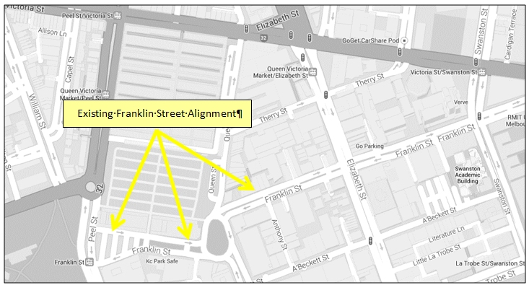
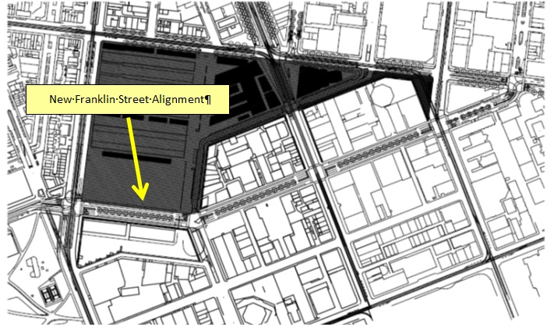
Figure 21: Franklin Street – Existing mid-block & intersection cross sections & conditions
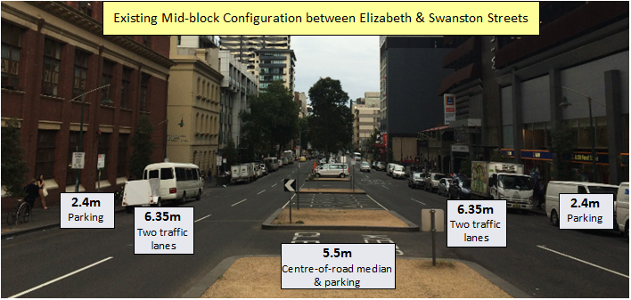
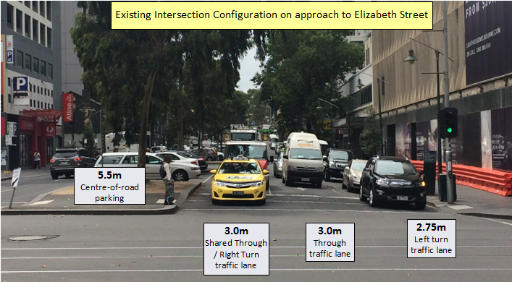
Figure 22: Franklin Street – Potential Design Option Consistent with Study Findings
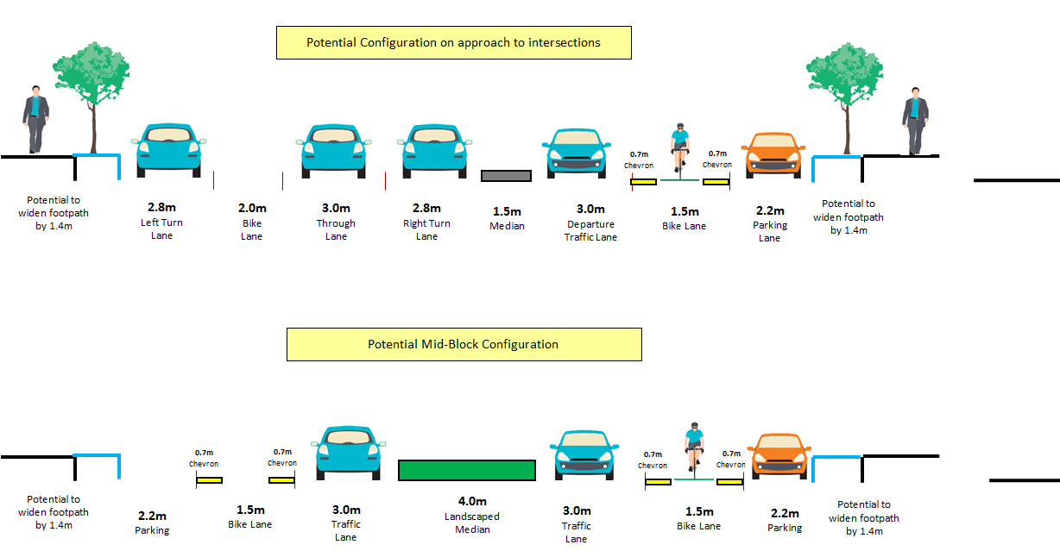

Consequences for La Trobe, Victoria & Peel Streets
La Trobe Street
The April 2011 study had recommended a consistent treatment along La Trobe Street, involving adoption of only a single mid-block traffic lane in each direction, accompanied by removal of clearways, provision of on-road bicycle lanes in each direction, and full-time parallel parking on both sides of the road. Since the release of the April 2011 study, physically separated kerbside bike lanes have been installed in La Trobe Street in 2013. This new treatment is largely consistent with the recommended design outcomes envisaged in the April 2011 study – in that it features the removed the peak period clearways, the widespread adoption of one mid-block traffic lane and retention of parallel parking. Two mid-block traffic lanes have been ‘kept’ for entire street blocks at two locations only, in order to maintain adequate traffic capacity:
- Eastbound: Exhibition to Victoria Streets; and
- Westbound: William to King Streets.
Two traffic lanes are also provided, for distances shorter than a full block, on both the eastbound approaches to Russell and Exhibition Streets.
Observations of traffic flow conditions, conducted as part of this 2015 study, have revealed that eastbound queues are now far more modest during the PM peak period, compared to the period immediately following the installation of the bike lanes (reflecting the dispersion of through traffic away from La Trobe Street that has progressively occurred since 2013).
Ultimately, the introduction of a more direct alignment on Franklin Street will further curtail the attractiveness of La Trobe Street as a through traffic route, thereby offering the opportunity to review the necessity to retain any blocks or sections of La Trobe Street with two mid-block traffic lanes – and therefore reallocate that road space to other uses. The sections of La Trobe Street that could be reviewed, once the Franklin Street realignment is completed, include the eastbound carriageway on the approaches to Russell Street, Exhibition Street and Victoria Street.
However, any further redistribution of traffic away from La Trobe Street and onto Franklin Street is dependent on Franklin Street remaining open to vehicle traffic along its entire length, between Peel and Victoria Streets.
Victoria Street
The 2011 study recommended that the same cross-section that has recently been installed in Victoria Street to the west of Peel Street be implemented for the entire length of Victoria Street between Peel Street and Elizabeth Street. The configuration west of Peel Street includes one mid-block traffic lane, double chevron line marking either side of an on-road bicycle lane and kerbside parking.
This 2015 study has found that the lack of any significant traffic volume fluctuation on Victoria Street since 2011 and the potential of a marked diminution in the volume of through traffic using this section of Victoria Street (in the event of a realignment of Franklin Street) offers the prospect of implementing the 2011 recommendations in full and, possibly, pursue footpath widening, particularly on the Queen Victoria Market side of Victoria Street.
Peel Street
The April 2011 study recommended that Peel Street be retained in its current form. The data collected and evidence observed from the traffic monitoring activities undertaken for this study confirm that Peel Street should remain unaltered.

Conclusion
This study was undertaken with the intent of providing an update to the April 2011 “Melbourne CBD North Edge Traffic Study” prepared by the City of Melbourne 4 years ago. The April 2011 study focussed on the likely consequences of reconstructing Franklin Street, between Queen and Peel Streets, to provide a more direct link to Dudley Street. In this context, the emphasis of this 2015 update study has been to understand and quantify the extent of any traffic flow changes that have occurred since April 2011 and to establish whether the findings and conclusions drawn in the April 2011 study are still valid.
Overall, the various traffic fluctuations recorded on La Trobe, Victoria, Peel and Franklin Streets, since 2011, would indicate that:
- Total daily traffic volume using east/west routes on the northern edge of the central city has reduced significantly between 2011 and 2015.
- There has already been a re-balancing of traffic volumes towards Franklin Street, despite the fact that a re-alignment of this route has yet to be constructed. This has been primarily encouraged by the construction of separated bike lanes on La Trobe Street which has reduced the attractiveness of this route for through traffic. Other road works have also contributed to the ‘traffic shift’ that has been recorded.
In summary, since the 2011 study, there has been an overall reduction recorded in the total daily and peak hour traffic volumes travelling along the east/west streets provided in the northern edge of the CBD (La Trobe Street, Franklin Street and Victoria Street). The reduction has also been characterised by some rebalancing of traffic flows towards Franklin Street. In fact, the peak period traffic flows (westbound during the AM peak and eastbound during the PM peak) are now relatively even across all three east-west routes. However, daily traffic volumes are still significantly lower on Franklin Street, compared with Victoria and La Trobe Streets.
This overall reduction in east/west traffic volumes is consistent with other data which indicates that overall traffic volumes entering the central city have decreased by 5% since 2012, bike volumes entering the central city fringe during the AM peak period have increased by 57% since 2011 (up from 7,335 in 2011 to 11,519 in 2015 – measured at a number of Council’s permanent monitoring stations) and public transport patronage across the network is estimated to have increased markedly since 2011.
Thus, this study concludes that the recorded reduction in access by car (and the strong and continued increase in the use of public transport and sustainable transport modes) supports retention of the 2011 vision for the creation of improved pedestrian and cyclist access on all three streets east-west streets under consideration, in order to deliver enhanced amenity across the entire precinct. The suitability of the 2011 recommendations is thus confirmed in this 2015 analysis. In particular, the evidence collected in this study confirms that the adoption of a more direct alignment for Franklin Street (linking it to Dudley Street through the existing Queen Victoria Market carpark via new signalised intersections at Peel Street and Queen Street) will allow the following cross-sectional arrangements to be implemented on Victoria Street and Franklin Street:
- One mid-block traffic lane on each road;
- On-road bicycle lane in each direction on each road;
- Potential for widened footpaths;
- Central median on Franklin Street to replace the current centre-of-road parking; and
- Retention of parallel parking on both sides of the road.
These treatments will support a more even distribution of traffic volumes on Victoria, Franklin and La Trobe Streets balanced throughout the day. Critical to achieving this more balanced distribution is the requirement for each block of Franklin Street to remain open to vehicle traffic along its entire length, between Peel and Victoria Streets.

