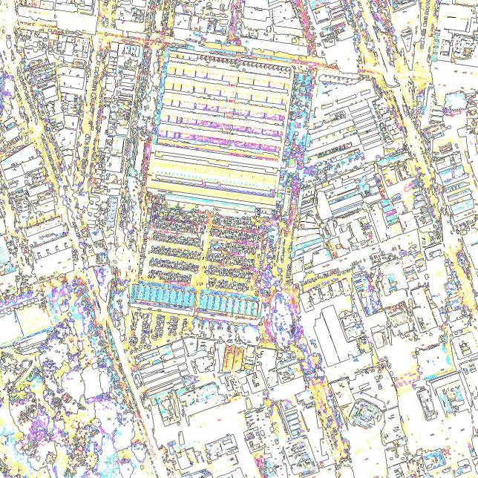
Queen Victoria Market Precinct Renewal
BUILT FORM REVIEW & RECOMMENDATIONS
Jones & Whitehead Pty Ltd
For the City of Melbourne
22 April 2015
Contents
1 Introduction 5
1.1 Executive summary 6
2 Strategic Context 9
2.1 Study area 9
2.2 The City North Growth Area 9
2.3 The QVM Precinct Renewal Project 12
2.3.1 Key improvements 12
2.3.2 State Government Agreement 13
2.3.3 Draft QVM Precinct Renewal Master Plan 14
2.4 Therry, Elizabeth, Franklin and Queen Block Plan 17
3 Existing urban form and issues 19
3.1 Existing built form 19
3.1.1 Urban structure 19
3.1.2 Streets and public spaces 20
3.1.3 Built form 21
3.2 Issues 23
3.2.1 Low levels of frontage activation 23
3.2.2 Poor contribution to street definition and activation by QVM 23
3.2.3 Poor provision for pedestrian capacity and amenity 23
3.2.4 Poor permeability of the large blocks 23
3.2.5 Support for retail activity 24
4 Existing controls and issues 25
4.1 Existing building height and setback controls 25
4.1.1 QVM Precinct Design and Development Overlay 25
4.1.2 New City North built form controls (Amendment C196) 26
4.2 Other built form controls 27
4.2.1 Frontage activation 27
4.2.2 Solar access and sunlight to public spaces 27
4.2.3 Wind impact mitigation 27
4.2.4 Traffic conflict frontages and weather protection 27
4.2.5 Mid block links and laneways 27
4.3 Heritage controls 29
4.4 Issues 32
4.4.1 Height and setback controls 32
4.4.2 Other built form controls 33
4.4.3 Heritage Controls 35
5 Built form vision for the precinct 37
5.1 Vision 37
5.1.1 Precinct definition 38
5.1.2 Market interface 39
5.1.3 Streetscape definition and activation 40
5.1.4 Sunlight to open spaces 41
5.1.5 Wind impact mitigation 42
5.1.6 Pedestrian amenity and safety 43
5.1.7 Heritage 44
5.2 Implications for controls 45
5.2.1 Built form controls over QVM itself 45
5.2.2 Statements of planning objectives in the MSS 45
5.2.3 Built form frontages adjoining QVM 46
5.2.4 Overall building heights 46
5.2.5 Built form street frontages along other Hoddle Grid streets 47
5.2.6 Potential Development Plan Overlay 47
5.2.8 Zoning 49
6 Appendix: Typical Hoddle Grid built form 51
6.1 Street-oriented development 51
6.1.1 Traditional, modernist and contemporary approaches 51
6.2 Podiums and streetscape activation 52
6.2.1 Ground level building alignments 52
6.2.2 Standards of frontage activation 52
6.3 Podium heights 54
6.3.1 Balancing positive and negative impacts 54
6.3.2 Street proportions 54
6.3.3 Architectural and spatial character 55
6.3.4 Support for activation and passive surveillance 55
6.3.5 Relation to tower heights 56
6.3.6 Overshadowing 56
6.3.7 Typical central Melbourne podium requirements 56
Figure 1: Study area
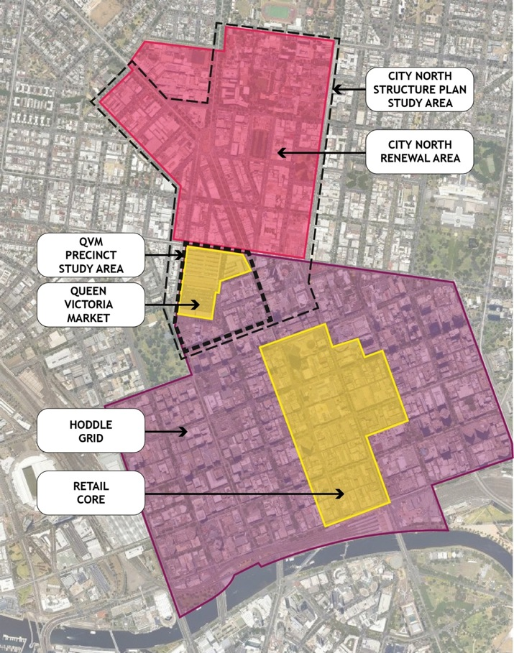
The above map shows the study area and its relationship to:
- The City North Renewal Area, Hoddle Grid, and Retail Core as identified in the MSS;
- The City North Structure Plan Study area; and
- The extent of Queen Victoria Market.

Introduction
In October 2013 the City of Melbourne announced the largest investment in its history to renew the Queen Victoria Market (QVM) and create one of the world’s great market precincts. A Draft Master Plan was released for public consultation in February 2015. Council’s aim for the QVM Precinct Renewal Project is to conserve the Market’s heritage and authentic atmosphere while allowing it to evolve to meet contemporary needs of traders, shoppers and the growing city.
Queen Victoria Market is positioned at the heart of Melbourne’s growing inner north, and Council’s commitment to renew the precinct could not be timelier. Central Melbourne is growing faster than any other area in Australia. According to the latest ABS figures on population trends, Melbourne’s growth has outstripped Sydney over the past decade and it will be Australia’s most populous city by 2053. Between 2008 and 2013 the Melbourne Local Government Area’s residential population increased by almost 30% to about 116,447 people.
Understandings of the strategic role of the QVM precinct have changed from a transitional zone between the central city and low-intensity suburbs in the past, to an integral part of today’s central city and emerging City North growth area. Existing controls over the built form of development in the vicinity of the QVM, based on past conceptions of the area, require review.
In addition to this strategic imperative, other factors indicate a need for a review:
- Recent development approvals in the area south and southeast of QVM have allowed buildings to exceed existing building height controls to such a degree that the aims of those controls have been compromised.
- The QVM Renewal Project proposes reconfiguring a variety of reserves south of the New Franklin Street to create a new development site. Current planning controls relate to the current land configuration.
- Built form controls in the wider area have been examined twice in recent years by the City of Melbourne, through a review of Central City Built Form Controls (2011, not adopted) and City North Structure Plan (2012, adopted by Council). These indicated that existing controls should be amended, but refrained from final recommendations for the QVM precinct pending resolution of plans for QVM.
This review is focused on built form and relationships of development with streets and public spaces, and is intended to complement the Draft QVM Precinct Renewal Master Plan, which sets out broad directions for the precinct and more specific recommendations for QVM itself.
The review focuses on concerns that are specific to the QVM precinct, rather than reviewing general policies and controls that apply to the area as a part of the wider Hoddle Grid/CCZ1 zone.

Executive summary
The area addressed by this review is a portion of the Hoddle Grid adjoining QVM (Figure 1). Development in this area is now managed through various planning policies and controls that apply more generally to the Capital City Zone (CCZ1). In addition, the Design and Development Overly DDO14 (Figure 2) sets a range of height limits across the area. Heritage Overlay HO7 - Queen Victoria Market Precinct applies to a part of the area (Figure 3).
Heritage controls affecting the area have been the subject of a very recent review and Planning Scheme Amendment process.
Figure 2: City of Melbourne Planning Scheme showing the extent of DDO14
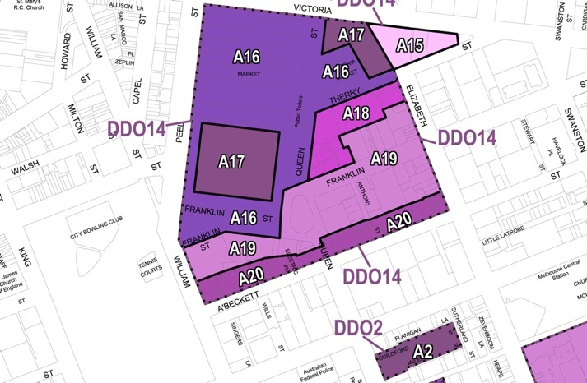
The above map shows the details from the City of Melbourne Planning Scheme showing the extent of DDO14. The discretionary height limits are:
A15 – 12m max.
A16 – 7m max.
A17 – 10m max.
A18 – 20m max.
A19 – 30m max.
A20 – 60m max.
Figure 3: City of Melbourne Planning Scheme showing the extent of DDO14
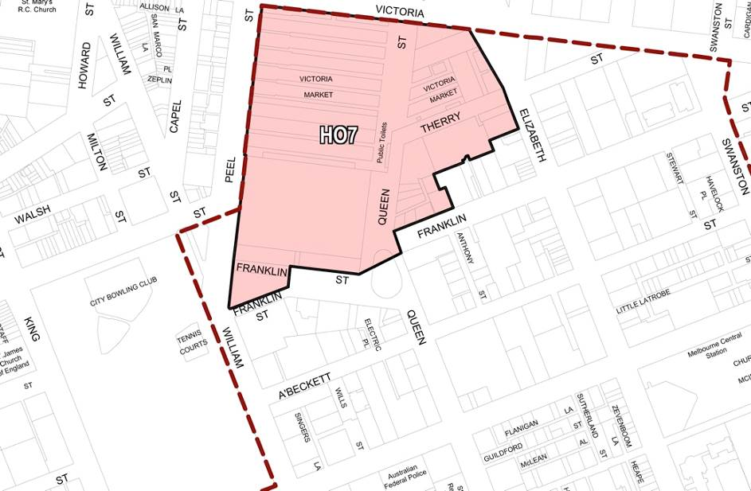
The above map shows the existing extent of the Heritage Overlay HO7 – Queen Victoria Market Precinct. Relatively minor changes to this are proposed under Amendment C198.
One of the outstanding issues for development control in the area is the degree to which development is encouraged to contribute to the quality of the public realm, especially in streets around and connecting to the QVM. The QVM Precinct Renewal Draft Master Plan (February 2015) identifies public spaces in and around QVM that are of particular importance as active pedestrian environments and as part of one of Melbourne’s most significant retail precincts. Existing controls do not adequately recognise this importance.
A second issue is the discrepancy between heights recommended in DDO14, both in relation to the reality of recent approvals and construction that significantly exceeds those heights and in relation to strategic objectives to support growth in the area. The City North Structure Plan (approved by Council in 2012) sets out a vision for the QVM Precinct that includes intensified development - in essence with the characteristic built form scale of the Hoddle Grid extending northward to the Market and Victoria Street – and with an emphasis on creating active pedestrian-friendly streets.
The general implication of the City North Structure Plan is that high density, relatively high rise development characteristic of the Hoddle Grid should and will extend northward to the southern edge of QVM, continuing recent trends, and that this should be coupled with streets that are designed and managed as high quality public spaces as in other parts of central Melbourne.
If properly managed and well designed, this growth will contribute to the activation and viability of the Market as well as creating a strong visual framework of contemporary urban development that frames the historic QVM site.
The key aims in managing this future development are:
- A very high level of environmental amenity should be maintained in streets and public spaces in and adjoining QVM in order to support their use. Given the low-rise buildings on the Market site and the northerly orientation of sensitive frontages for new development sites, overshadowing is not a concern but the mitigation of wind impacts is a very serious concern and will be a significant factor in shaping new buildings in the area, especially along frontages to Therry Street, Queen Street and New Franklin Street.
- Building uses, and especially frontages onto streets, should contribute to an active, interesting and safe public environment and support retail and other activities that complement the roles of QVM.
- Heritage structures should be integrated into new development to help ‘tell the story’ of QVM and its relationship with the precinct.
Figure 4: Recent tower approvals along Elizabeth Street, near QVM, now under construction. [urbanmelbourne.info]
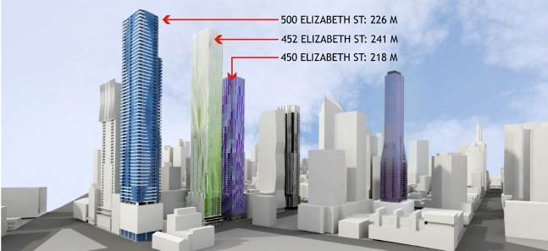
To achieve these aims, it is recommended that the existing DDO14 (beyond the site of QVM) should be replaced with new or amended controls which, rather than focussing on building height limits, ensure that:
- Development contributes to Melbourne’s distinctive character by reinforcing the distinction between the Hoddle Grid and adjoining areas.
- Development defines and activates QVM as a special place by creating a taller built form around, and oriented towards, the Market, albeit with relatively low podiums that establish as transition to the Market’s most intact heritage areas.
- Buildings contribute to safe and activated streets and public spaces via ground floor uses that interact with the street, and uses at upper levels that contribute to passive surveillance.
- Key public spaces in the precinct enjoy access to sun throughout the year.
- Streets and public spaces are protected from wind impacts so they are pleasant to use for outdoor cafes, window shopping and walking.
- Pedestrians are provided with weather protection and protected from conflicts with vehicular traffic along key routes.
- A fine grain of pedestrian routes encourages access throughout the precinct.
New development is respectful of heritage values of the Market and other significant buildings.

Strategic Context

Study area
The area under consideration in this review is shown in Figure 1. While referred to as the Queen Victoria Market Precinct in existing controls in the Planning Scheme, it encompasses only QVM itself and a few blocks to the south-southeast, rather than any wider precinct surrounding and related to the Market. The study area is a small part of the central city Hoddle Grid, and part of the Capital City Zone (CCZ1). It is also integrally related to the City North renewal area, and was included in the area addressed by the City North Structure Plan, although recommendations from that plan that would result in new built form controls south of Victoria Street have not been progressed. As such there are three existing sources of strategic directions for the precinct: The City North Structure Plan, policies pertaining to the Hoddle Grid, and objectives arising from current master planning for the QVM.
Figure 5: City North Structure Plan, City of Melbourne, March 2012
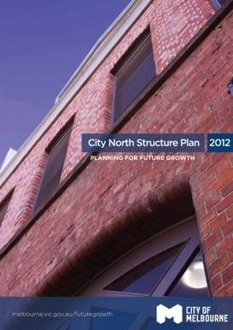

The City North Growth Area
As part of its Municipal Strategic Statement, the City of Melbourne identified City North as an urban renewal area that will accommodate significantly more residents and employment growth over the next thirty years. The City North Structure Plan (2012) was prepared to guide renewal of the area and fulfil the precinct’s potential as an extension of the central city.
Council adopted the City North Structure Plan in 2012.
The City North Structure Plan area has already seen extensive residential apartment development and considerably more is anticipated. QVM is becoming central to an extensive area of intensive development, and will be an important link between the older central city and its northward expansion. Planning for the Market needs to respond to the growing population of residents, workers, students and visitors. The increased local population will create new opportunities and pressures for trading at the Market, as well as increasing the importance of the Market’s open spaces. This intensification of nearby development is an important underpinning of the QVM’s long term viability.
Figure 6: Land use strategy for City North, from the City North Structure Plan
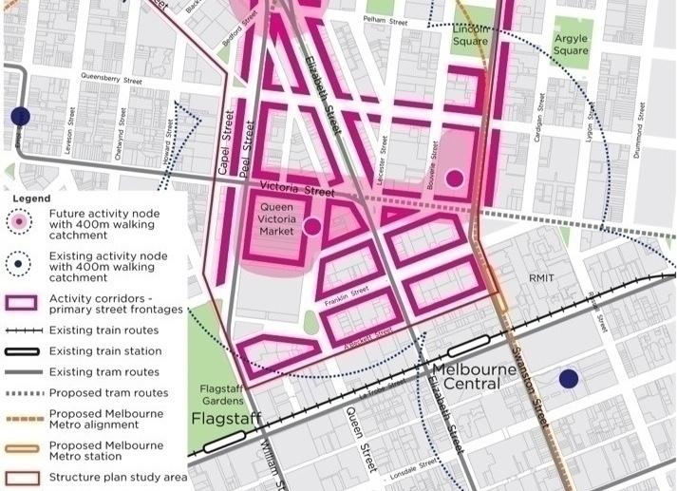
The above is an illustration of the land use strategy for City North, from the City North Structure Plan. Note the emphasis on QVM as part of a major ‘activity node’ focused along Victoria Street.
Figure 7: Existing land use zoning, from the City North Structure Plan
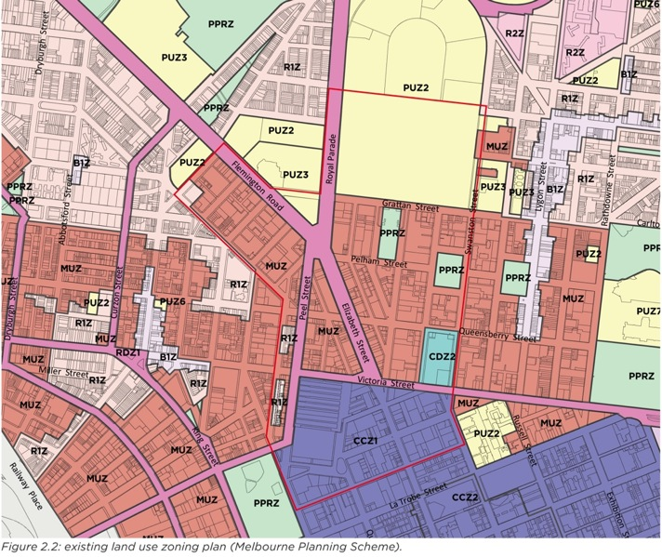
The above illustration shows existing land use zoning, from the City North Structure Plan. QVM is now at the edge of the Capital City Zone.
Figure 8: Proposed land use zoning plan
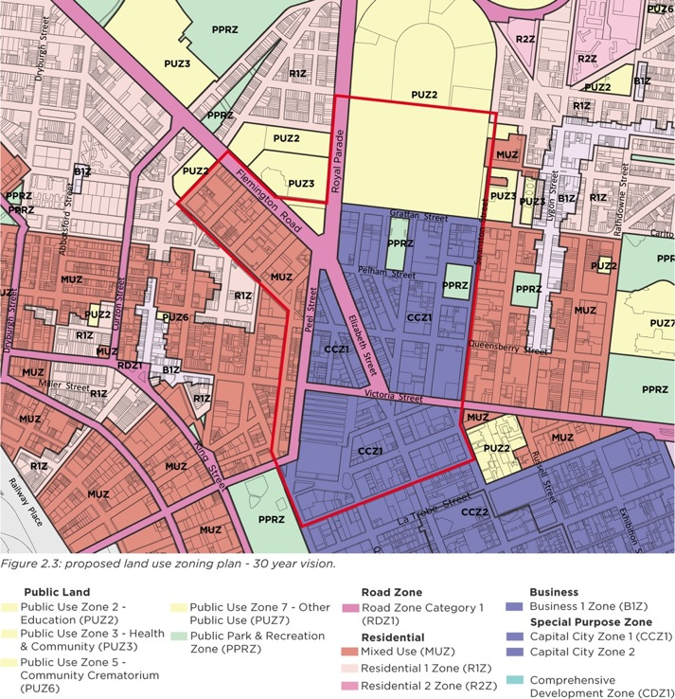
The above illustration shows the proposed land use zoning plan – 30 year vision, from the City North Structure Plan. While this envisages no change to the zoning of QVM and areas to its south, east and west, QVM is embedded within the Capital City Zone.
Figure 9: Built form precincts as shown in the City North Structure Plan.
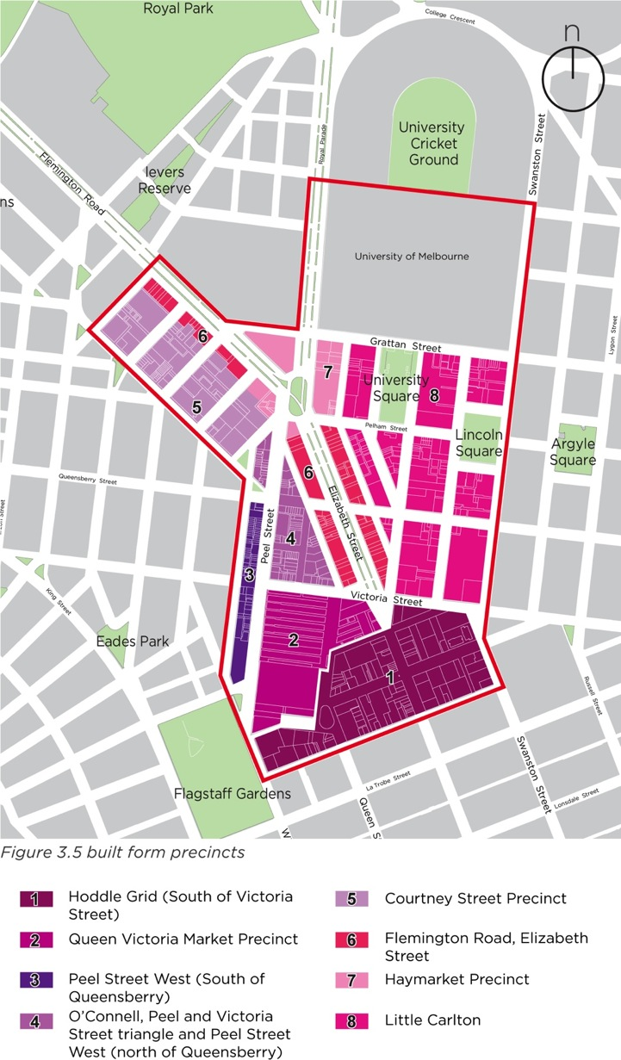
The above illustration shows built form precincts as shown in the City North Structure Plan. The City North Structure Plan proposes new controls to facilitate intensified development while providing a transition to existing low-scale suburbs, and maintaining a distinction between the Hoddle Grid (south of Victoria Street) and the remainder of the City North precinct. QVM and the wider QVM precinct to its south are indicated as two distinct areas in terms of anticipated built form character. The latter is regarded as integral to the Hoddle Grid, and QVM as an entity in itself.

The QVM Precinct Renewal Project
The rationale for renewal of the Queen Victoria Market is based on the economic, social, cultural and environmental importance of the Market in its central city location. The future form of QVM needs to emerge gradually within an enhanced physical environment that retains its important heritage values and enables market businesses to work throughout the renewal process.
To date, a community engagement process, consultation with key stakeholders, and professional investigations into the Market’s operation, site and context have been undertaken. Key principles have been established to preserve the Market’s heritage and authentic atmosphere, while allowing it to evolve to meet contemporary needs of traders, shoppers and the growing city.
Queen Victoria Market Pty Ltd has consolidated these inputs into a Strategic Brief, which describes the vision for the renewed Market and the nature of improvements and new facilities required. The City of Melbourne has developed a Draft Master Plan, which outlines high level planning objectives for renewal of the precinct with a focus on the Market and adjacent public realm. Council approved release of the Strategic Brief and Draft Master Plan on 24 February 2015, as part of a third major phase of community engagement for the QVM Precinct Renewal project.
Figure 10: Queen Victoria Market Precinct Renewal Strategic Brief, Queen Victoria Market Pty Ltd, February 2015
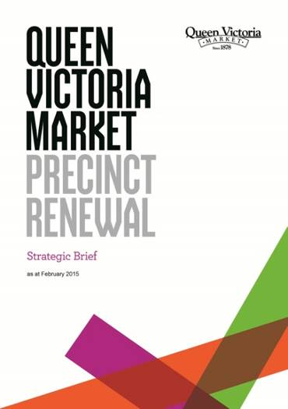
In addition, in October 2014 the City of Melbourne confirmed it was the successful bidder in an Expression of Interest process for the purchase of properties at Therry, Queen and Franklin Streets – a large site often referred to as the Munro site. The redevelopment of these properties will be of strategic importance in relation to QVM, and the Draft Master Plan addresses this as an integral part of the precinct.
Figure 11: Queen Victoria Market Precinct Renewal Draft Master Plan, City of Melbourne, February 2015
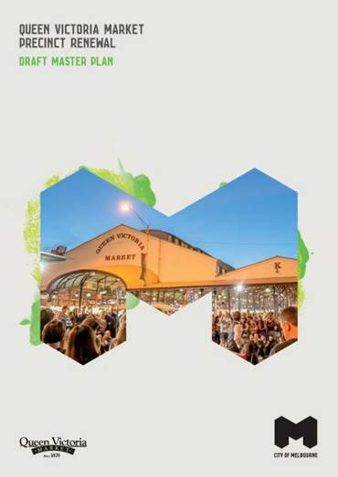

Key improvements
A comprehensive renewal program aims to preserve and celebrate QVM’s iconic features while retaining affordability and ensuring that the Market is competitive in a changing retail environment. Upgrades are intended to address essential infrastructure for traders, event spaces, improved car parking and pedestrian access, and new and improved public open spaces.
Key directions for improvements identified through a consultation and community engagement process include:
- Remove cars from public spaces to make room for more retail, hospitality and events.
- Provide alternative customer car parking along with new storage and operational facilities, making it more convenient for shoppers and traders.
- Retain and enhance the authentic market character and experience. Explore new retail, hospitality, events and activities.
- Create a new public open space on the site of the car park, and close Queen Street to traffic to create space for trading and the market community.
- Connect Franklin Street to Dudley Street and remove two roundabouts to make it safer and easier for people to move around and better link QVM with the central city and surrounding neighbourhood.
- Create mixed-use development sites and use funds raised through the development to support the market’s renewal.

State Government Agreement
To support the Queen Victoria Market Precinct Renewal, the Victorian government and the City of Melbourne have entered into a formal Agreement to realign Franklin Street at the south end of the Market and transfer some Crown land in that area to the City of Melbourne.
The new street configuration will remove two dangerous roundabouts, improve pedestrian and local traffic connections around the Market, and allow streetscape amenity improvements on all sides of the Market.
The land changes will create opportunities for new development to add to the vibrancy of the precinct. Funds secured through development of a large new site south of New Franklin Street will be reinvested in the Queen Victoria Market.
A new building location (provisionally dubbed ‘Queens Corner’) in part of the existing 40m wide reserve for Queen Street will enable provision of a new building with modern infrastructure and services within the heritage Market site.
The key aspects of the agreements are illustrated in (Figure 12):
- Car spaces within the existing at grade car park (A) replaced within the precinct by 2019, and the car park converted to a high quality public space by 2022
- Construction of a new Queen’s Corner building within a portion of Queen Street (B) for the Visitor Victoria Centre and new Market management facilities by 2026
- Construction of New Franklin Street by 2019 (C)
- Reconfiguration of land parcels (including the Franklin Street stores (D) and portions of the Franklin Street road reserve (E) to create mixed use development sites by 2026
- Enhancement and renovations of northern Upper Market Sheds to support trading and incorporate new market trading services and facilities by 2023
- Public realm improvements upgrading streetscapes adjoining Queen Victoria Market (Elizabeth, Peel, Queen, Therry and Victoria Streets) and public transport infrastructure by 2026
Figure 12: Re-planning of land areas at the south end of QVM
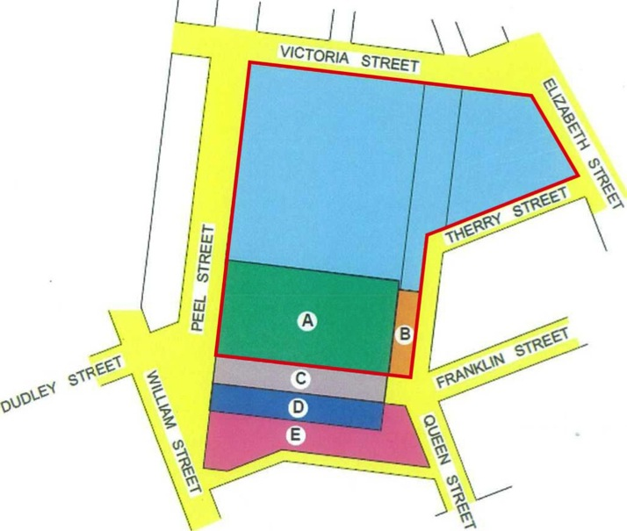
The above diagram shows the re-planning of land areas at the south end of QVM as per the Agreement between the State Government and City of Melbourne:
- A: Existing QVM car park to be converted to a high quality public space
- B: New ‘Queen’s Corner’ building in existing road reserve incorporating visitor centre and market management facilities
- C: Alignment of ‘New Franklin Street’ through existing QVM car park.
- D & E: Portions of existing QVM site and of Franklin Street road reserve to become available for development for other uses.
The resulting modified QVM site boundary is highlighted in red.

Draft QVM Precinct Renewal Master Plan
The Draft Master Plan outlines high level planning objectives and coordinating framework for projects that can be developed in stages. Its focus is on the Market and adjacent public realm (not the wider precinct addressed in this report).

Strategic directions
Three strategic directions are identified in the Draft QVM Precinct Renewal Master Plan. QVM is promoted as a place that is, and should remain:
- A market of markets:
QVM is not a simple, single market, it is a cluster of diverse markets within an interconnected precinct, some contained within the QVM site itself, while others spill into adjoining areas such as Elizabeth Street. It is of extreme importance to Melbourne as a retail area.
- A Melbourne experience:
QVM is a place to experience Melbourne’s local character, liveability and identity – traits that are closely associated with Melbourne’s public spaces and street life as well as with heritage buildings.
- A community meeting place:
QVM is an important meeting place connecting Melbourne’s diverse communities. It has a significant civic dimension as a public place.
All of these suggest the paramount importance of a high quality public realm, with adjoining development contributing to the activation and attractiveness of street spaces. The QVM precinct is, in various aspects, comparable Melbourne’s Retail Core, and to the vicinities of the State Library forecourt and Federation Square, all of which are subject to special built form controls.

Spatial planning – the ‘Market Cross’
The Draft Master Plan outlines high level planning objectives for renewal of the precinct, and assigns key functional and experiential outcomes to specific areas, or ‘quarters’, within the Market (Figure 13).
Figure 13: Queen Victoria Market Precinct Renewal - Project Planning Framework
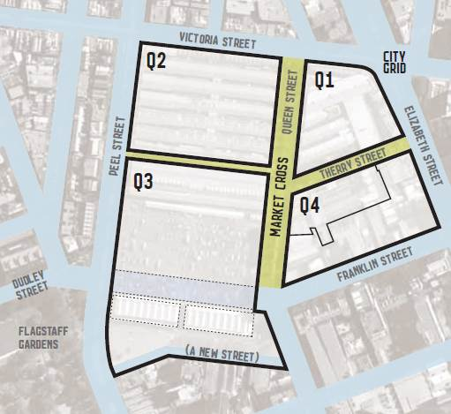
The division into quarters reflects a combination of:
- Varied building types and characters, which create diverse experiences for shoppers in different areas and which are associated with different heritage conservation issues
- Different market trading models, e.g. in shops or open stalls, and fixed or changeable, which have differing implications for strategies to deal with trader infrastructure, storage, etc.
- Different types of goods being sold, e.g. meat and fish, or fruit and vegetables, or non-food items, which result in particular requirements in relation to infrastructure such as waste disposal systems
- Immovable physical features, e.g. the former cemetery wall along F Shed, which create fixed boundaries between potential construction areas
This results in four major quarters of the Market, linked to each other by the ‘cross’ of public spaces in the heart of the precinct. This ‘Market Cross’ - comprised of existing and former road reserves of Therry Street (west of Elizabeth Street), Queen Street (between Victoria and Franklin Streets) and the area of J Shed (connecting through to Peel Street) - is proposed as a zone that should be the focus for different trading areas of the Market and where pedestrian activity should be prioritised and a high level of environmental amenity should be ensured.
In addition, other key public open spaces in the precinct are identified as:
- Elizabeth Street plaza, between Therry and Victoria Streets
- The proposed new open space on the site of the existing car park
Figure 14: The ‘Market Cross’ of key public spaces proposed in the Draft QVM Precinct Renewal Master Plan.
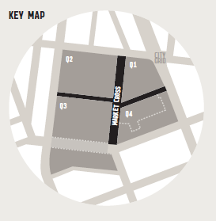
Within this planning framework, proposals for key public spaces within the Market (Figure 14) include:
- Queen Street between Victoria and Therry streets
Remove parking and public vehicular traffic. Separate service vehicle operation from public activity – physically or in time – and enhance as a major public space for casual use and programmed events.
- Therry Street and Queen Street, between Therry and Franklin streets
Improve the market’s central open spaces as a major meeting point with minimised through traffic and increased pedestrian space, providing more opportunities to sit, eat and relax. Remove the existing toilet building.
- Queens Corner
Create a new building that provides an active retail street edge and hospitality to the new open space, accommodating Queen Victoria Market management offices, public amenities, a Victoria Visitor Centre, Market Education Centre, on-site radio broadcasting facility and food and wine industry hub.
- Street activation
Create new pavilions for information and ATM hubs, and providing shelter and enclosure to the former road space.
- J Shed Enhance as a pedestrian thoroughfare, directly linking the tram stop in Peel Street into the heart of the market.
Figure 15: Key streetscapes around QVM identified for improvement in the Draft QVM Precinct Renewal Master Plan.
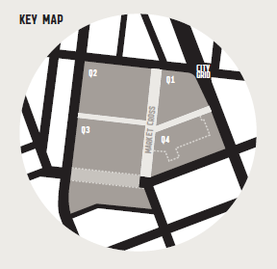
Proposals for key streetscapes around QVM (Figure 15) include:
- Improved public transport arrival points
Create improved tram stops in Victoria Street and Peel Street supporting universal access and with space to avoid congestion. Investigate the possible relocation and longer stop for the Elizabeth Street tram stop south of Therry Street to keep clear of other pedestrian activities in Elizabeth Street plaza.
- Elizabeth Street plaza
Minimise through traffic, and expand the pedestrian space. Create opportunities for al fresco dining and encourage cafes and restaurants in adjoining buildings to create a unique hospitality destination.
- Flagstaff corner
Create a compact, signalised intersection replacing the roundabout. Investigate the potential to expand Flagstaff Gardens across the existing tram spur.
- Victoria Street
Prioritise public transport and pedestrian movement and encourage evolution of the street into an activity spine for City North, linking Errol Street, Queen Victoria Market and the CUB site. Widen footpaths.
- Franklin Street
Prioritise local traffic distribution, pedestrian and cycle movement, as well as providing for re-routed buses from the existing alignment of Franklin Street. Widen footpaths and reduce space allocated to centre of road parking.
- Peel Street
Enhance formal boulevard quality.
- William Street, Queen Street and Elizabeth Street
Improve pedestrian links south from the market including to Flagstaff Station.
- General streetscape improvements
Significantly increase street tree plantings and other greening. Upgrade pavements, street furniture and lighting to standards appropriate for high-priority pedestrian precincts in central city.

Therry, Elizabeth, Franklin and Queen Block Plan
Prior to the City of Melbourne’s purchase of the Munro site, it prepared a document outlining development control guidelines for the block bounded by Queen, Therry, Elizabeth and Franklin streets. The purpose was to assist potential property developers and their consultants to prepare proposals that would be appropriate in the context of the Queen Victoria Market Precinct Renewal. With Council’s subsequent purchase of the Munro site, the audience for this document has changed, but the objectives it outlines are still relevant.
Key recommendations of the Block Plan are:
- Retention of some of the better buildings in the area is desirable to maintain a sense of the precinct’s history. In addition to highly graded buildings, consideration should be given to retaining key buildings that contribute character and visual interest, e.g. the Mercat Cross Hotel.
- New development (where not constrained by heritage buildings) should create a street wall along Therry and Queen Street between 20m and 30m height, to reduce the impacts of high-rise development to the south and east of the Market. Taller building elements should be set back at least 10m from the street.
- Building uses along street frontages must contribute to a high level of streetscape activation and passive surveillance of the public realm, with at least 80% of ground level street frontages as entries or display windows to shops or food and drink premises, or other uses such as customer service areas and activities that provide pedestrian interaction, with tenancies being at least 15 metres in depth. Provision of accessible balcony verandahs extending over the footpaths of streets adjoining QVM should be considered (i.e. along Therry and Queen Streets).
- A mid block pedestrian link should be created extending the existing laneway between 104-106 and 108 Franklin Street through to Therry Street. This should be lined with active frontages and allow for universal 24/7 public access. (see Figure 17)
- Other laneways should be extended to enable rear service access and minimise crossovers of busy pedestrian footpaths (see Figure 18).
Up to 400 car parking spaces, from among the number of spaces as permitted under extant planning controls, should be designed and managed to function as public parking spaces catering to QVM patrons.
Figure 16: Existing balcony verandah on the Mercat Cross Hotel.
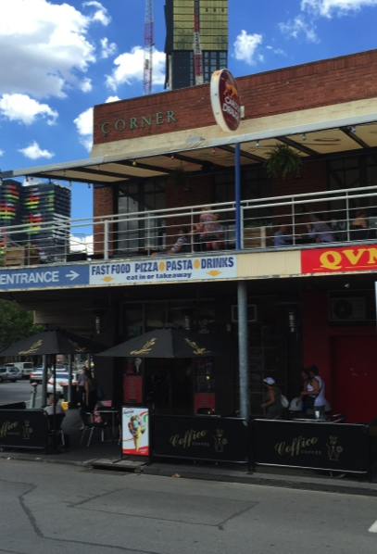
Figure 17: Midblock pedestrian link recommended in the Therry, Elizabeth, Franklin and
Queen Block Plan
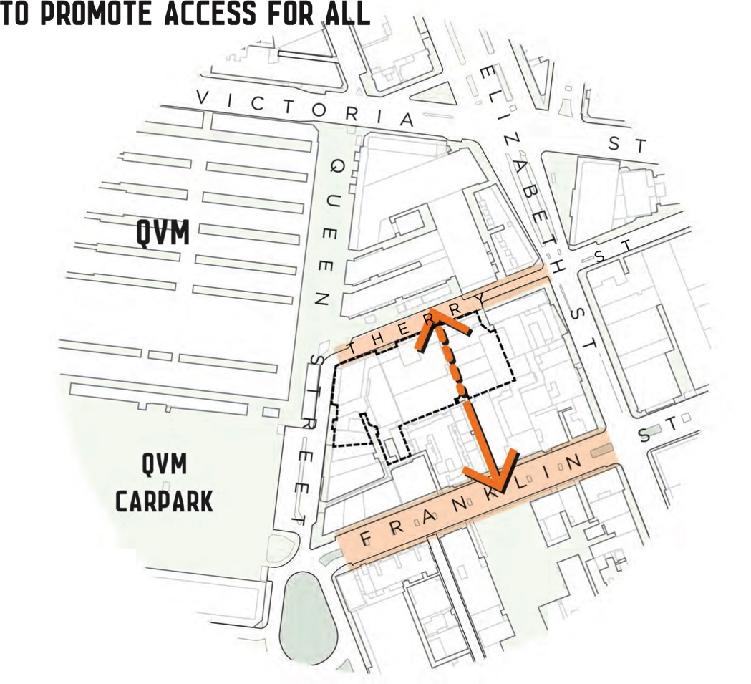
Figure 18: Service laneway links recommended in the Therry, Elizabeth, Franklin and
Queen Block Plan
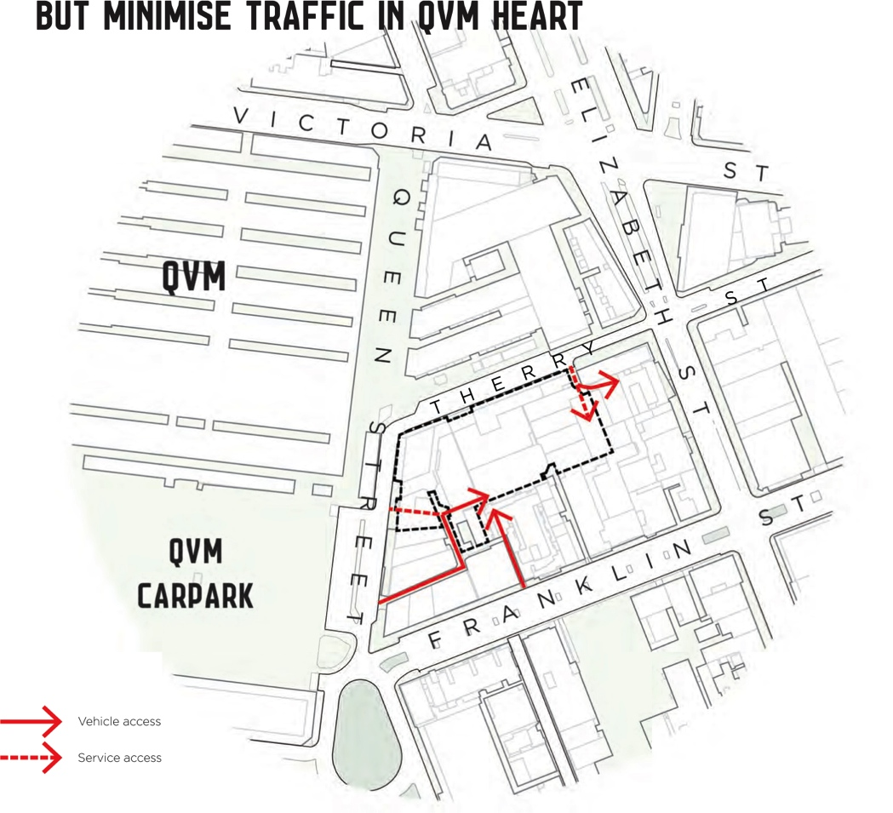

Existing urban form and issues

Existing built form

Urban structure
QVM is situated at the edge of Central Melbourne’s Hoddle Grid. Definition of this edge results from a combination of features including QVM itself, Flagstaff Gardens and the former Royal Melbourne Drill Hall (which are all listed on the Victorian Heritage Register). A series of spaces at the break between the Hoddle Grid and surrounding street grids including the Eight Hours Monument Reserve, and heritage buildings including the City Baths and Old Melbourne Gaol, further contribute to this definition. Historically, Victoria Street was Melbourne’s original town boundary and the location of these public places along it is not coincidental.
The result is not the stark contrast seen along the Spring Street edge of the Hoddle Grid, but it is no less important because of its complexity.
Figure 19: QVM situated at the northern edge of Hoddle Grid
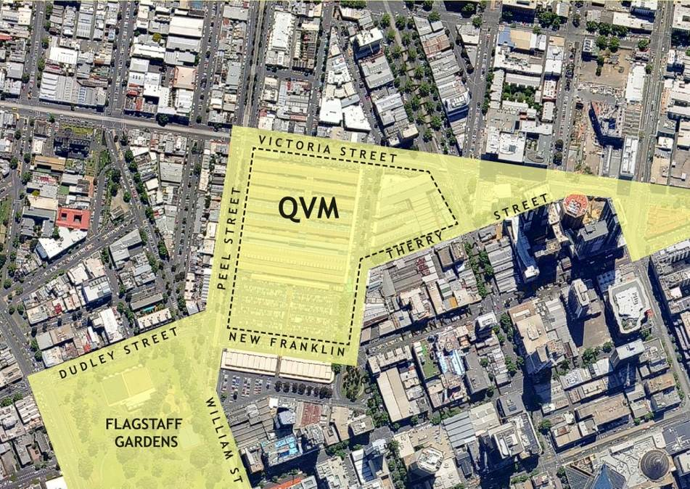
The above image shows the northern edge of the Hoddle Grid is defined – and separated from South Carlton and West Melbourne - by a the change in orientation of street grids in combination with a number of spaces and civic buildings including QVM, Flagstaff Gardens, the former Royal Melbourne Drill Hall, and City Baths.

Streets and public spaces
Flagstaff Gardens adjoins the precinct, QVM includes some off-street spaces, and the Draft Master Plan proposes redevelopment of the existing open air car park as a new public space, but as with most of Melbourne’s Central City the streets are of primary importance as public spaces.
Streets in the precinct include 30m wide streets that are part of the Hoddle Grid (Figure 20). The regularity of the 200m x 200m blocks formed by the 30m streets of the Hoddle Grid – each block typically halved by an east-west little street - is varied somewhat north of Latrobe Street, where the 10m little streets are replaced with 20m reserves for A’Beckett and Therry Streets. However, A’Beckett Street and Therry Street have a relatively intimate scale in comparison to the major streets simply due to their lesser widths, and also mainly serve a local function in relation to traffic and access.
While there are some service lanes within the blocks formed by this street grid, there are relatively few mid-block through links in comparison to other parts of the Hoddle Grid.
Figure 20: Local street grid
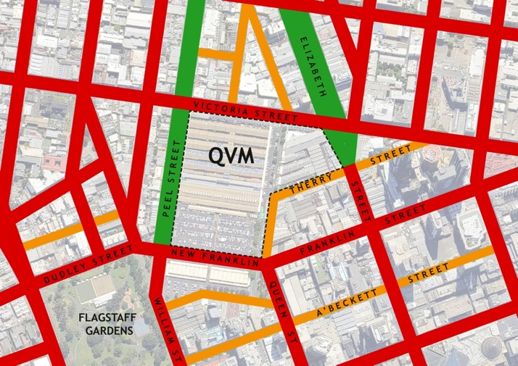
The local street grid as shown above is generally comprised of:
○ 30m wide primary streets
○ Secondary streets, generally 20m wide (rather than the 10m little streets in the rest of the Hoddle Grid)
○ Wider ‘boulevards’ including Peel Street (40m) and Elizabeth Street north of Victoria (60m)

Built form

Street walls
The existing built form in the precinct is consistent with commercial development typical of the inner Melbourne area, with buildings that occupy the full width of their sites and facades at the street frontage.
This building pattern results in streets that have a formal spatial character resulting from regular definition by ‘street walls’. This is demonstrated in historic as well as modern buildings such as Melbourne Terrace Apartments (designed by Nonda Katsalidis, 1994) at the corner of Franklin and Queen Streets (Figure 24). This spatial definition of streets as the primary system of public space through the city is an important characteristic of central Melbourne.
The containment of street spaces means that views are directed along the street. There are no views of significant buildings from street spaces across other open spaces or building sites in the precinct. As a result, ‘landmark buildings’ are usually only seen from near at hand, as with the facade of the QVM meat hall (Figure 21). The sole situation where buildings are (or will be) prominent in more distant views is at locations where the street grid changes direction, including, for example, the view east along the proposed New Franklin Street, which will focus on Melbourne Terrace Apartments. Other views of this type focus on the QVM site.
The sense of spatial definition of the streets that characterises the precinct does not rely on great consistency in the height of buildings. In typical perspective views along streets (rather than in architectural elevations), even where there is a mixture of building heights the aggregate effect tends to be dominated by the taller building elements at the street frontage, provided that gaps created by lower buildings are not so wide that they read strongly in views along the street. One of the clearest examples of this principle is in one of Melbourne’s most famous streetscapes, Collins Street at the end of the nineteenth century (Figure 22), where an extraordinary mix of building scales (and styles) existed side by side yet presented as a reasonably cohesive streetscape.
Figure 21: The QVM Meat Hall is an important landmark but is only visible from within adjoining streets, so views of it can’t be blocked by development on sites near the Market.
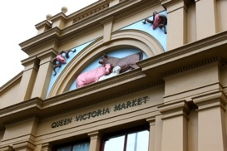
Figure 22: Varied building sizes and styles in Collins Street ca 1900.
[N. Caire, National Library of Australia]
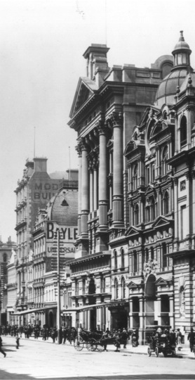

Building scale and architectural character
Within this consistent order of buildings lining the streets, buildings in the QVM precinct vary significantly. The precinct can be broadly described as relatively low rise – in comparison to modern high-rise tower construction – yet heights are quite varied, ranging from single storey to substantial Victorian buildings such as Burbank House at 100 Franklin Street (the former Ferguson and Urie warehouse, Figure 23), with larger modern buildings including the Jasper Hotel (former YWCA) and Melbourne Terrace Apartments, and more recent development that is significantly taller again.
Figure 23: The former Ferguson and Urie Warehouse at 100 Franklin Street.
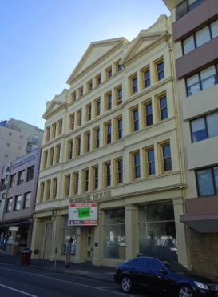
A number of developments currently under construction will have dramatic impacts on the precinct, with an increase in building height and density. A number of additional approved projects, if built, will extend these impacts.
The portion of the precinct with the most consistent existing building scale is the strip along the west side of Elizabeth Street, which is dominated by a continuous row of fine-grained 2-3 storey retail buildings, extending from A’Beckett Street to Victoria Street and including parts of QVM. The Jasper Hotel interrupts this strip, but even the Jasper maintains a low-rise street frontage with a substantial setback to the higher building element (Figure 25). The entirety of this frontage to Elizabeth Street is made up of buildings with heritage gradings ranging from B through D in the City North Heritage Review.
Several buildings in the remainder of the precinct are identified as having heritage value, although the majority of these are in the block north of Franklin Street with only isolated heritage buildings to the south.
Figure 24: Melbourne Terrace Apartments [John Gollings, as found at architectureau.com]
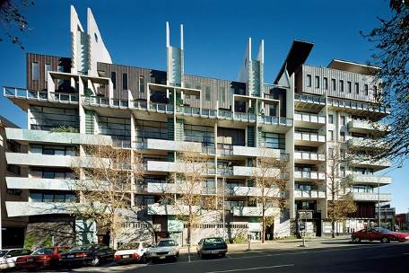
Figure 25: Low-rise retail strip on the west side of Elizabeth Street, including the Jasper Hotel.
[John Torcasio, Panoramio.com]
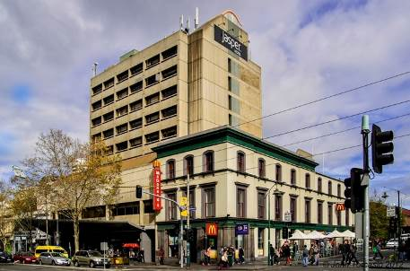

Issues

Low levels of frontage activation
Much of Elizabeth Street is and traditionally has been lined by retail premises, but the standard of frontage activation in other streets in the precinct is less consistent and generally much lower. As a result, the contribution of building uses to the activation and safety of street spaces is limited both in physical extent, and limited especially at night. QVM’s sporadic trading hours also contribute to bursts of activity and long quiet periods, which also results in a lack of ‘eyes on the street’ at many important times. With increasing density of development and an increasing residential population in the area, use of the streets is expected to increase at all times, and this lack of frontage activation will become increasingly undesirable.

Poor contribution to street definition and activation by QVM
The spatial definition of streets by building facades, and the contribution of building uses to streetscape activation and passive surveillance, is least consistent in streets directly adjoining QVM. This is partially due to irregularities in the street reserves at the south end of the Market. It is also a result of the relatively low level of development of QVM in comparison to the other former city Markets, which featured a substantial perimeter of buildings addressed to the streets (Figure 26, Figure 27) of a type that was developed at QVM only at a smaller scale and only around parts of the site. Demolition of buildings at QVM in the area of the existing car park after the wholesale market functions were relocated to Footscray Road further eroded this sense of street enclosure. However, this inconsistency results from the public Market buildings, not nearby private development. The Draft QVM Precinct Renewal Master Plan proposes to ‘investigate opportunities for buildings and uses to make adjoining streets active’ in a number of locations at the Market’.
To some degree, it may be possible to improve this interface between QVM and adjoining streets, and this is proposed in the Draft Master Plan. However, alterations of QVM are significantly constrained by heritage buildings. It is therefore especially important that buildings surrounding QVM – where heritage constraints allow for redevelopment – help to compensate for gaps in activation by the Market with very high levels of activation, at ground floor and above.
Figure 26: The former Eastern Market at Bourke and Exhibition Streets.
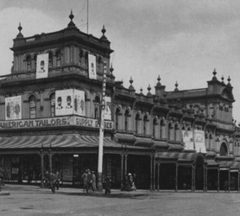
Figure 27: Former Melbourne Fish Market.
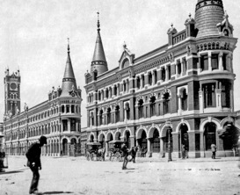

Poor provision for pedestrian capacity and amenity
Current development approvals for the area east of QVM will (if implemented) create one of the most densely populated urban areas in Melbourne (Figure 4). However, the precinct’s streets now offer the least amount of footpath space and poorest standard of streetscape amenity to be found within the typical range of conditions across Melbourne’s Hoddle grid (Figure 28). This situation should be reversed to support intensive use of the precinct with a very high standard of provision for pedestrians. This is largely a matter of the design and management of the streets themselves, but must be supported by appropriate locations of driveway crossovers and other service vehicle access points to properties, by weather protection to footpaths, etc. provided by adjoining development.
Figure 28: Typical streets in the precinct feature relatively narrow footpaths
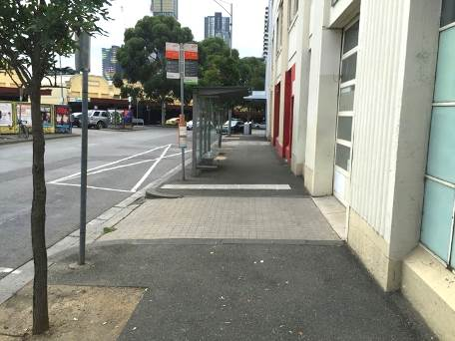
The image above is an example of typical streets in the precinct which feature relatively narrow footpaths, often interrupted by driveway crossovers. Pavements, street trees, lighting and street furniture are characteristic of parts of the city that are regarded as being of the least importance for pedestrians. Building frontage activation is often poor, and weather protection for pedestrians inconsistent. This treatment reflects the past character of land uses in the precinct. This land use character is rapidly being superseded by more uses that rely on more intensive pedestrian activity.

Poor permeability of the large blocks
In other parts of the central city, Melbourne’s large-scale street grid is broken down by system of lanes and arcades, which make important contributions to a walkable environment. This laneway network is poorly developed in the QVM precinct. While there are a number of service lanes, few connect through blocks to provide useful pedestrian links, and most are managed as purely utilitarian spaces. Further development of a fine-grained network of pedestrian routes in the precinct is desirable.
The Draft QVM Precinct Renewal Master Plan recommends a new north-south pedestrian link through the ‘Munro’ block, connecting Franklin and Therry Streets. This link is also supported by the City North Structure Plan (although the route proposed in the Structure Plan is less directly supportive of the policy objective of providing a direct through block link at least every 100m).
In addition, the City North Structure Plan indicates a new link parallel to Elizabeth Street, with the (implicit) aim of providing rear service access to the Elizabeth Street retail strip so as to reduce the need for any service access via the busy Elizabeth Street footpath.

Support for retail activity
While the QVM precinct is outside the Retail Core as defined in the MSS, the Queen Victoria Market is one of central Melbourne’s major retail destinations and this function extends into nearby areas, in particular Elizabeth Street to the south, which accommodates specialty shops that complement those within the Market. This retail activity is important in and of itself, not only as a way to activate streetscapes, and as such indicates the importance of maintaining substantial retail tenancies within the buildings with adequate floor areas and floor-to-ceiling heights to ensure their long term adaptability to a variety of retail operations (beyond hole-in-the-wall cafes).

Existing controls and issues

Existing building height and setback controls

QVM Precinct Design and Development Overlay
Height controls in the QVM precinct south of Victoria Street are detailed in DDO14 (Figure 29), which recommends low-rise development near the Market, transitioning upwards to A’Beckett Street, beyond which normal CBD height controls apply.
The objectives of DDO14 are:
- To ensure that any development within the Queen Victoria Market is consistent with its Victorian character and low-scale.
- To ensure that development around the Market edges and within close proximity to the Market provides an appropriate scale transition from the low scale Market buildings towards the medium and high-rise towers in the central city.
- To ensure that any development in close proximity to the Queen Victoria Market is compatible with the scale and character of the Market, surrounding residential developments and adjacent precincts.
DDO14 was put in place in 2004 through Planning Scheme Amendment C61. Fundamental concepts supporting this DDO include:
The precinct [was] considered to be in a transitional area between the high density built form and high intensity land use of the CAD to the south and south-east and the lower rise, lower intensity areas to the west (Flagstaff Gardens) and north and north-east. [Amendment C61 Panel report]
The future desired urban character of the Queen Victoria Market Precinct will reaffirm the traditional scale and image of the historic Market. … [and] achieve an appropriate transition from the broad proportion and low scale of the Market to the more substantial tower forms of ‘Central Melbourne’. [Queen Victoria Market Built Form Review, Hansen Partnership, 2003]
A number of other controls also apply. Of particular importance is the precinct’s zoning as part of the Capital City Zone (CCZ1). Although not a built form control, this carries with it policies that have a direct bearing on built form such as Clause 22.01 Urban Design within the Capital City Zone.
Figure 29: Detail from the City of Melbourne Planning Scheme showing the extent of DD014
The above detail from the City of Melbourne Planning Scheme shows the extent of DDO14. The discretionary height limits are:
A15 – 12m max.
A16 – 7m max.
A17 – 10m max.
A18 – 20m max.
A19 – 30m max.
A20 – 60m max.

New City North built form controls (Amendment C196)
Implementation of the City North Structure Plan has been pursued through Planning Scheme Amendment C196, although this pertains to land use and development controls north of Victoria Street only. The Amendment has been reviewed by a Planning Panel, adopted by Council, and referred to the Minister for approval.
Under the Melbourne Planning Scheme, DDO32 applies north and west of QVM and recommends a maximum building height of 14m. DDO44 applies to the northeast, recommending an eight-storey limit. These controls have been comprehensively reviewed through the City North Structure Plan, with significant changes to the north of QVM, while the 14m limit west of Peel Street under DDO32 is unchanged.
Under the new controls, most of the area along Victoria Street opposite QVM is indicated with a 24m maximum height. This is reduced to 20m at frontages along relatively narrow (20m) streets, but increased to 40m along Elizabeth Street north of Victoria Street (which is 60m wide). Recommended heights increase again at the Haymarket Roundabout, creating a consistent pattern of increased building height in proportion to increasing breadth of adjoining public spaces.
Figure 30: Plan showing proposed building height limits for the area north of QVM, as per Amendment C196.
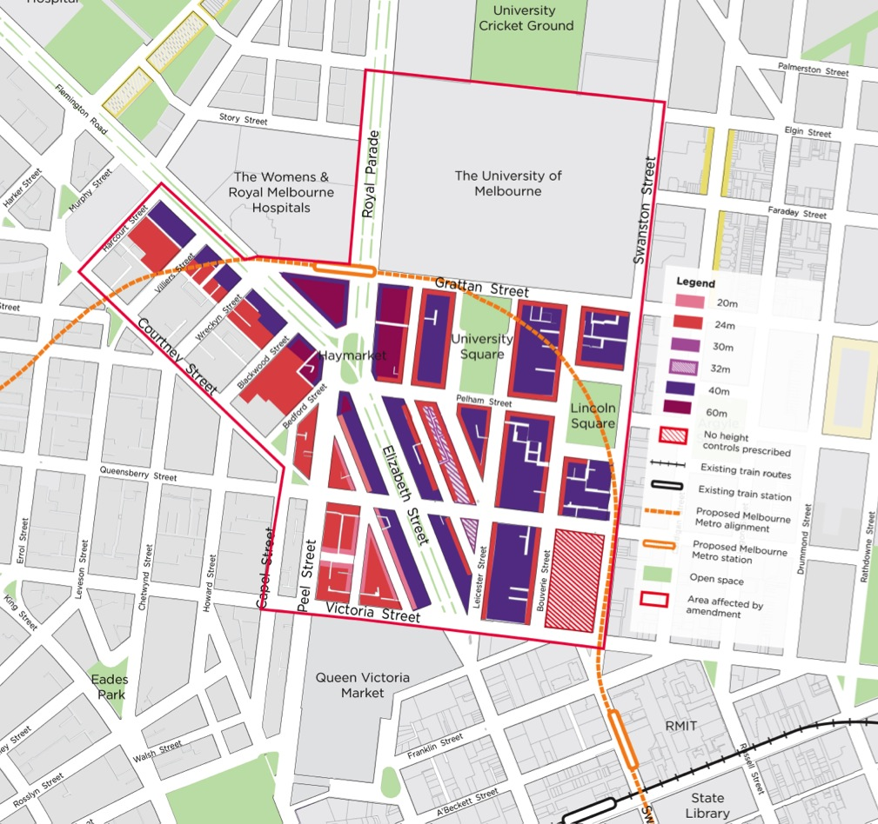

Other built form controls

Frontage activation
‘Active frontages’ offer two-way visual permeability at street level so that activities in buildings add a sense of life and diversity to the street. In addition to making streets more interesting and attractive, they contribute to safety through passive (or natural) surveillance of public spaces. DDO1 Area 2 (Figure 31) applies to key pedestrian routes in the CBD outside the Retail Core, and requires frontage activation in buildings with ground-level street frontages to major pedestrian areas.
Figure 31: DDO1 Area 2
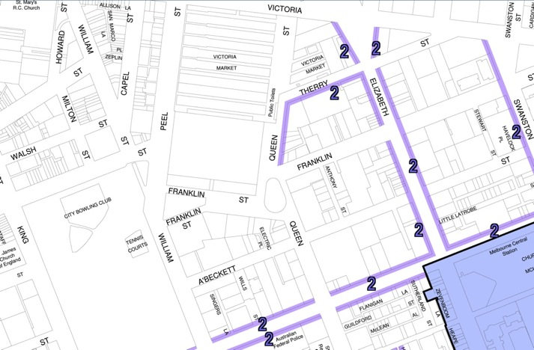
The above image showing DDO1 Area 2 applies to key pedestrian routes in the CBD outside the Retail Core. Its objectives are:
- To ensure ground floor frontages are pedestrian oriented and add interest and vitality to city streets.
- To provide continuity of ground floor shops along streets and lanes within the retail core.
- To ensure ground floor frontages contribute to city safety by providing lighting and activity.

Solar access and sunlight to public spaces
Melbourne’s liveability, comfort and attractiveness are supported by access to sunlight in streets and public spaces at the times of the year when pedestrian activity is greatest. Planning Scheme Clause 22.02 Sunlight to Public Spaces states:
Development should not reduce the amenity of public spaces by casting any additional shadows on public parks and gardens … between 11.00 am and 2.00 pm on 22 September.
This limits building heights near Flagstaff Gardens, including the new development sites south of New Franklin Street, which are within the QVM precinct.

Wind impact mitigation
Clause 22.01 - Urban Design Within the Capital City Zone, sets out standards against which wind and weather protection measures are to be assessed. Schedule 1 to the Capital City Zone - Outside the Retail Core also includes requirements to document the effect of development on wind impacts on public spaces, and decision guidelines include consideration of the potential for increased ground-level wind speeds and the effect on pedestrian comfort and the amenity of public places.

Traffic conflict frontages and weather protection
Development is controlled to promote pedestrian flow, safety and amenity along key CBD streets through two DDOs including:
- DDO3 discourages access to off-street car parking across footpaths where this would generate conflict between pedestrians and vehicles. (Figure 32)
- DDO4 requires provision of verandahs over footpaths for weather protection (although this may be inappropriate on some heritage buildings). (Figure 33)
Figure 32: Area DD03, Traffic Conflict Frontage – Capital City Zone
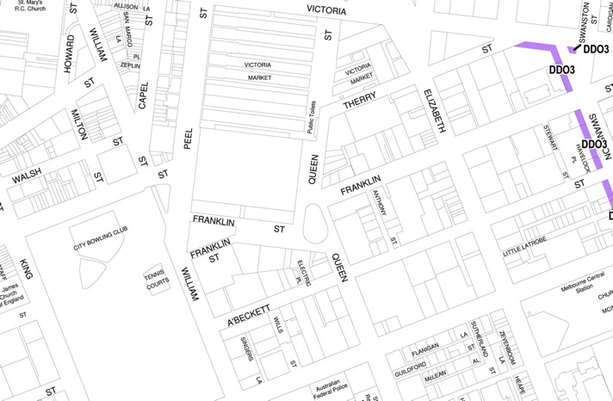
The objectives of DDO3, Traffic Conflict Frontage – Capital City Zone are:
- To promote pedestrian flow, safety and amenity.
- To improve opportunities for the enhancement of roads for pedestrian use by discouraging further access to off-street car parking across traffic conflict frontages.
- To minimise conflict between pedestrians and vehicles on footpaths.
Figure 33: Area DD04, Weather Protection – Capital City Zone
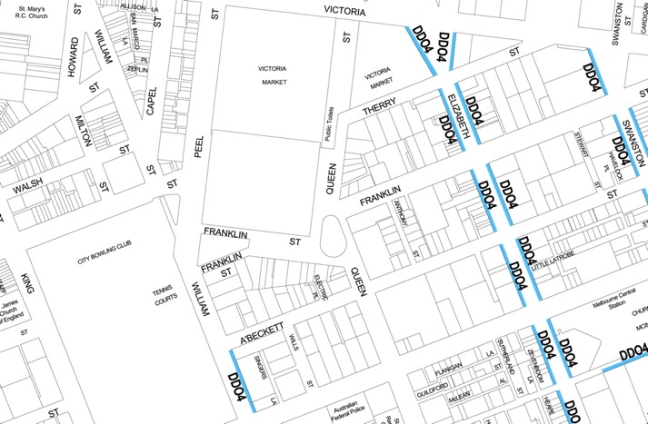
The objectives of DDO4, Weather Protection – Capital City Zone are:
- To promote pedestrian amenity on major pedestrian routes and areas.
- To provide protection, for pedestrians on footpaths, from rain, wind and sun without causing detriment to building or streetscape integrity.

Mid block links and laneways
Mid-block links through central Melbourne’s 200 metre long blocks make important contributions to pedestrian accessibility and amenity. Many lanes are popular and well-used public spaces. Others provide service access, enabling separation of garbage collection and other back-of-house activities from public activity areas. However, mid-block links are not distributed evenly across the city. Planning Scheme Clause 22.01 - Urban Design Within The Capital City Zone therefore states:
Pedestrian through block connections should be provided where the average length of a street block exceeds 100 metres. For street blocks exceeding 200m in length, at least two connections should be provided.
It goes on with additional design criteria for these new links. Planning Scheme Clause 22.20 - CBD Lanes also provides guidance in relation to objectives for the design of the lanes themselves and for adjoining development.

Heritage controls
Heritage controls that apply to the precinct include:
- Area-wide Heritage Overlays HO3 north and west of QVM, and HO7 which includes QVM and a small area to the south east that now also falls under DDO14 area A18.
- Heritage Overlays for specific buildings and places.
- Victorian Heritage Register listings for QVM, Flagstaff Gardens, the underground toilets in Elizabeth Street, and the Royal Melbourne Regiment Drill Hall.
Design guidance is provided through Clause 22.02 - Urban Design Within the Capital City Zone, which states:
When adjoining heritage buildings are located in a Heritage Overlay, the design of new buildings should have regard to the height, scale, rhythm of and proportions of the heritage buildings.
Additionally, Clause 22.04 - Heritage Places Within the Capital City Zone says:
All development affecting a heritage precinct should enhance the character of the precinct as described by the following statements of significance.
The relevant Statement of Significance for the Market precinct reads:
The Queen Victoria Market is one of the great 19th century markets of Australia and the only such market built by the Melbourne City Council to survive. The complex of enclosed food halls, open sheds, shops and stores illustrate a complete mode of commercial transaction, which is today substantially similar to the pattern in 1878 when the main fruit and vegetable market was opened. The Market was the principle market of fresh fruit and vegetable produce in Victoria from 1878 to 1975 and had a profound effect on the whole system of growing, selling and distribution in the state. As a retail market, it has been an important meeting place for a large component of Melbourne’s population and remains a vital link with a part of Melbourne’s domestic life.
The list of ‘Key Attributes’ following the Statement of Significance are:
The historic character of the precinct as a retail area.
The generally simple, low-scale and remarkably intact example of a utilitarian form from the period of its construction. Taken as a whole, the Market and its component buildings are substantially intact in its 1923 form.
The visual dominance of the Queen Victoria Market in the surrounding area.
The City North Heritage Review 2012 recommended several changes to heritage controls. Amendment C198, based on these recommendations, has been considered by a Planning Panel and Council and decisions are expected early in 2015 (Figure 39). In relation to the QVM precinct, the Amendment proposed to:
- Reduce the extent of the Heritage Overlay by removing the triangular site within the west end of Franklin Street (now used as an open air car park).
- Regrade some buildings and update the Heritage Places Inventory accordingly.
- Delete the list of ‘Key Attributes’ from the Statement of Significance in Clause 22.04 - Heritage Places Within the Capital City Zone.
Figure 34: City North Heritage Review, RBA Architects and Conservation Consultants,
January 2014 (four volumes).
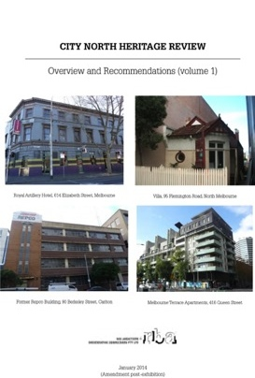
Figure 35: Panel Report: Melbourne Planning Scheme Amendment C198 City North Heritage Review, Planning Panels Victoria, 11 July 2014
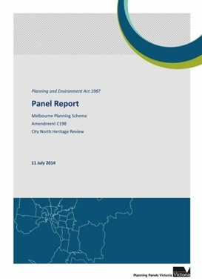
The Panel accepted removal of Franklin Street from the Overlay on the basis of the lack of heritage fabric on the site. The Panel was persuaded that the Heritage Overlay may be removed from this area in the context that the existing DDO14 would remain, ensuring development will be ‘consistent with the scale and built form of the Market’ given its immediate proximity to ‘key market buildings’.
The Panel did not support the removal of the list of Key Attributes, saying that there was no justification to remove these and that they provide useful directions in determining a design response within and around this significant precinct.
Figure 36: Areas affected by the Heritage Overlay
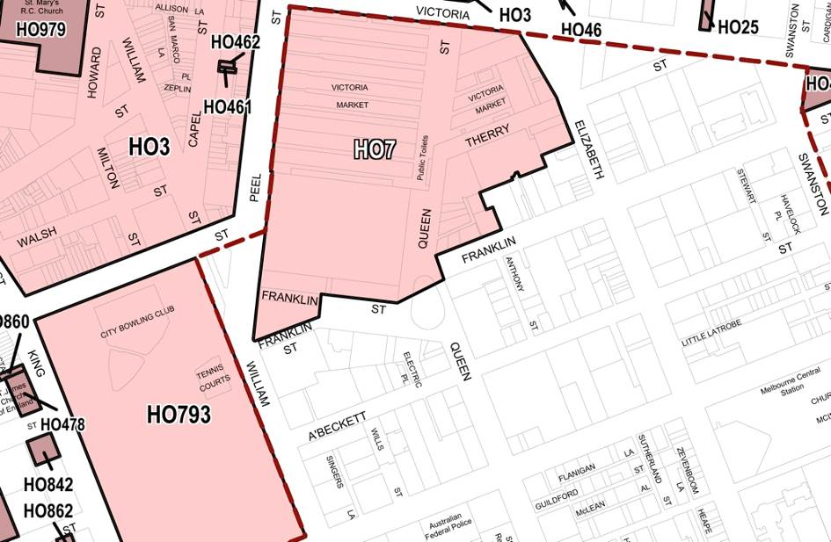
The above image shows areas affected by the Heritage Overlay, including the existing extent of the Heritage Overlay HO7 – Queen Victoria Market Precinct. Relatively minor changes to this are proposed to the extent of HO7 under Amendment C198.
Figure 37: Specific building and sites subject to the Heritage Overlay
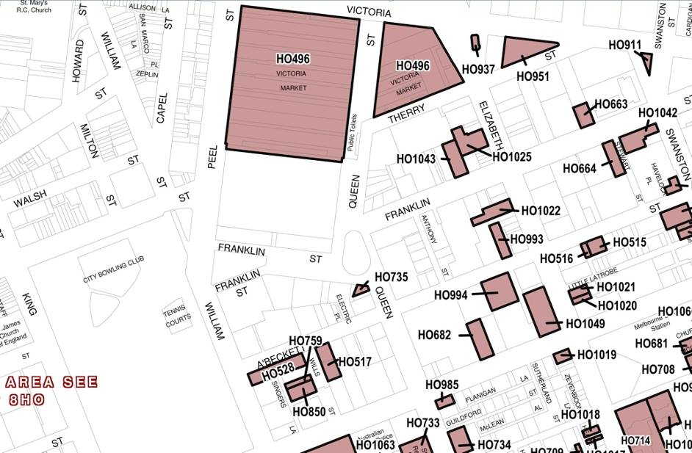
The above image shows specific buildings and sites subject to the Heritage Overlay.
Figure 38: Sites on the Victorian Heritage Register
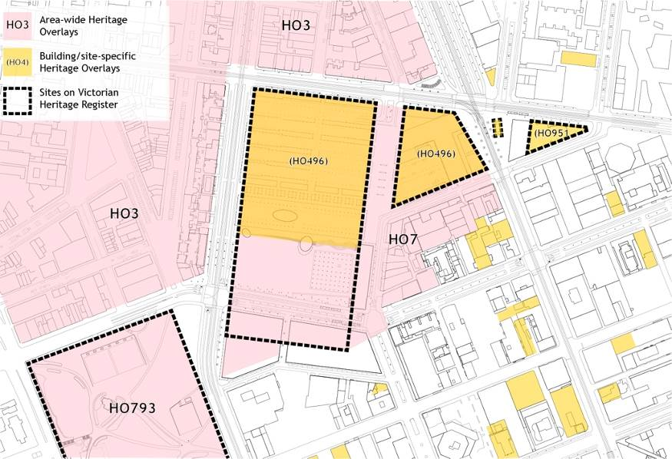
The above image shows sites on the Victorian Heritage Register, shown in relation to the areas subject to the Heritage Overlay in the Planning Scheme.
Figure 39: Recommended changes to the Heritage Overlay under Amendment C198
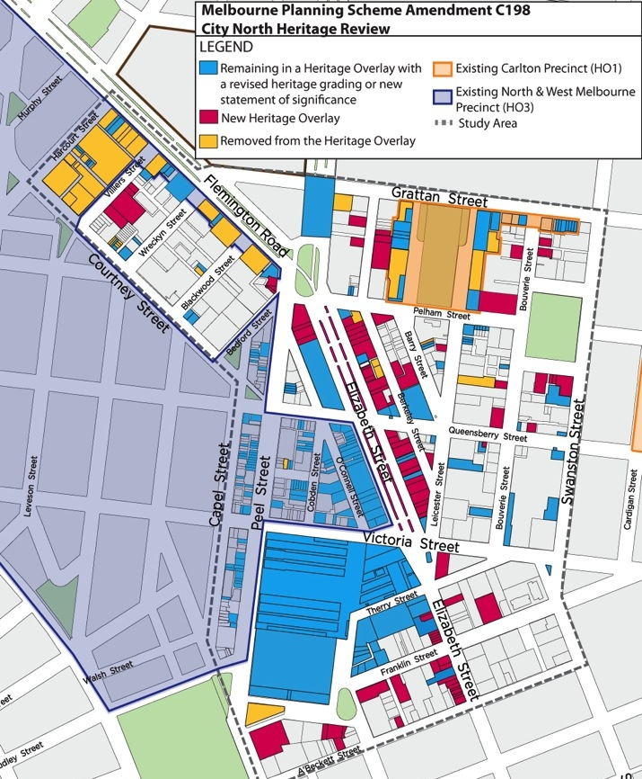
The above image shows recommended changes to the Heritage Overlay under Amendment C198. A number of buildings south of QVM have been added.

Issues

Height and setback controls

Poor fit with existing conditions
With or without the shift in strategic directions noted above, the urban context for which DDO14 was conceived ten or more years ago is now much changed. Since that time, development approvals have allowed buildings to exceed the recommended heights by factors of 300%, 500%, or more, including towers rising sheer from the street (Figure 40). Although some of these are outside the area affected by DDO14, they have a direct bearing on DDO14. Extremely tall towers nearby will be visible from within the QVM precinct. A transition from a 226m tower on the east side of Elizabeth Street to 10m or 20m buildings in parts of the QVM precinct on the west side of Elizabeth Street is not, in any sense, gradual. The objective of DDO14 to maintain a gradual transition between low-rise QVM buildings and taller CBD buildings – whatever its merit may have been - is therefore unattainable.
Figure 40: 500 Elizabeth Street
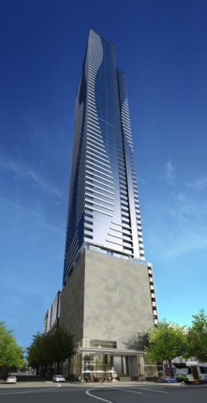
The image above shows the 226m high building now under construction at 500 Elizabeth St, opposite QVM. DDO14 sets height limits of 10m, 12m and 20m at the other corners of this intersection. [skyscrapercity.com]

Poor fit with strategic intent for the area
The MSS and City North Structure Plan identify the QVM precinct as a strategic renewal opportunity. The built form intent described in the Structure Plan promotes extension of development typical of the central city north towards Victoria Street. The existing height controls, which promote a reduction in scale near the Market, conflict with this vision of an expanded central city and fail to recognise QVM’s increasingly central location within that context.

Inadequate rationale for existing height limits
The objectives of DDO14 assume that building heights graduating from low within QVM to increasingly tall buildings at greater distances will protect important qualities of the precinct. However, there are problems with this concept:
- Lack of support through adopted heritage policy
None of the Statements of Significance for QVM mention its surroundings except in a broad sense of its role in serving the city. None indicate that QVM’s heritage values relate to the scale of buildings beyond the site. Current heritage advice (Lovell Chen, April 2015) indicates that building heights only in the immediate proximity of QVM are a concern with respect to the market’s heritage values.
- Inconsistency with other areas adjoining QVM
Amendment C196 allows buildings up to 40m along Elizabeth Street, across Victoria Street from the iconic facade of the QVM meat hall.
- Inconsistency with other heritage precincts
Comparisons to other heritage public spaces like Treasury and Flagstaff Gardens, where there are tall buildings on the opposite side adjoining streets, suggest that the visual impact of nearby building heights on values of QVM is not a concern that can be substantiated. While height limits have been imposed around Parliament House, its significance as a monumental civic building depends on its visual relationship with other buildings; this concern does not apply to QVM.

Prescriptive controls tailored to irrelevant design options
DDO14 areas 16 and 17 across the QVM car park set a 7m height limit near the street and allow slightly taller buildings at its centre. This reflects an abandoned scheme from the 1990s to build a multi-storey car park and supermarket surrounded by other buildings. Although the limits are discretionary, the rationale behind them is prescriptive in nature, enabling a specific and now irrelevant design proposal. Other built form controls

Frontage activation
The existing DDO1 Area 2 (Frontage Activation) applies only to the parts of the QVM precinct, and omits approaches to Flagstaff Station, despite their importance as pedestrian routes.
DDO1 also only pertains to uses at ground level, but building levels above this can make important contributions to streetscape activation. This contribution decreases with increasing building height, while negative impacts of overshadowing and wind turbulence may increase. There is no precise cut-off where benefits begin to be outweighed by disadvantages, but Jan Gehl’s research indicates that the balance remains positive up to at least 20 metres in height. This suggests that the focus of the existing control on the ground level is narrower than it should be, and can also be used as an argument for defining a minimum acceptable building height at the street frontage as a means to maximise potential streetscape activation.
Activation also does not rely upon retail uses, and can be provided to some degree even in residential frontages. Passive surveillance is supported by any use in which people in buildings have views over the street.
There can also be a gradation of levels of activation; it should not simply present or absent. There are no streets in the central city where some level of activation is not desirable, but while DDO1 calls for a high level of activation in certain streets it sets no standards for activation for less important streets.
The City North Structure Plan recommends extending frontage activation requirements along ‘primary active streets’ throughout the area – i.e. to every street frontage in the QVM precinct - and also recommends that activation should involve ground floor uses and uses that enable passive surveillance from upper floors (see Figure 6).

Wind impacts
QVM’s open spaces and low buildings leave frontages to its south and east exposed to Melbourne’s strongest typical winds (northerlies through to westerlies). These exposed frontages (Figure 41) also adjoin the spaces that the draft Master Plan prioritises for pedestrian activity. Increased building heights in these areas risks increased wind impacts at street level. Indeed, anything above a two- to three-storey building frontage in these areas is likely to have an adverse effect on pedestrian activity, unless elements above two or three storeys are set back by about 10m, set at angles to the street, rounded in form, partially permeable to wind, or use some combination of these or other equivalent built form design approaches to minimise wind impacts. As a result, it is uncertain that existing controls relating to wind impacts are adequate to deal with this issue, especially in considering the cumulative impact of potential individual developments.
Schedule 3 to the Capital City Zone – Southbank provides greater certainty in relation to this issue that the controls that now apply to the Hoddle Grid (and therefore also to the QVM precinct) by detailing three measurable levels of wind impact against which development proposals can be assessed, including conditions that are acceptable for:
- Stationary long term wind exposure (e.g. outdoor cafes and other recreation)
- Short term wind exposure (window shopping, waiting for buses, etc.)
- Areas only ever likely to be used as a thoroughfare
In addition, three is also a conflict with Clause 22.01 - Urban Design within the Capital City Zone where it states that it is policy to ‘encourage buildings, including towers to align to the street pattern and to respect the continuity of street facades’. This prioritisation of a visual relationship of upper building levels to the street is problematic with respect to wind impacts, as towers set parallel to the street result in significantly greater wind impacts than if they are angled at 45 degrees, or rounded in plan.

Sunlight to public spaces
In addition to limiting overshadowing of Flagstaff Gardens at the equinox (Figure 42), Clause 22.02 protects a number of key civic spaces from shading even in midwinter:
development should not cast any additional shadows across [key civic spaces]… between 11.00 am and 2.00 pm on 22 June.
Planning for QVM envisages active pedestrian spaces in and around the Market that will continue to play an important role as a type of civic open space that is equivalent to these ‘key civic spaces’. It would be appropriate for spaces at QVM to be given a similar level of protection from overshadowing, throughout QVM’s year-round operation.
Figure 41: Frontages exposed to Melbourne’s strongest typical winds
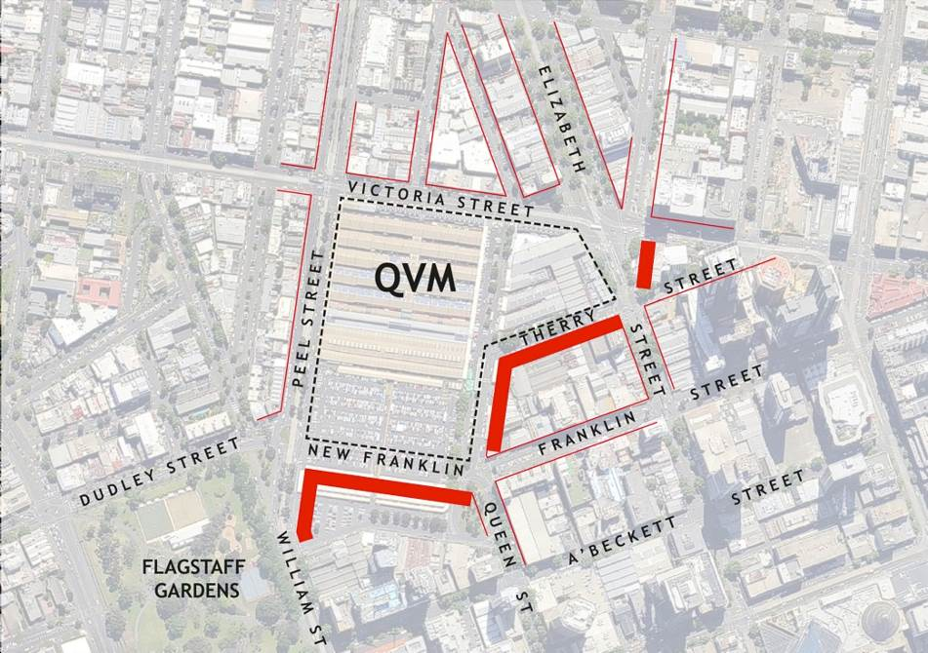
The image above shows exposed frontages. The locations where wind impact is a particularly important factor limiting built form are to the south and southeast of QVM, where potential development sites are exposed to prevailing winds from the west through north.
Figure 42: Proposed building at 386-412 William Street
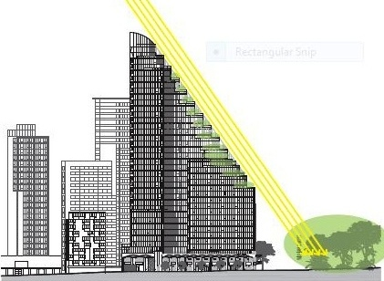
The image above shows the elevation of proposed building at 386-412 William Street, the subject of a current application, with stepped form to minimise overshadowing of Flagstaff Gardens. [Elenberg Fraser, Architects; images from urbanmelbourne.info]

Mid-block links
The block immediately south of QVM including the Munro site does not have any public access links, and the proposed development site south of New Franklin Street is also now designated as a single parcel without specific locations for mid-block through links (as no detailed planning or design has been undertaken for the site).
The importance of pedestrian activity in and around the Market clearly supports continued application of the existing policy requiring mid-block links to the precinct.

Weather protection and traffic conflict frontages
These controls apply mainly in Melbourne’s retail core, but the same concerns for pedestrian amenity should apply to the QVM precinct, which is also a significant retail and pedestrian area.

Heritage Controls
As noted in 4.3, the Panel for Amendment C198 believed the list of ‘Key Attributes’ following the Statement of Significance for the QVM Precinct in Clause 22.04 provides useful directions for design responses. However, it is unclear how it does so, as the list focuses on uses (which are not the subject of built form controls), on the Market itself (which is not the subject of most development applications) and on the visual dominance of QVM (which arguably does not exist). The assertion that QVM is ‘substantially intact in its 1923 form’ is also true only in part; there have been many significant changes to QVM since 1923 (Figure 44).
The heritage controls allow a wide latitude for development responses and little certainty as to what will be protected. This is particularly the case as, in the central city context, to ‘have regard to the height, scale, rhythm of and proportions of’ heritage buildings does not normally require the replication of any of those attributes, in particular scale (despite comments by the Amendment C198 Planning Panel in relation to removal of the Heritage Overlay from a portion of Franklin Street). Proximity to heritage buildings is not typically accepted as a basis for height restrictions in the CCZ and growth areas. Accepted practice allows for juxtapositions of new, old, small and large, and the conspicuous presence of new structures beside, behind or even on top of historic buildings in a way that is seldom accepted in the context of a Heritage Overlay in suburban areas (Figure 43).
Figure 43: New built form in relation to central city heritage buildings. The addition to RMIT Building 9 (right) received the AIA award for heritage architecture in 2010. [commercialrealestate.com.au; ‪en.wikipedia.org; walkingmelbourne.com]‬‬‬‬‬‬‬‬‬‬‬‬‬‬‬‬‬‬‬‬‬‬‬‬‬‬‬‬‬‬‬‬‬‬‬‬‬‬‬‬‬‬‬‬‬‬‬‬‬‬‬‬‬‬‬‬‬‬‬‬‬‬‬‬‬‬‬‬‬‬‬‬‬‬‬‬‬
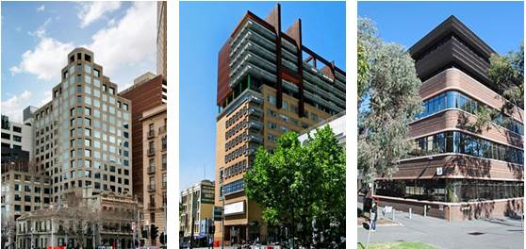
The only likely exceptions to this flexibility, where the Heritage Overlay applies to a relatively consistent built form scale across a group of buildings, and these factors in combination provide an arguable basis for restrictions on building heights, are:
- The west side of Elizabeth Street between Franklin and Therry Streets, where the frontage (but not the entire depth of the properties) remains a consistent 19th / early 20th century scale retail strip.
- The buildings along south side of Therry Street, west of Elizabeth and extending to some extent south along the east side of Queen Street, which are important because of their proximity to the most intact parts of QVM.
Figure 44: Extent of change of QVM from 1923 to the present, from Queen Victoria Market Conservation Management Plan, Allom Lovell Associates, 2003, Figures 24, 25 and 26.
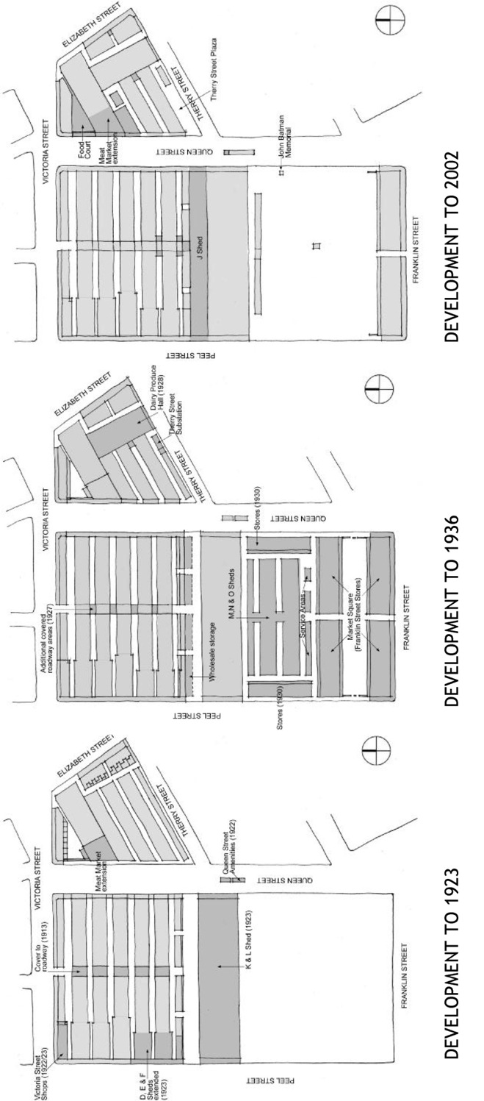

Built form vision for the precinct

Vision
The City North Structure Plan sets out a vision for the area of QVM as:
The vision for the Central City is to create streets which are active, protected from the elements, provide a permeable pedestrian environment, provide appropriate vehicular access, and appropriately manage waste. There will be a strong distinction between the built form scale in the Hoddle Grid [south of Victoria Street] and the remainder of the City North precinct…
The area south of the Queen Victoria Market is a strategic renewal opportunity and intensification of development in the Queen Victoria Market is encouraged where appropriate.
The Draft Queen Victoria Precinct Renewal Master Plan sets out a vision for the public spaces within the Market:
One of Melbourne’s great public and local places
Welcoming and full of urban life, Queen Victoria Market’s public spaces encapsulate qualities that make our city liveable – year in year out – within a variety of pedestrian-friendly streets and plazas. These open spaces interconnect, help to define, and add value to the different trading areas of the market while providing for a growing community.
And, for the public realm around the Market, it proposes:
The best of Melbourne’s city streets
Queen Victoria Market connects seamlessly into the surrounding city with its tree-lined streets. Streets prioritise different combinations of movement – walking, public transport, cycling and cars – with space allocated according to these priorities. All streets are attractive public places enriched by adjoining land uses.
The built form of the QVM precinct should contribute to this combined vision by ensuring that:
- Development contributes to Melbourne’s distinctive character by reinforcing the distinction between the Hoddle Grid and adjoining areas.
- Development defines and activates QVM as a special place by creating a taller built form around, and oriented towards, the Market, albeit with relatively low podiums that establish as transition to the Market’s most intact heritage areas.
- Buildings contribute to safe and activated streets and public spaces via ground floor uses that interact with the street, and uses at upper levels that contribute to passive surveillance.
- Key public spaces in the precinct enjoy access to sun throughout the year.
- Streets and public spaces are protected from wind impacts so they are pleasant to use for outdoor cafes, window shopping and walking.
- Pedestrians are provided with weather protection and protected from conflicts with vehicular traffic along key routes.
- A fine grain of pedestrian routes encourages access throughout the precinct.
- New development is respectful of heritage values of the Market and other significant buildings.

Precinct definition
Development contributes to Melbourne’s distinctive character by reinforcing the distinction between the Hoddle Grid and adjoining areas.
The City North Structure Plan, the Strategic Review of Controls for the QVM Precinct, and indeed the 1987 publication Grids and Greenery (a reference document in the Melbourne Planning Scheme) and Council’s MSS, argue that maintaining a clear distinction in urban form and identity between central Melbourne’s Hoddle Grid and adjoining neighbourhoods is important not only to these immediate areas but to the identity of Melbourne as a whole. The City North Structure Plan also proposes that ‘there [should] be a strong distinction between the built form scale in the Hoddle Grid and the remainder of the City North precinct.’
Figure 45: Grids & Greenery, 1987
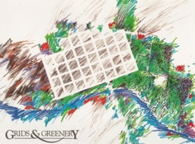
QVM, the Flagstaff Gardens and former Drill Hall play an important role in fixing the location of boundary between the Central City, City North and West Melbourne, and in giving this boundary a visible presence. These sites form a boundary that distinguishes the urban form and identify of central Melbourne’s Hoddle Grid and adjoining suburbs. All three sites are on the Victorian Heritage Register and the larger two are Crown Land reserves. The public functions of these heritage sites helps to ensure a long-term distinction of their character in relation to surrounding development. Without the break this creates in the urban fabric, northward expansion of the Capital City Zone would result in City North and the Hoddle Grid merging into one another.
The distinct identity of the Hoddle Grid, City North and West Melbourne will be maintained and enhance with a general approach in which development around the edges of the QVM reflects the character of each neighbourhood, rather than matching the character of the Market or attempting to create a uniform context for the Market, i.e.:
- Hoddle Grid development extends to the southern edge of QVM.
- City North development extends to the Victoria Street.
- West Melbourne development extends to Peel Street.
Figure 46: The four sites on the Victorian Heritage Register
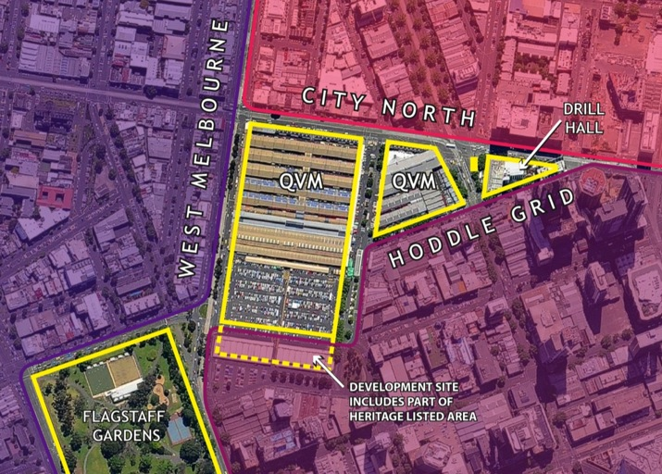
The image above shows the four sites on the Victorian Heritage Register including Flagstaff Gardens, QVM, the Elizabeth St underground toilets and former Royal Melbourne Regiment Drill Hall create a clear demarcation between the Central City, City North and West Melbourne. This establishes logical boundaries for changes in built form control regimes between the various areas.

Market interface
Development defines and activates QVM as a special place by creating a taller built form around, and oriented towards, the Market.
The strategic priorities for the precinct as well as realities of recent development approvals support a vision in which a contrast between the Market and surrounding development accentuates QVM as a special public place.
Examples of this include historic city markets such as Barcelona’s Santa Caterina Market (Figure 47), where the scale of the market itself and of the surrounding buildings is different from QVM, but where the contrast between the built form of the market and that of surrounding development is none-the-less quite evident.
Figure 47: The Santa Caterina Market, Barcelona.
[barcelona-home.com]
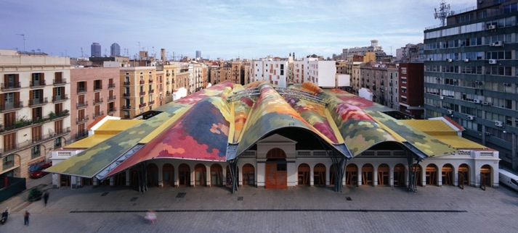
This built form pattern will also maximise the potential for synergies between the space and through allowing for more intensive surrounding land uses.
This approach will be supported by development around the Market with taller buildings massed around it, creating a visual containment of the Market site and that contrasts with the low-rise buildings open spaces of the Market.
Figure 48: Key development frontages surrounding QVM.
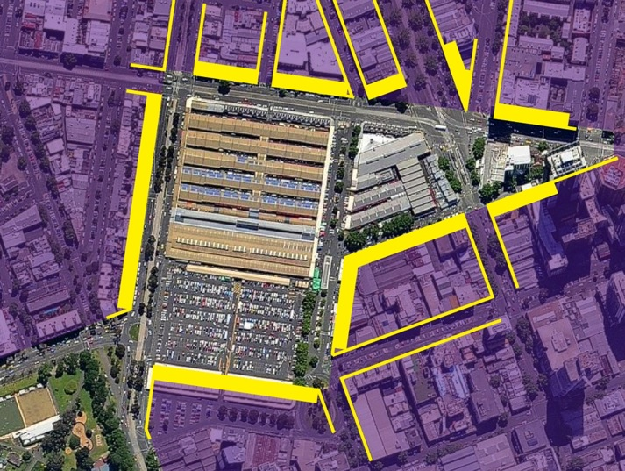

Streetscape definition and activation
Buildings contribute to safe and activated streets and public spaces via ground floor uses that interact with the street, and uses at upper levels that contribute to passive surveillance
Streets are the most extensive and significant public spaces of inner Melbourne. Much more than travel routes, they are also settings for business, socialising and recreation. Streetscape qualities that enhance these other activities also support streets’ use for sustainable transport options including walking and cycling.
Buildings lining streets make vital contributions to the public realm through frontage activation and support for passive surveillance, and these contributions should be maximised on streets surrounding and leading to QVM through:
- Provision of active ground floor frontages along the street edge, and accommodation of building uses that encourage interaction with the street.
- Activation and support for passive surveillance at upper building levels, with a required minimum building height at the street frontage of three storeys and a preferred height of around 20 metres above street level (subject to resolution of wind mitigation issues and integration with heritage structures), and inclusion of building uses throughout these levels that maximise opportunities for people in buildings to overlook the street.
- Activation through means other than retail above ground floor.
Figure 49: Preferred build form outcome for typical Hoddle Grid streestscapes
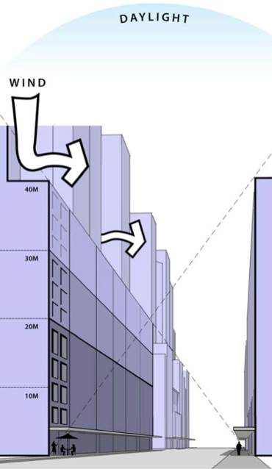
The above Illustration shows the preferred built form outcome for typical Hoddle Grid streetscapes (Planisphere, Central City Built Form Review, 2001). A desirable minimum 20m street wall maximises potential for activation of the street space. Above 40m, setbacks are desirable to allow sunlight into the street and help to mitigate wind impacts. Upper and lower parts of any one building are seen as part of the streetscape as a whole, not simply as part of the one building.
Figure 50: Frontage activation requirements
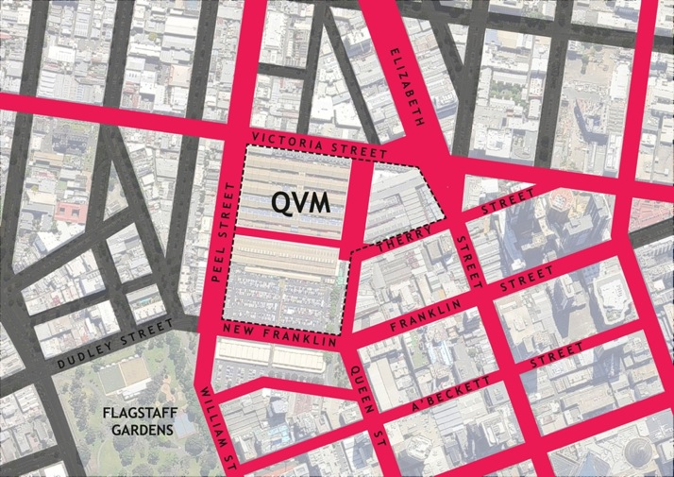
○ Frontage activation requirements should be extended into and throughout the QVM precinct along these streets and spaces to:
- enhance the Market’s vitality, and to
- strengthen pedestrian links with the surrounding city.

Sunlight to open spaces
Key public spaces in the precinct enjoy access to sun throughout the year
The Draft QVM Precinct Renewal Master Plan proposes the improvement of open spaces in and adjoining the Market site as major civic spaces, including:
- Queen Street north of Therry Street, to be pedestrianized and enhanced as a major public space for casual use and programmed events.
- Elizabeth Street plaza (between Therry Street and Victoria Street), to be designed and managed to minimise through traffic, and with expanded pedestrian space to create a unique hospitality destination linked to QVM.
- A major new open space, to be created on the site of the existing QVM car park, supporting market-related activities and events, recreational opportunities that complement Flagstaff Gardens, and catering to Market patrons and needs of the local community.
These spaces should be protected from overshadowing between 11.00 am and 2.00 pm throughout the year.
The solar panel array on the shed roofs of the Market should also be protected from any overshadowing.
Figure 51: Open spaces within QVM and existing restrictions on overshadowing of Flagstaff Gardens
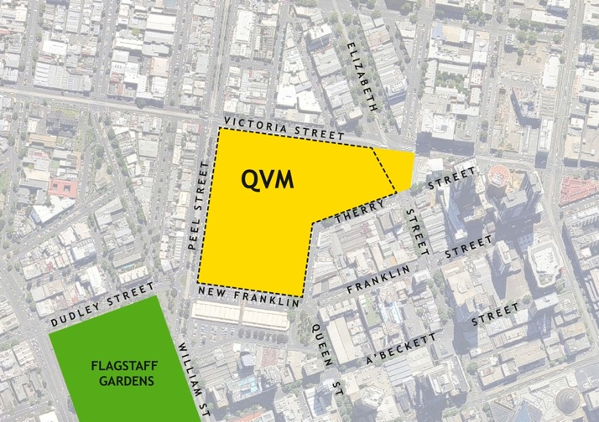
In the image above:
○ Yellow indicates all open spaces within QVM, and the Elizabeth Street plaza between Victoria Street and Therry Street, should be protected from overshadowing between 11.00 am and 2.00 pm throughout the year. (Exceptions may be appropriate for structures that directly contribute to sheltering and activation of the open spaces.)
○ Green indicates existing restrictions on overshadowing of Flagstaff Gardens should be maintained and will also continue to influence development in the QVM Precinct.

Wind impact mitigation
Streets and public spaces are protected from wind impacts so they are pleasant to use for outdoor cafes, window shopping and walking
The active use of spaces in QVM and adjoining streets is envisaged as including outdoor cafes, places to sit, eat, relax and socialise. Streets extending from the Market are important pedestrian links between QVM and the surrounding city and include retail uses where window shopping and similar activities are important. Many of these streets also provide access to public transport services including bus and tram stops, making them important walking routes.
Development should not generate wind turbulence that detracts from these uses.
Wind mitigation standards should be applied to the QVM precinct as indicated below, linked to measurable performance criteria related to desired types of uses (as specified in Schedule 3 to the Capital City Zone – Southbank), i.e.:
- For areas designated to be generally acceptable for stationary long term wind exposure, the design of developments must ensure that the peak gust speed during the hourly average with a probability of exceedence of 0.1% in any 22.5º wind direction sector does not exceed 10ms-1.
- For areas designated to be generally acceptable for short term wind exposure, the design of developments must ensure that the peak gust speed during the hourly average with a probability of exceedence of 0.1% in any 22.5º wind direction sector does not exceed 13ms-1.
- In street frontages or trafficable areas that are only likely to be used as a thoroughfare, building interfaces must be designed to be generally acceptable for walking. The peak gust speed during the hourly average with a probability of exceedence of 0.1% in any 22.5º wind direction sector must not exceed 16 ms1.
- Developments should not rely on street trees for wind protection.
In addition, given the magnitude of the problem in mitigating wind impacts in frontages facing the Market, the policy in Clause 22.01 calling for towers to be aligned to the street should not apply to development along these frontages.
Any architect/developer of sites in the precinct should to seek advice from wind consultants early in the design phase to assist with the mitigation of built form wind impacts.
Figure 52: Stationery long term and short term wind exposure criteria
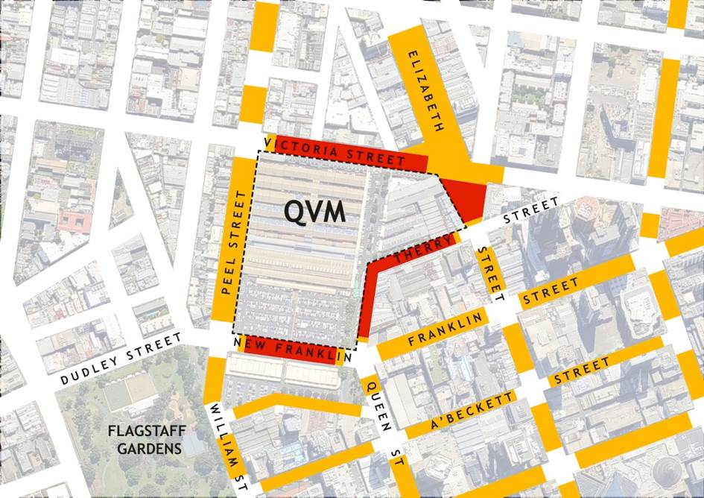
In the image above:
○ Red indicates where development should be designed to achieve stationary long term wind exposure criteria for public spaces designated for outdoor retail or important pedestrian recreational uses, regardless of uses proposed within any development.
○ Yellow indicates where development should be designed to achieve short term wind exposure criteria for frontages in key streets linking QVM to the surrounding city (away from corners). Design to achieve stationary long term wind exposure criteria may also be appropriate in locations related to particular development proposals e.g. where there is an intent to operate on-street cafes.
In all streets, the building interface must be designed to achieve wind conditions that are generally acceptable for walking.

Pedestrian amenity and safety
Pedestrians are provided with weather protection and protected from conflicts with vehicular traffic along key routes
A fine grain of pedestrian routes encourages access throughout the precinct.
Streets in the QVM precinct include important retail areas and key public transport corridors where pedestrian access in all weather conditions is important and where pedestrians should given a high priority in relation to vehicular access. Weather protection should therefore be provided to footpaths along these streets (e.g. as per DDO4), and conflicts between pedestrian traffic and vehicles at service and car park entry points should also be minimised along these streets, by locating crossovers along other frontages where possible (e.g. as per DDO3).
The importance of pedestrian activity in the area also indicates the need for creation of a fine grain of pedestrian routes with new mid-block links, and for protection of footpaths from service vehicle conflicts through provision of rear service lanes. Existing lanes should be extended to create new pedestrian and service access connecting through the blocks south of the Market.
Figure 53: Pedestrian amenity and safety
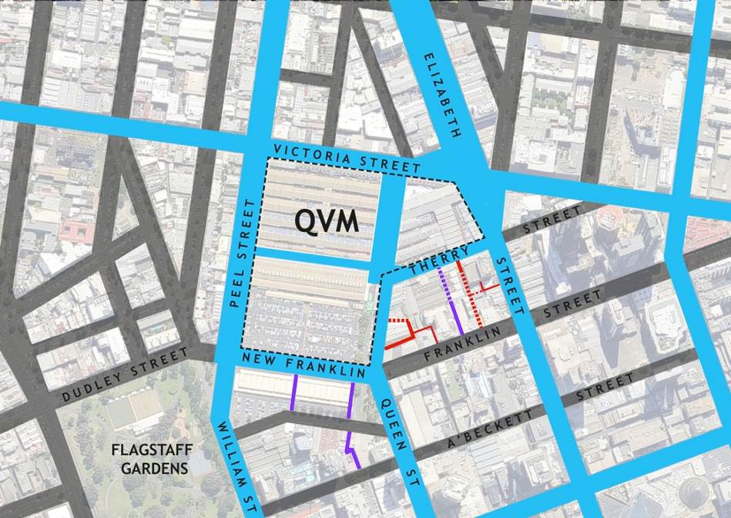
In the image above:
○ Blue shows provision of weather protection to footpaths and management of traffic conflict frontages should be extended into the QVM precinct along these streets and spaces to support pedestrian access
- in key retail areas, and
- along public transport corridors.
○ Red shows existing service lanes should be extended where opportunities allow to reduce loading, garbage removal and car park access conflicts with important pedestrian frontages.
○ Purple shows existing laneways should be extended and new links created to provide mid-block pedestrian links where block lengths exceed 100m.

Heritage
New development is respectful of heritage values of the Market and other significant buildings.
One of the aims of the QVM Precinct Renewal project is to retain the Market’s authentic atmosphere while addressing long-standing issues that constrain its potential. Regardless of any formal heritage conservation gradings, it is important to the community to know the history of the place, and to retain its ‘texture’ and ‘feel.’ It is therefore desirable that redevelopment adjoining QVM retains both some sense of the pedestrian scale of spaces in and around the Market, and some of the highly textural built fabric of the place.
Figure 54: Key building retainment
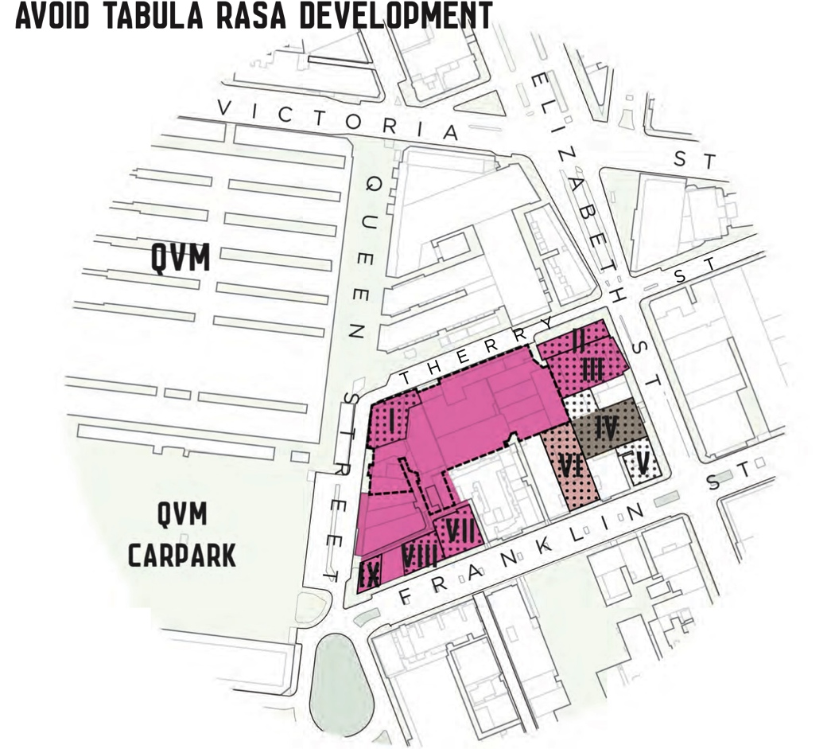
The Therry, Elizabeth, Franklin and Queen Block Plan recommends that, in addition to graded heritage buildings, consideration should be given to retaining key buildings that contribute character and visual interest, including the Mercat Cross Hotel and other buildings in the precinct identified as I - IX in the above diagram.

Implications for controls

Built form controls over QVM itself
QVM is listed on the State Heritage Register. Decisions about development on the site will be determined principally by heritage considerations, and are subject to approval by Heritage Victoria.
DDO14, which now imposes a range of height limits on QVM itself, is intended to protect the Market’s heritage qualities by ensuring ‘that development is consistent with its Victorian character and low scale’. However, only holistic consideration of heritage issues will achieve this objective. It is arguable that using a control such as these height limits – a control intended to manage relatively crude design outcomes - is a simplistic and inappropriate way to deal with the subtleties of heritage conservation concerns at QVM.
There is therefore a clear logic to remove DDO14 from the area of QVM itself and not replace it with another DDO, but rather to ensure that heritage conservation issues are directly managed through heritage conservation policies and processes, rather than indirectly through other mechanisms.
Figure 55: Sites on the Victorian Heritage Register
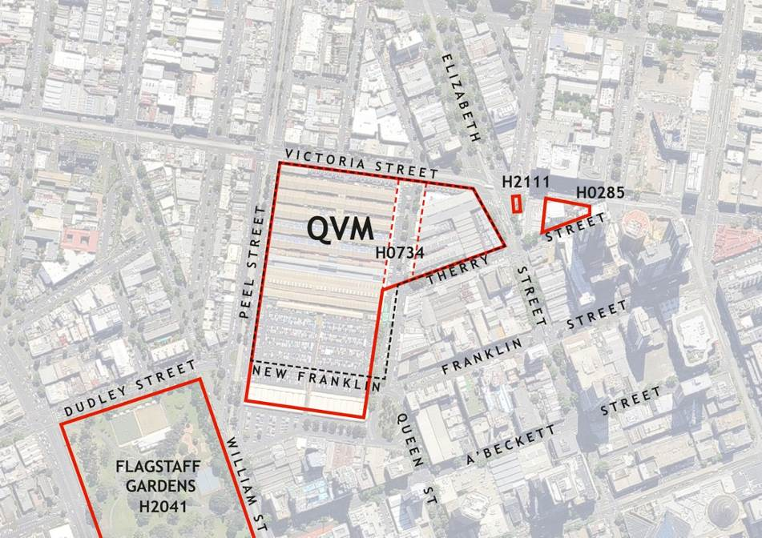
○ In the image above red indicates sites on the Victorian Heritage Register. Heritage conservation issues on these sites should be managed through heritage conservation policies and processes, rather than a DDO. It would seem to be appropriate to unify the registered area for QVM, which is now split by Queen Street, as part of a more holistic approach to conservation of the Market.

Statements of planning objectives in the MSS
Detailed controls including DDO14 are foreshadowed by more general strategies and objectives in the MSS, including Clause 21.12 Hoddle Grid - Built Environment and Heritage (8th dot point), which states:
Ensure the area bounded by Latrobe and Victoria Streets and Elizabeth/Peel Streets has a lower scale than the Hoddle Grid and provides a contrast in built form scale between the lower scale of Carlton and North Melbourne and the higher scale of the Hoddle Grid.
This statement was written to support an objective which is no longer tenable and no longer consistent with other strategic objectives for the area, and so it would therefore be appropriate to be deleted or amended.

Built form frontages adjoining QVM
The key area where special development controls associated with QVM should apply – beyond policies and controls that apply (or should apply) more generally to the Hoddle Grid – is at the immediate perimeter of the Market, where potential development sites face onto streets around QVM. Assuming an allowance for an increase in building height on these sites – even to the 20m now permitted south of Therry Street – the impact of buildings at greater distances will be insignificant. This is also the area of greatest concern in relation to wind turbulence due to the exposure of buildings adjoining the open spaces and low-rise buildings of QVM.
Development along these frontages will be shaped by a combination of objectives:
- Addressing the City to the Market in a positive manner
- Maximising activation and passive surveillance of the public realm
- Avoidance of wind impacts on pedestrian activity
- Perceptions of an appropriate scale in relation to the Market’s heritage values
- The first two of these press for an increase in building scale relative to existing conditions. As indicated by the Therry, Elizabeth, Franklin and Queen Block Plan, a 20m height street wall would be desirable to maximise activation and passive surveillance, as well as to provide some building bulk addressed to QVM that creates an effective buffer to higher building forms that do not relate to the street and Market. Norms associated with the Hoddle Grid (see Appendix: Typical Hoddle Grid built form) suggest that 40m maximum would be acceptable visually along New Franklin Street, where development will be separated from Market spaced by the new 30m wide street, as typical of the main Hoddle Grid streets; and that a 30m maximum (or even 40m) would be acceptable visually along Therry and Queen Streets, where the street space is or will be only 20m wide.
In contrast, for these same locations, objectives relating to wind and heritage are constraints on height. Not even a 20m minimum height street wall is likely to be achievable – as a solid facade at the street edge extending to that height - while maintaining acceptable wind conditions on frontages along the south and east edges of QVM. In order to achieve the recommended wind conditions at street level along these frontages, buildings will need to adopt one or several design strategies such as reduced podium height, setting upper building elements at angles to the street or rounded in form, and facades that are permeable to wind. (However, these present a variety of options that suggest that any prescription for a lower built form is not necessary to protect from wind impacts.)
Heritage conservation objectives will also limit heights, particularly along Therry Street, and along New Franklin Street where the the Franklin Street Stores buildings will become part of the new development site south of the new street. These existing buildings are still part of the QVM site listed on the State Heritage Register. Their retention will, in effect, create a low-rise podium frontage along the new street for any future redevelopment of the remainder of the development site.
Figure 56: Key development frontages surrounding QVM
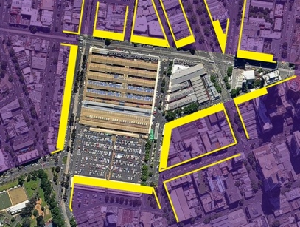

Overall building heights
Given the combination of existing policies and controls, recommendations outlined above in relation to sunlight to open spaces and frontages onto streets, and the potential to mitigate wind impacts on public spaces through the use of podium elements, if there are no other height controls, overall building height in the precinct would be limited only by a few performance criteria that apply to the entire CCZ1, including:
- Prevention of overshadowing of Flagstaff Gardens and key spaces at QVM. These will have a most obvious impact on development near Flagstaff Gardens.
- Prevention of overshadowing the Yarra River and of airport flight paths (although it seems improbable that these would be a factor in reality, they could be).
In effect, as with much of the Hoddle Grid, there is no limit on overall building height for most of the precinct that would come into play except in proposals for exceptionally tall buildings. There is no clear basis to depart from this approach in areas away from the immediate perimeter of QVM.

Built form street frontages along other Hoddle Grid streets
For the remainder of the precinct away from the immediate perimeter of QVM, strategic policy directions indicate that, rather than an existing built form character that should be protected, there is a desired new built form character that should be encouraged, i.e. a pattern of development more consistent with accepted norms of Melbourne’s Hoddle Grid. What is considered to be best practice in relation to these norms, and the rationale behind them, has been well defined in a number of places including Planning Scheme Clause 22.01 - Urban Design within the Capital City Zone, and the May 2011 Central City (Hoddle Grid) Built Form Review prepared by Planisphere for the City of Melbourne (but not adopted). The Appendix to this report also sets out issues relating to this approach to built form in Melbourne’s central city.
Beyond the streets at the Market’s perimeter, there is no clear reason to depart from these Hoddle Grid norms, i.e.:
- A minimum 20m high podium at the street edge is desirable (except if heritage concerns require otherwise), and should incorporate uses addressed to the street at all levels to contribute to streetscape activation and passive surveillance.
- A maximum 40m building height at the street edge is desirable to avoid excessive overshadowing of the street space.
- Above 40m, any additional building height should be set back from the street by at least 10m.
Above 40m, side setbacks should be provided to ensure generous spacing between towers, and other typical design objectives and criteria intended to address private amenity should also be applied.

Potential Development Plan Overlay
A DDO, as with DDO14, controls built form only. The redevelopment proposed as part of the QVM Precinct Master Plan also entails changes in land uses, including re-alignment of streets, creation of new development parcels, and conversion of the open air car park at QVM into a public open space. A Development Plan Overlay (DPO) may therefore be a more appropriate mechanism to deal with planning issues in the precinct than replacement of DDO14 with another DDO.
If a DPO is determined to be the most logical form of control for the area, the extent could be as in Figure 57. This includes the proposed new and discontinued roads to the south of the Market and major development sites. It also encompasses the proposed conversion of the existing QVM car park to a new open space. It excludes other parts of QVM where the Draft Master Plan envisages improvements and adaptive works rather than any change in use or significant shifts in built form.
In addition to including the major potential redevelopment sites in the precinct, this area encompasses the street frontages which are of most concern in relation to QVM due to their visibility from the heritage Market environs, the problem of wind impacts along exposed frontages, and the concern to maximse frontage activation (potentially even beyond standards applied to other important pedestrian areas). Other areas identfied as being of potential concern in regard to wind impacts (see Figure 52) are lined by low rise heritage buildings that are not likely to be redeveloped, so no special wind-related control is necessary for those areas.
For the remainder of the area of the existing DDO14 beyond the this potential DPO, no re-organisation of street and land parcels is envisaged and built form issues are of a nature appropriate to control through a DDO.
Figure 57: Potential extent of a DPO including major development sites and key frontages with sensitivities related to QVM
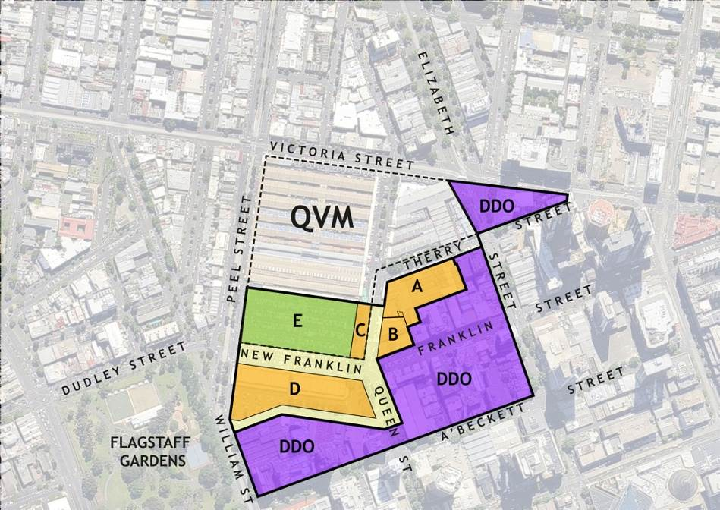
The image above shows the potential extent of a DPO including major development sites and key frontages with sensitivities related to QVM.
A. Munro Site
B. Other Queen Street and Franklin Street properties
C. Queens Corner building
D. Franklin Street site
E. Proposed open space
Built form controls for areas beyond this would appropriately be addressed through a DDO.
Figure 58: Recommended built form in the QVM area
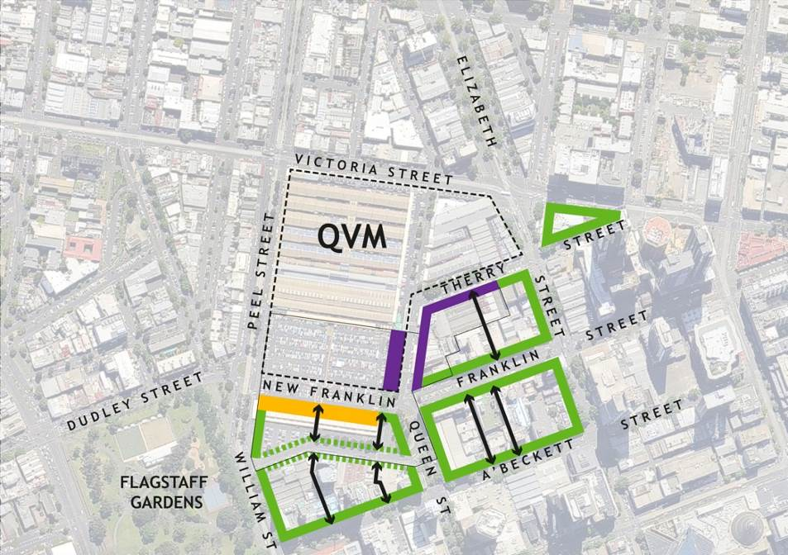
The diagram above shows the recommended built form in the QVM area. Unless wind mitigation or heritage conservation requires otherwise, heights should be:
○ Purple indicates heights should be 10m min./20m max. at the street frontage along Therry and Queen Streets adjoining QVM, with any greater height set back at least 10m; also 10m min./20m max. for whole of the proposed Queens Corner building.
○ Green indicates heights should be 20m min./40m max. at the street frontage, with any greater height set back at least 10m from 30m wide streets and at least 6m from former alignment of Franklin Street.
○ Yellow indicates heights should be Retain existing Franklin Street stores building. New buildings of greater height may cantilever over the rear half of the existing buildings but must be set back at least 10m behind the northern masonry facade.
Public mid-block pedestrian links should be created or maintained at or near the locations indicated.

Elizabeth Street west side

Figure 59:
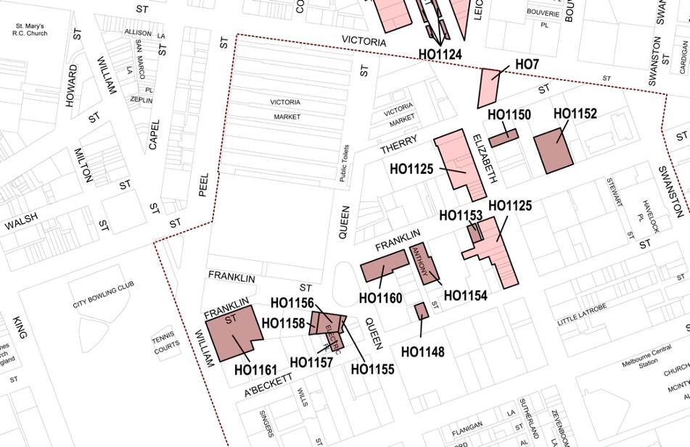
Proposed Heritage Overlays to the southeast of QVM as per Amendment C198, including HO1125, which applies to the strip along the west side of Elizabeth Street.

Zoning
QVM now falls within the Capital City Zone (CCZ1). This a widely inclusive zone, allowing for diverse land uses including open spaces, public institutions etc. that are often separately zoned in other contexts, e.g. through application of the Public Park and Recreation Zone (PPRZ), Public Use Zone (PUZ), or Special Use Zone (SUZ). However, there are some key spaces within the Hoddle Grid that are specially zoned, including the City Square.
The application of the CCZ1 to the Market is therefore not improper, but it does not express the City of Melbourne’s stated priorities in relation to maintaining the long term continuity of QVM’s operation as a public market and major civic place.
It may therefore be appropriate to consider rezoning QVM as a Public Use Zone.
It may also be appropriate to consider application of the Public Park and Recreation Zone to the proposed open space on the site of the QVM car park.
Figure 60: Extent of the CCZ, including extension into City North under Amendment C196 City North
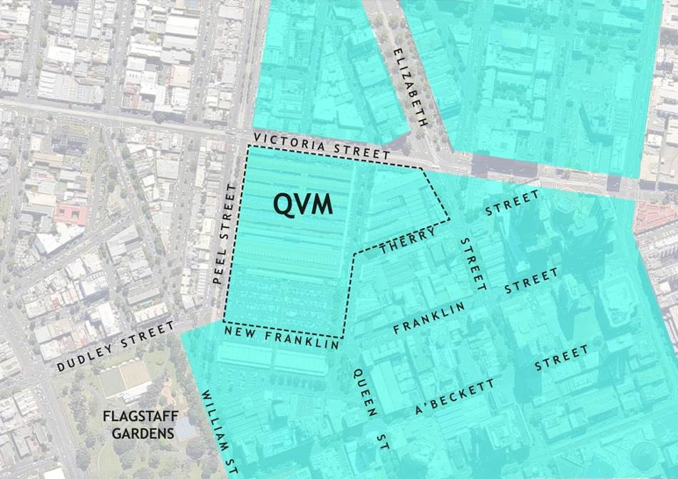
Figure 61: Potential rezoning to place QVM in a Public Use Zone, and the proposed open space in a Public Park and Recreation Zone
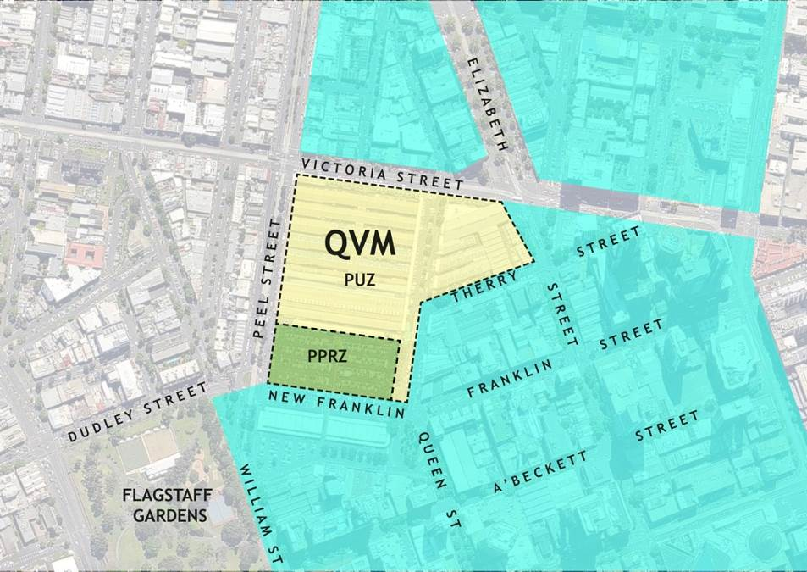

Appendix: Typical Hoddle Grid built form

Street-oriented development
A development pattern with buildings lining streets, extending across the width of each property with no front setback and collectively creating a ‘street wall’, is characteristic of central Melbourne and of many cities around the world. This pattern is desirable:
- It supports interaction between passing pedestrian traffic and activity within buildings, and is important to the viability of many retail operations.
- It contributes to the ‘activation’ of the public realm, with frontages that generate activity in the street and add interest for passers-by.
- It contributes to personal safety by encouraging ‘passive surveillance’ or ‘eyes on the street’, including people using the street and in adjoining buildings.
- It provides a degree of shelter to pedestrians, even more-so when verandahs, awnings, colonnades or arcades are incorporated into the facades.
- It defines street spaces as linear corridors that are easy to follow through what could otherwise be chaotic jumbles of buildings, supporting way-finding
There is an extensive body of professional literature arguing the importance of these benefits. They are also promoted by the Victorian Urban Design Charter.
The basic pattern of street-oriented development varies, depending on location within an urban area. The simplest arrangement described above is typical of central retail, commercial and mixed use areas. Residential neighbourhoods are often characterised by small front setbacks, which limit interaction between people in streets and in buildings to a visual basis (which is controllable by the building occupants) rather than inviting entry and trade.
These variations respond to building uses and street functions. They are not arbitrary styles. Throughout inner Melbourne, there are examples of formerly residential buildings that have been absorbed into expanding retail precincts, where this front setback has been built over to create a retail frontage at the street boundary.

Traditional, modernist and contemporary approaches
Before the development of modern construction technologies, it was common for the full height of city buildings to rise in a wall directly at the street edge. Upper level setbacks were mandated in very few cities, most notably 19th century Paris due to its unusually dense development combined with a legacy of very narrow medieval streets, and in New York after 1916 as skyscrapers began to turn its streets into shady wind tunnels. In Melbourne, because of the lower building scale and wider streets, it is most common to see the tallest parts of 19th and early 20th century buildings directly abutting streets, while lower parts are at the rear.
Modern high rise construction technologies freed builders from the economic imperatives of building boundary to boundary. Some architects took this freedom as an aim in itself, with a Modernist approach epitomised by Corbusier’s proclamation of the ‘death of the street’ and a preference for detached towers that can be seen as individual objects in an open landscape. This was fashionable particularly in the decades after WWII. The clearest Melbourne examples are the high rise Housing Commission flats in various inner suburbs.
Repudiation of this Modernist approach was marked by Jane Jacobs’s publication of The Death and Life of Great American Cities in 1961. Jacobs inspired the recovery of an appreciation of the social value of streets and street activity, but a variety of people contributed to the understanding that while buildings cause positive and negative impacts on the public realm, the Modernist approach was eliminating the positive impacts while leaving the problems – of wind turbulence, and so on. One result of this is the contemporary preference for development with towers rising from a ‘podium’. The podium provides traditional street-oriented development, while any high-rise towers rising above this are set back to reduce their impacts.
If the buildings in an area collectively create a high quality street wall, the height, form and character of towers above this level are relatively unimportant to the quality of the public space in the street. However this priority for a focus on the street wall or podium of buildings does not make it the only concern:
- It is not true that overall heights and the built form above podium level have no impact on the public realm or on other properties – they cause overshadowing, block access to sunlight, block views, overlook other buildings, and so on.
- The relationship between the podium and tower is critical to the effectiveness of the podium. Low podia are not effective with tall towers, and small setbacks can also make a podium ineffective.
For a podium and tower development to provide the desirable effects of a street wall, a number of factors need to work in combination, including:
- Activation of the frontage through the location of building uses facing onto, and to varying degrees exposed to, the street.
The height of the building at the street frontage, and its proportion to the height of the tower and setbacks of the tower.

Podiums and streetscape activation

Ground level building alignments
A fundamental requirement for an activated building frontage within a ‘street wall’ is the presence of buildings lining the street. Irregularities in the street wall – with unused gaps between buildings, facades set back from the street, alcoves and recesses – can be detrimental in reducing personal safety. They can reduce visibility, and create hiding spaces and entrapment risks. This issue is commonly raised in relation to crime prevention through urban design. Frontage inconsistencies also break down synergies in activation, with a consequent reduction of retail viability. Small isolated exceptions are not ruinous in their impact, but the collective impact of many gaps and setbacks in active frontages is.

Standards of frontage activation
Jan Gehl defines good active frontages as offering ‘two-way visual permeability at street level’ so that ‘activities occurring within these buildings add a sense of life and diversity to the streetscape’. Inactive facades ‘have a poor street interface due to poor or no visibility, such as tinted one-way glazing, windows raised above pedestrian level, solid walls or absence of ground floor occupation.’ In addition to the sense of interest that active frontages provide, there is conclusive evidence through international research of their benefit through provision of passive (or natural) surveillance of public spaces.
Provision of active frontages is frequently interpreted as requiring retail tenancies and the common architectural response is to expose these to the street with sheets of plate glass (which often as not are then covered with blinds or cluttered with some kind of advertising). This simplistic approach fails to recognise that activation can occur through a variety of uses; that activation is not a black and white or on/off quality; and that sheer transparency is not the most effective or interesting means of supporting exchange between building uses and street activities.
Five grades of frontage activation adapted from the work of Jan Gehl are set out in the English Partnerships’ Urban Design Compendium:
- Grade A frontage (the best):
More than 15 premises every 100m
More than 25 doors and windows every 100m
A large range of functions
No blind facades and few passive ones
Much depth and relief in the building surface
High quality materials and refined details
- Grade B frontage:
10 to 15 premises every 100m
More than 15 doors and windows every 100m
A moderate range of functions
A few blind or passive facades
Some depth and modelling in the building surface
Good quality materials and refined details
- Grade C frontage:
6 to 10 premises every 100m
Some range of functions
Less than half blind or passive facades
Very little depth and modelling in the building surface
Standard materials and few details
- Grade D frontage:
3 to 5 premises every 100m
Little or no range of functions
Predominantly blind or passive facades
Flat building surfaces
Few or no details
- Grade E frontage (the worst):
1 or 2 premises every 100m
No range of functions
Predominantly blind or passive facades
Flat building surfaces
No details and nothing to look at
Research has not been undertaken to test these standards in relation to conditions in Melbourne, and it may be the case that criteria such as ‘more than 25 doors and windows every 100m’ are reasonable and appropriate in Copenhagen or medieval European towns, but unreasonably ambitious for a modern city such as Melbourne. Nonetheless, the key principles in Gehl’s system that are relevant to Melbourne:
- Activation does not rely upon retail, but some kind of activity in the building is vital. Windows onto unused spaces (e.g. upper levels of multi-storey foyers) and artworks on a facades (e.g. Error: Reference source not foundFigure 64) may add visual interest for people in the street, but do not contribute to activation or passive surveillance.
- Variety along any length of street (sometimes referred to as a ‘fine grain’), both in terms of use and visual character, contributes to the quality of the public realm.
- A wide spectrum of frontage activation should be considered and appropriate levels of activation should be promoted along every street and public space.
Frontage activation is desirable wherever possible, especially but not only in major pedestrian areas. The highest grades of frontage activation are appropriate along streets where pedestrian activity is most important. The lowest levels are appropriate only where there is absolutely no regard for pedestrians, and there are very few public streets (except freeways) in a central city context where this is the case. Grade A levels of activation are appropriate in major pedestrian areas, but grades B and C may be acceptable elsewhere. Grades D and E should only be allowed along freeways and new laneways created or designated for the sole purpose of vehicular access for loading bays, rubbish collection, etc. – and if possible in new development these would ideally be contained within properties and screened from public spaces by intervening buildings.
Figure 62: Apple store in Sydney, indicating the potential for building activities to contribute visibly to a streetscape
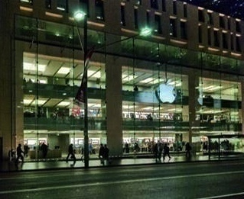
Figure 63: Former Georges store, Collins St.
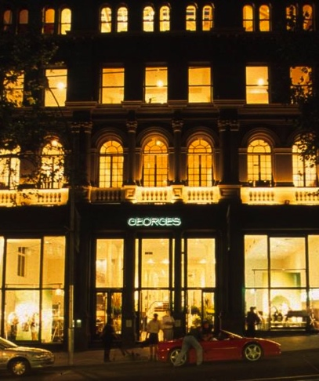
Figure 64: Screen on the Arkley Building, Docklands. This does not contribute to frontage activation. Art does not participate in social interchanges or ring the police in emergencies.
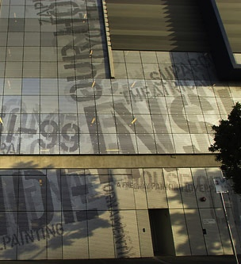

Podium heights

Balancing positive and negative impacts
The benefits of a traditional building pattern with street walls involve a balance of spatial, social and environmental qualities – the building walls that contain and define the space of the street; the activity and interaction between people in and around the street; and the sunlight, shade, shelter and other environmental factors that make the space physically comfortable or uncomfortable.
These qualities compete with one another. In particular, there is often a trade-off between environmental qualities (access to sunlight, etc.) and social qualities of a street. Where a space is rich in one, a deficiency in the other is most likely to be acceptable. For example, Degraves Street and Centre Place in Melbourne offer an intensely activated environment where there is an intimate relationship between street and shop spaces, a rich variety of retail activity and very high levels of social interaction, but they are deeply shaded through most of the day and the built environment is ‘gritty’ to say the least, with views into a mess of rubbish bins near the junction between Centre Place and Centreway Arcade. The social qualities of the space are very high; the environmental qualities are low. Treasury Gardens, in contrast, provides a beautiful green, sunny space (weather permitting) with views to handsome buildings, but with virtually no animation from adjoining land uses. In theory, an ideal city space might feature the beauty and amenity of the Treasury Gardens and the rich social environment of Degraves Street, but in reality these qualities conflict with each other.
This balance is an important consideration for heights of a street wall or podium. Too high and the environmental qualities at street level suffer – with shading, wind turbulence, etc. Too low and the activation and passive surveillance from adjoining land uses are reduced, as is the visual containment of the street corridor and the potential for architectural enrichment. But what is too high, and what is too low? Various arguments are encountered in relation to this question, some of which are important, and others that should be disregarded.

Street proportions
There is no such thing as an ideal proportion between street width and height.
Acceptable proportions of street width to building height depend upon what people are accustomed to and the context of the street. The proportions of an attractive and pleasant street in Melbourne, such as the Spring Street end of Bourke Street, are radically different from those of an attractive street like the Via del Babuino in Rome. ‘Tall’ buildings in Geelong are not as high as ‘tall’ buildings in Chicago, although Geelong streets of are generally wider than Chicago’s.
Acceptable proportions also vary within a given locale. 19th and early 20th century buildings of similar heights lined Flinders Lane and Collins Street, one 10m wide the other 30m, but this is not seen as a problem. The variable proportions are actually valued as an expression of a hierarchy of major and minor spaces.

Architectural and spatial character
Podium type development that creates a wall of buildings along the street defines streets as architectural spaces, and collectively contributes to the city’s character. The most important building parts in this regard are the lower floors, but while the ground is most important for activation, and detail at this level is critical for pedestrians’ interest, it is problematic with respect to creating a high quality architectural effect for a building as a whole, especially with retail uses. Shop displays and signs often create clutter that overwhelms the ‘architecture’ of a city building at ground level, so the key part of the facade in a formal architectural sense is often from first floor upwards. The ground floor may not even relate clearly to upper levels. There is nothing wrong with this. The problem is in one-storey retail areas where all you see is clutter. In two storey retail strips the ‘architecture’ still only makes up half the scene. This is one reason many suburban shopping strips are so unattractive; a higher podium provides an architectural framework that can hold its own against the clutter of a retail ground level.
To what height architectural character matters is arguable. Visibility of architectural detail at heights is a red herring; tall towers can contribute interest to a streetscape if their design detail is appropriately composed for greater viewing distances. The issue is the proportion between the cluttered ground floor and the rest of the podium; it is desirable for the podium levels above ground level to predominate. That can be achieved in a three storey podium, so three storeys could be argued as a minimum podium height from this perspective, and a taller podium encouraged. As with frontage activation, the benefits of architectural character reduce with height while environmental problems increase – wind, shadowing – although there is no precise cut-off where the balance tilts from positive to negative.
Figure 65: Melbourne Terrace, corner Franklin and Queen Streets
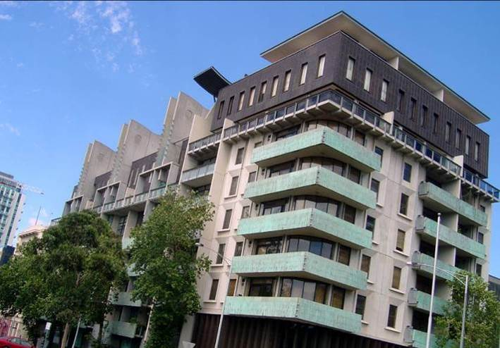
Figure 66: RMIT, Swanston Street frontage
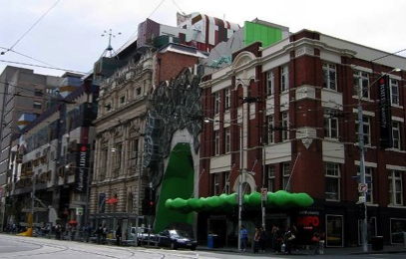

Support for activation and passive surveillance
Maximisation of pedestrian activity in the street, and support for passive surveillance are important objectives of frontage activation. The ground level of buildings is the primary concern here as it offers opportunities for physical access and interchange, as well as line-of-sight visual links. However, building levels above ground floor can make important contributions. Activity in the street (licit and illicit) can be seen from inside buildings. Activities (and signs of activity) in buildings can be seen from the street. There is an actual possibility of speaking, gesturing, waving etc. between people in street and building spaces, even above ground levels (while privacy within a building is easily controlled when elevated only slightly above street level, simply by stepping back from the window).
This interchange reduces with height. A person on the second floor can converse with a person in the street. Above five or six storeys only a visual connection is feasible, so beyond 20m social factors become relatively unimportant (but not irrelevant). Balconies are also unusable at very high levels, and this also reduces the frequency when people in buildings are exposed to people in the street. At much higher levels, a building’s positive contribution to activation and passive surveillance of a street is minimal, while negative impacts of overshadowing and wind turbulence increase, outweighing any small added benefit. There is no precise cut-off where benefits begin to be outweighed by disadvantages, but within an approximate 20 metre height range, Jan Gehl’s research indicates that the balance is positive. Examples in Melbourne and elsewhere (e.g. see Figure 67) indicate that buildings up to 30 metres are still within the beneficial range.
Figure 67: Tietgen dormitory, Denmark, showing a strong relationship between a public space and a seven-level building
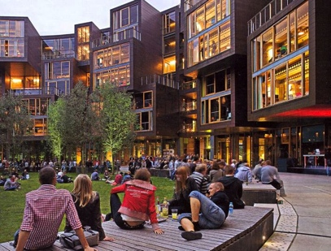
This is a strong argument for a minimum podium height. It is not a matter of taste, or local custom, which in an area of major change like Southbank would be an inappropriate constraint. It concerns the use, vitality and safety of public spaces.

Relation to tower heights
Part of the function of the podium is to mitigate impacts of towers. If the proportion of a podium to a tower is too small, the tower will dominate. In an urban area dominated by high rise development, this is an important reason for setting minimum podium heights and for these to be relatively high.
Matched parapet heights along a streetscape are not necessarily desirable with regard to the street wall itself. Substantial variation in parapet height is an obvious characteristic of some of the most attractive streetscape scenes in Melbourne, both existing and historical (e.g. see Figure 68), and in the central city as well as in many suburban activity centres. It provides variety and interest that counterbalances the potential monotony of straight, gridded streets.
However, a reasonably consistent approach within an area is necessary for podia to be effective in mitigating the visual impacts of the towers. Most people do not stand and look at buildings from a point on the opposite side of the street. More typical views are at oblique angles along a street. Generally, this means that the podium of a nearby building is mitigating the impact of the towers of buildings further along the street, and vice versa when seen from the opposite direction. Buildings are seen collectively as part of the city, not as independent objects.
Figure 68: Collins St, ca 1900 [Nicholas Caire. National Library of Australia]
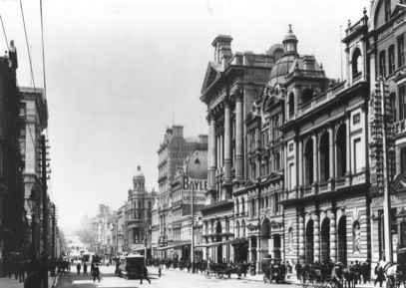

Overshadowing
As with the issue of street proportions, the degree of overshadowing that is acceptable in streets largely depends on local custom and expectations. The prevalence of 30 metre buildings in Melbourne’s retail core establishes a benchmark beyond which the negative impacts of overshadowing may be seen to become unacceptable. While this is a subjective measure, it is an obvious local standard to refer to as a precedent when determining controls.
Shade from buildings can also be a problem for street trees, which are widely regarded as very important to support the amenity of public spaces. The City of Melbourne Urban Forest Strategy aims to dramatically increase the number of trees throughout the City. As with all other factors relating to building and podium height, there is no definite threshold at which this becomes, or ceases to be, a problem. However, poor tree health due to shading is significantly more noticeable in the east and west ends of Melbourne’s CBD, where there are numerous tower developments, than it is in the retail core.

Typical central Melbourne podium requirements
In summary, the rationale for podium heights suggests that:
- The extreme limit of acceptability for a minimum podium height is three full storeys, below which a podium would be ineffectual.
- The aim to support activation and passive surveillance of street spaces means that buildings of at least five storeys and up to a 20 metre height are desirable for streetscape activation, as spaces in building up to this height can have a good relationship with a street space.
- Taller buildings detract from the streetscape through overshadowing, etc. to a greater degree than they contribute through activation; the 30 metre buildings in Melbourne’s CBD establish a reasonable local benchmark for an acceptable height, beyond which detrimental impacts are likely to be reasonably regarded as inappropriately outweighing beneficial impacts.

Places for People: Melbourne 2004. City of Melbourne with Gehl Architects, p 20.
The Value of Urban Design: The Economic, Environmental and Social Benefits of Urban Design. New Zealand Ministry for the Environment, 2005.
Heritage Victoria, Victorian Heritage Database Report, Queen Victoria Market, report generated 20 Dec 2014. Allom Lovell & Associates, Queen Victoria Market, Elizabeth Street, Melbourne: Conservation Management Plan, April 2003. RBA Architects and Conservation Consultants, City North Heritage Review, Volume 3: Melbourne, January 2014.
Jan Gehl, Life Between Buildings: Using Public Spaces, New York, Van Nostrand Reinhold, 1987, p. 100.
One of the clearest digests of this literature is ‘The Value of Urban Design: The Economic, Environmental and Social Benefits of Urban Design’, prepared for the NZ Ministry for the Environment, 2005 and which aims to substantiate claimed values of urban design, both in general terms and in relation to specific elements that are regarded as central to good urban design.
Places for People: Melbourne 2004. City of Melbourne with Gehl Architects, p 20.
The Value Of Urban Design: The Economic, Environmental and Social Benefits of Urban Design. New Zealand Ministry for the Environment, 2005.
Urban Design Compendium. English Partnerships with The Housing Corporation, accessed at www.scribd.com/doc/27230122/ URBAN-DESIGN-COMPENDIUM-1-MANUAL
Jan Gehl, Life Between Buildings: Using Public Spaces, trans. Jo Koch (New York, Van Nostrand Reinhold, 1987) p. 100.

