22.02 SUNLIGHT TO PUBLIC SPACES
15/10/2015

Proposed C245

This policy applies to public spaces such as parks and gardens, squares, streets and lanes, and includes privately owned spaces accessible to the public, such as building forecourts, atria and plazas within the municipality excluding the Docklands Zone.
Policy Basis
The State Planning Policy Framework sets out objectives for a high quality public realm. Similarly, the Municipal Strategic Statement sets out objectives for public realm quality. A fundamental feature of Melbourne’s character, livability, comfort and attractiveness is its ability to offer sunlight to its streets and public spaces at the times of the year when the intensity of pedestrian activity is highest.
Objectives
- To ensure new buildings and works allow good sun penetration to public spaces.
- To ensure that overshadowing from new buildings or works does not result in significant loss of sunlight and diminish the enjoyment of public spaces for pedestrians.
- To achieve a comfortable and enjoyable street environment for pedestrians.
- To protect and where possible increase the level of sunlight to public spaces during the times of the year when the intensity of use is at its highest.
Policy
It is policy that development proposals are assessed against the following standards:
General
- Development should not reduce the amenity of public spaces by casting any additional shadows on public parks and gardens, public squares, major pedestrian routes including streets and lanes (including all streets within the retail core of the Capital City Zone), and privately owned plazas accessible to the public between 11.00 am and 2.00 pm on 22 September.
Yarra River Corridor
- Development in the Capital City Zone and Docklands Zone must not cast:
- a shadow across the south bank of the Yarra River between 11.00 am and 2.00 pm on 22 June.
- any additional shadow across the north bank of the Yarra River (15 metres north from its edge) between 11.00 am and 2.00 pm from 22 March to 22 September.
Federation Square, City Square, Queensbridge Square, State Library Forecourt, Parliament House Steps and Forecourt, Shrine of Remembrance, Flagstaff Gardens
- Development must not cast any additional shadows across St Paul’s Square, the Plaza and the Atrium which are part of Federation Square, any open space of City Square, Queensbridge Square or the State Library forecourt, between 11.00 am and 2.00 pm from 22 March to 22 September.Development must not cast any additional shadows across the Parliament House steps and ‘forecourt’, between 11.00 am and 4.00 pm on 22 September.
- Development must not cast any additional shadow across the Shrine of Remembrance and its northern forecourt between 11.00 am and 4.00 pm on 22 September.

- New development should not cast any additional shadow across Flagstaff Gardens between 11am and 2pm on 21 June.

Definitions for the Purpose of this Policy
The south bank is the north edge of the existing physical boundary bordering the south side of the river.
The north bank is the south edge of the existing physical boundary bordering the north side of the river.
The Parliament House steps and forecourt is the area shown at Figure 1.
The Shrine of Remembrance and its northern forecourt is the area shown at Figure 2.

Figure 1: Parliament House Steps and Forecourt
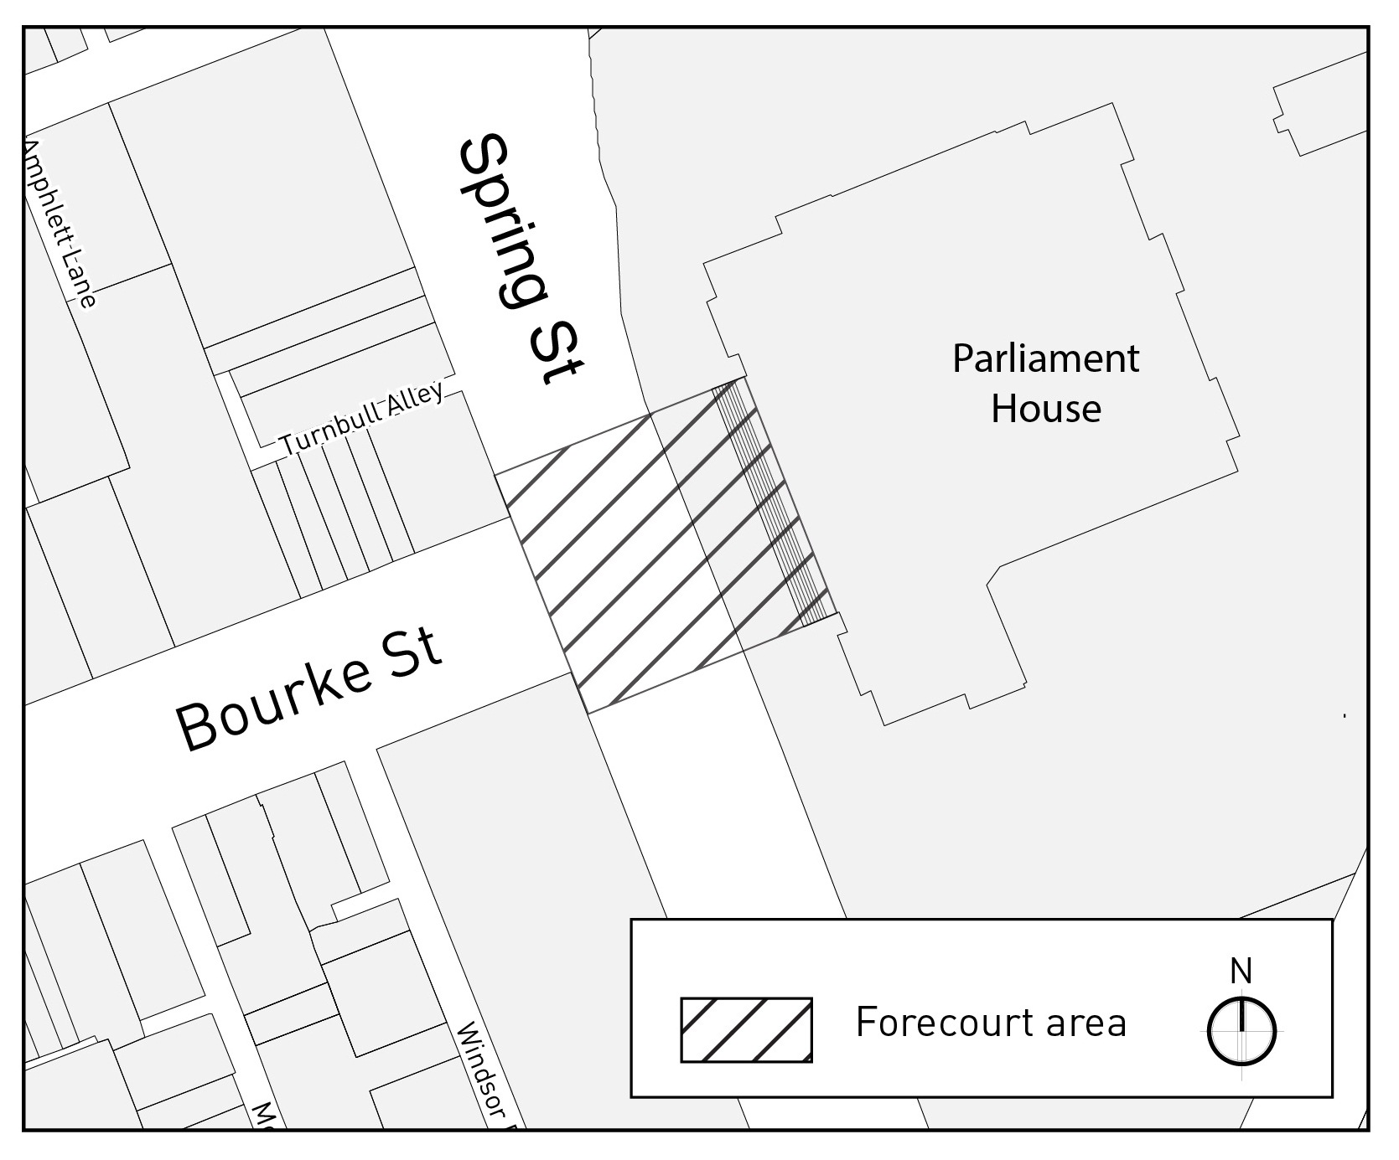
Figure 2: Shrine of Remembrance and its northern forecourt
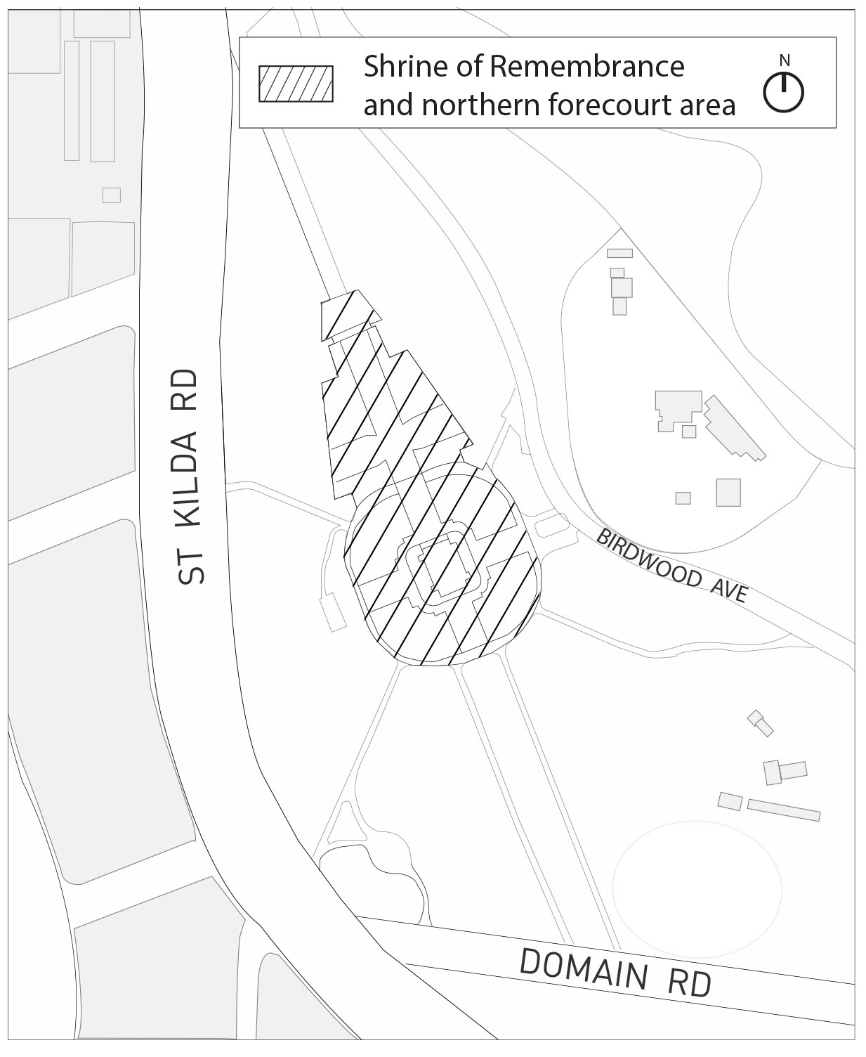

Policy Reference
Places for People (1994)
Bourke Hill Heritage, Planning and Urban Design Review, Department of Transport, Planning and Local Infrastructure, September 2014

