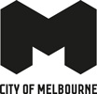
Skate Melbourne Framework
Background Paper 2016

Contents
Introduction and context 4
Why does skate activity need a framework? 4
Benefits of skate activity 6
Skate and the City of Melbourne 8
Skater demographics in the City of Melbourne 9
Styles of skateboarding 10
Reasons for skating 11
Different types of spaces for skating 12
Skating in the public realm 12
Skating in a designated skate park or facility 14
Activity management methods in capital cities and public spaces 16
For more information on skate 18
Bibliography and references 18
Terms 19
Appendix 20
How to contact us 23

Disclaimer
This report is provided for information and it does not purport to be complete. While care has been taken to ensure the content in the report is accurate, we cannot guarantee it is without flaw of any kind. There may be errors and omissions or it may not be wholly appropriate for your particular purposes. In addition, the publication is a snapshot in time based on historic information which is liable to change. The City of Melbourne accepts no responsibility and disclaims all liability for any error, loss or other consequence which may arise from you relying on any information contained in this report.

Introduction and context
Melbourne is known within the local, national and international skateboarding community as a great place for skateboarding. As such, many people visit the city to skate in its designated skate parks, streets and other public spaces. Melbourne is home to some of the world’s top skate talent, skate brands, and has hosted skate world cup events in the past.
Skating is popular in Melbourne due to some of the following reasons:
- The central city is relatively flat with a lot of it’s hard surfaced areas being quite smooth
- Public Transport is very accessible with trains, trams and buses operating regularly in the central city
- Melbourne is known for its skating talent and culture, many world skate champions have come from Melbourne as have many skate brands and events
- Melbourne is known for its street culture, street art, street performers, laneways and being a very walkable and people oriented city
Skateboarding, and other wheeled activities (BMX, scooter riding, in-line skating) have some of the highest youth participation rates in Victoria, and Australia, significantly outnumbering other organised sports (ABS, 2012). Skateboarding has been growing as a popular form of recreation since the 1960s and is regarded as one key way of keeping young people engaged in active recreation. For some skaters it is more than just recreation, it can also be considered a sport, a career, a lifestyle and a form of self-expression or art.

Why does skate activity need a framework?
There are challenges associated with skate activity in public spaces, so the City of Melbourne is working to develop a Skate Framework to guide the provision, location and management of skating in the city.
Skating can contribute to the goal of making Melbourne ‘accessible, inclusive, safe and engaging. Our streets, buildings and open spaces will be alive with activity. People of all ages and abilities will feel secure and empowered, to freely participate in their community and lead healthy lives’ - Melbourne for All People, 2013
This background paper outlines some of the context, elements and culture of skate in order, to inform discussions about skating in the city.
‘Skateboarding is a lifestyle sport experiencing a rapid surge in popularity... Skateboard fashion and skateboard equipment are large and fast-growing industries.’ - CSIRO, 2013, The Future of Australian Sport

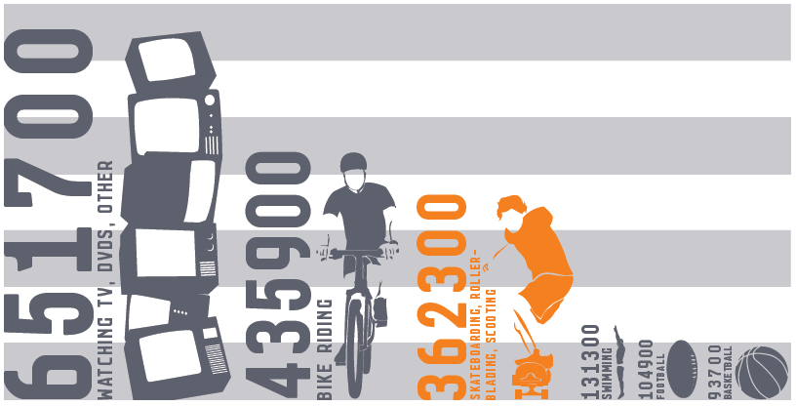
Victorian Children’s (aged 5-14) Participation in recreational, cultural and leisure activities. Australian Bureau of Statistics, Table 21, Children’s Participation in Cultural and Leisure Activities, Australia, 2012 – Victoria – 2012.
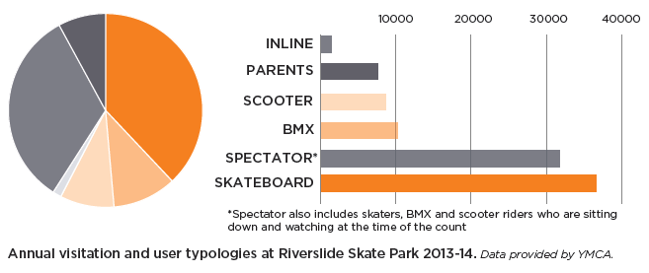
Annual visitation and user typologies at Riverslide Skate Park 2013-14. Data provided by YMCA.

Benefits of skate activity
Skateboarding can have a positive impact on social connectedness, mental and physical health and general wellbeing. Skateboarding also fosters values of personal freedom, self-expression and cooperation (Bradley, G.L. 2010).
Skateboarding is a flexible and accessible form of recreation, it is relatively cheap to participate in, and as such some people regard it as a part of their lifestyle. For cities, it can be easier and cheaper to provide facilities for unstructured recreational pursuits such as skating, compared to organised sports that require clubs, designated times, and significantly sized spaces or facilities (Kellett, P. Russell, R. 2009).
Skateboarding can provide vibrancy in a city and create a positive impact on the economy and tourism through skate provision and events (Weinstein, R. et al, 2010, pp. 7-8). By providing safe, inclusive and suitable spaces for skateboarding, research has shown these spaces can make surrounding areas safer and reduce criminal behaviour (Woolley, H. et al. 2010, p. 227).
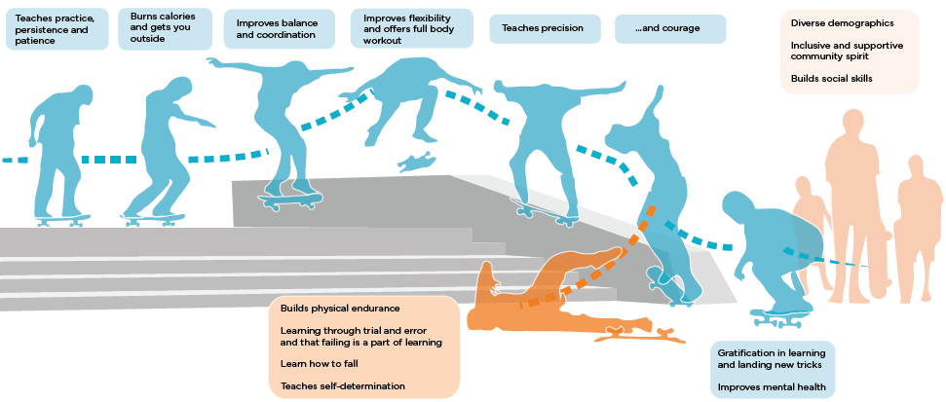
An infographic displaying the different benefits to individuals participating in skate activity.
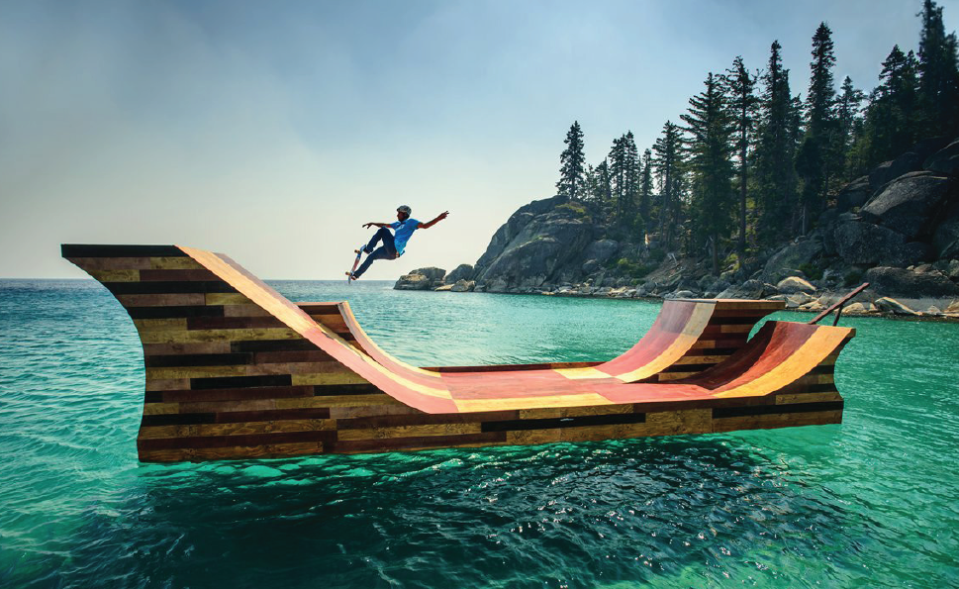
This floating skate ramp in Lake Tahoe, California, USA was designed by pro skater Bob Burnquist and art director Jerry Blohm for a Californian tourism campaign, which aimed to inspire big thinking. It also recognised and raised the profile of skate in California. Photo provided by Visit California and 9MPhoto.

Skate and the City of Melbourne
The City of Melbourne has two formal skate parks that were built in 2001 and 2000, Riverslide Skate Park in Alexandra Gardens and South Kensington Skate Park in JJ Holland Reserve, providing a total of approximately 2400m2 of skate-able space. Riverslide has 100,000 annual visits and hosts regular events and programs. At peak times these parks can be heavily used, and as a result of this and other reasons, skaters sometimes seek out other close-by public spaces to skate within and around the central city.
The City of Melbourne has been addressing the management challenges of street skateboarding in the city since 1996 (see Appendix Figure 1) and currently provides a peer support program called the Skate Safe Ambassador Program to help avoid conflict on our streets and in our public spaces.
While skateboarding does contribute to the vibrancy and activity of the city, it isn’t suitable for all public spaces through the city. Through the Activities Local Law 2009, City of Melbourne does prohibit skateboarding for various reasons in 4 locations across the city; Lincoln Square in Carlton, Waterview Walk in the Docklands, State Library in central Melbourne, and Burston Reserve in East Melbourne. There is no formal framework for the provision of informal street style skating within the municipality, nor any private skate parks which cater to it.
For more information on skating in the City of Melbourne please visit: melbourne.vic.gov.au/skating
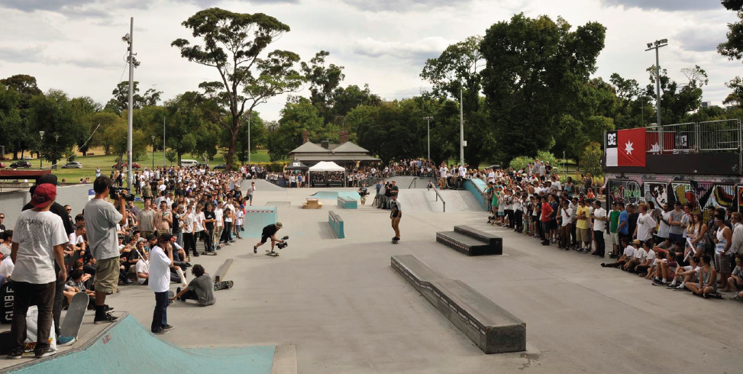
Riverslide Skate Park being utilised for a large skate event. Photo supplied by YMCA.
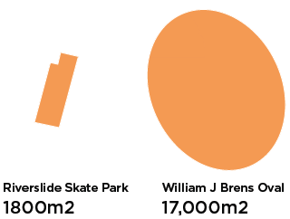
A comparison between the amount of space required for a skate park and a sports oval.
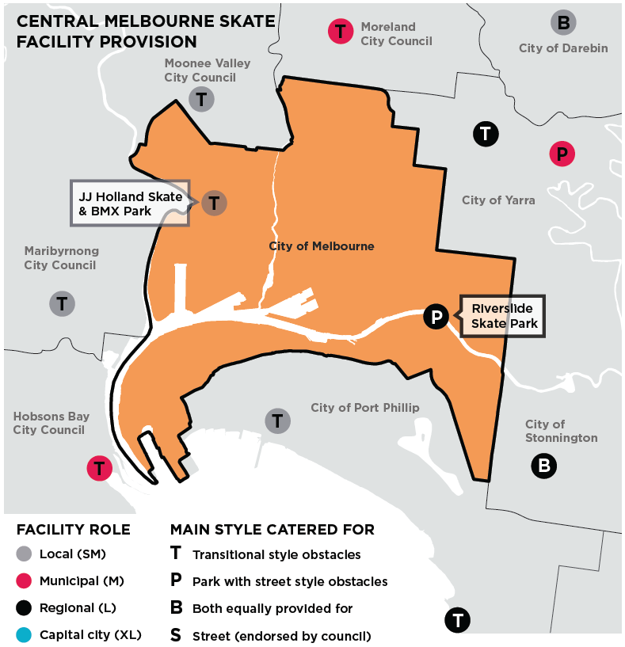
A map of the current central city council provisions of skate facilities
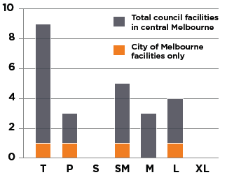
A graph comparing the current central city council provisions of skate facilities and the City of Melbourne’s

Skater demographics in the City of Melbourne
Melbourne has a high proportion of young people, people aged 15 to 29 years make up the largest proportion of the residential population in the municipality, at over 40 percent (Melbourne For All People, 2013). Skating also attracts a large proportion of young people.
A survey of 324 skaters conducted by the City of Melbourne and YMCA in September 2015 (see extra content Skate Survey Data 2015) indicated a few things:
- 60% of skaters were under the age of 18, and 85% were under the age of 25, which aligns with City of Melbourne’s largest proportion of the residential population. This also means spaces provided by City of Melbourne for skateboarding need to be safe, engaging and inclusive for youth and young adults
- Skateboarding is currently a male dominated sport with 95% surveyed being male, which indicates more could be done to increase gender equity
- 95% of skaters either worked or studied which means skateboarding predominantly takes place in the individual’s leisure time
- 80% identified as both street and park style skaters
- Street style locations are a drawcard for skaters in Melbourne with 80% favouring informal ‘street style’ locations

Styles of skateboarding
There are four main styles of skateboarding and many others; many skaters also enjoy participating in a number of these styles.

Street skating
Street skaters prefer to use hard surfaced public spaces rather than designated skate parks. Flat, smooth plazas and forecourts are key areas to use for ‘sessioning’ at particular spots for an hour or more and they enjoy being around other skaters and city users. Street skaters enjoy the journey and exploration of the city, skating from spot to spot and will sometimes modify spaces by moving or bringing in obstacles.
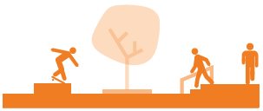

Park skating
Park skaters use skate parks and obstacles, which are common in typical skate parks. Skate Parks are typically family friendly environments for all ages and skill levels and often accommodate other wheeled activities.

Transitional (or vert or bowl)
Transitional skaters prefer ramps, bowls and surfaces with a curve. This style evolved from skaters utilising empty swimming pools in the 1970s.

Cruiser skating or longboarding
Cruiser Skaters utilise large, sloped roads and pathways to cruise around, usually on longboards. This style is popular for all ages and often used as a means of transport.
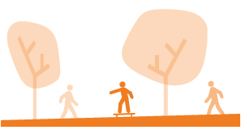

Reasons for skating

Fun and social
- It is fun and accessible (no memberships or set times required)
- It has positive impacts on social connectedness and developing social skills
- Great for stress relief and mental health
- It is a physical activity that builds flexibility, strength and resilience
- It is challenging and task oriented

Travel and accessibility
- Cheap and easy way to get places quicker
- Easy to carry around with you (compared with taking a bike on public transport)
- Considered a sustainable form of transport

Culture and creativity
- Many see skating as an art form and a form of self-expression
- Generates a feeling of personal freedom and self determination
- Cooperation is valued and nurtured in skate culture
- Skating can be used as a platform for other creative skills e.g. film, photography, fashion and design

Sport and career
- Some enjoy skateboarding for the challenge and healthy competition
- Skateboarding is highlighted to become an Olympic Sport
- Pro-skateboarders can be highly paid
- Sponsorships can provide income for youth or mature skaters alike
- Skaters can move into managing, promoting and marketing their own skating businesses

Different types of spaces for skating
Designing for skate in a city will need to include many different components, such as the following.
For more detail on these spaces and facilities see Appendix Figure 2.

Skating in the public realm

Street skate element
Permanent small and robust pieces of infrastructure and street furniture that seamlessly fit into the aesthetic of the surrounding urban design. They’re designed to withstand and accommodate skating.

Street skate spot
Skate-able areas in public spaces with sufficient room to hang out and do a variety of tricks, all users in the area share the space for different uses and activities.
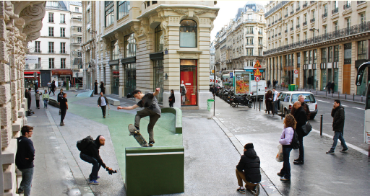
Rue Leon Claden, in Melun, Paris is an example of a skate spot being seamlessly integrated into the central city. The design took advantage of repurposing an underutilised street and still manages to allow for pedestrian and emergency or service vehicle access. Photo supplied by project architects Constructo Skatepark Architecture.

Street skate plaza
Usually quite large in size and the surfaces are relatively flat. Skate Plazas are located in the urban environment, not parks. These spaces are easily read by skaters, and provide plenty of different trick options for different ages and skill levels.

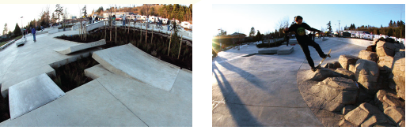
Ed Benedict Skate Plaza in Portland, OR, USA is one of 9-16 skate facilities to be rolled out for City of Portland’s Skatepark System Plan developed in 2008. This skate plaza was designed collaboratively with local skaters and artists. Besides providing an aesthetically pleasing skate-able space, the final design also enhanced biodiversity, ecology and storm water management in the area. Photos by Brooke Geery.

Street skate links (or trails)
A series of skate-able elements placed strategically through a particular route of the city.

Skate zoning
A broad area of public realm where skate and other active uses are endorsed activities.
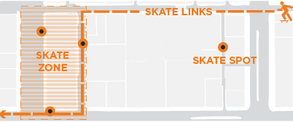
A draft concept diagram of how skate zones and/or skate links can better tie skate spaces together and enable skating in broader areas.

Skating in a designated skate park or facility

Transitional skate park
Parks specifically for transitional style skateboarding – including ramps, bowls and surfaces with a curve.
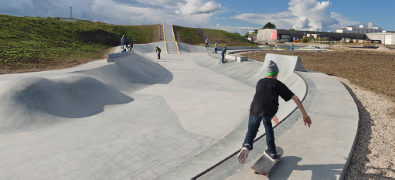
Rabalder Parken is a skate park in Roskilde, Denmark. The 40,000 m2 park is integrated with a water management system which can transport and hold up to 23,000 cubic metres of water. Photo provided by SNE Architects, photo taken by Rune Johansen.

Skate park
Skate Parks typically cater for all styles and skill levels in skateboarding, as well as BMX, Scooter and In-Line.

Temporary skate infrastructures
Modular and simple skate elements that can be moved relatively easily. Temporary Skate Parks can be formed with an assortment of elements like these and utilised for short demonstrations or events. Within permanent Skate Facilities temporary elements are utilised to help prevent the park becoming stale.

Indoor skate facility
Indoor Skate Facilities are usually built in warehouses or underutilised large buildings. These provide skating opportunities at all times in a safe environment. These facilities may also charge admission fees for specified session times to make sure there’s no case of overcrowding and to maintain the integrity of the facility itself.
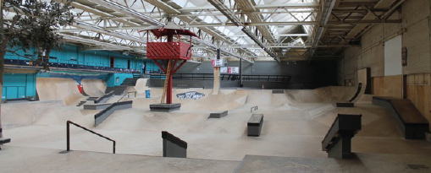
AreaFiftyOne is an indoor skate park in the Netherlands. Other than hosting a number of skate, BMX , in-line and scooter events it also functions as a live music venue, exhibition space and has a bar, store and cafe. Photo supplied by AreaFiftyOne skatepark.

Multi-purpose spaces
Spaces that provide for many different activities, skill levels and age groups. An example in Fremantle, Western Australia is the Esplanade Youth Plaza which caters for free running (or parkour), basketball, table tennis, skate, BMX, scoot, slack-lining, live performances and rock climbing.
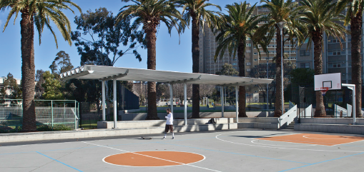
Neill Street Reserve is a multi-purpose open space designed by the City of Melbourne. The space above has had steel coping incorporated into the seating for the multi-purpose court in order to withstand and allow for skating activity that may happen.

Activity management methods in capital cities and public spaces
There are a variety of methods which are utilised by councils in relation to managing certain behaviours and activities in public spaces. These are sometimes used in isolation or multiple methods can be employed at once.

Building awareness through community outreach and campaigns
Certain behaviours or activities can be encouraged or discouraged through community groups, engagement, promotional campaigns and/or marketing within a community or space.

Local law
When awareness campaigns are not successful or behaviour does not change, and there is significant risk to other users and/or complaints, local law can be enacted by Council. Local Law prohibits or provides guidelines around specific behaviours and uses in a space, if these are not being met fines can be issued by enforcement officers.

Enforcement and signage
Enforcement via signage and officers is utilised in order to enforce local law and encourage or discourage certain behaviours and activities. These laws may be passed in relation to activities taking place in certain spaces and within certain timeframes.
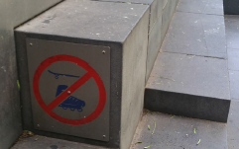

Physical design
When local law, enforcement and signage methods are ineffective or are impractical, due to cost or resources required, the physical design of a space can be modified to encourage or discourage certain uses. For skate activity, this can be an effective method. Examples of this being used to discourage skate activity can be seen in the city where ‘skate stoppers’ on street furniture, or rough surfaces have been incorporated into an area in order to discourage skate activity occurring.
Where skating is found to be suitable, more inclusive approaches are currently being trialled. Docklands Link and Neill Street Reserve are great examples of this, where smooth steel edging has been incorporated into the design of concrete benches to withstand and accommodate skate activity as a shared use.
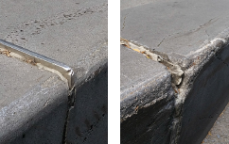
An example of physical design, in this case ‘skate stoppers’, discouraging skate activity in a space.
In this example we see how skate stoppers look when installed into existing infrastructure in order to prevent skate activity. The contrast image illustrates how these elements are often forcibly removed, which can damage the infrastructure. Re-installing these numerous times can become an expensive process.
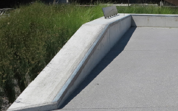
An example of physical design allowing for skate activity as a shared use, where found suitable.
Docklands Link is a recently completed project by the City of Melbourne. Much like Neill Street Reserve the seating and wall designs incorporates smooth steel edging which can withstand and allow for skate activity that may happen.
The site has minimal conflicting uses and activities adjacent and in the broader area, which makes it more suitable than other sites for skate activity.

For more information on skate
- Australian Bureau of Statistics 2012, ‘Table 21 Children’s Participation in Cultural and Leisure Activities, Australia, 2012 – Victoria’.
- Department of State and Regional Development, Sport and Recreation Victoria 2001, ‘The Skate Facility Guide (PDF 2 MB)’.
- CSIRO for the Australian Sports Commission 2013, ‘The Future of Australian sport - Megatrends shaping the sports sector over the coming decades (PDF 2 MB)’.
- Child in the City 2015, ‘Parks for Teens: 10 features teens want to see’.
- Domain, Jenny Brown 2016, ‘The secret to successful community infrastructure for teenagers’ .
- Skate Sculpture 2013, ‘Share Path Skate Path’.
- Skateistan Theory of change.
- Ben Kelly, Transworld Skateboarding 2011, ‘10 Best Cities to Skate in the World’.
- Morgan Campbell 2014, Kingpin Magazine – ‘The 25 Most Iconic Skate Plazas in the World’.
- City of Seattle 2007, ‘Citywide Skatepark Plan (PDF 2.5 MB)’.
- Portland Parks and Recreation ‘Skatepark System Plan 2008 (PDF 870 KB)’.
- City of Kingston Active Youth Spaces Strategy 2011.
- Vic Skate History – 1974-1986.
- Public skatepark development guide.
- City of Fremantle ‘Esplanade Youth Plaza’.
- Calgary Skateboarding Amenities Strategy 2011.
- City of Melbourne 2015, Council meeting 28 April, ‘Skateboarding in Lincoln Square (PDF 2.2 MB)’.
- City of Melbourne 2014, Future Melbourne Committee minutes 9 December, 'Skateboarding in Lincoln Square (PDF 3.2 MB)'.

Bibliography and references
Woolley, H. & Johns, R. 2010, Skateboarding: The City as a Playground.
Borden, I. 2001, Skateboarding, Space and the City.
Roy Weinstein, Jeremy DeGracia and Edna Lin 2010, ‘Economic Impact of the 2010 X Games 16 on Los Angeles County’.
Graham L. Bradley 2010, ‘Skate Parks as a Context for Adolescent Development’.
Walker, Tessa 2013 ‘Skateboarding as Transportation: Findings from an Exploratory Study’. Dissertations and Theses. Paper 1505.
Vanessa Roth Wiggin 2011, ‘To us these things are more: skateboarding and public art’.
Pamm Kellett, Roslyn Russell 2009, ‘A comparison between mainstream and action sport industries in Australia: A case study of the skateboarding cluster’.
Taylor, MF & Khan, U 2011 ‘Skate-Park Builds, Teenaphobia and the Adolescent Need for Hang-Out Spaces: The Social Utility and Functionality of Urban Skate Parks’, Journal of Urban Design, vol 16, no 4, pp. 489-510.
Jenson, A, Swords, J & Jeffries, M 2012, ‘The Accidental Youth Club: Skateboarding in Newcastle-Gateshead’, Journal of Urban Design, vol 17, no 3, pp. 371-388.
Dupont, T 2014, ‘From Core to Consumer: The Informal Hierarchy of the Skateboard Scene’, Journal of Contemporary Ethnography, vol 43, no 5, pp. 556-581.

Terms
Public space: Spaces that are managed by the council and intended for use by the public. This can include open spaces such as public parks, gardens, reserves, waterways, publicly owned forecourts, plazas and squares. It can also include laneways, streets and spaces under bridges.
Skater: Skater refers to anyone that rides a skateboard, longboard, penny skateboard or old school skateboard. A street skater refers specifically to those undertaking street style skateboarding.
Skate / skating: This term mainly focuses on skateboarding, however, scooter riding, BMX and inline skating can also be associated with the term ‘skate’ as they are also wheeled activities which can be used to slide and grind on surfaces across the city.

Appendix
Figure 1. What has been the City of Melbourne’s involvement with skateboarding to date?
The left column in the table below is a brief summary of how skateboarding has developed over the last 50 years in the USA and Australia and the right column lists what the City of Melbourne’s involvement in skateboarding has been over the same period.
Era | Skate Trends (USA and Australia) | City of Melbourne
1960s | Small planks of wood with wheels attached were used to roll around and perform manoeuvres in urban streets, drains and empty swimming pools. Skating was an ‘off season’ activity for surfers. | Small competition scene, not necessarily in City of Melbourne.  No dedicated facilities.
1970s | The first purpose built concrete bowls constructed in USA and Australia.  The USA influence on the overall approach and management of skating and the sub-culture is evident. | Skating in streets and drains throughout greater Melbourne has been documented.
1980s | In America, the provision of concrete skate parks declines due to issues of litigation and liability, street skating becomes more prevalent.  This era also features the rise of mega and modular wooden ramps, big competitions and major sponsorship. | ‘Flatlands’ (where Fed Square now stands) was a popular skate spot. St Kilda Road also had series of skate spots that were utilised and often linked together.
1990s | In the USA, skateboarding is recognised as a ‘Hazardous Recreational Activity’, and removes the previous litigation issues for skate park operators. Multi-style skate parks (private and public) with both vertical and street elements in the same facility were beginning to be built.  Australians (including ones from inner Melbourne) in the top 10 of global skate competitions. In Australia, Local councils build skate parks to cater for the growing interest in the activity. This new range of skate parks are designed by specialist providers, and a range of skating styles are catered for. | 1996 – The Sailyards Temporary Skate Park built on the site of the former Queen Victoria Hospital (Now QV shopping centre). This Park was run and supervised by the City of Melbourne.  1997 – The Skate Safe Ambassador Program launched. This peer support program employed young skaters to liaise and talk with other skaters to create a safe environment. This was an innovative development at the time.  1998 – The ‘Skatesafe’ Skate Management Plan for the City of Melbourne was endorsed by council. The objectives were to: Improve safety of pedestrians and skaters, decrease property damage, increase access opportunities and encourage people to use and enjoy the city.  This included six major and interconnected components: Provision of a venue, Code of Conduct, Designated Areas, Education and Awareness, Physical Measures, and Local Law.
2000s | In the USA, skater-designed skate parks and formulation of citywide skate strategies are new developments.  Skaters are early users of social media as a way of communicating skating skills, locations and culture via video. The concept of ‘iconic skate spots’ grows.  In Australia, the growth in skate parks continues.  Multi-purpose spaces also became become popular, that is, outdoor facilities where a number of youth focussed activities, dominated by skating, are co-located. (for example Geelong Foreshore youth space). | 2000 - JJ Holland Skate Park and BMX circuit in Kensington built.  2001 – With the construction of QV development and closure of the Sailyards, a temporary skate park is built in Alexandra Gardens (Riverslide Skate Park). A best practice skate park design at the time, the adjacent Gardener’s cottage was used to provide a base for the skate park staff, a small shop and café. This is still the only supervised skate park in the whole of Australia.  Other locations were investigated for a permanent skate park, including underneath the Flinders St viaducts across from Market Street, however nothing came to fruition.  Night sessions introduced at Riverslide.  Lincoln Square Plaza rebuilt
2010s | In the USA (and Europe) a new development in some cities is to endorse particular spots within the City for street style skating.  In other cities there is a zero tolerance approach and spots are closed down. | 2009 – Amendments are made under the Activities Local Law to specifically prohibit skate activity in four locations in the City of Melbourne-Lincoln Square, Waterview Walk, Docklands, State Library forecourt and Burston Reserve.  A Feasibility Study for a Skate Park in Docklands commenced, but the project never advanced beyond the investigation stage.  A change in Planning Scheme rules removed the provision which had dictated that the Riverslide facility be classified as temporary, allowing the location and facility to be come by default, a permanent facility.
2013 - - 2015 | In various parts of the world Skate Parks/spaces are now being integrated with other uses, including flood mitigation, youth hubs, performance spaces, art installations and exhibitions and events. | JJ Holland’s BMX track upgraded to more contemporary design  2014-15 – Council directs that Lincoln Square Plaza be re-designed to remove skate activity, requests the development of a Strategic Skate Framework and to investigate the feasibility of an internationally renowned skate park for Melbourne. Council also endorses the development of a temporary trial street style skate facility to cater for the displacement from Lincoln Square.

Figure 2. Skate facility typology matrix
The table below describes in more detail the different facilities described on pages 14-15. This table is to be used as a guide only. The figures presented have been based off other councils and projects from around the world. Size, active and inactive users represent the amount of space required for certain facilities and the amount of people these can then cater to. The cost section is a rough approximation only and costs will vary depending on project briefs for particular facilities. Time of interest represents how long these facilities usually interest skaters for and designated use refers to whether these spaces may be designated for skate activity as a primary or shared use.
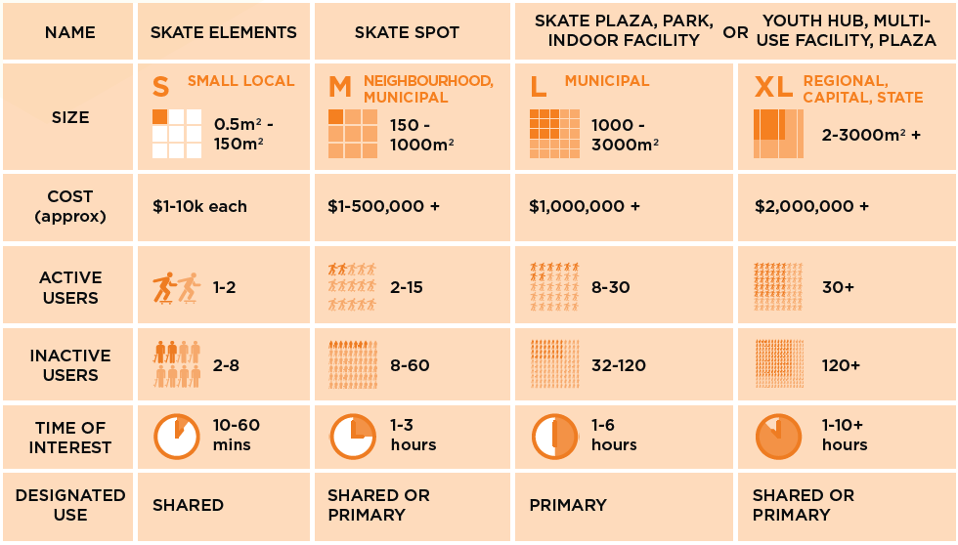

How to contact us
Online: melbourne.vic.gov.au
In person:
Melbourne Town Hall - Administration Building 120 Swanston Street, Melbourne
7.30am to 5pm, Monday to Friday (public holidays excluded)
Telephone: 03 9658 9658
7.30am to 6pm, Monday to Friday (public holidays excluded)
In writing:
City of Melbourne GPO Box 3603 Melbourne VIC 3001 Australia
Fax: 03 9654 4854
National Relay Service: If you are deaf, hearing impaired or speech-impaired, call us via the National Relay Service: Teletypewriter (TTY) users phone 1300 555 727 then ask for 03 9658 9658.
9am to 5pm, Monday to Friday (public holidays excluded)

http://www.abs.gov.au/AUSSTATS/abs@.nsf/DetailsPage/4901.0Apr%202012
http://www.dpcd.vic.gov.au/__data/assets/pdf_file/0019/134902/skatefacilityguide.pdf
CSIRO for the Australian Sports Commission, 2013, The Future of Australian sport - Megatrends shaping the sports sector over the coming decades
http://www.childinthecity.eu/2015/12/02/parks-for-teens-10-features-teens-want-to-see/
http://www.domain.com.au/news/the-secret-to-successful-community-infrastructure-for-teenagers-20160120-gm8efm/
https://vimeo.com/53518261
http://skateistan.org/theory-of-change
http://skateboarding.transworld.net/features/tws-10-best-cities-to-skate-in-the-world/#qPUFmD7YSoe660DZ.97
http://kingpinmag.com/features/20-legendary-skate-plazas-time.html
http://www.seattle.gov/parks/skateparks/CitywideSkateparkPlan.pdf
http://www.portlandoregon.gov/parks/article/202401
http://www.kingston.vic.gov.au/Home
http://www.vicskatehistory.com/
http://publicskateparkguide.org/
http://www.fremantle.wa.gov.au/youthplaza
http://www.calgary.ca/CSPS/Recreation/Pages/Skateparks/Skateboard-amenities-strategy.aspx
http://www.melbourne.vic.gov.au/about-council/committees-meetings/meeting-archive/pages/28april2015council.aspx
http://www.melbourne.vic.gov.au/about-council/committees-meetings/meeting-archive/MeetingAgendaItemAttachments/673/12035/AGENDA%20ITEM%206.5.pdf
http://www.melbourne.vic.gov.au/Pages/contact-us.aspx

