Discussion Paper
Preparing a Domain Parklands Master Plan
Community consultation Monday 4 July to Friday 12 August 2016
Contents
The Domain Parklands 3
Preparing a Master Plan for the Domain Parklands 4
Purpose of the discussion paper 4
Theme 1 Making one park of many 5
Theme 2 Landscape Character 6
Theme 3 Environmental Sustainability 9
Theme 4 Activities and access 11
Theme 5 Vehicles in the Park – traffic movement and parking 18
Theme 6 Cultural and historical significance 22
Conclusion and next steps 24

The Domain Parklands

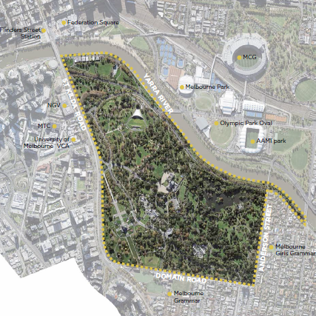

Figure 1 Aerial photo of Domain Parklands

The Domain Parklands are a treasured and important part of Melbourne. They have always played a major role in the life of Melbourne, as a place of recreation, civic function, respite and events. Before European settlement it was an area of great importance to Aboriginal people, a meeting place and a food source.

The City of Melbourne is preparing a new master plan for the Domain Parklands. The plan will guide the future development and management of the Domain Parklands over the next 20 years. Our aspiration is that this work will bring the individual parts of the park together to recognise the magnificent parklands as one Domain, while also celebrating the individual places within it.

The name Domain Parklands was first used in the 1997 Domain Parklands Master Plan and describes the collective parks and gardens known individually as Alexandra Gardens, Alexandra Park, Queen Victoria Gardens, Kings Domain, Sidney Myer Music Bowl, Royal Botanic Gardens, Shrine of Remembrance Reserve and Government House. The Domain Parklands are permanently reserved Crown Land.

The City of Melbourne does not manage all parts of the Domain Parklands, as the Royal Botanic Gardens, Shrine of Remembrance, Sidney Myer Music Bowl and Government House have separate governance and purposes. We are working with these organisations to develop the Domain Parklands Master Plan. While the master plan will focus on the areas managed by the City of Melbourne, it will address the way the parkland relates to these places.

The Domain Parklands has 1.8 kilometres of Yarra River frontage. The connection to this unique and special landscape feature has important management and recreational considerations and presents opportunities for improvements into the future.

There is increasing recognition of the critical ecological and environmental service function of the Domain Parklands in helping cool the city and provide habitat. The landscape needs to be healthy and resilient to provide these services into the future and this will be a key focus of the master plan.

The master plan will also consider access to and within the Domain Parklands, its relationship with other major parks around the central city and changes to surrounding areas.

Preparing a Master Plan for the Domain Parklands

The parklands have changed and evolved over time. Some changes have been major, such as realigning the Yarra River. Some show how a place can evolve to community needs. An example of this is the tan track, which was used for horse riding, and is now primarily used for people walking and exercising.

The parklands have a relationship with surrounding areas including the Arts precinct, Southbank, the central city, Birrarung Marr and the sports precinct across the river. These areas are also changing and may influence the Domain Parklands.

City strategies and policy directions also evolve to prepare the City for future changes. Population growth and climate change are two significant challenges. Preparing the Master Plan allows us to apply contemporary policy direction, for example implementation of the Urban Forest Strategy 2012.

As we prepare the master plan we need to think about how these parklands can meet the needs of future generations.

The following themes identify some of the key opportunities that will be explored through the development of the Master Plan.

Purpose of the discussion paper

This discussion paper will explore the issues and opportunities that have emerged in our research and initial consultation for the master plan. It has been divided into six themes and ideas for consideration:

making one park of many

landscape character

environmental sustainability

activities and access

vehicles in the park

cultural and historical significance.

This phase of engagement is the second of three opportunities for input to the development of the master plan for the Domain Parklands. Comments received in the first phase of engagement have informed the development of this discussion paper. Visit participate.melbourne.vic.gov.au for a summary of feedback received during phase one community engagement. [hyperlink to participate webpage – to be added]

Theme 1 Making one park of many

Principle: Adopt a shared vision for the Domain Parklands which recognises the distinct character and purpose of individual parts of the Domain while uniting them in one special place.
Objective: The Domain Parklands will have an even more important role in the future as climate change brings greater challenges. By uniting these parklands we will strengthen the environmental services role for the city, as well as greatly improve the visitor experience of the place.
Over time, traffic on roads through the parklands has increased. This has made the parklands appear to be a collection of smaller parks rather than one expanse of parklands. The roads have become barriers for pedestrians to cross, affecting the connectivity of the parklands.
Parking throughout the parklands creates a visual barrier and impacts the visitor experience of landscape character and parkland.
As the parklands are large, lack of coordinated signage and the number of path choices also create poor linkages for journeys through the parklands to particular destinations.
One of the aims of the master plan is to unite the parklands, to read as one special place made up of a series of important destinations.

Focus
Key elements to improve connection throughout the parklands will include:
- Measures to reduce the impact of through traffic within the parklands
- Modification of car parking in some areas to reduce the visual impact of parked cars within the parklands
- Consistent signage and wayfinding
- Creating accessible paths and ensuring path links are effective
- Enhancing design and visual cues to connect the landscape and improve physical and visual permeability
- Working with the land managers to create a united parklands.

Theme 2 Landscape Character

Principle: Enhance valued elements of landscape character while managing and adapting the landscape for the future challenges of climate change.
Objective: The Domain Parklands are one of Melbourne’s finest and most important parklands. They are a place with history but also contemporary use. We recognise the opportunity to allow the old to evolve with the new, respect the values and places identified as important and allow for change in the way places are used and enjoyed in the future.

The historic landscape
Before European settlement the land we know now as the Domain Parklands was a rich and fertile landscape. The river followed a different course, with extensive wetlands along much of the lower parts of the area. Vegetation would have included open grasslands and grassy woodland, including River Red gums, and on the higher areas most likely plains grassland and plains grassy woodland. It was an area of great importance to Aboriginal people, a meeting place and a food source.
In 1841, following English colonial planning tradition, 121 hectares of high ground overlooking Melbourne was reserved as land for a vice-regal residence, including provision for a botanical gardens. The natural vegetation was modified and replaced, wetlands were filled in and topography was altered.
The existing parklands have developed over an extended period. During this time several significant directions in design have been implemented, some of which remain intact today. Key periods include:
- 1860 - Von Mueller plan
- 1874 – William Guilfoyle and Sayce plan
- 1890’s – Catani plan
- 1933 - Linaker plan.
The features that make up the Domain Parklands landscape today include:
- Open grassy lawns framed by trees, networks of paths, water features, garden beds and horticultural displays within the parklands, and the long river frontage.
- Distinct horticultural features such as the Pioneer Women’s memorial garden, the fern gully, the floral clock and Government House shrub border.
- Paths and views to the Queen Victoria memorial and King George V memorial; and numerous other historical sculptures and memorials.
- Major destinations of Government House, the Shrine of Remembrance, Royal Botanic Gardens, and the Sidney Myer Music Bowl.
The Domain Parklands have been listed on the Victorian Heritage Register. This reflects the post settlement values. The original land form, use and connection to Aboriginal people are not obvious in the landscape today.
The master plan will help us identify the special features of the Domain Parklands, while highlighting the need for change. The master plan will outline how we can best transition the landscape while respecting its important history.
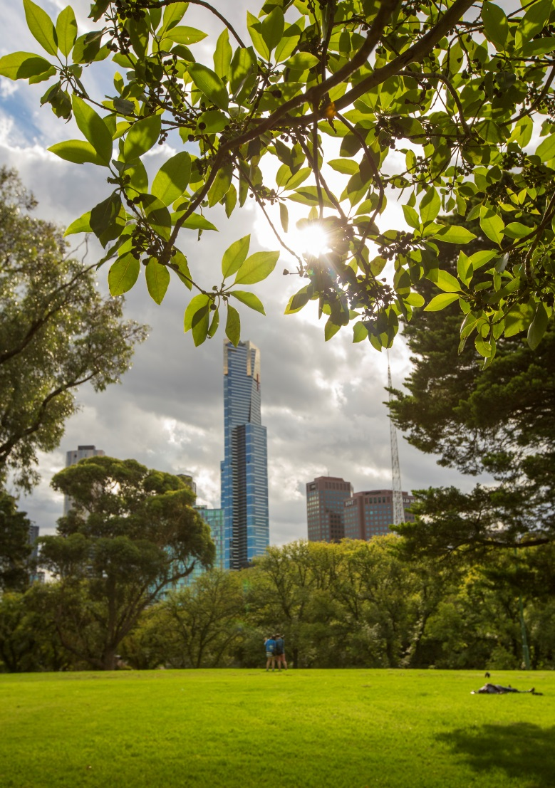
Figure 2. Image showing the city of Melbourne from Domain Parklands

Existing Landscape Characters
The landscape of the Domain Parklands comprises a number of distinct character areas within it. These are described below:

Destination Melbourne Landscape
These are places where large crowds gather for organised events, sports and commercialised activities including: Moomba, ticketed concerts, fun runs, rowing training and regattas, cricket games, personal training, arts and cultural community events, education activities and cafe/restaurant. Many activities tread lightly on the parkland, while others have greater impact with areas of parkland being removed from public use for event set up and reinstatement.

Ornamental Garden Landscape
These landscaped gardens are detailed, pretty and colourful, creating a quiet oasis in the city. The focus is a higher level of horticultural maintenance, including floral displays that are regularly rotated. Several of the gardens include water features, furthering the experience of a garden setting in a city landscape.

Rivers Edge
The Rivers Edge provides a green linear corridor along the banks of the Yarra River. The space supports a linear path network that is enjoyed for recreation and commuting and affords superb views to the city skyline. The orientation and topography make traversing the sloped river bank difficult and creates limited opportunities for connecting with the river. There are several areas for socialising around the barbecues.

Open Parkland
The Open Parkland is characterised by rolling lawns, punctuated by mainly exotic trees with meandering pathways. They provide visitors quiet open green space with (now) established trees to enjoy and contribute significantly to the idea of the parkland being the lungs of the city.

Botanical Landscape
This landscape comprises the main area of the Royal Botanical Gardens. They are home to one of the world's leading botanic gardens and a centre of excellence for horticulture, science and education. The Royal Botanic Gardens is dedicated to the conservation, display and enjoyment of plants and while fenced is open daily for public enjoyment.

Memorial Artefacts
Monuments and memorials are dotted through the lawns of Shrine Reserve, Tom’s Block and some areas of Kings Domain. Monuments and ornamental features are used as focal points or to commemorate a past event adding decorative primarily historic embellishments to the landscape.

Government House and surrounds
The Government House gardens and grounds feature sweeping lawns planted with specimen trees and are surrounded by large ornamental beds of shrubs and perennials. The gardens were originally part of the Domain gardens designed by Baron Von Meuller. The character of the gardens form an extension of Kings Domain however public access is limited.

What did the community say about the landscape?
When people described what they value most in the Domain Parklands, the experience in and of the landscape was the strongest theme. People love the tranquillity of quieter open areas, the green oasis in the city, planted borders near Government house, lawns, ornamental lakes, cooler temperatures during summer, views of the city, pioneer women’s memorial garden and fern gully. Plants, flowers, the river and wide open spaces, shady open spaces and quality gardens, including discovery of gardens. The fabulous large trees and beautifully kept gardens. They raised the connection between the parklands and the river, and the horticulture and botanic collections.
As people explained what they valued in the setting, they also described how they experienced them such as places to relax and walk, walking in and forgetting you are in the city, lack of traffic noise, watching the kookaburras, swans and ducks. Watching how plants have grown over the time a person has visited the parklands. Peace and solitude as well as the opportunity to be with others. Breathing clean air, and watching happy people enjoying the beauty. To get away from the heat, noise and congestion in the city, and away from retail. One person described how they valued connecting to the changes of weather and season in a meaningful way.

Focus
The master plan will seek to reinforce and renew the landscape characters of the Domain Parklands.
We recognise that there are elements that should be retained and other parts which may need to adapt to future opportunities. We need to:
- Identify and reinforce key elements of landscape character.
- Investigate opportunities to use horticultural knowledge and practices to more clearly define different landscape characters.
- Diversify landscape experience and relevance by introducing indigenous landscape features.
- Strengthen the parklands connection to the river through the river edge landscape.
- Rationalise and balance heavily activated areas.
- Rationalise the internal roadway to reflect the character of the parklands.

Theme 3 Environmental Sustainability

Principle: Manage the landscape to reflect and implement the principles and targets of the City of Melbourne Urban Forest Strategy.
Objective: We recognise that healthy parklands contribute essential environmental services to urban environments. We aim to increase canopy cover and urban forest diversity, improve vegetation health, habitat and improve soil moisture and water quality.
The City of Melbourne is currently facing three significant challenges: climate change, urban heating and population growth. These will place pressure on the built fabric, services and people of the city. We need to respond to these challenges by building healthy resilient landscapes.
The Domain Parklands play a critical role in the health and well-being of the community of Melbourne through reducing the urban heat island effect. The parklands have a significant urban forest which has proven to be the most effective way of mitigating heat retention in urban areas.
The Domain Parklands play a critical environmental health role, acting as lungs for the city. All of the elements – soil, water, trees and plants - that make the parklands work most effectively need good management and resourcing. We want to maximise the environmental contribution of the parklands and incorporate this into future decision making.
Water is essential to achieving a healthy resilient landscape in the parklands and for the parklands to provide the environmental services we require for the city. We will continue to work toward integrated water management systems throughout the parklands.
Adequate soil moisture is critical for healthy vegetation. It enables trees to actively transpire and cool the surrounding air. Tree health and the ability to maintain shade and cooling benefits are primarily influenced by the conditions in which trees are growing, as well as the choice of tree species.
Climate change considerations will influence the future planning and management of the parklands. Many of the trees in the Domain Parklands are reaching the later part of their life and will need to be replaced. In some instances it may not be appropriate to replace trees with the same species in the same location . The City of Melbourne has been conducting research into which trees are better at coping with future climate challenges to inform tree planting and renewal. Increasing diversity of the tree population will improve the resilience of this landscape.
Working with the Royal Botanic Gardens, it is proposed to develop a City Arboretum to assist with the development of a diverse, resilient and climate change ready urban forest. An arboretum is a collection of trees, cultivated for conservation, scientific, research and educational purposes . As well as contributing to the aesthetic quality of the Domain, it will inform and educate people about the use of trees in a modern city.
It is recognised that there are already some rare and special trees in the Domain Parklands. These will be retained and protected, and will inform the Arboretum plan.
Styles, trends and practices change in horticulture. Horticultural elements provide some of the pleasure enjoyed by people visiting the parklands. Maintenance requirements also influence decisions on horticultural outcomes. A planned approach is needed to achieve a successful balance of quality visual experience and healthy landscape outcomes in a cost effective way.
We need to understand and monitor the ways the Domain Parklands promote and support urban ecology and biodiversity in the municipality and ensure our management improves these values.

Focus
Tree senescence and population renewal is a critical driver in this project. Providing a healthy resilient urban forest is the vision of the Urban Forest Strategy. Tree selection, succession planting, locations of trees and proposed arboretum need to be considered holistically with other park uses.
We recognise the critical role of green infrastructure in the health of the city. On hot days this parkland will be a cool refuge for people.

We need to:
- Apply the principles of the Urban Forest Strategy to the context of the Domain Parklands, which will include developing a succession planting plan to manage tree senescence to achieve a healthy, resilient urban landscape.
- Prepare a City Arboretum plan to implement within the Domain Parklands.
- Recognise the environmental contribution and services that the Domain Parkland provides to the city and its role as a significant place for protecting and enhancing ecology and biodiversity in an increasingly dense urban environment.
- Recognise this place contributes to the health and well-being of the community as healthy parks support healthy people.
- Promote understanding by the community about how green infrastructure supports their health and well-being.
- Recognise that horticultural aspirations may vary across the parklands. Identify the options for horticultural display and work with the community to appreciate what could be included.
- Provide appropriate levels of resourcing to support the mix of essential ingredients for a healthy resilient landscape.

Theme 4 Activities and access

Principle: Create and manage an environment to support recreation use throughout the parklands.
Objective: We recognise that visiting parks is good for physical and mental health and well-being, so applying universal access principles to improving the physical environment to and within the parklands will promote and facilitate opportunities for participation. We recognise the importance of encouraging and promoting participation in physical activity and participation in community and learning.

Visitor experience and recreation
The Domain Parklands attract many visitors of all ages and abilities every year including residents, workers, interstate and international tourists. Many people come to visit particular destinations within the parkland, in particular the Royal Botanic Gardens, the Shrine of Remembrance and the Sidney Myer Music Bowl. Many people attend concerts, ceremonies and commemorations.
During phase one, we heard that people value visiting the parklands for recreation, to relax, walk or exercise, for picnics and family gatherings, for play, walking the dog on a lead, attend events and to generally explore the park.
The rowing community congregate in the boatshed area in Alexandra Gardens as the base for their activities. Skaters of all ages use the Riverslide skate park. There is one formal sports ground, the Edmund Herring Oval on Domain Road, which is used for cricket in summer and soccer in winter. The Tan track is a hub for people exercising.
It is difficult to collect actual numbers of park visitors to the Domain Parklands. However, we can gather some indicative information from visitor numbers to destinations within the parklands. The Royal Botanic Gardens had over 1.5 million visitors during 2013 / 2014. The Shrine of Remembrance has around 900,000 visitors per year. Recent Tan track counts have between 9,000 and 12,000 people using the track per day.
In managing the parklands, we would like to encourage participation in physical activity, facilitate opportunities for participation in community events and provide opportunities to experience nature and learn about the environment. We also recognise that visiting parks is good for physical and mental health and well-being, and that play in parks is important for the healthy development of children and young people. We also respect that places of quiet reflection and environmental beauty can provide relief from the urban environment.
The Domain Parklands are recognised as Capital City parklands in the Open Space Strategy, reflecting their immense importance to the City. Provision of well- located amenities including public toilets, seating, drink fountains, bins and lighting are all essential throughout the parklands to support the many visitors. Providing appropriate levels of amenities encourages participation by all and makes the visit a positive experience. Community feedback particularly requested more seating and public toilets. Opportunities for further provision of food and drink could be considered.

Focus
We recognise there is the need to improve a number of facilities to support the recreation use of the Domain Parklands. This includes improving the picnic and BBQ areas adjacent to the river, while also identifying if there are other suitable locations for picnic facilities. Opportunities for further provision of food and drink could be considered.
The Alexandra Gardens are so intensively used that a detailed plan is required to better support visitor use and address a range of issues. There is a need to upgrade the skate facility at Riverslide. The public toilets need redesign to manage both general and event use. A number of improvements are required in the boatshed area, including changes to parking, creating drop off areas, circulation for boat trailers, and future upgrading of the boat landing. Resolution of the conflict with commuter cyclists in the area is important.
We recognise that there are opportunities to enhance the visitor experience in the Domain Parklands. We need to:
- Upgrade the picnic and BBQ area along the river, while also identifying opportunities for other suitable picnic facilities in the parklands.
- Resolve a range of use and circulation issues in the Alexandra Gardens, and upgrade a number of facilities.
- Recognise that people of all ages and abilities visit the parklands and some upgrades of facilities amenities and paths may be required.
- Investigate further opportunities for provision of food and drink
- Provide more seating throughout the parklands.
- Improve the journey through the parklands to the destinations within it.
- Provide opportunities to learn about the natural environment, to experience nature, and to share information with others.

Events
The Domain Parklands has become an increasingly popular location for major events, which bring people from all over Melbourne and regional Victoria. There is high demand to stage events of all types in this premier location.
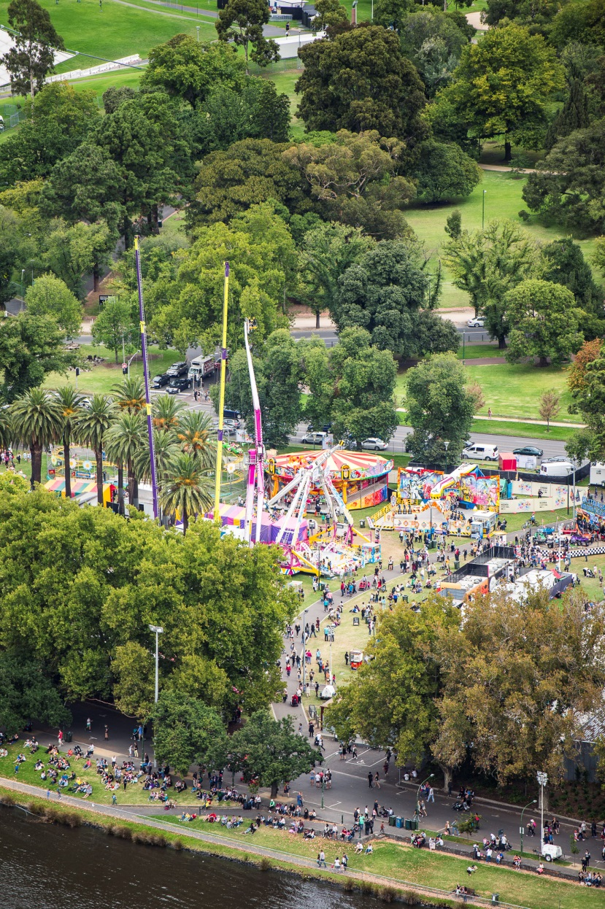
Figure 3. Moomba in Alexandra Gardens
Managing events in parks requires consideration of landscape capacity and sustainability. As the parks are soft landscapes the areas used require reinstatement after events.
The City of Melbourne has guidelines with three broad categories for events – high impact, medium impact and low impact. These categories consider numbers of attendees, length of event and scale of structures involved.
While the Alexandra Gardens has always been a home for Moomba, there are now more events located here and across the river in Birrarung Marr, because of the central city proximity. Other major events in the precinct are fun runs, which draw thousands of participants. Many of these start or finish in the Alexandra Gardens or Kings Domain, and incorporate some of the parklands in their circuits.

Creating time to pause between activities

There has been a steady increase in use of the parklands over the past 20 years. Not only from the growth of existing uses such as rowing and cycling, but also with the introduction of more major events.
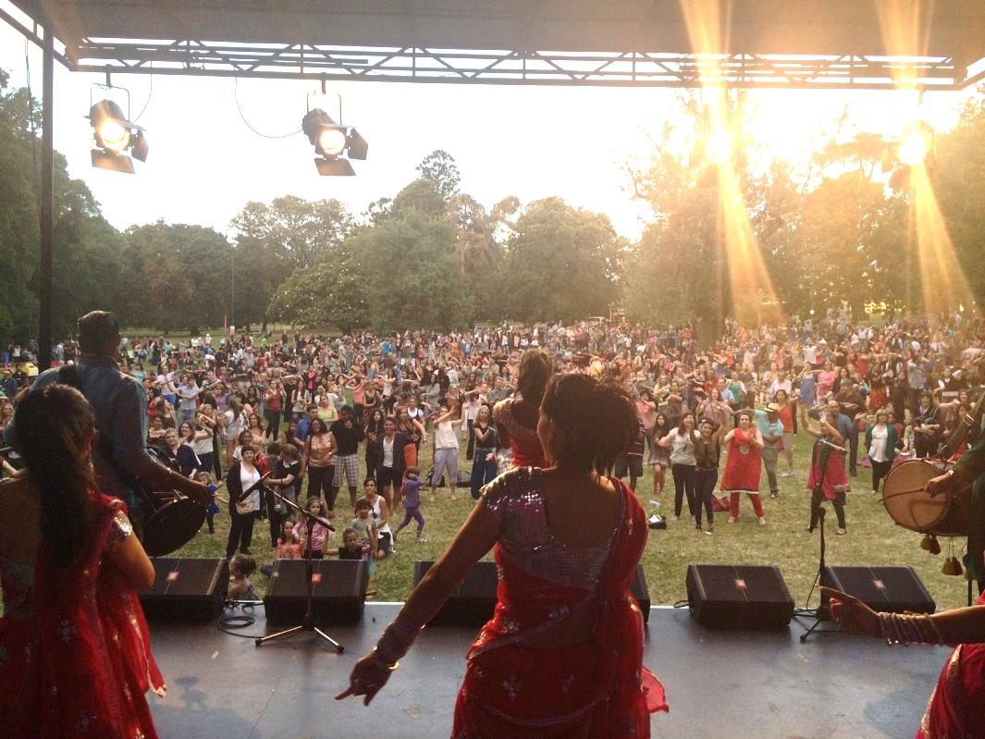
Figure 4. Sunrise Series event in Domain Parklands
Such high levels of use are not sustainable. There is an increase in conflict between some uses. More activities in the area results in more competition between legitimate uses and consequently some people’s enjoyment of the space is impacted. The increasing demand to use this location for events is leaving no pause time between events (because of the need for reinstatement), so passive recreation use of the gardens is affected. Finally, the resource demand of reinstatement (at times requiring new turf as well as water) suggests the need for review.
The landscape has a finite carrying capacity, even with provision of water, selection of suitable turf and good horticultural management. There is a need to balance provision of activities with a time to rest and be available for passive unstructured recreation.
Investigation into high impact events in the Domain Parklands and feedback from the community has raised questions about the number and sustainability of major events.

What did the community say about events?
Some people described enjoyment attending events such as the concerts at the Myer Music bowl and Moomba. Other events attended included movies and outdoor theatre at the Royal Botanic Gardens, exercise related events and commemorative events at the Shrine.
The frequency of fun runs around the Domain parklands was raised by those living in the neighbourhood, with concern about the road closures, the numbers of people and the length of time the area is congested. Noise from music concerts was raised. Some people choose not to attend events and preferred to visit the park for quiet relaxation.
Suggestions about events included using the Myer Music Bowl and Observatory gate as areas for events, and having park related events (such as Floriade in Canberra). Feedback suggested that while events are a positive way to enliven a space, there is a view that they should be for public benefit, have minimal impact and be free to attend.

Focus
Events vary in their size, attendance numbers, impact, and the area they use. In order to consider the capacity for the Domain Parklands for events, the different types of events need to be examined.
We recognise that many areas within the parklands can support multiple uses. We need to:
- Better manage zones within the parklands associated with major event use to maintain a healthy landscape.
- Provide pause time between major events in the same location or busy areas within the Domain parklands. This will enable events to be provided in other city locations.
- Balance the levels of use to enable equal enjoyment of parkland for passive and informal recreation.
- Consider designating areas which will not be available for events.

Access
The Domain Parklands are visited by millions of people each year and this will continue to grow. Access to and within the parklands is important for its role as a welcoming, safe and enjoyable space, and an important consideration for the master plan.
The parklands have many beautiful areas that are easy to find and visit. There are also hidden jewels, providing a discovery experience for visitors.
There are multiple entrances to the parklands. Pedestrian access at most entrances could be improved to provide both more continuous paths of travel and an invitation to enter. Some parts of the Parkland are highly visible from St Kilda Road (Alexandra Gardens and Queen Victoria Gardens) and this in part provides a welcoming entrance to the park. Other areas, such as Kings Domain (including Tom’s Block) are elevated and less visible to the visitor who is unfamiliar with the park, and as such require better signage and clear points of entry. Attention to universal access principles in the parkland is a key ingredient to helping access to and within the parklands where possible.
Provision of a river landing adjacent to the Royal Botanic Gardens could encourage new ways to access the Domain Parklands. A new entry to the Gardens at this point would enhance access by river transport in addition to removing congestion from other entries.
The way people attend the Sidney Myer Music Bowl has changed. When the venue was built, there was little change to the path network. Today, it is evident the paths do not provide good access to the bowl. It is important that good access to this and other major destinations in the parkland is provided.
Providing better cycling routes and connections has emerged as an important need within the parklands. Currently most cycling occurs along the river path, where there are increasing conflicts with other uses as commuter cycling grows. There is congestion where the river path passes the boatsheds. This requires a more precinct based solution providing safe and convenient alternative routes for commuter cyclists.
Access by public transport to the Domain Parklands is very poor. There is currently a tram along the St Kilda Road boundary which has accessible stops at the Arts Centre, Grant Street, Coventry street, the Shrine, and then Domain Interchange. One tram travels along Domain road with a stop at Park Street near a Royal Botanic Gardens entrance. Unfortunately the new tram stops along St Kilda Road adjacent to the Kings Domain (Grant Street) and Shrine do not stop at any accessible entry to the park. The Domain interchange is at the bottom of a steep hill with no accessible path to the Shrine and Royal Botanic Gardens Observatory Gate entries. There will need to be a solution found to improve access by tram to the parklands.
The proposed Domain Station will be efficient in bringing people to the Domain interchange, but as noted earlier this is not an accessible entry to the parklands or the destinations within it. Ideally, an accessible entry near the Birdwood Avenue Shrine and Royal Botanic Gardens entries should be developed, which will support the millions of visitors to these major destinations.
Improving public transport is important to provide alternatives to car travel to the parklands.

What did the community say about access?
People who described problems with access primarily discussed the need to provide more pedestrian crossings and improved connections from public transport, and the need for an integrated bike network. Improving connections within the parklands included support for traffic and speed reduction, attention to path links, longer traffic signals and the particular divide of Alexandra Avenue. Solutions to improve access to Boathouse drive were requested, as well as better connection from the tram stops to the Shrine. Other suggestions included use of a people mover and encouraging more people to use public transport during events to assist with access. Attention to any areas where pedestrians, park users and traffic were intersecting was highlighted.

Focus
It is important that, where possible, key destinations in the parklands are accessible for everybody. Well located path networks are an important part of this.
We acknowledge that there may be a need to improve pedestrian linkages within the parklands to provide good access to destinations. This could include realignment of some existing paths and establishing a hierarchy of paths.
We also recognise the importance of planning for improvements to public transport access to the Domain Parklands and the destinations within it. This needs consideration of the size of the parklands and the need to bring people to different entrances.
We need to:
- Provide coordinated signage and way finding to improve access.
- Identify and promote accessible paths of travel.
- Give attention to path links and good pedestrian priority across internal roads to assist with providing an effective path network.
- Reduce road widths where possible to improve pedestrian access and the visibility of the path network.
- Provide better cycling routes and connections in the parklands, with particular attention to alternative routes to using Alexandra Gardens.
- Improve access to the parklands from public transport.
- Improve entrances.
- Provide a river landing adjacent to the Royal Botanic Gardens.
- Create visual cues for people to access the parklands from different locations.
- Apply universal access principles to assist in improving the park infrastructure.
- Recognise the value an element of discovery provides in experiencing the Domain Parklands.
- Advocate for improved public transport to the parklands.

Theme 5 Vehicles in the Park – traffic movement and parking

Principle: Reduce the impact of vehicles on the visitors’ parkland experience, while supporting good access to the destinations within the parklands.
Objective: We recognise that people are used to driving to the parklands, but acknowledge that by reducing some vehicles in the park the visitor experience can be improved and the long term benefits of uniting the parkland can be great.
Attention to traffic movement and parking is critical to help us make one park of many and improve the landscape.
Roads with through traffic create difficult barriers for pedestrians to cross. Alexandra Avenue in particular is extremely busy and is difficult to cross between Alexandra Gardens and Queen Victoria Gardens. Pedestrian counts show this crossing has the lowest use of all pedestrian links.
Parking throughout the parklands has a visual impact and influences the visitor experience of landscape character and parkland. The cars are highly visible, and draw the eye to the car, rather than the park.
A comprehensive parking and traffic study has been conducted in the Domain Parklands to understand the existing conditions and inform the master plan. It has captured information about the existing use of the roads around and through the parkland.

Key points in the study findings about existing use.
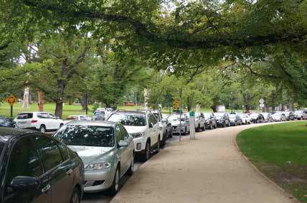
Figure 5. Image showing existing parking along Linlithgow Avenue.
The roads and parking spaces in the Domain Parklands are used by:
- Genuine parkland users - these are the people that have come to enjoy the parks and gardens and/or visit the various attractions within; and
- Other non-parkland users - those destined for locations outside the parklands area who drive through or use the area to park.
- On an average weekday, 78 per cent of the vehicle movement is through traffic.
- Of the 22 per cent stopping in the parklands many are using the all -day car parking but are not visiting the parklands.
- Weekend traffic volumes are lower than weekday traffic volumes.
- Over 1300 car parking spaces are provided.
- 63 per cent of car parking is used at the busiest period on an average weekday, 61 per cent of car parking is used on the weekend. Nearly half the weekday parking is by commuters.
- Parking demand is heavily influenced by events within the Domain Parklands or nearby precincts (MCG or Melbourne Olympic Park area).
- Parking occupancies during events can reach very high levels.
- When no events are held, parking occupancy is similar on weekdays and weekends.
- Most of the parking is used for destinations other than the Domain Parklands.
What other considerations may influence thinking about vehicles in the park?
- Provision of a Domain railway station through the Melbourne Metro Rail Project could improve public transport to the parklands.
- In 20 years technological advances in cars may reduce the need for parking (for example driverless cars).
- Best practice planning for car parking in parks does not plan for peak activity, rather the general use. This is to maximise the parkland and minimise the car parking (hard surfaces).
- Parking of empty buses is not necessary within the parkland, where they have a strong visual impact. Provision of bus drop off and pick up areas is required and some provision on the exterior of the parklands for bus parking.
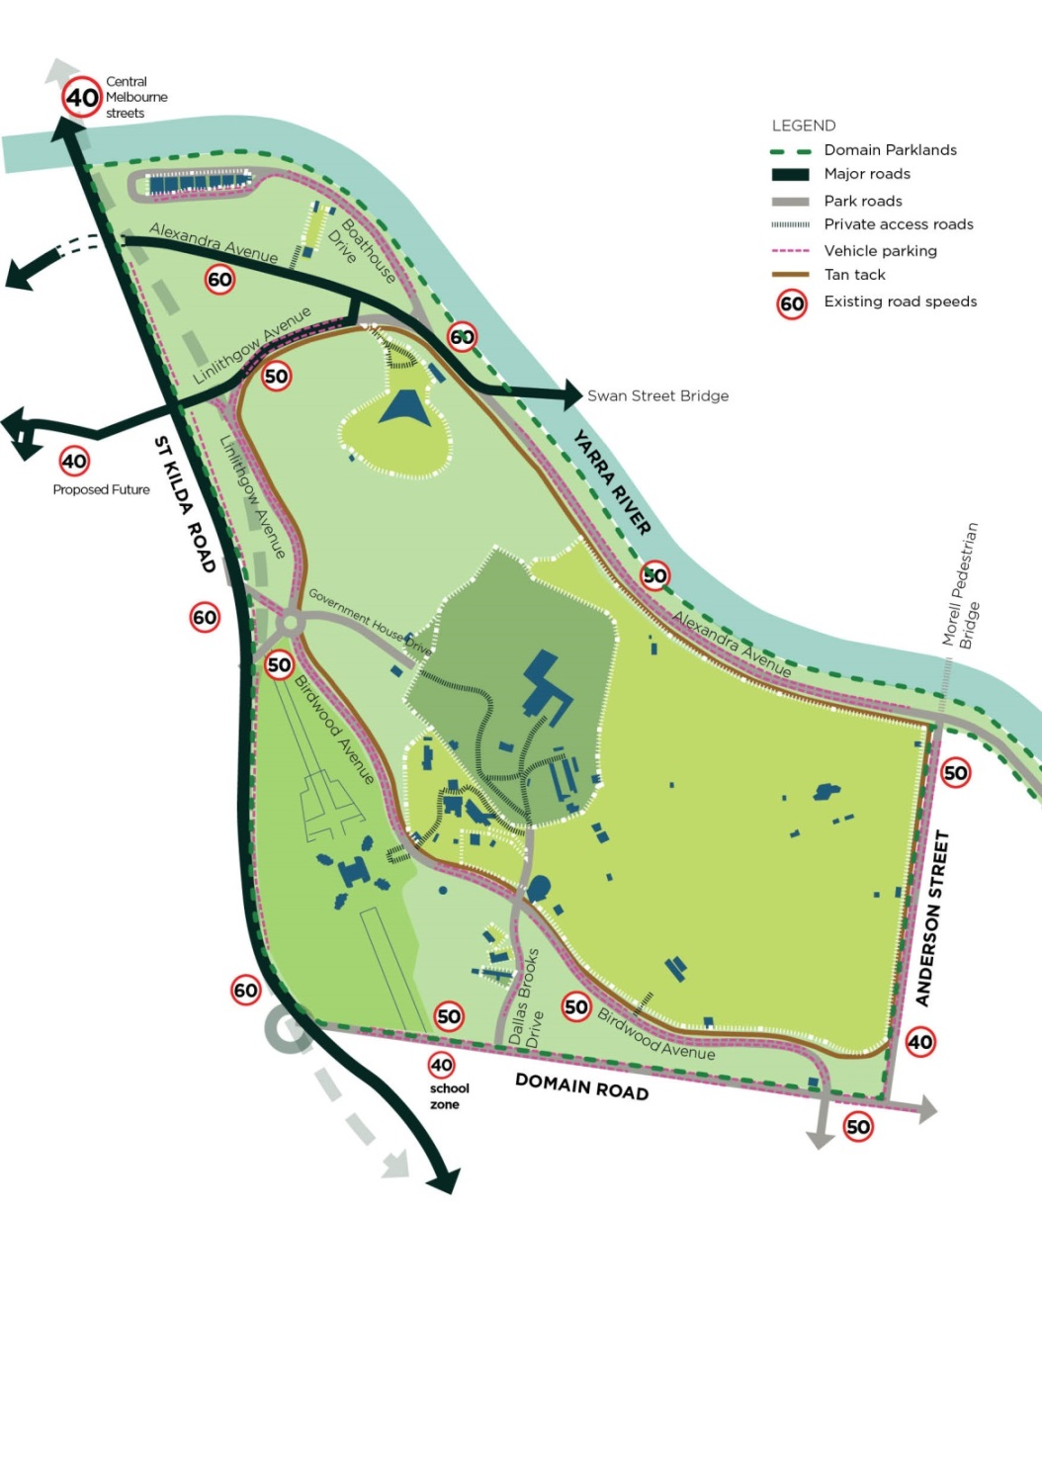
Figure 6. Existing road network in Domain Parklands

What did the community say about vehicles in the park – traffic and parking?
People were generally interested to review how traffic and parking was managed in the parklands. There was support for a focus on the parklands as a people space not a car space.
There was a diverse range of views on possible road closures and car parking. The suggestion of closing or narrowing the section of Alexandra Avenue between the Royal Botanic Gardens and the Yarra was met with commentary on how some people enjoy driving along this section of road, particularly at night.
More generally others were quite supportive of some road closure suggesting this could be beneficial. Those not supportive of road closure were concerned about local traffic impacts and circulation. Tunnelling Alexandra Avenue and providing park and pedestrian access above between the Queen Victoria Gardens and Alexandra Gardens was suggested. Others linked the discussion to provision of good pedestrian and cycle links, and the potential to separate the two. It was suggested events could be placed on closed roads rather than grass which needs reinstatement.
Ensuring good access to the park was important to anyone with concerns about any parking changes. Car parking comments were either supportive of some removal or described why parking is required for good access (picnics and BBQs, activities in the early morning, and for those with mobility difficulties).

Focus
As the Master Plan will guide the planning and management for the parklands for the next 20 years, we have the opportunity to consider some longer term changes to make the focus a people and park space not a car space.
Measures to reduce the impact of through traffic within the parklands and modification of car parking in some areas will assist in uniting the Domain parklands.
We recognise:
- Good access to destinations within the parklands is important. While parking to visit destinations within the Domain Parklands will be retained, some on-street car parking could be converted to parkland to improve the visual experience and better connect the parklands.
- Parking restrictions could be modified to better meet the needs of visitors to the Domain Parklands. This could include changing all day parking to 4 – 5 hour parking.
- Provision of bus drop off and pick up areas at destinations is required, and some bus parking could be provided on the park perimeter.
- Through traffic on internal park roads is a barrier to good pedestrian circulation and provides no benefit to park users. The master plan presents an opportunity to rethink options for how the road network can better support the park user.
- Traffic calming measures on internal park roads should be introduced.
- Roads closed for events could be used for placement of temporary structures, such as marquees, rather than grass.
- Temporary road closures on internal park roads could be trialled for pedestrian and cycle use.
- Alexandra Avenue is a major barrier to circulating through the parklands and traffic noise has an impact on park visitors in the Queen Victoria and Alexandra Gardens. We will examine ways to reduce the impact of noise on park visitors.

Theme 6 Cultural and historical significance

Principle: Recognise and conserve the Domain’s cultural significance.
Objective: We recognise that the place is of cultural and historic interest to the State of Victoria as evidenced by various separate listings on the Victorian Heritage Register and Aboriginal Sites Register. In addition to the official histories, monuments and structures there is also the “other” history- the stories and memories of people over generations, which influences what people value today.
As we weave the themes together to prepare the Master Plan, we need to understand the cultural values and character within the Parklands and identify what is important. These elements should be managed well.
There are some unique parts of the Domain Parklands that contribute to the cultural significance, including:
- Places such as the Pioneer Women’s memorial Garden, the fern gully and the boatsheds. They also include elements such as the Queen Victoria memorial, the Sydney Myer Music bowl, and Janet Lady Clarke rotunda.
- Specific journeys or path links such as the path to King George V memorial and the Tan track.
- Particular views, such as the view of Government House tower and the Shrine of Remembrance.
- Aboriginal cultural significance elements such as the connection to the river, the high view -points, the memorial and remnant trees.
- Horticultural places such as the floral clock, the Government House boundary and the ‘star bed’. And there are many parts of the landscape character that contribute to the cultural significance.
The area that is now the Domain Parklands is significant to Aboriginal People. It is a place of shared Aboriginal and non-Aboriginal history and cultural heritage values. There are two particular layers. One is the burial stone which is for all the nations in Victoria. The other is that there are 4 specific groups who have stated connection to the area.

Focus
We need to:
- Maintain and enhance the Domain’s role as the setting for Government House, the Shrine of Remembrance, the Royal Botanic Gardens and its association with the history of Melbourne.
- Celebrate the important civic, ceremonial, recreational and landscape experiences and features that this place provides for the central city/Melbourne.
Identify the parts of underlying landscape character and structure which give value to the recent historic significance of the settlement of Melbourne, and introduce the layers as identified to acknowledge the Aboriginal cultural heritage. Work with Traditional Owners to identify suitable locations.
- Increase the public visibility of the history of the Parklands through information and interpretation.
- Promote an increase in community understanding and recognition of cultural heritage.

Memorials in the Domain Parklands
Because of its central location and the high profile civic and commemoration destinations within the Domain Parklands it is a popular location for memorials. There are continued requests for permission to place new memorials in the parklands, particularly within the Kings Domain.
However, memorials in the parklands do have an impact. In addition to the introduction of a new visual element into the landscape, they also occupy an area of land that is then unavailable for other park purposes. There is also a question of what should be memorialised and the form it should take.
The City of Melbourne has a plaques and memorials policy and process with strict criteria for assessment of applications for new memorials. In the 1997 Domain Parklands Master Plan an area fronting St Kilda Road, running from Princes Bridge to Government House Drive, was designated for civic monuments. Since this time four major memorials have been installed in the parkland, not all in this designated area.
As part of the master plan it is important to establish a position on the future placement and form of memorials within the Kings Domain and more broadly within the Domain Parklands.

What did the community say about memorials?
While there was acknowledgement that some memorials have historical interest and importance for special interest groups, there was also recognition of the finite area of parkland available and the inability to continue to provide memorials in this fashion. Views expressed were either strongly in favour of change to the way memorials are provided or in favour of no change.
Some of the views expressed about memorials described enjoying points of reflection on walking past, the interest in discovery and the importance of recognition of people or agencies that have served the community. Issues of concern included relevance, parkland as a limited resource, the dominating scale of some memorials, and the difficulty of how to place more.
There was support for the need for rigorous assessment, as well as finding alternative methods for commemoration. Suggestions included smaller scale installations, horticultural beds, park amenities (functional artistic seating, drink fountains), a de-accession or rotation policy (similar to Galleries) and retaining them on the boundaries of the parklands only. There were also suggestions for better interpretation of existing memorials.

Focus
While memorials have an important civic role in commemoration, the current way of providing these memorials is impacting on other landscape and use values of the parklands.
There are other possibilities for memorials of a different form, such as horticultural memorials (including display garden beds). Other ideas raised would be more complex, such as retiring a memorial before installing a new memorial. A further concept would have one memorial where all commemorations are applied, such as a commemorative wall.
We recognise:
- Different approaches are required for memorials in the Domain Parklands in the future.
- Memorials which contribute to horticultural values could be more consistent with the park setting, contributing to the biological diversity as well as the visitor experience.
- Memorials should contribute to the experience of the park visitor.
- Interpretation of existing memorials should be provided.

Conclusion and next steps
There are multiple layers for consideration in preparation of the master plan for the Domain Parklands. In addition to the main themes raised in this discussion paper, there are many technical considerations. These include research and examination in the following areas:
- physical - adjacencies, circulation, built form, sports facilities, roads
- social – demographics, recreation needs study & open space strategy, understanding the visitor
- habitat – soils and geology, vegetation, topography, fauna, hydrology, drainage
- circulation – walking paths, car parking, public transport, linkages
- research- options and ideas for programs and settings
- heritage – conservation management plan and heritage registration
- management – opportunities to explore for the five land managers.
The following studies are underway or soon to commence to provide more detailed technical information, as an example of the range of information being analysed to inform the master plan:
- traffic modelling
- conservation management plan
- arboretum study
- water management / soil management mapping
- disability audit.
The Royal Botanic Gardens is currently preparing a building master plan, the Shrine has recently revised their landscape master plan and the Arts Centre anticipates further plans for the Sidney Myer Music Bowl. These will all inform and intersect with the Domain Parklands Master Plan.
There are also many considerations from projects and plans in adjacent precincts, including the Southbank Boulevard proposal, City Road Master Plan, Arts precinct blueprint and Melbourne Metro project.
The information gathered from the engagement will be combined with technical and research information to inform the development of the draft master plan. This will be completed in late 2016 for further consultation in 2017.

