We need to talk
Preventing violence against women discussion paper

________________________________________________

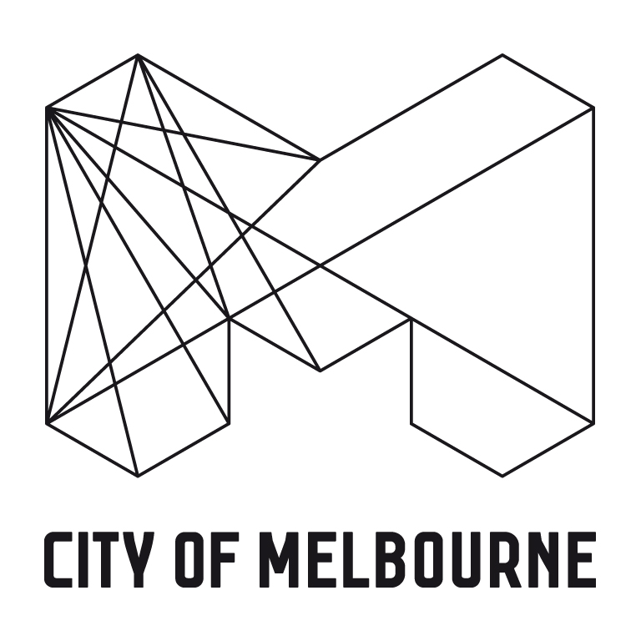

Contact
Community Safety and Wellbeing Branch
Council House 1
Level 3
T: 9658 9962

www.melbourne.vic.gov.au/preventingviolence

Table of contents

Glossary of key terms 5

Introduction 7

Who perpetrates violence against women? 8

How prevalent is violence against women? 8

What are the issues associated with reporting violence against women? 9

Effects of violence against women 10

Effects of violence against women on children 10

What are the economic impacts of violence against women? 11

Why does violence against women occur? 11

Preventing violence before it occurs 13

Addressing determinants of violence – the ecological model 13

Preventing violence against women - a spectrum of strategies 16

The Role of Local Government in the Primary Prevention of Violence against Women 17

What role can the workplace play? 19

What are the incidences of violence against women? 20

What is the City of Melbourne planning to do to address violence against women? 23

Community consultation and engagement 23

Draft Strategic Framework 26

The Role of Local Government in the Primary Prevention of Violence against Women 26

Links with existing City of Melbourne policies, plans and programs 28

Guiding principles and practices 28

Our Vision 29

Setting One. In our organisation and other workplaces 29

Setting Two. In the Community 30

Setting Three. In the Home 30

Opportunity for Community & Stakeholder input 30

For further information 31

References 32

Glossary of key terms

Violence against women is understood to occur on a continuum of economic, psychological and emotional abuse through to physical and sexual violence. It refers to ‘any act of gender-based violence that results in, or is likely to result in, physical, sexual or psychological harm or suffering to women, including threats of such acts, coercion or arbitrary deprivation of liberty, whether occurring in public or private life’ (UN 1993). Violence against women includes intimate partner violence, sexual violence and workplace sexual harassment.

Intimate partner violence, sometimes referred to as domestic violence, family violence or relationship violence, refers to violence occurring between people who are, or were formerly, in an intimate relationship. It includes behaviour that in any way controls or dominates a current or former intimate partner, causing them to fear for their own, or another family member’s, safety or wellbeing. It can include physical, sexual, psychological, emotional or economic abuse, and stalking. It includes behaviours that children hear, witness, or are exposed to the effects of. This form of violence against women is largely perpetrated by men in the context of a known and intimate relationship.

Interpersonal violence is violence occurring between individuals either known or unknown to one another. It is distinguished from collective violence (such as violence occurring in the course of war) and self-directed violence (such as suicide and other forms of self-harm) (WHO 2002).

Family violence is a broader term that refers to violence between family members and as well violence between intimate partners. The term family violence is the preferred term to describe this type of violence in Victorian indigenous communities as it implies that violence can involve and affect the wider family and community.

Physical violence refers to a woman being slapped, had something thrown at her; pushed; shoved; hair being pulled; hit with a fist or something else; choked or burned; threatened with or had a weapon used against her.

Sexual violence: any sexual act, attempt to obtain a sexual act, unwanted sexual comments or advances, or acts to traffic, or otherwise directed, against a person's sexuality, using coercion, threats of harm or physical force, by any person regardless of relationship to the victim, in any setting, including but not limited to home and work.
White Ribbon came to Australia in 2003 as part of UNIFEM (now UN Women). It formally became a Foundation in 2007. White Ribbon is Australia's only national male-led violence prevention campaign. The White Ribbon Campaign is now the largest global male led movement to stop violence against women.
Gender refers to the socially constructed roles, behaviours and attributes that society considers appropriate for women and men. Unlike the biological characteristics and differences between women and men known as sex, gender roles are socially learnt, differ among cultures and change over time.

Sex refers to the biological characteristics that define humans as female or male.

Social norms consist of rules of conduct and models of behaviour expected by a society or social group. They are rooted in the customs, traditions and value systems that gradually develop in a society or social group.

A determinant is an attribute or exposure which increases the probability of the occurrence of a disease or other specified outcome (in this paper, violence against women). The term risk factor is sometimes used interchangeably with this term in the literature.

Primary prevention refers to activities and interventions that seek to prevent violence against women before it occurs. Interventions can be delivered to the whole population (universal) or targeted to particular groups that are at higher risk of using or experiencing violence in the future (VicHealth 2007).

Gender equity is an important social justice goal. The concept recognises that within all communities, women and men have different benefits, access to power, resources and responsibilities. Gender equity is the process of being fair to women and men by recognising diversity and disadvantage and directing resources and services towards those most in need to ensure equal outcomes for all. A gender equity approach therefore acknowledges that it is often necessary to have different strategies for women and men.

Gender equality means equal participation of women and men in all spheres of public and private life. Gender equality is about society giving equal value to the similarities and differences between women and men, and the varying roles they play. The experience of inequality is by no means confined to women. Differences occur between both sexes on questions of race, sexuality, class, age, disability and geography. But on key questions of economic security, health, wellbeing and political participation – within and across cultures – women more commonly experience greater disadvantage and discrimination relative to men.

Gender analysis is a method of assessing difference in the lives of women and men and the impacts that policies, programs and services may have. Implementing gender analysis therefore provides more equitable access for both groups, by also taking into account variables such as socioeconomic status, age, family structure, ability and cultural and linguistic background.

Bystander a person or persons, not directly involved as a victim or perpetrator, who observes an act of violence, discrimination or other unacceptable or offensive behaviour; for the purposes of this report this includes sexism, discrimination or violence against women.
Bystander action taken by a bystander to identify, speak out about or seek to engage others in responding to specific incidents of sexism, discrimination or violence against women; and/or behaviours, attitudes, practices or policies that contribute to sexism, discrimination or violence against women.

Workplace sexual harassment refers to behaviours of an unwelcome nature which occur in a work context that could reasonably be expected to make a person feel offended, humiliated or intimidated. It includes behaviour that occurs in a physical workplace, as well as in situations associated with employment (for example at social functions, conferences or in off-site work locations). Workplace sexual harassment includes sexual hostility (explicitly sexual verbal and non-verbal behaviours) and sexist hostility (insulting verbal and non-verbal behaviours that are not sexual but are based on gender), unwanted sexual attention (unwelcome, offensive interest of a sexual nature), and sexual coercion (demands for sexual cooperation in return for job benefits). Examples of workplace sexual harassment include jokes of a sexually offensive nature, questions about a person’s sex life, repeated requests for dates, displaying sexually offensive posters or explicit emails and text messages.

Acronyms
PVAW – prevention of violence against women
FV – family violence

Introduction

Violence against women is a violation of women’s human rights, sometimes deadly and always unacceptable.

Given the extensive role local government plays in creating safe public environments, developing community facilities and providing health and community services they are well placed to take active roles in preventing violence against women (VicHealth, 2007). Local government is in an advantageous position to drive and embed positive cultural change through their ability to model appropriate attitudes and behaviours towards women. Local council’s have the ability to demonstrate leadership in resourcing and coordinating strategies across a spectrum of government services, drawing upon the experiences of existing service providers (Hayes, 2006). As a result of these factors, the City of Melbourne is well placed to address this important issue.

Violence against women is a complex and persistent problem with multiple causes. The overall impact of such violence is incalcuable, as it not only directly affects individual victims but also their children, their families and friends, workplaces and communities. In health terms, there is no greater impact than the harm manifested by intimate partner violence on women’s lives. The elimination of such violence has become an obligation of all governments (VicHealth, 2010)

The United Nations Declaration on the Elimination of Violence against Women defines violence against women as:

‘any act of gender-based violence that results in, or is likely to result in, physical, sexual or psychological harm or suffering to women, including threats of such acts, coercion or arbitrary deprivation of liberty, whether occurring in public or private life’

There are various forms of violence against women, including:

- Physical abuse and aggression such as stalking, grabbing, slapping, hitting, kicking, choking and beating
- Rape and other forms of sexual coercion, unwanted sexual advances or harassment, forced prostitution and sex trafficking for the purposes of sexual exploitation,
- Intimidation, derogatory name calling, cyber stalking, sexting, belittling, humiliation, and other forms of emotional and psychological abuse
- A range of controlling behaviours such as isolating women from their family and friends, monitoring their movements, or restricting their access to money and bank accounts, information, assistance and other resources
- Threatening to hurt people and animals, threatening to hurt themselves as a means to control, blaming others for their behaviour
- Dowry-related violence, female genital mutilation, and other practices harmful to women (VicHealth, 2011)
- Threatening to ‘out’ people or to infect them with a sexually transmitted disease or other illness.

Who perpetrates violence against women?

Violence against women is a crime predominately perpetrated by men known to them. According to the Personal Safety Survey (Australian Bureau of Statistics (ABS), 2006), most women assaulted in the last 12 months were assaulted by either a currrent or previous partner (31%), a male family member or friend (28%) or another male person (12%). In comparison, men were more likely to be assaulted by a stranger (70% and in the great majority of cases the perpetrator was another man). Only a very small proportion of assaults against men were perpetrated by women known to them and a former or current female intimate partner was the perpetrator in only 4.3% of assaults (Flood 2006 in VicHealth 2007)

Men’s violence against women affects women across all sectors of society. It occurs in private and in public: in homes and in the workplace, in schools, clubs and pubs, in prisons, detention centres and in hospitals. Men’s violence against women is widespread, systematic and culturally entrenched (Amnesty International, 2008). Whilst violence occurs in a variety of settings, it most commonly occurs in the home, with 75% of all assaults against women since the age of 15 occuring in the home (ABS, 2006)

How prevalent is violence against women?

Violence against women in Australia is widespread:

- One in three women having experienced physical violence since the age of 15 (ABS, 2006)
- Just over one in five women having experienced sexual violence since the age of 15 (AHRC, 2012)
- Around 75 women die every year at the hand of a violent partner or former partner (ABS, 2011).

It is important to note that whilst violence has the potential to impact women across the entire social continuum, the experiences of women and the contributing factors to violence vary greatly. There are female populations which are particularly at risk to violence these include young women, women with a disability, pregnant women, women of Aborginal and Torres Strait Islander descent and women from Culturally and Linguistically Diverse (CALD) backgrounds (ABS 2006; VicHealth 2011).

International and Australian studies show that for young women, the risk of violence by a male intimate partner can be up to three to four times higher than the risk for women across all other age groups (Young et.al in VicHealth 2011). Women with a disability are particularly vulnerable to intimate partner violence, especially where the abuser is also a carer and can exercise control over access to medication, or restrict mobility and access to external supports (Brownridge, 2006 in Vichealth 2010). An ABS study found that 36% of women who had experienced partner violence were pregnant at the time of the violence and 17% of those women were pregnant at the time when the violence had commenced (ABS 2006).

Indigenous women are almost ten times more likely to die from assault than non-Aborginal women and are 35 times more likely to be admitted to hospital as a result of intimate partner violence (Al-Yaman, Van Doeland, Wallis, 2006 in Women’s Health West). While there are questions about the increased vulnerability or heightened risk for women from CALD backgrounds, there is consensus that attitudes and perceptions about the legitimacy of, and about what constitutes, violence against women varies according to class, ethnicity, age, gender, and disadvantage. These factors may make CALD women more vulnerable to ongoing violence and its impacts (VicHealth, 2010).

Domestic violence is by far the most common pathway into homelessness for Australian women. The population of women who are homeless because of domestic and family violence is increasingly becoming a group with complex and multiple needs, that is, due to drug and alcohol dependency, mental health and disability. The single greatest reason people present to Supported Accommodation Assistance Program (SAAP) is domestic or family violence, accounting for 22% of support periods. While SAAP clients do not represent the whole homeless population, for women with children, domestic or family violence accounted for 48% of SAAP support periods (Department of Parliamentary Services, 2011).

In Victoria, domestic and family violence represents the main reason for women seeking assistance from homelessness services (AIHW 2011). It is evident that addressing violence against women in the community remains one of the critical areas for helping to prevent homelsseness. This is relevant to the City of Melbourne and confirms the findings of the Homelessness and Women in the City of Melbourne 2011 study which found that all participants had become homeless as a result of family violence and that lack of affordable housing alternatives placed them under pressure to return to the family home.

What are the issues associated with reporting violence against women?

In 2006, the ABS estimated that only 36% of women who experience physical family violence assaults ever report the assault to police and even fewer report their experience of sexual assault (19%). Women are least likely to report violent incidents (either sexual or physical) committed by current or former intimate partner as compaired with reporting incidents perpetrated by a stranger or non-intimate partner. There are many reasons why victims of family violence may not report the violence to police or seek assistance from support services, including fear of repercussions from the perpetrator, fear of losing children to DHS Child Protection, financial dependence on intimate partners, lack of confidence in the the legal process, lack of alternative accommodation or cultural and religious beliefs (Department of Justice, 2012).

Attempting to leave a violent relationship can result in an escalation of violence, with evidence showing that separation from a partner increases the risk of women being killed by that partner (Department of Justice, 2012).

Community attitudes reflect limited understanding of the nature and dynamics of family violence, which can often lead to victims being blamed for the abuse, especially if they do not leave the relationship. The National Survey on Community Attitudes to Violence Against Women found that approximately 50% of the community believe a woman can leave a violent relationship if she really wants to leave (VicHealth, 2009 in Department of Justice, 2012)

It is important to recognise that whilst the statistics relating to violence against women are alarmingly high, they do not accurately reflect the true extent of violence. Most efforts to determine the actual prevalence of family violence in the community are directed towards physical and sexual assault, or threats of assault, as such these incidents are relatively easy to define and count. By contrast, abuse of an economic, emotional, verbal and social kind, varies so widely in its intensity and form, that is difficult to measure in a consistent and reliable fashion.

Effects of violence against women

Violence against women is a prevalent problem with serious health, social and economic consequences. Women exposed to violence are placed at greater risk of developing a range of health problems including stress, anxiety, depression, pain syndromes, phobias and medical symptoms (WHO, 2000). Intimate partner violence contributes to more ill health and premature death for women aged 15 to 44 in Victoria than any other single factor, including high blood pressure, tobacco and obesity (VicHealth, 2004)

Effects of violence against women on children

Family violence is intergenerational and damages the health and wellbeing of infants and children

Living with domestic and family violence, and the homelessness that is so often associated with it, can have adverse impacts on children. Living with domestic violence can affect their emotional and cognitive development, and one in four children who have experienced domestic violence have serious social and behavioural problems. Living with tension, aggression, and violence damages children’s developing brains by influencing the ways in which their neural pathways link together, particularly in the first three years of life. (AHURI, 2011)

The ways in which a child can be changed by experiencing domestic and family violence include: children are denied a good father and positive role model; abuse can harm the mother/child bond; children can develop negative core beliefs about themselves; children can be isolated from helpful resources of support; unhealthy family roles can evolve in homes; abuse destroys a child’s view of the world as a safe and predictable space; a child’s style of coping and survival may become problematic; children may adopt some of the rationalisations for abuse; and children can believe that domestic or family violence is inevitable or normal. (AHURI, 2011)

Infants exposed to significant trauma may be less able to form healthy attachments and can have signifcant emotional, physical and develomental issues. Children can be affected by violence through witnessing or overhearing abuse or by being victims of violence themselves. Effects upon children include depression and low self-esteem, aggressive and bullying behaviour, sleeplessness or bedwetting, loss of interests or friends, poor school performance, post traumatic stress disorder, drug related problems and suicidal and antisocial behaviour. In addition some children later model their own adult and family relationships on the violence and abuse they have witnessessed at home and can perpetuate the abusive patten of behaviour to the next generation. The 2005 Women’s Safety Survey conducted by ABS found that 61% of women who had experienced violence from their partner at some time had children in their care, with around two-thirds of these children having witnessed the violence to their knowledge. Similarly, children were present in about two-thirds of family violence incidents attended by police in Victoria.

There is a growing body of international research that confirms family violence and child abuse frequently co-occur within the same families (Think Child: Partnership Agreement, September 2010).

The Victorian Child Death Review Committee in its annual inquiry into the deaths of children known to Child Protection reported that of the 16 deaths examined between April 2009-March 2010 family violence and parental substance abuse presented equally as the most prevalent risk factors to children.

What are the economic impacts of violence against women?

Violence against women has enormous direct and indirect costs for individuals, families, communities, employers and the public sector including health, police, legal and related as well as lost wages and productivity (Department of Planning and Community Services, 2009 in VicHealth 2010). It was estimated in 2009 that violence against women costs the Australian economy $13.6 billion and in Victoria $3.4 billion. If appropriate action is not taken to prevent violence, the sum will increase to $15.6 billion per year by 2021 with Victoria’s share of the cost reaching approximately $3.9billion. However, it was also found that for every woman whose experience of violence can be prevented, over $20,000 in costs can be saved (National Council 2009a in VicHealth 2010; Victorian Government 2012).

Workplace sexual harassment is estimated by one American study to cost $24,600AUD per individual employee harassed, a cost which is mostly borne by employers. This includes the costs of legal fees and settlements incurred in court cases, lost productivity and health costs. (VicHealth, 2012b)

Why does violence against women occur?

Violence against women has unmistakable social and cultural foundations. Physical and sexual violence against women in relationships, families, and elsewhere is shaped by a number of underlying factors including social norms, gender roles and relations, and gendered power inequalities. Attitudes and beliefs are central to the contexts in which violence against women occurs. While they are not the only influence on violence against women, their role is critical. (VicHealth 2010).

The most consistent themes apparent from international research are links between the perpetration of violence against women and:

- the way gender roles, identities and relationships are constructed and defined within societies, communities and organisations and by individual women and men, and
- the distribution of power and material resources between women and men.

Key international frameworks, such as those developed by the World Health Organisation (2002) and VicHealth (2007) identify the key determinants of violence as including the following factors:

- unequal power relations between men and women
- social norms and practices related to violence in general, and
- lack of access to resources and systems of support.

The World Economic Forum introduced a Global Gender Gap Index in 2006 which measures the magnitude and scope of gender-based disparities between countries in four fundamental categories: economic participation and opportunity, educational attainment, health and survival and political empowerment. Australia’s world ranking in this Index has progressively declined over time (15th in 2006, 17th in 2007 and 23rd in 2011) (World Economic Forum, 2011). This indicates that women in Australia are behind and going backwards on a number of objective measures. This result is alarming as gender inequality is strongly tied to violence against women.

Societies that value women’s participation and representation, and where there are fewer economic, social or political differences in power between men and women, have lower levels of violence against women and girls (Fergus, 2012) (refer to Figure One).

Figure 1. As gender equality improves, the prevalence of intimate partner violence against women is lower

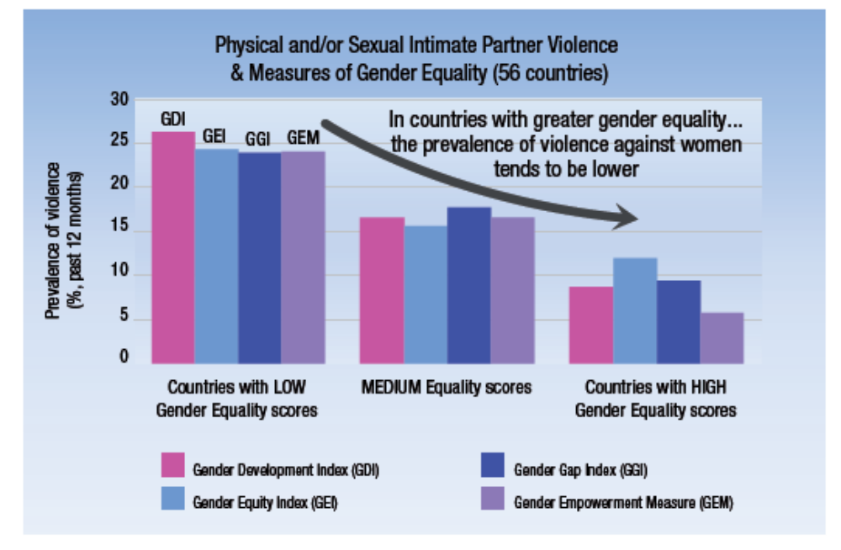

Preventing violence before it occurs

There is international consensus that violence against women can be stopped by tackling its causes – all of which are modifiable and can be eliminated. By addressing the underlying determinants and contributing factors of violence against women, we can prevent the problem from happening in the first place. This kind of intervention is known as primary prevention.

Currently in Victoria, there is a call to prevent violence against women before it occurs through actions guided by three themes (VicHealth 2007; Victorian Government 2012):

- Promoting equal and respectful relationships between men and women.
- Promoting non-violent social norms and reducing the effects of prior exposure to violence (especially on children).
- Improving access to resources and systems of support.

Initiatives to prevent violence against women must consider:

- universal strategies - that is strategies for the whole community
- selected or targeted strategies to reach those who can be missed through universal efforts (such as culturally and linguistically diverse or Aboriginal communities) and to build the capacity of specific groups to take action such as young people, men, women or carers of women with disabilities. (VicHealth 2007)

Addressing determinants of violence – the ecological model

To effectively address the key determinants and contributing factors of violence against women across all levels of causality, initiatives must have mutually reinforcing strategies that address factors across the levels of the ecological model (that is, societal, community/organisational and individual/relationship) (refer to Figure Two)
Figure 2. An ecological approach to understanding and preventing violence

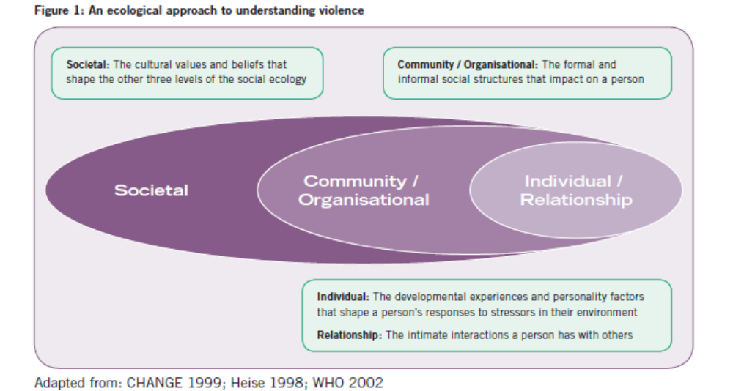

In order to address determinants and factors as they occur in lived experience, efforts should be located in everyday ‘settings’, such as: education and training, local government, health and community services, sports and recreation, workplaces, cultural institutions and networks, faith communities, other institutions (e.g. military), arts, media and popular culture and cyberspace and new technologies (VicHealth 2007;Victorian Government 2012).

In 2010, the European Commission developed an interactive online model with four levels of contributing/risk factors and three dimensional models illustrating the varying strengths and interactions between these factors. In 2011, the United Kingdom End Violence Against Women Coalition drew on this model to develop the policy implications associated with each level (refer to Figure Three) (Fergus 2012):

Figure Three. Policy implications for the four levels of contributing / risk factors to violence against women
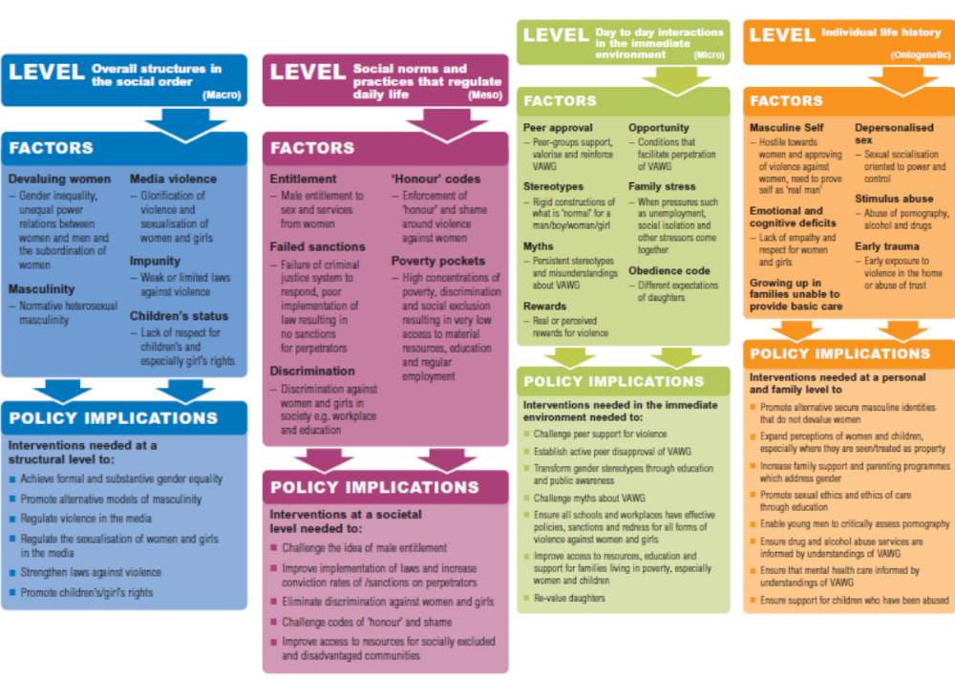

Preventing violence against women - a spectrum of strategies

In 2007, the VicHealth Prevention of Violence Against Women Framework and Discussion paper identified three levels at which strategies to prevent violence against women can be implemented. This framework has guided the development of the National and State plans.

Primary prevention – preventing violence before it occurs

Primary prevention strategies seek to prevent violence before it occurs. Interventions can be delivered to the whole population (universal) or to particular groups that are at higher risk of using or experiencing violence in the future (targeted or selective). Some primary prevention strategies focus on changing behaviour and/or building the knowledge and skills of individuals. However, the structural, cultural and societal contexts in which violence occurs are also very important targets for primary prevention. Strategies that do not have a particular focus on violence against women but address its underlying causes (such as gender inequality and poverty) are also primary prevention strategies.

Early intervention strategies – taking action on the early signs of violence

Early intervention (sometimes referred to as secondary prevention) is targeted at individuals and groups who exhibit early signs of perpetrating violent behaviour or of being subject to violence. Early intervention strategies can be aimed at changing behaviours or increasing the skills of individuals and groups. Violence against women takes many forms. It often begins with subtly controlling behaviours and escalates into a pattern of coercion and physical violence. At the individual level early intervention can seek to address controlling behaviours before they become established patterns. Early intervention strategies can also be targeted at environments in which there are strong signs that violence may occur (for example, peer groups or sporting clubs in which there is a strong culture of disrespect for women).

Intervention strategies – intervening after violence has occurred

Intervention (sometimes referred to as tertiary prevention) involves providing support and treatment to women and children who are affected by violence or to men who use violence. Intervention strategies are implemented after violence occurs. They aim to deal with the violence, prevent its consequences (such as mental health problems) and to ensure that it does not occur again or escalate. Intervention includes things such as crisis accommodation and social support for victims and criminal justice and therapeutic interventions for perpetrators.

At present the City of Melbourne provides family violence related support and services that are focused on the intervention and early intervention end of the prevention spectrum. We offer support to families (in particular women and children) through our family services, maternal and child health services, parenting services and family support and counselling services. The City of Melbourne support agencies and organisations to implement family violence and women’s safety related programs within our municipality through our Community Grants Program.

The City of Melbourne recognises that as a local government and a capital city council we will have a greater impact on addressing violence against women by focussing our new efforts on primary prevention and addressing the underlying determinants of violence against women i.e. gender inequality, social and cultural norms and access to resources and systems of support.

The Role of Local Government in the Primary Prevention of Violence against Women

Local government can play a leadership role in ‘resourcing’, ‘mainstreaming’ and ‘coordinating’ violence prevention strategies across the broad spectrum of government services, drawing upon the experience and wisdom of these existing services. Good practices in relation to the role of local government in preventing violence against women include:
- Providing local leadership and coordination
- Promoting a positive example to the community that violence is unacceptable
- Fostering partnerships for a whole of community response to preventing violence against women
- Advocating to all levels of government and to relevant local services to address violence against women
- Promoting integration of planning and actions to address violence prevention into other relevant strategies and programs of council
- Facilitating ongoing discussion, debate and information sharing regarding primary prevention of violence against women
- Maintaining awareness and providing input into state and federal policy relating to violence against women (Hayes, 2006 in Women’s Health West, 2010).

According to VicHealth’s 2009 National Survey on Community Attitudes to Violence Against Women, substantial proportions of the Australian population retain violence supportive beliefs regarding some issues, for example, just on half of the survey respondents believed that a woman could leave a violent relationship if she really wanted to. Local government are in an advantageous position to drive and embed positive cultural change through their ability to model appropriate attitudes and behaviours towards women (Hayes, 2006).

The work of local government in the primary prevention of violence is also underpinned and supported by a wide range of international, national, state and City of Melbourne instruments, legislation and policy including:

International
- United Nations Universal Declaration of Human Rights
- United Nations Declaration on the Elimination of Violence against Women 1993
- United Nations Convention for the Elimination of All Forms of Discrimination against Women

National
- Time for Action: National Plan to Reduce Violence against Women and their Children 2010-2022
- Sex Discrimination Act 1984
- Equal Opportunity for Women in the Workplace Act 1999
- Gender Equality Blueprint 2010

State
- Equal Opportunity Act 1995
- Occupational Health and Safety Act 2004
- Children Youth and Family Act 2005
- Child Wellbeing and Safety Act 2005
- Victorian Charter of Human Rights and Responsibilities Act 2006
- Human Rights and Equal Opportunity Commission Act 1996
- Local Government Act 1989
- Family Violence Protection Act 2008
- Victoria’s Action Plan to Address Violence against Women and their Children: Everyone has a responsibility to act 2012-2015
- Victorian Homelessness Action Plan 2011-2015
- The Sexual Assault Reform Strategy: A Right to Safety and Justice: Strategic Framework to Guide Continuing Family Violence Reform in Victoria 2010-2020
- Living Free from Violence – Upholding the Right: the Victoria Police Strategy to Reduce Violence against Women and Children 2009-2014
- VicHealth – Preventing violence before it occurs: a framework and background paper to guide the primary prevention of violence against women in Victoria 2007
- Municipal Association of Victoria Preventing Violence Against Women Leadership Statement
- Victorian Government - Family Violence Protection Act 2008
- Victoria Police Code of Practise for the Investigation of Family Violence 2nd edition (2010)

Regional
- Preventing Violence Together: Western Region Action Plan to Prevent Violence Against Women

City of Melbourne
- City of Melbourne Enterprise Bargaining Agreement 2010
- City of Melbourne Workforce Diversity Strategy and Action Plan 2011-2013
- City of Melbourne Workplace Stress Management Policy and Procedure
- City of Melbourne Employee Code of Conduct
- City of Melbourne Councillor Code of Conduct
- City of Melbourne Occupational Health and Safety Policy
- City of Melbourne People Assist Program Policy
- City of Melbourne HR Emergency and Influenza Pandemic Guidelines
- City of Melbourne Equal Opportunity, Discrimination and Harassment Prevention Policy
- City of Melbourne Strategy for a Safer City 2011-2013
- City of Melbourne Homelessness Strategy
- City of Melbourne as a signatory to the Victorian Local Government Women’s Charter
- City of Melbourne Children’s Plan
- City of Melbourne Young People’s Policy

What role can the workplace play?

It is estimated that two-thirds of women experiencing family violence are in paid employment which means workplaces provide a critical setting for intervention (McFerran, 2011).

There are a number of reasons for organisations and workplaces to take up health promotion messages: they have legal obligations with the new Victorian Equal Opportunity Act 2010 stating that employers have a positive duty to prevent harassment and discrimination.

There are economic reasons – In 2009, violence against women costs the Australian economy $13.6 billion. Economic modeling suggests that if we take no action, this cost will rise to $15.6 billion by 2021–2022, of which $456 million borne by employers. Workplace sexual harassment is estimated by one American study to cost $24,600 AUD per individual employee harassed, as cost which is mostly borne by employers. There are also significant economic benefits to organisations. Women as a population group are workers and they are a resource that can be better and more effectively tapped into. Workplace impacts of violence include anything from a lack of concentration at work, to women being employed at a lower level than their capacity to absenteeism to mental health issues such as depression and anxiety.

Another benefit of promoting health in and through workplaces is that there is currently momentum to do so – State and Federal governments, and the community more broadly, are supportive of workplaces playing a role in promoting gender equality and preventing violence against women.

And we know that organisations from a range of sectors, like to see themselves as ‘leaders in the field’. Whilst the issue of violence against women may not be a typical issue for workplaces to focus on, because workplaces play a critical role in determining the health of society if they take on health promotion as a core part of their work, as their ‘everyday business’ then they will have happier and healthier employees and workplace cultures and will be able to attract the best people and increase their productivity. (VicHealth, 2012)

For many people experiencing family violence the workplace is one of the few places, if not the only place, that they may be able to spend a significant amount of time away from the perpetrator. Thus the workplace is an ideal place for people experiencing family violence to seek support and work on a plan to put an end to the family violence they are experiencing without the perpetrator’s knowledge.

Even though the workplace may be a safe haven for many people experiencing family violence it is important to acknowledge it is not for all. Measures to protect the safety of fellow workers and the worker experiencing family violence often needs to be implemented by way of a work based safety plan.

Furthermore, the effects of family violence can have a negative impact on someone’s employment through a more disrupted work history and absenteeism, and employee rights to job security must be protected. In addition, employment is an important element for many victims of family violence to maintain economic independence, security and confidence, which in turn can enable them to leave a violent relationship.
Employers can play a tangible role in eradicating family violence by making provision for income security during a time when a worker seeks to deal with their violent situation.

The Australian Services Union advocates that measures to support workers who are experiencing family violence are a crucial health and safety issue and make good business sense. (ASU, 2011)

Workplaces, however, have a much greater role to play than simply supporting individuals who may be experiencing family violence. Workplaces are an important site for primary prevention. This is because they provide opportunities to address the social factors underlying family violence and can play a key role in creating and promoting values, norms and behaviours that are supportive of gender equality.
According to primary prevention experts when you engage individuals through workplaces, they take the skills they learn, their new attitudes, behaviors and beliefs into their families, their friendship groups and into the community.

Key findings of the VicHealth Bystander Research Project suggest that there is a potential leadership role for Victorian organisations in undertaking pro-social bystander action in support of preventing violence against women and that there is strong community support for this role. Organisations in the government, non-government, business and community sectors can create cultures, policies and working conditions that promote gender equality and respectful relationships, which will in turn have the effect of increasing bystander action from individuals and groups in the community (VicHealth, 2012a).

The Bystander research also suggests there is a current and immediate opportunity to strengthen formal and informal support in key settings (such as at the workplace, within sports clubs and within the family home) to enable more individuals and groups – especially among young people and men – to consistently and confidently respond to the social conditions that support violence against women.

What are the incidences of violence against women?

Victorian Public Hospital Emergency Dataset

According to Victorian Public Hospital Emergency Dataset for the Melbourne LGA for the 2004-5 to 2009-10 period (see table one), women make up 72% of all injury caused by “human intent” cases presented to the Victoria Public Hospital (Emergency). More than half of these women are aged between 18 to 34 years (with 33% aged 25-34 years; and 27% 18-24years). The majority of these women presented at the Royal Melbourne Hospital (38%) and the St Vincent’s Hospital (28%) (Refer to table one)

Table 1. Victorian Public Hospital Emergency Dataset – Injury Caused by Human Intent (Melbourne data)

 |  | Count | Percent
Gender of patient | Male | 17 | 28%
Gender of patient | Female | 43 | 72%
Gender of patient | Total | 60 | 100%
Patient age group | 17 years and younger | 1 | 2%
Patient age group | 18-24 years | 16 | 27%
Patient age group | 25-34 years | 20 | 33%
Patient age group | 35-44 years | 11 | 18%
Patient age group | 45 years and older | 12 | 20%
Patient age group | Total | 60 | 100%
Campus code | The Alfred (Prahran ) | 9 | 15%
Campus code | Royal Melbourne Hospital City Campus [Grattan Street] | 23 | 38%
Campus code | St Vincent’s Hospital (Melbourne) Ltd [Fitzroy] | 17 | 28%
Campus code | Royal Women’s Hospital [Carlton] | 6 | 10%
Campus code | Royal Victorian Eye & Ear Hospital [East Melbourne] | Cell sizes <5 and too small to report | 2%
Campus code | Mercy Public Hospitals Mercy Werribee Hospital | Cell sizes <5 and too small to report | 2%
Campus code | Royal Children’s Hospital [Parkville] | Cell sizes <5 and too small to report | 2%
Campus code | Austin Health The Austin Hospital | Cell sizes <5 and too small to report | 2%
Campus code | Ballarat Health Services [Base Campus] | Cell sizes <5 and too small to report | 2%
Campus code | Total | 60 | 100%

Source: Measuring Family Violence in Victoria: Victorian Family Violence Database Vol 5: Eleven year trend analysis 1999-2010 (Department of Justice, 2012)

Victoria Police family incidents reports

Victoria Police Crime Statistics for 2011-2012 show that the incidence of family violence in Victoria remains unacceptably high, with 50,382 family incidence reported, up by 23.4per cent from the previous year. The incidence of sexual assault is also disturbing with 2,044 incidents of rape recorded in Victoria in 2011-2012 up by 11.8 per cent from 2010-2011. This improved police response is the result of a number of major reforms in Victoria, including: Victoria Police Code of Practise for the Investigation of Family Violence (2004-2010); improved and standardised risk assessment and risk management practises; on-going education and training and more recently, the introduction of the Family Violence Protection Act 2008, including the introduction of the police issued Family Violence Safety Notices and a complementary state-wide communications campaign. (Dept of Justice, 2012)

Most violence against women is committed by men. According to the Victoria Police Crime Statistics for 2011-2012, women make up 75.8 per cent of family violence victims, 88.7 per cent of rape victims and 79.5 per cent of victims of sex (non rape) offences. Children were present in 36 per cent of family violence incidents attended by Victoria Police.

For the Melbourne local government area, the number of family incidents reported to Victoria Police has increased in the last year by 20% from 673 incidents in 2010/11 to 841 in 2011/12 (refer to Table Two). The number of Intervention Orders applied for (29%) and Safety notices issued (7.7%) has significantly increased over the last 12 months.
Table 2. Victoria Police Family Incidents Reports for Melbourne LGA for the period 2007/8 to 2011/12
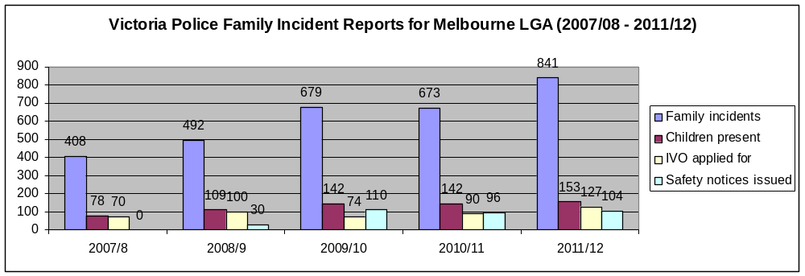
Data extracted from LEAP on 16 July 2012

What is the City of Melbourne planning to do to address violence against women?

Violence against women is a widespread problem around the world. It is recognised nationally and internationally as a serious breach of human rights, and has major health and economic consequences for women, families and communities. But violence against women is preventable; and our understanding of what is needed to stop the problem from occurring in the first place is now well developed.

On the 25 June 2012, the City of Melbourne joined the global campaign to prevent violence against women by becoming a White Ribbon City and a White Ribbon Campaign partner. At the celebration event the Lord Mayor stated… “the City of Melbourne will do what it can to end violence against women”.

Over the period 2012 -2016 the City of Melbourne will be developing and implementing a Prevention of Violence Against Women Strategic Framework and Action Plan to help prevent violence against women within our own workplace and in our municipality.

Community consultation and engagement

The City of Melbourne will be consulting with and engaging a number of internal and external stakeholders throughout the process of developing, implementing and reviewing the Strategic Framework and Action Plan. Below is a summary of the community consultation and engagement process (July - November 2012):

Development and dissemination of a Discussion Paper on the Prevention of Violence Against Women to:

- City of Melbourne staff / branches
- relevant advisory committees of Council i.e. Family and Children’s Services Advisory Committee, Disability Advisory Committee, Homelessness Advisory Community and the Melbourne Safe Community Committee.
- local service providers
- family violence experts
- violence against women prevention experts
- relevant State Government departments

In November – December 2012 we will host community and stakeholder workshops to assist with the development of a City of Melbourne Prevention of Violence Against Women Strategic Framework and Action Plan. The following groups will be invited:

- local service providers
- community groups i.e. Police and Community Consultative Committees, Residents Groups
- family violence experts
- violence against women prevention experts and networks
- survivors of family violence (women and their children)
- men’s support groups
- other local governments

In March 2013 we will present a draft City of Melbourne Prevention of Violence Against Women Strategic Framework (see pages 27 – 36 of this document) and Action Plan to Council’s Future Melbourne Committee for release for community consultation. Draft Strategic Framework & Action Plan will be sent to:

- City of Melbourne staff
- community groups i.e. Police and Community Consultative Committees, Residents Groups
- relevant advisory committees of Council i.e. Family and Children’s Services Advisory Committee, Disability Advisory Committee, Melbourne Safe Community Committee.
- violence against women prevention experts and networks
- local service providers
- other local governments
- relevant State Government departments

In May 2013 we will present the Final draft City of Melbourne Prevention of Violence Against Women Strategic Framework and Action Plan to Council’s Future Melbourne Committee for endorsement.

We need to talk
Preventing violence against women

________________________________________________

Draft Strategic Framework

Draft Strategic Framework

On the 25 June 2012, the City of Melbourne joined the global campaign to prevent violence against women by becoming a White Ribbon City and a White Ribbon Campaign partner. At the celebration event the Lord Mayor stated… “the City of Melbourne will do what it can to end violence against women”.

Over the period 2012-2016 the City of Melbourne will be developing and implementing a Prevention of Violence Against Women Strategic Framework and Action Plan to help prevent violence against women within our organisation and other workplaces, in the community and in the home.

Local, regional, national and international policy and research has been used to develop the draft guiding principles, vision, settings and objectives. This information has been prepared to help facilitate discussion and consultation with our key stakeholders including the community and should not be interpreted as the final plan.

The proposed Strategic Framework and Action Plan including the vision, objectives and actions are based on developing an integrated ‘road map’ for the City to prevent violence against women and children across our own organisation and other workplaces, communities and homes.

The Role of Local Government in the Primary Prevention of Violence against Women

Given the extensive role local government plays in creating safe public environments, developing community facilities and providing health and community services they are well placed to take active roles in preventing violence against women (VicHealth, 2007). Local government is in an advantageous position to drive and embed positive cultural change through their ability to model appropriate attitudes and behaviours towards women. Local council’s have the ability to demonstrate leadership in resourcing and coordinating strategies across a spectrum of government services, drawing upon the experiences of existing service providers (Hayes, 2006).

The work of local governement in the prevention of violence is underpinned and supported by a wide range of international, national, state and City of Melbourne instruments, legislation and policy including:

International
- United Nations Universal Declaration of Human Rights
- United Nations Declaration on the Elimination of Violence against Women 1993
- United Nations Convention for the Elimination of All Forms of Discrimination against Women

National
- Time for Action: National Plan to Reduce Violence against Women and their Children 2010-2022
- Sex Discrimination Act 1984
- Equal Opportunity for Women in the Workplace Act 1999
- Gender Equality Blueprint 2010

State
- Equal Opportunity Act 1995
- Occupational Health and Safety Act 2004
- Children Youth and Family Act 2005
- Child Wellbeing and Safety Act 2005
- Victorian Charter of Human Rights and Responsibilities Act 2006
- Human Rights and Equal Opportunity Commission Act 1996
- Local Government Act 1989
- Family Violence Protection Act 2008
- Victorian Homelessness Action Plan 2011-2015
- Victoria’s Action Plan to Address Violence against Women and their Children: Everyone has a responsibility to act 2012-2015
- The Sexual Assault Reform Strategy: A Right to Safety and Justice: Strategic Framework to Guide Continuing Family Violence Reform in Victoria 2010-2020
- Living Free from Violence – Upholding the Right: the Victoria Police Strategy to Reduce Violence against Women and Children 2009-2014
- VicHealth – Preventing violence before it occurs: a framework and background paper to guide the primary prevention of violence against women in Victoria 2007
- Municipal Association of Victoria Preventing Violence Against Women Leadership Statement
- Victorian Government - Family Violence Protection Act 2008
- Victoria Police Code of Practise for the Investigation of Family Violence 2nd edition (2010)

Regional
- Preventing Violence Together: Western Region Action Plan to Prevent Violence Against Women

City of Melbourne
- City of Melbourne Enterprise Bargaining Agreement 2010
- City of Melbourne Work force Diversity Strategy and Action Plan 2011-2013
- City of Melbourne Workplace Stress Management Policy and Procedure

- City of Melbourne Employee Code of Conduct
- City of Melbourne Councillor Code of Conduct
- City of Melbourne Occupational Health and Safety Policy
- City of Melbourne People Assist Program Policy
- City of Melbourne HR Emergency and Influenza Pandemic Guidelines
- City of Melbourne Equal Opportunity, Discrimination and Harassment Prevention Policy
- City of Melbourne as a signatory to the Victorian Local Government Women’s Charter

Links with existing City of Melbourne policies, plans and programs

The prevention of violence against women (PVAW) work aims to build on and strengthen the existing policies and programs the City of Melbourne has in place to address many of the underlying issues including health and wellbeing, crime and safety, homelessness, disability access, diversity and inclusion, gender equity, workplace occupational health and safety practises and emergency management:

- Council Plan & Municipal Public Health Plan
- Strategy for a Safer City 2011-2013
- Policy for the 24 Hour City
- Homelessness Strategy 2011-2013
- Children’s Plan
- Empowering Young People Policy 2010–13
- Disability Action Plan
- Multicultural Strategy
- HR Leadership Capability Framework
- HR Work Flexibility Policy
- HR Equal Opportunity, Discrimination and Harassment Prevention Policy
- HR Workplace Diversity Framework / Action Plan
- HR Women in Leadership Strategy
- My Mentor: challenging women to make it happen!
- HR Indigenous Employment Strategy
- HR Codes of conduct for staff and Councillors
- HR OHS Wellbeing Strategic Plan 2009-2013
- HR Workplace Stress Management Policy & Procedure
- Municipal Emergency Management Plan

Guiding principles and practices

Our approach to preventing violence against women will be based on eight principles. Each of these principles will be applied in the development and implementation of actions across the three settings outlined in the Action Plan:

1. Women’s and children’s rights to safety: Violence against women and their children is a violation of human rights and therefore we have a commitment to exercise due diligence. We need to address the root causes of violence against women and their children, such as structural inequalities between men and women, issues of power and control and gender discrimination. We also need to foster an ‘inclusive human rights culture’ to prevent violence against women from occurring

2. Empowering women to make changes in their lives and society: We need to empower women, economically, politically or in other ways, to make changes in their lives and in society. Women survivors, particularly service users, should play a key role in program design, implementation and evaluation. Effective interventions are those that are based on understanding the needs articulated by women themselves and not on behalf of women.

3. Men as perpetrators and as role models in prevention: We need to support and advocate for prevention programs that target men. Programs that acknowledge men’s responsibility as perpetrators of violence and establish appropriate prosecution and treatment measures, as well as programs that engage non-violent men as positive role models, as pro-social bystanders, activists in preventing violence against women and as advocates for gender equality in all spheres.

4. Commitment and leadership across all levels of government: Good practices are those that are based on and supported by a clear political will from national, state and local authorities. Leaders at all levels can influence how violence against women is perceived and can play a role in changing societal tolerance for this problem.

5. Evidence-based approaches: All effective interventions are underpinned by accurate empirical data about the scope of violence against women, its causes and its consequences for individual women survivors but also for family members and society at large.

6. Coordination, collaboration and partnerships to bring about change: To be an effective change agent we need to work with a broad range of professionals and services from the national to the community and grass-roots level and forge partnerships across traditional and non traditional sectors.

7. Sharing of knowledge, skills and training: The use of knowledge-exchange, educational programs and training should be integrated into routine staff development.

8. Monitoring and evaluation our strategy and action plan: Our strategy, approach and projects will include in its design a plan to monitor and evaluate to show the progress and impact achieved.

Our Vision

Women and children in the municipality of Melbourne live safely and are free from violence. Relationships between women and men are healthy, equal and respectful

It is our intention to develop actions under the following three settings:

Setting One. In our organisation and other workplaces

Objectives:
- Promote equal and respectful working relationships between men and women
- Reduce the effects of staff exposure to violence
- Increase staff knowledge and response to family violence
- Position the City of Melbourne as a leading organisation across Victoria and Australia in the prevention of violence against women

Setting Two. In the Community

Objectives:
- Promote cultural change to support a safe and inclusive community
- Raise awareness of violence against women and children in the community
- Foster relationships, organisations, communities and cultures that are gender equitable and non violent

Setting Three. In the Home

Objectives:
- Promote healthy, equal and respectful relationships between men, women and children in families
- Improve survivors and perpetrators access to resources and systems of support

Opportunity for Community & Stakeholder input

Now that you have read the Discussion Paper and Draft Strategic Framework, we need your assistance in helping us shape the Prevention of Violence Against Women Strategy and Action Plan.

1. Are there any comments you would like to make regarding our vision, guiding principles or settings for action?

- Are you aware of any programs, activities or services that you consider to be effective and innovative in preventing violence against women that the City of Melbourne should explore?

- Which of the following activities and/or programs should the City of Melbourne focus on to PREVENT violence against women?

(Choose your preferred five activities in order of preference with 1 being ‘most important’ and 5 being ‘somewhat important’)
- Raise community awareness of the prevalence and impacts of violence against women
- Provide and promote gender equitable services, programs, activities and events
- Build the knowledge and skills of communities to prevent violence against women
- Bring organisations and agencies together through a local primary prevention network
- Provide leadership to other local councils and workplaces
- Facilitate and / or promote local services and support groups for women, men and children
- Promote leadership opportunities for women
- Promote positive images of capable and competent women and girls
- Promote male role models
- Enhance individuals access to prevention of violence against women information and pathways for support
- Other (please state) ______________________

- Are there any other comments you would like to make regarding the issue of prevention of violence against women in our community?

For further information:
Contact the City of Melbourne on 9658 9658 or visit our website on: www.melbourne.vic.gov.au/preventingviolence

References

Australian Bureau of Statistics (2006) Personal safety survey.

Australian Housing and Urban Research Institute (2011) Homelessness prevention for women and children who have experienced domestic and family violence: innovations in policy and practice. www.ahuri.edu.au/publications/download/50602_pp

Australian Human Rights Commission (2012) Working without fear: results of the sexual harassment national telephone survey 2012 at
http://www.humanrights.gov.au/sexualharassment/survey/SHSR_2012%20Web%20Version%20Final.pdf

Australian Institute of Health and Welfare (2011) Government-funded specialist homelessness service SAAP National Data Collection annual report for 2009-2010 Australia Canberra Cat. no. HOU 246 http://www.aihw.gov.au/WorkArea/DownloadAsset.aspx?id=10737419171&libID=10737419170

Australian Services Union (2011) Family violence is a workplace issue at http://www.dvandwork.unsw.edu.au/download/file/fid/15

Department of Justice (2012) Measuring Family Violence in Victoria: Victorian Family Violence Database Volume 5: Eleven year trend analysis 1999-2010.

Family Violence Services - Child FIRST/Family Services - Child Protection (2010) Think Child Partnership Agreement for the North and West Metropolitan Region

Fergus, L (2012) Prevention of violence against women and girls Background paper by Lara Fergus, Australia for the UN Women in cooperation with ESCAP, UNDP, UNFPA, UNICEF and WHO Expert Group Meeting Prevention of violence against women and girls in Bangkok, Thailand 17-20 September 2012 http://www.unwomen.org/wp-content/uploads/2012/09/cs557-EGM-prevention-background-paper.pdf
Hayes, T. (2006). Gender, Local Governance and Violence Prevention, Learning from International Good Practice to develop a Victorian Model. VicHealth, Melbourne

Inner East Primary Care Partnership (2011) Inner East Prevention Violence Against Women Discussion Paper

McFerran, L (2011) Safe at Home Safe at Work? National Domestic Violence and the Workplace survey Australian Domestic Violence Workplace Rights and Entitlement Project, Centre for Gender Related Violence Studies, UNSW.

Mitchell, L (2011) Domestic Violence in Australia – an overview of the issues, Social Policy Section, Department of Parliamentary Services

Municipal Association of Victoria (2012) Family Violence: Issues for Local Government Summary
http://www.mav.asn.au/policy-services/social-community/gender-equity/Related%20documents%20%20Research%20%20data/Family%20violence,%20issues%20for%20local%20government.doc

Organization for the Security and Cooperation in Europe (2009): Bringing Security Home: Combating Violence Against Women in the OSCE region: A compilation of good practices. OSCE Secretariat, Office of the Secretary General, Gender section.

VicHealth (2007) Preventing violence before it occurs: A framework and background paper to guide the primary prevention of violence against women in Victoria. Victorian Health Promotion Foundation.

VicHealth (2010) National Survey on Community Attitudes to Violence Against Women 2009: Changing cultures, changing attitudes – preventing violence against women. Victorian Health Promotion Foundation.

VicHealth (2011) Preventing violence against women in Australia: Research summary. Victorian Health Promotion Foundation.

VicHealth (2012a) More than ready: Bystander action to prevention violence against women in the Victorian community research report. Victorian Health Promotion Foundation.

VicHealth (2012b) Preventing violence against women in the workplace: An evidence review: full report. Victorian Health Promotion Foundation.

United Nations (1993) General Assembly 85th plenary meeting 20 December 1993 Ref 48/104. Declaration on the Elimination of Violence against Women http://www.un.org/documents/ga/res/48/a48r104.htm

Women’s Health West (2010) Preventing Violence Together: Western Region Action Plan to Prevent Violence Against Women

World Economic Forum (2011) Global Gender Gap Report 2011. http://www3.weforum.org/docs/WEF_GenderGap_Report_2011.pdf

