Acknowledgement of Traditional Custodians
The City of Melbourne respectfully acknowledges the Traditional Custodians of the land, the Bunurong Boon Wurrung and Wurundjeri Woi Wurrung peoples of the Eastern Kulin Nation and pays respect to their Elders past, present and emerging. We are committed to our reconciliation journey, because at its heart, reconciliation is about strengthening relationships between Aboriginal and non-Aboriginal peoples, for the benefit of all Victorians.
Purpose of this Document

This plan is the Council’s key strategic document. It describes the Council’s and community’s vision for the future, how the Council will strive towards that vision during its four-year term, where it will focus its efforts, and how it will measure progress. It also outlines how the Council will protect, improve and promote public health and wellbeing within the municipality.
This plan is the result of deliberative engagement with a broad cross-section of the community, who are defined as people who live, work, study, visit or own a business in the municipality. These engagement processes have brought the voice of the community to Council and helped shape the long-term direction of the municipality and key components of this plan.
As such, this plan considers the needs of all people who access and experience all neighbourhoods and places within the City of Melbourne municipality.

Table of Contents

Acknowledgement of Traditional Custodians 2
Purpose of this document 3
Introduction
Council and what we do 6
Municipal snapshot 6
Melbourne city council 2020–2024 9
Council Plan
City context 11
How to read this document 12
Community Vision 13
Council’s strategic objectives 15
Health and wellbeing in our city 28
Next steps 31
Glossary 34
Appendixes 36
Appendix A: Integrated planning and reporting framework 37
Appendix B: About this Council Plan 39
Appendix C: How this plan was developed 40
Appendix D: Council’s strategies 42
Appendix E: Council’s services 45
Appendix F: Health and Wellbeing Plan summary 47
Bibliography 51

Introduction
Council and what we do
Local councils are responsible for the governance and delivery of services that support the community at the municipal level. This includes planning and building services, waste management, local laws and emergency management and recreation and community services.
In governance terms, local councils are elected by, and accountable to, the people who live and do business within the municipality. As such, the importance of being responsive to the voices in the community is critical to success.
Municipal Snapshot
The City of Melbourne is a dynamic municipality with a broad set of neighbourhoods, each with its own unique characteristics and needs – from densely populated urban environments, such as the central business district, to more residential areas, such as Kensington, Carlton and South Yarra.
Municipality map
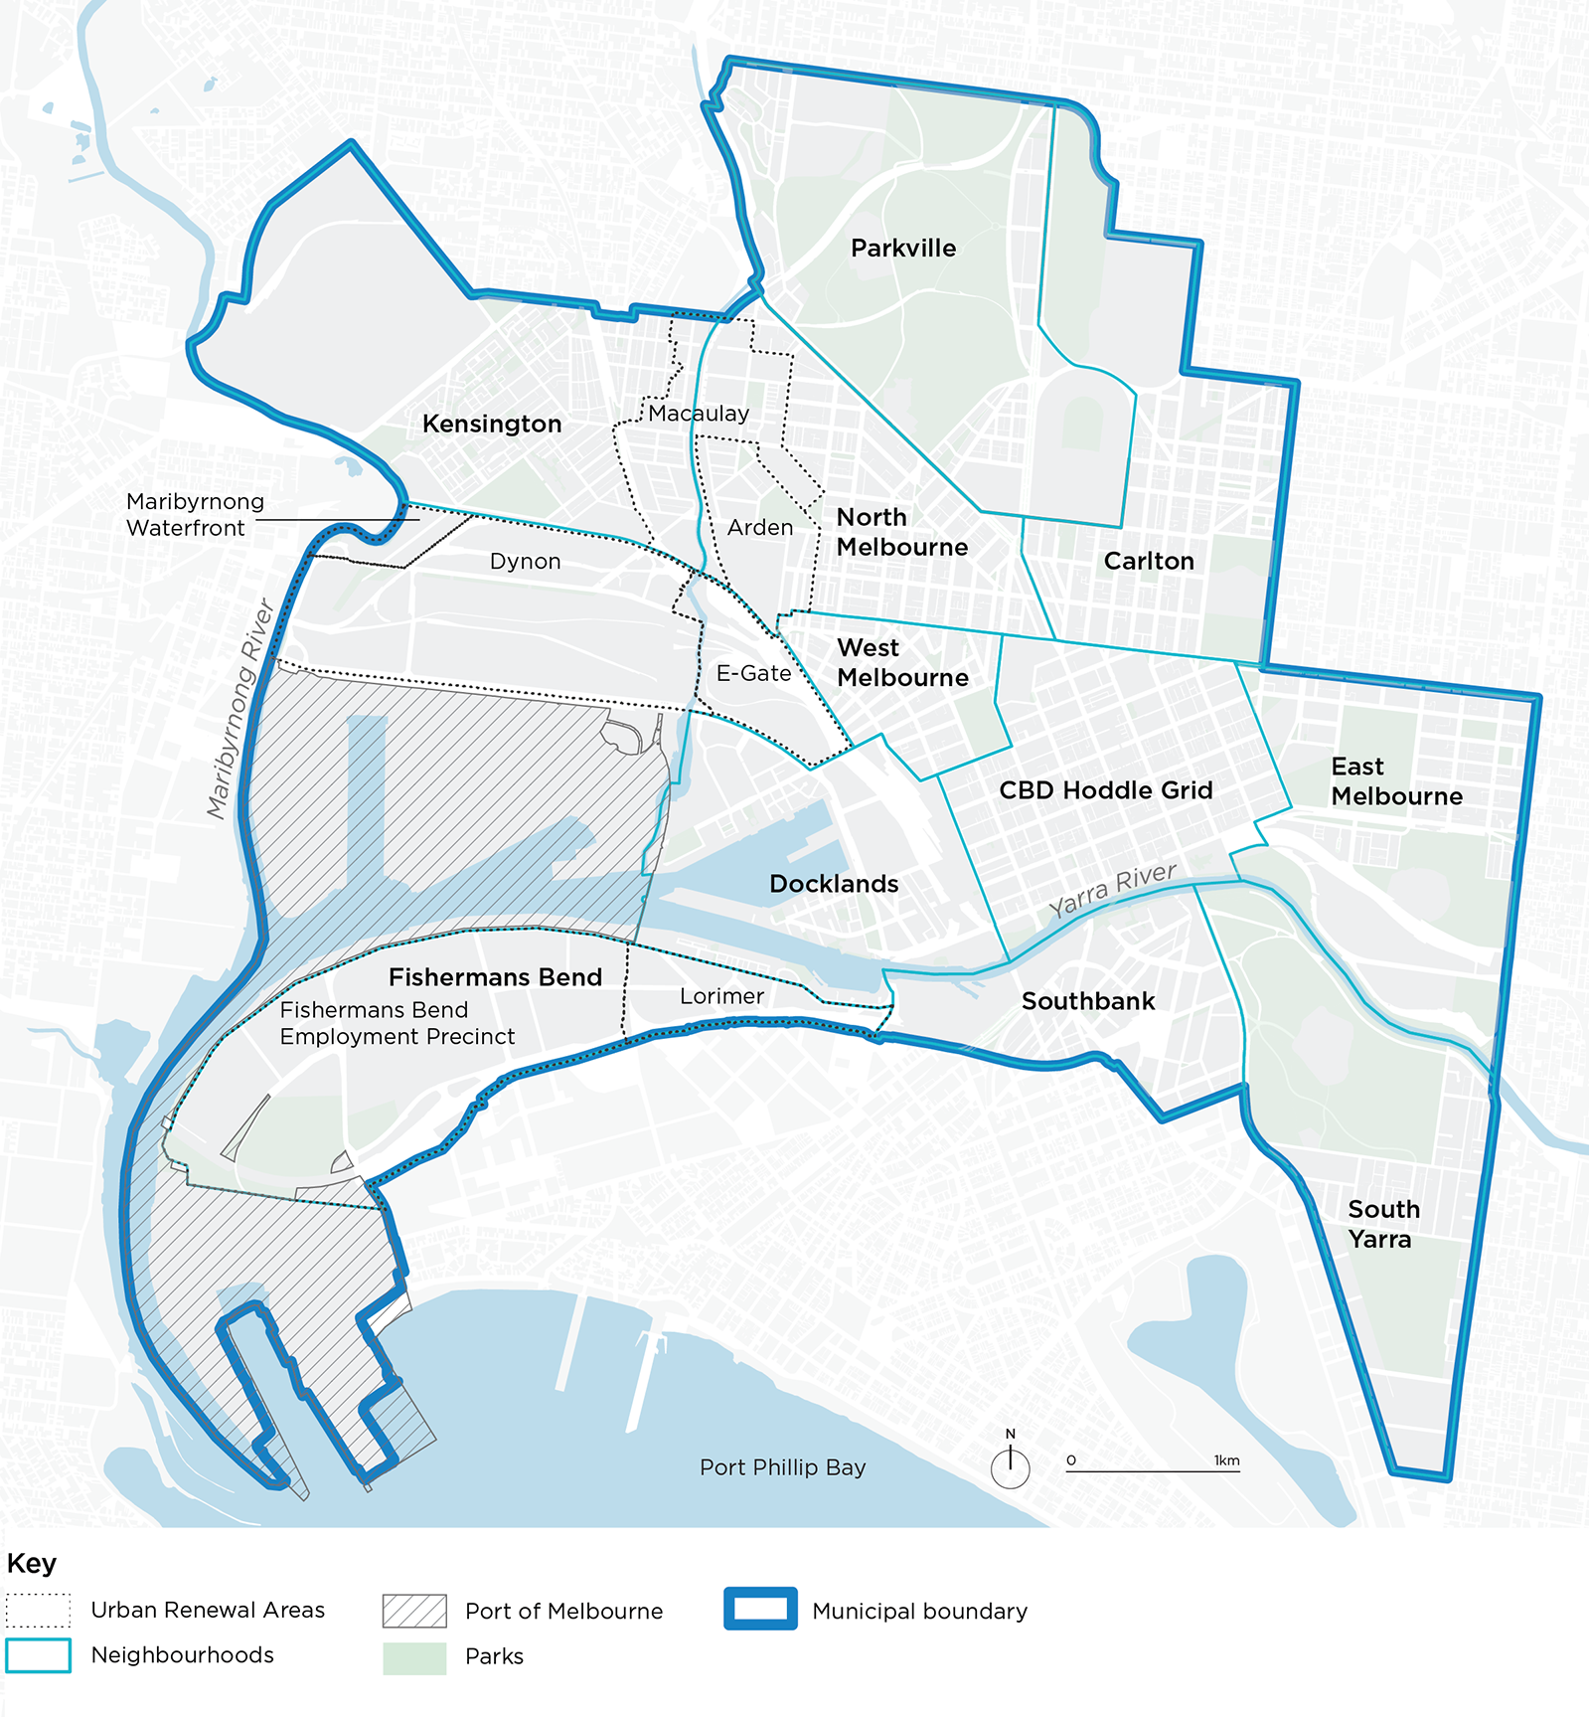
The diversity of the municipality is evident in our demographic and urban profile:
(Disclaimer: Unless otherwise stated, the figures below typically reflect pre-COVID-19 data. This does not take into consideration impacts stemming from the pandemic and therefore should not be taken as a current reflection of the city.)
Resident population
- 183,756 residents
- 49% males, 51% females
- 56% born overseas
- 48% speak a language other than English
- 1,653 same-sex couple households
- 468 Aboriginal people
- 1.7% live with a disability
- 100 people sleeping rough*
- 910,800 people live, work, study or socialise in the municipality
- 79,230 overseas students
* This is lower than historic numbers due to a proportion currently being provided temporary hotel emergency accommodation during the COVID-19 pandemic.
Economic environment
- Melbourne contributes 24% to the Victorian economy
- 16,700 businesses
- 497,200 jobs
- 3.7% unemployment rate
- 32% of households experience rental and mortgage stress
- 33% experience food insecurity

Built and natural environment
- 92% residents live within a 300m walk to open space
- 71% of trips to the city are made by public transport, cycling or walking
- 65% grow and consume their own food at home
- 23.5% tree canopy cover in the public realm
- 27 tonnes of greenhouse gas emissions per capita, an annual decrease of 0.8%
- 0.35 tonnes of landfill waste per household
- 120.5 kilolitres from alternative water sources used to meet municipal needs

Social and cultural environment
- 63.9% feel a sense of belonging to their community
- 94.4% believe the relationship with Aboriginal people is important
- 21.1% participate in arts and cultural activities
- 82.5% feel safe during the day
- 53.7% feel safe at night
- 929 per 100,000 reported incidences of family violence

Health and wellbeing status
- 18% experience high or very high psychological distress in their day-to-day lives
- 22% have been diagnosed with depression or anxiety
- 15% have sought help from a mental health professional
- 93% of adults do not eat enough fruit and vegetables
- 52.7% of adults do not engage in sufficient physical activity
- 22% sit for 8+ hours on an average weekday
- 9.4% currently smoke

People’s health and wellbeing were significantly impacted by the COVID-19 pandemic and lockdown restrictions. More than half of those surveyed reported the aspects of their lives most impacted by the COVID-19 pandemic included participation in leisure and events, social connection, exercise, mental health and work. Of particular note:
Impacts of COVID-19
- 37% consumed more alcohol than usual
- 10% smoked more
- 62% exercised less
- 27% reported eating less healthy food

In contrast:
- 16% exercised more
- 16% ate more healthy food
- 16% drank less alcohol
- 4% smoked less than usual
People rated their wellbeing at 51.5 out of 100 in late 2020 (compared to historic scores of around 71).

Melbourne City Council 2020–2024
The current Council was elected in November 2020 on a four-year term. The Council is made up of eleven elected councillors, including the Lord Mayor and Deputy Lord Mayor.
Lord Mayor Sally Capp
03 9658 9658
lordmayor@melbourne.vic.gov.au
Deputy Lord Mayor Nicholas Reece
03 9658 9704
nicholas.reece@melbourne.vic.gov.au
Councillor Olivia Ball
03 9658 9086
olivia.ball@melbourne.vic.gov.au
Councillor Roshena Campbell
03 9658 9043
roshena.campbell@melbourne.vic.gov.au
Councillor Jason Chang
03 9658 9038
jason.chang@melbourne.vic.gov.au
Councillor Elizabeth Mary Doidge
03 9658 9636
ElizabethMary.Doidge@melbourne.vic.gov.au
Councillor Davydd Griffiths
03 9658 9056
davydd.griffiths@melbourne.vic.gov.au
Councillor Jamal Hakim
03 9658 8580
jamal.hakim@melbourne.vic.gov.au
Councillor Philip Le Liu
03 9658 9630
philip.leliu@melbourne.vic.gov.au
Councillor Rohan Leppert
03 9658 9051
rohan.leppert@melbourne.vic.gov.au
Councillor Kevin Louey
03 9658 9170
kevin.louey@melbourne.vic.gov.au
Postal address for all councillors
City of Melbourne
GPO Box 1603
Melbourne VIC 3001
Council Plan

City Context
Melbourne stands on the land of its Traditional Custodians, the Bunurong Boon Wurrung and Wurundjeri Woi Wurrung peoples of the Eastern Kulin Nation. It has always been an important meeting place, for thousands of years before European settlement and into our shared future.
This multicultural, modern city boasts a diversified economy and a passion for sporting and cultural events. It is one of the most liveable cities in the world, renowned for its world-class culture, universities and connected neighbourhoods.
Until early 2020, Melbourne was the fastest-growing city in Australia, and among the fastest-growing cities in the developed world. The global COVID-19 pandemic has since transformed the local landscape and put pressure on our communities and businesses and presented several challenges that Melburnians have adapted to with characteristic resilience.
However, the events and uncertainties of the past year have shifted our perception of what it means to be a liveable city. The pandemic has highlighted deep vulnerabilities in our social, environmental and economic fabric, and a need to better protect the systems, people and environment that sustain the city. This means we need to work together to share our ideas about the future of Melbourne, and to develop a vision we all can aspire to.
We have engaged with and listened to businesses, communities and government bodies across the city to understand what matters most to them, and to understand how Melbourne can evolve over the medium to long-term to be a truly great place for all.
We need to create a city and community where everyone feels culturally connected, safe and included. We need to create a city that is equitable and prosperous - and that values the wellbeing of both our people and the planet. We need to create a city that helps our unique and diverse mix of people, cultures and communities to adapt, survive and thrive. We need to create a city of endless possibility.
We must also lead by example and meaningfully engage with Aboriginal communities to build respect for Aboriginal heritage, culture and knowledge. Aboriginal voices and aspirations must be embedded in our core business and decision-making at every level as we strive for reconciliation, recognition, respect and truth telling.
We are sharpening our focus and finding ways for the city to evolve so that everyone can thrive, and Melbourne remains a unique and sustainable city where anything is possible, both now and for years to come.

How to read this document
This document contains three main components: the 10-year Community Vision, four-year Council Plan, and four-year Health and Wellbeing Plan. These pieces of work are presented here as a single integrated document because they are linked and have a cascading relationship.
Describes the community's 10-year aspirational vision for the future of the municipality.  This constitutes the  ‘call to action’ guiding all Council planning. | Community vision
 | Vision statement
 | Community aspirations
Council objectives represent the strategic direction for the next four years to achieve the Community Vision. | Council Plan
 | Council objectives
Council priorities describe the outcomes that the plan seeks to achieve and how we will fulfil our strategic objectives. | Priorities
Major Initiatives are critical pieces of work that will deliver on Council’s objectives and priorities. | Major initiatives
Indicators define how we will measure success. | Indicators
The Health and Wellbeing Plan outlines how the Council will protect, improve and promote public health and wellbeing within the municipality.  The key focus areas in this plan have strong connections across Council Plan, refer to page 28. | Health and Wellbeing Plan
Focus areas
The ♥ symbol throughout this plan denotes which priorities and major initiatives outlined in this Plan align with, and contribute to, addressing our city's health and wellbeing focus areas.
Community Vision
The Community Vision for the City of Melbourne was developed through a deliberative engagement process with people who live, work, study, visit or own a business across the municipality. The vision reflects this diverse set of voices collectively.
A detailed account of our deliberative engagement process can be found at Appendix C.
The Community Vision comprises an overarching vision statement and a series of future community aspirations. Together, these will guide decision makers in shaping policy, plans and prioritising investments.
VISION STATEMENT
Melbourne was hit hard by COVID-19 and together we experienced one of the world’s longest and most restrictive lockdowns. Our efforts enabled life to return to a new normal, but it has come at an incredible cost.
Now we have an opportunity to think about how we want to evolve as a city over the next 10 years and be bold in creating a better future for Melbourne. We need to build on today’s strong foundations to be a city that thrives as a place that benefits all. We’re creating a city of possibility, where the world meets and the extraordinary happens.
City of Melbourne. City of Possibility.
Our city is where people of all cultures, backgrounds, genders, sexualities and abilities are welcomed, celebrated and protected. We are proud of the vibrancy this diversity brings to every aspect of city life. Our urban communities are energy efficient, sustainable, safe, affordable and inclusive, drawing people from around the world to visit, work and live.
Our distinct neighbourhoods are enjoyed day and night. Every street, laneway and public square is filled with movement, colour and excitement. The sights and sounds of sport, performance, art and public discourse flow through the streets and continually inspire us.
Our many urban parks provide us a place for reflection and respite. A forest extends through our city, linking our parks and helping to keep our city cool and clean. We can connect with nature anywhere and celebrate our leading action on climate change.
We are one of the most connected cities in the world, where collaboration is second nature and innovative start-up, business and education sectors thrive as a result.
When we meet, we look out at one of our favourite places in the municipality—the beautiful Birrarung—and acknowledge and celebrate our Traditional Custodians of the land, part of the longest surviving culture in the world. Melbourne is an Aboriginal city where we govern with our Traditional Custodians and all have a shared commitment towards treaty, justice and reconciliation with our
First Peoples.
The City of Melbourne is a city of possibility.
Where the world meets and the extraordinary happens.

COMMUNITY ASPIRATIONS
Our community aspirations summarise what the community wants for the municipality over the next 10 years. These aspirations have helped guide the development of this Council Plan.
The community’s aspirations for the future... | In 10 years, this should look like… | Council’s four-year objectives in response
There is diversity in Melbourne's workforce  We support Melbourne's existing and new industries  Industries and communities are supported by a strong transport network | The City of Melbourne champions diversity in the workforce, driving a stronger and more resilient economy, with opportunity for all.  The creative energy of the municipality is harnessed and enhanced to be a defining feature of Melbourne’s unique character and contributes to its ongoing economic resilience and viability.  An efficient and affordable transport network is a basic element of an accessible city and a strong economy. | Economy of  the future
We celebrate and protect Melbourne's unique places  Celebration of diversity is at the heart of a liveable city | Melbourne’s unique streetscapes, open and green spaces, built environment and neighbourhood character are protected and enhanced as the city grows and evolves.  There is an opportunity for events to celebrate Melbourne's diversity to improve connections between local communities and create a sense of belonging in the city. | Melbourne’s unique identity and place
Aboriginal cultures are central to Melbourne's identity | Traditional knowledge is implemented practically and can be experienced by the whole community, so that Melbourne is seen, experienced and thought of as an Aboriginal city. | Aboriginal Melbourne
Buildings are built to the highest environmental standards  We have taken urgent action on climate change  We prioritise nature in our city | Planning provisions guide development in the city and ensure that our neighbourhoods and buildings are built to the highest quality and environmental standard.  The City of Melbourne commits to renewable energy and circular economies to ensure Melbourne remains liveable for future generations.  The city continues to strengthen its dense network of green streets and spaces so that plants and animals can thrive and communities can come together. | Climate and biodiversity emergency
Melbourne is affordable  The design of our city is inclusive  The community participates in city decisions | Our city remains vibrant and diverse by being affordable for everyone.  The city is made up of safe and accessible places and services where everyone can come together.  Members of the community feel empowered to contribute their ideas and knowledge to the decision-making process, finding solutions to complex problems that will work for everyone. | Access and affordability
The community is connected to each other  People feel safe in the city  Health and wellbeing is prioritised | The city's places and spaces bring people together and create spaces where they feel supported and can foster a sense of belonging.  All people who work in, live or visit the city can do so, and feel safe, at any time of the day or night.  The City of Melbourne's policies, spaces and services support the community's physical health and mental wellbeing for the benefit of all. | Safety and  wellbeing

Council’s Strategic Objectives
In response to the Community Vision, Council has developed the strategic objectives for the next
four-year Council Plan. These are outlined below and set the direction for the next four years. Our vision for Melbourne as a ‘city of possibility’ anchors and connects these objectives to deliver real outcomes for the community.
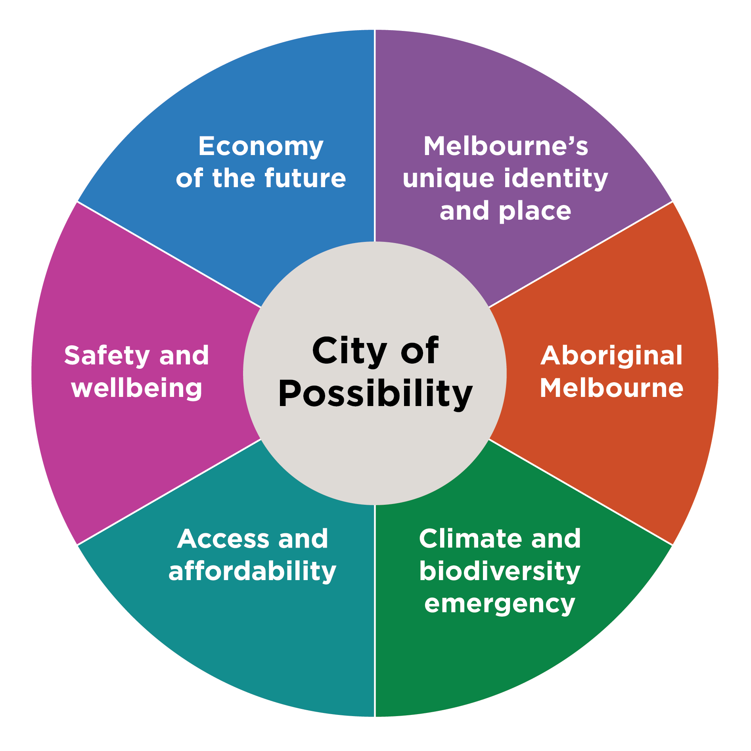

Economy of the future
Over the next four years, we will focus on driving economic recovery and creating the conditions for a strong, adaptive, sustainable and thriving future city economy supported by a diverse mix of industries and jobs that provide dignity and opportunity.
Our priorities
- The city economy is stronger, resilient and fully recovered from the impacts of COVID-19.
- Existing businesses are supported, new businesses, talent and investment are attracted to the city and our growing residential community has access to employment in the municipality.
- Increased economic participation, with a city economy that is more inclusive and fair, enabling residents access to employment and key workers access to accommodation in the city. ♥
- Doing business in the city is made more attractive by streamlining processes and alleviating costs.
- The central city is a magnet for events and has a strong reputation as a destination to visit, do business, study and live.
- A financially sustainable and highly effective City of Melbourne organisation.
- Melbourne is a digitally connected city that embraces new industries to create next-generation jobs and businesses.
♥ Aligns with a health and wellbeing focus area, refer to page 28.
How we’ll measure progress
Indicator | Target or desired trend
Capital city gross local product. | Increase
Number of businesses in the municipality. | Increase
Number of start-ups in the municipality. | Increase
Vacancy rate of retail premises. | Decrease
Proportion of residents employed in the municipality. | Increase
Gross local product per capita per person employed. | Increase
Number of jobs in the municipality. | Increase
Number of visitors to the municipality. | Increase
Planning applications decided within required timeframes. | 100%

Major initiatives
Major initiative | Council’s role
Continue to strengthen Melbourne's economic recovery, including through precinct and shopfront activation, delivery of an enhanced business concierge service and support for the night-time economy. ♥ | Deliver
Ensure Melbourne is the easiest place to start and grow a business through the establishment of Invest Melbourne which will facilitate headquarter attraction, business support and fast-tracked permits. | Deliver
Drive economic growth and resilience by implementing the Economic Development Strategy, focusing support on existing and emerging industry sectors. This will include close collaboration with industry and universities, development of globally competitive innovation districts (particularly in our renewal areas), strengthening of the creative sector, facilitation of digital and technology innovation, support for re-establishment of international education and efforts to unlock climate capital. | Deliver  Partner
Work in partnership with the Victorian Government and other stakeholders to advocate for and deliver integrated high-quality public and active transport in urban renewal areas including Melbourne Metro 2, tram to Fisherman’s Bend and tram to connect the Arden precinct. ♥ | Partner
Establish a new tourism entity called Visit Melbourne and review and refresh the program of City of Melbourne-owned and sponsored events to maximise opportunities to drive visitation and spend. The program will be diverse, accessible and affordable and showcase Melbourne's unique culture and creative strengths. | Deliver  Partner
Market and promote Melbourne as a great place to live for all, while ensuring key workers have access to affordable housing. ♥ | Deliver
Increase visitation to Docklands by partnering with the Victorian Government and key stakeholders to enable reconstruction and redevelopment in Central Pier and surrounds. | Partner  Advocate
Review Melbourne’s international relationships to optimise future and existing partnerships to enable mutual growth and opportunity. | Deliver
Partner with industry to support the development of globally competitive innovation ecosystems, including through international engagement, emerging technology trials and digital infrastructure delivery. | Partner  Deliver
Develop a corporate strategy for the City of Melbourne to drive exemplary customer service, digitise services and operations, improve productivity and identify new revenue opportunities. | Deliver
Embed the Sustainable Development Goals in the way City of Melbourne plans, prioritises its investments, reports and benchmarks against other cities. | Deliver

Melbourne’s unique identity and place
Over the next four years we will celebrate and protect the places, people and cultures that make Melbourne a unique, vibrant and creative city with world-leading liveability.
Our priorities
- Our environment, parks and waterways are protected, restored and managed well. ♥
- Our built, natural and cultural heritage is protected.
- New buildings, streets and spaces exhibit design excellence to create sustainable and enduring places and our renewal areas are emerging as high-quality inner-city precincts.
- Melbourne's diverse communities are celebrated. ♥
- Melbourne’s creative, entertainment and education sectors are supported and nurtured.
- Drawing on the full potential of Melbourne’s creative community is central to city planning, design and city operations.
- Melbourne is a university city and aspires to be the number one knowledge city in the world by 2030.
♥ Aligns with a health and wellbeing focus area, refer to page 28.
How we’ll measure progress
Indicator | Target or desired trend
Proportion of residents within 300m of public open space. | Increase
Proportion of people surveyed who visit a park in the municipality on a regular basis. | Increase
Area of new public open space in Southbank. | 1.1ha (by 2025)
Neighbourhoods in the municipality with up-to-date local heritage studies and controls. | 100%
Proportion of people who support the city being made up of different cultures. | 100%
Value of the creative sector to the local economy. | Increase
The number of creative spaces in the municipality. | Increase
The number of artists supported by City of Melbourne through city planning, design and city operations. | Increase
The number of design reviews of major projects. | Increase

Major initiatives
Major initiative | Council’s role
Partner with the Victorian Government and other stakeholders to deliver specific components of Greenline along the north bank of the Yarra River (including the implementation of the Yarra River – Birrarung Strategy). ♥ | Deliver  Partner
Protect Queen Victoria Market as a traditional open-air market, through heritage restoration and the provision of essential services and facilities that enhance the customer and trader experience, including projects such as the Shed Restoration, Food Hall, Trader Shed, Market Square, waste and logistics facility and future developments to the south of the market. ♥ | Deliver
Deliver Queen Victoria Market precinct improvements through quality public open space, new connections to the city, community services and facilities such as the Munro Community Hub. ♥ | Deliver  Partner
Deliver public art projects that reflect Melbourne's unique culture and heritage, attract visitors to the city and help stimulate our city's recovery. ♥ | Deliver
Increase the amount of public open space in the municipality with a focus on areas of greatest need, such as Southbank and emerging urban renewal areas. ♥ | Deliver
Play a lead role in facilitating the delivery of high-quality and climate adapted urban renewal in Arden and Macaulay, Fishermans Bend, and Docklands to deliver the emerging and future neighbourhoods of Melbourne in partnership with the Victorian Government and other partners. In Arden and Fishermans Bend, realise the place and investment conditions to support globally competitive innovation districts. | Partner
Facilitate increased investment in unique Melbourne events to further activate and celebrate the city. | Partner
Celebrate, partner and advocate for investment in the city's three key waterways, the Yarra River – Birrarung, the Maribyrnong and Moonee Ponds Creek, to connect these key recreational and biodiversity assets of our city. | Partner  Advocate
Adopt the Municipal Planning Strategy in 2022-23 | Deliver
Complete heritage reviews and implement associated planning scheme amendments to protect and celebrate heritage in our municipality. | Deliver
Champion high quality development and public realm design through delivering the Design Excellence Program, including implementing the City of Melbourne Design Review Panel and a Design Excellence Committee for strategic planning work. | Deliver

Aboriginal Melbourne
For the Wurundjeri, Bunurong, Taungurung, Dja Dja Wurrung and Wadawurrung peoples of the Eastern Kulin, the place now known as Melbourne has always been an important meeting place and location for events of political, cultural, social and educational significance. Over the next four years, we will ensure that First Peoples’ culture, lore, knowledge, and heritage enrich the city’s growth and development.
Our priorities
- Governing with First Peoples drives our city forward and allows community to make the changes needed for the City of Melbourne to be an Aboriginal city. ♥
- We embrace and promote our First Peoples’ identity across all areas of the city, including city design, and give voice to the treaty process with First Peoples. ♥
- The community is well educated about Melbourne’s First Peoples’ culture, lore, knowledge and heritage.
- The activation and protection of First Peoples’ culture and know-how is a key driver to economic growth and increases Melbourne’s international engagement and participation.
- First Peoples experts are consulted and lead sustainable land management practices and implement ‘Caring for Country’ principles in the management, planning and development of city land. ♥
♥ Aligns with a health and wellbeing focus area, refer to page 28.
How we’ll measure progress
Indicator | Target or desired trend
Proportion of people surveyed who demonstrate an understanding of Melbourne's Aboriginal heritage and culture. | 100%
Proportion of people surveyed who believe the relationship with Aboriginal people is important. | 100%
Delivery of the City of Melbourne’s Reconciliation Action Plan. | 100%
Level of involvement of Traditional Custodians in city governance. | Increase

Major initiatives
Major initiative | Council’s role
Explore and deliver opportunities for ‘truth-telling’ to facilitate learning, healing, and change within Melbourne and beyond. This will be an opportunity to impart knowledge of thousands of years of rich history, language and stories, as well as provide a form of restorative justice by acknowledging Aboriginal peoples’ experiences of dispossession and inequity. ♥ | Partner
Implement the Declaration of Recognition and Commitment in good faith which signals and elevates the City of Melbourne’s shared commitment for reconciliation across the whole of the organisation. | Deliver
Govern with Sovereign First Nations to enable true self-determination, where deliberative engagement is proactive, responsive and consistent. ♥ | Deliver
Commence planning for a co-designed First Nations Cultural Precinct with First Peoples – a place to retain, maintain and recreate in a culturally specific geography, where First Peoples can practice continuity of customs and traditions, through uninterrupted connection to lands and waters. ♥ | Partner
Support a partnership forum – an annual gathering of the Eastern Kulin (noting the history of Tanderrum). | Partner

Climate and biodiversity emergency
Over the next four years, we will prioritise our environment and take urgent action to reduce emissions and waste in order to protect public health, strengthen the economy and create a city that mitigates and adapts to climate change. The City of Melbourne declared a climate and biodiversity emergency in 2019.
Our priorities
- City of Melbourne is a leading city globally that sets the standard in climate action. ♥
- Lead the transition towards zero net emissions for the city.
- Eliminate waste through circular economies.
- Spaces and buildings showcase world-leading sustainable design principles to enhance liveability and lead innovative responses to climate change, including protecting communities from the impact of extreme weather events. ♥
- Resilient and safe communities that are adapting to the public health impacts of climate change. ♥
- Biodiversity, habitat, green spaces, water quality and tree canopy cover are increased in the city. ♥
♥ Aligns with a health and wellbeing focus area, refer to page 28.
How we’ll measure progress
Indicator | Target or desired trend
Municipal greenhouse gas emissions. | 33% reduction (from 2015 baseline by 2025)
Installed battery storage capacity in the municipality. | Increase
Household waste produced. | 10% reduction (by 2025)
Municipal waste diverted from landfill. | 50% increase (by 2025)
Alternative water use. | Increase
Stormwater quality. | Increase
Hospital admissions in relation to extreme weather events. | Decrease
Percentage of tree canopy cover in the public realm. | TBD (Modelling for this target is nearing completion and will appear in the final version of the Council Plan)
Number of trees planted in the municipality. | TBD (Modelling for this target is nearing completion and will appear in the final version of the Council Plan)
Area of native understorey habitat in the public realm. | Increase
Major initiatives
Major initiative | Council’s role
To enhance Melbourne’s position as a global leader on climate action, we will undertake bold advocacy on behalf of our community. | Advocate
Create an enabling environment for Melbourne businesses and universities to become the employment centre of a resilient zero-carbon economy. | Partner
Progress a planning scheme amendment to improve the environmental performance of buildings in order to reduce emissions to zero by 2040. ♥ | Deliver
Deliver on our Urban Forest Strategy including tree canopy, private greening incentives and city greening. ♥ | Deliver
Lead the reduction of food waste and diversion of waste from landfill, by continuing the Food Organics, Green Organics rollout through high-rise apartment innovation and by addressing food-waste reduction. ♥ | Deliver
Support the development of a circular economy through bold leadership and community neighbourhood projects, including the container deposit scheme, alternative waste technologies, circular economy guidelines and partnered or aggregated demand to stimulate end markets. ♥ | Partner
Support the development of battery storage and renewable energy in the municipality and electric vehicle charging stations through the Power Melbourne initiative. | Partner
Implement the Climate and Biodiversity Emergency action plan. ♥ | Deliver

Access and affordability
Over the next four years, we will reduce economic and social inequality by ensuring universal access to housing, core services and information.
Our priorities
- Fair, appropriate and accessible range of affordable housing for people of all backgrounds is available, with special focus on people experiencing homelessness. ♥
- Increased food security for everyone, especially the most vulnerable. ♥
- Core services are accessible and affordable to everyone, with special attention to mental health, lifelong education and internet services. ♥
- City activities including events, the arts and culture are accessible and affordable for everyone. ♥
- People with disability feel welcome in the city and have equal access. ♥
♥ Aligns with a health and wellbeing focus area, refer to page 28.
How we’ll measure progress
Indicator | Target or desired trend
Number of people sleeping rough who are seeking accommodation. | Zero
Number of people supported through a range of accommodation including long-term supportive housing and affordable housing. | 500 (by 2025)
Number of new demonstration social and affordable housing units facilitated on City of Melbourne land. | 100 (by 2025)
Proportion of people reporting food insecurity. | 25% reduction (by 2025)
Proportion of people surveyed who participate in lifelong learning in the municipality. | Increase
Proportion of people surveyed who participate in arts and cultural activities in the municipality. | Increase
Number of City of Melbourne programs that are inclusive and respond to the needs of people with disability. | Increase

Major initiatives
Major initiative | Council’s role
Increase and upgrade accessible, inclusive spaces for women in City of Melbourne sports facilities. ♥ | Deliver
Implement a neighbourhood model by working with communities to develop neighbourhood plans and neighbourhood service centres that respond to the local community’s existing and projected needs. ♥ | Deliver
Deliver a revitalised library network, including pop-up libraries, to increase access for our diverse community and to help revitalise the city. ♥ | Deliver
Deliver the Disability Access Plan 2020–2024 including ensuring our services and events are more accessible, increasing the number of accessible adult change facilities, and partnering with community and transport groups to make transport more accessible. ♥ | Deliver  Partner
Develop and deliver initiatives and programs that will provide food relief to vulnerable members of our community and improve local food production by supporting communities to grow their own food. ♥ | Deliver  Partner  Advocate
As part of a new corporate strategy for the City of Melbourne, ensure our core services remain accessible and affordable. ♥ | Deliver
In partnership with the Victorian Government commence construction on a replacement North Melbourne Community Centre precinct for the Melrose St community and growing Macaulay population. | Deliver  Parter
Deliver programs that will build digital literacy skills and capabilities, improve access to free wi-fi from our community facilities and advocate for appropriate digital infrastructure, to improve digital inclusion for all, particularly for vulnerable groups. ♥ | Deliver
Create a new entity 'Homes Melbourne', to coordinate and facilitate more affordable housing for key workers and people on low-incomes and progress a demonstration project on Council-owned land, support the Make Room accommodation project and new homeless support hubs for vulnerable citizens to access essential support services including food, showers, lockers, information, and housing and homelessness advice. ♥ | Partner

Safety and wellbeing
Over the next four years, we will plan and design for the safety and wellbeing of those who live, visit, work and do business in Melbourne, regardless of their background.
Our priorities
- All people feel safe and included when participating in Melbourne’s economic, visitor and community life. ♥
- Bonds and social connections between individuals and communities of different backgrounds are strengthened. ♥
- Enforce zero tolerance of violence in our community including family violence, violence against women, racism and discrimination in all forms. ♥
- People are supported and encouraged to make healthy and sustainable lifestyle decisions. ♥
- An efficient and safe transport network where our streets are safer for all users. ♥
♥ Aligns with a health and wellbeing focus area, refer to page 28.
How we’ll measure progress
Indicator | Target or desired trend
Proportion of people who report feeling safe in the city. | 90% by day, 65% by night
Melburnians' self-reported sense of belonging to community. | At least 70 on a scale of 100
Rate of recorded family violence incidents. | Decrease
Complaints of discrimination based on sexual orientation, sexuality, disability, sex, gender, race, religious or political beliefs or other grounds for unlawful discrimination. | Decrease
Proportion of adults who get adequate physical exercise. | Increase
Rate of ambulance attendance for alcohol and drug misuse in the municipality. | Decrease
Number of transport related injuries and fatalities. | Decrease
Proportion of trips made by public transport, bicycle or on foot. | Increase

Major initiatives
Major initiative | Council’s role
Continue to implement the Transport Strategy 2030, including delivery of a protected bike lane network, station precincts as key gateways, little streets as streets for people, safer speed limits, micro mobility trials, more efficient traffic signal timing and bicycling encouragement programs. ♥ | Advocate  Partner  Deliver
Deliver the North and West Melbourne and Docklands Transport and Amenity Program in partnerships with the Victorian Government. | Deliver  Parter
As part of the delivery of the City Road Master Plan, the City of Melbourne will design and deliver the upgrades to the City Road northern undercroft by end of 2023-2024 and advocate to the Victorian Government for the full delivery of upgrades to the City Road East and West. | Deliver  Advocate
Adopt in 2021-22 and then implement an Inclusive Melbourne Strategy that will increase access to opportunities for all people and outline how the City of Melbourne will respond to the diversity of religions, cultures, age groups, gender and ability among the people who live, work, study in and visit the city. ♥ | Deliver
We will be a leading organisation on equality and inclusion and deliver programs in communities that will reduce physical and psychological violence against women, children, young people, LGBTIQ+ people and culturally diverse communities. ♥ | Deliver
We will continue to work with Victoria Police and other agencies to deliver a range of initiatives that improve physical safety on the streets of Melbourne and within our communities. ♥ | Partner  Deliver
Deliver and maintain a clean city through the Rapid Response Clean Team initiative. ♥ | Deliver
Engage and prepare socially vulnerable residents and communities to enhance their resilience to hazards and disasters. ♥ | Deliver

Health and wellbeing in our city
In line with the Public Health and Wellbeing Act 2008, the City of Melbourne prepares a Municipal Public Health and Wellbeing Plan every four years and includes public health and wellbeing matters into the Council Plan. Throughout this plan, this is referred to as the Health and Wellbeing Plan.
For the fourth time, the City of Melbourne has chosen to integrate our Health and Wellbeing Plan into the Council Plan, highlighting our commitment that health and wellbeing is vital to a liveable city, and that planning for people is at the heart of what we do.
The ♥ symbol denotes which strategic priorities and major initiatives outlined in this plan align with and contribute to addressing our city’s health and wellbeing focus areas, outlined below.
Our health and wellbeing focus areas 2021–25
The following outlines the health and wellbeing focus areas for Council over the next four years. For more information on how we arrived at these, see Appendix C on page 40.
- Public health and safety  All people feel safe and included when participating in community life, with a zero tolerance of violence in our community including family violence, violence against women, racism and discrimination in all forms. | Planning lenses guiding our work:  Health and social inequalities through a people and place-based approach  City recovery and resilience  Working together for co-benefits
- Mental wellbeing and inclusion
Melbourne’s diverse community is celebrated, with our Aboriginal community and history central to our city. Bonds and social connections are strengthened, and all people have equal access to employment, arts, culture, nature and physical activity in the city and core services such as mental healthcare, lifelong learning and the internet.
- Healthy and sustainable lifestyles
People are supported and encouraged to make healthy and sustainable lifestyle decisions, including healthy eating, active living and reducing alcohol and other drug related harm.
- Housing and homelessness
Fair, appropriate and accessible range of affordable housing for people of all backgrounds is available, with special focus on people experiencing homelessness.
- Food security
Access to nutritious, safe, fair and culturally appropriate food for everyone, especially the most vulnerable.
- Health impacts of climate change
Resilient and safe communities that are adapting to the public health impacts of climate change.

Public health and wellbeing planning context
Being healthy and well is more than being free from disease; it comprises all aspects of a person’s life that enables them to lead a happy, fulfilled and meaningful life. City of Melbourne applies a holistic approach to health and wellbeing, in line with Aboriginal people’s perspective that health does not just mean the physical wellbeing of an individual, but refers to the social, emotional, and cultural wellbeing of the whole community. For Aboriginal people this is seen in terms of the whole-life-view. As such, health and wellbeing encompass all the following elements:
- physical health, being free from disease and illness
- mental health, quality of life and happiness
- connection to community, culture and country
- spiritual health
- safety, perception of feeling safe and free from harm or violence
- resilience, ability to cope with challenges.
The environmental or living conditions in which a person is born, grows, lives, works, plays and ages has a huge impact on their health and wellbeing outcomes. Liveable communities provide a basis for good health and wellbeing. A liveable place has been defined as a place that is safe, attractive, socially cohesive, inclusive and environmentally sustainable. Affordable and diverse housing should also be linked to employment, education, public open space, local shops, health and community services, as well as leisure and cultural opportunities. This should be made possible through convenient infrastructure for public transport, walking and cycling. Local government, as the closest tier of government to the community, has a key role to play in shaping social, economic and environmental conditions in which people live and can thrive.
Lens: Health and social inequalities through a people and place-based approach
The City of Melbourne acknowledges that people’s living conditions are not always equal, and this can lead to poorer health and wellbeing outcomes for some. We also know that the COVID-19 pandemic has widened existing health and social inequalities within the municipality.
The most marked health and wellbeing inequalities in the City of Melbourne are experienced by: Aboriginal people, people with disability, people experiencing or at risk of homelessness, people and local areas experiencing social and economic disadvantage, refugees, people seeking asylum and international students, people who are lesbian, gay, bisexual, trans and gender diverse, intersex, and queer and questioning (LGBTIQ+). We note that for many Melburnians, inequality may be compounded by other forms of disadvantage or discrimination that a person may experience due to other characteristics, such as their gender, race, Aboriginality, religion, ethnicity, disability, age, sexual orientation, and gender identity.
To improve health and wellbeing of the community, we need to address the drivers of disadvantage, so everyone has a fair opportunity to reach their full potential. We will use a people and place-based approach to planning by targeting our efforts and investment towards the population groups and neighbourhoods that are experiencing the greatest inequalities. We will do this through the development of an Inclusive Melbourne Strategy for our city that will increase access to opportunities for all people and outline how Council will respond to the diversity of religions, cultures, age, gender and ability of the people who live, work, study and visit the municipality. For more information on how we will work with a place-based approach, refer to page 31.

Lens: City recovery and resilience
We need to consider the global context and broader societal trends that are shaping the conditions of daily life in our city. This Health and Wellbeing Plan has been written as our city comes to terms with the effects of the COVID-19, the most significant public health challenge Melbourne has faced in more than a century.
The impact of this major public health crisis on our community cannot be underestimated. The flow-on effects on the municipality’s social, cultural and economic environment will be felt for many years to come, especially after such a long second lockdown. It has also widened inequalities, with those who were already vulnerable being hit the hardest. Council will play an important role in supporting our community’s recovery in the aftermath of the pandemic and help ensure that segments of the community are not left behind.
In addition to the COVID-19 pandemic, there are several other existing stresses facing our city such as climate change; social justice issues and the fast-tracked digitisation of our world which will influence our ability to recover. The future success of a global city like Melbourne will increasingly rely on understanding and managing these challenges and finding ways to thrive.
Lens: Working together for health co-benefits
As the city deals with the impacts of COVID-19 and other stresses such as climate change, we need to look to adopt actions which provide co-benefits – multiple benefits from one action – to maximise resources and community impact. Good illustrations of co-benefits include actions that:
- provide or retain jobs
- are good for the environment (city cooling, clearer air, less waste) and
- provide health and social connection benefits.
For example, initiatives to improve active transport can help to reduce the number of trips by car and reduce emissions and can also produce health co-benefits through improvements to air quality and increasing opportunities for physical activity. Initiatives to improve access to public green spaces can help air quality and biodiversity and can also provide health co-benefits through providing places for mental refuge and social connection.
We can’t do this work alone; a partnership approach is vital. As an organisation, we are committed to working in partnership with key players including community groups, local business, professional stakeholders and other levels of government as we recognise this as the most effective way to bring about change.
Our key partners include Victorian Department of Health and the Department of Families, Fairness and Housing and other government departments, CoHealth, Women’s Health West, Inner North West Primary Care Partnership, Victoria Police, health and community service providers, local community organisations, charities and groups, businesses, education and early childhood settings, state-wide bodies and other councils.
Implementation
There are 20 strategic priorities and 30 major initiatives aligned to the health and wellbeing focus areas and they will be implemented over four years (refer to Appendix F on page 47 for a summary). Other health and wellbeing activity, not captured in Council Plan, may be referenced in other strategic documents. This activity, combined with any new health related actions that respond to the focus areas, will be captured in a separate document and made publicly available. As part of our implementation process, we will monitor impacts and measure the progress of our activities.
Next Steps
Realising the Community Vision will take a united approach across Melbourne, including investment and commitment from the public, private and not-for-profit sectors. Importantly, it will take an effort from every member of the community. It’s an ambitious agenda to create a City of Possibility – but together we can make the possibilities a reality.
This section outlines how the Council will work with the community, other levels of government and our stakeholders over the next four years.
Place-based approach
The conversations with Melbourne’s community that shaped this Council Plan do not stop with its endorsement. Our collective community voice will guide how we deliver on this Council Plan and ensure we continually evolve the approach as circumstances change.
Over the next four years, we will further explore collaboration with the community using a place-based approach to ensure we tap into the rich knowledge and experiences across our diverse communities and neighbourhoods. Our community will be at the heart of everything we do.
The City of Melbourne’s Community Engagement Policy outlines that commitment to meaningful and effective engagement in ways that are inclusive, transparent and respectful. Our commitment to place-based and community development includes:
- City of Melbourne understands the strengths, assets and connections to place that our community has, and we are committed to build on that capacity to lead and affect change.
- We will engage creatively in the places where our communities live, work, play and visit, and will work to strengthen the connections and understanding of local areas and issues.
- We will seek experts alongside local expertise and will foster reciprocal relationships and proactive partnerships with Traditional Custodians, community organisations, residents, workers, businesses, students and other precinct and neighbourhood-based individuals, leaders and groups.
- We will ensure the community is supported to identify place-based concerns and opportunities, and we will work together to address these concerns and realise aspirations.
- We will respect the many neighbourhoods and renewal precincts that have their own character, story and history. Each also has unique service and infrastructure needs that needs to be accommodated.
In this context, we will connect with and empower communities to have meaningful participation, to bring about community-led change and to develop a shared vision and understanding.
Over time, the City of Melbourne will develop a complete repository of insights and intelligence for each of our neighbourhoods to allow us to understand more fully the impacts of long-term planning and investment decisions from a detailed place perspective.

How we’ll collaborate and advocate
Collaboration is critical to future success and a connected experience across our community. We partner with state, federal and regional governments as well as stakeholders across the community, business and industry sectors so we can drive collective change.
With all groups bringing a unique perspective, a common approach can be agreed, as is appropriate in a healthy democratic environment.
We value the cooperative working partnerships we have with the Victorian Government, industry and other community stakeholders. We are keen to continue these partnerships as we look ahead to the next four years. Some of the key areas of partnership in the Council Plan include:
- Partnering to bring visitors and tourism back to Melbourne and supporting business and jobs growth post-COVID-19.
- Delivering Greenline – working with the Victorian Government to transform the Yarra River – Birrarung, and its surrounds into a revitalised waterfront, unlocking its potential as a centrepiece attraction and economic driver in the city.
- Working closely with the Victorian Government and industry to deliver affordable housing in the municipality as part of Victoria’s Big Housing Build.
- Coordinating on the delivery of our Transport Strategy 2030 as one of the critical levers for the city’s economic recovery and future prosperity.
- Delivering high-quality spaces in emerging and future neighbourhoods to support residential and jobs growth in partnership with the Victorian Government.
- Supporting Victoria’s move towards a circular economy as part of the important transition to a less carbon-intensive lifestyle by reducing the amount of waste produced.
- Partnering with our key health stakeholders and community support services to deliver our health and wellbeing focus areas.

Tracking our progress
The Council Plan will be implemented, reported, evaluated and reviewed as part of a dynamic ongoing process.
The City of Melbourne will monitor progress against the indicators in this plan and report back to the community annually on progress through the Annual Report.
While reporting will track progress, these regular reviews will also ensure the plan continues to meet the needs of the community in an environment facing ongoing changes. Our community engagement will be ongoing and help shape any shifts required.

The United Nations Sustainable Development Goals
The indicators of progress in this plan will help demonstrate progress against the Sustainable Development Goals (SDGs), a United Nations framework supported by the City of Melbourne.
In 2015, all 193 member states of the United Nations committed to a new, overarching framework for global development titled Transforming Our World: The 2030 Agenda for Sustainable Development. The 2030 Agenda sets out 17 ambitious SDGs for all countries to aim to achieve by the year 2030. These global goals contain 169 targets, which are aligned with 231 unique indicators designed to measure progress at a national level.
The 17 Sustainable Development Goals
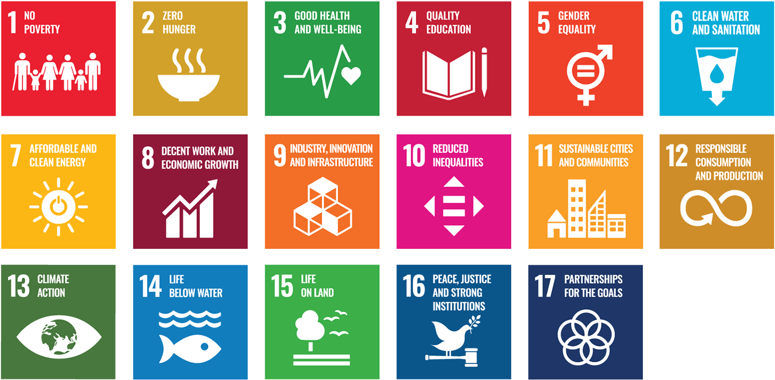
Source: The United Nations Sustainable Development Goals
More than half of the world’s population now lives in cities, with urban dwellers accounting for a disproportionate share of economic production, consumption, and associated waste. As a result, implementation of the 2030 Agenda within urban areas is critical to its success.
The City of Melbourne has identified an initial set of indicators – starting with those that appear in this Council Plan – that will help us track Melbourne’s performance against the global SDGs over time. This will enable us to benchmark our performance against other cities and make informed decisions on where to prioritise our effort, share success and learn from others.

Glossary
City of Melbourne | The City of Melbourne is the local government body responsible for the municipality of Melbourne.
Circular economy | A circular economy continually seeks to reduce the environmental impacts of production and consumption, while enabling economic growth through more productive use of natural resources. It allows us to avoid waste with good design and effective recovery of materials that can be reused.
Community Vision | A Community Vision is designed to articulate the long-term hopes that the community has for the municipality. The Community Vision is prescribed by the Local Government Act 2020 Section 88.  The City of Melbourne’s community vision comprises two parts – a vision statement and narrative, supported by a series of aspiration statements.  These constitute the ‘call to action’ guiding Council planning.
Community aspirations | Community aspirations are a series of statements that were developed through community engagement and reflect the community’s hopes for the future of the municipality. The aspiration statements are the foundations on which the Vision statement and narrative are built.
Council Plan | The Council Plan is the Melbourne City Council’s key strategic document, which defines the Council’s four-year objectives, priorities, major initiatives and measures of success. Integrated in this plan is the 10-year Community Vision and four-year Health and Wellbeing Plan for the City of Melbourne.  The Council Plan is developed in accordance with the Local Government Act 2020 section 90.
Council objectives | The Council objectives represent the strategic direction for the next four years as we work to achieve the Community Vision.
Council priorities | The Council priorities describe the outcomes that the plan seeks to achieve and how we will fulfil our strategic objectives.
Council major initiatives | Major initiatives are critical pieces of work that will deliver on Council’s objectives and priorities.
Council indicators | The measures of success for monitoring and reporting Council’s performance and the municipality’s progress.
Food insecurity | Food security exists when everyone has the physical, social and economic access to sufficient, safe and nutritious food to meet their dietary needs and food preferences for an active, healthy lifestyle at all times.
Health and wellbeing focus areas | Where Council will focus efforts to address key health and wellbeing issues over the next four years as prescribed under section 26(2)(b) of the Public Health and Wellbeing Act 2008. These have been informed by health and wellbeing data and extensive community engagement.
Integrated Planning and Reporting Framework | Our planning framework describes how the City of Melbourne strives to realise the community’s aspirations through a cascading hierarchy of long and medium-term plans, resourcing decisions, and continual process of implementation, monitoring and review.
Melbourne | Refers to the area within the municipality of Melbourne.
Municipal Public Health and Wellbeing Plan (MPHWP) | The Municipal Public Health and Wellbeing Plan outlines how the Council will protect, improve and promote public health and wellbeing within the municipality. The City of Melbourne is required under the Public Health and Wellbeing Act 2008 (Section 26 and 27) to prepare a Municipal Public Health and Wellbeing Plan (MPHWP) every four years, or to include public health and wellbeing matters into the Council Plan.
Reconciliation Action Plan (RAP) | The Reconciliation Action Plan is a strategic document that drives an organisation’s contribution to reconciliation both internally and in the communities in which it operates. Reconciliation means working to ensure Melbourne is an inclusive city for Aboriginal people, and working to close the gap of disadvantage experienced by Aboriginal people since European settlement.
The city | Refers to the municipality of Melbourne.
The Council | The elected officials of the Melbourne City Council, comprising a Lord Mayor, Deputy Lord Mayor and nine councillors elected in November 2020.
The community | Traditional owners of land, people who work, live, study, visit, are ratepayers or own a business in the municipality.
Vision statement and narrative | A single, memorable statement and narrative that describe the aspirational future for the city.

Appendixes

Appendix A: Integrated planning AND REPORTING framework
Our planning framework describes how the City of Melbourne strives to realise the community’s aspirations through a cascading hierarchy of long and medium-term plans, resourcing decisions, and continual process of implementation, monitoring and review.
The suite of documents illustrated in the framework below encapsulate the processes and decisions the Council undertakes in the interests of the municipality, with community input, in accordance with the Local Government Act 2020 and other key legislation.
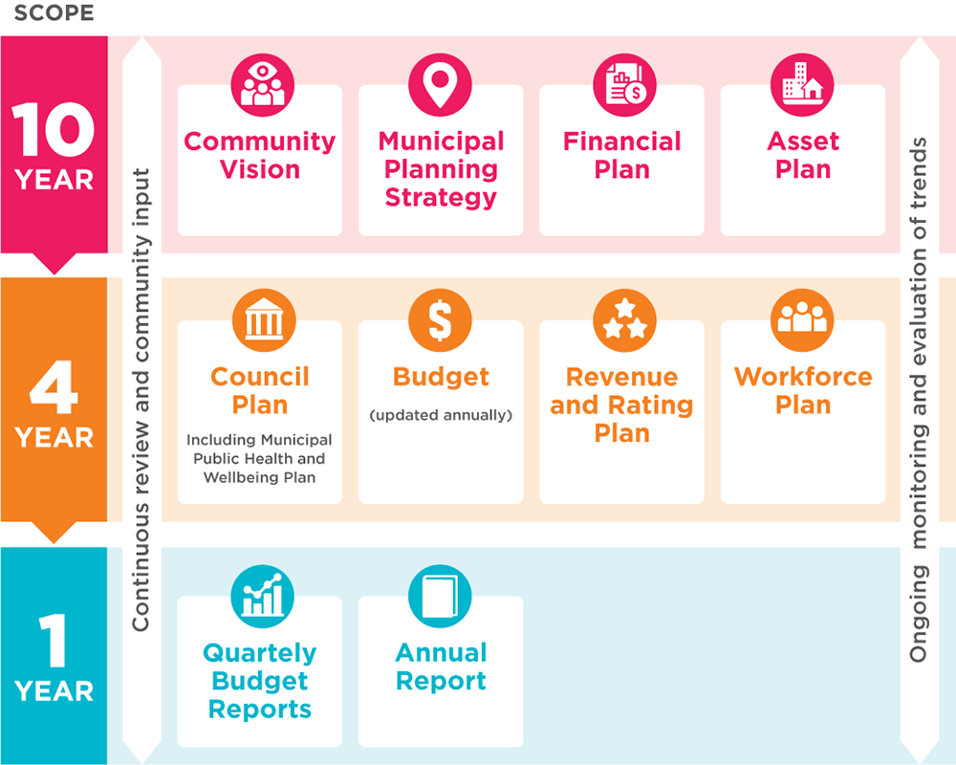
10-year perspective
The Community Vision represents the community’s aspirations for Melbourne for the next 10 years. It guides everything the Council does, including all strategic decision-making and collaboration with key partners, stakeholders and the community. The Community Vision is incorporated into the Council Plan.
The Municipal Planning Strategy guides long-term land use and development to achieve desired social, economic and environmental outcomes for the city. It supports the state-wide Melbourne Planning Scheme that governs the use, development and protection of municipal land.
The Financial Plan provides a 10-year view of the Council’s resources and sources of funding and how those resources will be applied across services, operations, capital investments and assets.
The Asset Plan outlines the Council’s high-level asset management priorities for the next 10 years and how the Council proposes to manage its portfolio of assets.
Four-year perspective
The Council Plan is a four-year commitment to the community. Guided by the Community Vision, it outlines how the Council will strive towards the community’s aspirations and how it will measure success.
The Health and Wellbeing Plan 2021–25 outlines the strategic health and wellbeing focus areas for the municipality over the next four years. This is the fourth time Council has chosen to integrate the health and wellbeing priorities into the Council Plan. For more on how the Health and Wellbeing Plan was developed see Appendix C.
The Budget details the City of Melbourne’s annualised activities over the next four years and the resources required to deliver the Council Plan.
The Revenue and Rating and Plan describes how the Council will generate income to deliver on the Council Plan, programs and services and capital works commitments.
The Workforce Plan describes the anticipated staffing requirements for a period of at least four years and the organisational structure. The Chief Executive Officer is responsible for establishing and maintaining an organisation structure for the Council and is also responsible for all staffing matters.
Annual perspective
The Council’s progress on implementation of the Council Plan, Health and Wellbeing Plan and the Budget is presented in the Annual Report.
During each financial year, a Quarterly Budget Report is prepared for the Council on actual and budgeted results and variances.

Appendix B: About this Council Plan
This plan addresses the City of Melbourne’s obligations under the Local Government Act 2020 and the Public Health and Wellbeing Act 2008 and incorporates the:
- Community Vision
- Council Plan
- Health and Wellbeing Plan
This plan describes the Council and community’s vision for the future, how the Council will strive towards that vision during its four year term, where it will focus its efforts, and how it will measure progress.
How to read this plan
The Community Vision comprises two parts:
- Vision statement and narrative, a memorable statement and narrative that describe the aspirational future the community desires for the city
- Community aspirations, which describe the community’s needs behind the Vision statement and narrative constituting a ‘call to action’ guiding Council planning.
The Council Plan is comprised of six strategic objectives that guide the Council to achieve the community’s aspirations outlined in the Community Vision. Together, the strategic objectives reflect the City of Melbourne’s long-term strategic direction that considers people, culture, the economy and the environment holistically.
Each of the six Council strategic objective includes:
- The Council’s four-year priorities, describing the type of change the Council wants to achieve.
- Major initiatives or key projects the Council will commit to deliver or progress during its term to achieve the desired change.
- A set of indicators that represents the Council’s definition of success and provides the basis for how it will track and report progress towards the strategic objective year on year.
The Health and Wellbeing Plan outlines how the Council will protect, improve and promote public health and wellbeing within the municipality:
- Throughout the plan, the heart icon is used to indicate which of the Council’s priorities and major initiatives contribute to our health and wellbeing priorities.
- The ‘Health and Wellbeing in our city’ chapter of the Council Plan defines health and wellbeing and describes the municipality’s top health and wellbeing issues through the Health and Wellbeing Focus Areas.
- Appendix F: Summary snapshot of the health and wellbeing content in this plan.

Appendix C: How this plan was developed
The Council Plan was informed by the integrated development of the Community Vision and the Health and Wellbeing Plan. This development consisted of a number of key phases that ensured that each of these documents were informed by a robust evidence base, deliberative community engagement and complied with key legislation.
Phase one: Understanding Context (October 2019 to December 2020)
- Review of key legislation and policy, including:
  - Public Health and Wellbeing Act 2008
  - Local Government Act 2020
  - Victorian Public Health and Wellbeing Plan 2019–2023
  - Royal Commission of Family Violence
  - Climate Change Act 2017
  - Sustainable Development Goals
  - City Resilience Framework
  - Victorian Government’s Environments for Health Framework
- Audit of existing City of Melbourne strategies and plans
  - See Appendix D for a complete list of the City of Melbourne’s strategies and plans
- Identifying initial community aspirations through engagement on the COVID-19 Reactivation and Recovery Plan
- Development of the Health and Wellbeing Profile 2020 for the city in partnership with subject matter experts. This profile can be accessed via www.melbourne.vic.gov.au/HWP2020
- Development of 13 Neighbourhood Profiles
Phase two: Deliberative Community Engagement (December 2020 to April 2021)
The City of Melbourne hosted a range of different deliberative engagement activities to ensure that the Community Vision, Council Plan, and Health and Wellbeing Plan were informed by a real mix of voices in a supported environment.
- 1641 people participated in online and in person surveys, workshops and focus groups.
- Eight targeted workshops and focus groups held with communities that are under-represented, including children, young people, people with lived experience of homelessness, culturally and linguistically diverse communities, people with a disability and key representatives from The City of Melbourne’s Traditional Custodians.
- Four public workshops in different neighbourhoods across the municipality.

Phase three: Integrating community insights and developing Council priorities (April 2021)
The deliberative engagement process identified a series of community aspirations and priorities for the future of the city. Using a ‘whole of Council’ approach, the community’s voice informed the Community Vision, Health and Wellbeing Plan 2021–25, as well as the strategic objectives and priorities of the draft Council Plan.
Phase four: Draft Council Plan for community engagement (May 2021)
The draft Council Plan is released for further community engagement allowing an opportunity for community feedback in May 2021. This provides the community with the opportunity to reflect on how their insights informed the objectives and priorities of the draft Council Plan.
Phase five: Finalisation of Council Plan for endorsement by Council (June 2021)
Phase six: Development and delivery of the initiatives of the Council Plan
Appendix D: Council’s strategies
Strategies, frameworks and action plans
- A Great Place to Age Strategic Plan
- Affordable Housing Strategy 2030
- Arts Infrastructure Framework
- Climate Change Adaptation Strategy
- Climate Change Mitigation Strategy to 2050
- Community Infrastructure Development Framework
- COVID-19 Reactivation and Recovery Plan: City of the Future
- Creative Strategy
- Disability Access and Inclusion Plan
- Elizabeth Street Strategic Opportunities Plan
- Food City: City of Melbourne Food Policy
- Green our City Strategic Action Plan
- Heritage Strategy
- Municipal Integrated Water Management Plan
- Music Plan
- Nature in the City
- Open Space Strategy
- Reconciliation Action Plan
- Resilient Melbourne
- Skate Plan
- Start-up Action Plan
- Transport Strategy 2030
- Urban Forest Strategy
- Waste and Resource Recovery Plan

Place-based structure plans and master plans
- Arden-Macaulay Structure Plan
- City North Structure Plan
- Docklands Community and Place Plan
- Docklands Public Realm Plan
- Docklands Waterways Strategic Plan
- Maribyrnong Waterfront – A Way Forward
- Melbourne Innovation Districts Opportunities Plan
- Moonee Ponds Creek Strategic Opportunities Plan
- Queen Victoria Market Precinct Renewal Master Plan
- Southbank Structure Plan
- West Melbourne Structure Plan
- Yarra River – Birrarung Strategy
Public space master plans
- Carlton Gardens Master Plan
- Domain Parklands Master Plan
- Fawkner Park Master Plan
- Fitzroy Gardens Master Plan
- Flagstaff Gardens Master Plan
- Lincoln Square Concept Plan
- Princes Park Master Plan
- Royal Park Master Plan
- University Square Master Plan
Urban forest precinct plans
- Carlton Urban Forest Precinct Plan
- Central City Urban Forest Precinct Plan
- Docklands Urban Forest Precinct Plan
- East Melbourne Urban Forest Precinct Plan
- Fishermans Bend Urban Forest Precinct Plan
- Kensington Urban Forest Precinct Plan
- North and West Melbourne Urban Forest Precinct Plan
- Parkville Urban Forest Precinct Plan
- South Yarra Urban Forest Precinct Plan
- Southbank Urban Forest Precinct Plan
Major streetscape master plans
- City Road Master Plan
- Elizabeth Street Strategic Opportunities Plan
- Southbank Boulevard and Dodds Street Concept Plan

Appendix E: Council’s Services
Service areas
Providing valued services to our customers and community is central to everything we do. Our ‘service families’ are groups of services that share a common purpose. We use this lens to consider what we offer to our customers, the outcomes that are delivered, the benefits that can be achieved and how the needs of our community may change in the future. These families may be further refined as we continue to manage and improve our services.
Service area | Services
ASSISTANCE AND CARE  Supporting vulnerable people to enable safe and independent living. | - Assisting independence  - Counselling and support  - Financial support to outsourced care providers  - Food security  - Targeted interventions for childhood development
ECONOMIC DEVELOPMENT  Fostering the development of Melbourne’s economy. | - Enable positive experiences within Melbourne  - Support communities and businesses to prosper  - Encourage investment in Melbourne  - Promote Melbourne as a destination
SAFETY MANAGEMENT  Ensuring people are protected and safe when accessing and using spaces. | - Safeguarding public health  - Reducing the risk of accident and injury  - Planning for and responding to emergency and disaster events  - Responding to and managing city issues
WELCOME AND  CONNECTION  Supporting people to experience and engage  with Melbourne. | - Providing opportunities for social cohesion and connection with people  - Welcoming visitors and providing opportunities to connect with the city  - Providing opportunities to enhance our connection with country
EARLY YEARS DEVELOPMENT  Supporting families with children to develop and thrive. | - Access to toys and equipment  - Early learning and care  - Parent education and family health  - Delivery of language and literacy programs
WASTE AND RESOURCE MANAGEMENT  Repurposing, recycling or disposing of waste and reducing resource waste in the municipality. | - The collection of public waste  - The collection of waste from ratepayers  - The sustainable management of resources
CREATIVITY AND KNOWLEDGE  Providing opportunities to create, learn, connect, experience and share. | - Providing and promoting access to creative opportunities, experiences, knowledge, information and education programs  - Activating and embedding a culture that values creativity, inquiry and critical thought
MOVEMENT AND TRAFFIC  Facilitating movement into, around and out of the municipality. | - Advising and responding to varied transport needs  - Enabling access through regulation and compliance  - Providing and maintaining movement infrastructure
WELLBEING AND LEISURE  Encouraging people to be healthy and active. | - Plan, fund and deliver wellbeing programs and events  - Producing and distributing healthy living information and advice  - Providing, maintaining and managing access to recreation facilities and open space infrastructure

Appendix F: Health and Wellbeing Plan Summary
This shows alignment of priorities and initiatives, represented by a ♥ to the relevant health and wellbeing focus area.
Health and Wellbeing Focus Areas | Link to Council Plan Priority | Link to Council Plan Major Initiatives | Council’s Role
- Public Health and Safety | All people feel safe and included when participating in Melbourne’s economic, visitor and community life. | We will continue to work with Victoria Police and other agencies to deliver a range of initiatives that improve physical safety on the streets of Melbourne and within our communities. | Partner  Deliver
 |  | Deliver and maintain a clean city through the Rapid Response Clean Team initiative. | Deliver
 |  | Engage and prepare socially vulnerable residents and communities to enhance their resilience to hazards and disasters. | Deliver
 | Enforce zero tolerance of violence in our community including family violence, violence against women, racism and discrimination in all forms. | We will be a leading organisation on equality and inclusion and deliver programs in communities that will reduce physical and psychological violence against women, children, young people, LGBTIQ+ people and culturally diverse communities. | Deliver
 | An efficient and safe transport network where our streets are safer for all users. | Continue to implement the Transport Strategy 2030, including delivery of a protected bike lane network, station precincts as key gateways, little streets as streets for people, safer speed limits, micro mobility trials, more efficient traffic signal timing and bicycling encouragement programs. | Advocate  Partner  Deliver
- Mental Wellbeing and Inclusion | Bonds and social connections between individuals and communities of different backgrounds are strengthened. | Adopt in 2021-22 and then implement an Inclusive Melbourne Strategy that will increase access to opportunities for all people and outline how the City of Melbourne will respond to the diversity of religions, cultures, age groups, gender and ability among the people who live, work, study in and visit the city. | Deliver
 |  | Implement a neighbourhood model by working with communities to develop neighbourhood plans and neighbourhood service centres that respond to the local community’s existing and projected needs. | Deliver
 | Increased economic participation, with a city economy that is more inclusive and fair, enabling resident’s access to employment and key workers access to accommodation in the city. | Continue to strengthen Melbourne’s economic recovery, including through precinct and shopfront activation, delivery of an enhanced business concierge service and support for the night-time economy. | Deliver
 | Melbourne’s diverse communities are celebrated. | Work in partnership with the Victorian Government and other stakeholders to advocate for and deliver integrated high-quality public and active transport in urban renewal areas including Melbourne Metro 2 and tram to Fisherman’s Bend and tram to connect the Arden precinct. | Partner
 | Governing with First Peoples drives our city forward and allows community to make the changes needed for the City of Melbourne to be an Aboriginal city. | Govern with Sovereign First Nations to enable true self-determination, where deliberative engagement is proactive, responsive and consistent. | Deliver
 | We embrace and promote our First Peoples’ identity across all areas of the city, including city design, and give voice to the treaty process with First Peoples. | Explore and deliver opportunities for ‘truth-telling’ to facilitate learning healing, and change within Melbourne and beyond. This will be an opportunity to impart knowledge of thousands of years of rich history, language and stories, as well as provide a form of restorative justice by acknowledging Aboriginal peoples’ experiences of dispossession and inequity. | Partner
 | First Peoples experts are consulted and lead sustainable land management practices and implement ‘Caring for Country’ principles in the management, planning and development of city land. | Commence planning for a co-designed First Nations Cultural Precinct with First Peoples – a place to retain, maintain and recreate in a culturally specific geography, where First Peoples can practice continuity of customs and traditions, through uninterrupted connection to lands and waters. | Partner
 | Core services are accessible and affordable to everyone, with special attention to mental health, lifelong education and internet services. | As part of a new corporate strategy for the City of Melbourne, ensure our core services remain accessible and affordable. | Deliver
 |  | Deliver a revitalised library network, including pop-up libraries, to increase access for our diverse community and to help revitalise the city. | Deliver
 |  | Deliver programs that will build digital literacy skills and capabilities, improve access to free Wi-Fi from our community facilities and advocate for appropriate digital infrastructure, to improve digital inclusion for all, particularly for vulnerable groups. | Deliver
 |  | Deliver Queen Victoria Market precinct improvements through quality public open space, new connections to the city, community services and facilities such as the Munro Community Hub. | Deliver  Partner
 | City activities including events, the arts and culture are accessible and affordable for everyone. | Deliver public art projects that reflect Melbourne’s unique culture and heritage, attract visitors to the city and help stimulate our city’s recovery. | Deliver
 | People with disability feel welcome in the city and have equal access. | Deliver the Disability Access Plan 2020–2024 including ensuring our services and events are more accessible, increasing the number of accessible adult change facilities, and partnering with community and transport groups to make transport more accessible. | Deliver  Partner
- Healthy and Sustainable Lifestyles | People are supported and encouraged to make healthy and sustainable lifestyle decisions. | Partner with the Victorian Government and other stakeholders to deliver specific components of Greenline along the north bank of the Yarra River (including the implementation of the Yarra River – Birrarung Strategy). | Deliver  Partner
 |  | Increase and upgrade accessible, inclusive spaces for women in City of Melbourne sports facilities. | Deliver
 |  | Increase the amount of public open space in the municipality with a focus on areas of greatest need, such as Southbank and emerging urban renewal areas. | Deliver
- Housing and Homelessness | Fair, appropriate and accessible range of affordable housing for people of all backgrounds is available, with special focus on people experiencing homelessness. | Create a new entity ‘Homes Melbourne’, to coordinate and facilitate more affordable housing for key workers and people on low-incomes and progress a demonstration project on Council-owned land, support the Make Room accommodation project and new homeless support hubs for vulnerable citizens to access essential support services including food, showers, lockers, information, and housing and homelessness advice. | Partner
 |  | Market and promote Melbourne as a great place to live for all while ensuring key workers have access to affordable housing. | Deliver
- Food Security | Increased food security for everyone, especially the most vulnerable. | Develop and deliver initiatives and programs that will provide food relief to vulnerable members of our community and improve local food production by supporting communities to grow their own food. | Deliver  Partner  Advocate
 |  | Protect Queen Victoria Market as a traditional open-air market, through heritage restoration and the provision of essential services and facilities that enhance the customer and trader experience, including projects such as the Shed Restoration, Food Hall, Trader Shed, Market Square, waste and logistics facility and future developments to the south of the market. | Deliver
- Health Impacts of Climate Change | City of Melbourne is a leading city globally that sets the standard in climate action. | Support the development of a circular economy through bold leadership and community neighbourhood projects, including the container deposit scheme, alternative waste technologies, circular economy guidelines and partnered or aggregated demand to stimulate end markets. | Partner
 |  | Lead the reduction of food waste and diversion of waste from landfill, by continuing the Food Organics, Green Organics rollout through high-rise apartment innovation and by addressing food-waste reduction. | Deliver
 | Spaces and buildings showcase world-leading sustainable design principles to enhance liveability and lead innovative responses to climate change, including protecting communities from the impact of extreme weather events. | Progress a planning scheme amendment to improve the environmental performance of buildings in order to reduce emissions to zero by 2040. | Deliver
 | Resilient and safe communities that are adapting to the public health impacts of climate change. | Implement the Climate and Biodiversity Emergency action plan. | Deliver
 | Our environment, parks and waterways are protected, restored and managed well. | Deliver on our Urban Forest Strategy including tree canopy, private greening incentives and city greening. | Deliver

Bibliography

Australian Bureau of Statistics 2016
Australian Bureau of Statistics, Regional Population, 2019-20
City of Melbourne, Annual Report 2017–18, 2019–20
City of Melbourne, By Name List 2021
City of Melbourne, Census of Land Use and Employment (CLUE), 2019
City of Melbourne, Community Indicator Survey 2020
City of Melbourne Daily Population 2016
City of Melbourne, Daily Population Estimates, 2019
Crime Statistics Agency 2020
National Skills Commission, Small Area Labour Markets (SALM), December Quarter 2020
Victorian Population Health Survey 2017
Victorian Integrated Survey of Travel and Activity 2016

This does not include units already committed during the life of the previous Council Plan on the Munro and Boyd sites which are also expected to be completed during the life of the 2021-25 Council Plan.

