Creating Communities of Equality and Respect:
Prevention of Violence Against Women Action Plan
2021–2024
Foreword
Acknowledgement of Traditional Owners
The City of Melbourne respectfully acknowledges the Traditional Custodians of the land, the Bunurong Boon Wurrung and Wurundjeri Woi Wurrung peoples of the Eastern Kulin Nation and pays respect to their Elders past, present and emerging. We are committed to our reconciliation journey, because at its heart, reconciliation is about strengthening relationships between Aboriginal and non-Aboriginal peoples, for the benefit of all Victorians.

Acknowledgement of victim survivors of violence
The City of Melbourne acknowledges the strength and resilience of victim survivors of family violence – adults, children and young people.
We pay our heartfelt respects to those who have been harmed or who did not survive.
We also acknowledge the loss and impact on friends, families and communities who have lost loved ones through violence.

Our Commitment
We know that family violence can be prevented and eliminated.
We must address and shift the underlying drivers of gender equality –the distribution of power, resources, value and opportunities.
We commit to increasing gender equality and to equal and respectful relationships so we can reduce the prevalence of family violence.
Our ultimate aim is for all people to have a life free of violence.

Our strategic context for action
The Creating Communities of Equality and Respect: Prevention of Violence Against Women Action Plan (Action Plan) was developed in consultation with City of Melbourne leaders, practice leaders in the prevention sector, community leaders, business leaders and other stakeholders on opportunities for our external-facing work. We are especially interested in their ideas for partnership activities across the settings, places and spaces that characterise Melbourne as a capital city local government area.
Our discussions gave strong strategic consideration to the enabling policy environment for prevention that currently exists in Victoria – the direct result of the findings and recommendations arising from the historic Royal Commission into Family Violence (RCFV), which concluded in March 2016. (State of Victoria, 2016) Of particular guidance to our discussions were:
- Safe and Strong: A Victorian gender equality strategy
- Free from Violence: Victoria’s strategy to prevent family violence and all forms of violence against women - and its current 3 yr action plan.
The existence of these ‘twin’ pieces of policy in Victoria links directly to RCFV Recommendation 187 and the Commissioners’ recognition that parallel implementation of a stand-alone gender equality strategy and a stand-alone primary prevention strategy will help to accelerate both towards realising their respective visions. It is important to note that the two pieces while standalone do intersect each other to drive change.
Our consultations were guided by a third policy Ending Family Violence: Victoria’s plan for change. This is the Victorian Government’s overarching policy for implementing all 227 RCFV recommendations, and its current Rolling Action Plan 2020–2023 contains 12 priority areas, among them primary prevention.

Alignment with City of Melbourne and other plans
At the municipal level, this action plan forms part of the developing Inclusive Melbourne Strategy and Statement of Commitment to Gender Equality and aligns with a number of priority areas and actions set out in Future Melbourne 2026, Council Plan 2021–2025, Municipal Public Health and Wellbeing Plan, COVID-19 Reactivation and Recovery Plan, and various other plans. It also contributes to City of Melbourne’s progress towards the United Nation’s Sustainable Development Goals in particular Goal 5 Gender Equality.
At the regional level, this action plan aligns with objectives of Preventing Violence Together 2030, which is the strategy for preventing violence against women in Melbourne’s west. (Women’s Health West, 2017b). City of Melbourne adheres to the principles for preventing violence against women outlined in Preventing Violence Together 2030:
- women’s rights to freedom from violence
- gender-transformative practice
- intersectional prevention practice
- evidence-based practice
- cultural safety for Aboriginal and Torres Strait Islander communities;
- collaboration and participation
- accountability to women’s lived experiences of violence and gender inequality.
In upholding the principle of accountability to women’s lived experiences, we further recognise the commitment and engagement of men as allies in the work of primary prevention.

Background to this action plan
City of Melbourne has a strong history of work in the prevention of violence against women. This has included:
- Membership of the Western Region Prevention of Violence Against Women and Family Violence Network since 2006.

- Implementing the We Need to Talk: Preventing violence against women strategy 2013–2016. This identified workplaces and communities as settings for prevention work and transformed our organisation’s practices and culture and, commenced important conversations about violence against women in the community through our partnership activity.

- A Male Champions of Change program to achieve a significant and sustainable increase in the representation of women in leadership and non-traditional careers.

- A public commitment in 2018 to prioritise gender equality in all current and future Council planning, policy, service delivery and practice through a Statement of Commitment to Gender Equality.

- Each year the City of Melbourne provides a range of counselling and support services to those experiencing family violence and supports activities and events to raise awareness of violence including 16 Days of Activism Against Gender Based Violence and International Women’s Day.

This Action Plan is dedicated to our external-facing work with communities and sits alongside the newly enacted Gender Equality Act 2020 requiring all local councils to take positive action towards achieving workplace gender equality, and to consider and promote gender equality in policies, programs and services that interface with communities.
With the ongoing social and economic impacts of COVID-19 and the uncertainty it presents to the City of Melbourne and our local communities and businesses we will be preparing annual action plans instead of a three year action plan. Activities outlined in the action plan below are activities we have resources and capacity to deliver over the next 12 months. Actions plans for year two (2022-23) and year three (2023-24) will be presented to Council for endorsement at a later date.

Violence against women is prevalent and serious
Violence against women in Australia is prevalent and serious. The Australian Bureau of Statistics tell us that:
- one in two women (53%) has experienced sexual harassment in their lifetime;
- one in three women (31%) has experienced at least one incident of violence;
- almost one in five women (18%) has experienced sexual violence such as the occurrence, attempt or threat of sexual assault;
- over one in six women (17%) has experienced an episode of stalking. (ABS, 2017)
Women are very likely to experience violence by someone they know, such as a current or previous intimate partner, than by a stranger.
In the majority of cases, violence against women occurs while women are in their own homes. Large numbers of children are also impacted by seeing and hearing violence in the family home.
The rates of family violence against lesbian, gay, bisexual, transgender, intersex and queer (LGBTIQ) people is as high as, if not higher than, family violence against heterosexual, cisgendered women and their children. (OurWatch, 2017)
The situation for men is different - they typically face violence from strangers in public places. (ANROWS, 2018)

Impacts
The impact of violence against women is serious and profound.
Intimate partner violence contributes more to the burden of disease (or total amount of ill health) of women aged 18–44 years than any other known risk factor.
Sadly, on average one woman a week in Australia is killed by a current or former partner (ANROWS, 2018).
At a local level there are lower perceptions of safety at night for women than men and an increase in assaults and sexual offenses. (Reported Crime Statistics and CoMSIS- refer addendum)

Violence against women is preventable
While prevalent and serious, violence against women is not inevitable and all of us can take action to prevent violence.
This Action Plan focusses on how to:
- Transform the deep underlying causes of violence against women so that violence against women doesn’t occur in the first place and
- Target and disrupt the drivers of violence against women. This approach is known as primary prevention.
The Change the Story: A shared framework for the primary prevention of violence against women and their children in Australia (Our Watch et al., 2015) identifies gender inequality in public and private life – or the unequal distribution of power, resources, opportunity and value afforded to men and women in society – as the most necessary condition of violence against women.
Gender inequality is expressed in four ways to cause violence against women:
- condoning of violence against women
- men’s control of decision-making and limits to women’s independence
- rigid gender roles and stereotyped constructions of masculinity and femininity
- male peer relations that emphasise aggression and disrespect.
As women and men are not valued equally and do not have equal access to power, resources and opportunity these inequalities have become embedded over a long period of time.
We can change the story of violence against women by acting on the gendered drivers. The most important action we can take is to promote and normalise gender equality in public and private life.
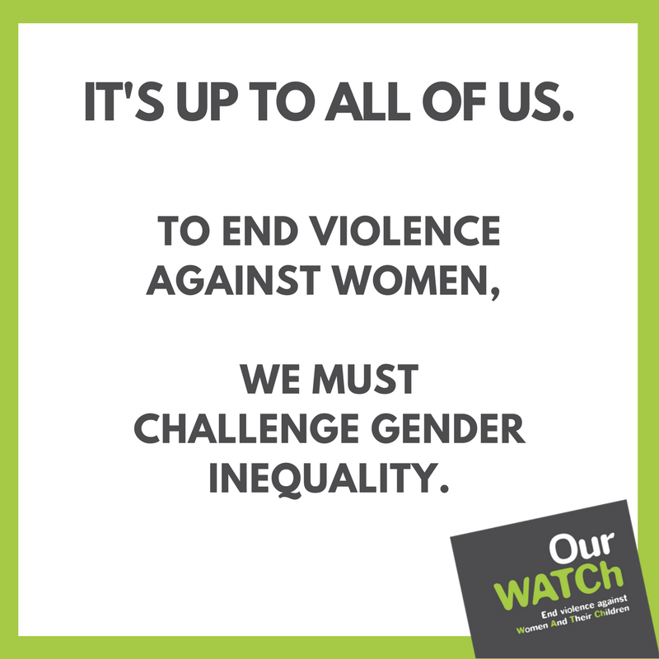
Figure 1 Social media tiles produced by Our Watch
Why Intersectional prevention practice is important
Change the Story signals to us that the gendered drivers never operate in isolation but intersect with other historically based forces that operate in society. The more compounding these unequal relations, the less equality that exists, and greater the exposures to violence. Some examples include the following:
- Over a 12-month period, Aboriginal and Torres Strait Islander women report experiencing violence at 3.1 times the rate of non-Indigenous women with injuries more severe and hospitalisation rates due to family violence-related assaults 32 times the rate for non-Indigenous women. Violence against Aboriginal and Torres Strait Islander women is perpetrated by non-indigenous and indigenous men. (Our Watch, 2018)

- Gender based and disability based discrimination doubles the risk of violence for women with disabilities compared to women without disabilities. Women living with disabilities experience all types of violence at higher rates, with increased severity and for longer than other women. Violence includes impairment related abuse such as withholding medication and disability aids. (Women with Disabilities Victoria, n.d.)

- Women’s experience of racially based violence perpetrated against them is a type of violence that immigrant and refugee women endure. This experience is not always perceived as violence against women, but must be included as part of prevention action. (Multicultural Centre for Women’s Health, 2017) Women on temporary visas face unique layers of disadvantage, including social isolation and ineligibility for universal health care or other services. Their migration status can also be weaponised as a distinct tool of coercion and control by those perpetrating violence against them. (InTouch, 2020)

- Trans and gender diverse intimate partner violence is reported to be at higher rates than cisgendered experiences, and there are indications that trans women report higher rates of violence than trans men. While the types of violence that occur are similar to those found in cisgender heterosexual relationships, there are unique dynamics. Perpetrators can exploit knowledge of identity within networks or community to control and harm their intimate partners. (Rainbow Health Victoria, 2020)
This tells us that City of Melbourne’s prevention work must be for all women, it must ‘leave no woman behind.’ This also means attending to the intersecting systems of inequality- known as intersectional prevention practice.
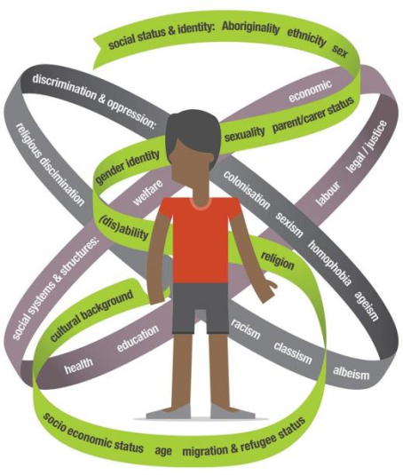
Intersectional prevention practice recognises the multiple structural and institutionalised systems of privilege and disadvantage that intersect with one another to influence the risks to, and the dynamics and severity of, violence against women.
‘The systems we target (and seek to transform) are sexism as well as heterosexism, cissexism, racism, colonialism (and its ongoing legacy), ethnocentrism and ableism – to name but a few.’
(Women’s Health West, 2017a)

Intersectional prevention practice will be applied to all actions developed as part of the annual action plans.

Rigid gender norms, cisnormativity and heteronormativity are key factors in the abuse and violence experienced by LGBTIQ people within their families of origin, and in society more generally … This connection reinforces the need for gender-transformative approaches that challenge rigid gender norms by simultaneously addressing cisnormativity and heteronormativity. Pride in Prevention
We prioritise and resource ongoing action to promote gender and disability equality. Prevention of Violence Against Women with Disabilities

A truly intersectional approach to prevention requires us to work in partnership with others to ensure all systems of oppression are dismantled, to realise all women’s rights to safety, respect and equality. Preventing Violence Together 2030
The urgency for prevention action
There is emerging evidence that gender inequality in Australia is getting worse, and this means violence against women is likely to continue unabated well into the future unless we start to turn the tide now.
A young women born in Australia at the turn of the millennium and who is set to celebrate her 21st birthday sometime in 2021, has actually spent her entire lifetime experiencing a diminishing of gender equality.

COVID-19
There are indications that the COVID-19 global pandemic is further propelling this downward direction of gender inequality in Australia.
Emerging evidence is telling us that the impact of COVID-19 has not been gender equal, with public health lockdowns and economic slowdowns having more far-reaching negative consequences for women than men. In Victoria, which endured a succession of months of strict public health measures over 2020 the effects have been:
- 55% of job losses due to COVID-19 were felt by women
- women have been depleting their superannuation at a higher rate than men when withdrawing emergency COVID-19 funds
- the majority of casual workers who were not able to access JobKeeper were women
- women were found to be performing far more of the unpaid labour and additional education support to children at home during lockdown.

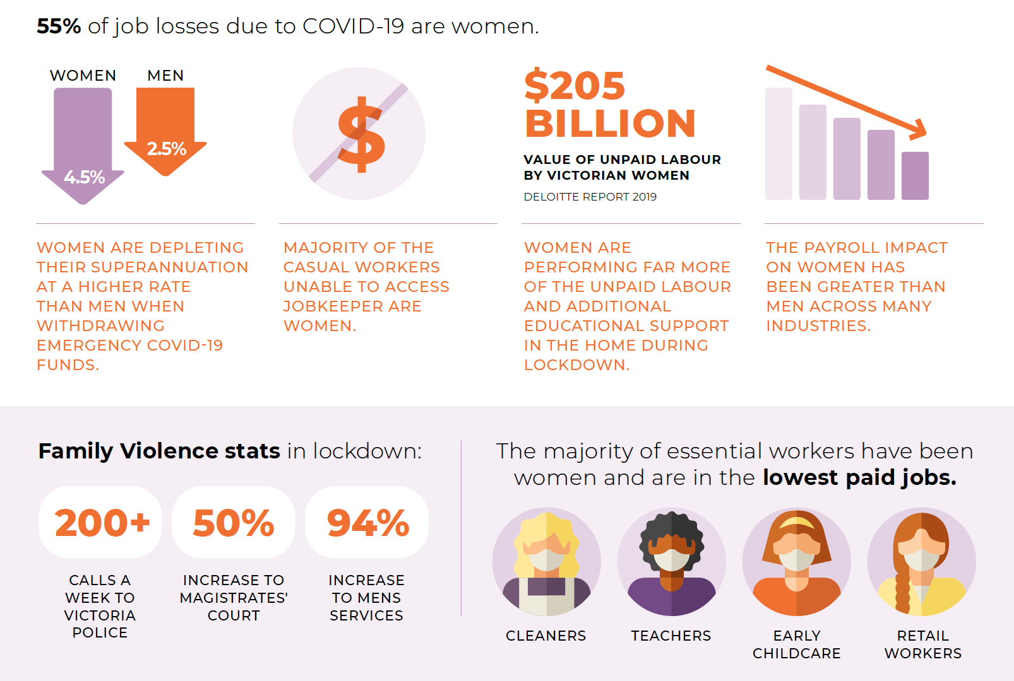
Figure 2 COVID-19 inequalities (GEN VIC, 2020)

Our plan’s themes and high-level actions
The Action Plan contains four broad themes and 12 actions to be delivered in year one (2021-22).
The four broad themes contained in our plan are:
- Advance women’s leadership and participation in economic, social and civic life across the municipality
- Promote the safety of women and girls in our communities and public spaces
- Engage men and boys to shift unhealthy norms of masculinity and condoning of violence
- Achieve sustainable primary prevention for our municipality

Evaluation for learning, improving and decision-making
The Prevention of Violence Action Plan has an evaluation framework to support a planned and coordinated approach to collecting data throughout the course of implementation.
Success measures will be determined; data will be collected against these and analysed; results will be used to learn from the work, and also to improve implementation in real time; and overall evaluation findings at the end of this year, will be considered to help with our decisions around future annual actions for the City of Melbourne.

Prevention of Violence Against Women Year One Action Plan 2021–2022
Strategic themes and high-level actions | Potential partners | Key Outcomes | SDG and Council Plan links
- Advance women’s leadership and participation in economic, social and civic life across the municipality  - Pilot free period care product vending machines in council facilities to address period poverty.  - Continue to work with other local governments and Women’s Health West to implement the Women’s Participation in Sports and Active Recreation in Melbourne’s West: An Action Plan for Change 2020– 2025  - Continue to tell the stories of women’s achievements through street naming, monuments, plaques, arts, awards, and events so that influential women throughout Melbourne’s history and in the present time are acknowledged – with particular focus on Aboriginal women and immigrant and refugee women (e.g Put Her Name On It campaign, International Women’s Day) | Women’s Health West and PVT Partnership  History Council of Victoria  Victorian Women’s Trust  Her Place Women’s Museum | People who menstruate have free access to period products  Increased opportunity and participation of women in sports and recreation.  Increased representation and recognition of women in our public places and spaces.  In the long term women are safe and included in all aspects of civic, economic and social life in the municipality | Sustainable Development Goals  - SDG 5 Gender equality  - SDG 10 Reduced inequality  Council Plan 2021–2025  - Melbourne’s unique identity and place  - Access and affordability  Municipal Public Health and Wellbeing Plan  - Mental wellbeing and inclusion  COVID-19 Reactivation and Recovery Plan  - Expand equitable opportunity / access
- Promote the safety of women and girls in our communities and public spaces  - Raise community awareness of violence against women (prevalence, dynamics, impacts, underlying drivers) by participating in evidence-based campaigns and initiatives such as (but not limited to) 16-Days of Activism Against Gender-based Violence, Walk Against Family Violence  - Promote and encourage community and businesses to get involved in the shEqual advertising equality campaign and take action against (hetero)sexist and gender stereotypical advertising  - Partner with the Night Time Economy Advisory Committee and businesses on activities or projects such as Project Night Justice that prioritise the safety and participation of women and non-binary gender diverse people in the late night economy. | Safe Steps  Women’s Health West and PVT Partnership  Women’s Health Victoria  Respect Victoria  CoM Night Time Economy Advisory Committee  CoM’s Family and Children’s Services Advisory Committee  CoM’s Disability Advisory Committee  Melbourne Licensees Forum  Victoria Police  Crime Stoppers Victoria  Rape and Domestic Violence Services Australia  University of Melbourne  Precinct Associations | Increased capacity and capability of businesses and licenced premises to adopt/initiate gender equitable practices  Increased number of organisations, and businesses who do not advertise products or services in a gender stereotypical way.  Increased skills/confidence of night-time licenced premises contacts for prosocial bystander action  In the long term women and gender diverse people feel safer and more included when using council facilities, conducting their businesses, walking in our streets, or attending events & licenced premises | Sustainable Development Goals  - SDG 3 Good health and wellbeing  - SDG5 Gender equality  Council Plan 2021–2025  - Safety and wellbeing  - Access and affordability  Municipal Public Health and Wellbeing Plan  - Public health and safety  - Mental wellbeing and inclusion  Child Safe Framework  - Create a culturally safe environment for children and young people that is free from harassment, bullying, violence, discrimination, racism or sexism
- Engage men and boys to shift unhealthy norms of masculinity and condoning of violence  - Provide opportunities for men and boys to engage in conversations about their role as prosocial bystanders and allies for creating a more gender equitable future  - Work with men to support and promote neighbourhood based men’s groups and health promotion programs that discuss healthier forms of masculinities and the role of men in promoting gender equality e.g. Modelling Respect and Equality (MoRE) and Sons of the West | Community organisations and Advocacy groups  Women’s Health West and PVT Partnership  The Men’s Project / Jesuit Social Services  Western Bulldogs Community Foundation | Increased skills / confidence of men and boys to understand and challenge harmful expressions of masculinity | Sustainable Development Goals  - SDG 3 Good health and wellbeing  - SDG 5 Gender equality  Council Plan 2021–2025  - Safety and wellbeing  Municipal Public Health and Wellbeing Plan  - Public health and safety  - Mental wellbeing and inclusion  Child Safe Framework  - Create a culturally safe environment for children and young people that is free from harassment, bullying, violence, discrimination, racism or sexism
- Achieve sustainable primary prevention for our municipality  - Support community groups and businesses to develop and deliver localised responses to the underlying drivers of violence against women through our community grants and sponsorship programs  - Continue contributing to the Preventing Violence Together 2030 strategy as a full member in the western metropolitan region’s partnership to prevent violence against women  - Participate in and actively contribute to the Municipal Association of Victoria’s Gender Equality, Prevention of Violence Against Women and Gender Based Violence Network  - Learn from and share knowledge with other international cities on global best practice in primary prevention | Community organisations and Advocacy groups  Municipal Association of Victoria  Women’s Health West and PVT Partnership  Respect Victoria | Increased capacity and capability of community groups and businesses to adopt/initiate gender equitable practices  Increased visibility of councils advocacy, leadership and commitment to PVAW and gender equality  Sustained partnerships for PVAW and gender equality  Knowledge and best practice in primary prevention informs future Action Plans. | Sustainable Development Goals  - SDG 3 Good health and wellbeing  - SDG 5 Gender equality  - SDG 17 Partnerships for the Goals  Council Plan 2021–2025  - Safety and wellbeing  Municipal Public Health and Wellbeing Plan  - Public health and safety  - Mental wellbeing and inclusion

Definitions of terms used in our plan
Cissexism and cisnormativity | Systemic discrimination based on normative assumptions (cisnormativity) that everyone falls into one of two binary categories, woman or man; and that our gender aligns with binary sex characteristics used to define female or male assigned at birth. As a system of discrimination, cissexism encompasses the norms, stereotypes, attitudes, practices, structures and institutions that facilitate such discrimination.
Gender | The socially learned and acquired roles, behaviours, practices, attitudes and attributes that society considers appropriate for women and men. Gender is a social construction of binarised ‘femininity’ and ‘masculinity’ and how these are experienced and lived by us. Gender is distinct to – but not wholly disconnected from – our understandings of binary sex as the biological and physical characteristics used to define male or female.
Gender inequality | The unequal distribution of power, resources, opportunity and value afforded to men and women in society arising from the social construction of gender.
Gender-transformative practice | We understand gender-transformative practice as practice that seeks to interrupt and disrupt the formation and perpetuation of rigid binary gender norms, practices and structures that exist across the entire social ecology.
Heterosexism and heteronormativity | Systemic discrimination based on normative assumptions (heteronormativity) of hetero-sexuality as the central or normal sexual orientation of human beings. Heterosexism is deeply organised by cissexism, and as a system of discrimination it encompasses the norms, stereotypes, attitudes, practices, structures and institutions that facilitate both forms of discrimination.
Intersectional prevention practice | Our prevention practice is intersectional, meaning it leaves no woman behind.  We are acutely aware that deep structural forces or institutionalised systems of privilege and disadvantage intersect with one another to influence the risks to, and dynamics and severity of, violence against women. The more compounding the relations of privilege and disadvantage, the less equality exists, and the greater the exposures to violence.  Our prevention practice targets intersecting systems so that we can achieve equality for all women and put an end to violence once and for all. The systems we target (and seek to transform) are sexism as well as heterosexism, cissexism, racism, colonialism (and its ongoing legacy), ethnocentrism and ableism – to name but a few.  Intersectionality actually helps us to be more effective in preventing violence against women because it helps us to disrupt all the intersecting forces that shape women’s lived experiences of inequality.
Sexism | Systemic discrimination based on socially-constructed concepts of gender and the gender inequality arising from this. As a system of discrimination, sexism encompasses the norms, stereotypes, attitudes, practices, structures and institutions that facilitate such discrimination. Sexism is deeply interconnected with heterosexism and cissexism.
Social ecology | 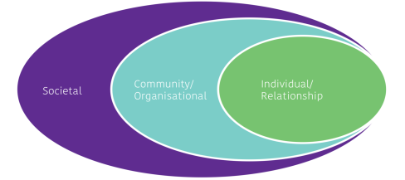  The social ecology helps us to understand that the drivers of violence against women are exerted and ‘lived’ across multiple, connected levels. These are the societal, community and organisational levels, all of which ‘nest’ the relational and individual level. The social ecology also helps us to see where we can direct our actions to transform the drivers of violence. For prevention to be effective, our actions must be addressed across all levels, not only the relational or individual.  (Women’s Health West, 2017a)
Violence against women | We understand violence against women as any act of gender-based violence that results in, or is likely to result in, physical, sexual or psychological harm or suffering to women, including threats of such acts, coercion or arbitrary deprivation of liberty, whether occurring in public or private life. (United Nations General Assembly, 1993)  Violence against women can be criminal or non-criminal in its forms. There are many manifestations of violence including (but not limited to) physical, sexual, emotional, psychological, economic, spiritual and social violence. No matter how it manifests, violence against women is always an intentional act to exert power and control  (Women’s Health West, 2017a)

Addendum: Local data on violence against women and perceptions of safety
Reported crime statistics

Family violence

According to the latest reported crime statistics, the rate of family violence incidents in Melbourne increased by 18.5 per cent from 2019–20 to 2020–21. There were 176 more reports per 100,000 population from 947.5 to 1122.9.

Family incidents | 2016/17 | 2017/18 | 2018/19 | 2019/20 | 2020/21
Number | 1481 | 1619 | 1567 | 1741 | 2052
Rate per 100,000 population | 930.6 | 950.6 | 875.4 | 947.5 | 1122.9

The majority of affected family members are women (77%) aged between 25-44 years (58%).
Assault and sexual offences
There has been a general increase in assaults and sexual offences against women across Victoria in the last four years to March 2020. Sexual offences against women have increased from 6413 reports in 2017, to 7403 reports in 2020 – an increase of almost 15 per cent. Similarly, assaults against women have risen by 6 per cent over the same period (21,010 reports in April 2017 compared with 22,271 in March 2020).
The City of Melbourne is experiencing similar trends to Victoria in sexual assault offences. In 2020, rates of sexual assault offences reached 521.6 per 100,000 residents, close to the 10-year high of 524.3 offences per 100,000 residents reported in 2018. The majority of sexual assault victims in Victoria are female (approximately 84 per cent in 2020). We also know that the LGBTIQ+ communities experience similar levels of sexual and other violence.
Perceptions of crime and safety
City of Melbourne’s Social Indicator Survey (CoMSiS)* consistently reports lower perceptions of safety at night for women than men. Just over sixty three percent of men who participated in the 2021 CoMSiS reported feeling safe at night compared with thirty six percent of women and twenty five percent of people who identified as other. The table below provides trends over fours years indicating these statistically significant findings based on gender:

CoMSiS - Perceptions of Safety* |  | 2018 | 2019 | 2020 | 2021
Women | Feel safe during the day | 86.1% | 81.7% | 81.1% | 76.8%
Men | Feel safe during the day | 90.4% | 86.3% | 84.4% | 81.6%
Other** | Feel safe during the day | 81.8% | 76.9% | 87.0% | 63.1%
Women | Feel safe at night | 48.3% | 32% | 43.8% | 36%
Men | Feel safe at night | 70.6% | 63.1% | 68.3% | 63.5%
Other** | Feel safe at night | 40.9% | 11.5% | 43.5% | 25.4%
* CoMSiS, surveys City of Melbourne residents and is conducted every year at the same time during the months of April and May.
**Please note small sample sizes for “Other” across all years (i.e. n<30). Results for this group should be treated with caution

Between 2018 and 2019 there was a marked decline in perceptions of safety at night likely due to a number of high-profile sexual and violent crimes against women. The majority of these crimes occurred at night.

In addition, CoMSiS consistently reports lower perceptions of safety on public transport at night for women than men. Fifty eight percent of men who participated in the CoMSiS (2021) reported feeling safe on public transport at night compared with thirty one percent of women and twenty seven percept of people who identified as other. The table below provides trends over fours years indicating these statistically significant findings based on gender:

CoMSiS - Perceptions of safety on public transport |  | 2018 | 2019 | 2020 | 2021
Women | Feel safe on public transport during the day | 84.5% | 78.4% | 77% | 75.4%
Men | Feel safe on public transport during the day | 86.6% | 85.7% | 80% | 84.2%
Other* | Feel safe on public transport during the day | 90.5% | 37.5% | 78.3% | 71.3%
Women | Feel safe on public transport at night | 44.1% | 32.7% | 36.2% | 31%
Men | Feel safe on public transport at night | 65.2% | 62.6% | 60.1% | 58.2%
Other* | Feel safe on public transport at night | 47.6% | 29.2% | 45.5% | 27.4%
**Please note small sample sizes for “Other” across all years (i.e. n<30). Results for this group should be treated with caution.

The recent Perceptions of Crime and Safety (PoCS) Research (2020) also indicated women’s feelings of safety at night are lower than men’s. The research posed questions regarding our community’s sense of safety at night prior to COVID-19. On the issue of women’s safety at night, women reported awareness of crimes committed against women due to media coverage. Both the crimes committed against women (between 2018 and in 2019) and the increased media coverage contributed to their concern about being alone in the city at night. The research indicated that our community feel least safe on Saturday after midnight (12am-3am), with fifty four percent feeling unsafe at this time. A large proportion also feel unsafe after midnight on Friday (fifty percent). The findings of the CoMSiS 2021 and the PoCS 2020 provide a compelling evidence base for renewed efforts to support women’s safety at night.

According to the latest Perceptions of Crime and Safety Research conducted in 2020, perceptions of personal safety and safety for families with young children decreased slightly in 2020 from 81 per cent to 78 per cent between 2013 and 2020.

Based on comparisons with the 2013 survey there has been significant decline in perceptions of safety in Melbourne’s car parks, laneways, public toilets and public spaces in and around Melbourne’s bars and nightclubs prior to the pandemic.

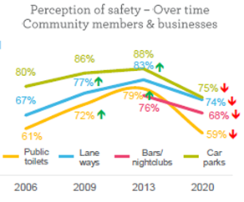
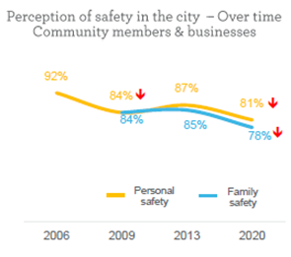

Women (76%), young people (14-25 years) (74%) and middle aged people (36 – 55 years) (73%) feel the least safe in the city due to public drunkenness, threatening/aggressive behaviour, people sleeping rough and evidence of drug use and drug dealing.

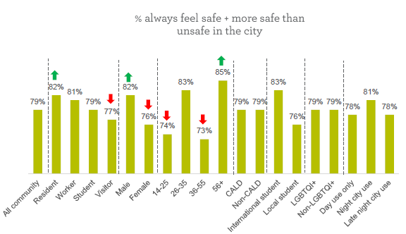

Women report concerns regarding verbal harassment (36%) and inadequate street lighting (45%) as contributing to feeling unsafe in public spaces. King Street near the night clubs (40%) and King Street generally (26%), Flinders Street Station (37%) and corner Elizabeth & Flinders Streets (36%) are reported as the most unsafe areas.

References
ABS 2017, Personal Safety, Australia, 2016. Australian Bureau of Statistics. Canberra, ACT <https://www.abs.gov.au/statistics/people/crime-and-justice/personal-safety-australia/latest-release>
ANROWS 2018, Violence Against Women: Accurate use of key statistics. Australia’s National Research Organisation for Women’s Safety. Sydney, NSW. <https://www.anrows.org.au/publication/violence-against-women-accurate-use-of-key-statistics/>
GEN VIC 2020, Gender Equity and COVID-19. Fact Sheet. Gender Equity Victoria. Melbourne. Vic. <https://www.genvic.org.au/resources/covid-19-resources/>
inTouch 2020, Women on Temporary Visas Experiencing Family Violence. Position Paper March 2020. inTouch Multicultural Centre Against Family Violence. Melbourne, Vic. <https://intouch.org.au/media-release-position-paper-on-women-on-temporary-visas-experiencing-family-violence/>
Multicultural Centre for Women’s Health 2017, Intersectionality Matters: A guide to engaging immigrant and refugee communities to prevent violence against women. Multicultural Centre for Women’s Health, Melbourne, Vic. <https://www.mcwh.com.au/intersectionality-matters-a-new-resource-for-preventing-violence-against-women/>
Our Watch 2017, Primary prevention of family violence against people from LGBTI communities. Our Watch. Melbourne, Vic , <https://handbook.ourwatch.org.au/resource-topic/tailor-primary-prevention-to-groups-and-settings/preventing-violence-against-lgbtiq-people/>
Our Watch 2018, Changing the Picture: A national resource to support the prevention of violence against Aboriginal and Torres Strait Islander women and their children. Our Watch. Melbourne, Vic. <https://www.ourwatch.org.au/resource/changing-the-picture/>
Our Watch, ANROWS & VicHealth 2015, Change the Story: A shared framework for the primary prevention of violence against women and their children in Australia. Our Watch. Melbourne, Vic. <https://www.ourwatch.org.au/change-the-story/>
Per Capita 2020, Measure for Measure: Gender equality in Australia. Per Capita. Melbourne, Vic. <https://percapita.org.au/our_work/measure-for-measure-gender-equality-in-australia/>
Rainbow Health Victoria 2020, Pride in Prevention: A guide to primary prevention of family violence experienced by LGBTIQ communities. La Trobe University. Bundoora, Vic. <https://www.rainbowhealthvic.org.au/news/launch-pride-in-prevention-evidence-guide>
State of Victoria 2016, Royal Commission into Family Violence. Report and Recommendations. Parl Paper No 132 (2014–16). <http://rcfv.archive.royalcommission.vic.gov.au/Report-Recommendations.html>
Women with Disabilities Victoria n.d., Violence Against Women with Disabilities. Fact Sheet 03. Women with Disabilities Victoria. Melbourne, Vic. <https://www.wdv.org.au/publications-resources/wdv-fact-sheets/>
Women with Disabilities Victoria 2021, Prevention of Violence Against Women with Disabilities: Workforce resources for action. Women with Disabilities Victoria. Melbourne, Vic. <https://www.wdv.org.au/resources-to-accompany-prevention-of-violence-against-women-with-disabilities-workforce-resources-for-action/>
Women’s Health West 2017a, Preventing Violence Together 2030: Western region strategy to prevent violence against women. Background Paper. Women’s Health West. Melbourne, Vic. <https://whwest.org.au/resource/preventing-violence-together-2030/>
Women’s Health West 2017b, Preventing Violence Together 2030: Western region strategy to prevent violence against women. Women’s Health West. Melbourne, Vic. <https://whwest.org.au/resource/preventing-violence-together-2030/>

