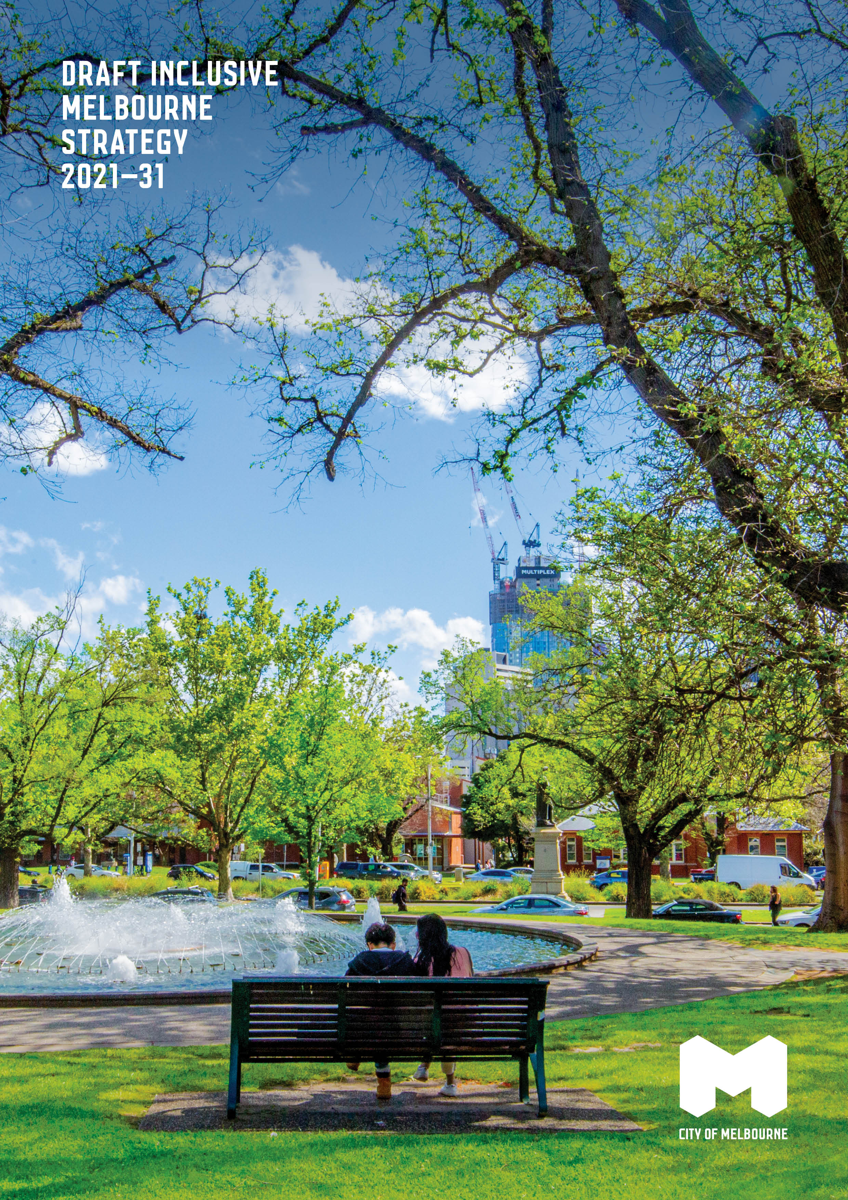
Figure 1 - Draft Inclusive Melbourne Strategy 2021-31

Acknowledgement of Traditional Owners
The City of Melbourne respectfully acknowledges the Traditional Owners of the land, the Wurundjeri Woi Wurrung and Bunurong Boon Wurrung peoples of the Eastern Kulin and pays respect to their Elders past, present and emerging. We are committed to our reconciliation journey because, at its heart, reconciliation is about strengthening relationships between Aboriginal and non-Aboriginal peoples, for the benefit of all Victorians.
Melbourne.vic.gov.au
December 2021

Contents
Acknowledgement of Traditional Owners 1
Contents 2
Message from the Lord Mayor 4
Introduction 5
Purpose 5
Defining inclusion and diversity 5
Vision 5
Priority areas 6
Impact of COVID-19 and ensuring an inclusive recovery 7
Social exclusion 7
Addressing barriers to inclusion 7
Community consultation 8
Strategic context 8
Global context: United Nations Sustainable Development Goals 8
Australian context: National and Victorian legislation 9
City of Melbourne snapshot 10
Key statistics 11
What we heard from the community 12
Priority 1. Organisation, services, programs and places for all 13
Our workforce 13
Our services, programs and places 14
Alignment to the Sustainable Development Goals 16
Priority 2. Sustainable and fair recovery 16
Alignment to the Sustainable Development Goals 18
Priority 3. Empowered, participatory communities 18
Alignment to the Sustainable Development Goals 20
A whole of City of Melbourne approach 20
Embedding a community development approach 20
Tracking progress 22
Priority 1. Organisation, services, programs and places for all 22
Priority 2. Sustainable and fair recovery 23
Priority 3. Empowered, participatory communities 24
References 26

Message from the Lord Mayor

The City of Melbourne has a bold vision. We want Melbourne to be a city of possibility, where the world meets and the extraordinary happens. A city that is accessible, affordable and inclusive.

The Inclusive Melbourne Strategy will enable us to realise this vision and continue important work towards reducing inequality and enhancing safety and accessibility across the municipality.

It is underpinned by a number of existing plans, strategies and policies that together contribute to a more inclusive city.

From the Affordable Housing and Economic Development strategies to the Disability and Access and Inclusion Plan and Reconciliation Action Plan, this overarching Inclusive Melbourne Strategy brings all of our thinking about inclusivity into one clear framework for the next 10 years.

This strategy has been devised with our recovery efforts in mind. It provides an opportunity to reset the trajectory of our city to ensure no one is left behind in our city’s renaissance.

Regardless of culture, age, gender, sexuality, religion or ability, Melbourne must be a place where everyone can prosper, where every voice is as important as the next and where diversity is celebrated for the vibrancy and richness that benefits us all.

This notion is inherent in our commitment as members of the Welcoming Cities national network, and the pledge we have made to report our progress towards the United Nations Sustainable Development Goals.

Thank you to everyone who has dedicated time to this strategy, to listening and responding to the aspirations of our community and making meaningful plans to create a more diverse, more inclusive and more resilient Melbourne.

Melbourne, a city of possibility for everyone.

Sally Capp
Lord Mayor

Introduction

Melbourne has always been a significant gathering place. The city’s Aboriginal culture, knowledge and heritage provides the foundation for today, a place where all cultures, backgrounds, genders, sexualities and abilities are welcomed, celebrated and protected.

The diversity of our municipality is one of our greatest assets. We are proud of Melbourne’s diverse communities and recognise that we are all better off when everyone has a voice, can contribute and thrive. As a prosperous city, we strive to provide greater opportunities for all. Everyone should benefit from participating in our city’s social, economic, cultural, physical, and political aspects.

Purpose
This Inclusive Melbourne Strategy will help realise our vision of a truly inclusive Melbourne over the next 10 years. It outlines how the City of Melbourne will embrace the diversity of cultures, ages, genders, sexualities, backgrounds, religions and abilities of the people who live, work, study and visit the city.

This strategy recognises that groups of people within the community experience persistent barriers to equal participation. This strategy amplifies the voices of Aboriginal peoples, LGBTIQ+, young people, older people, women, people with a disability, culturally and linguistically diverse people, international students and people experiencing poverty and homelessness.

Defining inclusion and diversity
Social inclusion is defined as the process of improving the terms of participation in society through enhancing opportunities, access to resources, voice and respect for rights – United Nations. Diversity refers to the differences between people and how they identify, such as cultural and ethnic background, sexuality, age, gender, beliefs, socioeconomic status, income, education level, occupation, ability, faith and beliefs.

Vision
Our city is where people of all cultures, backgrounds, ages, genders, sexualities, beliefs and abilities are welcomed, celebrated and protected. As a result, our urban communities are sustainable, safe, affordable and inclusive, drawing people from around the world to visit, work and live. We are proud of the vibrancy this diversity brings to every aspect of city life.

Priority areas
Our three overarching priorities have corresponding outcomes and evaluation measures. We will monitor our performance against our priorities annually.
Priority 1. Organisation, services, programs and places for all
A diverse and inclusive workforce underpins our delivery of services, programs and places that are accessible and meet the needs of our diverse communities.
- Our organisation is diverse and inclusive.
- Our people feel culturally safe, valued and belong.
- Our services, programs and places are responsive to the evolving priorities of our diverse communities.
- Our services, programs and places are welcoming, safe, accessible and affordable for all.
- Our information is accessible, and messaging is inclusive.
- Council policies, strategies, plans and other publicly-facing information are developed and published under universal design principles.

Priority 2. Sustainable and fair recovery
The city’s recovery and regeneration from COVID-19 provides an opportunity to build back better for all. A diverse and resilient community is at the centre of a livable city.
- Our city economy is inclusive – all people can contribute to and benefit from our shared prosperity.
- The City of Melbourne and our partners support a community-led recovery through capacity building practices.
- Our Council Plan initiatives deliver a long-term, sustainable recovery through integrating social, economic and environmental priorities.
- Our leadership and decision-making follow the five guiding principles of an inclusive recovery.

Priority 3. Empowered, participatory communities

We want to encourage participation from all community members, ensuring that people feel heard and their needs are addressed.

- People have the capacity to identify local needs and are empowered to lead change in their neighbourhoods.
- People and communities are connected and participate fully in community life.
- All people can participate in city decision-making.

Impact of COVID-19 and ensuring an inclusive recovery
Melbourne has been hit hard by the COVID-19 pandemic, and it continues to have profound economic, health and wellbeing impacts on our community.

Many existing stressors were facing Melbourne before the pandemic, including racism towards minority groups and people of colour, food insecurity, safety, youth unemployment, mental health, homelessness – with the highest rates of presentation for homeless assistance by Aboriginal people in Australia – and critical shortages of affordable, accessible and quality housing.

The pandemic has exacerbated these underlying vulnerabilities and inequities, with some groups being disproportionately impacted, such as women, low-income earners, international students and people experiencing homelessness. As a result, economic and social disadvantage has increased. In addition, some community members have experienced violence and racism, and people have reported poor mental health through social isolation and loss of community connection. The pandemic also exposed the digital divide in our communities.

The World Bank defines an inclusive recovery as one which addresses the exclusion and long-standing systemic inequalities that COVID-19 has laid bare (October 2020). Investing in economic reactivation and recovery is essential. We can do this in a way that ensures that no one is left behind and that builds towards a more sustainable and fair society.

Social exclusion
Several factors drive exclusion and cause people in the community to experience structural and systemic disadvantages. These factors include unemployment, job insecurity, physical and mental health issues, isolation, loneliness, racism, gender inequality, family violence, poverty, childhood or adult trauma and lack of access to education and technology. In addition, we acknowledge the intersection of factors that contribute to the experience of exclusion. For instance, people who are sleeping rough and experiencing homelessness are often impacted by several of these factors.

Addressing barriers to inclusion
Although significant factors cause exclusion for members of our community, the City of Melbourne is home to one of the world’s most harmonious and culturally diverse communities. More than 56 per cent of residents were born overseas, and 48 per cent speak a language other than English. In addition, city of Melbourne residents speak over 137 languages, and more than 83,000 international students lived in Melbourne before COVID (2019).

As a member of the Welcoming Cities national network, we are committed to creating a place where everyone can belong and participate. We will improve participation in society for all members of the community through enhancing opportunities, access to resources, voice and respect for rights. We will address barriers to inclusion when:
- designing physical environments
- providing programs and services
- running events and activities in the municipality
- planning and delivering projects
- employing and promoting our workforce
- undertaking decision-making processes.

Community consultation
The strategy has been developed through an extensive consultation process. We consulted widely with stakeholder organisations. In addition, we held focus groups with community members representing city workers, businesses, residents, students, and a diversity of cultures, religions, abilities, genders and sexualities. In implementing the strategy, we will collaborate with Traditional Owners, government, business, community organisations and stakeholder groups.

Strategic context
The Inclusive Melbourne Strategy will ensure that all groups of people can harness the possibilities that our city has to offer. It responds to the Council Plan and the Health and Wellbeing Plan and provides a framework for the City of Melbourne that progresses inclusion for our city.

Global context: United Nations Sustainable Development Goals
Leaving no one behind is an essential theme of the Sustainable Development Goals (Goals), a United Nations framework that the City of Melbourne supports. The framework consists of 17 goals with specific targets focused on economic growth, social inclusion and environmental protection. The City of Melbourne has embraced the Goals as a means for making Melbourne a better place to live, work and visit.

The Inclusive Melbourne Strategy plays an important role in further integrating the Sustainable Development Goals into our key strategic initiatives. ​​The most applicable goals are:
Goal 3: healthy lives and wellbeing for all
Goal 5: gender equality
Goal 8: decent work and economic growth
Goal 10: reduce inequalities
Goal 11: inclusive, safe, resilient and sustainable cities
Goal 16: peace, justice and strong institutions.

We have mapped the alignment of the Goals to our work throughout this strategy. We will measure our progress against relevant indicators from these Goals in addition to the specific indicators in this strategy.

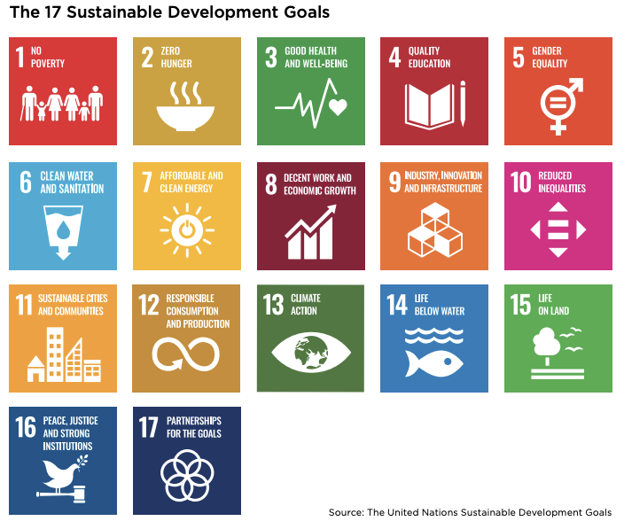

Australian context: National and Victorian legislation
In developing the Inclusive Melbourne Strategy, we have considered relevant legislation at both the Victorian and Australian Government levels in the areas of inclusion, diversity and equity.

It is unlawful to discriminate based on age, disability, race, sex, intersex status, gender identity, and sexual orientation in Australia. These anti-discrimination laws are contained in national legislation:
- Age Discrimination Act 2004
- Disability Discrimination Act 1992
- Racial Discrimination Act 1975
- Sex Discrimination Act 1984

Under Victoria’s Local Government Act 2020, councils must act for the benefit and wellbeing of the municipal community. They must achieve the best outcomes for the community, plan for climate change and provide accessible and equitable services responsive to diverse needs.
The Local Government Act 2020 requires councils to create a Community Engagement Policy. The City of Melbourne’s Policy states that: “whenever the City of Melbourne is planning, delivering a project or making a decision that significantly impacts the way our community experiences the city or their interaction with our organisation, the community must have the opportunity to participate in that process meaningfully.”
Victoria’s Gender Equality Act 2020 requires public entities, including councils, to support the identification and elimination of systemic causes of gender inequality in policy, programs and delivery of services in our workplaces and in the communities we serve. As per the Act, the City of Melbourne will conduct gender impact assessments on all policies, programs and services we develop.

We are also bound by Victoria’s Equal Opportunity Act 2010, which aims to make public life free from discrimination, sexual harassment and victimisation. It protects people from discrimination and harassment in areas of public life, including workplaces, places that provide services and local government.

The Charter of Human Rights and Responsibilities is a Victorian law that sets out all people’s fundamental rights, freedoms, and responsibilities in Victoria. It contains 20 basic rights that promote and protect freedom, respect, equality and dignity. The Charter requires public authorities, such as Victorian state and local government departments and agencies, and people delivering services on behalf of government, to act consistently with the human rights in the Charter.

The Multicultural Victoria Act 2011 enshrines principles of multiculturalism which the City of Melbourne follows. The Act acknowledges that individuals come from diverse backgrounds and are entitled to mutual respect and understanding and to access opportunities and participate in and contribute to the community’s social, cultural, economic, and political life.

Local Government has a role in supporting community members to achieve optimal health and wellbeing, as set out in section 24 of the Victorian Public Health and Wellbeing Act 2008. Under this Act, local governments are required to develop a municipal public health and wellbeing plan every four years. To meet this requirement, the City of Melbourne has developed the Health and Wellbeing Plan 2021–25, integrated as part of the Council Plan to demonstrate what the Council will do to protect, improve and promote public health and wellbeing in the City of Melbourne.

City of Melbourne snapshot
The population of Melbourne’s municipality is made up of people of all ages and from many different cultures. Residents include young professionals, international students and older couples. Before the COVID-19 pandemic, around 972,000 people used the city on an average weekday, and each year Melbourne hosted over three million international visitors.

183,756 residents
49% male
51% female
56% of residents born overseas (2016)
48% speak a language other than English (2016)
19% speak mandarin (2016)
910,800 people live, work, study or socialise in the municipality
79,230 overseas students
1,653 same-sex couple households
468 Aboriginal people
1.7% live with a disability
100 people sleeping rough
32% of households experience rental and mortgage stress
33% experience food insecurity
22% have been diagnosed with depression or anxiety
929 per 100,000 reported incidents of family violence

*Statistics typically reflect pre COVID-19 data. They do not take into consideration impacts stemming from this event, such as travel and working from home restrictions and should not be taken to reflect the current daily population.

Key statistics
Poverty affects almost one in 10 residents in the municipality (Geografia 2021). A lack of affordable housing means that one-third of people renting in Melbourne are living in rental stress (Australian Bureau of Statistics 2016). In addition, overseas-born residents are more likely to be unemployed than Australian born residents (Australian Bureau of Statistics 2016).
COVID-19 has exacerbated existing inequalities with increased disadvantage across already vulnerable populations of our municipality. The City of Melbourne Social Indicators Survey 2021 shows that young people, residents from CALD backgrounds and low-income residents are most heavily impacted by social isolation as a result of COVID-19.
The City of Melbourne survey reports that personal wellbeing and feeling part of the community have declined compared to pre-pandemic results, along with participation in sport and exercise and people volunteering. In addition, there has been a 33 per cent increase in self-harm injuries and a 90 per cent increase in demand for mental health services (City of Melbourne, 2020). While wellbeing outcomes are lower across all groups, people from English speaking backgrounds and people on higher-income earners enjoy better personal wellbeing outcomes than people from non-English speaking backgrounds and lower-income residents.
The City of Melbourne survey consistently reports lower perceptions of safety at night for women than men. In 2021, 63 per cent of men reported feeling safe at night compared with just 36 per cent of women. There has been an increase in family violence during the pandemic. According to the latest reported crime statistics, the rate of family violence incidents in Melbourne increased by 18.5 per cent from 2019–20 to 2020–21.

What we heard from the community
We developed this strategy through extensive consultation with specific groups, including Aboriginal and culturally and linguistically diverse communities. For example, we consulted people with a disability, people of all ages, faith-based, transgender and non-binary community members. We also engaged with people who identified as lesbian, gay, bisexual, pansexual or queer, and young people.

Engagement included:
- twelve focus groups and four in-depth interviews with city residents, workers and visitors
- five workshops with community organisations and individual stakeholders
- two Inclusive Recovery Workshops with industry, government and community stakeholders.

The community engagement provided valuable insights centred on themes of representation, opportunity, accessibility and participation. People understood inclusion as feeling a sense of belonging, having a voice in community decisions, and visible diversity in the community.

Throughout our engagement with our diverse communities on our community vision, four-year Council Plan and Community Engagement Policy, we heard that inclusion matters to everyone. One in five – 19 per cent – of people said their top priority for the City of Melbourne is for it to be inclusive, accessible and affordable.

Stakeholders identified the following groups as at risk of exclusion: Aboriginal communities, multicultural communities, LGBTIQ+, people with socioeconomic disadvantage, people experiencing homelessness, people with disabilities, women, older people, people with a mental illness or who are neurodiverse, refugees, international students and young people.

Across most of our community consultations, participants identified that there are groups in the community who face persistent barriers to participating in the social, physical, economic, cultural and political life in the City of Melbourne. Barriers included:
- Safety concerns – feeling concerned about physical safety, elevated for some groups of people, including women and LGBTIQ+ community members.
- Representation – lack of opportunity to be represented in aspects of city life, including leadership and events and festivals.
- Social – lack of understanding of the needs of different groups can lead to not feeling welcome to participate.
- Physical – limited access to streets, buildings and public transport.
- Economic – lack of finances preventing participation in some activities in Melbourne.

Participants suggested the City of Melbourne could embed inclusivity when designing physical environments, programs and services, running events and decision-making processes.

As part of the consultation process, we held two workshops on ‘how we can ensure that our COVID-19 recovery is inclusive and sustainable.’ Stakeholders from across the community, business, university, environment and arts sectors and the Victorian Government reflected on their vision for Melbourne’s recovery and how to ensure that we create opportunities for everyone in a post-COVID world.

Given this crisis’s unprecedented and evolving nature, stakeholders focused on the ‘how’ of recovery, over articulating a clear, mapped out vision of a good recovery. Workshop participants highlighted the need to bring diverse voices into shaping our recovery because of the strength that a diversity of people, experiences, and thinking provides.

Other workshop outcomes included the need to work in partnership, leveraging existing investments to deliver on a fair and inclusive recovery, keeping the community at the centre of decisions and taking a conscious approach to legacy. Participants wanted a long-term, equitable and sustainable recovery, not just building back to where we were but transporting us into a bigger, better future.

Priority 1. Organisation, services, programs and places for all
This priority aims to achieve a diverse and inclusive workforce and delivery of services, programs and places that are accessible and meet the needs of our diverse communities.

Our workforce
As the first local government to have a Reconciliation Action Plan endorsed by Reconciliation Australia, we are committed to supporting local Aboriginal peoples’ voices, ambitions, and employment. We will continue to participate in advancing reconciliation actively.

We continue to strive for equality for people of all genders and are committed to ending men’s violence against women in all its forms. Our workplace culture ensures that women enjoy respect, equal opportunity and full participation.

We aim to provide all LGBTIQ+ persons with a safe, engaging and diverse working environment that offers equal opportunities. We are a proud member of Pride in Diversity and work to improve our policies and entitlements so that they are fair.

We seek an ‘access for all’ working environment. Therefore, we will increase the number of employees with a disability across our organisation and regularly implement disability awareness training.

We also seek to have a diverse age profile that is representative of the municipality. Amplifying young voices and harnessing the experience of our mature workforce will improve our decision-making and services.

We strive to overcome barriers to employment for people from culturally diverse backgrounds and recognise the significant benefits of recruiting highly-skilled, creative migrants and refugees who reflect the diverse people in our communities.

Community members and staff made the following comments about diversity in the workforce:

‘People being able to see diversity in the workforce is important—police force, tram driver, Lord Mayor... helping people feel that things are possible.’ – community member.

‘So when I finished university, I realised that there were a lot more barriers that were going to come my way as a migrant woman, as a black woman, trying to kick start my career, essentially. So I think one of the more pressing issues for me is that there’s a whole new generation of those who I will probably represent.’ – community member.

‘We're working on our employment policies, strategies and the way that we do business so we can make these processes more inclusive and responsive to the needs of all people.’ - City of Melbourne staff member.

Our services, programs and places
We commit to making all services, programs and places delivered by the City of Melbourne accessible and equitable. Accessibility includes physical access, as well as making everyone feel secure, comfortable and welcomed. Our programs will support the needs and priorities of all communities.

By including diverse groups in the design of our programs, services, facilities, built environments and public open space, we will ensure these assets are accessible for everyone. In addition, this co-design approach will reduce barriers to participation in events, activities, services and programs.

We will create safe, inclusive recreation facilities and programs that support the community’s physical health and mental wellbeing. We will improve the accessibility of our facilities for all people, including people with a disability. For example, we will increase and upgrade inclusive spaces for women in City of Melbourne sports facilities.
Our events and activities will be accessible, safe, affordable, celebrate Melbourne’s diversity and create a sense of belonging in the city. In addition, our library services will expand to include digital literacy services, facilities and initiatives to reduce the digital divide.

Community members made the following comments about services and spaces in the City of Melbourne:

‘We want to ensure that our services are safe and accessible because we know from experience, if they’re not, that people simply won’t access them and then they’ll be left looking for other places to go. And it can be through simple things like misgendering somebody or assuming that somebody’s partner is of a particular gender. Just those simple things can suddenly set up a barrier that says, “I’m not safe here, I’m not included here”.’

‘I think we need to consider a co-designed approach by having women of all ages, trans women, women of colour, women with disability, women who work in the city, who study in the city all come together and talk about, “how can we make certain spaces safer for us?”’

‘There could be more efforts made to, you know, celebrate people of different backgrounds and different communities. I feel like the Council could have control over that, and that could be something that they could easily do. Having events that show appreciation for everyone in Melbourne would be really nice.’

‘This is about being a great place to live, having the right services for people so the community can thrive.’

‘My vision for the city is to be able to go into the City of Melbourne and feel welcomed and embraced and respected.’

Outcomes | Indicators | Timeframe | Our Role
Our organisation is diverse and inclusive. | Increased diversity reflected in workforce data | Medium | Deliver
Our people feel culturally safe, valued and belong. | Increased reporting safety and belonging through staff survey data. | Immediate | Deliver
Our services, programs and places are responsive to the evolving priorities of our diverse communities. | Increased diversity of people and communities accessing services, programs and places. | Medium | Deliver
Our services, programs and places are welcoming, safe, accessible and affordable for all. | The needs of all people in the community are a key input into the planning and design of services programs and places. | Medium | Deliver
Our information is accessible, and messaging is inclusive. | Communication and information meet accessibility standards. Style guide reflects inclusive language applied across all channels. | Immediate | Deliver
Council policies, strategies, plans and other publicly-facing information are developed and published under universal design principles. | Universal design policy created. Number of staff trained in universal design principles. Proportion of Council policies, strategies and plans that are developed according to universal design principles. | Medium | Deliver

Alignment to the Sustainable Development Goals

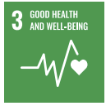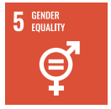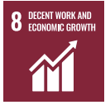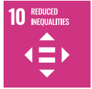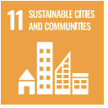

Priority 2. Sustainable and fair recovery
The city’s recovery and regeneration from COVID-19 provides an opportunity to build back better for all. A diverse and resilient community is at the centre of a livable city.
The World Bank has defined inclusive recovery as addressing the exclusion and long-standing systemic inequalities that COVID-19 has laid bare. It is integral that our recovery expands opportunities for everyone to experience prosperity and overcome barriers to advancing their wellbeing. Underpinning this approach is the theory of inclusive growth which argues that economic growth, social development, and inclusion help support a robust economy where all people can thrive and access equal opportunities.
We are committed to building a more sustainable and fair recovery that ensures no one is left behind. We acknowledge that this is a dynamic, evolving and complex challenge, and our focus is on how we engage, lead, partner, adapt and work together to work through this uncertainty. We have developed the following guiding principles to support this commitment.
Five guiding principles for an inclusive recovery:
- Legacy building
- Work in partnership
- Draw on evidence to continually adapt approaches
- Deliver best value
- Strengthen community resilience and enable community-led activity
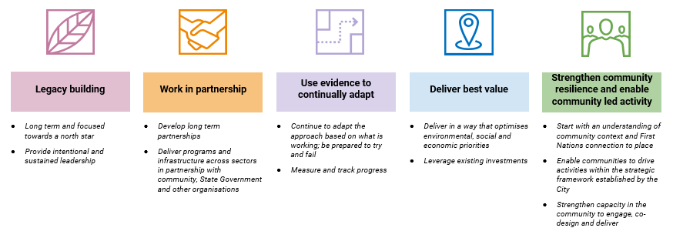
Inclusive Recovery Workshop participants made the following comments about rebuilding post-COVID-19:

‘We’ve got an opportunity to really rethink the role and shape of the city. We have a once in a lifetime opportunity to build back better, to create a city that is more diverse, more inclusive and more resilient. My vision for the city is one of diversity and constant evolution.’

‘Recovery will demand that everyone contributes to it. It will require leveraging inclusion to drive that recovery.’

‘The foundation of a truly inclusive approach is understanding, working with and empowering the community.’

‘The key things in any good recovery are that the community is at the centre of decisions that are made. Every decision you make around the environment, around business, around infrastructure impacts on the other components of a good city, and indeed a good recovery.’

‘If you can help shape what the offerings are, you feel more tie-in, belonging, and it becomes more genuine.’

Outcomes | Indicators | Timeframe | Our role
Our city economy is inclusive – all people can contribute to and benefit from our shared prosperity. | - An increased number of social enterprises, socially responsible businesses, minority-owned businesses are operating in the City of Melbourne.  - Inclusion is built into the governance, implementation and advocacy of our economic recovery initiatives. | Medium | Deliver, partner and advocate
The City of Melbourne and our partners support a community-led recovery through capacity building practices. | - City of Melbourne grants, social procurement and employment practices have been reviewed to deliver inclusive outcomes.  - Increased number of partners and networks engaging in capacity building to support a community-led recovery activity through investment, volunteering, and supporting infrastructure. | Medium | Deliver, partner and advocate
Our Council Plan initiatives deliver a long-term, sustainable recovery through integrating social, economic and environmental priorities. | - Thirty per cent of Council Plan major initiatives apply an integrated approach, delivering on social, economic and environmental outcomes. | Immediate. | Deliver
Our leadership and decision-making follow the five guiding principles of an inclusive recovery. | - The Management Leadership Team regularly reviews progress against the guiding principles. | Immediate | Deliver

Alignment to the Sustainable Development Goals
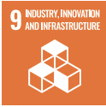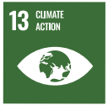

Priority 3. Empowered, participatory communities
This priority aims to build connection and empowerment. We want to encourage participation from all members of our community. Representation from diverse voices will lead to a more cohesive, inclusive city. We want to ensure that people feel heard, and our organisation’s responses demonstrate we have listened to people’s needs and aspirations.
We want people to share their ideas and perspectives, recognising that contributing to decision-making is essential to strong communities. Our aim is for people to shape the future of their city.
The City of Melbourne understands the strengths, assets and connections to place that our community has. We invest in building the capacity of our community to lead and affect change. We will ensure that the community is supported to identify place-based concerns and opportunities, and we will work together to address these and realise aspirations.
We will implement a neighbourhood model by working with communities to develop neighbourhood plans and service centres that respond to the local community’s existing and projected needs. The neighbourhood model will ensure that community strengths, needs and priorities are understood and supported through our work, investment and advocacy.
We will foster reciprocal relationships with different parts of our communities, including Traditional Custodians, community organisations, residents, workers, businesses, students and other precinct and neighbourhood-based stakeholders. We will bring groups together to forge connections, share ideas and learn from each other.
Community members made the following comments about creating inclusive communities:

‘You know, if you have things where people can make a statement or voice, they feel they’re more part of it, that they're part of this community and it belongs to them as well. It changes
that idea of it belonging to the business people. No, the city belongs to everyone because we all make up the city.’

‘95 per cent of people consulted agreed that: “Public participation in Council planning leads to better decisions and more sustainable solutions. Our different perspectives and experiences are valuable, and we all have a right to be involved in decisions that affect where and how we live.’

‘The future is local. We need to move residents out of the status of consumers and to have that, you need to delegate authority, power, resources, and bring in residents to have legitimate decision-making power.’

Outcomes | Indicators | Timeframe | Our role
People have the capacity to identify local needs and are empowered to lead change in their neighbourhoods. | Communities develop neighbourhood plans and collaborate to implement priority actions. | Medium | Deliver and  partner
People and communities are connected and participate fully in community life. | Communities report high levels of social connection, access to learning, volunteering, recreation and cultural opportunities. | Immediate | Deliver, partner and advocate
All people can participate in city decision-making. | Increase in ranking for community decisions, consultation and engagement in Satisfaction Survey (higher than Victorian average). | Immediate | Deliver

Alignment to the Sustainable Development Goals
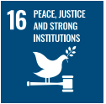

A whole of City of Melbourne approach
We will operationalise the Inclusive Melbourne Strategy across the whole of our organisation. The strategy builds on the inclusive priorities, actions, and commitments in the Economic Development Strategy 2031 and the Affordable Housing Strategy 2030. The strategy provides an overarching framework for existing plans, including our Cultural Diversity Statement, Melbourne a Great Place to Age, Health and Wellbeing Plan 2021–25 and Active Melbourne. In addition, it is a framework for the Disability Access and Inclusion Plan, Reconciliation Action Plan, our place-based plans and Creating Communities of Equality and Respect: prevention of violence against women Action Plan 2021–24.

Working in partnership will be vital to creating a genuinely Inclusive Melbourne. In implementing the strategy, we will collaborate with Traditional Owners, government, business, community organisations and stakeholder groups. We will achieve the priorities and outcomes through delivering them ourselves, collaborating with others and advocating for change. We will advocate with all levels of government and other partners to deliver this strategy acknowledging our shared responsibilities in progressing inclusion.

We commit to embedding engagement through our Community Engagement Policy and our Participate Melbourne online platform.

Embedding a community development approach
Adopting a community development approach is central to the implementation of this strategy. Our city comprises a broad set of unique and diverse neighbourhoods, from the densely-populated CBD to residential Kensington, Carlton and South Yarra. Implementing a neighbourhood model strengthens how we understand and work with different communities across our city.
Using community development practice and this place-based approach, we seek to understand better our communities’ strengths, needs, and priorities to guide our work and empower communities to identify their priorities and lead change. We will ensure the participation of diverse voices, views, and people, facilitate individual capacity, and build stronger, more united local communities.

Through understanding our communities better with neighbourhood level insights, we can confidently engage and communicate with communities on our work and respond to needs. It will also allow us to tailor services, programs and facilities effectively.
It will help ensure that our long-term COVID recovery is sustainable and inclusive by building resilience, creating space for community participation in government decision-making and supporting co-designed and locally-led recovery initiatives.
We will also implement a business partnering model to embed inclusion, access and meaningful community engagement across City of Melbourne projects and initiatives. Our business partnering includes a team of Community Engagement and Impact Advisors working with around 80 projects every year. The Advisors will provide support on maximising value for our communities through our everyday work.

Tracking progress
We will monitor the implementation of this strategy annually through ‘Pulse Check’ reports. Success indicators will be tracked over the 10 years of the strategy and published publicly on our Participate Melbourne digital engagement platform. We will continue to enhance and improve our approach to tracking and monitoring the indicators over time. These measures will contribute to the City’s progress on a range of UN Sustainable Development Goals.
We will undertake a participatory review of the strategy at the five-year mid-point to ensure our outcomes and indicators continue to meet community aspirations. In its tenth year, a comprehensive evaluation of the strategy’s effectiveness will determine the extent to which Melbourne has met its inclusion objectives. We will celebrate the most significant changes through storytelling and community events.

Priority 1. Organisation, services, programs and places for all
Outcomes | Indicators | Monitoring our progress | City of Melbourne’s role | Implementation Timeframe
Our organisation is diverse and inclusive | Increased diversity reflected in workforce data | - Annual employee demographics metrics tracking. | Deliver | Medium
Our people feel culturally safe, valued and belong. | Increased reporting safety and belonging through staff survey data. | - Three-yearly review of People and Culture diversity targets and capacity-building programs.  - Staff Satisfaction and Culture Survey every quarter. | Deliver | Immediate
Our services, programs and places are responsive to the evolving priorities of our diverse communities. | Increased diversity of people and communities accessing services, programs and places. | - Annual Specific council services and programs data on diverse participation. | Deliver | Medium
Our services, programs and places are welcoming, safe, accessible and affordable for all. | The needs of all people in the community are a key input into the planning and design of services programs and places. | - Four-yearly facilities disability and cultural safety audit.  - Neighbourhood insights incorporating diverse views and voices are consistent key inputs to planning, design and delivery of services, programs and places. | Deliver | Medium
Our information is accessible, and messaging is inclusive. | Communication and information meet accessibility standards. Style guide reflects inclusive language applied across all channels. | - Diversity of people engaging through Participate Melbourne and community consultations- measured annually. | Deliver | Immediate
Council policies, strategies, plans and other publicly-facing information are developed and published under universal design principles. | Universal design policy created. Number of staff trained in universal design principles. Proportion of Council policies, strategies and plans that are developed according to universal design principles. | - Universal design policy is developed and staff trained. Universal design principles inform Council policies, strategies and plans. | Deliver | Medium

Priority 2. Sustainable and fair recovery
Outcomes | Indicators | Monitoring our progress | City of Melbourne’s role | Timeframe
Our city economy is inclusive – all people can contribute to and benefit from our shared prosperity. | An increased number of social enterprises, socially responsible businesses, minority-owned businesses are operating in the  City of Melbourne.  Inclusion is built into the governance, implementation and advocacy of our economic recovery initiatives. | - Specific data relating to businesses (from the second year of strategy).  - Implementation of the Economic Development strategy (from the second year of strategy). | Deliver, partner and advocate | Medium
The City of Melbourne and our partners support a community-led recovery through capacity building practices. | City of Melbourne grants, social procurement and employment practices have been reviewed to deliver inclusive outcomes.  Increased number of partners and networks engaging in capacity building to support a community-led recovery activity through investment, volunteering, and supporting infrastructure. | - Annual City of Melbourne data on grants, procurement and employment (from the second year of strategy).  - Partnership registry to be established (from the second year of strategy). | Deliver, partner and advocate | Medium
Our Council Plan initiatives deliver a long-term, sustainable recovery through integrating social, economic and environmental priorities. | Thirty per cent of Council Plan major initiatives apply an integrated approach, delivering on social, economic and environmental outcomes. | - Annual Social Return on Investment measurement (from the second year of strategy). | Deliver | Immediate.
Our leadership and decision-making follow the five guiding principles of an inclusive recovery. | The Management Leadership Team regularly reviews progress against the guiding principles. | - A six-monthly survey in the first two years and then annual. | Deliver | Immediate

Priority 3. Empowered, participatory communities
Outcomes | Indicators | Monitoring our progress | City of Melbourne’s role | Timeframe
People have the capacity to identify local needs and are empowered to lead change in their neighbourhoods. | Communities develop neighbourhood plans and collaborate to implement priority actions. | - Annual reporting on Neighbourhood Plans and progress. | Deliver and partner | Medium
People and communities are connected and participate fully in community life. | Communities report high levels of social connection, access to learning, volunteering, recreation and cultural opportunities. | - Annual City of Melbourne Liveability and Social Indicator Survey results. | Deliver and partner | Medium
All people can participate in city decision-making. | Increase in ranking for community decisions, consultation and engagement in Satisfaction Survey (higher than Victorian average). | - Annual Victorian Community Satisfaction Survey results.  - An annual increase in membership of Participate Melbourne online engagement platform. | Deliver | Immediate

References
(In development)
Affordable Housing Strategy 2020–2030
https://www.melbourne.vic.gov.au/building-and-development/urban-planning/community-housing/Pages/affordable-housing.aspx
Leaving no one behind: the imperative of inclusive development
https://www.un.org/esa/socdev/rwss/2016/full-report.pdf
https://www.worldbank.org/en/news/immersive-story/2020/10/22/the-human-face-of-covid-19-six-things-to-consider-for-an-inclusive-recovery
Women’s work: the impact of the COVID crisis on Australian women https://grattan.edu.au/report/womens-work/
The economic benefits of improving social inclusion A report commissioned by SBS August 2019 https://www2.deloitte.com/content/dam/Deloitte/my/Documents/risk/my-risk-sdg10-economic-benefits-of-improving-social-inclusion.pdf
Building social cohesion in our communities https://humanrights.gov.au/our-work/race-discrimination/publications/building-social-cohesion-our-communities
City of Melbourne Social Indicators Survey 2021
COVID-19 Reactivation and Recovery Plan
https://www.melbourne.vic.gov.au/sitecollectiondocuments/covid-19-reactivation-recovery-plan.pdf
https://www.lmcf.org.au/getmedia/0bc3beb3-6d18-4b72-a5d3-9f6eb2acedef/VS_Report2020_A4_Pager_ONLINE_v1.pdf.aspx
Baum F, Bush R, Modra C, Murray C, Cox E, Alexander K, Potter R. 2000, “Epidemiology of participation: an Australian community study”. Journal of Epidemiology and Community Health; 54(6): 414-423.
www.oecd.org%2Fels%2Fsoc%2FOECD2015-In-It-Together-Chapter1-Overview-Inequality.pdf&clen=1791423&chunk=true
https://www.worldbank.org/en/topic/social-inclusion#1
http://www.acqol.com.au/uploads/surveys/20yr-anniversary-report.pdf
https://www.worldbank.org/en/topic/social-inclusion#2
https://www.wgea.gov.au/publications/gender-equality-business-case
https://www.parliament.vic.gov.au/images/stories/committees/fcdc/inquiries/57th/iopvs/Submissions/S92_Visionary_Design_Developement.pdf
https://www2.deloitte.com/au/en/pages/economics/articles/economic-benefits-improving-social-inclusion.html

Back cover
Contact details and interpreter services
melbourne.vic.gov.au

