Funding

Fitzroy Gardens Pavilion
ENGAGEMENT ANALYSIS

April 2021

Prepared by Global Research Ltd.
For
Contents
Executive summary 2
Infographic 6
Introduction and background 9
Community Consultation 11
Survey results 15
Appendix 46

Report prepared by
Global Research
150 Office Rd
Merivale
Christchurch 8014
New Zealand
P +64 3 355 4562
M +64 27 2433 083
E. patrick.oneill@globalresearch.nz
www.globalresearch.nz

Executive summary

About the consultation
The City of Melbourne is planning for the future use of the Fitzroy Gardens Pavilion. The pavilion is a single-storey space located in the centre of Fitzroy Gardens in East Melbourne. It contains an outdoor terrace and an external service and storage area.
The City of Melbourne have three options for the space – leasing it for either commercial or not-for-profit use or removing the building to create open space. Concept proposals for each option were released on the Participate Melbourne website, alongside a survey for the public to contribute their thoughts on how the Fitzroy Gardens Pavilion space should be used in the future. Feedback was sought on respondents’ preferred use, and preferred outcomes within their chosen use (i.e., what respondents want to see in the space).
The engagement ran from 24 February to 24 March 2021 and featured communications across multiple online and offline platforms. Respondents could provide their feedback via the Participate Melbourne survey, emailing the council directly, or participating in one of three pop-up sessions held at the site.
Overall, 511 individuals contributed to the engagement, with 467 online surveys, 10 email submissions, and 34 participants across 3 pop-up sessions. All responses have been read and analysed by Global Research analysts within the same framework. This report contains both qualitative and quantitative analysis of respondents’ answers.

Key findings
There was strong support for retaining the “iconic” building, as it was felt the building and location offered a valuable opportunity to provide a space for the community and visitors to enjoy.
Not-for-profit was the most popular option, selected by 51% of survey respondents. Within this, using the pavilion as a ‘creative space’ garnered the most support (39%). Most comments advocated for the pavilion becoming a multi-use space (for example, a combined gallery and performance space). A community hub was the second-most popular not-for-profit option (25%).
Commercial use gained support from 40% of survey respondents, with 79% within this (the largest single group of respondents) selecting ‘food and beverage’ as their preferred option. A café was the most popular option specified in comments.
Ideas for what the space could be were often similar across both those who selected not-for-profit and those who preferred commercial use. Many respondents were supportive of a dynamic, multi-use space that included both commercial and not-for-profit functions.
Overall, respondents appeared to be more interested in the value added for the community as a whole rather than heavily invested in one particular use.

At a glance

Engagement reach
511  total contributions | 467  surveys completed | 10  email submissions | 34  pop-up participants
1,958  website views | 27,111  newsletter reach | 30,063  Facebook reach | 54,224  Facebook impressions

What was proposed
Not-for-profit use | Commercial use | Open space or parklands

Respondents’ preferred use for pavilion space
236 | 189 | 42
Respondents preferred not-for-profit use | Respondents preferred commercial use | Respondents preferred open space or parklands

Who respondents were
67% | 63% | 44% | 31% | 4%
I visit the park | I live nearby | I am interested in the pavilion space | I work nearby | Other

Key facts about the project
Several answers to frequently asked questions were included on the Participate Melbourne website:

Location of the pavilion
The pavilion is located in the middle of Fitzroy Gardens between the Tudor Village, Fairies Tree Lawn and the Temple of Winds. The Fitzroy Gardens are listed on the Victorian Heritage Register and are a popular destination for visitors to the city, as well as city workers who use the Gardens heavily during their lunch break and the journey to and from work. Residents of East Melbourne and Jolimont also identify strongly with the Fitzroy Gardens as part of their neighbourhood.

Previous uses of the pavilion
A kiosk or tearoom has been offered in this general location since 1903. The pavilion café was constructed in 1963 and operated as a café/function space until March 2017. Its closure was due to a number of contributing factors including:
- The building quality and maintenance requirements
- The construction of a purpose-built integrated Visitors Centre with toilets, a new café and visitor services
- Investigation of future use of the site

Current use of the pavilion
The pavilion is currently being used by the Creative Spaces program until June 2021 to provide opportunities for artists to help reactivate and reinvigorate Melbourne whilst providing a boost to the local economy, in line with the goals of City of Melbourne’s COVID-19 Reactivation and Recovery Plan.

Selection of the three possible options
The Fitzroy Gardens are located on Crown land and permanently reserved as public gardens, with Committee of Management status vested in Council. Under the terms of the Crown Land Reserves Act and Regulations, activities and services in the gardens need to be ancillary to its main purpose – as a garden. This means that services that support the visitors are acceptable but other uses that have nothing to do with the gardens are not. The three options are consistent with this approach.
The options have also been guided by the Master Plan for the Fitzroy Gardens in 1996 and Master Plan Review 2010. These plans identify that increases in services or infrastructure solely to meet local residents’ recreational needs are not consistent with the broad purpose of the Gardens.
The Master Plan Review in 2010 originally envisaged that if an integrated visitor facility was established in the Gardens, the pavilion could be removed and the area converted to an informal picnic and mobile refreshments area. However, as the pavilion was under a lease until March 2017, Council chose to consider the requirements of current garden users once the lease expired and the Visitor Centre was built.
As it has been 11 years since the Master Plan Review and the integrated Visitor Centre has been constructed, it is now a great opportunity to ask the community what their preference is for the future and purpose of the site.

Selection process for a commercial or community operator
If the community engagement outcome is to retain the building (either as commercial or not-for-profit community use) then Council will carry out an expression of interest to lease process to determine a successful operator of the premises.

What does ‘return to open space’ mean?
If the community engagement outcome is to convert the area to open space, this may include removal of the building and returning it to parkland, creating a new garden area or an informal picnic and playground space. Council’s Parks and City Greening Team will design the landscape of the area to ensure the space meets visitors’ passive recreational needs.

How Council will use community feedback
All feedback gathered during the consultation period will help inform management recommendations to Council. The consultation findings and recommendations will be presented in a briefing paper to Council.

How people could have their say
There were a number of ways people were able to contribute, including:
- The online survey on Participate Melbourne
- Attending one of our pop-up conversation kiosks at the pavilion – 10am on 27 February, 4pm on 2 March & midday on 18 March 2021
- Email: property@melbourne.vic.gov.au

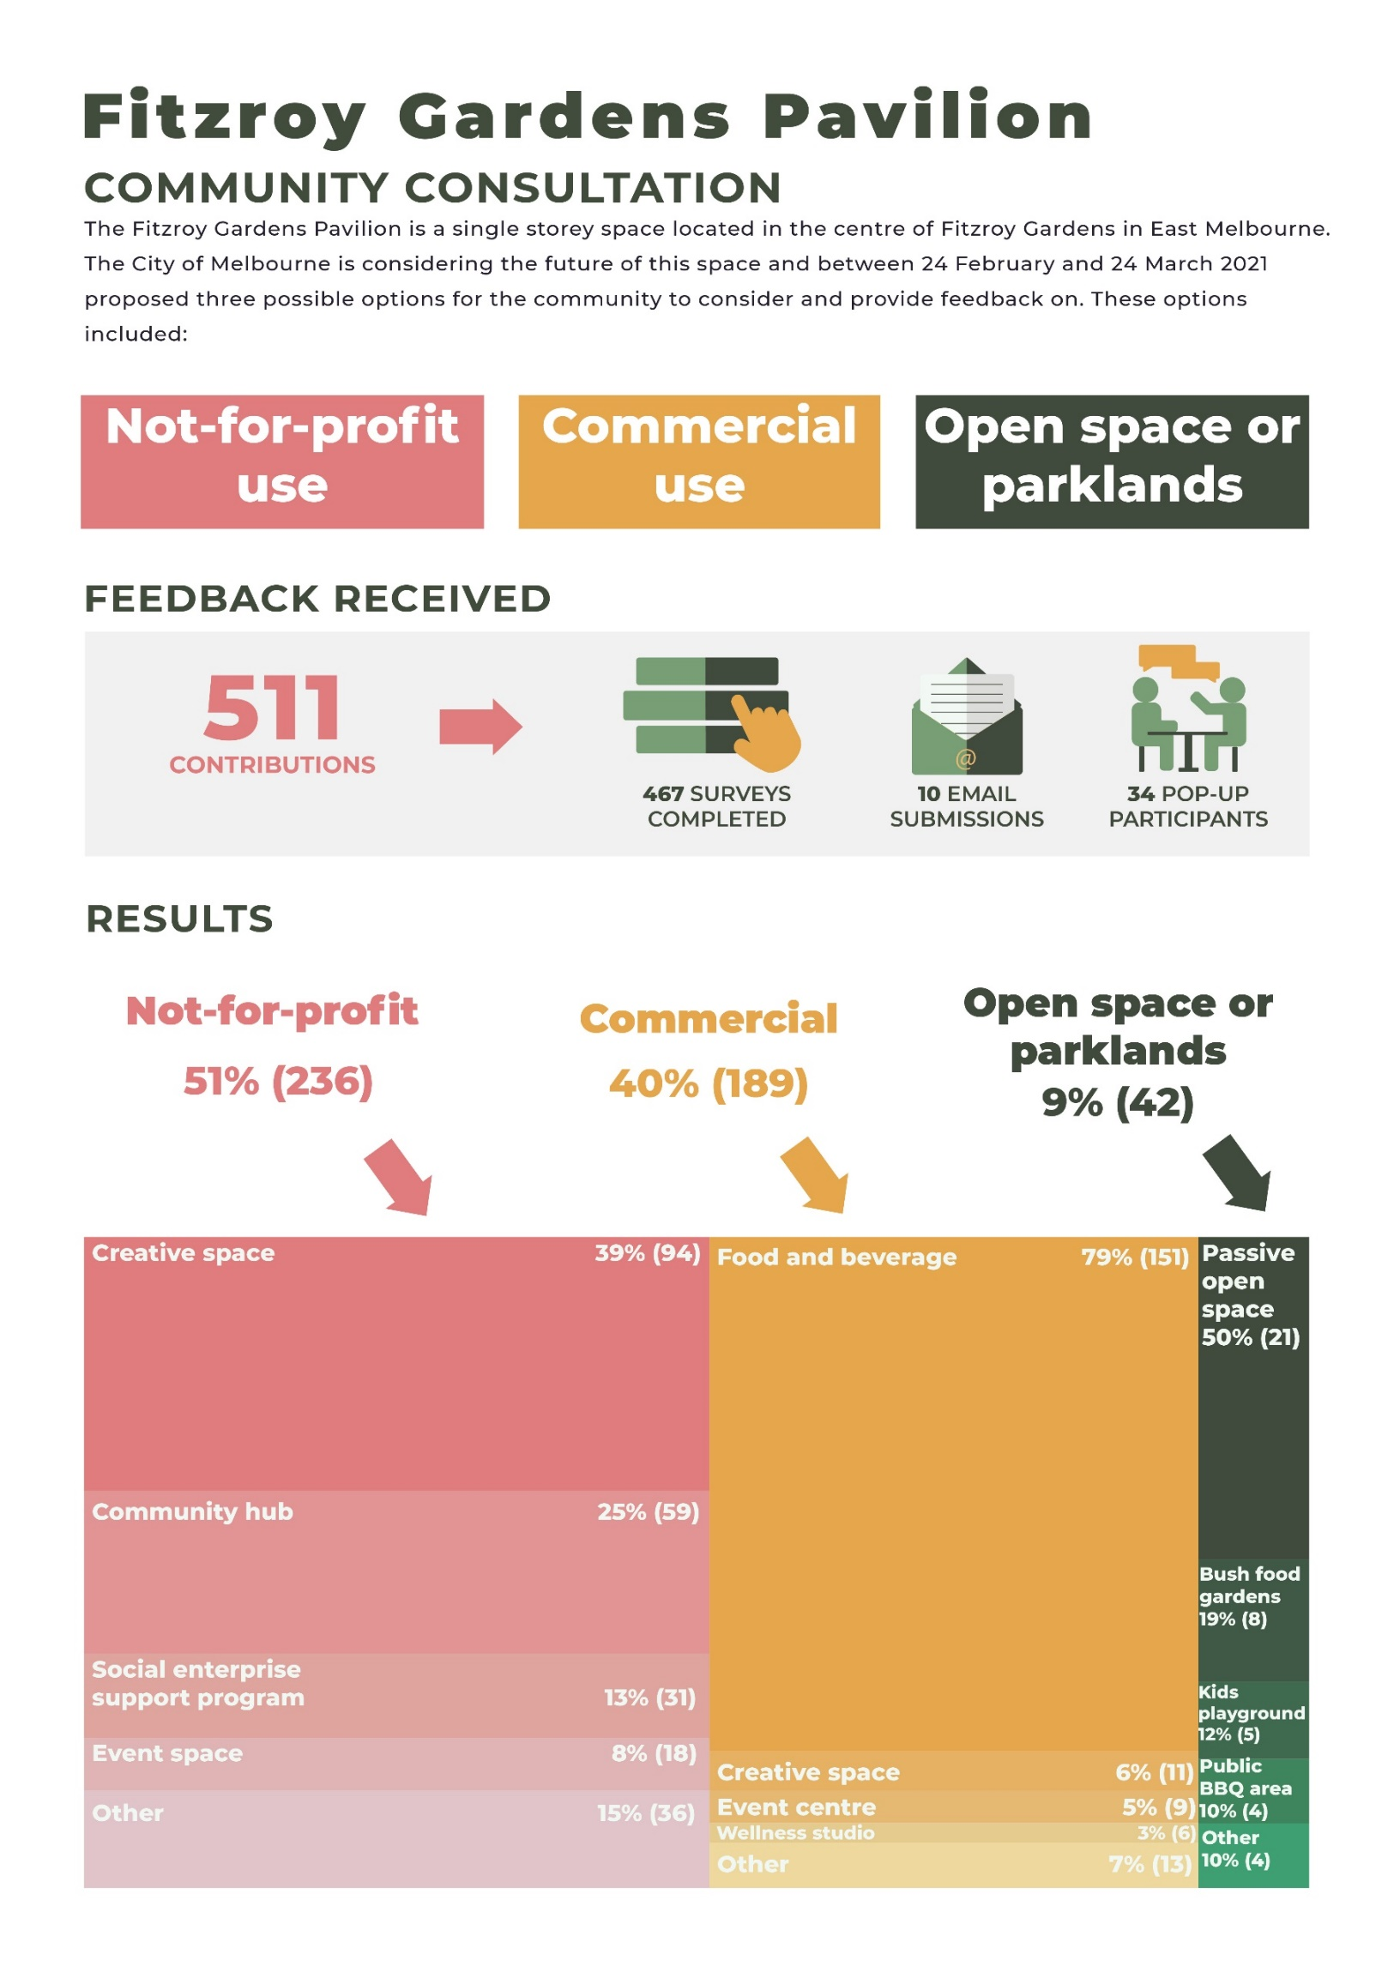Infographic
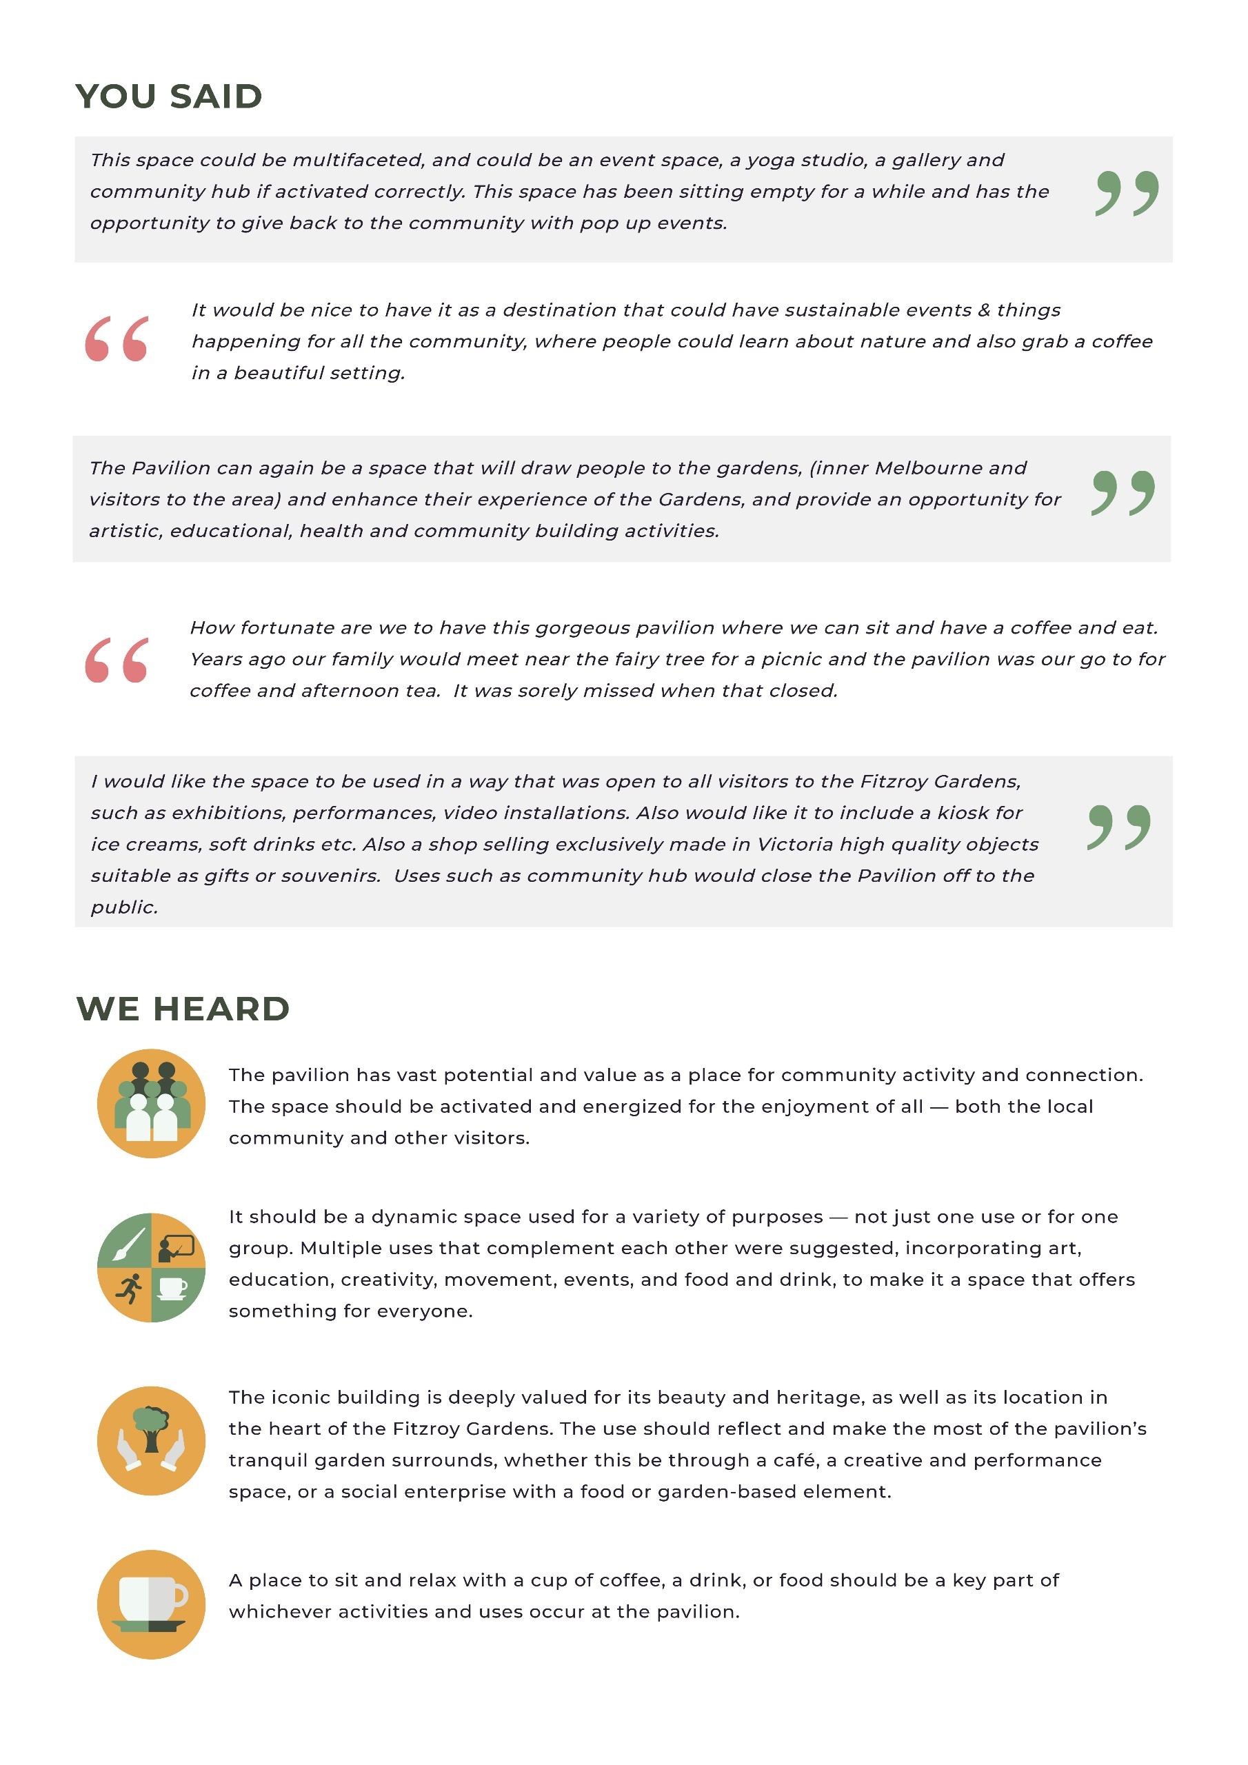

Key findings
- A slight majority (51%) of survey respondents wanted the space to be not-for-profit, with ‘creative space’ the most popular option selected within this group (94 respondents).
- The majority of these comments suggested multiple complementary uses, e.g., a combined gallery and performance space where workshops and events could be held. The building and garden location were felt to offer a unique opportunity to showcase artistic work.
- Commercial was the next-most preferred option, garnering support from 40% of survey respondents. A strong majority (79%) within this group selected ‘food and beverage’ as their preferred option – this was the single largest group of respondents (151). In the comments, a café was the most popular suggestion, with respondents commonly observing that this use would make the most of the beautiful garden location and iconic building, or that they had appreciated it being a café in the past.
- Ideas for what the space could be were often similar across both those who selected not-for-profit and those who preferred commercial use. Many respondents were supportive of a multi-use space that included both commercial and not-for-profit functions. In most cases the commercial aspect of this was a cafe.
- Across both these groups, support was often expressed ambivalently, with respondents appearing to be interested in the overall value added for the community rather than heavily invested in one particular use.
- There was strong support for preserving the iconic building. A common thread within the comments regarding commercial uses was that the uses for the pavilion, as a quality destination, should be limited to those in which its status is respected and preserved.
- Within those who selected not-for-profit, 25% of survey respondents supported the space becoming a community hub. These comments similarly advocated for its use to be multifaceted, noting that it should not be closed off for the exclusive use of certain groups and that it would be more appealing as a dynamic and varied space.
- Using the space for a social enterprise was backed by 13% of respondents who selected not-for-profit. The majority of these supported a food-focused enterprise such as a community café, often tying this to the park environment and suggesting an element of gardening or sustainability education. Opportunities to support disadvantaged groups through a café/restaurant social enterprise were also highlighted.

Introduction and background
The Fitzroy Gardens pavilion is a single storey space located in the centre of Fitzroy Gardens in East Melbourne. It contains an outdoor terrace and an external service and storage area.

The City of Melbourne is considering the future of this space and between 24 February and 24 March 2021 proposed three possible options for the community to consider and provide feedback on. These options were:

Option 1: Open space/parklands
(remove the building with option to include playground, food gardens)
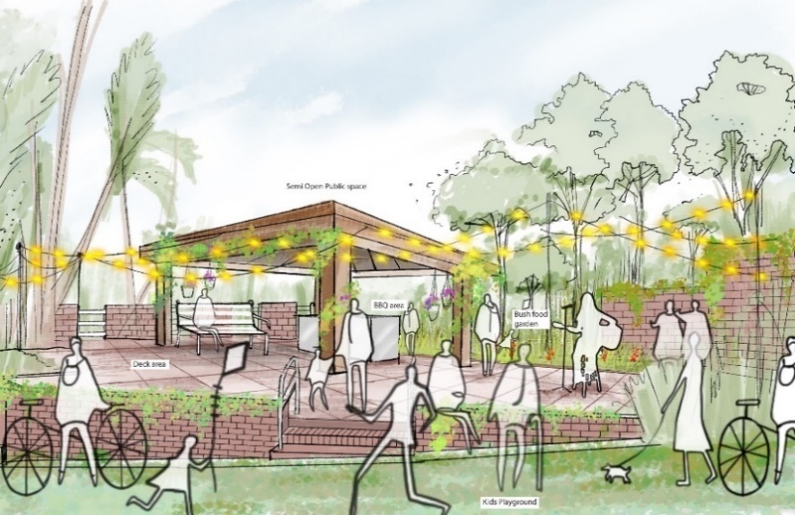

Option 2: Commercial
(e.g., cafe, event centre, wellness studio, creative space)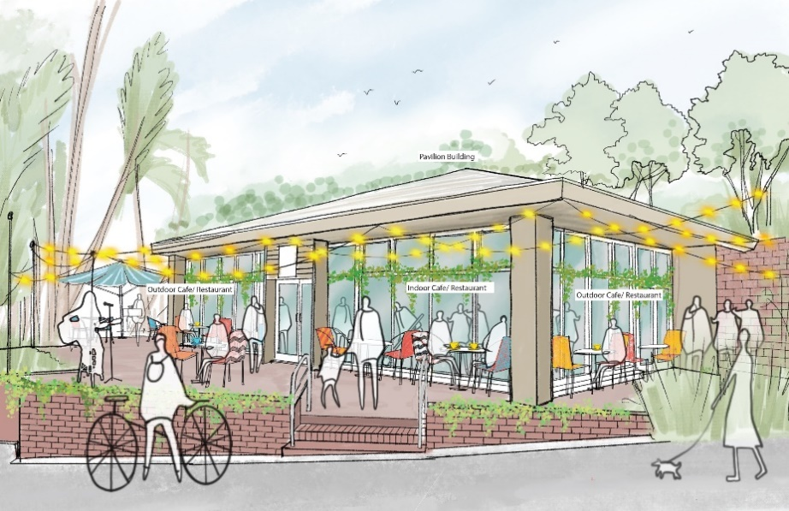

Option 3: Not-for-profit
(e.g., social enterprise support programs, event space, community hub, creative space)
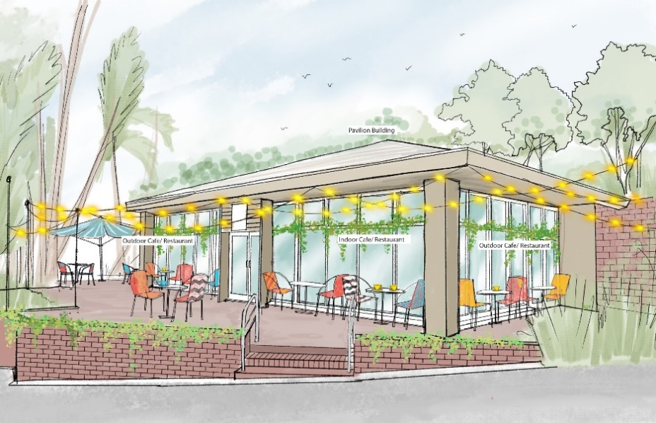

Community Consultation

Consultation method
The community consultation goal was to hear what the community thinks about how the pavilion space should be used in the future.
The engagement process sought to encourage a wide range of diverse voices from the community to take part.
Feedback was sought on:
- Respondents’ preferred use for the pavilion (open space/parklands, commercial, or not-for-profit)
- Preferred outcomes within their chosen use (i.e., the things that respondents want in the space such as a kids’ play area, wellness studio, events space, or community hub)
- Any other comments that respondents had about the future of the Fitzroy Gardens pavilion
- The relationships that respondents have with the pavilion space

From 24 February 2021 until 24 March 2021, the City of Melbourne consulted with the public on the future of The Pavilion in Fitzroy Gardens. This featured communications across multiple platforms including:
- Site map, FAQs and a survey on Participate Melbourne
- Emails to key stakeholders
- Updates to the Parks and Public Spaces page on the City of Melbourne website.
- A poster at the East Melbourne Library
- A Facebook ad via Zenith, aimed at people who ‘like’ Fitzroy Gardens
- A Yammer post
- Temporary signs at the pavilion site
- Inclusion in the Business in Melbourne newsletter, the Participate Melbourne newsletter and others
- Pop-ups at the site

The overall reach of this engagement included:
511  total contributions | 467  surveys completed | 10  email submissions | 34  pop-up participants
1,958  website views | 27,111  newsletter reach | 30,063  Facebook reach | 54,224  Facebook impressions
Respondents participated primarily via the online survey on Participate Melbourne, however, people were also able to send submissions via email during the submission period.
Overall, 511 individuals contributed to this engagement. This consisted of:
- 467 surveys
- 10 email submissions
- 34 pop-up participants at 3 pop-up sessions

Quantitative analysis overview
Frequency analysis was completed on the questions listed below. The results are presented as charts, along with key findings. Because of the relatively small number of people who answered some questions compared to others, both percentages and numbers of respondents are presented in the charts.
- What is your connection to Fitzroy Gardens?
- What use would you like to see at the Fitzroy Gardens Pavilion located in Fitzroy Gardens? Select one
  - If the participant chose ‘parklands or passive open space’, they were asked: If the area is to be returned to open space, what is your preferred outcome?
  - If the participant chose ‘commercial’, they were asked: What is your preferred commercial use?
  - If the participant chose ‘not-for-profit’, they were asked: What is your preferred operation?
- How did you hear about this project?

Written comments analysis overview

Analysis approach
The following discussion presents results from qualitative analysis of the one free-text question included in the survey.
- Do you have any other comments you would like to add?
Comments were filtered based on respondents’ preferred uses for the space as these answers were often related. The summaries that follow present the key points under each of the preferred uses selected by respondents.
To complete the analysis, Global Research analysts read each comment received from the community and organised them into themes and topics based on the points made. Some comments contained multiple points, relevant to multiple topics, resulting in a number of comments being coded to multiple places. The analysis was assisted by NVivo qualitative analysis software.
Analysts developed a coding schedule based on the desired objectives for the project, as listed by City of Melbourne and the content of comments. New topics were created and comments coded to these as they arose, ensuring all comments and the points made were included in the analysis.
To give a clear and consistent indication of the number of comments received on each topic, the following key was used to describe the relative number of comments on each topic:
Number of comments | Written as:
3 comments | a few
4—7 comments | a small number
8—14 comments | several
15—24 comments | a moderate number
25—49 comments | a considerable number
50—74 comments | a substantial number
75—99 comments | a sizeable number
100—149 comments | a large number
150+ comments | a very large number

Comments from respondents have been included in this report verbatim. However, obvious spelling or grammatical errors have been amended for clarity.

Survey results

Full results
As explained above, results were collected primarily through a survey, but some responses were also received via email or at pop up events.
The survey form asked for each respondent’s connection to Fitzroy Gardens, how they heard about the project, their preferred use for the space out of open space or parklands, commercial, or not-for-profit, and their preferred outcomes within their preferred use.
Note that the charts presented in this section are based solely on the responses received via the online survey form, and do not include the respondents who provided a response via email or at a pop-up event. However, the thematic analysis of written responses comes from all responses received from all three sources.

Connection to Fitzroy Gardens
Respondents were asked: What is your connection to Fitzroy Gardens?
Options were: I visit the park; I live nearby; I am interested in the pavilion space; I work nearby; Other
Note that respondents could select more than one option for this question, therefore percentages do not add to 100%.

Findings:
- The most common connection respondents had to Fitzroy Gardens was ‘I visit the park’ (67%).
- This was closely followed by respondents who live nearby (63%).
- Forty-four (44%) percent of respondents selected ‘I am interested in the pavilion’.
- The least common connection to Fitzroy Gardens was ‘I work nearby’ (31%).

Preferred uses for Fitzroy Gardens Pavilion
Respondents were asked: What use would you like to see at the Fitzroy Gardens Pavilion located in Fitzroy Gardens? Select one
Options were: Parkland or Passive Open Space; Commercial; Not-for-profit.

Findings:
- ‘Not-for-profit’ use was the most popular choice, with over half of respondents selecting this as their preferred option (51%).
- The next most popular option was ‘commercial’ use, which was selected by 40% of respondents.
- ‘Parklands or open space’ was the least popular choice, with only 9% of respondents selecting this option.

Not-for-profit
If the participant chose ‘not-for-profit’, they were asked: What is your preferred operation?
Options were: Social enterprise support program; Events space; Community hub; Creative spaces (Artist gallery, dance studio); Other.
Note that results presented in the following chart only include responses from those who selected ‘not-for-profit’ as their answer to the previous question (236 respondents).

Findings:
- Of those who selected ‘not-for-profit’ in the previous question, over one third (39%) wanted to see the area used as a creative space (i.e., a dance studio or gallery space).
- A quarter of respondents (25%) wanted the space to be used as a community hub.
- Event space was the least popular option, selected by only 8% of respondents.
- Respondents who selected ‘other’ (15%) were asked to specify their response in a text-box. Comments from this group are included in the ‘any other comments’ section of this report.

Commercial
If the participant chose ‘commercial’, they were asked: What is your preferred commercial use?
Options were: Food and beverage; Events Centre; Wellness studio; Creative Spaces (Artist gallery, dance studio); Other.
Note that results presented in the following chart only include responses from those who selected ‘commercial’ as their answer to the previous question (189 respondents).

Findings:
- ‘Food and beverage’ was selected significantly more often than other options (79%).
- ‘Creative space’ (6%) and ‘event centre’ (5%) were the next most popular options.
- Respondents who selected ‘other’ (7%) were asked to specify their response in a text-box. Comments from this group are included in the ‘any other comments’ section of this report.

Parklands or passive open space
If the participant chose ‘parklands or passive open space’, they were asked: If the area is to be returned to open space, what is your preferred outcome?
Options were: Kids playground; BBQ area for public use; Passive open space; Bush food garden; Other.
Note that results presented in the following chart include only responses from those who selected ‘parklands or passive open space’ as their answer to the previous question (42 respondents).

Findings:
- Half (50%) of those who selected ‘parklands or passive open space’ as their preferred use for the Fitzroy Gardens Pavilion space specified that ‘passive open space’ would be their preferred outcome.
- ‘Bush food gardens’ was the second most popular option, selected by nearly one-fifth of respondents who answered this question (19%).
- Respondents who selected ‘other’ (10%) were asked to specify their response in a text-box. Comments from this group are included in the ‘any other comments’ section of this report.

Comments analysis
Respondents were asked: Do you have any other comments you would like to add?
These comments have been filtered based on respondents’ preferred use for Fitzroy Gardens Pavilion, and then further categorised by the specific elements discussed.

Not-for-profit 331 comments

Summary findings
  - Respondents who selected not-for-profit most commonly supported the pavilion becoming some form of creative space. The majority of these comments suggested multiple complementary uses, e.g., a combined gallery and performance space where workshops and events could be held. For many respondents this did not preclude some form of café or retail (e.g., a craft shop). The building and garden location were felt to offer a unique opportunity to showcase artistic work.
  - A substantial number of respondents supported the space becoming a community hub. These comments similarly advocated for its use to be multifaceted, noting that it should not be closed off for the exclusive use of certain groups, and that it would be more appealing as a dynamic and varied space.
  - Using the space for a social enterprise was backed by a substantial number of respondents. The majority of these supported some form of food-based enterprise such as a community café, often tying this to the park environment and suggesting an element of gardening, nature, or sustainability education. Opportunities to support disadvantaged groups through a café/restaurant social enterprise were also highlighted.
  - A recurring theme across different preferred options was that respondents wanted the space to be “activated” and “energized” and for it to be welcoming and accessible to all. They called for it to be a place that enhanced community connection rather than being limited to the use of certain groups.

Creative space 112 comments
The most popular option amongst respondents who wanted the space to be not-for-profit was for it to be converted to a creative space. Comments have been discussed below in sub-topics, due to the larger number of comments than other topics.

Events and performance space 33 comments
There was strong enthusiasm for using the pavilion as a performance space. Many respondents felt this overarching concept would enable it to be used for a multitude of purposes, encompassing dance, theatre, and music performances, as well as lectures, exhibitions, workshops, art and dance programmes, pop-up events, and artists in residence.
A few respondents suggested it could provide a performance space while also incorporating some retail and community use, such as a café, a shop selling locally made crafts and products, an exercise and yoga space, or for community art and cooking classes.
A key theme highlighted in the comments was that people wanted the pavilion to be used to enhance community connection rather than in a way that meant it was closed-off or held exclusively for certain groups, as the following comment illustrates:
I would like the space to be used in a way that was open to all visitors to the Fitzroy Gardens, such as exhibitions, performances, video installations. Also would like it to include a kiosk for ice creams, soft drinks etc. Also a shop selling exclusively made in Victoria high quality objects suitable as gifts or souvenirs. Uses such as community hub would close the Pavilion off to the public.
Respondents felt the surrounding garden, secluded location and “magical” atmosphere of the pavilion made it ideal for creative events, with several respondents heaping praise upon the dance performances they had recently attended:
Attended an event here recently and it is a fantastic arts space with magical atmosphere in the middle of the gardens. It would be perfect for community dance, performance and artist residencies.
Creative performance uses were lauded for their potential to “activate” and “energise” the space and “reverberate life and energy into the park”, with one comment noting that previous uses of the space had been disappointing. They went on say:
I’ve travelled to art venues all around the room and I’ve never seen a space that has the potential to do that this space has. It would be wonderful and utterly unique to Melbourne.
Other benefits raised included that it could be a “hit” with tourists, and that it would provide crucial support to the arts community who, it was noted, have been hard-hit by the pandemic:
This presents such an incredible opportunity for local creatives that have been hit hard through COVID. Many venues have closed their doors and it has become harder to find public spaces that support these local artists, during a time where the community could benefit so much from these activities to band together and support one another. A large variety of events could be held in the space that would give artists a chance to connect to the wider community, from family and cultural events to creating a platform give voice to talented locals who have something to offer, enriching the lives of all involved during a time when it is sorely needed!

General creative space 31 comments
A considerable number of respondents expressed support for turning the pavilion into a creative space for artists and the community. These comments echoed the arguments of those who supported it being a dance or performance space but tended to make more general recommendations without specifying a particular artistic discipline. Others suggested inviting artists from a cross-section of disciplines and focusing on variety:
It will be amazing for it to be a creative space for artists of different disciplines to practice, share ideas, run workshops and events. A creative hub for artists and audiences!
Keep this as a space where multiple people can express themselves! Diversity is key!
Others comments focused on incorporating creative and educational uses for the community, such as making a versatile space where art classes and workshops could be held:
Diverse creative program for all art forms with a dynamic range of free educational activities for everyone.
The value for the artistic community and the specific benefits of the pavilion as a creative space were reiterated, with several respondents noting that they have appreciated the “activation” brought by the recent artist in residence.
This is a perfect place for a range of creative practices providing possibilities for observation, exchange and research between practitioners, local community, other park users and workers and visitors. It is a necessary and beguiling place for creative research offering the opportunity for artists to see out, and be seen working in a situation that via pedestrian traffic allows an unusual possibility for interchange. The garden setting is quite unique in offering these possibilities.
One respondent stipulated that it could have multiple uses as a creative space, gallery, or community learning centre but that it should not be “something that closes it off like a dance studio.” They also warned that the space was unlikely to be a viable commercial operation and that people were wary of walking through the gardens after dark, particularly in winter, so whatever was done with it needed to take that into account.

Gallery 22 comments
A moderate number of respondents suggested the pavilion would provide an ideal place for an art gallery. It was common for it to be promoted as a gallery alongside other uses, such as artists in residence, public workshops, performances, an exercise/yoga/dance studio, a café, a function venue, and a shop selling crafts and art. One respondent offered the following vision summing up the space’s potential for multiple artistic uses:
I support using this building to create an accessible and diverse creative space for artistic work, including artist residencies, public workshops, pop-up gallery and work-in-progress showings. It could be a beautiful, informal space for artists to connect with audiences, with the capacity to expand indoor/outdoor over the warmer months. A new artistic presence would enrich Fitzroy Gardens.
Various suggestions for how people envisioned the gallery included for young artists to display their work, for temporary art exhibitions, that it be run by non-profit, volunteer-run art groups, or as a place to display kindergarten and school students’ artwork (similar to Gallery Sunshine Everywhere). Another respondent suggested it could provide an open space for the community to create and present their own artistic projects. One respondent offered specific ideas for the layout, suggesting a gallery space and “multiple lockable spaces in a glass building letting in natural light with a view of the gardens” that would cater to multiple writers and artists in residence for set periods of time.
Lastly, one respondent observed that the gallery theme could reflect its natural surroundings:
As a unique space in a beautiful setting it should be accessible to the community. A gallery with a focus on botanical or flora would be lovely and appropriate.

Dance space 16 comments
Respondents who supported using the pavilion as a dance space were often also in support of it acting as a performance venue or aligning with other creative uses like workshops and classes focusing on movement. One respondent suggested:
I think a space dedicated to the moving arts, dance, somatic event and body-based experiences would be wonderful. Dancing and moving and experiencing in a garden is a unique offering in the inner city.
Its suitability for this purpose was highlighted by another respondent, who noted:
The Pavilion is a perfect arts space - offering a quiet, focused environment to work while being openly accessible to the general public. It is particularly appropriate for dance as it is quite a large space with appropriate flooring.
Several comments lauded the recent artist’s residency, with people appreciating both the performances and her day-to-day presence in the space. Her residency was felt to offer a rare opportunity for people to see and experience the process of making creative work, with one comment describing this as giving a “creative heart to the green space”. Another comment stated:
I have been engaging with The Pavilion while Deanne Butterworth has been artist in residence there and it has been a very vibrant hub with lots of passers-by stopping to engage in conversation with the artist, curious in the work she is doing. I believe this is a space Melbourne needs right now.
A comment from the artist in residency herself elaborated on how working in the Pavilion had enabled connections and conversations with the broader community:
During my time there I have had numerous conversations with park visitors, children, other artists, and locals. At first there was a sense of both curiosity and excitement when people enquired what I was doing. They were SO happy to see the space used and wanted to know what the future of it might be […] That would lead to them talking about the creative hobbies they pursue and how they accessed them. Many people talked about how they would love for the building to become some kind of creative space – these conversations often happened with people who I might have originally thought would be sceptical of my work in the arts or maybe not even have that much interest in creative endeavours.
A few comments reiterated that using the pavilion for dance would support and “nourish” the arts community, with one respondent (who had worked there with the recent artist in residence) highlighting the rich value the pavilion could offer for both artists and the community:
I am a professional dancer and having a space that is handed over to artists to work as artists for a lengthy period of time has been amazing. Often spaces like this do not come by often, or are usually very expensive to hire out. Through working each day in this space on various different projects, events and performances, we have been able to connect with communities of people, new and old; whether they are friends, family members, colleagues, or pedestrians coincidentally strolling on by.

Aboriginal culture 10 comments
Using the pavilion as a place to celebrate Aboriginal culture was supported by several respondents, who suggested a variety of ways to do this. Ideas included showcasing Aboriginal art and history through various exhibitions, workshops, film screening, music, and tours; having it as a hub for indigenous people or youth; or focusing on indigenous food and ecology.
A couple of respondents highlighted that, despite Fitzroy’s strong link with Aboriginal communities, there was currently little visibility of Aboriginal culture throughout the city and there was scope to enhance this:
A creative space involving the practices of indigenous and other marginalised groups would be powerful. North Fitzroy is known as “stuff white people like”, so mix it up some more.
Another respondent reiterated this point and suggested using the pavilion for an endeavour which showcased indigenous foods:
Fitzroy has a very strong link with Aboriginal communities but there are less spaces for them to celebrate and showcase their culture due to gentrification. White farmers are now capitalising on indigenous foods but there need to be avenues for Aboriginal people to share knowledge and profit from their cultural heritage and there are so many people who want to know and taste this now. Could be a real draw card and diversify East Melbourne a little.
Finally, a couple of respondents suggested it could be utilised as a space for more formal cultural education. One respondent proposed that the pavilion could be a dedicated education space covering a range of areas, but which should include staff from representatives of Wurundjeri First Nations people. Another offered a detailed suggestion for an exhibition focused on pre-colonial indigenous ecology:
An authentic, rigorously researched exposition of the pre-European micro-local ecology before its reshaping by British colonists would give the superb modern-day Fitzroy Gardens context. The scope of such an expo should be the equivalent of the scope of Cooks' Cottage. The Fitzroy Gardens and all their current features (which must remain) tell a significant story. An indigenous ecological expo is a fundamental component, currently missing, of that story. The more complete story would be of interest to Australian visitors and, particularly, international tourists. There are many questions and understandings that would arise from the juxtaposition of the introduced landscape, the numerous other British features, the scarred tree and the central indigenous expo mooted here.

Community hub topics 69 comments

Support community hub 62 comments
Respondents in support of a community hub recommended a range of suggestions for what this could look like, underscoring that the pavilion lends itself to being used for multiple purposes to cater to different groups:
This space could be multifaceted, and could be an event space, a yoga studio, a gallery and community hub if activated correctly. This space has been sitting empty for a while and has the opportunity to give back to the community with pop up events.
I would like to see mixed use, which might include classes in arts, music, yoga, dance, but also a meeting space for community groups and event space at weekends.
Several respondents stipulated that it should not be closed off for the exclusive use of certain groups, and that it would be more appealing as a dynamic and varied space:
Would like it to be usable by different changing groups - so not just one user. Would like it to be dynamic and interesting [so] that people visit regularly.
The Pavilion should be retained for use as a community hub (not just for local residents but for all visitors to the Fitzroy Gardens) or for a not for profit purpose.
Specific suggestions included making it a bookable space for groups to use; community classes and events as well as a café where people can work, socialise, and relax; a centre offering arts, music, and health and wellbeing classes; a yoga or exercise studio; an occasional event space; card afternoons for older local residents; a library; having a small food garden outside; or as a space for holding information sessions and talks. One comment offered a detailed suggestion for it to be used as a garden centre, among other things:
It would be really nice to see a garden centre here where people can learn about the plantings in the garden, history etc and it could be run by local community members. You could even sell saplings/seedlings etc that match current plants in the gardens.
The suitability of the pavilion for a community space was emphasised, with respondents describing how it was a convenient and attractive location, and how making it a community hub would enhance and activate the larger space and provide mutual benefits:
A community hub offering a range of interesting activities that are accessible by all would create a space that is attractive, vibrant, welcoming and engaging. It would appropriately activate the site and enhance the attractiveness of the Heritage listed Fitzroy Gardens by bringing more people and activity into the Gardens.
Several respondents also highlighted the need for a community space, noting that East Melbourne currently lacked options for community groups and activities.
While a few respondents did explicitly support a café being an element of the community hub, a small number of respondents specifically opposed the inclusion of a café, noting there was already a café in the gardens or that they opposed any commercial use of the space:
Fitzroy Gardens is such a peaceful oasis in a busy and increasingly noisy city. Whatever the use, peace and community must be at its heart. There is already a cafe in the park and retail nearby, please no commercial use in this location.
The pavilion has been twice over operated by commercial enterprises and twice over the food and service was not Melbourne and twice they failed. Let’s give the community an opportunity and see what they do with it, my hope and money is on the community.

Oppose community hub 7 comments
The small number of respondents who specifically opposed the pavilion becoming a community hub primarily did so on the grounds that this would exclude the wider public and casual visitors to the park, and they felt the pavilion should be open and inclusive to all:
Public park for all of Melbourne and not private use for certain community groups.
A couple of respondents particularly warned against giving over the space for the exclusive use of the East Melbourne Group, describing them as a “very non-inclusive group”.
One respondent argued there was no need as it was “not a residential area”, while another respondent felt that a community hub would not be utilising the full potential of the space, saying:
The planning needs to offer more to the community than just another meeting room space. Plenty of people use the gardens and would give patronage to business situated in the Pavilion.

Social enterprise 63 comments

Food and environment focus 38 comments
A considerable number of comments suggested a not-for-profit venture involving food, often incorporating a focus on indigenous foods, garden-grown produce, or a concentration on the surrounding natural environment. Several of these simply suggested a café or food kiosk should be part of whatever other activities occurred there, noting that this was central to draw people to the pavilion and that a not-for-profit is preferable to a commercial venture:
All of the above, multiuse but with a community cafe as the mainstay.
I’d actually like there to still be a cafe there but I chose ‘not for profit’ because I’d rather a social enterprise cafe than a commercial offering (similar to the other cafe in the Gardens).
Others called for a café that provided social benefits, suggesting this could be through offering free or pay-as-you-feel meals to those in need or employing people from vulnerable or disadvantaged groups. A community-run café or using the kitchen for community cooking classes was also mooted.
A cafe or something similar to Streat in Collingwood that gives back to the community would be great for visitors to the park as well as locals needing support.
Cafe or event space that could be used for training disadvantaged or disabled people to give the employment experience.
A community kitchen [such] as KereKere Green Café.
A moderate number of respondents suggested that the initiative should encourage learning about food, gardening, living sustainably, and nature. A variety of options were suggested, including a café with a garden; a café with events where people could learn about nature; a community garden where people could compost their waste; and a cottage garden or interactive hub where people can seek gardening advice and that promotes gardening.
Something like CERES, with a cafe and herb/ bush food garden and a training room for garden sustainability & maybe cooking etc
Enlist the help of Joost Bakker and @futurefoodsystem to create a space that recreates to nature. Let him turn the pavilion into a zero-waste learning space, much like the one in Fed Square, where visitors can learn new ways of living, growing, eating while enjoying a beautiful space and eating fantastic Fitzroy garden grown produce.
A space relating to the garden, including plants, ideas for small space, terrace and balcony gardens and productive gardening. Make it part of the ‘greening the city’ strategy. So much potential!!
A few respondents proposed that the focus should be on indigenous ecology and food, with one suggesting an indigenous ecology expo and another comment stating:
Indigenous food garden and cafe run by an indigenous organisation. This would serve to educate and inform as well as be a place of enjoyment and empowerment. A good counterbalance to Captain Cook's cottage and beneficial to locals, tourists and visitors of all ages and abilities.

Social support 14 comments
The potential of the pavilion to be used to provide social benefits was noted in a moderate number of comments. Several respondents expressed general support for this idea, with comments such as the following:
I think a social enterprise model is the best. A commercial enterprise with a social output. That way you’re engaging groups while having a commercial output.
Would welcome a space that could be accessed by all and provide opportunities for work for those in need.
The use of this space for social enterprise would be a great avenue for local residents (many retired and highly skilled) to volunteer their time, give back to the community and to benefit from social interaction with purpose.
Other comments made more detailed or specific suggestions. These included lunches or programs for Melbourne’s homeless; an initiative that provides jobs for people with disabilities, a program that provides opportunities for young people who are isolated or disconnected; or cultural activities.
A couple of respondents suggested combining the social enterprise element with a community hub, creative space, or commercial venture like a gift shop, having maker spaces, or having weddings, events and talks about the gardens.
A couple of comments noted that social enterprises in Melbourne could do with more support or suggested that they would be interested in taking on the space.

Education 9 comments
Several respondents called for the pavilion to be used as an education centre for both children and adults, with a few proposing that it could be funded partially or fully by the Department of Education. The surrounding elements of the Fitzroy Gardens, such as the Fairy Tree, the Tudor Cottage, Sinclair’s Cottage, and the wider historic precinct of East Melbourne, as well as the features of the pavilion itself, were highlighted as valuable attributes for a learning centre for children, older students and adults:
The area is close to the Fairy Tree and the mock Tudor village. These features lend themselves, specifically for primary aged students, to explore the historical links of these features in the gardens. Moreover, there is wide scope for nature walks and the study of flora and fauna. Nearby is Cook’s cottage with potential for educational development. The possibilities for creative expression are also significant as children engage with the environment.
Two respondents made comprehensive proposals reiterating the valuable characteristics of the Pavilion as a learning centre and making specific suggestions regarding possible programmes, staffing, and funding. These programme suggestions included a historical and environmental focus, as well as a focus on visual and performing arts.
My suggestion to the decision makers is to convert the existing structure, to allow it to become a first-class excursion destination in its own right, from Monday to Friday and at weekends open it up for adult education.
Another comment suggested it could be an early learning centre with an interactive visual and audio display for kids’ groups that use the garden or are run by the Council.
Two respondents suggested that it could be used as a U3A classroom to enable senior citizens’ education.
Lastly, two comments focused on musical education, suggesting music and composition programmes for kids accompanied by musical performances in the evening.

Retail 2 comments
Two comments simply suggested that the Pavilion could incorporate social enterprise shops alongside café venues.

Event space (other than art events) 30 comments
Note that comments regarding arts events are discussed on page 20. This section covers comments regarding all other event types.
A considerable number of respondents were in favour of the space being available for events, suggesting it could be bookable by community groups or used for functions like weddings. Respondents often did not specify what kind of events they wanted to see here, with comments like:
It could be [an] event space or community hub as long as this would be bookable space for community organisations or social enterprises. There aren’t a lot of spaces with that purpose around the city especially in the eastern end of the city of Melbourne.
I think the Pavilion would be an awesome place for a program of community events and activities.
Several respondents noted that this use could be in tandem with other activities such as a yoga studio, exhibitions, or café, while other respondents offered suggestions for specific types of events, such as:
Would also be nice to host history evenings here with guest speakers from the East Melbourne Society, Johnson house, the library etc as well as other talks. I’d hate to see it locked up all the time or only used for yoga or something that excludes much of the community.
Another idea is making it available for the running of a weekend market, perhaps during the summer months.
One respondent felt that only certain types of events would be appropriate for the setting, saying:
Fitzroy Gardens is such a peaceful oasis in a busy and increasingly noisy city. Whatever the use, peace and community must be at its heart. There is already a cafe in the park and retail nearby, please no commercial use in this location. Occasional day-time hire by the local community with catering to support surrounding picnics would be OK but no amplified music.
A few respondents noted that hiring out the space for functions could support and fund the upkeep, while others stipulated that it should be low-cost or affordable for the public to hire out.
Weddings, events, talks about the gardens etc would include the people of Melbourne and raise some money for upkeep but it's important that it be run conservatively.
A few comments supported events being held there but felt these should be open rather than booked out private events, or that it should only be bookable in the evenings:
Keen for an event space including F&B offering but not closed functions.
I loved it as a cafe but I didn't like how it was often booked out for events. It would be nice to have it as a destination that could have sustainable events & things happening for all the community, where people could learn about nature and also grab a coffee in a beautiful setting.

Not-for-profit management 28 comments
A considerable number of respondents elaborated on how the space could be managed, predominantly focusing on who should run it or cost concerns.
A couple of respondents suggested James Murphy and the Kerekere Green team should be involved, with one stating:
This space should be in the hands of someone who understands the community and wants the local community to benefit above any commercial gain. This is why I would like to see James Murphy have a role - I also think Gus McAllister from Tippler & Co would be a valuable source of ideas and input.
Other suggestions concerned with the running and management included: it should be run by community members as a garden centre; it should be a community centre offering various programmes run by a management committee and employed coordinator; a not-for-profit, community-based coordinator should run the space and have a service agreement with the Council; it should be community-run as past commercial operations had been unsuccessful; it should be a centre for community activity that is hired out and “run conservatively”; it should be bookable for community organisations and enterprises; it could be bookable Monday to Thursday and be a food and beverage venue Friday to Sunday; and that it should be managed by an incorporated community body “for the community”. One comment noted:
I get it’s hard for Council, and they want a hands off approach [to managing it]. Perhaps a committee of management model could work.
East Melbourne Neighbourhood Network offered to facilitate the programming (with no hire fee) if it became a community space, suggesting that it could be bookable (similar to the MPavilion), but that the Council would have to bear the costs of maintaining and operating the pavilion. They stipulated they would need guaranteed minimum hours per week.
A small number of respondents focused on how it should be run if it becomes an art space, with suggestions including that it be an “artist-run gallery and event space”, that independent artists “would take good care of the space”, that it be that it should be run by non-profit volunteer-run art groups; and one comment noting:
There are many NFP arts companies in Melbourne who could oversee management of such a space, and it would be sensible and efficient to add this to the administrative capacities of an existing organisation rather than creating a new organisation. For example, a well-established and innovative company such as Chamber Made, who have cross-artform credentials and a track record of creating inclusive programs for women and gender-diverse artists.
One respondent stated that they work with local arts organisations in the area and “would love to pitch to program the space”.
Comments regarding cost included that community use could be self-funding if the pavilion was hired out for occasional private events; that the rent for any venture would need to be very low as “the reality is that it is probably not a viable commercial spot”, that any profit should go back into the gardens or used for supporting the wider community; or that the hiring rates should be low or affordable:
Community Facility – yoga, dance, programming for youth and indigenous, holiday workshops, creative industry, craft, aged, Garden Talks. NFP could run these programs and Council could assist with offering affordable rates to the hirers
Another respondent stated that the public should be able to access grants from the City of Melbourne to contribute to the programme.
Finally, one respondent stipulated that:
Whatever goes there should contribute to the activity and liveliness of the park. It should not be exclusive and should be inclusive of different people. No expensive or fancy restaurant/function space please.

All of the above or multiple uses 19 comments
Respondents pointed out that the options offered are not mutually exclusive and that it should be used for multiple purposes, offering comments like “all of these” or “a space where all of the above can take place”. A few respondents offered specific suggestions, noting that its uses could vary from day to night or throughout the week. One respondent stated that they would be happy with almost any of the suggested options:
The Pavilion is the perfect place for a cafe in the middle of the glorious gardens. However, any of the options listed under commercial or not for profit would be great, with the exception of event centre.
Another two comments pointed out that it did not need to be run as either a commercial or not-for profit, but that it could be a “hybrid model” or a “meeting ground” where it was commercial at certain times (possibly weekends) and for community use some of the time. They elaborated:
The model could be half/half. Half subsidised City of Melbourne programs, half community use. Everybody would be welcome. You could run a program of info sessions.
One respondent urged Council not to limit options for its use:
I think it should be multi use e.g. creative space, event space, community markets etc but the previous question does not allow for more than 1 answer. I don't think you should limit the options but think more broadly about possible activities that would be enhanced if conducted in such a beautiful parkland location.

Other 10 comments
Several respondents made general comments or suggested options not offered in the survey. One comment simply noted that it was “such a shame” the pavilion was rarely used, despite increasing patronage of the park, while another praised the pavilion as a “great space” that has always been there, and another suggested the council use their imagination.
Two respondents commented on making the most of the pavilion’s features, including the “magnificent view of the gardens” and the 60s modernist architecture, which entails ensuring “the infrastructure inside should not compromise the appearance from the outside.”
Others offered various ideas:
The options in this survey were extremely limited. A skate park or nature play area would be amazing in this location.
How about a homeless shelter!
The heritage of this park and area is significant. You could run heritage walking tours from here, a range of walking tours.
One respondent merely noted that there are “plenty of cafés, yoga spaces nearby”, while another expressed their dissatisfaction with the current artist in residence programme, which they felt was not “open to the public as promised”. They went on to state the pavilion was:
Not being used to full potential, don’t want it to be used long term by creative sector.

Commercial uses 291 comments

Summary findings
  - The most preferred commercial use by a significant margin was a food and beverage offering. A café was the most popular suggestion, with respondents commonly observing that this use would make the most of the beautiful garden location and iconic building, or that they had appreciated it being a café in the past.
  - A significant proportion of comments on this topic noted their support for a café as a suitable complement to some other use of the space. That is, respondents supported the pavilion having a dual function, such as a commercial café alongside some other not-for-profit function.
  - A considerable number of respondents stipulated that a café would need to be managed well and offer high-quality, well-priced food and drink.
  - It was common for respondents to suggest multiple forms of food provider, e.g., a café and/or restaurant, or to make general comments about food and beverage. Opinions were varied as to the style and atmosphere of what the food provider should be (i.e., some wanted “upmarket”, while some highlighted that it should affordable or relaxed).
  - A moderate number of respondents opposed the inclusion of a new and food beverage venue on the grounds that it was not necessary as there were sufficient other cafés nearby, that it would be disruptive, or that it would negatively affect KereKere café.
  - A considerable number of comments suggested some form of events venue or function hire, again, frequently proposing this be aligned with other uses.
  - A considerable number of respondents expressed support for the pavilion to be used as a creative space, often calling for this in general terms without defining specifically what they envisioned.

Food and beverage 206 comments
The majority of comments that supported the pavilion having a commercial use wanted to see it becoming or including food and/or beverage sales.

Support for a café 89 comments
The majority of comments in support of a café were general statements about the benefits that a café would bring. Almost two-thirds of the café comments were general statements about the pavilion being used as a café.
Comments in general support of a café often stated simply that the space is suited to this type of function. Respondents variously described the idea of a café there as great, nice, amazing, or ideal, or that they would love or like a café there. Typical examples follow:
It would be amazing to have a nice, relaxed cafe or wine bar in the gardens available for use.
I have looked at that building a lot, and believe it would be a great cafe and in the evenings could be used as an event space.
A significant proportion of comments on this topic noted their support for a café as a suitable complement to some other use of the space. That is, respondents supported the pavilion having a dual function. In the cases discussed here, this included a commercial café as well as some other not-for-profit function (as discussed elsewhere in this report).
Comments of this nature frequently included words such as “as well as a café”, “along with other functions and outdoor café”, and:
A gallery space which also has a café.
Community work-space with creative area and café.
In many cases respondents noted the natural beauty of the setting, and that this makes it an ideal location for a place to sit, have a hot or cold beverage, and enjoy the space. The following words and phrases were used to describe this:
Great café setting.
A cafe is needed in this area. The view from inside the building is beautiful.
The gardens are spectacular and it would be wonderful to add a beautiful cafe to this very special place.
Respondents, in several cases, expressed their support for a café as an imperative. A café was described as ‘needed’ in the area, and one respondent expressed in an urgent tone:
Please make sure it's a cafe - I used to visit the cafe in the past. It was a wonderful place to meet friends, have lunch or just a coffee.
In addition to general support for a café, a considerable number of respondents noted that the site previously housed a café, and that this had been well-used and much loved. Respondents argued that the café was a “fabulous resource” for locals and neighbours, as well as for visitors. A small number of those who discussed the previous café at the site asked why it had closed, while others noted that they “missed” it, or expressed in reflective tones that they had enjoyed it in the past.
This was so lovely as a meeting place with the fairy tree & miniature village set high with wonderful views could never understand why a NEW one was built.
This was a beautiful place to go to, in its former life. Its surroundings would be prefect for a café.
A small number of respondents noted the existence of a café in the area, specifically citing KereKere in the context of its adding value to the area.

Management 32 comments
A considerable number of respondents raised the management of any potential café using the pavilion. Generally, these comments took a position of concern that any new café be well-managed to produce good quality and well-priced food and beverages.
My wife and have fond memories of being regulars at the Pavilion before it was shut down. The fact that it was badly run by the tenant for the last 5 to 10 years should not preclude the council from trying a bit harder to find a suitable operator (they should be a dime a dozen round about now). This is a world class spot it should be handled a little better than a school tuck shop.
As the comment above shows, there was clear concern that any new café in the space be well-run. To reiterate this point, a small number of respondents agreed that when Spotless managed the space, quality declined, while a similar number criticised KereKere for being “canteen style”, having a poor range of food, and for not being “upmarket” enough.
While some comments expressed preference for a high-end style café, others wanted to see prices and food be accessible to all.

Opposition to a food and beverage operator 24 comments
A moderate number of respondents expressed concern about an (additional) café in the area. Comments consistently included the following points: there is little need for a café; there are plenty of cafes nearby already; and that a café would disrupt parking and the ability of locals to use the space freely.
There are enough cafes and venues close by that cater well to the community.
No need for more cafes.
Additionally, a few people raised the potential for noise and anti-social behaviour to increase if a café/restaurant was reinstated at the pavilion.
A few respondents expressed concern around what effect a new café could have on the existing KereKere café. A few respondents reported that a coffee cart or something similar could cater to the needs of those wanting food and beverages.

General food and beverage 18 comments
A moderate number of respondents whose preferred use for the pavilion was commercial and who selected the Food and beverage option gave general explanations for their choice, simply expressing the sentiment that food and beverages should be available from the pavilion. Respondents felt they should be able to eat or drink within the Gardens, in most cases because of the visual amenity that this space provides.
It's important that good-quality food is served from the Pavilion as it's such an iconic, beautiful building.
Food and beverage plus a venue for weddings, family gatherings etc. a beautiful spot which if well run gives lots of people lots of pleasure.

Restaurant 16 comments
A moderate number of respondents reported they would like a restaurant in the pavilion. In almost all cases, this was noted alongside calls for a café. Consequently, it can be inferred that a food provider of some sort is a preferred use for the pavilion.
Again, there were divergent opinions as to whether a restaurant should be fine dining or more casual. Respondents supported an “upmarket”, “sophisticated”, “lovely”, “good” and “nice” restaurant, as well as a restaurant that is “accessible”, not necessarily a ”5-star restaurant”, and not a “fine restaurant dining”.
It would be great to see one of Melbourne’s great chefs using this beautiful space to showcase Melbourne’s amazing world class food scene (please not just a grubby café).

Other food and beverage considerations 15 comments
The following alternative food and beverage types were noted by respondents (note that not all are directly related to the use of the pavilion): barbeques; dedicated picnic places (and provisions available to purchase on site); places that showcase locally made food products; rotating food-truck vendors; coffee carts; and an ice cream kiosk.
Lastly, one respondent gave a detailed appeal for an all-access, welcoming café for all ages (including children) and those with disabilities, with a diverse, healthy food offering that catered to people with allergies and eating difficulties.

Bar 12 comments
Several respondents included reference to a bar, or to the ability to purchase alcoholic beverages at a commercial operation within the pavilion. Comments included that the site should be a café during the day and a bar in the evenings; that the suite is suitable for a beer garden; that a wine bar is preferable; and that the ability to have a “glass of wine” would add to a dining experience.
In a few cases live music was noted alongside support for a licenced premises.

Events 27 comments
The considerable number of comments on using the pavilion for events were comprised of a majority in which the word “events” was included in some way. This was either simply as “events space”, or “special events”, or in conjunction with a series of other potential uses.
This space should follow the Hopetoun Tea rooms model and also be used for events in the evenings.
Make it a relaxed, family friendly event space.
Food and beverage during the day and then a space for functions and gatherings at night
The pavilion’s suitability for weddings was noted in a small number of comments. Respondents frequently related stories of weddings they had attended in the area, and spoke of it as an ideal venue for such activities, as the comments below show:
I had the most beautiful wedding ceremony here in 1997 - fairy lights, jazz playing, it was the most superb venue in the world.
They used to have weddings in the park, in the evenings, from this spot. It was lovely.
Using the space for other private functions like cocktail parties or engagement events was also suggested.
A small number of respondents stated that events were not a suitable use for this space. These comments were against an events centre, mostly due to the potential for the space to be closed off to the general public.

Creative space (gallery, studio) 24 comments
There was general support from several respondents for a creative space to occupy the pavilion.
Support for general creative space was expressed in simple terms by several respondents. Creative space was rarely defined, but when it was, it included: creative activities and products; high-quality objects (for sale); creative area; performance venue; music venue; and art space. In a small number of comments food or café space was presented as a suitable use to accompany creative space.
Community work-space with creative area and café.
I believe that the pavilion would work very well as a showcase for locally made food, beverages and Melbourne-made creative activities or products.
An additional several respondents specifically supported the idea of an art gallery for the space, including the showing and sale of art, or of artisans’ products. While some comments were ambivalent, e.g., “I think using the space for something cool/interesting (e.g. art gallery) would be great”, others had quite specific ideas about the use of the pavilion. These included that the space be a Japanese restaurant featuring Japanese art, and the following:
And if possible the interior of the existing store be separated (sectioned off) as a gallery boutique featuring art from 3 to 5 local artists on a monthly rotation.
Lastly, a few other sales-oriented creative enterprises were supported. Gift shop style social enterprises were noted.
Social enterprise component as well as commercial (e.g., Gift shop)

Commercial considerations 11 comments
Several respondents made comments relating specifically to the commercialisation of the pavilion. There was an appeal for consideration of how a commercial enterprise could impact on the serenity of the environment (particularly vehicles associated with setting up/packing down from events or functions).
A few comments reflected their concerns about how a ‘for-profit’ enterprise might change the area. This was done in subtle ways, such as the following suggestions:
The commercial use should have a remit that allows an openness and access to spaces that are a part of the amenity.
The space needs to be a meeting ground – maybe commercial at weekends and community during the week.
Lastly, there was a strong sense within comments from a few respondents that commercial considerations should be second to community considerations.
I strongly believe that this test in relation to this publicly funded building sitting comfortably within its site in the Fitzroy Gardens, would be to preserve it for selective public use.
A common thread within comments was that the pavilion, as a quality destination, should limit its uses to those in which its status is respected and preserved.

Wellness studio 8 comments
Several comments were made, all in simple terms, that a wellness-related enterprise might make use of the pavilion. These included: yoga, chair yoga, meditation, mindfulness, and simply “wellness studio”.
One comment against this was made, arguing that there are sufficient operations of this type already in existence.

Oppose commercial or private 7 comments
A small number opposed a commercial use of the pavilion on grounds solely related to profit-making. These included a pro forma submission in which a few respondents noted that, in addition to being against the pavilion “being pulled down”, they did not support it:
…being given to a commercial company to operate for profit purposes.
Other comments on this topic were simple statements against a commercial use, e.g., “not a commercial centre”. When this idea was expanded on, comments such as the following were made:
The building is a public utility in a unique parcel of Melbourne, not for a private enterprise. It needs to stay true to the heritage vision.

Other comments 8 comments
Additional comments included suggestions to use the pavilion for the following: two respondents wanted to see the space used as a community workspace (i.e., a place with wi-fi access for people to undertake work of a commercial or personal nature); as a business pop-up venue; for vocational/personal growth training (specifically SCARF); and as a visitor information centre. Two comments merely stated that functions should be combined according to need or that they would be happy for it to become any of the above.

Parklands or open space 32 comments

Summary findings
  - There was no overwhelming preference for any particular option within return to parklands or open space.
  - A small number of respondents each supported kids’ playground, passive open space, or a BBQ area. Several respondents offered their own varied suggestions.

Kids’ playground 7 comments
Respondents who wanted the space to be a kids’ playground specified that this should be a fun and interactive play space. A couple of respondents had suggestions for the design of the playground, such as “non-plastic” and “aesthetically pleasing”. Another respondent proposed a “natural playground” that incorporates water, trees, plants and rocks, similar to the one in the Botanical Gardens, where children can “play creatively in nature”. Another comment suggested that part of the building should be retained and converted into a small café for parents to enjoy while their children play.

Passive open space 6 comments
A small number of respondents argued the need for Melburnians to be able to relax and enjoy nature without needing to buy anything or be disturbed by events, commercial activity, or noise. These respondents indicated a desire for peace and tranquillity, something that a couple of respondents suggested was becoming increasingly more difficult to find in Melbourne.

BBQ area for public use 5 comments
Opinion was divided on barbecues in the gardens. Three of these comments argued that the installation of barbecue facilities would ruin the area’s appeal, while two comments suggested that having a sheltered area with barbecue facilities would be a nice addition to the gardens.

Bush food gardens 0 comments
No comments were made on this topic.

Other 14 comments
Respondents who selected ‘other’ offered suggestions on how the area could be used including: an open events space for different community groups; an off-leash dog park; exercise equipment for people over 60; and an “open but sheltered” space where people could stop and enjoy the gardens. Other comments included calls for Council not to cut down any more trees in the gardens, and one respondent commented:
A long-term strategy to de-colonise the gardens in particular, and the city in general is important for the cultural health of all who live here. Returning this albeit attractive modernist remnant as an act towards de-colonisation is a small but significant step.

Other comments 196 comments

Summary findings
  - A substantial number of comments observed that the use should make the most of the beauty and tranquillity of the gardens. Half of these comments felt that a food and beverage venue was the best way to do this.
  - Calls to preserve the building rather than demolish it account for a considerable number of comments in ‘other’. Respondents cited the value and beauty of the physical building as well as highlighting its potential for community use.
  - Various initiatives were offered as models to guide development of a new venture at the pavilion. These examples were predominantly cafés, restaurants, or other social enterprise models.
  - Specific ideas for design or alterations for the building were offered in a moderate number of comments.
  - Respondents argued that the new use should make the pavilion and gardens a “destination site” to draw people to the area.
  - Safety and accessibility concerns were raised, with respondents highlighting the need for more lighting and signage or suggesting various ways to make the site more accessible for all.

Embrace the garden environment 60 comments
The beauty and tranquillity of the gardens was raised in a substantial number of comments, with respondents describing the “gorgeous location”, “magnificent views”, and “a place where people go to recharge”. It was felt that the new use of the pavilion should create an opportunity for people to connect to and enjoy the garden environment, though opinion differed as to how this could best be done.
Around half of the comments felt that some sort of food or drink offering – examples included a café, an “upmarket” restaurant, tearooms, or a licensed venue – offered the best way for people to enjoy the garden, with comments such as:
Please don't miss this opportunity to build something amazing for all Victorians to love and treasure. How wonderful it would be to go for a walk in the gardens and then have a fantastic lunch, afternoon tea or dinner in the glorious surroundings.
We have enjoyed many meals and functions here. A more upmarket cafe would be wonderful in this space. The other cafe is fine for casual dining, but the gardens are such a beautiful space, it’s a pity not to incorporate opportunities for people to celebrate in style here.
How fortunate are we to have this gorgeous pavilion where we can sit and have a coffee and eat. Years ago our family would meet near the fairy tree for a picnic and the pavilion was our go to for coffee and afternoon tea. It was sorely missed when that closed.
Respondents also highlighted that its use should reflect the beauty of the “iconic” building, with several suggesting both the building’s attributes and its location mean it is particularly appropriate as an artistic or performance space:
It is a lovely mid-century building with a delightful airiness and transparency, that makes it harmonise with the gardens around it, which gives it a special aura and it would make a great creative space, - gallery but also an intimate performance venue.
The Pavilion as an artist studio provides an opportunity for people to connect and talk, share information and ideas not limited to only an arts audience- it becomes much broader. Then people often turn from the inside 'action' to look out towards the trees and observe. The discussion becomes about the trees, the layering of vegetation, the reflection of the glass, the design of the park and about the seasons. A demolished Pavilion building can't give that perspective.

Preserve the building 42 comments
Pleas to keep the building rather than demolish it were made by a considerable number of respondents, some of whom expressed vehement opposition to the idea that the building may be lost. These comments often described their love for the pavilion or specific features of it, expressing the sense that its removal would be a great loss for Melbourne. The heritage value of the building was highlighted, with one respondent noting it had been occupied since 1908 and should not fall “victim to a short-sighted rush to demolish”.
The one BIG thing once the community consultation notices went out that without a doubt everyone would say- 'oh no they can't demolish it'. They would then talk about how much they loved the building, the glass, the outlook and how there were too many cafes already. People had very strong opinions they were willing to share without any encouragement - I wasn't even asking them!
I have fond memories of visiting the Pavilion restaurant with my mother and sister when I was at boarding school nearby in the late 60s. I'd hate to see it demolished. It has such a great position and outlook over the gardens.
I love the Pavilion and the idea that it could be removed is appalling. Just. Cannot. Happen.
A range of reasons were offered for this view, ranging from concern that more open space would attract “unsavoury behaviour” due to the site’s location in the centre of the gardens, to the argument that any benefit from extra open space amongst the already large gardens was negligible.
Several comments emphasised its potential as a valuable community asset and activity space, observing that the local community is in need of a place which can be used for community events, and that this need will only increase as the population grows. One respondent stated:
We do not support it being pulled down as it is a valuable community asset. The Pavilion is an integral part of the Treasury and Fitzroy Gardens. It needs to be retained as a vibrant space for exhibitions and activities that will attract visitors to the Gardens and residents of the inner-city.
One respondent succinctly summed up the sentiment of this group:
The building is an absolute gold opportunity. Don’t waste it please.

Examples that could be followed 26 comments
Respondents offered a wide range of examples that could guide development of a new venture at the pavilion. The majority of these were food and beverage venues. Cafés mentioned included the Hopetoun Tearooms; Jardin Tan in the Botanic Gardens, Brunetti; and cafés in parks around the world like in Central Park in NYC and Luxembourg Gardens in Paris. One comment suggested having umbrellas and knee rugs like European venues have during the winter.
Not for profit or social enterprise models mentioned included: Streat in Collingwood; Vibe Café; Now and Not Yet; Lentil as Anything; and CERES. A few comments also noted KereKere café as an example to emulate, and Joost Bakker’s future food system at Fed Square was mentioned.
Restaurants mentioned included: Botanical in Adelaide; a Bavarian-style beer garden and restaurant; and Persillade (which holds young chef events).
Artistic initiatives or venues which could be used for inspiration included the Jam Factory in Adelaide; Gallery Sunshine Everywhere; and the Serpentine Gallery.

Specific design or building ideas 15 comments
Various additions or alterations were suggested for the pavilion. These were diverse, ranging from specific suggestions about building design to comments about increased lighting and wayfinding across the park.
Suggestions included: widening the terrace and featuring wholly acoustic live music; having additional facilities like toilets; having fixed outdoor tables which could be used outside of operating hours; adding ramps for disabled access; putting in double glazing and solar panels; having indoor and outdoor seating; having noise reducing flooring or panels; and having stackable windows and doors.
Changes suggested for the gardens included having additional interpretation signs explaining the significance of the Tudor village; additional signage throughout the gardens about the pavilion; increasing lighting on the pedestrian routes from Lansdowne and Clarendon Streets; and that “its operation needs to be supported through wayfinding and access support” (due to its secluded location).
A couple of comments were more general in nature, for example: it “needs refurbishment”; or “the building is a good structure and would not take much to fix up”.
Others offered design concepts or elements to consider, such as:
Consider the possibility of elements for a greater connection between indoor and outdoor spaces. The current architecture is a closed design that as a standalone building works as either as a commercial premise or an events centre or a studio, but within the context of the Fitzroy Gardens, there is a disconnect with the environment.
It would be good for it to be an integrated space, that is more than just food and drink but someone where you can take kids, interact with the garden space and find space to reflect.

Drawing people to the area 14 comments
The need for the pavilion to draw people to the site and the wider gardens was highlighted in several comments, with respondents suggesting it must be a “destination site” and that it should be “kept and accessed by many”:
It would be great to see a space [for] community and cultural events. The gardens are beautiful and enjoyed by locals currently but needs more to make it a destination.
Respondents felt there were different ways to ensure it was an attractive destination, with one suggesting a commercial space where they could “relax and enjoy a meal”, and another pointing out that the potential to eat outside on the terrace meant it could appeal to dog owners. Opening the pavilion in the evenings was felt to encourage further use of the park, particularly if lighting was increased to help people feel safer. One comment noted that there should be more signage throughout the garden directing people to the pavilion.
The potential benefits of the space as a drawcard for visitors as well as locals were raised:
This is an iconic and historical location and could be a significant destination for Melbourne locals and visitors. Be world renowned. The space should be a hub of gathering with food beverage and community and cultural events/celebrations that bring people to the centre of Melbourne.
The Pavilion can again be a space that will draw people to the gardens, (inner Melbourne and visitors to the area) and enhance their experience of the Gardens, and provide an opportunity for artistic, educational, health and community building activities.
Several comments noted that usage of the gardens had already been increasing, with one attributing this to the recent residency, and another noting that this could mean there was scope for patronage of a commercial venture.

Engagement process 12 comments
Several respondents offered their thoughts on the engagement process itself. A couple felt that the options provided were too limited, and views were expressed at one of the pop-up conversations that the consultation had been lacking, particularly regarding what was felt to be insufficient advertising. Another respondent suggested there should have been a QR code on the poster asking for feedback.
Two respondents suggested targeted consultation should occur – one suggested City of Melbourne consult with the Naomi Milgrom Foundation who have been running the MPavilion, while another observed that it was important that KereKere café and the Visitor Centre were included to “enhance what’s in the garden” rather than compete with them.
Three respondents expressed that they were keen to add more ideas or talk to someone about their specific suggestion for the use of the space.
One merely congratulated City of Melbourne and expressed their appreciation for having the opportunity to contribute.

Safety 11 comments
Comments mentioning safety were divided. Concern was expressed in a couple of comments that increased use of the pavilion in the evening (as a restaurant or as an events venue) would heighten safety risks in the park. A comment from one of the pop-up conversations argued that private and commercial use would bring issues with music, drinking, parking, isolation, and anti-social behaviour, and another respondent suggested that more visitors to the park would make the area less safe.
On the other hand, a few respondents felt that activating the space in the evenings and bringing more people in would increase safety in the park:
In the warmer months, it should open in the evenings too with a bar and live music. There are very few users in the evening and this venue would be amazing for a wine bar and live low-key music. More people would also improve general safety in the park after dark.
A few others noted that additional measures such as increased lighting or security would need to accompany any sort of evening activity to ensure people felt safe coming through the park at night.
One comment noted that the secluded location meant it was ideal for children, particularly those with special needs, as it was “away from noisy cars and roads and their safety concerns”.

Accessibility 8 comments
Several respondents mentioned accessibility, referring to both the physical accessibility of the site and accessibility in a broader sense.
Comments pertaining to physical accessibility included that the pavilion, if turned into an education hub, would require minimal additions besides “access ramps for disabled students and visitors”, and another comment (from the pop up conversations) suggested it should incorporate “stackable windows and doors” and “golf carts to assist older members/disabled to the pavilion.”
Parking and vehicle access was also raised, with one respondent mentioning it was ideal for a school programme as it was accessible for buses, while another argued against it becoming a restaurant as this would mean less parking available for locals.
Other comments focused more on making it generally accessible to a broad swathe of society, with one comment highlighting it should be accessible to locals and used by the community, and another noting:
I support using this building to create an accessible and diverse creative space for artistic work, including artist residencies, public workshops, pop-up gallery and work-in-progress showings.
A detailed comment from one respondent observed that the pavilion and garden offered a calming natural refuge away from noise and roads, which was particularly suitable for “those with sensory and behavioural challenges to self-regulate”. They requested that if the pavilion became a café, it should focus on meeting the needs of people with various disabilities, elaborating:
The focus should be child, disability and multi-age friendly, with careful planning of low noise acoustics and outdoor dining option, with a diverse healthy food focus (also important for people with disabilities, allergies and eating difficulties). This “healthy diversity cafe” could be a world leading concept and better address the needs of families and people with disabilities and neuro-diversities (including ASD, ADHD and intellectual disabilities - both children and adults). Consultation from dieticians, physiotherapists, Occupational Therapists, acoustic engineers, visual and auditory impairment experts would be important. This could be an important way City of Melbourne could address the needs of its diverse population.

Other 8 comments
Various additional points were offered by respondents, with two stating that the current building was “ugly”. A small number of other comments decried the time the building has spent empty as “a waste”. One stated that City of Melbourne needed to ensure the site is improved, either by the council or the new operator, while another questioned whether the building is heritage. Another suggested that the Council should request philanthropic donations.

Social Media
A Facebook post published on the City of Melbourne Facebook page on 15 March, 2021gained a significant amount of attention from the community.
Overall, this post received:
- 182 reactions
- 94 comments
- 18 shares
Below is an analysis of the comments made on this facbook post. Note that some comments contained more than one idea or suggestion.

Café (44)
Just under half of the comments on this post suggested that the Pavilion space should be used as a café. Many of these comments were simple statements such as “Cafe!!!”, while others felt that a café could be combined with other uses such as a gallery, restaurant, or yoga studio.

Resminiscing (14)
Several people used this post as a platform to reminisce about the pavilion’s history. Commenters included people who had previously worked in or visited cafes there, or who had hosted/attended wedding receptions in the pavilion.

Music and arts (13)
Several comments called for the pavilion to be used as a small music venue or a space for other performances and exhibitions to be held. About a third of these comments wanted to see the space used as a gallery, with a few of them suggesting that it could also include a café or be used to hold small events.

Functions and weddings (4)
A small number of respondents noted that the space should be used as a venue for weddings and other functions.

Parkland or outdoor space (2)
One comment called for the existing building to be demolished and the land reverted to parklands. Another comment suggested the space could have covered barbecues available for the public to use.

Yoga (2)
A couple of comments suggested that the space would make a nice wellness or yoga studio, and that it could be used for yoga in the mornings and fulfil other functions during the day, such as a café or gallery.

As is (2)
Two people called for City of Melbourne to leave the pavilion space as it is.

Appendix

Survey questions
What is your connection to Fitzroy Gardens? Select all that apply
I live nearby
I work nearby
I visit the park
I am just interested
Other (please specify)

What use would you like to see at the Fitzroy Gardens Pavilion located in Fitzroy Gardens? Select one
- Parklands or open space
- Commercial
- Not-for-profit

If the participant chooses 1:
If the area is to be returned to open space, what is your preferred outcome?
- Kids playground
- Passive Open space
- Bush food garden
- Other ______________

If the participant chooses 2:
What is your preferred Commercial use?
- Food and beverage
- Events Centre
- Wellness studio
- Creative Space’s (Artist gallery, dance studio)
- Other _______________
If the participant chooses 3:
What is your preferred operation?
- Social enterprise support program
- Events space
- Community hub
- Creative Space’s (Artist gallery, dance studio)
- Other _______________

This report has been prepared by:
Global Research
150 Office Rd
Merivale
Christchurch 8014
New Zealand
+64 3 355 4562
www.globalresearch.nz

