A proposal to ‘green’ Little Baillie Street

Little Baillie Street, North Melbourne has a mix of residential homes and businesses. Currently, the ‘C’ shaped one-way road has no street trees or greenery. The North and West Melbourne Urban Forest Precinct Plan identified an opportunity to enhance this street as part of the Urban Forest Strategy, which looks at the needs of our growing and changing community. It also ensures our environment is better adapted to the effects of climate change.

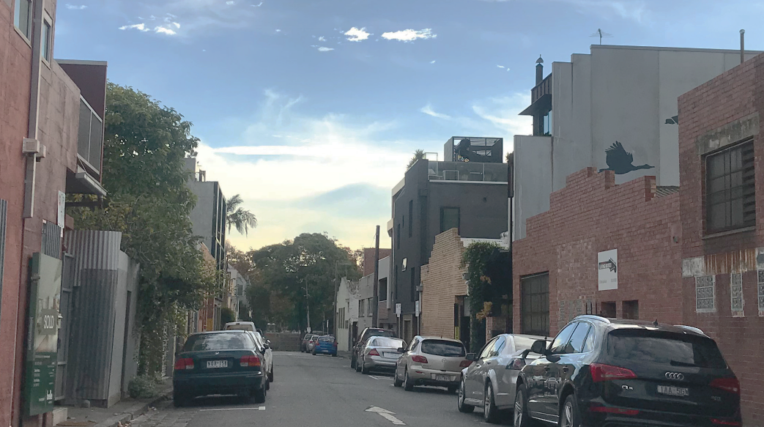

Image: Current conditions at Little Baillie Street

In June 2021, City of Melbourne shared a street greening concept design to generate community conversation about our proposal to introduce:
- tree canopy cover — for summer shade, visual impact and climate mitigation
- street greening to help reduce traffic speed and ensure greater safety for pedestrians
- biodiverse garden beds within passively irrigated tree plots to enhance native ecology, increase permeability and reduce storm water run-off.
Throughout July 2021, we encouraged feedback on the proposal from local residents, businesses and property owners in the street and immediately surrounding Little Baillie Street. The consultation sought to understand levels of community support for the proposed project and improvements to refine the design.
This Consultation Summary provides a record of our engagement activities, what we heard, who we heard from, and how feedback has influenced plans for the future of Little Baillie.

Key findings
- Overall, support for the proposed changes for Little Baillie significantly outweighs opposition, with 85.45% of Participate Melbourne survey respondents either ‘very’ or ‘somewhat’ supportive.

- The introduction of green space is felt to be a key benefit for the community. Respondents emphasised the importance of introducing more trees and plants into urban areas for the liveability, aesthetic and environmental benefits.

- Respondents felt that the overall quality of life of those who live in and around Little Baillie Street would be improved by the upgrades. Comments indicated that the upgrades to the streetscape would provide a more pleasant environment for people to spend time in.

- Respondents who were ‘very’ or ‘somewhat’ unsupportive of the proposal (12.73%) generally did so based on specific concerns around parking loss, maintenance issues, functionality of street and the possible effect on future development access.

- It was noted that finding parking was already difficult for residents, with parking enforcement an issue. Respondents felt the reduction in parking would likely exacerbate these issues.

- Maintenance issues related to clearing of leaf litter and tree and root pruning has also been raised as a consideration.

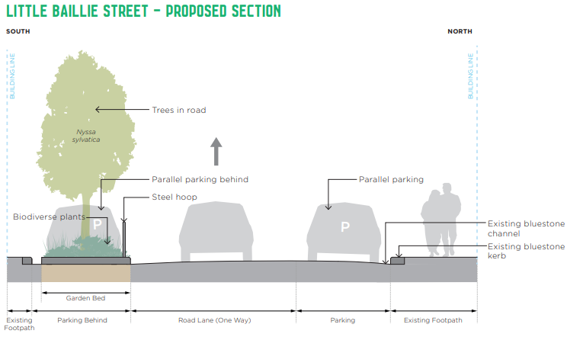

Cross section: Proposed improvements for Little Baillie Street including street trees and a biodiverse garden beds

How we engaged
Letters were sent to all residents, businesses and property owners in and directly surrounding Little Baillie Street, inviting them to complete our online survey, or to contact us directly with any queries or feedback. We also posted onsite signage to reach visitors to Little Baillie.
In total, we reached at least 6,650 people via our website, e-newsletters, direct emails and posted letters.
321 163 6500 Website visitors Letters sent E-newsletters sent
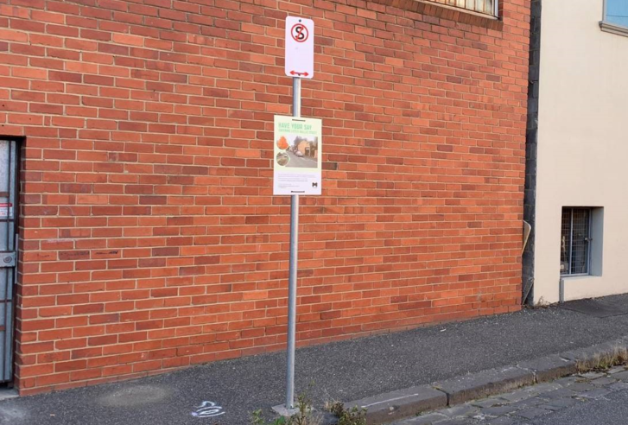
Image: Signage on site at Little Baillie Street, North Melbourne during the community consultation period

Who participated?
Between 29 June and 25 July 2021, we gathered insights online and over the phone.
60 people provided feedback about our Little Baillie Street Greening Proposal via phone calls, emails, or online survey.
52 4 6
Online surveys completed phone calls emails received

Note that the charts presented in the following section are based on the responses received via the Participate Melbourne online survey, and do not include the respondents who provided a response via email or over the phone. However, the thematic analysis of written responses comes from all responses received. The question about participants’ primary connection was optional.
71% of online survey participants either live/work/own property on Little Baillie Street or in a nearby street.
Table: Results from the Participate Melbourne online survey Question: “What is your primary connection to Little Baillie Street?”

Your top hopes for the Street Greening of Little Baillie Street
52 online survey respondents selected their ‘top three’ hopes that the street greening project could achieve from seven multiple-choice options, including “other”.
Visual appeal (76%), climate resilience (73%), and ecological value (60%) are the features that rated highest as aspirations for street enhancements.
Table: Results from the Participate Melbourne online survey Question: What are the key things you hope the Street Greening for Little Baillie Street could achieve?

The liveability and aesthetics of Little Baillie Street (21 responses)
We heard
An increase in greenery would improve the way Little Baillie Street looks, as well as the wellbeing of the people of the area.

You said
“Considering the location, having more greenery in an inner city suburb would add so much more value and quality of life"
North Melbourne really needs more trees and parks. Nature brings happiness and well being"

Enhancing green space and trees (20 responses)
We heard
A greener streetscape, with canopy trees and garden beds, would be welcomed at Little Baillie Street.

You said
"I am positive about trees being planted anywhere in North Melbourne. Little Baillie St. currently has no trees at all and I think planting will enhance the streets liveability and attractiveness."
"I want more green investment by Melbourne city council. We have to start better using space and particularly unused space"

Environmental benefits (12 responses)
We heard
Caring for the sustainability of our urban environment is a priority.

You said
"We need to do all we can to provide more green spaces and canopy cover in the City of Melbourne - initiatives such as this will help mitigate the Urban Heat Island Effect, and improve aesthetics, among other benefits"
"It will be good for the climate"

Overall level of support for the concept
55 online survey respondents rated their overall level support for the proposed greening of Baillie Street from 1 – 5, with 1 being least supportive, and 5 being most supportive.
When including feedback received through all forums, 81% of participants were ‘very’ or ‘somewhat supportive’ of the Street Greening Proposal with 19% of participants indicating they were ‘very’ or ‘ somewhat unsupportive’.

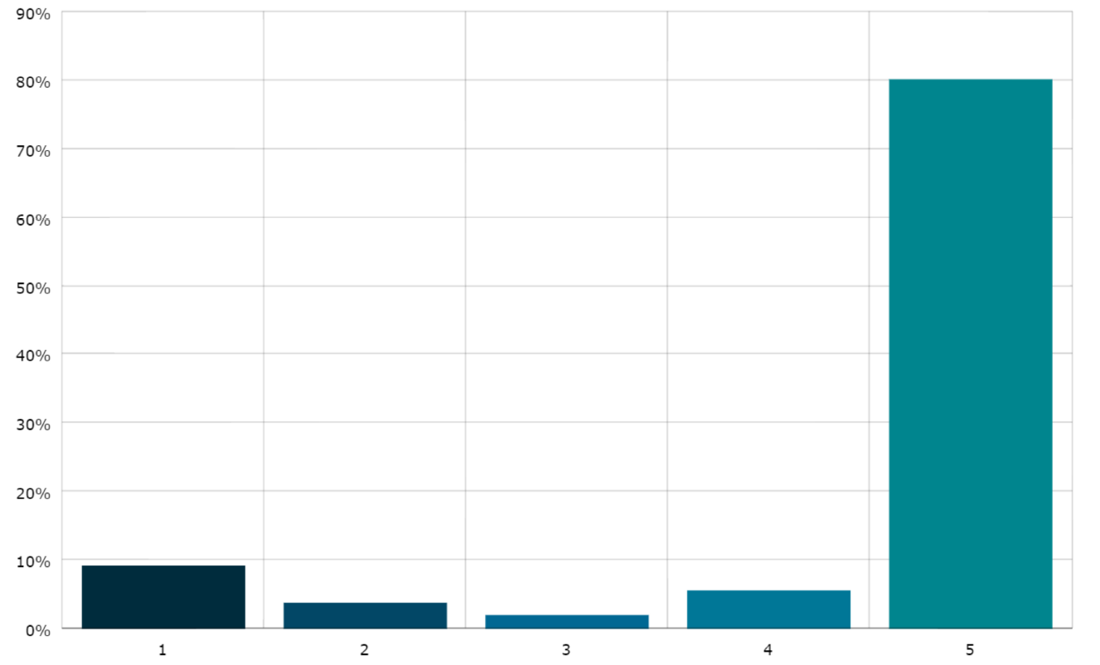
Very Somewhat Neutral Somewhat Very
unsupportive unsupportive supportive supportive

9.09% 3.64% 1.82% 5.45% 80%
(5 votes) (2 votes) (1 vote) (3 votes) (44 votes)
Table: Results from the Participate Melbourne online survey Question: “Overall, how supportive are you of the proposed greening of Baillie Street?”

Parking loss (six responses)
You said
"During peak hours (8 -4pm, Monday to Friday) Baillie Street and Little Baillie Street are at capacity for parking for residents and those who work in the street and neighbouring streets.”
"Less car parking is not ideal. Parking removal seems to be in the MCC DNA Council has removed far too many car parks already not just in North Melbourne but across the entire municipality."

We heard
The availability of on-street parking close to people’s properties must continue to be a primary objective, and we should not repurpose more parking places than necessary.

Maintenance issues from street greening (five responses)
You said
"The ones planted on Baillie Street leave quite a lot of mess which is occasionally cleaned by council street cleaning trucks. As a result there is constant leaf litter in our front yard, which comes into our house.”

We heard
It’s important to ensure that street planting and the street itself is well maintained, to minimise untidiness.

Functionality of street affected by greening (five responses)
We heard
We must be mindful not to narrow the dimensions of the road to make it difficult to navigate when driving.

You said
"The current width barely allows a vehicle to move between the two sides of the lane with parked cars on either side."
Functionality of street affected by greening

Community benefits (four responses)
We heard
A streetscape that encourages community interaction would be something to look forward to.

You said
"I feel greening streets and making them more attractive for residents, workers and visitors enhances the environment and community wellbeing"
"Visual and climate impact. This will be fabulous for the community!"

Effect on future development access (four responses)
You said
“We are currently investigating options to re-develop our property"

We heard
Ideally, current property development plans should not be impacted by proposed changes to the street.

Other things we should consider
When asked “Is there anything else we should consider to make this street look, function and feel even better? Several suggestions were made to further enhance the design and strengthen the outcomes sought.
We heard
Australian native plant species should be included in the streetscape.

Better enforcement of parking restrictions in time-limited spaces at Little Baillie Street would improve parking availability for locals.

You said
“Natives would be great"

"Parking however, is a massive issue for residents in our street. Every week, during business hours, we have cars parked in the 1, 2, and 4 hour car spaces in our street all day, not moving."

How your feedback has influenced our planning

Given the significant community support expressed through this consultation period for street greening interventions, we are developing plans for Little Baillie.
Based on your feedback, we have updated our designs to:

- Minimise car parking loss, by reducing the number of repurposed on-street car parking spaces from four, to three.

- Include Australian native plant species in the understory garden beds.

- Accommodate approved Building/Planning Applications at three properties.

Next steps
Thank you to everyone who shared their views through our consultation period. Your local knowledge and experience of the area is crucial. We look forward to working with you to achieve some outstanding outcomes that will enhance the value and liveability of the neighbourhood.
We have updated the Little Baillie Street Greening Proposal to include the ‘hoped for’ social and environmental benefits: creating a space that residents, visitors, and businesses can enjoy now and into the future.
Our landscape designers, engineers and horticultural experts are hard at work balancing the space and service requirements of drivers, pedestrians, families, businesses, and ecology through detailed design.
Funding has been allocated to commence construction in the first half of 2022.

We will notify all affected households and businesses of expected construction timelines, road closures, tree removals or other disruptions. Follow the Greening Little Baillie Street | Participate Melbourne project page to receive online notifications as the project meets progressive milestones.
Should you have questions or concerns about this exciting project, you are welcome to contact Erica Read, Project Officer, Parks and City Greening by calling 9658 8421 or emailing erica.read@melbourne.vic.gov.au.

