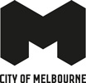
Future Libraries Framework 2021
Contents
What is a library? 3
City of Melbourne Libraries 3
Neighbourhood models 4
Community hubs 4
Supportive social connector 4
All libraries 5
City challenges and opportunities 6
Melbourne’s unique Aboriginal identity 6
Wellbeing 6
Digital inclusion and access 6
Economic and workforce development 6
A changed city 7
Explaining this document 7
The shift we want to see 8
Aboriginal Melbourne 8
Social Equity + Access 8
Sustainable Cities 8
Service Delivery 9
Technology 9
Physical Access 9
Collection and Programing 9
Communications 9
Safe Public Spaces 9
Strong social access and equity 10
A thriving city 10
Priorities and deliverables 10
Aboriginal knowledge 10
Strong social access and equity role 10
A thriving city 11

What is a library?
Libraries promote the free flow of information and ideas in the interests of all Australians. They support a thriving culture and democracy by:
- Enabling everyone to participate in, and contribute to society.
- Contributing to social inclusion and connection.
- Supporting the educational and economic wellbeing of individuals, communities and the nation.
Libraries welcome everyone and most services are free. They aim to remove barriers to participation for people from diverse backgrounds, and promote equity of access to information, activities and resources.
Libraries support literacy in all its forms and in all phases of life, from early childhood onwards. They foster:
- a love of reading
- lifelong learning
- free expression of ideas
- arts, culture and creativity
- local heritage and family history
- cyber-safety
- digital inclusion.
Libraries are an important part of the Australian literature sector, promoting writers and creators. They are safe, inclusive spaces for community meetings, study, work and relaxation. Importantly, they also ensure that everyone has the freedom to access the information and services they need for their personal development, health, wellbeing and active participation in our democratic society. (Australian Library and Information Association [ALIA] Statement on Public Library Services, adopted 2004 and amended 2009 and 2018)
Libraries are more important than ever in a post-COVID world where social and economic recovery is challenging. The most vulnerable in society have been the most deeply affected. Unemployment has risen and mental health challenges are hard felt. The gap between the haves and have nots has widened, along with the ‘digital divide’. It is likely that more people than ever before will come to rely on libraries for access to information and technology, for help with finding jobs, and for social connection.
Libraries connect people and communities in a way no other public institution can. They also activate and enliven the environment, contributing to the economic stimulus of surrounding districts. Purposeful partnerships with cultural organisations, and other service providers, can extend the reach and impact of libraries into neighbourhoods, city streets and local business.

City of Melbourne Libraries
Before COVID-19, Melbourne was one of the world’s fastest growing and most culturally diverse cities. City of Melbourne’s library’s services has evolved accordingly, in response to community needs and expectations. Over the years, our service has grown significantly, with six local branches of varying sizes and characteristics across the municipality as well as an extensive online library of e-resources for loan.
City of Melbourne’s library model is based on a distributed network: all locations are local branches and have equal roles to play in the service. This model is typically used for smaller networks of less than 10 branches, where it is possible to maintain an overall high service level without cumbersome centralised control.
It is important to stress that equal does not mean sameness. While the libraries may have the same operational responsibilities in the network, each has its own character and identity. As Melbourne is often celebrated for its collection of distinct neighbourhoods, it seems natural that the library network also mirrors the city’s urban realm and flair. The sum of the whole is greater than its parts.

Neighbourhood models
- Traditional library offering
- Stand-alone service

East Melbourne Library
A balanced atmosphere and connection to the natural environment create a local nexus for life-long learning.

North Melbourne Library
A community focused library. Caters for a variety of people from various cultural backgrounds.

Community hubs
- Strong community connections and programs
- Creative studios

Library at the Dock
A catalyst for community, creative and cultural development in an emerging neighbourhood.

Kathleen Syme Library
Offers unique spaces and special equipment to enable deeper engagement with patrons.

Southbank Library, Boyd Community Hub
A creative and convivial community centre that adds character to the city, south of the Yarra River Birrarung.

Supportive social connector
- Strong social support focus
- High diversity and volume of patrons

City Library
Popular with workers, students and visitors. CBD location. Small eclectic building with limited capacity for innovative programing. Library borrowers by postcode.

All libraries
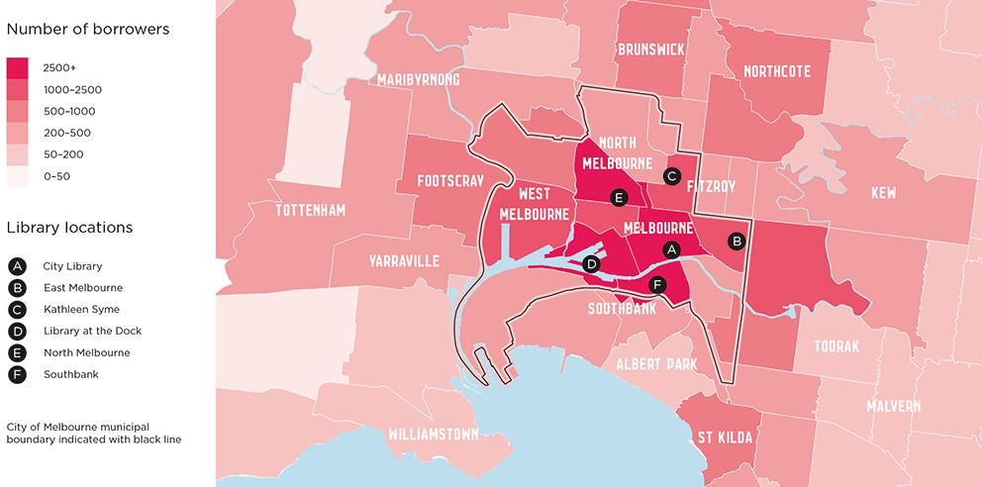
The graph above shows active borrowers by postcode in the financial year 2018–19. While City of Melbourne’s six libraries cater to a municipality of approximately 186,000 residents, they also serve thousands more as they are located in a capital city with close to 900,000 daily visitors. (City of Melbourne Daily Population Estimates 2019)

City challenges and opportunities

Melbourne’s unique Aboriginal identity
A critical goal for the City of Melbourne and its libraries is to reconcile the past, as well as truth telling and integrating Melbourne’s ancient and continuous Aboriginal culture and knowledge into every facet of the city. This is a core principle for library planning and decision-making and will be carefully developed by working closely with Traditional Custodians.

Wellbeing
Libraries support individual and community wellbeing at all times, especially for vulnerable people – including those suffering from social isolation, mental health or family violence, and in times of significant stress – such as public health outbreaks, bushfires and floods. (Australian Public Library Alliance – Australian Library and Information Association [APLA-ALIA] Standards and Guidelines for Australian Public Libraries, 2021)
Libraries are a connection point for people in neighbourhoods and are well-placed to support people who need to access information, attend programs around health and wellness, meet with others or simply relax in a space free of judgement. Several of the City of Melbourne’s library branches are co-located with other Council services, such as Family Services. This strengthens the concept of neighbourhood hubs and makes it possible for libraries to support Council’s broader community objectives.
Melbourne has one of the highest rates in the country of Aboriginal people presenting for assistance with homelessness. Issues of social justice, including racism and homelessness, are challenges that can be somewhat met by public libraries. The introduction of the Library Social Worker role in 2019 saw City of Melbourne take positive steps to address these issues in Melbourne. More targeted programming in partnership with social agencies is planned for these vulnerable cohorts.
Libraries strengthen communities and nurture feelings of connectedness. They support creativity, inclusion, equitable access to information, promote tolerance, and the diversity of ideas. Programmed activities offered by libraries bring likeminded people together for a common purpose and a shared learning experience. A constant challenge, and a key focus of this framework, is to proactively and continually introduce the library service to new and different audiences.

Digital inclusion and access
The ability to access and use technology is fundamental to meaningful engagement in Australian society. However, internet access is not universal and COVID-19 has further exacerbated the digital divide. There are significant numbers of older people, people with disability, unemployed and underemployed people, and people with low incomes (among others) who do not have home or mobile internet access, or lack the skills and confidence to use computers effectively. (ALPA-ALIA Standards and Guidelines for Australian Public Libraries, 2021). Libraries play a key role in addressing this ‘digital divide’ through the provision of free WIFI and access to technology, as well as delivering programs to build digital literacy skills and capability.

Economic and workforce development
Libraries revitalise areas by creating a buzz and increasing foot traffic. Programs such as library pop-ups can serve to activate underused or vacant sites across the city, while also increasing access to the service. Every dollar invested in public libraries in Victoria generates $4.30 of benefits to the local community. (‘Libraries Work! The Socio-Economic Value of Public Libraries to Victorians’, SGS Economics and Planning, 2018)
The use of library services and programs by a diverse range of community groups can support improved employment and productivity outcomes. Some of the methods used by City of Melbourne’s libraries to support economic and workforce development include:
- delivering programs to assist people in preparing job resumes
- providing free WIFI to job seekers
- partnering with local adult and community education providers to present programs
- offering taxation and retirement seminars for seniors
- providing co-working spaces
- promoting small business connection and support (ALPA-ALIA Standards and Guidelines for Australian Public Libraries, 2021).

A changed city
A culturally diverse and changing population increases the demand for infrastructure and open space. While previous projections for population growth have been affected by the COVID-19 pandemic, planning is underway for the forecast population increase across the north-west of the municipality. The Arden Structure Plan Community Infrastructure Needs Assessment and Macaulay Structure Plan will inform land use planning in those precincts to 2051. These plans recommend the delivery of several community hubs over the next 20 years including an innovation and learning hub in Arden Central, which may also include a library. (Prepared by ASR Research on behalf of the Victoria Planning Authority and City of Melbourne, 2020).
Other parts of the municipality are also evolving and changing, such as Docklands, Southbank and the increasingly dense residential north-west corner of the Hoddle Grid around Queen Victoria Market. These neighbourhoods are home to families that are culturally and linguistically diverse, and who predominantly live in apartments. This demographic affects not just Council’s decision-making about its library collection, but also how it offers in-person activities, learning programs and multi-use community spaces. Consideration will be given to offering outdoor learning and gathering places for residents, creating a ‘third space’ to be enjoyed as part of a neighbourhood experience, and another way to support general wellbeing.
Students are a significant group of library visitors especially at City Library, Library at The Dock and Kathleen Syme Library. They use study spaces, access free WIFI, attend language and conversation programs and enjoy the community connection that libraries offer. While in-person numbers are down until national borders fully re-open, the number of people accessing the service online has grown significantly, with a 58 per cent increase in the use of eBooks and eAudio from March to October 2020, compared to the same period in 2019. Participation in online programming increased during this time and, in line with demand, some services are likely to continue online in a COVID-normal environment, particularly where the feedback has been that online delivery increases access for people who are housebound or living with disability.

Explaining this document
The Future Libraries Framework will support all space, collection and service decisions for City of Melbourne Libraries. It will be a guide when deciding on funding, operations and delivery priorities. In addition to the longer-term deliverables, an annual Implementation Plan will drive actions and resourcing to support the realization of this framework.
The framework is also aligned to the achievement of various United Nations Sustainable Development Goals (SDGs) from the Transforming Our World: the 2030 Agenda for Sustainable Development (2015). The SDGs that best align with City of Melbourne’s libraries include:

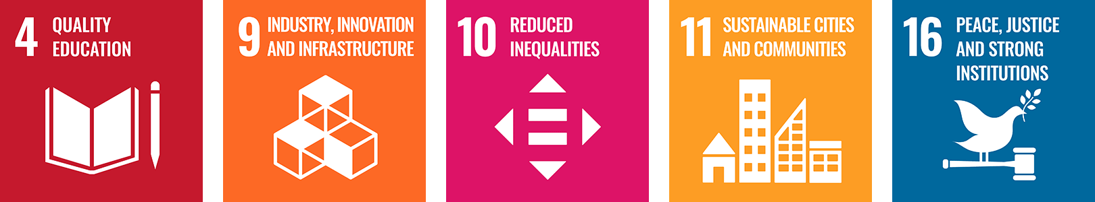
Where an action directly contributes to the achievement of one of the SDG Indicators, its measure is noted as such.

The shift we want to see
In imagining City of Melbourne’s future library service, several changes are intended for all aspects of library operations.

Aboriginal Melbourne
Shift from | Shift to
The service we offer reflects a Eurocentric world view.  The spaces we deliver it in have little relationship to country. | Aboriginal knowledge and world view are intrinsic to decision-making about library design, collection and service

Social Equity + Access
Shift from | Shift to
Our social services and outreach are limited and reactive. | We offer purposeful and strategic social services in partnership with others.  We remove barriers to access.

Sustainable Cities
Shift from | Shift to
We respond to sustainability initiatives and events. | Our actions are aligned to the achievement of the United Nations Sustainable Development Goals and we are known as leaders in sustainability education, data and conversation.  Decisions are grounded in city data and projections and deliberative community engagement.

Service Delivery
Shift from | Shift to
The service doesn’t fully meet the needs of our diverse population. | We reach new and more people and better meet their needs.

Technology
Shift from | Shift to
User expectations of the systems are always changing and we attempt to anticipate them. | We deliver integrated and seamless customer systems that are responsive to public expectations, including health and safety.  We better support the public to discover and use new technology.

Physical Access
Shift from | Shift to
Building access is often addressed in a reactive way. | Our physical and digital spaces, and technology systems, are planned with access in mind.

Collection and Programing
Shift from | Shift to
The collection and programming could be more strategic. | We find new and better ways to connect people with the collection and programming.

Communications
Shift from | Shift to
We focus on our current users. | We are purposeful and proactive in how we reach new and different people.

Safe Public Spaces
Shift from | Shift to
We provide reading, study and public space but are not sure if those who need it most are able to access it. | Our libraries are welcoming and safe and instil a sense of belonging and community ownership.  Our libraries are fit for purpose and create a ‘social living room’ and a ‘third space’ for the community.  Our room hire policies are guided by a more equitable and considered policy.

Strong social access and equity
In response to our diverse community we reach as many residents, workers, students and visitors as possible and are responsive to their needs.
We are committed to leaving no-one behind, bridging social inequities, connecting people and helping them to live full lives.
We provide free or subsidised access to library collections, activities and programs.
Outcome measure:
- Social connectedness is improved.

A thriving city
We are a hub of learning, conversation, citizen engagement and information sharing to support a sustainable and resilient city and its community. We help to reduce inequalities, and we support education and employment.
Our libraries are anchor points for our community. They connect local people, organisations and services by providing spaces to meet, offering programs that bring together people with similar interests, and providing access to local information. These services foster a sense of community belonging.
Outcome measures:
- Knowledge, ideas and insights are increased.
- People feel better equipped to obtain employment, or to better carry out tasks and responsibilities within their current job.

Priorities and deliverables
To work towards these three principles, we will take the following actions and track our effectiveness with a series of measures and user feedback.

Aboriginal knowledge
- We will create culturally safe spaces where everyone is welcome and feels a sense of belonging.
- We will make space, collection and service decisions that are informed by Aboriginal wisdom and knowledge.
- We will audit the whole library network and how well, or otherwise, we represent and celebrate Aboriginal culture and values through our spaces, collections and programs. With Traditional Custodian advice, we will take focused action to uplift our libraries.

Strong social access and equity role
- We will proactively welcome and connect new people to our libraries.
- We will connect new audiences to our libraries through partnerships with cultural and education institutions.
- We will make space, collection and service decisions based on our diverse population and its changing needs.
- We will offer targeted support for vulnerable people.
- We will design and manage our public spaces with our users’ experience and public safety in mind.
- We will achieve the right balance between allocation of space to different functions (including the collection, study or reading spaces, relaxing, programs and technology) and according to community need.
- We will locate our libraries where the community most needs them, including pop-up libraries.

A thriving city
- Our libraries will be places of conversation, information and support for community, sustainable development and resilience.
- City data and deliberative community engagement will inform our spaces, services and programming.
- We will contribute to the recovery and reactivation of the city by supporting digital literacy and employment readiness for the community.
- We will deliver a series of pop up libraries across the city to enliven vacant and underutilized spaces and extend community access to the library service.
- We will use technology to deliver a safe, personalised and intuitive experience of the library service.
- We will manage City of Melbourne libraries’ print, digital collections and creative technology to anticipate and respond to community demand.
- We will develop new and imaginative ways to deliver accessible 24/7 library services.
- We will establish a customer satisfaction benchmark for the library service to support excellence in all we do.

