Carlton Gardens Draft Master Plan
December 2021

Prepared on behalf of City of Melbourne by Capire Consulting Group

engagement findings report

Privacy
Capire Consulting Group and any person(s) acting on our behalf is committed to protecting privacy and personally identifiable information by meeting our responsibilities under the Victorian Privacy Act 1988 and the Australian Privacy Principles 2014 as well as relevant industry codes of ethics and conduct.
For the purpose of program delivery, and on behalf of our clients, we collect personal information from individuals, such as e-mail addresses, contact details, demographic data and program feedback to enable us to facilitate participation in consultation activities. We follow a strict procedure for the collection, use, disclosure, storage and destruction of personal information. Any information we collect is stored securely on our server for the duration of the program and only disclosed to our client or the program team. Written notes from consultation activities are manually transferred to our server and disposed of securely.
Comments recorded during any consultation activities are faithfully transcribed however not attributed to individuals. Diligence is taken to ensure that any comments or sensitive information does not become personally identifiable in our reporting, or at any stage of the program.
Capire operates an in-office server with security measures that include, but are not limited to, password protected access, restrictions to sensitive data and the encrypted transfer of data.
For more information about the way we collect information, how we use, store and disclose information as well as our complaints procedure, please see www.capire.com.au or telephone (03) 9285 9000.

Consultation
Unless otherwise stated, all feedback documented by Capire Consulting Group and any person(s) acting on our behalf is written and/or recorded during our program/consultation activities.
Capire staff and associates take great care while transcribing participant feedback but unfortunately cannot guarantee the accuracy of all notes. We are however confident that we capture the full range of ideas, concerns and views expressed during our consultation activities.
Unless otherwise noted, the views expressed in our work represent those of the participants and not necessarily those of our consultants or our clients.

Definitions
The following lists the key definitions for common terms used in the design and delivery of community engagement as stated in the City of Melbourne’s Community Engagement Policy, 2021.
Community: An individual or a group of people united by at least one common characteristic such as geography, shared interests, values, experiences, or tradition.
Stakeholder: An individual or group that has an interest in any Council decision or activity, including Traditional Custodians and Aboriginal communities, other tiers of government and government agencies, businesses, educational institutes, not-for-profits and philanthropic organisations, visitors, residents, advocacy groups, children, ratepayers and renters, emergency services, culturally and linguistically diverse people and many more.
Community engagement: A planned process with the specific purpose of working with individuals and groups to encourage active involvement in decisions that affect them or are of interest to them.
Place-based: An approach that acknowledges the uniqueness and diversity of our neighbourhoods and builds strong connections with local stakeholders, community organisations, groups, leaders and individuals to strengthen and support local places, spaces and people.
Public participation: The involvement of people who live, work, create, visit or study across the City of Melbourne in local government decisions and planning. Participants know how they can influence a decision and are encouraged and supported to participate.

1 Introduction 7
1.1 Report purpose 7
1.2 Project background 7
1.3 Next steps 7
1.4 Limitations 8
2 Engagement approach 9
2.1 Communication and promotion 9
2.2 Engagement activities 10
2.3 Participation 11
3 Summary of findings 12
4 Detailed findings 13
4.1 Survey demographics 13
4.2 Carlton Garden uses 15
4.3 Carlton Gardens 17
4.3.1 Children’s likes, dislikes, and improvements 17
4.3.2 New garden furniture 18
4.3.3 Tree replacement 19
4.4 Carlton Gardens South 21
4.4.1 New garden beds 21
4.4.2 Major events 22
4.4.3 Public toilets 23
4.4.4 Pedestrian crossings 23
4.4.5 Interpretation, visitor experience and tourism 24
4.5 Carlton Gardens North 26
4.5.1 Public toilets 26
4.5.2 Night usage including lighting 26
4.5.3 Trees for shade 28
Appendices 29
Appendix A: Online Survey questions 29
Appendix B: Public online focus group agenda 34
Appendix C: Online children focus group questions 35
Appendix C: Walking tour map activity 36

Figure 1. Overview of engagement activity participation
Figure 2. Word cloud displaying the postcodes represented by survey respondents (n=149)
Figure 3. Survey respondent’s age groups (n=149)
Figure 4. Survey respondent’s gender (n=149)
Figure 5. Survey respondent’s relationship to the City of Melbourne (n=149)
Figure 6. Children focus group and survey responses to ‘How do you use Carlton Gardens?’ (Survey n=149; focus group n=190; multiple answers were selected)
Figure 7. Survey respondent’ visitation frequency of Carlton Gardens (n=149)
Figure 8. Children focus group responses to ‘What time of the day do you most often go to the Gardens’ (n=64)
Figure 9. Children focus group responses to ‘Who do you usually go to the Gardens with?’ (n=102)
Figure 10. Survey respondent’s understanding of the rationale for the recommendation of replacing vulnerable trees in a changing climate with similar but more suitable tree species choice when the time comes to replace these species (n=149)
Figure 11. Survey respondents’ level of support to prioritising the introduction of new garden beds at key intersections in Carlton Gardens South consistent with the original layout (n=145)
Figure 12. Survey respondents’ level of support to increasing the overall number of garden (shrub) beds and lower-level planting throughout the Gardens (n=144)
Figure 13. Survey respondents’ level of support for introducing a cap of 13 weeks (or 25% of the calendar year) for the total period of time allowed for major events per year in Carlton Gardens South. This includes event set up, delivery and required post event reinstatement works (n=144)
Figure 14. Survey respondents’ level of support for replacing the existing public toilet facilities in Carlton Gardens South to make them safer, secure, and accessible to use (n=144)
Figure 15. Survey respondents’ level of support for the City of Melbourne to continue to advocate to VicRoads for improved, safer pedestrian crossing points on Victoria Street (n=146)
Figure 16. Survey respondents’ level of support for revision on site interpretation to recognise and celebrate a broader range of stories and cultural values across the Gardens (n=145)
Figure 17. Survey respondents’ level of support for replacing the existing public toilet facilities in Carlton Gardens North to make them safer, secure, and accessible to use (n=147)
Figure 18. Survey respondents’ level of support for installing new pathway lighting along the eastern pathway- from Tennis courts to corner of Carlton Street and Nicholson Street (n=147)
Figure 19. Survey respondents’ answer to if increasing the hours of lighting in activity areas will encourage them to use Carlton Gardens more (n=149)
Figure 20. Survey respondents’ level of support for planting new trees to increase the amount of shade in activity areas (playground, basketball court and picnic areas) (n=148)

- Introduction
  - Report purpose
This report presents the key consultation findings from community engagement on the Carlton Gardens Draft Master Plan. The findings in this report will be reviewed by the City of Melbourne project team and used to adjust recommendations prior to the finalisation of the Carlton Gardens Master Plan.

  - Project background
The Carlton Gardens are among Australia’s most significant heritage gardens. Together with the Royal Exhibition Building, they were inscribed on the UNESCO World Heritage List on 1 July 2004. The Carlton Gardens are much loved by Melburnians and visitors alike and form a key component of Council’s capital city and inner-urban regional open space network, providing a valuable recreational space for Melbourne residents, workers, and visitors.
As part of the review of the Royal Exhibition Building and Carlton Gardens World Heritage Management Plan led by Heritage Victoria, the 2005 Carlton Gardens Master Plan is being revised by the City of Melbourne. A Master Plan sets out the long-term vision and guides the future management of a park or garden.
The purpose of the engagement was to raise awareness about the revised Draft Master Plan and seek stakeholder and community input and feedback on the recommendations. The engagement commenced on Wednesday 6 October and concluded on Sunday 21 November 2021. Feedback was sought on recommendations to:
- improve amenities, additional lighting, signage, and park furniture
- increase natural shade in activity areas
- introduce new trees and rejuvenate garden beds
- update the self-guided walk and signage to improve visitor experiences in Melbourne
- introduce new guidance around events; events are part of a range of activities that occur in Carlton Gardens, however the number and impact of these events needs to be balanced against both the impact on the cultural and historic values of the site and the other agreed uses at the site.

  - Next steps
Feedback gathered through the engagement will used to inform a final revision of the Draft Master Plan with a final Master Plan presented to Council for consideration in early 2022.

  - Limitations
The engagement methodology while robust, also has several limitations that should be acknowledged when reading this report. These are outlined below.
- Capire has reported on information documented by participants and interpreted the information to represent the views of participants as closely as possible.
- The engagement program included multiple opportunities for participants to contribute. Some people may have taken part in multiple engagement activities, for example completed the survey and participated in the public online focus group. Their views may have been captured more than once.
- In some instances, participants did not respond to all survey questions, this meant that some questions received fewer responses than others.
- People who participated in the engagement self-selected to take part. As such, whilst every effort has been made to gather the views of stakeholders and the community the information in this report does not reflect the views of a representative sample.
- In some instances, participants used the opportunity to provide feedback that was not related to the project. This feedback has not been included in this report however all data collected has been provided to City of Melbourne for their review and consideration. This includes information relating to the Exhibition Reserve Master Plan which has been passed onto Museums Victoria.
- Seven direct public stakeholder submissions were received. These submissions, alongside emails included feedback that was outside the scope of the engagement, have been reviewed, included in the analysis of this report, and passed onto the City of Melbourne project team.
- The engagement program occurred during a global pandemic commencing during a period when stay at home directions were in place and finishing after an easing of restrictions. While this situation was planned for in the engagement process, it may have reduced the participation rates across engagement tools including the public online focus group, pop-up kiosk events and the walking tour map
- Melbourne’s weather during the public online focus group was sunny and inviting. As such, this may have reduced the number of participants. Additionally, the weather during the pop-up kiosk event on 13 November was cold, wet and windy in comparison to a sunny afternoon during the pop-up kiosk event on 17 November, impacting the number of Garden users during the times of the pop-up kiosks event.
- Engagement approach
  - Communication and promotion
Throughout the engagement period, we sought to inform as many people as possible about the project to encourage feedback on the Draft Master Plan. Communications material provided information about the project and promoted engagement opportunities, encouraging people to visit the project website for more information about the project.
The following activities were used to inform the community and stakeholders about the project.
Table 1. Activities used to inform people about the project
Participate Melbourne website | The project website (participate.melbourne.vic.gov.au/carlton-gardens-master-plan-review) on Council’s Participate Melbourne engagement website provided project information, including the Draft Master Plan, project timeline, maps showing proposed works, the World Heritage Management Plan and FAQs.  During the engagement period a total of 2,539 visitors visited the webpage, resulting in 3,377 visits over the engagement period.
Social media | Facebook, Instagram, and LinkedIn were used to promote the project and encourage participation through posts and paid social media advertisements by the City of Melbourne.  The paid social media advertisements on Facebook and LinkedIn resulted in 1,801 clicks and 3080 engagements at an engagement rate of 1.15%.
Static signage in Carlton Gardens | A total of 12 x A1 static signs were located at key entry points in both the South and North Gardens to promote the project; these included a QR code that directed people to the Participate Melbourne website.  A total of 438 scans and 393 unique scans resulted from the QR code.
Local newspaper adverts/stories | Local newspaper articles appeared in CBD News, Inner City News and Northwest to announce the project and direct people to the Participate Melbourne website.
Postcards | Postcards raised awareness of the project and promoted engagement opportunities, including a QR code that directed people to the Participate Melbourne website.  A total of 438 scans and 393 unique scans resulted from the QR code.  A total of 3,000 postcards were distributed primarily via the Melbourne Library Service “Click and Collect” book loan system.
Emails/letters | Emails were sent to key stakeholder groups and community organisations at the beginning of the consultation period, advising of the consultation process running via the Participate Melbourne website.
Overview presentations | The project team provided online briefing presentations at three resident group meetings. The purpose of the sessions was to provide a provide overview and encourage feedback via Participate Melbourne.

  - Engagement activities
We provided a range of ways for people to find out more about the project and provide their feedback. The following activities were used to provide information and elicit feedback.
Table 2. Activities used to inform and receive feedback
Activity | Purpose
Online survey | The online survey available on Participate Melbourne was included on the project webpage to gather feedback. Hard copy versions were also available at the onsite pop-up kiosk events.  See Appendix A for all survey questions.
Public online focus group | The 1.5-hour public online focus group with stakeholders and community members on 8 November 2021 sought input and feedback on the Draft Master Plan recommendations through deeper conversations.  See Appendix B for the focus group agenda. The discussions consisted of questions from the online survey.
Online children focus groups | Three online focus groups with children were conducted with grade 5/6 students at three local schools. These were held between 6 October and 21 November 2021.  See Appendix C for the focus group questions.
Onsite pop-up kiosk events including walking tours | There were two 2-hour pop-up kiosk events at Carlton Gardens held on:  - 13 November 2021, 10am to 12pm (Carlton Gardens South)  - 17 November 2021, 4pm to 6pm (Carlton Gardens North).  Both pop-ups included a walking tour in the selected Garden with an arborist and Council officer. Council park rangers also attended these sessions. Feedback was captured through the online and hard copy surveys, the walking tour map and conversations.
Walking tour map activity | A walking tour map was created to provide children and other interested stakeholders the opportunity to draw where they would take family or friends on a walking tour around Carlton Gardens.  The walking tour map was shared with local schools, at the pop-ups and was also part of the City of Melbourne’s Children’s Week activities.  See Appendix D for the walking tour map activity.
Public stakeholder submissions | Seven public stakeholder submissions were received during the engagement period. These submissions mostly included feedback on matters additional to those covered in the formal engagement scope. They have been reviewed, included in the analysis of this report, and passed onto the City of Melbourne project team.

  - Participation
Approximately, 346 people participated in the engagement with approximately 269 providing feedback on the recommendations proposed in the draft Master Plan. Figure 1 provides an overview of the participation through each engagement activity.
149 | 5 | ~115
Online Surveys | Public online focus group participants | Online children focus group participants
~70 | 7 | 7
Pop-up kiosk event participants | Walking tour maps completed | Public stakeholder submissions were received
Figure 1. Overview of engagement activity participation

- Summary of findings
Throughout the engagement we heard from a diverse range of community members representing various experiences and interactions with the Gardens. The following key findings emerged from the engagement.
- People use the Gardens on a highly frequent basis and for various reasons. ‘Walking’ was the most popular use for survey respondents whilst ‘Using the children’s playground’ was the highest response from the focus groups with children.
- Children visit the Gardens throughout the day but predominantly between 1pm and 5pm accompanied by direct family members and friends or classmates.
- Children shared various likes, dislikes and improvement suggestions whilst primarily focusing on the Garden’s nature and opportunities for active uses and play.
- Survey respondents and pop-up participants shared thoughts on the need for and suggested locations for new garden furniture such as seating, picnic tables, rubbish bins, and drinking fountains.
- 69% of survey respondents fully understand the rationale of the recommendation that when the time comes to replace tree species that have been assessed as vulnerable in a changing climate scenario, that a similar but climate suitable species be planted. The 31% of survey respondents who partially or do not understand requested additional information to further understand the rationale.
- There was high support for prioritising the introduction of new garden beds at key intersections consistent with the original layout and increasing the overall number of garden beds and lower-level planting in Carlton Gardens South.
- There were varied levels of support for introducing a cap of 13 weeks for the total period of time allowed for major events per year in Carlton Gardens South. 64% of survey respondents support or highly support the recommendation, a few participants shared their desire to reduce the cap, whilst no one shared that the cap was too restrictive.
- There was high support for existing public toilet facilities in Carlton Gardens South and North to be replaced to make them safer, secure, and accessible to use.
- 93% of survey respondents support or highly support Council continuing to advocate to VicRoads for improved, safer pedestrian crossing points on Victoria Street.
- 87% of survey respondents support or highly support the revision of on-site interpretation to recognise and celebrate a broader range of stories and cultural values. Participants shared additional ideas that would improve their visitor experience.
- 91% of survey respondents support or highly support installing new pathway lighting along the eastern pathway from the tennis courts to the corner of Carlton Street and Nicholson Street. Many participants shared they would be encouraged to use the Gardens more if the hours of lighting in activity areas was increased.
- 91% of survey respondents support or highly support increasing the amount of shade in activity areas (playground, basketball court and picnic areas).
- Detailed findings
The following findings represent a summary of the data collected through the engagement program (as detailed in Table 2). The findings are presented under the questions asked via the survey and have been grouped under themes. Quotes from participants have been used to illustrate sentiment.

  - Survey demographics
Children in the focus groups provided basic age demographic information. All 115 children were aged between 10 and 12 years old.
To understand who was reached through the Participate Melbourne survey, respondents answered demographic questions. This information was sought to ensure we heard the views, experiences, and aspirations of the range of community members.

Postcode
Survey respondents were asked to indicate which postcode they live in. Suburbs geographically close to the Gardens provided a higher percentage of responses. The top three postcodes were 3053-Carlton (35), 3000-Melbourne (33), and 3065-Fitzroy (17). Figure 2 displays all 39 postcodes represented. The larger the postcode, the higher number of respondents live in the postcode.
Figure 2. Word cloud displaying the postcodes represented by survey respondents (n=149)

Age
As shown in Figure 3 there was an even spread of survey respondents’ age groups. There was no respondent younger than 15 years of age or older than 84 years of age.

Figure 3. Survey respondent’s age groups (n=149)

Gender
As shown in Figure 4, 87 survey respondents (59%) identified as female whilst 59 (40%) identified as male. Three respondents identified as an ‘Other identity’.

Figure 4. Survey respondent’s gender (n=149)

Primary relationship to the City of Melbourne
As shown in Figure 5, 107 (72%) stated they live in the City of Melbourne, followed by 29 (19%) who visit the municipality.

Figure 5. Survey respondent’s relationship to the City of Melbourne (n=149)
  - Carlton Garden uses

How people use the Gardens
Survey respondents and participants at the children’s focus groups were asked how they use Carlton Gardens. Participants were able to choose from a list of 13 options. Survey respondents were able to add an additional use under ‘Other’.
As shown in Figure 6, ‘Walking’ was the most popular use for survey respondents with 133 responses whilst it was the second-highest use for children focus group participants with 29 responses.
‘Using the children’s playground’ was the highest response from children focus group participants. Other popular uses amongst survey respondents were ‘Socialisation’, ‘Visiting the Museum or the Royal Exhibition Building’ and ‘Picnics’.
Of the 14 survey respondents who chose the ‘Other’ use, nine of them said they use Carlton Gardens to cycle, skateboard, or roller-skate. The remaining five uses consisted of getting COVID-19 vaccinations, working, drawing/sketching, taking lunch breaks, and attending the Melbourne International Flower and Garden Show.

Figure 6. Children focus group and survey responses to ‘How do you use Carlton Gardens?’ (Survey n=149; focus group n=190; multiple answers were selected)

How frequent people visit the Gardens
Survey respondents were asked how frequently they visit Carlton Gardens.
As shown in Figure 7, 107 respondents visit daily or weekly. Respondents were able to choose from a list of options and were able to add an additional answer under ‘Other’.

Figure 7. Survey respondent’ visitation frequency of Carlton Gardens (n=149)

When children visit the Gardens
Children focus group participants were asked ‘What time of the day do you most often go to the Gardens?’. As shown in Figure 8, from the 64 responses received, most participants go to the Gardens in the afternoon between 1pm to 5pm.
Figure 8. Children focus group responses to ‘What time of the day do you most often go to the Gardens’ (n=64)
The pop-up in Carlton Gardens North (17 November 4pm-6pm) supported these findings, with many children playing on the children’s playground and in the surrounding area between 4:00pm and approximately 5:15pm. These children were of various ages with most children aged between five and nine years of age.

Who children visit the gardens with
Children focus group participants were also asked ‘Who do you usually go to the Gardens with?’. As displayed in Figure 9, most participants (52) shared they go to the Gardens with their direct family members. This was followed by 36 participants who visit with friends or classmates. The two ‘other’ responses consisted of family friends and club scouts.
Figure 9. Children focus group responses to ‘Who do you usually go to the Gardens with?’ (n=102)

  - Carlton Gardens
    - Children’s likes, dislikes, and improvements
At the children focus groups and through the pop-ups and walking tour map activity, children were asked what they liked and disliked about the Gardens as well as their ideas for improvements. Across the three activities, there were varied responses with common themes.

Nature
- When the children were asked what they think of when they think of the Gardens the main theme was nature, including trees, flowers, ponds, possums, and ducks.
- Many children shared they like the nature and greenery of the Gardens including the trees, flowers, grass, water fountains, lakes, and the smell of nature.
- A couple of children stated more trees should be planted such as evergreen trees.
- There were mixed views on the presence of bees whilst a few children shared they like the many ducks in Carlton Gardens.
- A couple of children suggested increasing the number of possum and bird houses.

Opportunities for active uses and play
- When they think of the Gardens, many children shared they think of playing and exercise, including the playground, walking, jogging, cycling, skateboarding, and tennis.
- Many children like the playground, basketball court and the spaciousness of the Gardens which offers many opportunities for play, picnics, and the ability to run around. They appreciate the Gardens are a fun place to hang-out.
- Specific play equipment children and parents liked included the slide, swings, getting lost in the concrete maze, and the small house.
- Key places cited on the walking tours activity included the tennis court, central fountain (Victorian-era Hochgurtel Fountain) and the two ponds in Carlton Gardens South.
- One parent shared they dislike the amount of concrete in the playground.
- Suggestions for improvements included playground equipment that is suitable and fun for older children and young people such as:
  - a longer slide, sand pits, monkey bars, water features and more swings
  - a skateboard and bicycle area
  - marking the 3-point line on the basketball court and a second basketball court.

Additional likes and suggested improvements
- Some children appreciate feeling peaceful, free, and calm in the Gardens.
- Additional likes included the location of the Gardens near their school and 7-Eleven, and the lighting at night.
- Common areas for improvement included the lack of clean public toilets, rubbish bins, clean benches and drinking fountains.
- Other suggestions included an off-leash dog area, food stalls, a park library, music such as live buskers, and more shelter.

    - New garden furniture
The Draft Master Plan suggested replacing existing furniture and install new garden furniture as required. Survey respondents were asked if there were specific locations they would like more seating, picnic tables, rubbish bins or drinking fountains. A total of 82 respondents made suggestions on types and locations of furniture. Pop-up event participants also shared their thoughts on locations for new garden furniture.

Seating
Of the 82 survey respondents, 42 shared thoughts regarding seating. Most of these comments were positive and appreciative of new and updated seating. Recommended locations included:
- in locations friendly for people with disabilities including along main walking paths
- clustered and set back from the main paths
- near the playground, basketball court and tennis court
- under shady trees and shelter
- next to the ponds, lakes and fountains
- scattered throughout Carlton Gardens
- around the edges of Carlton Gardens such as in the North-west corner.
Additional recommendations consisted of:
- using sustainable materials such as recycled plastic, and including nature-based seating such as rock or timber seats
- using seating material that allows water to dry quickly
- replicating the concrete seating in front of the Melbourne Museum, and continuing with the Gardens’ heritage styles and values
- regularly cleaning the seating
- providing comfortable seating for people with disability.

Picnic tables
The inclusion and addition of picnic tables was also highly supported by 30 survey respondents. Suggested locations for picnic tables included along the outer edge of the Gardens, in Carlton Gardens North near the playground, and in Carlton Gardens South near the ponds. Survey and pop-up participants shared the need for picnic tables under shade such as trees or permanent shelter. Eight survey respondents did not support the inclusion of more picnic tables.

Rubbish bins
Approximately 19 survey respondents shared their support for more rubbish bins. Recommended locations included near the Garden entrances and along Nicolson Street. A couple of pop-up participants shared bins have overflowed during holidays and busy periods and therefore people dump rubbish. The option of temporary bins during busy time periods was proposed along with compost bins and recycling bins for coffee cups.

Drinking fountains
There was general support for more drinking fountains by 16 survey respondents. Respondents mentioned locating more in Carlton Gardens North and specifically near the playground, basketball court and public toilets. Additional suggestions included drinking fountains for dogs, water bottles, and in Carlton Gardens South.

Additional amenities
Other recommended facilities consisted of providing permanent barbeques, dog bag stations and shade pavilions around the lakes.
‘A compost bin should be installed wherever rubbish and recycling bins are placed. More seating and picnic tables should be installed near the playground. Improved maintenance and increased number of bubblers; separation of animal drinking facilities and human drinking facilities.’
- Survey respondent
‘Extra garden furniture would be great. I am hoping the style will be in keeping with the gardens as a heritage space.’
- Survey respondent

    - Tree replacement
The Draft Master Plan identifies that a modest proportion of tree species have been assessed as vulnerable in a changing climate scenario. It recommends that when the time comes to replace these species, similar but climate suitable tree species need to be planted.
Survey and public focus group participants were asked about their level of understanding of the rationale for this recommendation.
Figure 10 displays the results of the survey responses with 103 (69%) fully understanding the rationale whilst only nine (6%) not understanding the recommendation’s rationale.
Figure 10. Survey respondent’s understanding of the rationale for the recommendation of replacing vulnerable trees in a changing climate with similar but more suitable tree species choice when the time comes to replace these species (n=149)
The 46 survey respondents (31%) who stated they partially or do not understand the rationale of the recommendation were asked what further information is needed. They shared the following:
- the types of assessed trees including if they are heritage species
- the types of replacement trees including their maturity, how identical they are to the assessed trees, if they are more climate appropriate or indigenous
- the tree locations
- why the trees need to be removed
- benefits and appearance of different tree species
- budget and detailed work schedule include when the replacement will occur
- how tree replacement will co-exist with the historical feeling of Carlton Gardens
- the opportunity to maintain trunks and hollows of old trees to provide fauna habitat.
A few survey respondents shared native trees should be considered instead of similar climate resilient tree species.
The recommendation was discussed in detail during the public focus group with participants expressing concern for:
- the desire to keep ornamental trees
- the current trees having already survived extreme weather conditions thus far and are unique
- the possibility to replace vulnerable trees with like-for-like
- the need to continue providing tree hollows for birds.
Five of the seven stakeholder submissions supported the recommendation. Two submissions requested active tree monitoring and more information on the vulnerable tree assessments.
‘I support the replacement of trees that will not thrive with climate change. I would like to see more native planting in the gardens, to attract birds and wildlife. The proposed plan places a heavy emphasis on keeping the same species, which limits the ability to introduce more native trees. Surely a desire to recognise traditional owners might extend to the plantings as well.’
- Survey respondent
‘How will this coexist with traditional garden that already exists and preserve the feel of the gardens as a historical site?’
- Survey respondent

  - Carlton Gardens South
    - New garden beds

Introducing new garden beds
Survey respondents and public focus group participants were asked how supportive they are about prioritising the introduction of new garden beds at key intersections in the Gardens consistent with the original layout. As shown in Figure 11, 130 respondents (90%) supported or highly supported this recommendation. This is consistent with the responses of the five public focus group participants who supported or highly supported the recommendation. Reasons given by public focus group participants for supporting this proposal included that it was in line with the original layout and form, and also that flowers are a great moral boost.
Figure 11. Survey respondents’ level of support to prioritising the introduction of new garden beds at key intersections in Carlton Gardens South consistent with the original layout (n=145)

Increasing the overall number of garden beds
Survey respondents and public focus group participants were also asked how supportive they are about increasing the overall number of garden (shrub) beds and lower-level planting throughout the Gardens. As shown in Figure 12, there was high support for this recommendation with 130 respondents (90%) stating they support or highly support it. Two respondents perceived the recommendation as an opportunity to incorporate more indigenous plants. Public focus group participants also supported and highly supported this recommendation.
Figure 12. Survey respondents’ level of support to increasing the overall number of garden (shrub) beds and lower-level planting throughout the Gardens (n=144)

    - Major events
Survey respondents and public focus group participants were asked how supportive they are about introducing a cap of 13 weeks (or 25% of the calendar year) for the total period of time (including event set up, delivery and post event reinstatement works) allowed for major events per year in Carlton Gardens South. As shown in Figure 13, there was a more varied response to this recommendation compared to other recommendations with 93 respondents (64%) supporting or highly supporting it.

Figure 13. Survey respondents’ level of support for introducing a cap of 13 weeks (or 25% of the calendar year) for the total period of time allowed for major events per year in Carlton Gardens South. This includes event set up, delivery and required post event reinstatement works (n=144)
Some survey respondents and public focus group participants shared their level of support depends on the type of event, including if the event is a public or private event. Expressed concerns for this recommendation included:
- negative impacts on the health of trees, garden beds, lawns, and water features
- the need for the Gardens to recover and regenerate after events
- disruption to the heritage value of the Gardens
- exclusivity of ticketed events
- disruption to public access including the loss of public use during Autumn with the Melbourne International Flower and Garden Show.
When asked for any additional comments about the Carlton Gardens South draft recommendations a few survey respondents and public focus group participants expressed that whilst they are supportive of introducing an event cap in Carlton Gardens South, the period of time should be less than 13 weeks. No one shared the cap of 13 weeks was too restrictive.
Four stakeholder submissions did not support the recommendation due to vegetation damage and loss of public access to Carlton Gardens South. Three submissions suggested the use of paved areas for major events. Two submissions supported the recommendation whilst acknowledging the need for rigorous monitoring and stewardship.
‘The Carlton Gardens should never be fenced off so the public is not allowed in. They are World Heritage and should be able to be visited at all times. The proposed 13 weeks is much too long a time for them to be unavailable.’
- Survey respondent
    - Public toilets
Survey respondents were asked how supportive they are about the existing public toilet facilities in Carlton Gardens South being replaced to make them safer, secure, and accessible to use. As shown in Figure 14, 125 respondents (87%) supported or highly supported it.
Twenty additional survey comments were received regarding public toilets in Carlton Gardens South. Respondents shared they would prefer the appearance to be consistent with the heritage characteristics of the Gardens, to be clean, accessible, and easy to use for all ages.
One submission stated their preference to retain the cast iron public toilets.

Figure 14. Survey respondents’ level of support for replacing the existing public toilet facilities in Carlton Gardens South to make them safer, secure, and accessible to use (n=144)

    - Pedestrian crossings
Survey respondents were asked how supportive they are about Council continuing to advocate to VicRoads for improved, safer pedestrian crossing points on Victoria Street. As shown in Figure 15,Figure 14 136 respondents supported or highly supported it (93%).
Three submissions shared their support for improved accessibility across Victoria Street.
Figure 15. Survey respondents’ level of support for the City of Melbourne to continue to advocate to VicRoads for improved, safer pedestrian crossing points on Victoria Street (n=146)

    - Interpretation, visitor experience and tourism
The Draft Master Plan recommends improving interpretation, visitor experience and tourism of the Gardens as a World Heritage Site.
Survey respondents were asked how supportive they are about revising on site interpretation to recognise and celebrate a broader range of stories and cultural values across the Gardens. This could include Aboriginal cultural connections, historic elements, and horticultural features. As shown in Figure 16,Figure 14 126 respondents (87%) supported or highly supported it.

Figure 16. Survey respondents’ level of support for revision on site interpretation to recognise and celebrate a broader range of stories and cultural values across the Gardens (n=145)
In addition to the recommendations to update the current self-guided walk and create new digital formats, survey respondents were asked if there would be additional matters that would improve their visitor experience. Their ideas alongside suggestions shared by three stakeholder submissions are outlined below.

Interpretation and information
- Providing guided tours.
- Providing online information about flora, fauna, events, Aboriginal and European history and stories of the Gardens and Royal Exhibition Building. This could be a phone app or a QR code which leads to an accessible webpage or virtual reality experience.
- Introducing signage, name plates and maps providing details of flora and fauna and the history of Carlton Gardens
- Improving First Nations’ recognition
- Re-use historic fencing and gates
- Use green ‘heritage’ signage.

Visitor experience
- Pedestrian safety
- Balancing the use of commuting through Carlton Gardens with visitor experiences.
- Introducing smoother footpaths.
- Ensure the Gardens are safe, well cleaned and monitored.
- Increase the number of basketball courts
- Introduce outdoor exercise equipment in Carlton Gardens North.
Whenever I walk through Carlton Gardens, I am filled with immense pride that the Exhibition Buildings hosted the basketball at the 1956 Melbourne Olympics where arguably the greatest player of all time (Bill Russell) led the USA team to an Olympic gold medal. I would also like to recommend the gardens place a plaque near the existing basketball court to commemorate that fact
- Survey respondent
‘I would like to see a map that identified the trees that are in the garden, giving details about when they were planted and brief information about their species. I would also like to see information about the birds that frequent the gardens, so that visitors can birdwatch. It would be great to have this information on an interactive app.’
- Survey respondent
‘I think self-guided walks are great. I've made a few. I don't want to download any new apps to my phone, especially ones made without the budget to be tested on multiple screen displays and devices. I would really prefer that funding bodies prioritise things that are accessible via mobile for web, and/or via established and stable apps.’
- Survey respondent
  - Carlton Gardens North
    - Public toilets
Survey respondents were asked how supportive they are about the existing public toilet facilities in Carlton Gardens North being replaced to make them safer, secure, and accessible to use. As shown in Figure 17, 132 respondents (90%) supported or highly supported it.
When asked for additional comments, 14 respondents supported increasing the number of public toilets including four stating the need for public toilets on the eastern side of Carlton Gardens North. Pop-up kiosk participants agreed with the need for additional clean public toilets in Carlton Gardens North that are easy to lock.

Figure 17. Survey respondents’ level of support for replacing the existing public toilet facilities in Carlton Gardens North to make them safer, secure, and accessible to use (n=147)
‘In addition to upgrading the existing toilets, you should add toilets on the Nicholson Street side.’
- Survey respondent
‘We need more toilets, not just new toilets. We need toilets that are also accessible, gender sensitive and that are safe to use.’
- Survey respondent

    - Night usage including lighting
Survey and children focus group participants were asked their thoughts about increased lighting in Carlton Gardens North to encourage more use and improve safety.
Firstly, survey respondents were asked how supportive they are of installing new pathway lighting along the eastern pathway from the tennis courts to the corner of Carlton Street and Nicholson Street. As shown in Figure 18, 134 respondents (91%) supported or highly supported this recommendation. Most respondents expressed that installation of new lighting will allow park users and pedestrians to feel safer at night, while a few respondents expressed concern of excessive light and potential light pollution for to surrounding areas. One respondent suggested lighting to be energy efficient.

Figure 18. Survey respondents’ level of support for installing new pathway lighting along the eastern pathway- from Tennis courts to corner of Carlton Street and Nicholson Street (n=147)
Secondly, survey respondents were asked if they would be encouraged to use Carlton Gardens more if the hours of lighting in activity areas was increased, whilst children focus group participants were asked what would encourage them to use the activity areas (basketball court, playground, or picnic areas) more in the evenings.
As shown in Figure 19, 93 respondents (62 %) indicated increased lighting would encourage them to use Carlton Gardens more. Supporting this, 22 children (of 63 responses) also indicated increased lighting would encourage them to use the activity area during the evening.
Two Stakeholder submissions mentioned heritage management plan guidance for increased lighting. Pop-up participants agreed increased lighting is essential along paths for commuting and in the activity areas.

Figure 19. Survey respondents’ answer to if increasing the hours of lighting in activity areas will encourage them to use Carlton Gardens more (n=149)
‘Unlike the tennis courts, the highly popular basketball court has no suitable lighting to ensure safe use and enjoyment of the facilities especially during spring and autumn months. I propose new lights be installed with timers set until 8pm.’
- Survey respondent
‘The north part is so dark at night it feels dangerous, making it difficult to use for running during the colder months. Additional and consistent lighting throughout the paths (as opposed to dark spots) would be most welcome.’
- Survey respondent

    - Trees for shade
Survey respondents were asked how supportive they are of the recommendation to plant new trees to increase the amount of shade in activity areas (playground, basketball court and picnic areas) in Carlton Gardens North. As shown in Figure 20, 135 respondents (91%) supported or highly supported this recommendation. A total of 14 survey respondents further commented on the recommendation including a couple respondents sharing the selected species of trees should match the heritage characteristics of the Gardens, whilst one respondent stated keeping the balance between light and shade for safety at night will be important.
Many pop-up participants shared the need for increased shade in the activity areas, though there was consideration for falling branches and the desire to use similar species to the current trees.

Figure 20. Survey respondents’ level of support for planting new trees to increase the amount of shade in activity areas (playground, basketball court and picnic areas) (n=148)
‘The north part of the gardens is such an important meeting place for local families. Keeping the balance between shade and light and space is really important.’
- Survey respondent
‘If trees are to be planted or replaced, species should be used that befit a Victorian-era world heritage site’
- Survey respondent

Appendices

Appendix A: Online Survey questions
- How old are you? *
- Under 9  - 10 – 14  - 15 – 19  - 20 – 24  - 25 – 29  - 30 – 34  - 35 – 39  - 40 – 44  - 45 – 49 | - 50 – 54  - 55 – 59  - 60 – 64  - 65 – 69  - 70 – 74  - 74 – 79  - 80 – 84  - 85 and older
- Gender *
  - Male
  - Female
  - Other identity
- Postcode *
- What is your primary relationship to the City of Melbourne (tick one only) *
  - I live here
  - I work here
  - I study here
  - I visit here
- How do you use Carlton Gardens? (select all that are relevant) *
  - Walking (commuting or exercise)
  - Jogging/running
  - Socialisation
  - Use the children’s playground
  - Reading/relaxing
  - Play tennis
  - Play basketball
  - Picnics
  - Sightseeing
  - School excursions
  - Walk the dog
  - Attending events
  - While visiting the Museum or the Royal Exhibition Building
  - Others (please specify) _________________________
- How frequently do you visit Carlton Gardens? *
  - Daily
  - Weekly
  - Monthly
  - A few times a year
  - Other
Your feedback on the Master Plan: Carlton Gardens South
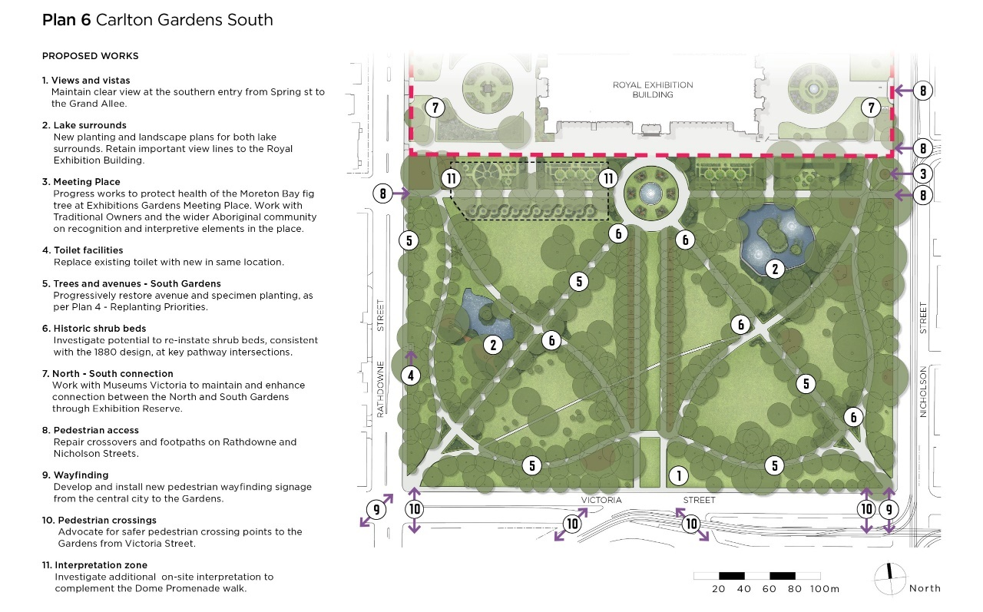
Plan 6 below displays the proposed works for Carlton Gardens South as stated in the Carlton Gardens draft Master Plan. Improvements (as shown in Plan 6) in Carlton Gardens South will continue to support tourism activities and recreational use for city workers, students, day visitors and residents.

- How supportive are you of the following recommendations for Carlton Gardens South? Mark the correct box with an ‘X’
 | No support | Low support | Unsure | Support | High support
Prioritise the introduction of new garden beds at key intersections in the Gardens consistent with the original layout.
Increase the overall number of garden (shrub) beds and lower-level planting throughout the Gardens, as shown in Plan 4.
The total period of time allowed for major events per year in Carlton Gardens South is capped at 13 weeks (or 25% of the calendar year). This includes event set up and delivery and any required post event reinstatement works. There is currently no cap.
Revise on site interpretation to recognise and celebrate a broader range of stories and cultural values across the Gardens (examples could include Aboriginal cultural connections, historic elements, horticultural features.
Replace the existing public toilet facilities to make them safer, secure, and accessible to use.
Continue to advocate to VicRoads for improved, safer pedestrian crossing points on Victoria Street (south of Carlton Gardens).

- Do you have any additional comments about any of the above draft recommendations for Carlton Gardens South?
- The Draft Master Plan includes recommendations to improve interpretation, visitor experience and tourism of Carlton Gardens as a World Heritage Site. The current recommendations propose to both update the current self-guided walk and create new digital formats. These recommendations would extend the visitor experience of the dome promenade walk (opening in 2022) in Carlton Gardens South.
Are there additional matters that would improve your visitor experience?
Your feedback on the Master Plan: Carlton Gardens North
Plan 7 below displays the proposed works for Carlton Gardens North as stated in the Carlton Gardens draft Master Plan.
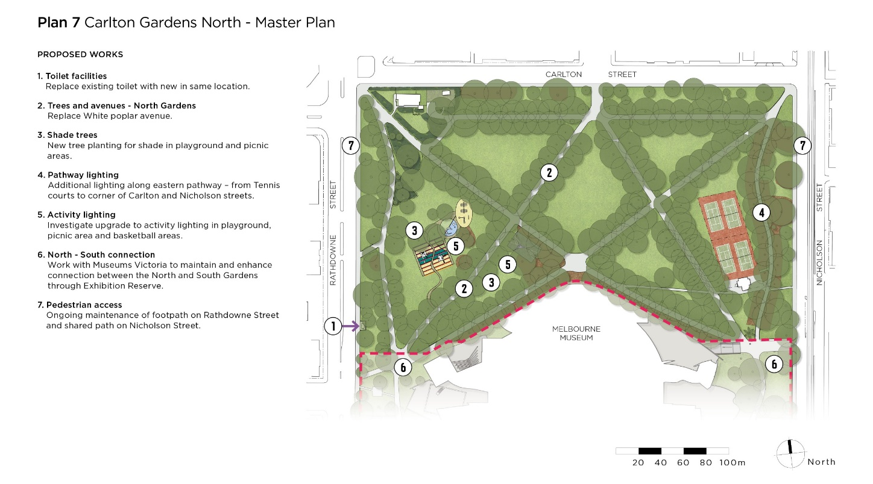
Improvements (as shown in Plan 7) in Carlton Gardens North will continue to support passive recreation and informal recreation activities in line with the current arrangements and facilities.
- How supportive are you of the following recommendations for Carlton Gardens North? Mark the correct box with an ‘X’
 | No support | Low support | Unsure | Support | High support
Replace the existing public toilet facilities to make them safer, secure, accessible to use.
Install new pathway lighting along the eastern pathway- from Tennis courts to corner of Carlton Street and Nicholson Street.
Plant new trees to increase the amount of shade in activity areas (playground and picnic areas).

- Do you have any additional comments about any of the above draft recommendations for Carlton Gardens North?

Garden furniture (both Gardens)
- The Draft Master Plan suggests to replace existing and install new garden furniture as required. Is there a specific location you would like more seats, picnic tables, rubbish bins or drinking fountains? Please specify the type of garden furniture and location.
Extending hours of use
- The Draft Master Plan proposes to increase the hours of lighting in activity areas (the basketball court, playground and picnic areas) to allow people to use the Gardens for a longer time period than at present. Will this change encourage you to use Carlton Gardens more? *
  - Yes
  - No → please specify why:
  - Unsure
Tree management and replacement (both Gardens)
The Master Plan identifies that a modest proportion of tree species have been assessed as vulnerable in a changing climate scenario. It recommends that when the time comes to replace these species, a similar but more suitable tree species choice should be made.
- What is your level of understanding of the rationale for this recommendation? *
  - I fully understand
  - I partially understand
  - I do not understand this recommendation
If you answered ‘partially understand’ or ‘do not understand’: What further information do you need?
Additional comments and stay up to date
- What other ideas for improvements or additional comments do you have regarding the Carlton Gardens Draft Master Plan?

- How did you hear about this consultation?
- Direct email  - Newsletter  - Local paper or magazine  - Postcard | - At the pop-up kiosk in the gardens  - Social media  - Word of mouth  - Other_____________________

- Email address (By sharing your email, we can let you know the result of our consultation and will keep you up to date with what’s decided).

Appendix B: Public online focus group agenda
Date: | Monday 8 November 2021
Location | Via Zoom

6.02pm | Formal welcome
6:05pm | Welcome and purpose
6:10pm | Warm up activity  - What’s your favourite memory / experience of Carlton Gardens?
6:15pm | Context presentation followed by Q&A  - Overview of the draft Master Plan  - Key themes
6:25pm | Discussion #1: Major events - Carlton Gardens South  - Presentation on rationale for recommendations  - Presentation on the survey findings to date  - Breakout room discussions
6:50pm | Discussion #2: Garden beds, tree replacement and new trees for shade - Carlton Gardens South and Carlton Gardens North  - Presentation on rationale for recommendations  - Presentation on the survey findings to date  - Breakout room discussions
7:25pm | Wrap up
7:30pm | Focus group close

Appendix C: Online children focus group questions
- What do you think of when you think of Carlton Gardens?
- What do you do at Carlton Gardens? Pick the top 2.
  - Walk
  - Jog or run
  - Meet friends
  - Use the playground
  - Read or relax
  - Play tennis
  - Play basketball
  - Have picnics
  - Sightseeing
  - School excursions
  - Walk the dog
  - Go to events
  - Visit the Gardens whilst visiting the Museum or the Royal Exhibition Building
- What time of day do you most often go to the Gardens?
- Who do you usually go with?
- What would encourage you to use the basketball court, playground or picnic areas more in the evenings?
- What do you like about Carlton Gardens?
- What do you dislike about Carlton Gardens?

Appendix C: Walking tour map activity
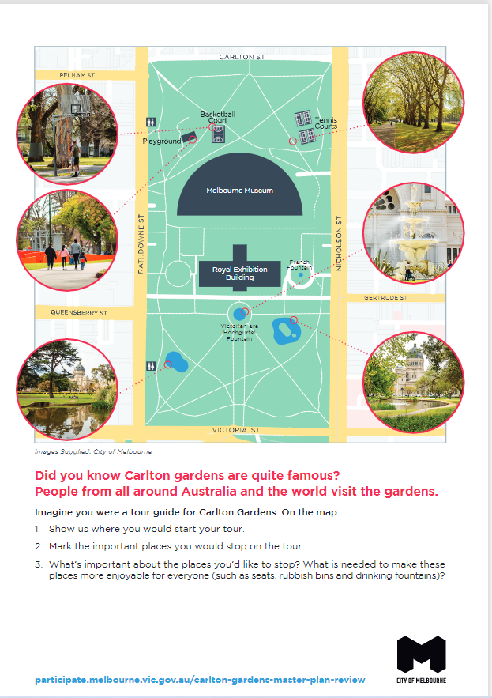

This number is an estimate.

