MELBOURNE PLANNING SCHEME

MELBOURNE PLANNING SCHEME

Incorporated Document

Heritage Places Inventory February 2020 Part B (Amended November 2021)

This document is an incorporated document in the Melbourne Planning Scheme pursuant to Section 6(2)(j) of the Planning and Environment Act 1987

MELBOURNE PLANNING SCHEME

Melbourne Planning Scheme Incorporated Document

TABLE OF CONTENTS

 |  | Page No.
1. | Introduction | 3
2. | Definitions | 4 – 5
3. | Geographical Areas Map | 6
4. | Carlton | 7 – 9
5. | East Melbourne & Jolimont | 10 – 11
6. | Flemington & Kensington | 12 – 13
7. | Melbourne | 14 – 15
8. | North & West Melbourne | 16 – 18
9. | Parkville | 19 – 20
10. | Southbank | 21 – 22
11. | South Yarra | 23 – 25

- INTRODUCTION
MELBOURNE PLANNING SCHEME

Most buildings in the Heritage Overlay of the Melbourne Planning Scheme are categorised Significant, Contributory or Non-Contributory. Buildings in the Heritage Overlay graded A to E are listed in this document.

Buildings with cultural heritage significance located within the City of Melbourne have been assessed and graded according to their importance. Streetscapes, that is complete collections of buildings along a street frontage, have also been assessed and graded. Individual buildings are graded from A to E, while streetscapes are graded from Level 1 to 3, both in descending order of significance.

All graded buildings and streetscapes are included as heritage places in the Heritage Overlay of the Melbourne Planning Scheme.

The property listings are divided into the following eight geographical areas:

- Carlton;
- East Melbourne and Jolimont;
- Flemington and Kensington;
- Melbourne;
- North and West Melbourne;
- Parkville;
- Southbank; and
- South Yarra.

The attached “Heritage Inventory Geographical Areas” map shows the location of each of the above areas. Within each area individual properties are listed alphabetically by street name and numerically, with all odd street numbers appearing first followed by even numbers.

In addition to this document further information regarding every graded building is recorded on the relevant “Building Identification Form”. These Building Identification Forms are available for inspection at Council’s Development Planning Department.

The performance standards applied by Council when considering relevant permit applications are dependent on the particular building and streetscape grading. These performance standards are set out in the “Heritage Places In the Capital City Zone” local policy at Clause 22.04 and the “Heritage Places Outside The Capital City Zone” local policy at Clause 22.05 of the Melbourne Planning Scheme.

The building and streetscape grading definitions are provided on the following page.

MELBOURNE PLANNING SCHEME

DEFINITIONS

  - Buildings
The definitions used for each of the building gradings are as follows:

‘A’ Graded Buildings

These buildings are of national or state importance, and are irreplaceable parts of Australia’s built form heritage. Many will be either already included on or recommended for the Victorian Heritage Register or the Register of the National Estate.

‘B’ Graded Buildings

These buildings are of regional or metropolitan significance, and stand as important milestones in the architectural development of the metropolis. Many will be either already included on or recommended for inclusion on the Register of the National Estate.

‘C’ Graded Buildings

These buildings demonstrate the historical or social development of the local area and/ or make an important aesthetic or scientific contribution. These buildings comprise a variety of styles and buildings types.
Architecturally they are substantially intact, but where altered, it is reversible. In some instances, buildings of high individual historic, scientific or social significance may have a greater degree of alteration.

‘D’ Graded Buildings

These buildings are representative of the historical, scientific, architectural or social development of the local area. They are often reasonably intact representatives of particular periods, styles or building types. In many instances alterations will be reversible. They may also be altered examples which stand within a group of similar period, style or type or a street which retains much of its original character. Where they stand in a row or street, the collective group will provide a setting which reinforces the value of the individual buildings.

‘E’ Graded Buildings

These buildings have generally been substantially altered and stand in relative isolation from other buildings of similar periods. Because of this they are not considered to make an essential contribution to the character of the area, although retention and restoration may still be beneficial.

Streetscapes
MELBOURNE PLANNING SCHEME

The definitions used for each of the streetscape gradings are as follows:

Level 1 Streetscape

These streetscapes are collections of buildings outstanding either because they are a particularly well- preserved group from a similar period or style, or because they are highly significant buildings in their own right.

Level 2 Streetscape

These streetscapes are of significance either because they still retain the predominant character and scale of a similar period or style, or because they contain individually significant buildings.

Level 3 Streetscape

These streetscapes may contain significant buildings, but they will be from diverse periods or styles, and of low individual significance or integrity.

MELBOURNE PLANNING SCHEME

GEOGRAPHICAL AREAS MAP
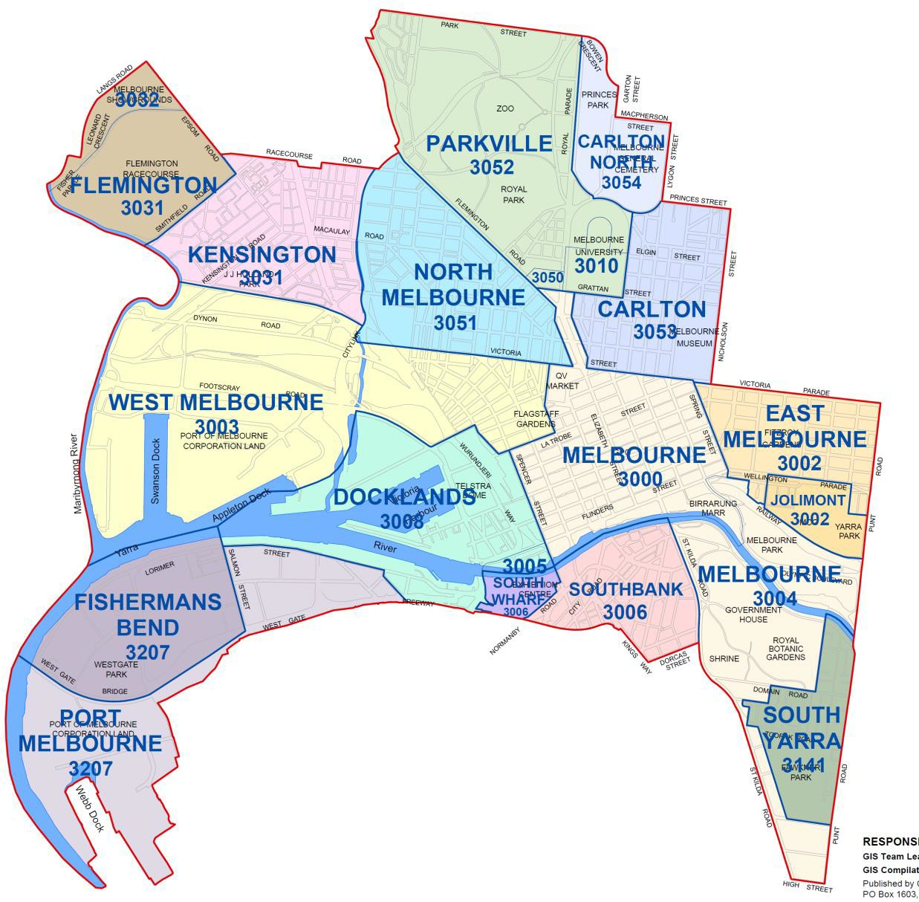

MELBOURNE PLANNING SCHEME

CARLTON

Carlton |  | CITY OF MELBOURNE HERITAGE GRADINGS
Street | Number |  | Building Grading | Streetscape Grading
Barry Street | 95 |  | C | 2
Barry Street | 97 |  | C | 2
Barry Street | 99 |  | C | 2
Barry Street | 101 |  | C | 2
Barry Street | 103 |  | C | 2
Barry Street | 105 |  | C | 2
Barry Street | 107 |  | C | 2
Barry Street | 109 |  | C | 2
Barry Street | 131 |  | C | 2
Barry Street | 139 |  | C | 2
Barry Street | 141 |  | C | 2
Barry Street | 143-151 |  | A | 1
Barry Street | 153 |  | C | 2
Barry Street | 155 |  | C | 2
Barry Street | 157 |  | C | 2
Barry Street | 159 |  | C | 2
Berkeley Street | 182-200 |  | C | 2
Bouverie Street | 183-195, includes:
 | - 193-195 Bouverie Street |  | C | 2
 | - 174-180 Leicester Street (excluding the rear of the site) |  | C | 2
Grattan Street | 163 |  | C | 2
Grattan Street | 165 |  | C | 2
Grattan Street | 167 |  | C | 2
Grattan Street | 169 |  | C | 2
Grattan Street | 171 |  | C | 2
Grattan Street | 173 |  | C | 2
Grattan Street | 175 |  | C | 2
Grattan Street | 177 |  | C | 3
Grattan Street | 205 |  | C | 2
Grattan Street | 207 |  | C | 2
Grattan Street | 209 |  | C | 2
Grattan Street | 211 |  | C | 2
Grattan Street | 213-215, includes: |  | C | 2
 | - 215 Grattan Street
Leicester Street | 210 |  | C | 2
Leicester Street | 212 |  | C | 2
Leicester Street | 214 |  | C | 2
Leicester Street | 222 |  | C | 2
Leicester Street | 224 |  | C | 2
Leicester Street | 226 |  | C | 2
Leicester Street | 228 |  | C | 2
Leicester Street | 230 |  | C | 2
Leicester Street | 232 |  | C | 2
Leicester Street | 234 |  | C | 2
Lincoln Square South | 1-13, includes: |  | C | 2
- 11-13 Lincoln Square South(primary address 631-
645 Swanston Street)

Carlton |  | CITY OF MELBOURNE HERITAGE GRADINGS
Street | Number |  | Building Grading | Streetscape Grading
Lincoln Square South | 15-17 |  | C | 2
Lincoln Square South | 23-31 |  | C | 2
Pelham Street | 196 |  | C | 2
Royal Parade | Carlton Football Club |  | C | 1
The University of Melbourne | Richard Berry Building |  | D | 2, 3
The University of Melbourne | Agriculture & Forestry |  | D | 2

MELBOURNE PLANNING SCHEME

EAST MELBOURNE & JOLIMONT

East Melbourne & Jolimont |  | CITY OF MELBOURNE HERITAGE GRADINGS
Street | Number |  | Building Grading | Streetscape Grading
Albert Street | 384-400 |  | A | 1
Albert Street | 402 |  | A | 1
Cathedral Place | St Patrick’s Cathedral |  | A | 1
Clarendon Street | 36 |  | A | 1
Clarendon Street | 120 |  | A | 1
Clarendon Street | 214-222, includes:
 | - 222 Clarendon Street |  | D | 2
 | - 376 Victoria Parade |  | A | 2
 | - 378 Victoria Parade |  | A | 2
Garden Avenue (Centre Off Wellington Pde Nth) | All |  | A | 1
George Street | 125-127, includes:
 | - 125 George Street |  | C | 2
 | - 125B George Street |  | C | 2
Gipps Street | 104 |  | A | 1
Hotham Street | 146 |  | A | 1
Hotham Street | 148 |  | A | 1
Landsdowne Street | 16 |  | D | 3
Powlett Street | Cnr Hotham & Powlett (interior) |  | C | -
Powlett Street | 105 |  | C | 2
Powlett Street | 107 |  | D | 2
Powlett Street | 129 |  | B | 1
Powlett Street | 135 |  | B | 1
Powlett Street | Median Strip b/w Albert & Victoria Sts |  | C | 2
Powlett Street | Cnr Hotham (Church) |  | B | 1
Powlett Street | 120 |  | B | 1
Simpson Street | 42-44 |  | D | 2
Spring Street | Parliament House & Grounds |  | A | 1
Wellington Parade | 56-70, includes:
 | - 8 Simpson Street |  | A | 2
 | - 10 Simpson Street |  | A | 2

MELBOURNE PLANNING SCHEME

FLEMINGTON & KENSINGTON

Flemington & Kensington |  | CITY OF MELBOURNE HERITAGE GRADINGS
Street | Number |  | Building Grading | Streetscape Grading
Barnett Street | 75-79 |  | D | 2
Barnett Street | 81, 83, 85, 87, 89 |  | D | 2
Barnett Street | 93 |  | D | 2
Barnett Street | 95 |  | D | 2
Barnett Street | 97 |  | D | 2
Bayswater Road | 17 |  | D | 3
Bayswater Road | 59 |  | D | 3
Bayswater Road | 83 |  | D | 3
Bayswater Road | 2 |  | D | 3
Bayswater Road | 76 |  | D | 3
Bayswater Road | 90 |  | D | 3
Chelmsford Street | Younghusband Ltd |  | B | 3
Elizabeth Street | 2-50 Younghusband Ltd |  | B | 1
Epsom Road | 1-7, includes:
 | - 5 Epsom Road |  | D | 3
 | - 7 Epsom Road |  | D | 3
Epsom Road | 25 |  | D | 3
Gordon Crescent | 4 |  | D | 3
Gower Street | 19 |  | D | 3
Gower Street | 37 - Gateway |  | D | 3
Kensington Road | 31 |  | D | 3
Kensington Road | 2-4 |  | D | 3
Kensington Road | 46 |  | D | 3
Kensington Road | 56 |  | D | 3
Macaulay Road | 429-431 |  | D | 3
Westbourne Road | 9 |  | D | 3
Westbourne Road | 17 |  | D | 3
Westbourne Road | 59 |  | D | 3
Westbourne Road | 67 (previously 69) |  | D | 3

MELBOURNE PLANNING SCHEME

MELBOURNE

Melbourne |  | CITY OF MELBOURNE HERITAGE GRADINGS
Street | Number |  | Building Grading | Streetscape Grading
Elizabeth Street | 527  (primary address 222-230 Victoria Street) |  | C | 2
Elizabeth Street | 529-533 |  | C | 2
Elizabeth Street | 535-541 |  | C | 2
Elizabeth Street | 543-545 |  | C | 2
Elizabeth Street | 547-549 |  | C | 2
Elizabeth Street | 579-581 |  | C | 2
Elizabeth Street | 583-585 |  | C | 2
Elizabeth Street | 595A |  | C | 2
Elizabeth Street | 597 |  | C | 2
Elizabeth Street | 605-607 |  | C | 2
Elizabeth Street | 611-669, includes: |  | C | 2
 | - 635-645 Elizabeth Street
Elizabeth Street | 520-522 |  | C | 2
Elizabeth Street | 524-530 |  | C | 2
Elizabeth Street | 532-534 (rear) |  | C | 2
Elizabeth Street | 544-548 (rear) |  | C | 2
Elizabeth Street | 552-554 |  | C | 2
Elizabeth Street | 556-562 |  | C | 2
Elizabeth Street | 576-578 |  | C | 2
Elizabeth Street | 580 |  | C | 2
Elizabeth Street | 600-608 |  | C | 2
Elizabeth Street | 618-630, includes:
 | - 618-630 Elizabeth Street |  | C | 2
Elizabeth Street | 650-652  (primary address 646-652 Elizabeth Street) |  | C | 2
Elizabeth Street | 656-658 |  | C | 2
Elizabeth Street | 676-678 |  | C | 2
Elizabeth Street | 680-682 |  | C | 2
Elizabeth Street | 684-686 |  | C | 2
Elizabeth Street | 688 |  | C | 2
Victoria Street | 222-230  (alternate address 527 Elizabeth Street) |  | C | 2
Victoria Street | 232-238 |  | C | 2

MELBOURNE PLANNING SCHEME

NORTH & WEST MELBOURNE

North & West Melbourne |  | CITY OF MELBOURNE HERITAGE GRADINGS
Street | Number |  | Building Grading | Streetscape Grading
Arden Street | 25-33 |  | D | 3
Arden Street | 2 |  | C | 2
Bendigo Street | 1 |  | D | 3
Bendigo Street | 14 |  | D | 3
Brougham Street | 9-21, includes: |  | C | 2
 | - 17 – Former Uniting Church, Brougham Street
Buncle Street | 103 |  | E | 3
Capel Street | 122 |  | C | 1
Capel Street | 124-126 |  | C | 1
Capel Street | 128 |  | C | 1
Capel Street | 130-134 |  | C | 1
Capel Street | 136-138 |  | C | 1
Capel Street | 150 |  | C | 1
Capel Street | 152 |  | C | 1
Capel Street | 156 |  | C | 1
Capel Street | 158 |  | C | 1
Capel Street | 160 |  | C | 1
Capel Street | 198 |  | C | 2
Capel Street | 202 |  | C | 2
Chetwynd Street | 91-93 |  | D | 3
Cobden Street | 13-15/15A |  | C | 2
Cobden Street | 31 |  | C | 2
Cobden Street | 33 |  | C | 2
Cobden Street | 41-43 |  | C | 2
Courtney Street | 4 |  | C | 3
Dryburgh Street | Rear 370-376 |  | D | 3
Errol Place | 12 |  | B | 3
Errol Street | 2-4 |  | C | 1
Errol Street | 110-114, includes: |  | B | 3
 | - 15 Bendigo Street
Flemington Road | 1-3 |  | C | 2
Flemington Road | 163-177, includes: |  | B | 3
 | - 56 Chapman Street
Howard Lane | Former NM Hotel Wall |  | D | 3
O’Connell Street | 1-7 |  | C | 2
O’Connell Street | 15-17 |  | C | 2
O’Connell Street | 39 |  | C | 2
O’Connell Street | 41-59 |  | C | 2
Peel Street | 111 |  | C | 3
Peel Street | 121 |  | C | 3
Peel Street | 137 |  | C | 2
Peel Street | 139 |  | C | 2
Peel Street | 151-153 |  | C | 2
Peel Street | 157 |  | C | 2
Peel Street | 191 |  | C | 3
Peel Street | 193 |  | C | 3
Peel Street | 241-243 |  | C | 3
Princess Street | 1 |  | C | 2
Princess Street | 3 |  | C | 2
Princess Street | 5 |  | C | 2
Princess Street | 4-6 |  | C | 2
Queensberry Street | 331 |  | C | 3
Queensberry Street | 335-339 |  | C | 3

North & West Melbourne |  | CITY OF MELBOURNE HERITAGE GRADINGS
Street | Number |  | Building Grading | Streetscape Grading
Queensberry Street | 351-359  Alternate address 171-175 Peel Street |  | C | 2
Queensberry Street | 384 |  | B | 3
Stawell Street | 56 (North Melbourne) |  | C | 3
Victoria Street | 240-248 |  | C | 3
Victoria Street | 502-506 |  | D | 3
Villiers Street | 24-34 |  | C | 2
Villiers Street | 36-38 |  | C | 2
Villiers Street | 40-42 |  | C | 2
Youngs Lane | 1-3 |  | C | 3
Youngs Lane | 2 |  | C | 3

MELBOURNE PLANNING SCHEME

PARKVILLE

Parkville |  | CITY OF MELBOURNE HERITAGE GRADINGS
Street | Number |  | Building Grading | Streetscape Grading
Bayles Street | 14 |  | C | 1
Gatehouse Street | 98 |  | C | 1
Gatehouse Street | 100 |  | D | 1
Gatehouse Street | 106 |  | C | 1
Gatehouse Street | 108 |  | C | 1
Gatehouse Street | 110 |  | C | 1
Gatehouse Street | 112 |  | C | 1
Royal Parade | 141 |  | C | 1
Royal Parade | 157 |  | A | 1
Royal Parade | 159 |  | A | 1
Royal Parade | 161 |  | A | 1
Royal Parade | 163 |  | A | 1
Royal Parade | 165 |  | A | 1
Royal Parade | 167 |  | A | 1
Royal Parade | 169 |  | A | 1
Royal Parade | 173 |  | A | 1
Royal Parade | 175 |  | A | 1
Royal Parade | 197-259; includes:
 | - 217 Royal Parade |  | B | 3
 | - Cnr Royal Pde, Leonard Street |  | A | 2
The Avenue | 160 |  | A | 2
The Avenue | Railway Bridge |  | C | 3

MELBOURNE PLANNING SCHEME

SOUTHBANK

Southbank |  | CITY OF MELBOURNE HERITAGE GRADINGS
Street | Number |  | Building Grading | Streetscape Grading
City Road | 157 |  | D | 2

SOUTH YARRA

South Yarra |  | CITY OF MELBOURNE HERITAGE GRADINGS
Street | Number |  | Building Grading | Streetscape Grading
Bromby Street | 1-7, includes:
 | - Myer Music School – MGS, Domain Street |  | C | 3
Bromby Street | 43 |  | B | 3
Clowes Street | 31 |  | D | 3
Clowes Street | 54 |  | D | 3
Domain Road | Melbourne Grammar (refer to St Kilda Rd)
Domain Road | 31 |  | F | 1
Domain Road | 129 |  | D | 2
Domain Street | 106 |  | B | 1
Domain Street | 110 |  | D | 1
Domain Street | 114 |  | C | 1
Domain Street | 118 |  | D | 1
Domain Street | 124 |  | B | 1
Domain Street | 132 |  | C | 1
Domain Street | 136 |  | C | 1
Domain Street | 142 |  | B | 1
Domain Street | 148 |  | A | 1
Fawkner Park | Kindergarten |  | C | -
Fawkner Park | Dressing Pavilions |  | A | -
Fawkner Park | Gardner’s Cottage |  | C | -
Fawkner Park | Substation |  | C | 1
Millswyn Street | 112-118, includes:
 | - Maples Store, Millswyn Street |  | D | -
 | - Maples Shed, Millswyn Street |  | D | -
 | - Maples Wall, Millswyn Street (also known as Rear, 44 St  Martins Lane) |  | D | -
 | - Unit 4, rear 114, Millswyn Street |  | D | -
Moubray Street | Ormond Hall |  | C | 1
Moubray Street | Blind Institute Workshop |  | C | 1
Punt Road | 437 |  | C | 3
Punt Road | 451 |  | A | 2
Punt Road | 485 |  | D | 3
Punt Road | 663-681, includes: |  | A | 1
 | - Christ Church Vicarage
Punt Road | 783 |  | D | 3
St Kilda Road | MCEGS West Front (9) South Front Extension |  | A | 1
St Kilda Road | Melbourne Grammar Buildings Nos. 6 & 7 |  | A | 1
St Kilda Road | Melbourne Grammar Buildings Nos. 3, 5, 8, 11, 13 |  | A | 1
St Kilda Road | Melbourne Grammar (14) |  | A | 1
St Kilda Road | Melbourne Grammar Building No. 20 |  | C | 1
St Kilda Road | War Memorial Hall |  | C | 1
St Kilda Road | Melbourne Grammar Building No. 10 |  | A | 1
St Kilda Road | Melbourne Grammar Building No. 12 |  | A | 1
St Kilda Road | Melbourne Grammar 2, 4 |  | A | 1
St Kilda Road | Melbourne Grammar 16 |  | C | 1

South Yarra |  | CITY OF MELBOURNE HERITAGE GRADINGS
Street | Number |  | Building Grading | Streetscape Grading
St Kilda Road | MGS Science Building |  | - | 1
St Kilda Road | 30 Wadhurst, Melbourne Grammar |  | C | 1
St Kilda Road | Melbourne Grammar Buildings Nos. 33, 34 |  | C | 1
St Kilda Road | 597 |  | A | 1
St Kilda Road | Tram Shelter Near Cnr High Street |  | C | 1
Toorak Road West | 2 (Synagogue) |  | A | 3
Toorak Road West | 52-56 (Fawkner Club Hotel) |  | C | 1
Walsh Street | Adjacent to 281 Walsh Street |  | D | 3
Walsh Street | 281 |  | D | 3
Walsh Street | 285 |  | D | 3
Walsh Street | 291 |  | D | 3
Walsh Street | 310 |  | D | 3
Walsh Street | 322 |  | D | 3

END OF DOCUMENT

