Statement of Significance: Punt Road Oval (Richmond Cricket Ground), Punt Road, East Melbourne (November, 2021)

Heritage Place: | Punt Road Oval (Richmond Cricket Ground) | PS ref no: | HO1400
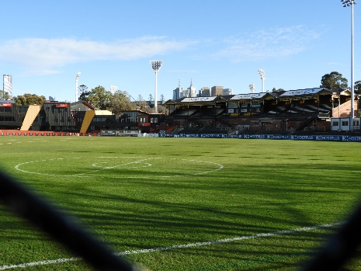 | 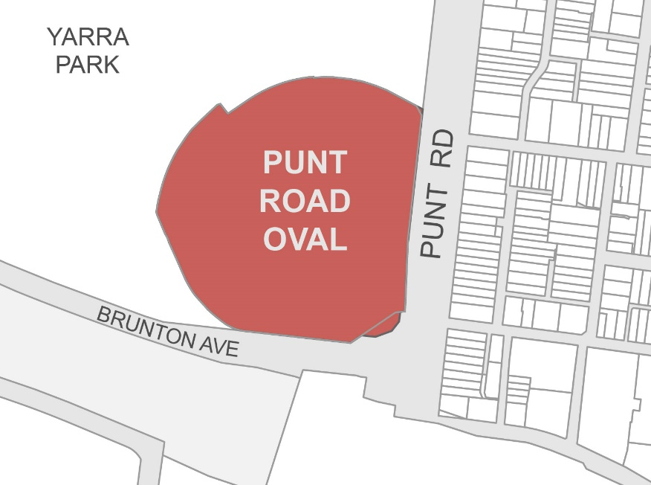

What is significant?
The Punt Road Oval (Richmond Cricket Ground) at Punt Road, East Melbourne, which was cleared, levelled and fenced in 1856 and used for the first time as a cricket ground in November 1856, is significant.
Elements that contribute to the significance of the place include (but are not limited to):
- the oval
- grassed embankments on the south and east sides and at the southeast corner of the ground
- the restriction of built form to the west and north boundaries of the ground
- open sides to the ground and transparent perimeter fencing on the east (Punt Road) and south (Brunton Avenue and railway line) boundaries
- the landmark qualities of Punt Road Oval
- the Jack Dyer Stand (1913–14) and 1927 west wing addition.
Elements that contribute to the significance of the Jack Dyer Stand include (but are not limited to):
- the building’s original curved plan form, materials and detailing, built to the design of architects Thomas Watts & Son
- the 1927 west wing addition built to the design of architect Frank Stapley
- the building’s relatively high integrity to its early design to all elevations
- the hip and gabled roof form
- the pattern and size of original fenestration
- slender cast iron and timber columns, decorative timber brackets and timber fretwork frieze; and
- other decorative details.
More recent buildings, including the administration building, the David Mandie Building, and the remnant red brick building, are not significant. The fabric of recent landscaping such as the cyclone wire fencing and gates around the perimeter of the ground, the pipe rail fencing around the oval, and the northeast corner wall and the Spotted Gum in the southeast corner of the ground are not significant.
More recent alterations and additions to the Jack Dyer Stand, including changes at podium level, modern external stairs, new openings in the curved north elevation, and commentary box within the stadium seating area are not significant.

How is it significant?
Punt Road Oval (Richmond Cricket Ground) at Punt Road, East Melbourne, is of local historical, representative, aesthetic, social, and associative significance to the City of Melbourne.

Why is it significant?
The Punt Road Oval, occupying the Traditional Country of the Wurundjeri Woiwurrung people of the East Kulin Nation, is of historical significance as part of the former Richmond Paddock (Yarra Park), which was used as an East Kulin living area, ngarrga and ceremonial ground, both prior to the British colonisation of Port Phillip and during the early settlement period in the 1830s and 1840s. It was used as a ngarrga and ceremonial ground in the 1840s. (Criterion A)
The Punt Road Oval, as part of the former Richmond Paddock (Yarra Park) that was set aside in 1837, is of historical significance for its use for the policing and administrative purposes of the colonial government of the Port Phillip District. From 1837, the wider area was used by Police Magistrate William Lonsdale, by the Mounted Police and the Native Police, and by officers of the Port Phillip Aboriginal Protectorate. (Criterion A)
The Punt Road Oval is of historical significance as an early cricket ground in Melbourne that was established in 1853 and used by the Richmond Cricket Club from 1856. It was used as a cricket ground for over 150 years and was the venue for significant events including interstate matches and as a training ground for the Aboriginal Cricket Team in 1867–68. (Criterion A)
The Punt Road Oval, established as the Richmond Cricket Ground in 1853, is of historical significance for its use as an early football ground from 1860 and its association with the early Richmond football team from that time, and for its earlier role in the development of the code of Australian Rules football in 1858; as the home ground for the present Richmond Football Club from 1885 to 1964 and for its use (up until the present time) as the club’s training ground and administrative centre. The development of the ground from 1907 when the club was accepted into the Victorian Football League, and through the early and mid-twentieth century, reflects the significant growth in membership of the Richmond Football Club over this time and the growing spectator base for Richmond home games. This period saw the construction of a large Edwardian grandstand in 1913–14 (named the Jack Dyer Stand in 1998), built to a design by architects Thomas Watts & Son and extended in 1927 to a design by architect Frank Stapley; a second grandstand, the Members Stand (later named the EM King Stand), erected in 1937–38 and since demolished; and other changes to the ground over time. (Criterion A)

The brick Edwardian-era Jack Dyer Stand is of representative significance as an example of the larger and more elaborate football stands that emerged in the late nineteenth century and early twentieth century. It retains key distinguishing features of its original 1913 design by Thomas Watts & Son and the matching 1927 extension designed by architect Frank Stapley. The stand is distinguished from the earliest known grandstand designed by Thomas Watts which is at Maryborough (1895) by its curved plan. The curved plan form is not typical for grandstands of this era. An earlier example is the 1909 Ald Gardiner Stand, Princes Park. (Criterion D)
The Punt Road Oval, as part of the former Richmond Paddock (Yarra Park) set aside in 1837, is of social significance for its important associations with the Aboriginal history of Melbourne; this includes being part of the wider Richmond Paddock that was a traditional East Kulin living area, and ngarrga and ceremonial ground that continued to be used as such into the 1840s, and being occupied by the Native Police Corps as a site for police training and police barracks. The Punt Road Oval, formerly the Richmond Cricket Ground, is also significant for its use as a training venue in 1867–68 for the Aboriginal Cricket Team made up of men from different parts of Victoria, and its current use as a training centre for Indigenous youth. (Criterion G)
The Punt Road Oval is of social significance for its long association with the Richmond Football Club, which used the oval as its home ground from 1884 until 1965; for its use by Richmond Football Club as a training ground and administrative centre from 1965 until the present day; and for its association with earlier Richmond football teams that also used the ground from 1860. The community for whom the place is significant includes members and supporters of the Richmond Football Club; past and present players, coaches and staff of the Richmond Football Club; residents of Richmond; and Melburnians more broadly. This community has had a strong attachment to the place for over 130 years. This attachment is strengthened by the strong and distinctive community identity of Richmond though much of the twentieth century. This was heavily anchored in local working-class politics that promoted fierce loyalty and physical toughness, which translated easily to football—for many Richmond supporters, ‘Tigerland’ is another name for Richmond. The social significance of the place as the former home ground of the Richmond Football Club resonates in the continued use of the ground for training; as the site of post-grand final premiership celebrations; and its powerful symbolic meaning to Richmond residents and followers of the Richmond football team who regard the ground as the spiritual home of the club. Its resonance is strengthened by the ground’s presence and visibility from major transport corridors (Punt Road, Brunton Avenue, the multi-track railway line and Richmond Railway Station) and within Yarra Park, making it a prominent landmark in the local area. The Richmond Cricket Ground is also of potential social significance to players, coaches and other staff, members and supporters of the Richmond Cricket Club, which was based at the ground for over 150 years—from 1854 until relocating to Waverley Park in 2011. (Criteria E and G)
The Punt Road Oval is of significance for its association with champion Richmond footballer John (‘Jack’) Raymond Dyer (1913–2003). Nicknamed Captain Blood, Dyer was captain–coach of Richmond in the 1930s and 1940s and one of the greats of the game, recognised for his strategic play, fine marking and straight kicking. He was selected numerous times for the Victorian team and was inducted into the Australian Football Hall of Fame. A bronze statue of Dyer was erected outside the ground in 2003 and the 1913–14 grandstand was named in his honour in 1998. (Criterion H)
The Punt Road Oval is of significance for its association with Thomas Wentworth Wills (1835–1880), first-class cricketer and co-founder of Australian Rules football. Wills was a member of the Richmond Cricket Club and one of its leading players in the 1850s and 1860s; he was also selected for intercolonial matches. In 1858-59 he was a co-founder of a new code of football suitable for conditions in the Colony of Victoria. Initially known as Melbourne rules football and later as ‘Australian rules’, this was the first game of football in the world to be formally codified. (Criterion H)

Primary source
Punt Road Oval (Richmond Cricket Ground) Heritage Review (Context, 2021)

