Statement of Significance: RMIT Buildings 51, 56 and 57, 80-89 Victoria Street and 33-89 Lygon Street, Carlton (November, 2021)

Heritage Place: | RMIT Buildings 51,56 and 57 | PS ref no: | HO1398

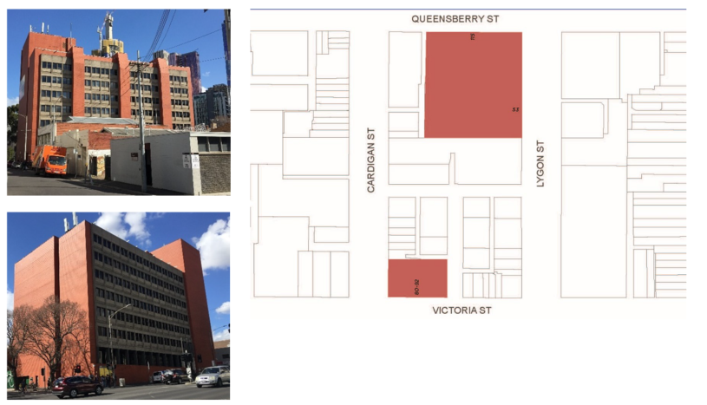

What is significant?
The three RMIT buildings, located in a complex of RMIT (Royal Melbourne Institute of Technology) buildings in the south of Carlton, are significant. The subject buildings are:
- Building 51 at 80-92 Victoria Street (1972)
- Building 56 at 33-89 Lygon Street also known as 115 Queensberry Street (1976)
- Building 57 at 33-89 Lygon Street also known as 53 Lygon Street (1983)
How is it significant?
RMIT Buildings 51, 56 and 57, located in a block bounded by Queensberry, Lygon, Victoria and Cardigan streets, Carlton, are of local historical and aesthetic significance.
Why is it significant?
Royal Melbourne Institute of Technology (RMIT) Buildings 51, 56 and 57 are of historical significance (Criterion A). The buildings were constructed between 1972 and 1983 to designs by the architectural practice of Demaine Russell Trundle Armstrong and Orton (later Demaine Partnership), with specific input from architect Dominic Kelly. The practice had earlier, in 1971, prepared a master plan for RMIT’s expansion into Carlton, at a time when the institute was experiencing significant growth in student numbers and course offerings. RMIT embarked on its Carlton building plan from 1970, after the Victorian government set aside properties for the institute’s development at the southern end of the suburb. The block in which the subject buildings are located was situated immediately to the north of the city campus, and also in close proximity to Trades Hall with which the institute, originally the Working Men’s College founded in 1887, had long had an association.
RMIT Buildings 51, 56 and 57 are also of aesthetic significance (Criterion E). The architects, Demaine, are a highly regarded Melbourne-based architectural practice, with a comprehensive and diverse portfolio of work including hospital, institutional, corporate and educational projects. Although their master plan for the Carlton campus was never fully realised, the three subject buildings, and their tertiary uses, were largely anticipated in the plan. This included their substantial footprints and overall massing, and notably their distinctive and monumental brick service shafts to the rear elevations. Aesthetically, the three buildings form a largely cohesive group, unified in the use of large-scale (monumental) red brick volumes; huge expanses of plain redbrick walling; recessed vertical window bays or, alternatively in the earlier building, regular arrangements of concrete window grilles; concrete detailing often expressed as a rough pebble-textured finish; and the striking service shafts with their corbelled forms.
While they are of a group, the three buildings are also individually distinguished, with each demonstrating different architectural references and specific influences, including some Brutalist influences. Building 51 shares commonalities with other Demaine tertiary buildings of the general period, including the rough surfaced pebble-textured window panels bracketed between brick end walls and service towers; and the ‘cellular’ form of the window grilles which recalls Le Corbusier’s earlier work. Building 56 on its north façade employs a thick red brick rectangular frame, reflective of the ‘solidity’ which marked Demaine projects from the 1960s onwards, which was in turn a reaction to the earlier predominance of curtain walling. Building 56 is also distinguished by its incorporation of a basement level and lightwell to the north side, which is largely concealed from Queensberry Street; and by its innovative continuous window framing system. Building 57 is the more overtly Brutalist of the three, seen in the angled (‘jagged’) form of the east façade to Lygon Street, and its sudden central break which reveals a ‘scooped’ vertical window bay. The tiered concrete form and concrete entrance ramp of the south elevation also draw strongly on Brutalist influences.
More broadly, the buildings are of aesthetic significance for being reflective of the built form changes in Carlton in the later twentieth century, when contemporary architects were responsible for some celebrated new developments which, in turn, challenged the typical building form and character of the suburb. The three buildings are also significant as large and robust forms, which dominate their contexts, and draw attention to RMIT’s presence in this area of Carlton.
Primary source
Carlton Heritage Review (Lovell Chen, 2021)

