Statement of Significance: Factory Warehouse, 96-106 Pelham Street, Carlton (November, 2021)

Heritage Place: | 96-106 Pelham Street, Carlton | PS ref no: | HO82

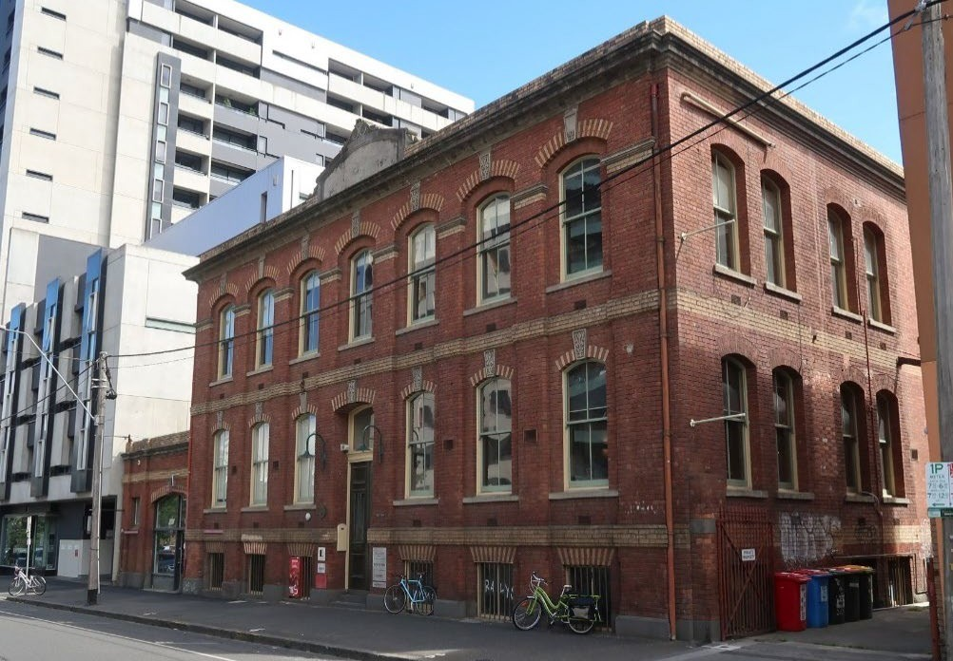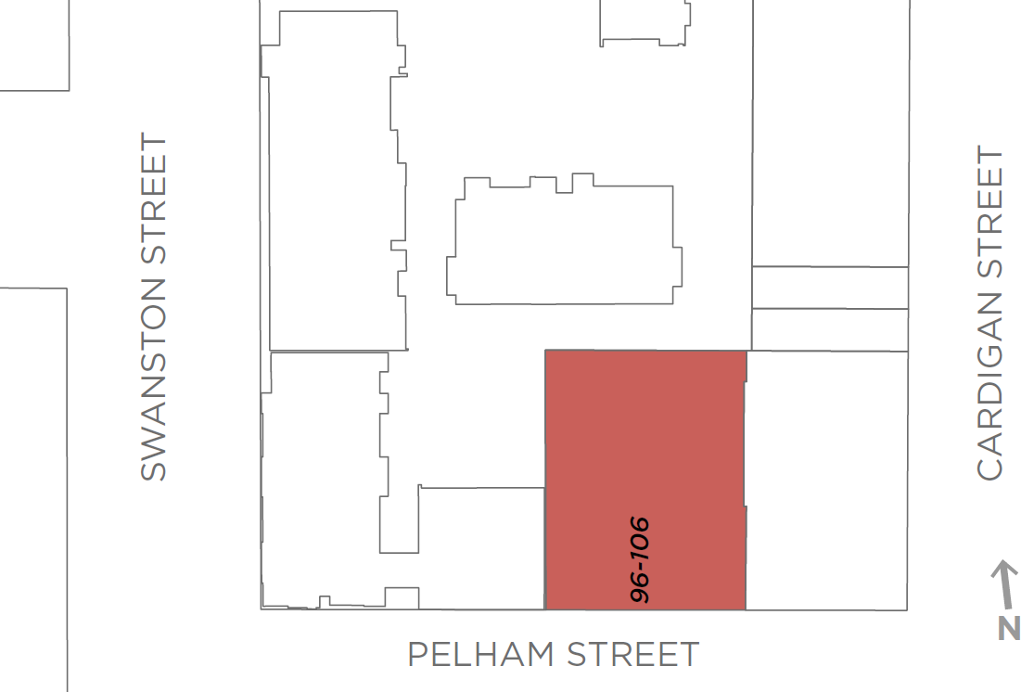

What is significant?
The former manufactory and store at 96-106 Pelham Street, Carlton, constructed in 1885 for Banks & Co to a design by noted architect Charles Webb, is significant.
How is it significant?
The former manufactory and store at 96-106 Pelham Street, Carlton, is of local historical (including rarity) and aesthetic significance.
Why is it significant?
The former manufactory and store at 96-106 Pelham Street, Carlton, is of historical significance (Criterion A). The building, with an associated storeman’s residence, was constructed in 1885 for clothing manufacturers Banks & Co, to a design by noted architect Charles Webb. Banks & Co had originally established their operations in the city in the late 1860s, before expanding by the 1880s into a large warehouse in Flinders Lane, the emerging focus of Melbourne’s ‘rag trade’. The Carlton building was a clothing factory and store, constructed at a time when the manufacture of ready-made clothing was expanding, consistent also with the economic Boom in Melbourne. The property is also significant as a rare example of a manufacturing building of this age and scale in Carlton. This may in part explain the positive attention the development received from the Melbourne press, where Banks & Co were couched as benevolent employers. The building was described in the Argus of May 1885 as a new factory which was ‘in every way equal to modern requirements’; and in 1888 by Victoria and its Metropolis, Past and Present as having an advantage over factories situated in the centre of the city, and built strictly in accordance with ‘the requirements of the Factories Act’. Banks & Co employed a large female workforce, and claimed to have adopted the wage terms which were the outcome of the Tailoresses’ Strike of the early 1880s.
The former manufactory and store is also of aesthetic significance (Criterion E). It is substantially externally intact, of two storeys plus part basement, designed in the manner of an Italian palazzo and incorporating fine polychrome brickwork. Floors are articulated externally by deep string courses in cream brick and by a substantial cornice at parapet level; and tall windows at ground and first floor levels adopt a segmental headed form, with brick voussoirs in alternating colours flanking rendered ornamental keystones. The original storeman’s, later caretaker’s residence survives, as does the street wall and carriage gate constructed between 1896 and 1927. While the 1880s represented the high water mark of Charles Webb’s practice, the
1885 factory in Pelham Street is a capable design rather than a key element in Webb’s catalogue. He did however produce a number of works in polychrome brickwork, and the polychrome expression of the subject building distinguishes it from the majority of later manufacturing, light industrial and warehouse buildings in Carlton, which were often utilitarian in design and unassuming in their presentation (Criterion B).
Primary source
Carlton Heritage Review (Lovell Chen, 2021)

