Statement of Significance: Former Manufacturing Building, 29-31 Rathdowne Street, Carlton (November, 2021)

Heritage Place: | 29-31 Rathdowne Carlton | PS ref no: | HO809

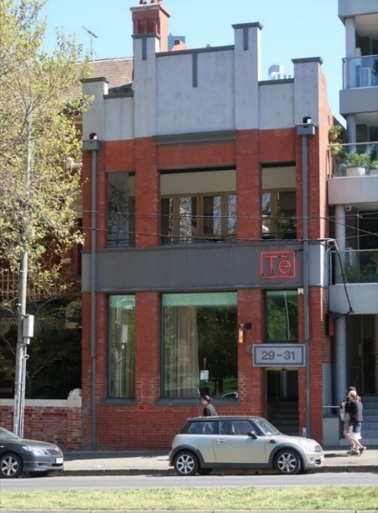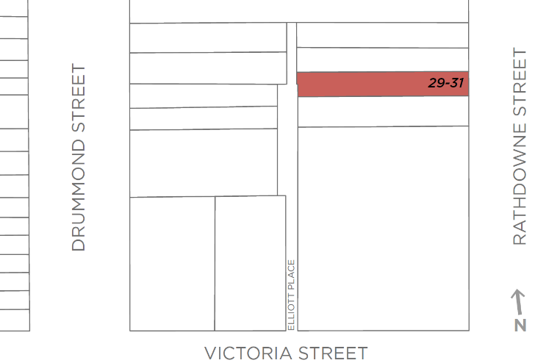

What is significant?
The former manufacturing building at 29-31 Rathdowne Street, Carlton, constructed in 1919 for George Khyat’s Continental Suspender Manufacturing Company, is significant.
How is it significant?
The former manufacturing building at 29-31 Rathdowne Street, Carlton, is of historical and aesthetic significance.
Why is it significant?
The former manufacturing building at 29-31 Rathdowne Street, Carlton, is of historical significance (Criterion A). It was constructed in 1919 for George Khyat’s Continental Suspender Manufacturing Company. The Khyat family, originally from Lebanon and Syria, were prominent in textile and clothing related businesses in Melbourne at this time, with family members variously running businesses in the city, in leather and fancy goods, and embroidery operations. The Khyat family remained at the Rathdowne Street premises until 1951, with the building continuing to be used for manufacturing related purposes until, unusually for Carlton, 1988. Since that time the property has been used as offices. The building is also significant for demonstrating the local pattern of small scale manufacturing and light industry, as established in Carlton in the early twentieth century and interwar period. It reflected the trend of comparatively small scale buildings of this type being constructed on generally limited footprints. The subject building also shares the history of many of Carlton’s former manufacturing or light industrial buildings in that it has been adapted to a later use.
The building at 29-31 Rathdowne Street, Carlton, is also of aesthetic significance (Criterion E). Distinguishing characteristics include the tall two-storey form, red brick and render materiality, and the articulated bays of the façade, with the red brick pilasters extending up and through the prominent panelled and rendered parapet. The lack of setback additionally distinguishes the property in the Rathdowne Street context, drawing attention to what is an atypical factory building in an otherwise mainly residential street, noted for some grand residential development of the 1880s and later.
Primary source
Carlton Heritage Review (Lovell Chen, 2021)

