Statement of Significance: Mary’s Terrace, 50-56 Cardigan Street, Carlton (November, 2021)

Heritage Place: | Mary’s Terrace | PS ref no: | HO36

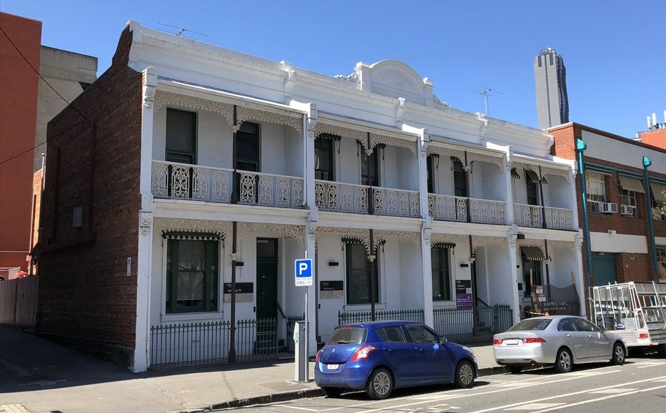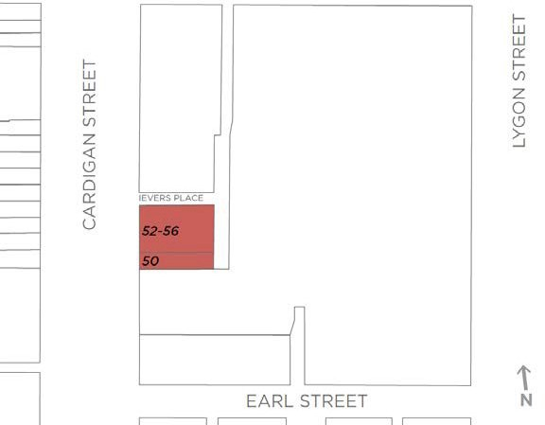

What is significant?
The terrace row of four attached, two-storey rendered Victorian dwellings at 50-56 Cardigan Street, Carlton, which dates from c. 1885-1886, is significant.
How is it significant?
The terrace row at 50-56 Cardigan Street, Carlton, is of local historical significance and representative value.
Why is it significant?
The terrace row at 50-56 Cardigan Street, Carlton, is of historical significance (Criterion A). The row consists of four dwellings constructed in c. 1885-1886, for prominent nineteenth century Carlton identify and property owner, William Ievers. The latter owned a successful real estate agency in Cardigan Street, established in 1859 near the end of that decade of remarkable Gold Rush related growth in Melbourne, but was particularly successful in the 1870s and 1880s. Ievers was also involved in local politics, being a Melbourne City councilor in the 1890s. The subject row bears the name of his wife, Mary.
The terrace row is also of representative value (Criterion D). The mid-1880s date of construction places the terrace firmly in the renowned Boom period of development in Melbourne, and it remains substantially intact to its original state. While straightforward and representative rather than remarkable in terms of its design, it is typical of the rows constructed during the Boom and in some cases in Carlton in the period following. The ornament is generally understated, although small pedestal devices to the parapet and central pediment suggest that orbs or urns have been removed, meaning that the original expression may have been slightly more exuberant than is the case today. The terrace also illustrates the tendency towards filigree in lacework that informed architectural design through the 1880s in Melbourne and remained relevant in Carlton at the turn of the twentieth century. Other elements of note include verandahs with cast iron columns, Corinthian capitals and lacework valences; the original cast iron palisade front fences on bluestone bases with original gates; and a simple parapet to the top of the row with a central pediment flaked by scrolls and incorporating the name ‘Mary’s Terrace’.
Primary source
Carlton Heritage Review (Lovell Chen, 2021)

