Statement of Significance: Hotel Lincoln and Environs Precinct, 91-95 Cardigan Street and 134-150 Queensberry Street, Carlton (November, 2021)

Heritage Place: | Hotel Lincoln and Environs Precinct | PS ref no: | HO97

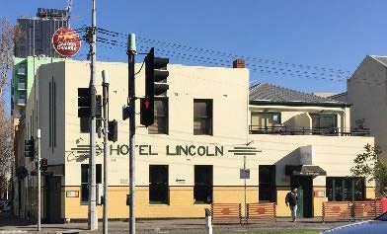  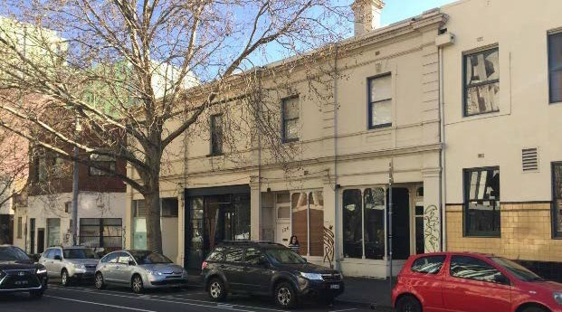 | 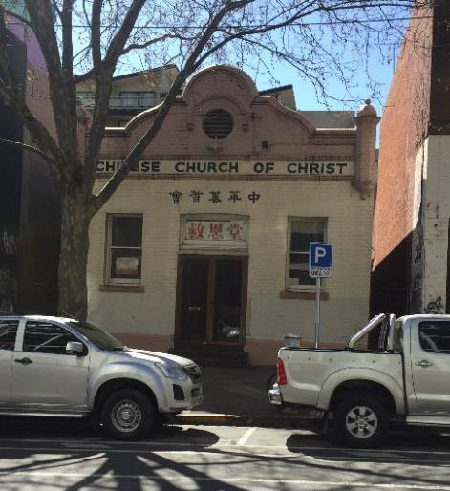
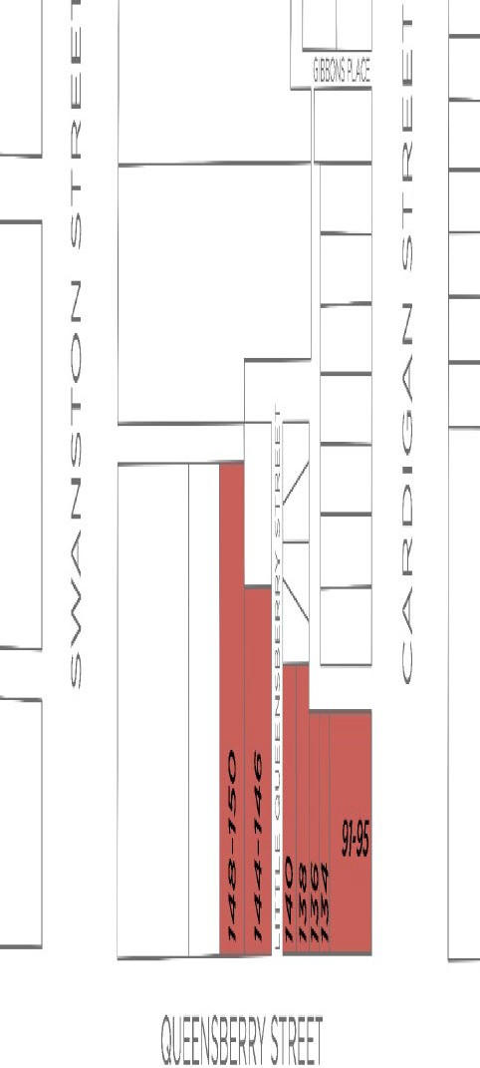

What is significant?
The Hotel Lincoln and Environs Precinct at 91-95 Cardigan Street and 128-150 Queensberry Street, Carlton, is significant at a local level to the City of Melbourne.

Within this group, the significance categories are as follows (Figure 31):
- The two-storey shop pair of 1877 at 134-136 Queensberry Street is significant
- The two-storey shop pair of 1894 at 138-140 Queensberry Street is contributory
- The former manufacturing building of 1927, 144-146 Queensberry Street is contributory
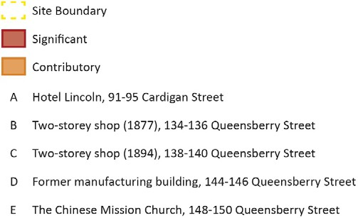
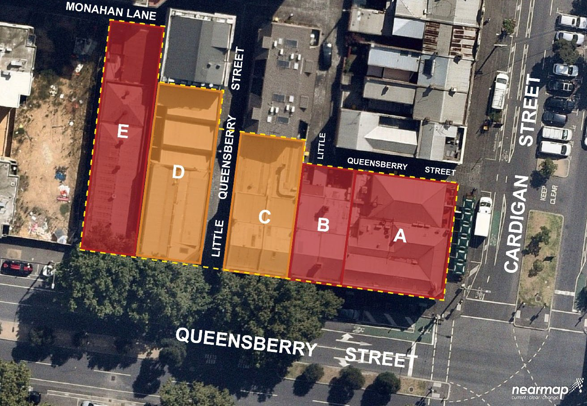
- The c. 1905 Chinese Mission Church, 148-150 Queensberry Street is significant

Figure 31 Significance categories in Hotel Lincoln and Environs Precinct Source: Nearmap (basemap)

How is it significant?
The Hotel Lincoln and Environs Precinct is of local historical, representative, aesthetic and social significance at a local level to the City of Melbourne.
Why is it significant?
The Hotel Lincoln and Environs Precinct is of local historical significance for its demonstration of the diversity of building types which typified development in Carlton through the nineteenth century and into the twentieth century (Criterion A). The individual buildings within the precinct are also of historical significance.
The Hotel Lincoln is of historical significance as a very early hotel of 1854-5 (Criterion A). It played an important role in early Carlton, as the site of community gatherings and protest meetings. Its early date is reinforced by its inclusion in the 1855 Kearney plan of Melbourne suburbs; it was also known in the early 1860s as the Old Lincoln Hotel or Inn, due to another newer hotel of the same name having opened on the corner of Faraday and Rathdowne streets. Another indication of its early date, and also its role as a hotel on a main street was the historical inclusion of stabling within the pitched rear yard; the latter is indicative of a hotel which attracted patrons from further afield than the local suburb. When the hotel underwent significant alterations and extensions in the later interwar period, this was in line with the more stringent liquor licensing laws of the period whereby hotel proprietors, in order to maintain their licences, were required to update and refurbish their buildings. Remarkably, the Lincoln Hotel, despite several name changes and the fluctuating fortunes of licensed premises, is still operating as a hotel, some 160 years after it first opened. The adjoining shops to Queensberry Street also have a significant association with the hotel, having been developed in stages by the then hotel owner, Mrs Downing, in the period of the mid-1870s to the 1890s. These, together with the hotel, illustrate the typical mixed use pattern of development to the historic main streets of Carlton.
The Chinese Mission Church at 148-150 Queensberry Street, Carlton, is of historical significance (Criterion A). It was constructed in 1905 by the Church of Christ as part of its ‘outreach’ missionary activities, for the purpose of converting members of the Chinese community to Christianity, and then servicing their conversion through missionary programmes. The Church of Christ was involved in missionary work in India, China, Hong Kong and the New Hebrides and had branches throughout Australia, including Victoria. The church was one of a number of denominations conducting these missionary activities in the community, activities which date back to atleast the arrival of Chinese people to the Victorian goldfields in the early 1850s. While Chinatown was a focus of this work, the Chinese Mission Church in Carlton provides evidence of the reach of the missions. The Carlton building is a slightly later, and more modest example of a Chinese mission building, than those constructed earlier in Little Bourke Street. Prominent architects were typically involved in the city buildings, which in turn were consequently more architecturally distinguished than the subject church building. While the Chinese Mission Church in Carlton is an ‘outlier’ to this group, it has historically performed the same function and is located in an area where the Chinese community were in residence in the early part of the twentieth century. As with the other mission buildings, it was also purpose-built and maintains its original historical use and function.
The former manufacturing building at 144-146 Queensberry Street, Carlton, is of historical significance (Criterion A). It was constructed in 1927 for coppersmith Alfred S Miles, who had earlier relocated his business to the site in 1900, having previously occupied premises near the corner of Queensberry and Madeline (Swanston) streets in Carlton. While Miles died in 1940, his firm continued to operate at the site until the early 1960s, representing over 60 years of ongoing occupation. Typical of many of Carlton’s former manufacturing or light industrial buildings, the subject building has been adapted to a different use.
The Hotel Lincoln and Environs Precinct is representative of the diversity of activity co-located within small areas of Carlton (Criterion D). It demonstrates the typically low-scale development of the suburb from the mid- nineteenth century and into the twentieth century. A number of individual buildings in the Hotel Lincoln and Environs Precinct are of local representative significance.
The Hotel Lincoln retains representative characteristics of early hotels, such as the two-storey form and splayed corner entrance (Criterion D). It also displays typical characteristics of the makeovers given to numerous Melbourne hotels in the interwar period, including the tiling to dado level, changes to openings at ground floor level, and construction of an additional accommodation wing.
The former manufacturing building at 144-146 Queensberry Street, is also of representative significance for its historical manufacturing use (Criterion D). It is demonstrative of small scale manufacturing and light industry as established in Carlton in the early twentieth century and interwar period (Criterion D). It reflected the trend in the suburb of comparatively small-scale buildings of this type being constructed on generally limited footprints. The building is broadly similar to other modest former manufacturing buildings in Carlton of generally utilitarian appearance, with typically stripped back or unadorned face brick expressions. It incorporates chamfered corner form which gives the building an asymmetrical appearance; and high brick parapet which turns with the chamfered corner and has capped piers and a raked gable end. The profile of the sawtooth-roofed northern bay, as it presents to Little Queensberry Street, is also of interest.
A number of individual buildings in the Hotel Lincoln and Environs Precinct are of local aesthetic significance (Criterion E). The Hotel Lincoln and associated nineteenth century shops, are of aesthetic significance. The c. 1940 works also gave the hotel building its current understated Moderne expression, incorporating plain rendered walls, modest horizontal detailing, and applied signage with the name ‘Hotel Lincoln’ at first floor level. The rendered masonry shops to Queensberry Street currently read as separate building components to the hotel, although they may have been more consistent in appearance prior to the hotel’s late interwar makeover. They are however substantially intact to their original states, with the two building programmes sharing a similar scale, architectural expression, and detailing, and presenting as a continuous row of four shops. The earlier pair at nos 134-136 substantially, and unusually, retain original shopfronts and offset recessed entries. The later pair at nos 138-140 were built to reflect the design of the earlier shops and while they are diminished by changes to the shopfront at no. 140, they generally retain their original appearance.
The Chinese Mission Church is also of social significance for servicing the Chinese Christian community of Carlton, and Melbourne, for over 110 years, and continuing to fulfil this role (Criterion G).
Primary source
Carlton Heritage Review (Lovell Chen, 2021)

