Statement of Significance: Ministry of Housing Infill Public Housing, 75-79 Kay Street, 76-80 Station Street, 78 Kay street, 43-45 Kay Street, 136 Canning Street,
51-53 Station Street and 56-62 Station Street, Carlton
(November, 2021)

Heritage Place: | Ministry of Housing Infill Housing | PS ref no: | HO1397

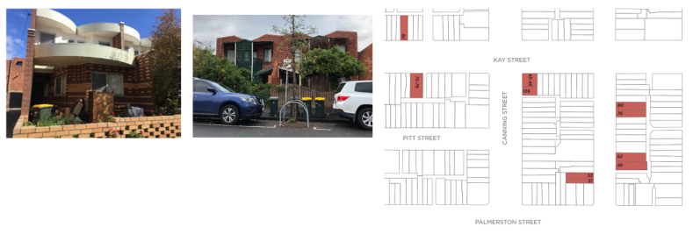

What is significant?
The six properties (townhouse pairs, groups or individual dwellings) constructed in 1981-83 and variously located in Kay, Canning and Station streets, Carlton, are significant. The six properties, located in the area known as the ‘Kay Street Reclamation Area’, bounded by Palmerston, Rathdowne, Princes and Nicholson streets, are as follows (with their architects indicated):
- 75-79 Kay Street (Edmond & Corrigan)
- 78 Kay Street (Edmond & Corrigan)
- 43-45 Kay Street/136 Canning Street (Gregory Burgess)
- 76 Station Street, 80 Station Street (Gregory Burgess)
- 51 Station Street, 53 Station Street (Peter Crone)
- 56-58 Station Street, 60-62 Station Street (Peter Crone)
How is it significant?
The six properties constructed in 1981-83 under the Ministry of Housing infill housing program and variously located in Kay, Canning and Station streets, Carlton, are of local historical and aesthetic significance.
Why is it significant?
The six Carlton properties constructed in 1981-83 under the then new Ministry of Housing infill housing program, are of historical significance (Criterion A). Their design and construction followed in the wake of several decades of ‘slum’ clearance in the suburb, and construction of the ultimately highly unpopular public housing towers. The new housing also came about after the former Housing Commission was renamed the Ministry of Housing in the late 1970s, and launched into a period of reform. Under the leadership of newly appointed architects John Devenish and Dimity Reed, a transformative approach to public housing was conceived, and this is clearly demonstrated in the subject dwellings. The new forms of public housing were intended to be more creative and humane, and to be built to higher standards; to better integrate their residents into their environments; and to help remove the stigma associated with public housing developments. The local architects chosen to design the new infill buildings were Edmond and Corrigan, Peter Crone and Gregory Burgess. Their individual Carlton designs went on to win awards (for each of the architects) including the Royal Australian Institute of Architects (Victorian Chapter) award for Outstanding Architecture, New Housing category, in 1983, 1984 and 1985. In 2010, the Carlton infill housing program as a whole (again involving each of the architects) also won the Australian Institute of Architecture (Victoria) 25 Year Award for Enduring Architecture.
The six Carlton public housing infill properties are also of aesthetic significance (Criterion E). While their architectural merit was recognised around the time of their construction, as per the awards cited above, their enduring excellence was reinforced some 25 years later with the 2010 award. The repeated use of images of the Kay Street townhouses, in particular, also emphasises their widespread recognition. The designs are additionally significant for incorporating easily recognised contextual references to their historic Carlton setting, including ‘side-by-side’ mirror image (reverse) plans, bichrome or two-colour face brickwork and detailing, brick dividing and wing walls, and verandahs. While the historic references assisted the new developments to fit more comfortably into their Carlton streetscapes, as was expected and anticipated of the infill housing program, the designs also display more contemporary influences, including the stamp of the individual architects involved who each demonstrated their own particular inspirations and preferences.
More broadly, the infill housing developments are also significant for being reflective of the built form changes in Carlton in the later twentieth century, including the 1980s, when contemporary architects were responsible for some celebrated new developments which, in turn, challenged the typical building form and character of the suburb.
Primary source
Carlton Heritage Review (Lovell Chen, 2021)

