Statement of Significance: Pair of Dwellings, 133-135 Queensberry Street, Carlton (November, 2021)

Heritage Place: | 133-135 Queensberry Street, Carlton | PS ref no: | HO91

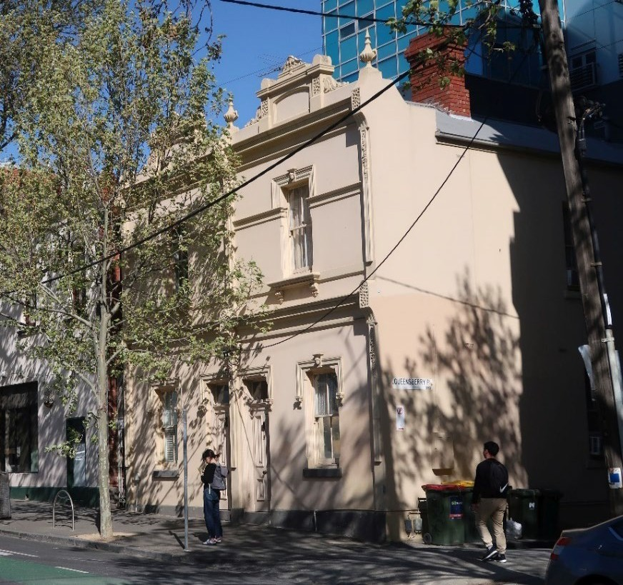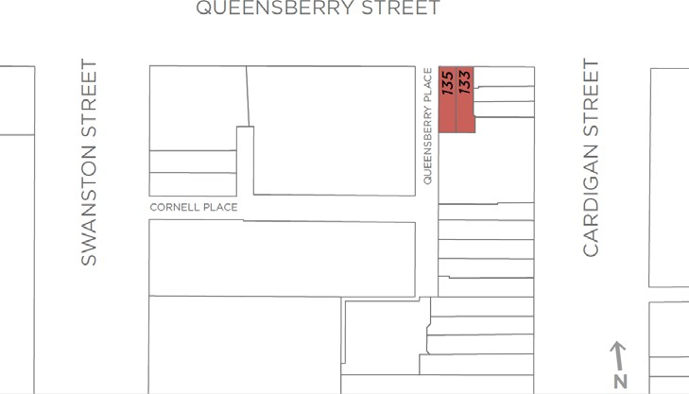

What is significant?
The two storey, rendered masonry semi-detached pair of dwellings at 133-135 Queensberry Street, Carlton constructed in 1902, is significant.
How is it significant?
The two storey, rendered masonry semi-detached pair of dwellings at 133-135 Queensberry Street, Carlton is of local historical significance, and of representative value.
Why is it significant?
The two storey semi-detached pair of dwellings at 133-135 Queensberry Street, Carlton, constructed in 1902 is of historical significance (Criterion A). While initially used as residences, and also as shops and dwellings, the premises have variously been used for commercial and residential purposes, although there is no evidence of shop-fronts ever having been constructed or introduced at ground floor level. The pair is part of a group of buildings, historically comprising two storey residences and shops, concentrated near the intersection of Cardigan and Queensberry streets, and constructed in stages between 1900 and 1904 by owner, Alice Mills. The subject pair, as with the broader group, replaced a suite of earlier and smaller timber buildings. This in turn followed a local pattern whereby the early rudimentary buildings of Carlton were replaced over time with more substantial masonry structures. The combination of residential and commercial uses within one building was also common, again emphasising an early and established local pattern.
The two storey semi-detached pair of dwellings at 133-135 Queensberry Street, Carlton, is also of representative value (Criterion D). As a building, the subject pair is directly associated with, and representative of, a housing type which originated in England in the late eighteenth century and grew in popularity in the next century. In Melbourne, architects, builders and developers often sought to produce less commodious variations on this English typology, and large numbers of semi-detached pairs survive in the inner suburbs.
Considered in the context of this development in Melbourne, 133-135 Queensberry Street stands as a later example of the semi-detached pair typology, but also as an unusual example in that it adopts a townhouse form with no verandah or front set back and entry directly from the street. The pair is distinguished by a high level of external intactness, and demonstrates a capable Italianate design. As it presents to the street, it is more or less unaltered from its original state apart from overpainting, and is notable for its reasonably lavish ornament to the rendered surfaces.
Primary source
Carlton Heritage Review (Lovell Chen, 2021)

