Statement of Significance: Pair of Dwellings, 554-556 Swanston Street (November, 2021)

Heritage Place: | 554-556 Swanston Street, Carlton | PS ref no: | HO113

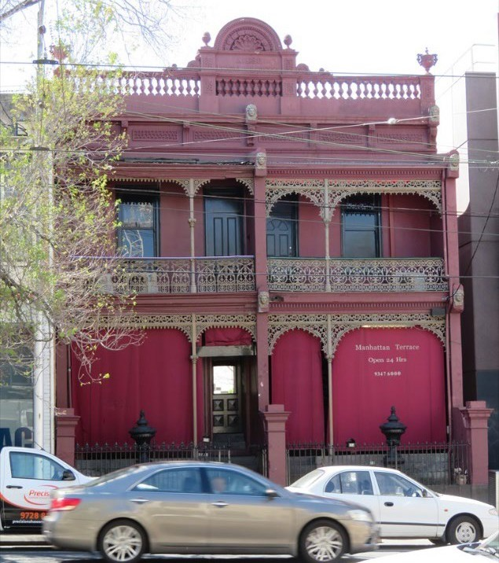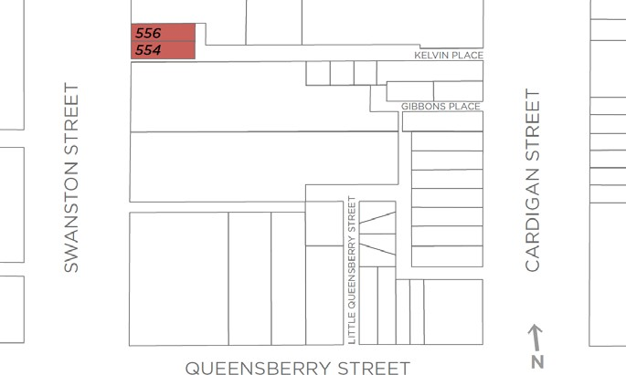

What is significant?
The semi-detached pair of rendered masonry houses at 554-556 Swanston Street, Carlton, constructed in 1883, is significant.

How is it significant?
The 1883 semi-detached pair of rendered masonry houses at 554-556 Swanston Street, Carlton, is of local historical and aesthetic significance.

Why is it significant?
The semi-detached pair of houses at 554-556 Swanston Street, Carlton, is of historical significance (Criterion A). The building was constructed in 1883 for Mrs A Mills, in the early period of the Boom in Melbourne. While now somewhat isolated from similar buildings, the pair still evoke the historic character of Carlton streetscapes of the nineteenth century. As a semi-detached pair, the building is directly associated with a housing type which originated in England in the late eighteenth century, and grew in popularity in the next century. In Melbourne, architects, builders and developers often sought to produce less commodious variations on this English typology, and large numbers of semi-detached pairs survive in the inner suburbs. The subject building is also associated with noted and prolific architect and builder, Norman Hitchcock, who was particularly busy in Melbourne’s inner northern suburbs during the 1880s.
The semi-detached pair of houses at 554-556 Swanston Street, is also of aesthetic significance (Criterion E). While a relatively straightforward, two-storey rendered masonry residential pair, with double-storey cast iron verandahs and elevated entrances behind original iron palisade fences on a bluestone plinth, the subject building gains additional interest for its rendered detail, being ‘trademarks’ of Hitchcock’s designs.
These details include mascarons at ground and first floor level to wing- and party-walls; the ornamented parapet with a balustraded form and a semi-circular pediment at its centre flanked by acorn devices; and wingwalls crowned by decorative urns.
Primary source
Carlton Heritage Review (November, 2021)

