Statement of Significance: Pair of Dwellings, 199-201 Cardigan Street, Carlton (November, 2021)

Heritage Place: | 199-201 Cardigan Street, Carlton | PS ref no: | HO32

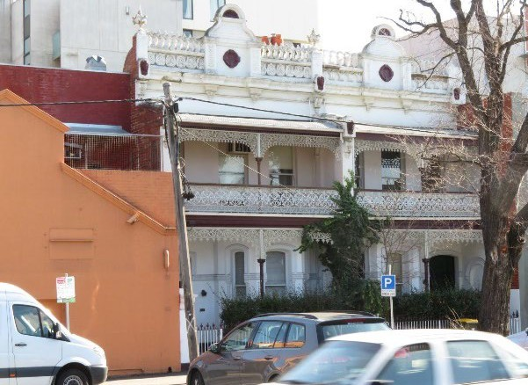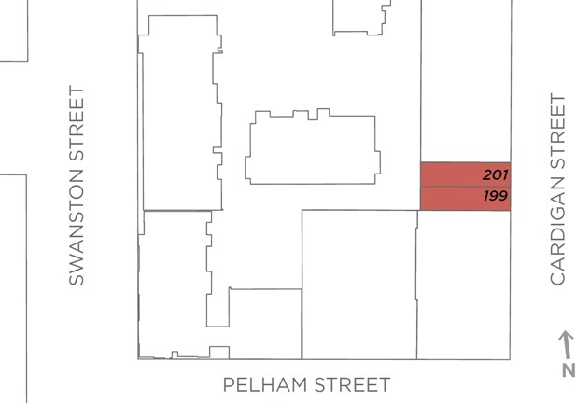

What is significant?
The two-storey, semi-detached pair of rendered brick dwellings at 199-201 Cardigan Street, Carlton, with no. 199 constructed in c. 1900-1901 and no. 201 in 1918-19, are significant.
How is it significant?
The two-storey, semi-detached pair of rendered brick dwellings at 199-201 Cardigan Street, Carlton, constructed in c. 1900-1901 and 1918-19 respectively, are of local historical and aesthetic significance.
Why is it significant?
The subject pair of two-storey brick dwellings, constructed in c. 1900-1901 and c. 1918-19 is of historical significance (Criterion A). When constructed, the dwellings were located in an area of Carlton characterised by mixed use development, which in turn was typical of parts of the suburb at the end of the nineteenth century. The owner and builder, Abraham Goldman, was apparently a local resident and businessman of some note, owning several properties including residences and light industrial buildings in Carlton in the first decades of the twentieth century, including the subject pair. He was also active in the growing Jewish community of Carlton, hosting a meeting of the ‘newly formed Zionist Society’ at his home in Cardigan Street, and being voted president of the society in 1902. As a building, the subject semi-detached pair is directly associated with a housing type which originated in England in the late eighteenth century, and grew in popularity in the next century. In Melbourne, architects, builders and developers often sought to produce less commodious variations on this English typology, and large numbers of semi-detached pairs survive in the inner suburbs.
The semi-detached pair of rendered brick dwellings at 199-201 Cardigan Street, Carlton, is also of aesthetic significance (Criterion E). While both dwellings adopt a reasonably straightforward double-storey and double height verandah between wing walls form, and retain somewhat elaborate cast iron balustrades and friezes, it is the rendered detailing which distinguishes the pair. Details of note are especially prevalent to the upper parts of the building and include tall central pediments to the parapets, flanked by pilasters rising to a hybrid pediment in which a swan’s neck (par enroulement) supports a more traditional semicircular pediment above; these are flanked by balustrades with idiosyncratic decorative panels with tablets, scrolls and small stilted arcades which terminate at either end in short columns surmounted by urns draped in swags; and female mascarons fixed to the wing walls and parapets. The varied detailing between the c. 1900-1901 and c. 1918- 19 construction programmes also adds interest and intrigue. Comparatively, as a semi-detached pair, the subject dwellings are unusual in the Carlton context, not least of all for the rendered detailing and the uncommon and possibly unique form and treatment of the parapets.
Primary source
Carlton Heritage Review (Lovell Chen, 2021)

