Statement of Significance: Pair of Shops and Residences, 508-512 Swanston Street, Carlton (November, 2021)

Heritage Place: | 508-512 Swanston Street, Carlton | PS ref no: | HO112

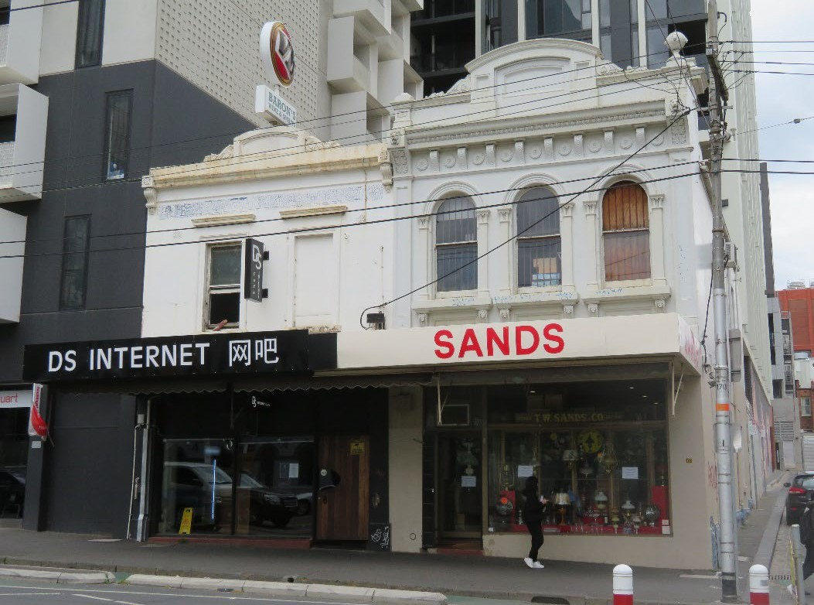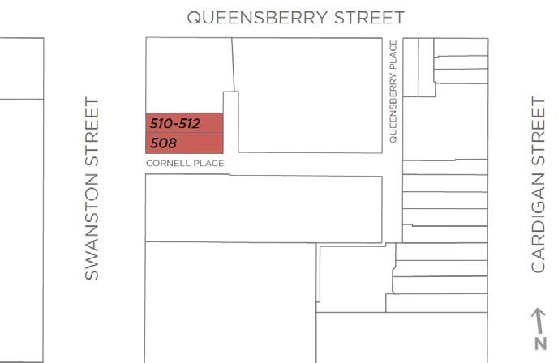

What is significant?
The two shops at 508 and 510-512 Swanston Street, Carlton, constructed in 1873-4, are significant.
How is it significant?
The shops at 508 and 510-512 Swanston Street, Carlton, are of historical and aesthetic significance, and of representative value.
Why is it significant?
The two shops at 508 and 510-512 Swanston Street, Carlton, are of historical significance (Criterion A). The shops were constructed in 1873-4 for different owners, and are significant surviving early commercial/retail buildings in this area of Swanston Street (formerly Madeline Street) in the southern part of Carlton. The subject section of street developed from the 1850s with small buildings, including timber and brick shops, with small timber houses and shanties to the rear. The construction of the subject more substantial masonry shops followed the introduction to Carlton in 1872 of tighter building regulations, with the extension of the Building Act to cover the suburb. The newer buildings tended to replace the earlier and more modest timber shops, with the current building at 508 Swanston Street being demonstrative of this historical pattern in that it replaced a much smaller three-roomed timber building. The survival of these buildings therefore informs an understanding of historic commercial development in Carlton, including to the main streets where they provide ongoing evidence of long-standing retail activity. The retention of the commercial/retail use for the shops’ 140 years of history is also of note, demonstrating the longevity and importance to the suburb, of these early historic land uses.
The two shops at 508 and 510-512 Swanston Street, Carlton, are of aesthetic significance (Criterion E). The building at 512 Swanston Street is finely detailed and relatively ornate at first floor level. Its Renaissance Revival elements include arch-headed windows with stylised Corinthian pilasters to reveals; wingwall pilasters extending above the verandah to parapet level; and upended classical consoles supporting the parapet cornice. By comparison, 508 Swanston Street is more simply detailed, but nonetheless consistent with its early 1870s date.
The two shops at 508 and 510-512 Swanston Street are also representative of the more substantial masonry shops with premises which were constructed in Carlton from the 1870s (Criterion D). They display the typical characteristics of many of these nineteenth century retail and commercial buildings in the suburb, being of two storeys, of rendered masonry, with no setbacks, and retaining intact first floor (and upper level) facades and parapets. The ground floor facades/shopfronts have been modified, and the original verandahs replaced by awnings, but again this is a commonplace outcome for these buildings.

Primary source
Carlton Heritage Review (Lovell Chen, 2021)

