Statement of Significance: Pair of Shops and Residences, 462-468 Swanston Street, Carlton (November, 2021)

Heritage Place: | 462-468 Swanston Street, Carlton | PS ref no: | HO111

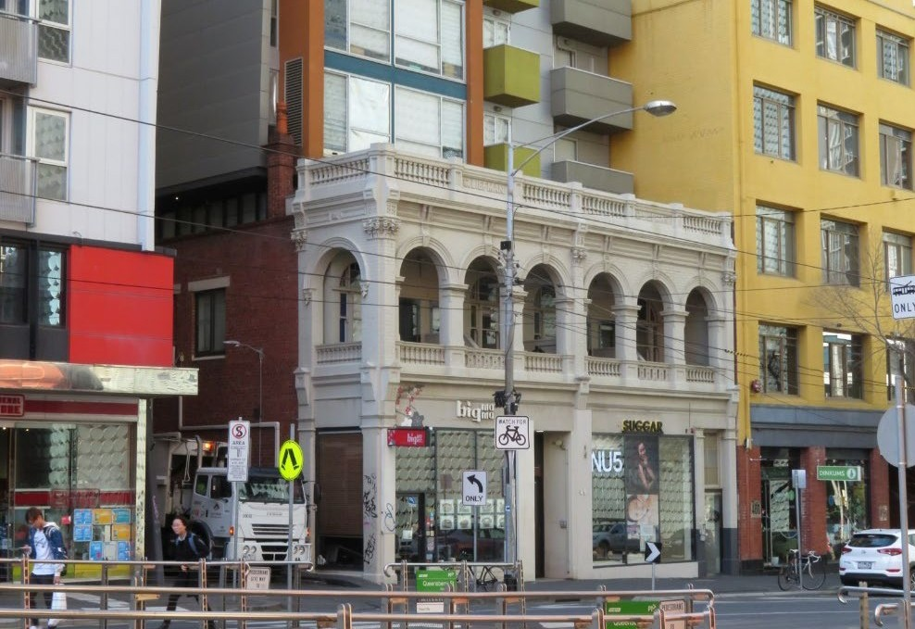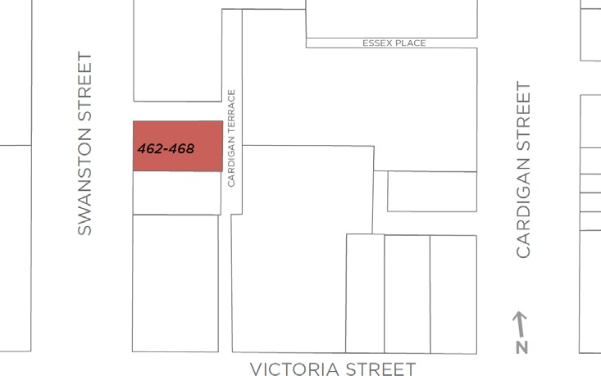

What is significant?
The two-storey, semi-detached pair of brick shops with dwellings above, constructed in two stages between 1899 and 1903, at 462-468 Swanston Street, Carlton is significant.
How is it significant?
The two-storey, semi-detached pair of brick shops with dwellings above, at 462 -468 Swanston Street, Carlton, is of local historical and aesthetic significance.
Why is it significant?
The subject pair of two-storey brick shops with dwellings above, constructed in two stages between 1899 and 1903, is of historical significance (Criterion A). The pair were built for Coleman Liefman, with the Liefman family remaining in possession of the property for some 30 years, and operating a drapery and furniture warehouse throughout. While retailing in Carlton is now concentrated around the high street shopping centre of Lygon Street and its crossroads, in the nineteenth century, smaller retail centres developed around the suburb including along the main north-south and east-west streets such as Madeline (now Swanston) Street. The subject shops are demonstrative of this local pattern of development. They also provide evidence of an early twentieth century drapery, albeit these businesses generally operated from smaller shops which were not necessarily purpose-built. The grand size of subject building is somewhat unusual in this context, indicative of the dual uses of the Liefman’s premises - drapery and furniture warehouse – and also of a level of ambition for, and confidence in, the business. The grand character of the shops carries through to the arcaded verandah to the residential component at first floor level. In addition, the substantial pair replaced earlier and smaller timber buildings, which followed another local pattern; as did the combination of residential and commercial uses within the one building.
The subject pair of two-storey brick shops with dwellings above, is also of aesthetic significance (Criterion E). While the (non-significant) modern development to the rear of the building is substantial and visible, the front portion, including the overall original form and detailing (save for the ground floor) retains its prominence and legibility. The building also demonstrably remains a building of some grandeur. The arcaded first floor is particularly distinguished, enhanced by elaborate Renaissance Revival details, arches with haunches and keystones expressed in render, brick pilasters rising to Corinthian capitals beneath a decorated cornice supported on rendered consoles, and capped parapets with rendered balustrades and incorporating the owner’s name, ‘Liefman’.
Primary source
Carlton Heritage Review (Lovell Chen, 2021)

