Statement of Significance: Residential Terrace Row, 676-682 Swanston Street, Carlton (November, 2021)

Heritage Place: | 676-682 Swanston Street, Carlton | PS ref no: | HO116

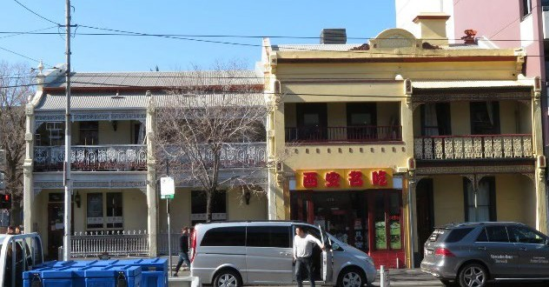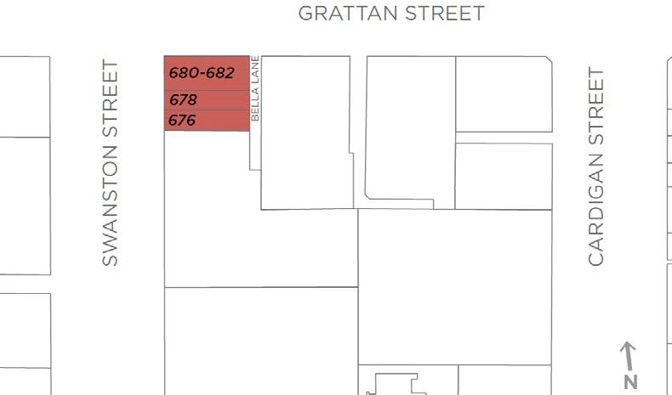

What is significant?
The two, semi-detached pairs of buildings at nos 676-678 and 680-682 Swanston Street, Carlton, constructed in c.1876 and c.1872 respectively, are significant.
Within this group:
- The pair at nos 676 Swanston Street and 678 Swanston Street is contributory.
- The pair at nos 680-682 Swanston Street is contributory.
How is it significant?
The two, semi-detached pairs of buildings at nos 676-678 and 680-682 Swanston Street, Carlton, constructed in c.1876 and c.1872, are of local historical and aesthetic significance.
Why is it significant?
The buildings at 676-678 and 680-682 Swanston Street, Carlton, constructed in c.1876 and c.1872 respectively, being semi-detached pairs, are of historical significance (Criterion A). Stonemason Richard Bool was the owner of the earlier pair at 680 and 682 Swanston Street, and the builder of the later pair at 676 and 678 Swanston Street, for owner, Charles Roy. Their construction in the 1870s is demonstrative of this phase of development, including semi-detached pairs, in the suburb in the pre-Boom era; and their survival informs an understanding of early Carlton and the development of the terrace type as a response to the pressure for accommodation in Melbourne on the fringe of the city. The buildings’ gradual conversion to commercial use from the late 1930s is not uncommon for early residences in this part of Carlton, and reflective of changing land uses in this area in the twentieth century.
The semi-detached pairs are also of aesthetic significance (Criterion E). While the earlier building at 680-682 Swanston Street has been altered, it retains its overall original form and Italianate details such as double height verandahs set between wingwalls, with original cast iron lacework friezes and brackets at each level; and decorative detailing such as elaborate pilasters to wingwalls and urns and acorns to gable ends. The simple gabled presentation to Grattan Street, as evident in historical images, also survives although extended. The later pair at 676-678 Swanston Street also retain double-height verandahs set between wingwalls and is distinguished from 680-682 Swanston Street by the prominent shared parapet with central circular pediment flanked by scrolls. Of the pair, no 676 survives largely intact to its early state with original wrought iron and timber elements to the verandah, and original door and window joinery at ground and first floor levels including unusual rendered architraves to openings. Both pairs also retain sufficient of their early character and role within the street to evoke a time when terrace rows proliferated through Melbourne’s inner north and the terrace row was a distinctive vernacular building type across suburban Melbourne.

Primary source
Carlton Heritage Review (Lovell Chen, 2021)

