Statement of Significance: Residential Terrace Row, 101-111 Cardigan Street, Carlton (November, 2021)

Heritage Place: | 101-111 Cardigan Street, Carlton | PS ref no: | HO30

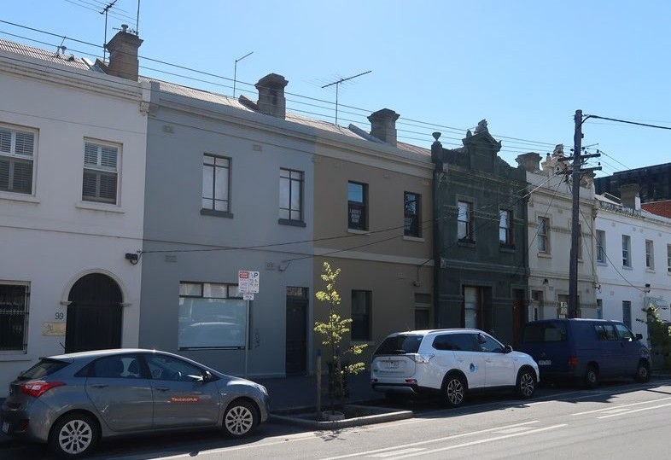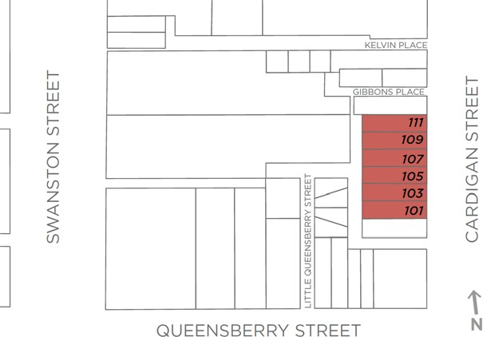

What is significant?
The terrace row of six attached, two-storey Victorian dwellings at 101-111 Cardigan Street, Carlton, which dates from 1857-8, with 1890s works, is significant.
How is it significant?
The terrace row at 101-111 Cardigan Street, Carlton, is of local historical (including rarity) and aesthetic significance.
Why is it significant?
The terrace row at 101-111 Cardigan Street, Carlton, built in stages in 1857-8 for owner, Patrick Costello, and later remodelled, is of historical significance (Criterion A) The row is associated with Costello who, after arriving from Ireland in 1841, had a colourful career in nineteenth century Melbourne being, respectively, a building contractor, hotel licensee, property developer, Melbourne City councillor, member of the Victorian Legislative Assembly, convicted criminal, bankrupt, and recovering in the late century to become a North Melbourne City Councillor. His great-great grandson is former Federal treasurer, Peter Costello. The terrace row is also significant for demonstrating the translation to Melbourne of the traditional ‘two-up/two-down’ terrace, as introduced to London in the 1630s and becoming a trademark of Georgian architecture through the eighteenth century. The row’s construction in the 1850s is additionally associated with the very earliest phase of development in Carlton and is a rare remnant of the early terrace type which developed in response to the pressure for accommodation on the fringe of the city (Criterion B). That pressure was particularly strong in 1850s Melbourne, with a booming Gold Rush population.
The terrace row is also of aesthetic significance (Criterion E). While originally constructed of face brick with rendered detailing, and austere Georgian facades to Cardigan Street with simple punched openings for doors and windows, a remodelling of the group in the 1890s transformed its appearance, particularly that of the central pair. This included rendering over the entire group and, unusually and rarely, altering the two central dwellings to present as a more elaborately detailed Renaissance Revival centrepiece to the Georgian row.
The terrace survives in a state of high integrity to its c. 1890s state but continues, also, to illustrate its very early origins. The southern and northern ends of the row still demonstrate an architectural expression which disappeared during the 1880s Boom. Conversely, the remodelled facades of the central pair illustrate the changes in architectural thought and fashion occurring through the 1880s. Consequently, the terrace row survives as an unusual but instructive group. It informs both an understanding of the development of this area of Carlton in the 1850s, while also illustrating the rapidly evolving tastes of late Victorian Melbourne.
Primary source
Carlton Heritage Review (Lovell Chen. 2021)

