Statement of Significance: Royal Terrace, 272-278 Faraday Street, Carlton (November, 2021)

Heritage Place: | Royal Terrace | PS ref no: | HO56

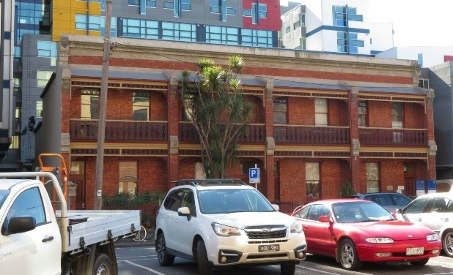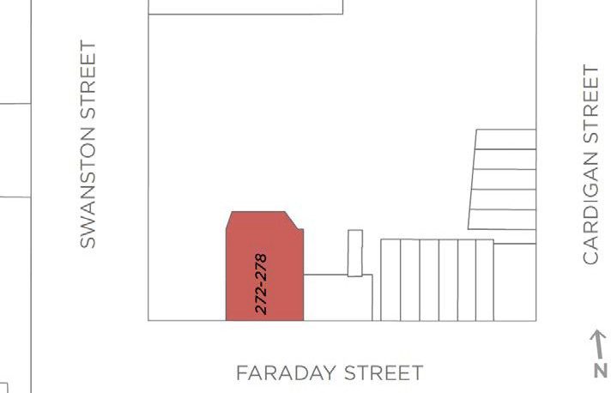

What is significant?
Royal Terrace at 272-278 Faraday Street, Carlton, comprising a row of four, two-storey dwellings constructed in 1875, is significant.
How is it significant?
Royal Terrace at 272-278 Faraday Street, Carlton, is of local historical and aesthetic significance.
Why is it significant?
The brick terrace row at 272-278 Faraday Street is of historical significance (Criterion A). The row was constructed in 1875 for owners Gledhill & Co, estate agents, and represented a terrace row development on a somewhat grander scale. The naming of the row as Royal Terrace, and their description in 1876 as seven roomed brick houses emphasises this, as does their prominent form and parapets, and presentation to Faraday Street. Historically, their mid-1870s date also places them within the period of development which is still comparatively early in Carlton, and they remain as significant evidence of nineteenth century residential development in this western section of Faraday Street.
The brick terrace row at 272-278 Faraday Street is also of aesthetic significance (Criterion E). While the works undertaken in 1976 diminished this significance to some extent, the buildings still demonstrably form a row of somewhat grander terraces. The uniform appearance, reinforced through the long-term single (University) ownership, is also of some note and enhances this aspect of significance. The early appearance of the group remains legible, and the former dwellings continue to evoke the character created when streetscapes of terrace rows proliferated through Melbourne’s inner north, and the terrace row became a distinctive vernacular building type.
Primary source
Carlton Heritage Review (Lovell Chen, 2021)

