Statement of Significance: Shops and Residences, 83-87 Cardigan Street, Carlton (November, 2021)

Heritage Place: | 83-87 Cardigan Street, Carlton | PS ref no: | HO29

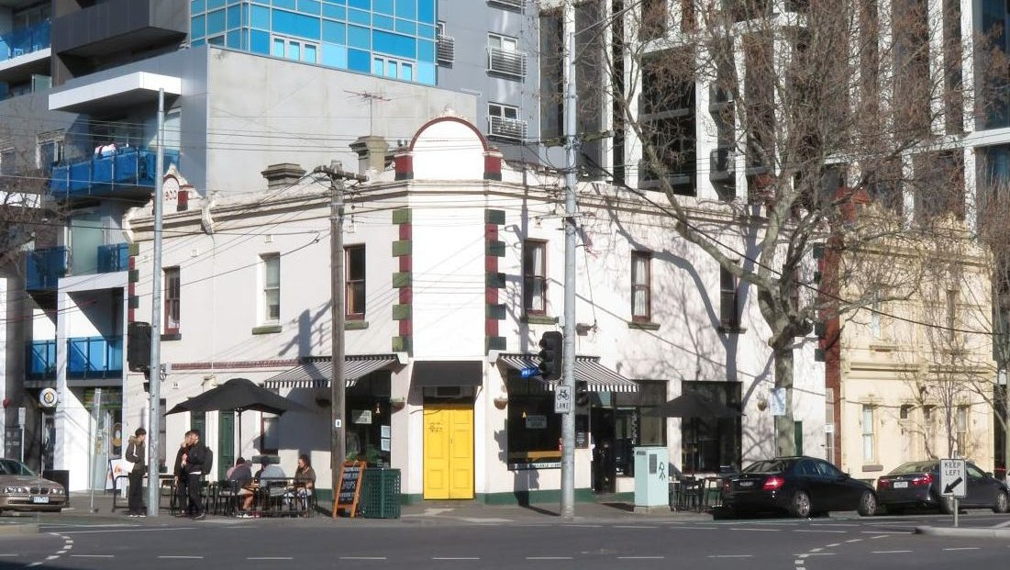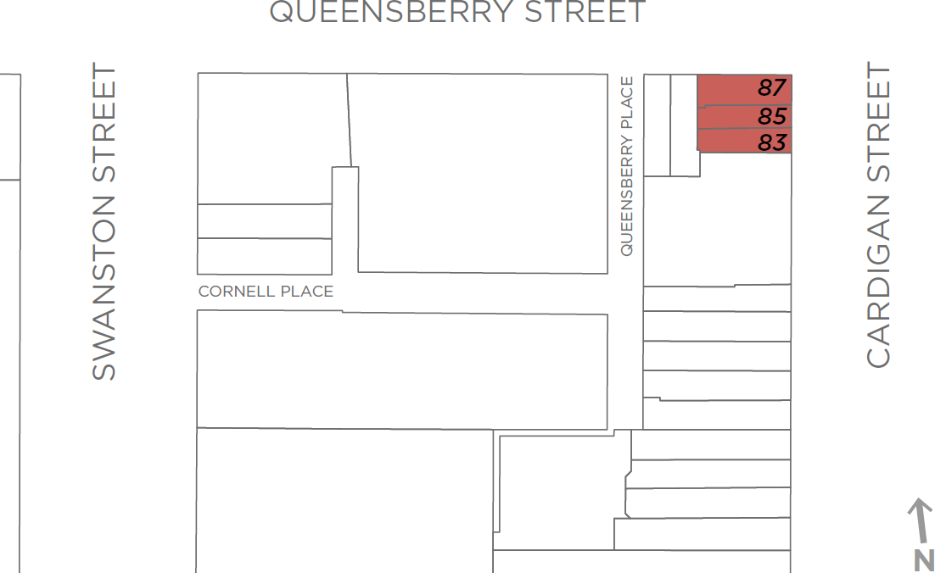

What is significant?
The shops and residences at 83-87 Cardigan Street, Carlton, built in stages in the early 1900s, are significant.
How is it significant?
The shops and residences at 83-87 Cardigan Street, Carlton, built in stages in the early 1900s, are of local historical and aesthetic significance.
Why is it significant?
The shops and residences at 83-87 Cardigan Street, Carlton, are of historical significance (Criterion A). The group of buildings, historically comprising residences and shops concentrated to the intersection of Cardigan and Queensberry streets, was constructed in stages between 1900 and 1904 by Alice Mills. The group replaced a suite of earlier and smaller timber buildings, following a local pattern whereby the early rudimentary buildings of Carlton were replaced over time with more substantial masonry structures. The incorporation of residences into the commercial/retail buildings was also common, again emphasising an early and established local pattern. Notably, this combination of residential and commercial uses has continued within the group through to the present. The location of the group, at the corner of Cardigan and Queensberry streets, is also reflective of the historical situation whereby a number of smaller retail centres developed around Carlton in the nineteenth century, and were not just concentrated in Lygon Street and its crossroads. This was typical of nineteenth century urban development, with small collections of shops servicing their immediate areas.
The rendered masonry shops and residences at 83-87 Cardigan Street, Carlton, are also of aesthetic significance (Criterion E). Architecturally, the group has a simple form and expression, and limited detailing, drawing inspiration from simple buildings constructed before the Boom of the 1880s. Nevertheless, the staged construction achieved a consistent style and a high degree of visual uniformity, with the buildings reading as a coherent group with a ‘completed’ appearance. Of interest is the central semi-circular pediment incorporating the ‘1900’ construction date for the earliest building in the group, at no. 83 Cardigan Street. The slightly later corner building repeated the semi-circular pediment device, although no date in raised lettering survives, if in fact it was included. The group is also noted for its approach to the prominent corner location, with the splayed entrance another element of the design which harked back to earlier times in Carlton.
Primary source
Carlton Heritage Review (Lovell Chen, 2021)

