Statement of Significance: George’s Terrace (Clare House) Terrace Row, 51-71 Cardigan Street, Carlton (November, 2021)

Heritage Place: | George’s Terrace (Clare House) | PS ref no: | HO27

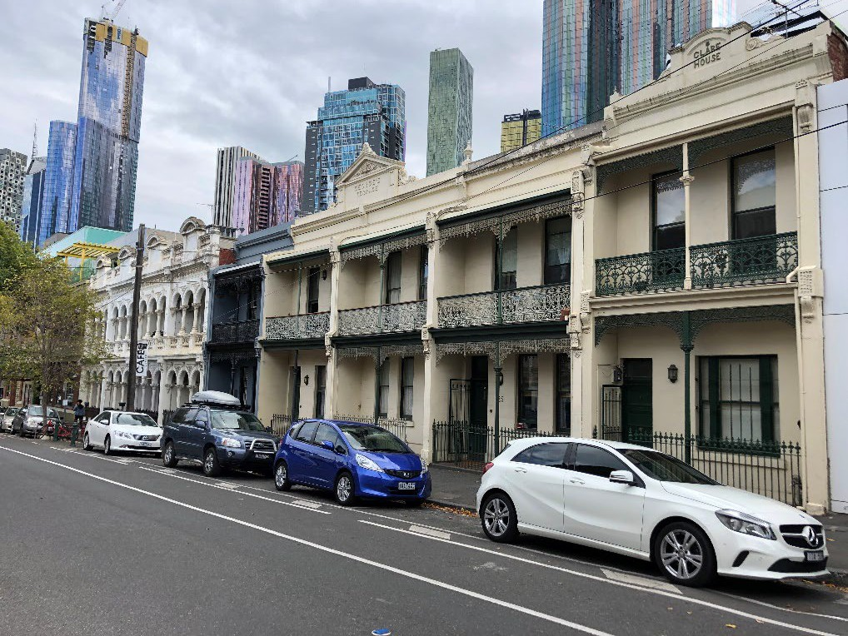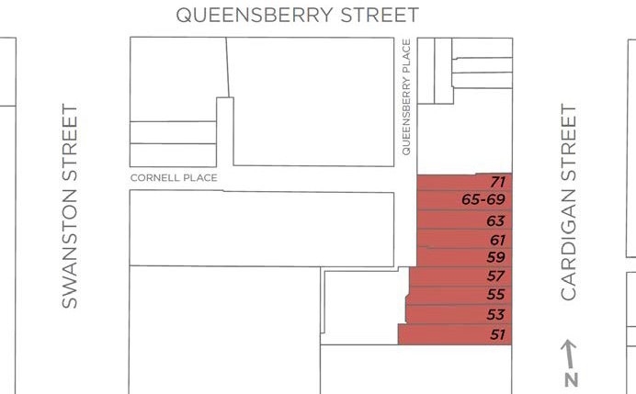

What is significant?
The terrace rows and dwellings at nos 51-57 Cardigan Street and nos 59-65 Cardigan Street (George’s Terrace),and Clare House at no. 71 Cardigan Street, Carlton, constructed between the mid-1880s and early 1900s, are significant.
How is it significant?
The terrace rows at nos 51-57 Cardigan Street and nos 59-65 Cardigan Street (George’s Terrace), and Clare House at no. 71 Cardigan Street, Carlton, are of local historical and aesthetic significance.

Why is it significant?
The terrace rows, dwellings and house at 51-71 Cardigan Street, Carlton, are of historical significance (Criterion A). The buildings were variously constructed in the mid-1880s through to the early 1900s. As such they demonstrate aspects of terrace house and residential development in Carlton from the affluent Boom period, through the more subdued 1890s and into the early twentieth century. They also speak to the ongoing popularity of the suburb in this historic period, and its continued development and evolution. The earliest of the buildings is the 1886 Clare House, built for owner James Coughlin; it is also the only building of the group to be constructed before the mid-1890s. This lapse in localised building activity is demonstrative of a wider economic downturn which affected Melbourne, and indeed Victoria, in the early 1890s and following the heady 1880s Boom. The four terrace houses at 51-57 Cardigan Street were built in two stages, with a single dwelling at no. 51 completed in 1897-98 and the three additional terraces in 1900. Again, within this historic row, the stop-start building activity of the 1890s is writ large. The last to be built in 1906 was George’s Terrace at 59-65 Cardigan Street, for George and Robert Ievers, sons of local identity, real estate agent and City of Melbourne councillor William Ievers. George was also a prominent local, who too became a Melbourne City Councillor.
The terrace rows, dwellings and house at 51-71 Cardigan Street, Carlton, are also of aesthetic significance (Criterion E). The group is unusual within the study area in comprising two rows of substantially externally intact terrace housing and a single detached dwelling which are buildings of individual note, illustrate the architectural variety of historic Carlton and collectively form a substantially intact remnant streetscape, with a strong and complementary streetscape presence. The dwellings variously retain Italianate detailing; prominent parapets with pediments; cast iron verandahs and lacework; a double-arcaded composition supported by elaborate decoration; and original iron palisade fences, all of which are representative of developments of this type. The dwellings are also distinguished by their intactness and integrity to their original states. While somewhat isolated from similar buildings, they nevertheless evoke the character created when streetscapes of terrace rows proliferated through Melbourne’s inner north and the terrace row became a distinctive vernacular building type across suburban Melbourne.
Primary source
Carlton Heritage Review (Lovell Chen, 2021)

