Hawke Street Linear Park
Community and Business Consultation Report
3
18 February 2022

report

Community
The term community refers to a group of people that has something in common such as identity, behaviours, interests or values. A community often share a sense of place in a given geographical area (e.g. a country, city, town, or neighbourhood) or in virtual space through communication platforms.

Stakeholder
The word stakeholder refers to individuals, groups or organisations with a stake or interest in the outcome of a decision. Stakeholders may also have the ability to influence the decision given their role or position.

Engagement
Engagement is defined as a planned process with the purpose of working with communities and stakeholders to inform decisions, share knowledge and strengthen relationships.

About Capire Consulting Group
Capire is a specialist community engagement company. We design and deliver tailored engagement strategies to build understanding, create local ownership and to inform sustainable decision making.
We use a lens of diversity, inclusion and accessibility to maximise social benefit on all our projects. Our team are skilled listeners, communicators, researchers, facilitators and problem solvers.

1 Background 1
1.1 Community Engagement on the Concept Plan 1
2 Community Workshop 3
3 Survey 4
4 Focus Groups and Interviews 4
Hawke Street Businesses 4
Residential Engagement 5
5 Results 5
Community Workshop 5
Survey 5
Focus Group and Interview - Business Owners 9
Focus Group Meeting - Residents 10
6 Key findings and observations 11
7 Recommendations 13
Appendices 15
Appendix A: List of questions and comments raised by attendees of the workshop 15
Appendix B: Graffiti Map 17
Appendix C: Comments on Graffiti Map 18
Appendix D: Aspirational cross-section diagram for residents between King and Spencer Streets 22

- Background
City of Melbourne is proposing to enhance the quality and function of public space in Hawke Street, West Melbourne.
Hawke Street is a wide paved road that runs between Railway Place and Victoria Street. It has two small parks with a substantial amount of parallel and median-strip parking along its length. It is home to a diverse mix of Victorian terrace houses, converted warehouse apartments, and a handful of large shopfronts. Notable landmarks include the McMahons Hotel, West Melbourne Baptist Community Centre and The Miami Hotel.
The area is transitioning from a commercial precinct to a mixed-use neighbourhood, with a rapidly growing population. With this change, comes an opportunity to redefine the street’s character as a linear boulevard of trees, green landscaping, and shared paths.
Initial online community consultation took place from 26 March to 25 April 2021 involving an online website and a survey, reaching at least 8000 people. City of Melbourne put forward the idea of a new linear park with traffic and parking changes.
The preliminary concept plan was supported by 73 per cent of survey respondents. There was positive response from community about increase in open green space and improvement to pedestrian and cycling connections. A small number of responses reported deep dissatisfaction with the reduction of local car parking space along Hawke Street. The reduction of car parking was noted to have a large impact on residents and businesses already struggling to park near their home or office.
Throughout December 2021 and February 2022, the City of Melbourne invited Capire Consulting Group to plan and facilitate a community workshop at the Apollo Café. Capire was also tasked with analysing an additional community survey and hosting a series of focus group meetings with residents and business owners. The purpose of this phase of engagement was to gather feedback on the concept design for the linear park from those highly impacted by the plan during the initial consultation phase.

  - Community Engagement on the Concept Plan
The City of Melbourne wanted to find out from residents and local community:
- How they think the park space will be used
- What design features, treatments and placements would they like to see access/restrictions
- Where further consultation is needed.
- What opportunities are there to amend parking conditions in the area.
The outcome of this consultation sought to understand any residual community concerns and identify areas to improve the design before the development stage begins.
Feedback was gathered from the community through these methods:
- Community workshop (8 December 2021)
- Online Survey (throughout the project)
- Business and resident focus groups and interviews

In total, 37 participants attended the Community Workshop. There were also 24 responses to the online survey. Six representatives from Hawke Street businesses, and seven residents attended the business and resident focus groups. A further two businesses were interviewed separately.

- Community Workshop
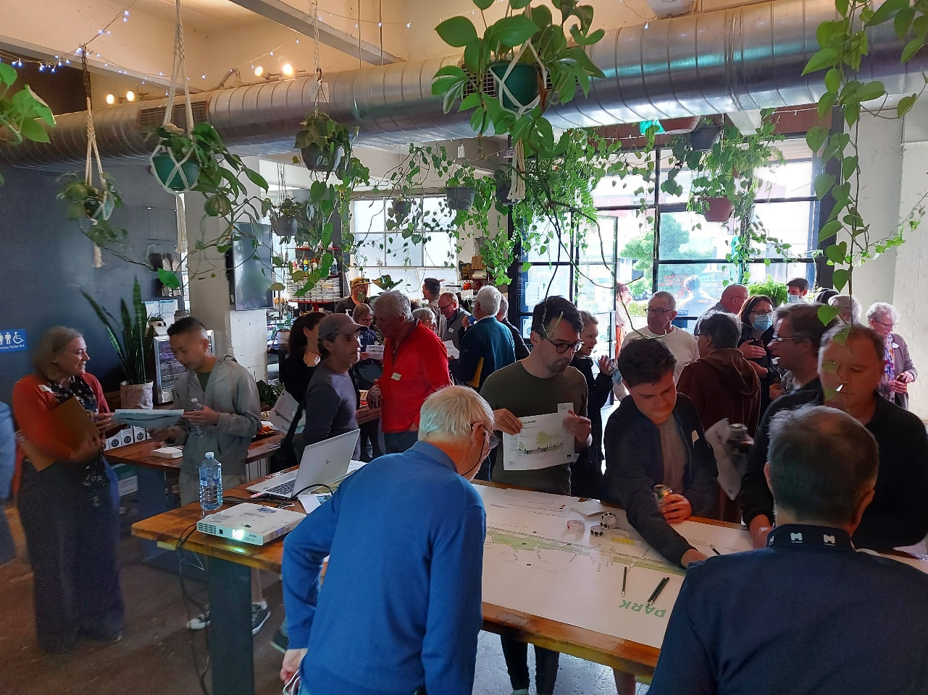
The community workshop was hosted on Wednesday 8 December 2021 and incorporated several activity stations set up throughout the Apollo Café space. This layout allowed people to arrive at their own convenience, explore the linear park plan, talk to people at the City of Melbourne and familiarize themselves with the project. During the workshop a presentation and question/answer session was facilitated.

The activities of the Open House included:
“Graffiti Map” - Interacting with concept design and exploring options
People were asked to comment/draw on printout of concept design and mark their contribution with one of three traffic light-colored sticky dots.
“Ask an expert” - Asking experts questions
A space for people to engage directly with subject matter experts from the City of Melbourne across a range of key topics
- Traffic and Parking issues
- Streetscape Design
- West Melbourne Structure Plan
- Consultation process and feedback to date
“Report back” - Understanding what has changed and what hasn’t
During the workshop, City of Melbourne presented an overview of the project and key changes made to the concept based on previous consultation. About an hour was allowed for people to ask questions and make comments about issues important to them.
“Case the place” - Walking around the proposed area of change and exploring options
Once the event formally concluded, people were invited to walk along a segment of Hawke Street with maps and experts to discuss various details, treatments and forms articulated
in the plan.
- Survey
A survey was created to gather sentiments on multiple aspects of the Hawke Street Linear Park project. This included whether people liked the:
- Roundabout at Adderley Street to stay, and upgrades made to make the flow at this intersection safer
- Introduction of separate protected bike lanes on both sides of the road
- Realignment of the kerb to better define the pedestrian area, and a slightly narrower footpath to allow for a greater expanse of greenery
- Careful location of on-road parking bays and tree plots to ensure clear sight lines when passing or turning out of driveways and laneways
- Retaining of 102 kerbside bays for parallel parking, and prioritisation for local residents and businesses with new signage and allocation
- Creation of new bike lanes between King Street and Errol Street that connect with Victoria Street, by narrowing the median strip and number of lanes.
- Kerb and layout upgrade of the Spencer Street and King Street intersections, plus a review of traffic light signals to make it safer and more convenient to cross over.
- Expansion and upgrade of Hawke & Curzon Street Reserve, and connection to Hawke and Adderley Park with a boulevard of canopy trees and understory planting down the length of Hawke Street.
Respondents were also asked how they would like to see the new and upgraded parkland used.
- Focus Groups and Interviews

Hawke Street Businesses
To gather feedback from businesses that would be impacted by the project, a small meeting was held with business owners to understand their concerns. This meeting also explored opportunities to improve the design of the linear park. The meeting was attended by four businesses:
- McMahons Hotel
- Tricycle Developments
- Miami Hotel
- Radio Parts
Two more Hawke Street business owners were also interviewed separately:
- Apollo Café
- Butcher Shop Café

Business owners highlighted some key issues around the linear park project. They were concerned about the impacts of parking reductions on their businesses, as well dangerous interactions between cyclists and heavy goods vehicles with the new bicycle lanes. The narrowing of the street would also obstruct goods vehicles from entering and leaving their premises. Furthermore, they sought clarification on how the scheme is to be constructed and explained how disruptions during construction could affect their business.

Residential Engagement
In recognition of the likely significant impact of residents located in the group of heritage terraces between King and Spencer Street on the North-east side of Hawke Street, a small meeting was held. The purpose of the meeting was to discuss design options that might ameliorate several specific issues.

Residents were especially concerned about the traffic speed entering Hawke Street from Victoria Street, as well as the dust, noise, and vibration impacts of traffic on their side of Hawke Street. They were also concerned about tree loss on their street as well as glare from the sun and energy-efficient streetlights. They described an unresolved ground water issue in the area, and also, highlighted concerns about construction impacts on their street.

- Results

Community Workshop
Attached to this report is a list of questions and comments raised during the “Report Back” activity of the community workshop. This can be found in Appendix A. In addition, community feedback from the Graffiti Map is noted and attached in Appendix B.

Survey
24 survey responses were received. Results of the survey are presented.

How do you rate these street modifications?

Figure 1 Graph illustrating how residents rated different street modifications

Results show most residents are satisfied with the street modifications proposed. The highest approval was given to the introduction of separate protected bike lanes on both sides of the road – 86% of residents liked this change. There is a higher number of residents who were not so sure about the retention of 102 kerb side parking bays for parallel parking. While 62% liked that street modification, 17% of residents were not sure about the street modification. 10% of residents either did not like the change or thought that the changes could be made better.

Why did you rate this way?
Figure 2 Themes of comments that describe why residents rated different street modifications

When residents were asked about why they rated these street improvements the way they did, a strong majority (58.6%) of residents highlighted issues surrounding parking and transport. Multiple residents were concerned about parking. Some wanted less car parking in the area to create more green space, while others were concerned about not being able to park their cars due to reduced car parking. There were also concerns about safe bicycle lane design.

“My concern is congestion and parking. I love the idea of green space but am cautious that I won’t be able to park at my house. I am also concerned as I have a townhouse and am not allocated a permit that I’ll be unable to park at all.”

“They are all good improvements to the space, although with only 57 residential parking permits in that area, I would have liked to have seen more parking removed to further disincentivise the usage of cars in the inner city.”

“I prefer round-abouts, and bike paths that reflect the flow direction of the traffic. wholly separate bike paths to not integrate well for cyclist as they go on to travel on the rest of the on-street paths and roads. less parking spaces and more green.”

20% of responses were focused on the urban realm, with residents asking for specific improvements such as picnic and dog park spaces, community gardens and preservation of the elm tree at Hawke/Miller Street Reserve. 10% highlighted sustainability issues and opportunities, such as the use of passive irrigation for the linear park and the need for greenery for the southern side of Hawke Street.

“Opportunity to take advantage of passive watering from storm water on the section between Railway and Adderley; please bury the power lines between Adderley & Spencer to support large canopy trees; bin collection between Adderley & Spencer is a conflict.”

“In general, I strongly support the plan’s core benefits of creating more greenery, reducing traffic, improving community feel and quality of life, encouraging active transport and prioritising people rather than cars.”

How would you like to see the new and upgraded parkland used?

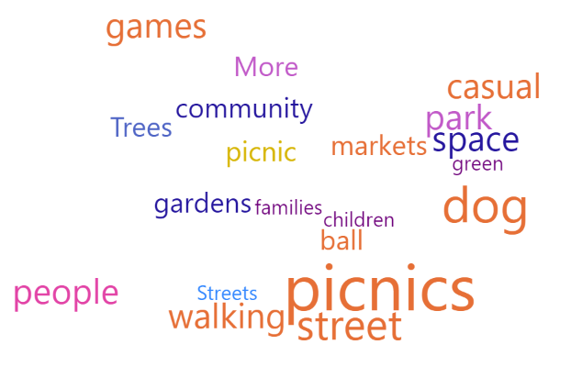
Figure 3 Word cloud illustrating commonly used words in the survey

Eight responses in the survey indicated that they would love to see picnics in the new and upgraded parkland. Dog walking (and dog-related issues) were also mentioned six times in survey responses. Community gardens, playgrounds and markets were also noted, to a lesser extent, as possible uses for the parkland area. Some residents were indicating that more greenery is needed for sound isolation, and to help make the urban realm interesting.

"The park at the south-western end of the street (I forget the name) is heavily used by families and kids, so enhancing that use-case would be good. The part at the top of the street is difficult to use for much as its really just a patch of grass and a big tree, it's pretty boring and doesn't provide any sound-isolation from the noisy road. If large plants could be added to provide some sound isolation and more seating added, I suspect it would be heavily used by people who work in the area."
“Lots of dogs in the Area so dog poo bags in the park would be great. Local markets would be amazing however of course fears about parking. More picnic tables and park games would be great. Community gardens or plots on the medium strips would be nice.”

Focus Group and Interview - Business Owners
Loading, unloading and freight movements
Business owners are concerned that the implementation of bicycle lanes between parking/loading zones, the kerb, and the reduction of four traffic lanes to two creates inherent conflict with loading and unloading areas adjacent to their businesses. Feedback includes specific concerns about:

- risking safety of school aged children being hit by oncoming cyclists as they alight or board buses/taxis at The Miami Hotel
- impeding deliveries at The Miami Hotel, Radio Parts and McMahons Hotel
- limiting access of large shipping containers to Radio Parts.

Both Butcher Shop and Apollo Cafes noted that they need loading zones for their deliveries:
- as with the other smaller businesses in the area, they utilize smaller vans to supply their businesses with goods.
- Butcher Shop Café reports that their delivery drivers normally find any parking spot available in the area and uses trollies to get goods to their shop. They prefer if there is a 15-minute loading zone for their shop.

From a broader context, some businesses expressed concern about how freight going through the area would be redirected to other alternative routes. If freight fails to be redirected to King Street, rat-running through Hawke Street will continue.

Parking and Transport
Tricycle Developments, located on the Western end of Hawke Street, expressed concern about the removal of the median strip car parking in the area. They describe the “happy equilibrium” that exists in the area, between residents and businesses sharing the 4P parking in the area without intruding into each other’s space. The loss of parking resulting from the removal of the median strip means this equilibrium is disrupted.

Radio Parts indicated that they did an informal study around their premises and found approximately 400 cars enter their car park daily. Some of these cars use the car park and Jones Place to jump the traffic lights on Spencer Street. There are also users who are not shopping at Radio Parts that tend to park illegally.

McMahon’s Hotel sees that the ¼P parking in front of its premises is crucial for its business. Parking on Spencer Street is unsafe and could affect deliveries to its premises.

Butcher Shop Café and Apollo Café, while very supportive of the Linear Park proposal note that the reduction of parking would affect their businesses. This is attributed to people not being able to park their cars and come into the cafés.

Butcher Shop Café also sees that the park would also invite more customers into her shop
Apollo Café says that parking pressure has been increasing in the area as the businesses in the area (as well as the general population of the area) are growing. For example, a neighboring business will have 950 staff on site.

Open Space
As most of the businesses are located on the South side of Hawke Street, there was discussion regarding the width of pavement areas and role of “parklets” (street dining) into the future. Across the hospitality businesses there was interest in the availability of outdoor dining options on the Southside of Hawke Street pavement as well as within the linear park itself.

Construction
Businesses were worried about the impact of construction will have on their bottom line, especially following a difficult commercial period during the Covid-19 pandemic. Businesses expect disruptions to occur throughout construction and wanted to understand the level and duration of these disruptions.

The Butcher Shop Café has heightened concerns that if pedestrian and car travel is prevented from accessing the North side of Hawke Street during construction, would significantly impact their ability to operate a business.

Focus Group Meeting - Residents
Open space and greenery
Residents were concerned about tree removals during the construction of the linear park – “losing the green oasis”. The trees currently help reduce traffic noise and provide some buffering of impact of traffic.

Residents emphasized the need for deciduous trees to shade sunlight during summer and allow sunlight during winter. This is based on concerns about the heritage terraces on the south side of the street not receiving enough greenery for solar attenuation.

Residents also noted the current new energy-saving streetlights are too bright. Light strays into bedrooms, which is disruptive to sleep.

A concern emphasized by multiple residents was the presence of a constant stream of water flowing down the kerb edge of Hawke Street, adjacent to the Miami Hotel. It is believed that this is a water leak originating from outside the Hawke Street area. This water leak accumulates behind the footpath in this area. It has inundated telecommunication pits and can cause tree roots to intrude into properties even during droughts.

Transport
Residents were concerned about the speed of traffic travelling into the area from Victoria Street. They describe the speed of traffic on Victoria Street as a “slingshot” that funnels into Hawke Street over King Street. This issue is prevalent all day but is worse at night when traffic volumes are lower.

Residents noted that traffic was on their side of the street (South side). This is a departure from the West Melbourne Structure Plan. Residents are concerned about the traffic noise, dust and vibration brought on by traffic on their side of the street. This is compounded by rat-running through the street and the presence of construction vehicles brought on by development on the western side of the street.

Construction
Residents were concerned about construction impacts on the local neighborhood. They would like to see construction that reduces the duration to set up the linear park, dust and noise generation.

- Key findings and observations
The community at large is broadly supportive of the project. Participants of the consultation were also very appreciative of the effort the City of Melbourne went to, to host a workshops and meetings to hear their views.
Capire notes a sense of satisfaction with the consultation process. Several participants commented that they felt heard, and their feedback understood and valued. However, throughout the consultation process several key concerns were raised which people would like addressed.
Reduction of Car Parking
The reduction of car parking was first and foremost the dominant issue raised in the concept design for Hawke Street. There were several specific aspects to this issue raised. These include:
- The lack of residential and business on-street car parking is a significant issue for locals
- Residents are calling for more efficient distribution of access to car parking to cater for local needs first
- Residents of new developments said that they were not eligible for resident parking permits and relied on on-street parking
- Small business owners advised that they needed parking for their visitors and workers
- Residents advised that it was impossible to get a parking spot on the weekends
- The Hawke Street area needed more parking enforcement
- Concerns raised new developments were not required to provide adequate on-site parking which has exacerbated the problems
- Concerns raised about the number of parking bays taken over by construction zones and construction workers
- Opportunities raised to increase parking along Spencer and King Street
From a business owner perspective, there was a specific request that the parking study consider the needs of loading and unloading of goods, the bus/taxi loading areas, construction, and freight movements that supply the businesses in the area. They would also like to have discussions with a parking expert at the City of Melbourne about parking issues in the area.
Two specific businesses, Miami Hotel and Radio Parts, would require further engagement about their specific delivery and parking circumstances. These include maintaining the bus parking space and drop-off parking spaces in front of The Miami Hotel and reducing the number of illegal parkers and rat-runners through the Radio Parts carpark.

Another business owner asked for the parking spaces between Adderley Street and Railway Place to be maintained. These parking spaces should only be available to permit holders after business hours.
A local business owner asked if 45-degree parking spaces would be considered for Hawke Street to fit in more parking spaces while also maintaining the integrity of the design.

Changes in Traffic Conditions
There were numerous questions and comments on the impact of changing traffic conditions. These centered around how calming techniques on Hawke Street will drive traffic elsewhere in the area.

The reduction of lanes and turning lanes in and out of Hawke Street will make it difficult for residents to complete the home commute. During peak hour, people expect cars to queue up on Hawke Street. While modeling suggests an overall reduction of traffic flow through the street, community maintain concern about congestions associated with less lanes.

Some people felt the issues at the Railway Place end of the street were very different to the Victoria Street end of the Street. The former being more about car parking and not traffic, the latter being more about traffic than parking.

People observed the linear park did not necessarily address these two issues efficiently or uniquely in the design. Several people suggested alternate design ideas. However, these ideas are constrained by the existing format of the streetscape.

Businesses emphasized that the new bicycle lanes would obstruct their deliveries and driveways, leading to dangerous interactions between cyclists and heavy goods vehicles. They proposed creating a bidirectional bicycle lane on the northern side of Hawke Street, next to the Hawke and Curzon Streets Park reserve. In addition, multiple businesses would like to see 15-minute loading zones created or maintained for their business to load and unload deliveries.

Residents suggested that electronic and conventional street signs indicating Hawke Street as an access road to other major roads in the area be amended or removed. Chicanes, speed humps, larger green spaces or a modified road profile incorporating gentle curves and narrowed lanes should be designed into Hawke Street to reduce traffic speed.

Design
Residents along the south side of Hawke Street shared concerns about structural damage based on increased vehicular movements on their homes and frontages. They noted a preference for the Adderley Street section design – which has extended nature strips on both sides of the road, rather than an extensive park realm on one side. They note the value in designing the streetscape for noise buffering and solar amenity.

On the same note, there were concerns around inequity/fairness of the design. While residents on the south side understood the barrier infrastructure services and driveways have on the design, they felt the overall benefit of the project was not shared for their side of the street.

Businesses and residents identified multiple opportunities to improve the design of the linear park:
- Narrowing the footpath to include a nature strip
- Usage of deciduous trees and vegetation, such as those found in front of the nearby St. Mary’s Church
- Growing trees in three specific parking spaces on the eastern part of the site, to dissipate the sun’s glare on the heritage terraces.
- Sculptures and painted hoardings
- Aboriginal art, acknowledgements of country and heritage trails focusing on the history of Railway Place
- Roadway paintings
- Expanding the playground at Adderley Street Reserve
Later design proposals developed by the City of Melbourne incorporating some of these design elements were enthusiastically accepted by the community.

Residents had multiple suggestions for the issues they have highlighted:
- Water sustainable urban design (WSUD) to deal with groundwater issues in the area.
- a lighting review for the Hawke Street area to reduce the impacts of street lighting glare on houses in the area.
- Ensuring trees are kept healthy so they grow to their full potential, or replanting mature trees in the area
- Designating Miller and Curzon Street Reservation as a permanent park reserve.

Construction
Businesses and residents expressed concern about the construction impacts on their community. They suggested implementing the scheme in one go to reduce disruptions.

Businesses enquired whether the construction would disrupt pedestrian footpaths and close the street to cars. They also suggested that construction should be confined to a December to March construction period, to maximise quiet period over summer holidays.
- Recommendations
Capire Consulting Group recommends, as a matter of priority, a detailed car parking study of the West Melbourne local area is conducted in early 2022. The study should determine requirements of residents and businesses, how the area caters for visitors, the level of compliance achieved and analyze how well the residential parking scheme is working in the area.
The study must seek direct feedback from residents and businesses about their general parking needs, issues, and concerns.
The study should inform a parking proposal prior to confirmation of the final design of the Hawke Street Linear Park.
Capire Consulting Group also recommends ongoing communication and consultation with businesses and residents participating with this consultation process.

Appendices

Appendix A: List of questions and comments raised by attendees of the workshop
One way bike paths?

What material will the buffer be?
Are you going to give people permanent parking (x7)

Would you be looking to reduce the hours of parking for non-residents? (x5)
- New developments aren’t given parking for a reason
- Reducing middle parking will reduce finite resources f fining parking in front of our house
- We need to put some balance
- Lack of policing and compliance of parking
- Some restrictions don’t apply on weekends
- Parking for events at Marvel
- Still need to have parking for local businesses during office hours
Has CoM done any study on the underutilized parking on Spencer and King?
- Better design should be added and add parking here instead of Hawke street
- Its currently dangerous so no one parks there – should be designed better
Would the team consider Hawke street being a one-way street and retain all the parking?

Will the number of parking permits go up?

Are we going to lose the parklets for cafes etc?
- Maybe there could be a snaky design along Hawke street
Is it correct King Street will take the majority of traffic and not Spencer?
- If you are a resident (Jones pl resident) with the new tram – this may create a trouble for Jones pl residents
Spencer and King street = State Road
- Have VicRoads signed off on the changed cycling route?
Education Program?

I understand the need for thoroughfares – I’m worried we are diverting problem for using the top end of King street accessing the City.
- Other options – green arrows at King street may decrease the issue
- I disagree we should encourage people to be outside and have open space – the proposal is a reasonable approach
Wurundjeri Way will probably work with the traffic
- It’s a matter for CoM to tighten traffic
Reduce the speed make it more useable for the green spaces and slow the traffic down

My main concern is single way – peak hour is dreadful
- There is a dedicated right and turn lane which blocks traffic

Has it occurred to you to sequence the project in stages? – “good idea”
- The traffic “Problem” is Spencer to King
- Start with this section then do the other sections
- Agree its three sections and having them segmented will give better feedback

Docklands Primary School – what will the traffic be there?
- How do kids get from West Melbourne to docklands?
I am a big fan – what is the timeline?

Would you consider traffic speed bumps to lower speed?

Where is the West Melbourne Structure Plan? – I heard it was cancelled

If traffic will be pushed to other streets
- Can we expand this idea and increase open space to other streets?
- I am all for this plan and the increase in open space in the city.
When does Council think we will see the end of the west gate tunnel?

Appendix B: Graffiti Map

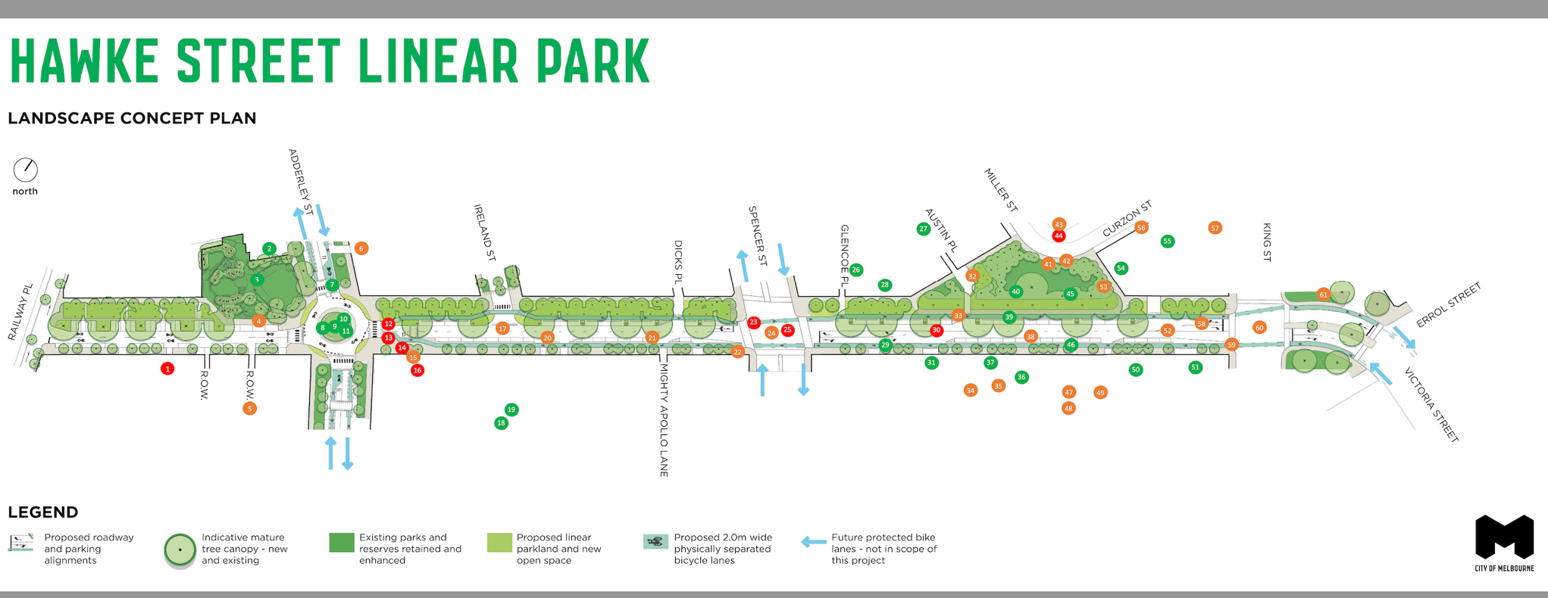

Appendix C: Comments on Graffiti Map
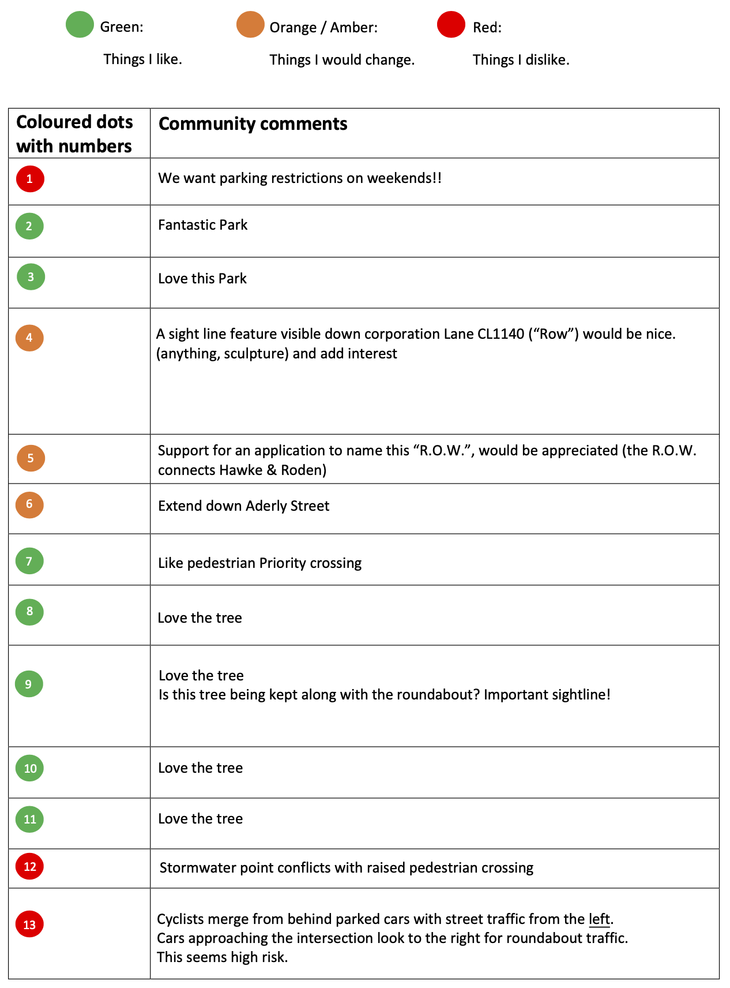

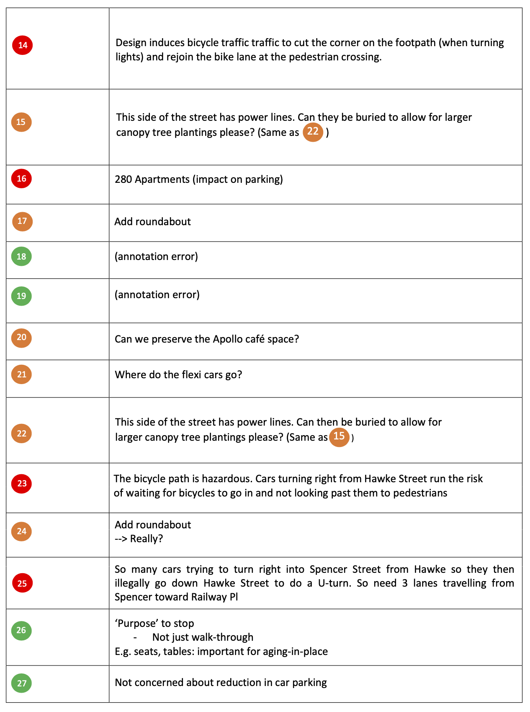

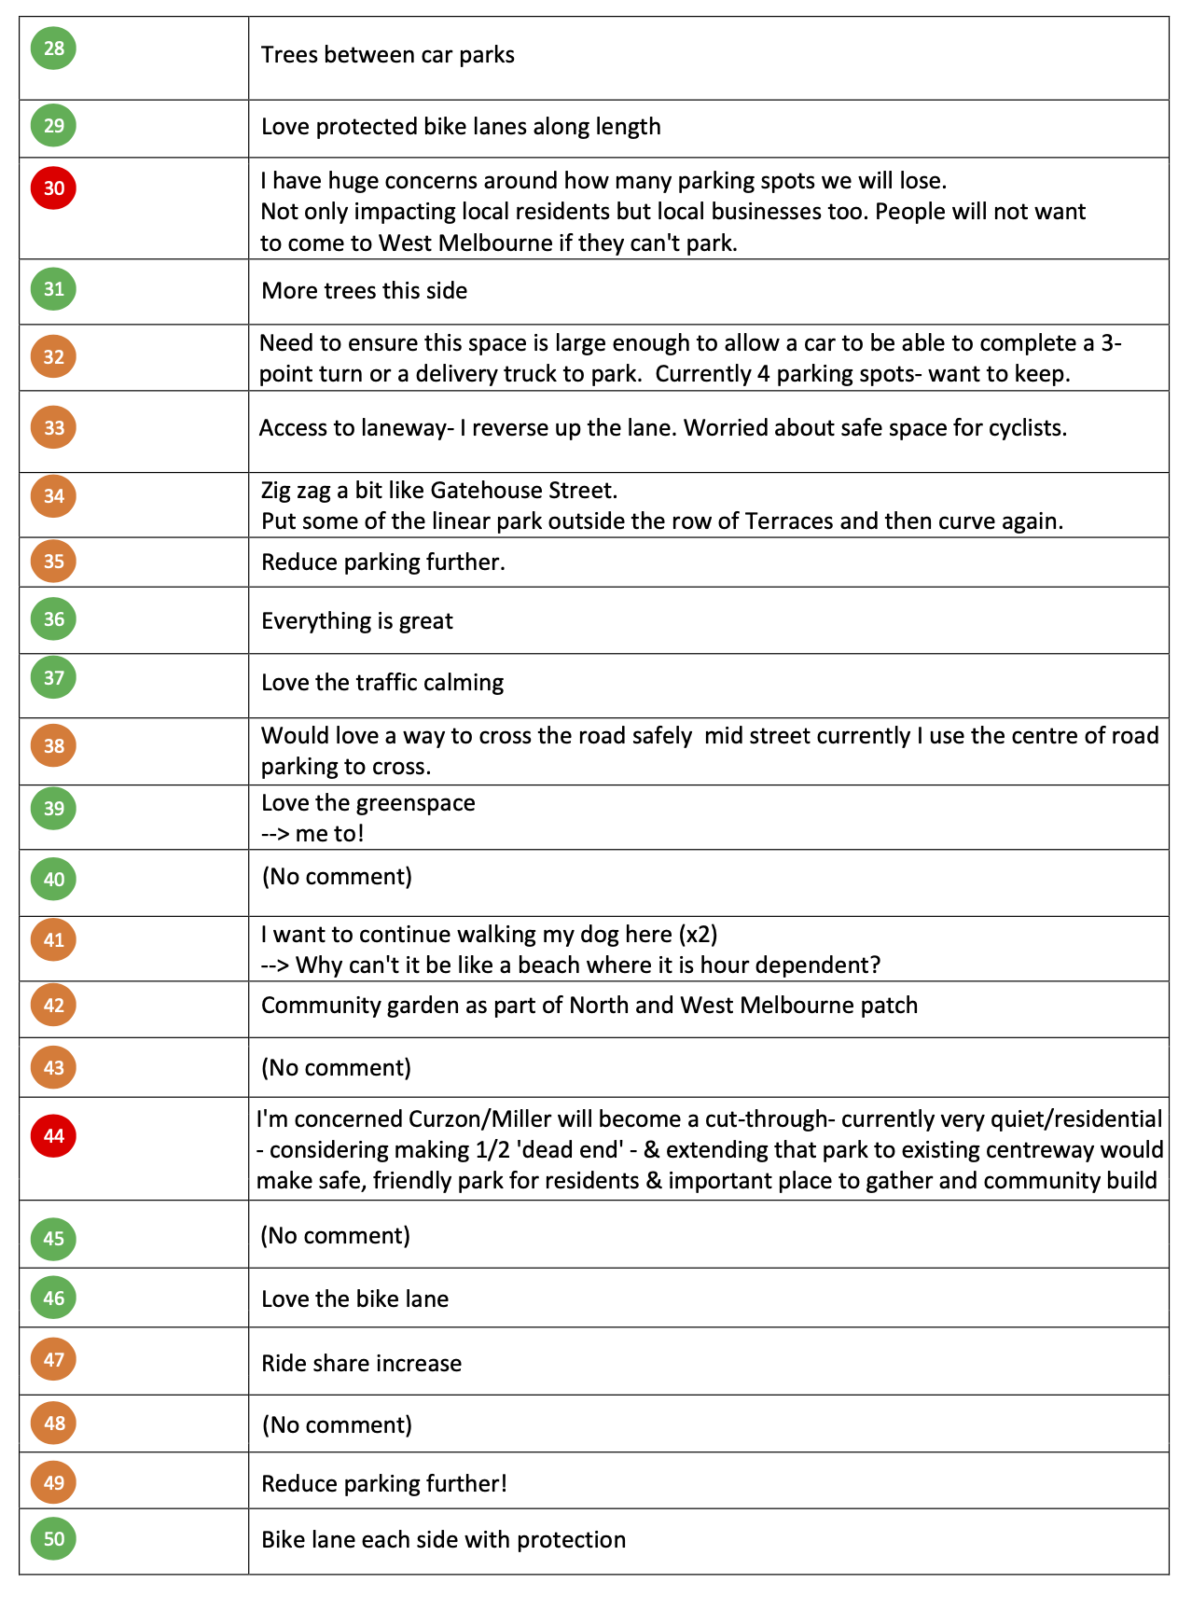

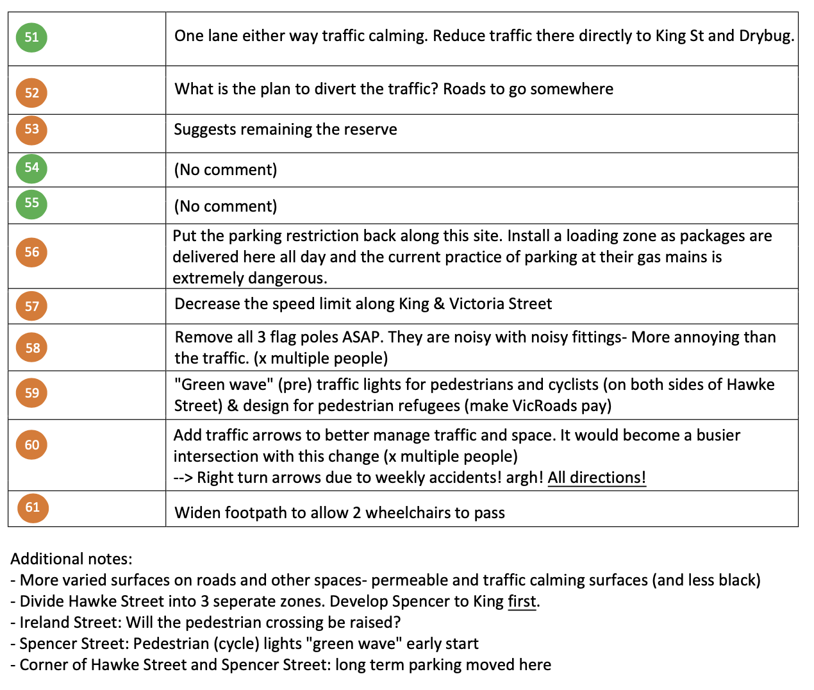

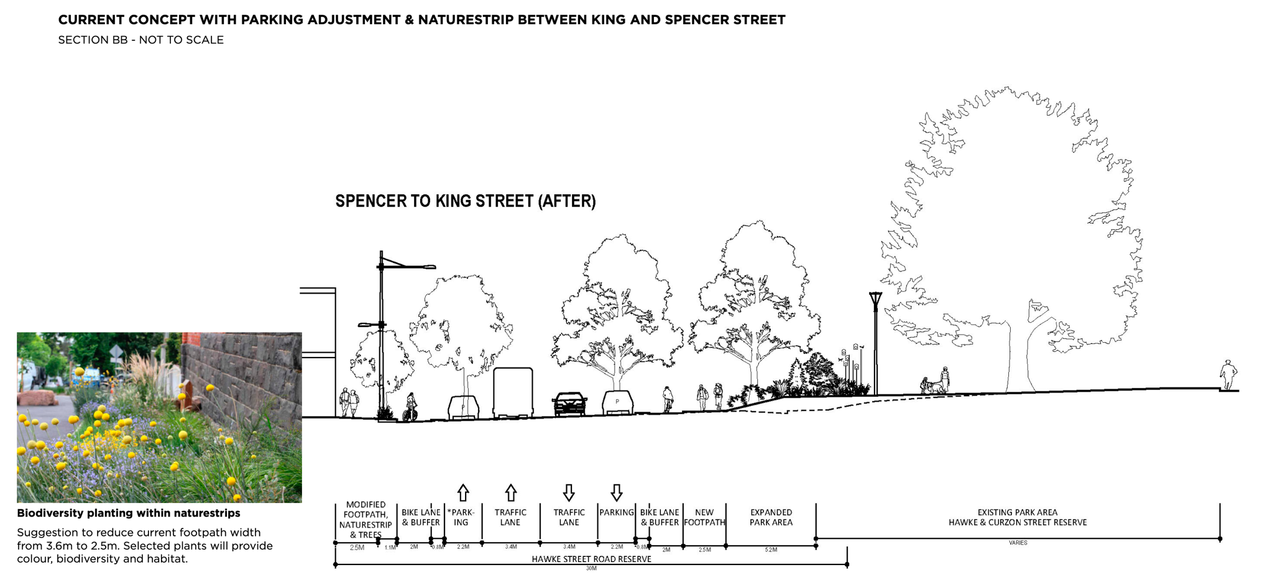
Appendix D: Aspirational cross-section diagram for residents between King and Spencer Streets

