Planning and Environment Act 1987

MELBOURNE PLANNING SCHEME

Notice of the preparation of Amendment C403melb
The City of Melbourne has prepared Amendment C403 to the Melbourne Planning Scheme.
The amendment applies to both the land shaded grey and the land with the dashed outline in Figure 1 below.
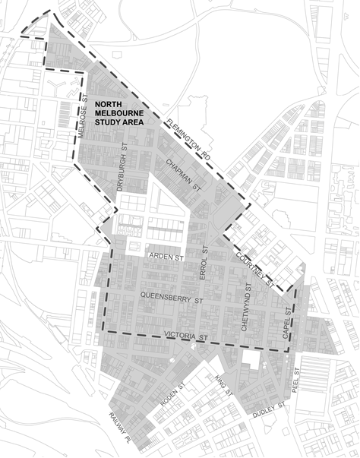
Figure 1. Land affected by the amendment (shown in grey shading), North Melbourne Heritage Review study area (shown in dashed outline)
Amendment C403 proposes to:
- Apply individual Heritage Overlays to four (4) new places and introduce new Statements of Significance for each of the four places:
  - HO1386 The Albion Hotel, 171-173 Curzon Street, North Melbourne.
  - HO1387 Hotham Gardens, Stage 1, 55-61, 63-69, 71-77, 79-85, 87-93, 95-101 O’Shanassy Street, North Melbourne.
  - HO1388 Harris Plane Tree Avenue, Harris Street (between Errol and Curzon Streets), Plane Tree Way (between Dryburgh and Abbotsford Streets), Part 302-326 Abbotsford Street, Part 50-56, 58-64, 66-72, 74-80, 92-132 O’Shanassy Street and Part 141-157 Curzon Street, North Melbourne.
  - HO1389 Flemington Bridge Railway Station, 211 Boundary Road, North Melbourne.
- Introduce a Statement of Significance for one (1) existing individual heritage overlay (HO295).
- Delete Heritage Overlays HO284 and HO953 and include some of the properties in HO3.
- Amend the boundary of the existing North & West Melbourne Precinct Heritage Overlay HO3.
- Amend the Statement of Significance for HO3.
- Amend the existing incorporated document titled Heritage Places Inventory March 2022 to change building heritage categories, streetscape categories and make address corrections for 119 properties.
- Amend the existing Heritage Overlay maps to reflect the above changes.
You may inspect the amendment, all documents that support the amendment including the explanatory report, free of charge, at the following locations:
- The City of Melbourne website: https://participate.melbourne.vic.gov.au/amendment-c403
- The Department of Environment, Land, Water and Planning website: www.delwp.vic.gov.au/public-inspection
- During office hours, at the office of the planning authority:
City of Melbourne
Customer Service Counter, Ground Floor
Melbourne Town Hall Administration Building
120 Swanston Street
MELBOURNE VIC 3000
Any person who may be affected by the amendment may make a submission to the planning authority (in this case the City of Melbourne) about the amendment. Submissions must be made in writing giving the submitter’s name and contact address, clearly stating the grounds on which the amendment is supported or opposed and indicating what changes (if any) the submitter is seeking.
Name and contact details of submitters are required for council to consider submissions and to notify submitters of the opportunity to attend council meetings and any public hearing held to consider submissions. The closing date for submissions is Thursday 15 September 2022.
A submission must be addressed to the Manager Heritage Strategy and lodged via one of the following:
- online at https://participate.melbourne.vic.gov.au/amendment-c403
- by email to heritage@melbourne.vic.gov.au
- by mail to the City of Melbourne, GPO Box 1603, Melbourne VIC 3001 and marked to the attention of the Manager Heritage Strategy.
The planning authority must make a copy of every submission available at its office and/or on its website for any person to inspect free of charge for two months after the amendment comes into operation or lapses.
Sophie Handley
Director City Strategy

