Statement of Significance: Flemington Bridge Railway Station, 211 Boundary Road, North Melbourne (July 2022)
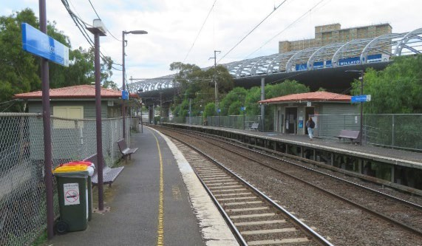
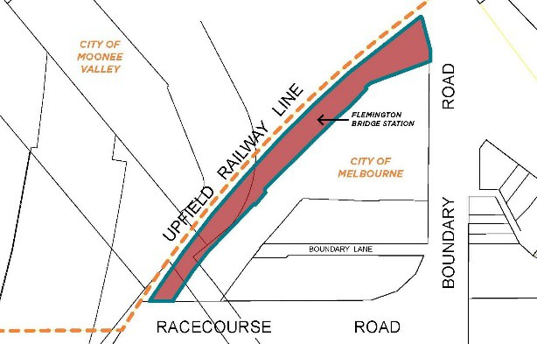
Heritage Place: Flemington Bridge Railway Station
PS ref no: HO1389

What is significant?
The Flemington Bridge Railway Station, ‘up’ side, Upfield Railway Line, North Melbourne, constructed in 1944-45. Elements that contribute to the significance of the place include (but are not limited to):
- 1944-45 weatherboard station building
- Platforms, including original substructure but excluding modern surfacing
- Access ramps
Non-original fabric including the platform fencing, ramp sides (steel and cyclone wire) and platform surface is not significant; nor is the overhead infrastructure or modern station elements such as lighting, seating, signage, barriers, bins.

How is it significant?
The Flemington Bridge Railway Station is of local historical and representative significance to the City of Melbourne.

Why is it significant?
The Flemington Bridge Railway Station is of local historical significance. Although no evidence remains of the original complex, the location of the railway station reflects on the development of the line to Coburg in the 1880s and the importance of Flemington Bridge as a key crossing point of the Moonee Ponds Creek. The location of the station also reflects concerted efforts and agitation by residents of the area in 1883-4 to have a railway station constructed after the line originally opened without a station at Flemington Bridge. The upgrading of the station in the mid-1940s and the inclusion of ramps for the earlier stairs was also in large part a response to community agitation for improved station facilities in this unusual elevated position (Criterion A).
The Flemington Bridge Railway Station is of representative significance as an example of a modest timber mid- twentieth century railway station. It is unusual in its elevated siting and adopts a form more typical of small rural railway stations. Its simple form, weatherboard construction and platform verandah are broadly demonstrative of the more modest form of timber stations constructed in this period by Victorian Railways (Criterion D).

Primary source
North Melbourne Heritage Review, Lovell Chen and Extent Heritage, 2022

This document is an incorporated document in the Melbourne Planning Scheme pursuant to section 6(2)(j) of the Planning and Environment Act 1987

