Statement of Significance: Harris Street Plane Tree Avenue - Harris Street (between Errol and Curzon Streets), Plane Tree Way (between Dryburgh and Abbotsford Streets), Part 302-326 Abbotsford Street, Part 50-56, 58-64, 66-72, 74-80, 92-132 O’Shanassy Street and Part 141-157 Curzon Street, North Melbourne (July 2022)
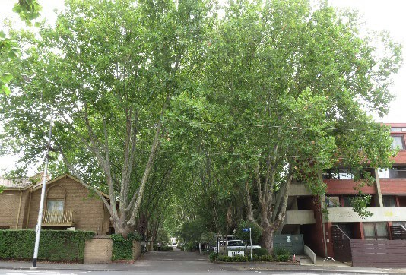
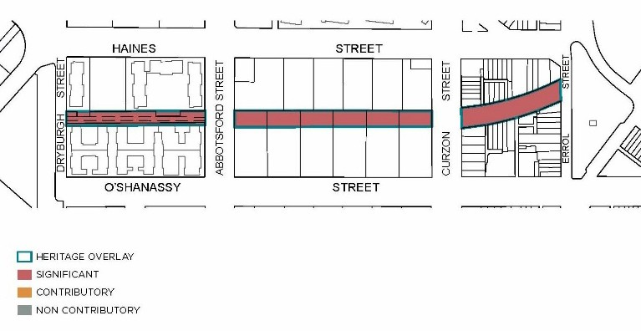
Heritage Place: Harris Street Plane Tree Avenue
PS ref no: HO1388

What is significant?
The Harris Street Plane Tree Avenue, an avenue planting of London Plane Trees (Platanus x acerifolia) extending approximately 500 metres from Dryburgh Street to Errol Street along the current and former alignment of Harris Street, including the private lane, Plane Tree Way. The avenue consists of more than 70 specimens, most of which date to the original 1905 planting with a small number of later replacements.
Elements that contribute to the significance of the place include:
- More than 70 Plane Trees, including original and replacement plantings which maintain the avenue form and extent of the original Harris Street planting.
All other built and landscape elements within the place are not significant, including other elements of the public streetscaping of Harris Street, and the private lanes, car parks, fences, buildings and other landscaping located within the blocks running from Curzon to Abbotsford Street and Abbotsford to Dryburgh Street.

How is it significant?
The Harris Street Plane Tree Avenue is of local historical, representative and aesthetic significance to the City of Melbourne.

Why is it significant?
The Harris Street Plane Tree Avenue is historically significant as a local improvement planted in 1905 by the then North Melbourne Town Council, in response to a petition from local residents. Its extensive nature and retention through later mass housing development are historically notable, and elevate the avenue above other streetscape improvements known to have been undertaken by North Melbourne Town Council, which generally survive on a more modest or fragmentary basis. The Plane Tree Avenue also provides an above-ground marker of the course of the original pre-colonial-era creek and then nineteenth century channel that now exists as a subsurface drain beneath the avenue’s alignment. (Criterion A)
The Harris Street Plane Tree Avenue is a notably intact and extensive example of a street tree planting established in the early twentieth century, in a period when establishment of street trees came into the fore as a public good for local streets and the London Plane was broadly adopted within Melbourne and its inner suburbs as a street planting. The avenue retains its legibility as a street planting both on the surviving section of Harris Street and within the altered context of the Hotham Gardens and City Gardens housing estates, including on the private lane, Plane Tree Way. (Criterion D)
The Harris Street Plane Tree Avenue is of aesthetic significance as a major landscape feature in North Melbourne, presenting a dense, continuous tree canopy within the avenue, and visible as a landscape feature from points throughout the surrounding area, most prominently in views along Dryburgh, Abbotsford and Curzon streets. (Criterion E)

Primary source
North Melbourne Heritage Review, Lovell Chen and Extent Heritage, 2022
This document is an incorporated document in the Melbourne Planning Scheme pursuant to section 6(2)(j) of the Planning and Environment Act 1987

