Statement of Significance: Hotham Gardens Stage 1, 55-101 O'Shanassy Street, North Melbourne (July 2022)
Heritage Place: Hotham Gardens - Stage 1  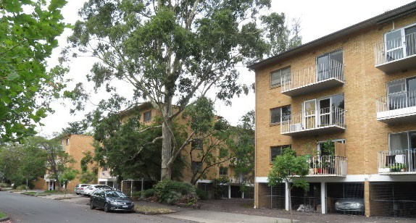 | PS ref no: HO1387  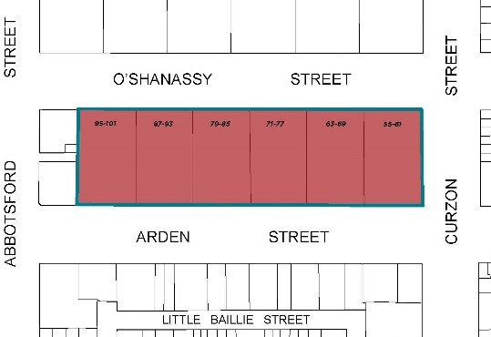

What is significant?
Hotham Gardens – Stage 1 housing development at 55-101 O’Shanassy Street, North Melbourne, constructed in 1959-1961 as own-your-own flats.
Elements that contribute to the significance of the place include (but are not limited to):
- The four face brick blocks of three-storey flats that comprise each of the six groups of flats at Hotham Gardens Stage 1 including their low pitched roofs overhanging eaves above and car parking below
- Original detailing including exterior brick cladding, timber doors, and aluminium-framed windows and balconies with fine steel railings
- The planning arrangement of the six groups of three-storey blocks of flats both individually and as an urban design, forming five large, U-shaped courtyard areas
- The original materiality and simple Modern form of the blocks of flats
- Amenities including covered breezeways and enclosed laundry blocks
- Original and mature trees
- Landscaping, including layout, stone retaining walls and garden edging

How is it significant?
Hotham Gardens – Stage 1 is of local historical, representative, aesthetic and associative significance to the City of Melbourne.

Why is it significant?
Hotham Gardens – Stage 1 is of historical significance as a demonstration of an alternative housing development led by the Housing Commission of Victoria (HCV) as part of its post-war slum clearance programme in the inner suburbs. While there are extensive HCV estates and projects across the state, this estate differs from the majority in that the land was cleared by the Commission, but developed by private industry, for private owners, rather than as public housing. In this way it acted as urban renewal, aiming to attract professionals to the inner suburb through affordable own-your-own flats. The development replaced numerous houses and other buildings, including nineteenth century workers’ cottages, changing the demographics in this part of North Melbourne. Hotham Gardens – Stage 1 was a ‘test case’ for this type of development, with three subsequent stages on adjacent sites following the general principles of Stage 1. The development is also evidence of the wide-ranging powers of the Housing Commission to acquire, clear and redevelop large areas across inner Melbourne. (Criterion A).
Hotham Gardens – Stage 1 is an important and intact example of a Modern flat development, undertaken by some of Melbourne’s pre-eminent mid-century architects. The development was a large residential project outside of the HCV’s public housing estates and the first time that the architectural profession had been engaged on a residential project of such transformative power. It demonstrates the practice of the Housing Commission of Victoria’s slum clearance work in constructing new estates with blocks of flats in a garden setting, where previously there had been individual residences, but in this case with the contribution of architects and landscape architects producing a higher quality outcome. (Criterion D)
Hotham Gardens – Stage 1 is of aesthetic (architectural) significance. Architecturally the design comprises a series of brick-clad cuboid buildings raised on slender walls suggesting stilts; their presentations suggesting mass- produced elements. The buildings as a group and most particularly in their presentation to O’Shannassy Street produce a Modernist urban design gesture on a scale and of a kind that had not been constructed in Melbourne previously (Criterion E).
The estate is also significant for its association with a panel comprising some of the most highly-regarded architects in Melbourne of the mid-twentieth century including, Roy Grounds, John Mockridge of Mockridge Stahle & Mitchell, John Murphy, of John & Phyllis Murphy, Phillip Pearce of Bates Smart and McCutcheon and Roy Simpson of Yuncken Freeman, and landscape architect Beryl Mann, also of Mockridge Stahle & Mitchell. While the design does not reflect the work of any individual architect it does reflect an attempt by the Royal Victorian Institute of Architects to influence the work of the Housing Commission of Victoria, and bring a higher standard of design into the built form of new housing estates (Criterion H).

Primary source
North Melbourne Heritage Review, Lovell Chen and Extent Heritage, 2022

This document is an incorporated document in the Melbourne Planning Scheme pursuant to section 6(2)(j) of the Planning and Environment Act 1987

