Statement of Significance: North Melbourne Primary School, 200-214 Errol Street, North Melbourne (July 2022)
Heritage Place: North Melbourne Primary School  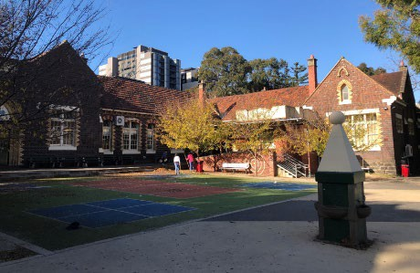 | PS ref no: HO295  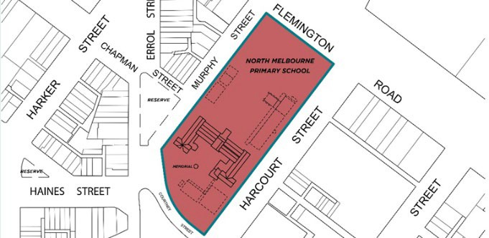

What is significant?
North Melbourne Primary School, 200-214 Errol Street, North Melbourne, constructed in 1874.
Elements that contribute to the significance of the place include (but are not limited to):
- 1874 school building
- World War I memorial drinking fountain (1919).
Late twentieth century elements and buildings, including the Flex, Gymnasium, Biz-E-Kidz and Administration buildings, are not significant.

How is it significant?
North Melbourne Primary School is of local historical, representative, and social significance to the City of Melbourne.

Why is it significant?
North Melbourne Primary School is of local historical significance. It was the first State school established in the suburb following the passing of the Victorian Education Act in 1872, which made education free and compulsory for primary school-aged children. The school was constructed during a period of intense building activity of new school buildings across Victoria, overseen by the Public Works Department and the Education Department’s architect Henry Bastow. Such was the density of population in North Melbourne that the school was built to accommodate 1,000 pupils, indicating a substantial need for free education in the suburb. The North Melbourne Primary School is important for having provided public education to the children of the suburb for 146 years, and is the oldest school in the suburb. It is believed to be the longest operating State school in the municipality, with other schools constructed in the 1870s and 1880s having since closed. (Criterion A)
North Melbourne Primary School is also of representative value as a substantially intact example of architects Wharton and Vickers’ prize-winning design of a large, single-storey school. This school design was adapted in at least five instances across Victoria, and the North Melbourne Primary School was the earliest of these schools to be completed. Although it has undergone some modifications, most notably in the 1910s, the 1874 building is extant, and its design is legible. (Criterion D)
North Melbourne Primary school is of social significance for nearly 150 years of educating North Melbourne children, with a particular association for Traditional Owners for educating many Aboriginal children in the twentieth century (Criterion G).

Primary source
North Melbourne Heritage Review, Lovell Chen and Extent Heritage, 2022
This document is an incorporated document in the Melbourne Planning Scheme pursuant to section 6(2)(j) of the Planning and Environment Act 1987

