Statement of Significance: The Albion Hotel, 171-173 Curzon Street, North Melbourne (July 2022)
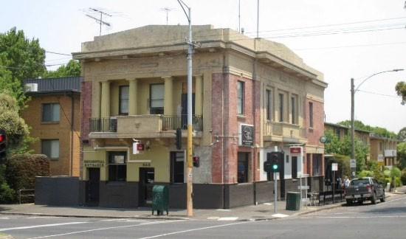
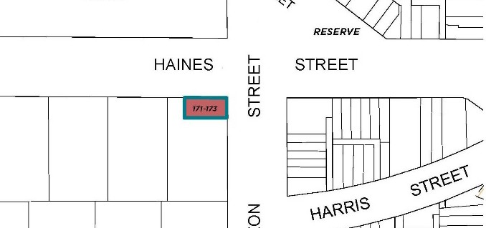
Heritage Place: The Albion Hotel
PS ref no: HO1386

What is significant?
The Albion Hotel, at 171-173 Curzon Street, North Melbourne, constructed in 1926.
Elements that contribute to the significance of the place include (but are not limited to):
- Prominent siting and two-storey block form
- Plain face red brick exterior with central and upper level rendered elements to each street facade
- Temple front motifs to street elevations including Doric columns and pilasters with modelled entablatures, cornices and parapets
- Balconies with ornamental balustrades in steel and rendered masonry at first floor level
- Windows expressed as small punched openings
- Original door and window joinery (to the extent that it survives)

How is it significant?
The Albion Hotel, at 171-173 Curzon Street, North Melbourne, is of local historical, representative and aesthetic significance to the City of Melbourne. It is also of potential social significance at the local level.

Why is it significant?
The Albion Hotel is of local historical significance, demonstrating the prevalence of hotels in North Melbourne from the mid-nineteenth century and through the twentieth century. Hotels were important socialising and refreshment places in the suburb, so much so that in 1890 there was one hotel for every 295 residents. This number reflects the typically modest housing in the suburb, with hotels providing spaces for gathering not available at home. The prominent corner location of the Albion Hotel is typical of such buildings, which were often the most substantial structures in their immediate context. Although many hotels closed in the early twentieth century as regulations tightened through the Licence Reduction Board, their popularity remained. The rebuilding of the Albion Hotel in 1926 by owners Carlton Brewery (CUB) is indicative of patronage numbers supporting the investment of a well-appointed new building, and contemporary and regulatory expectations of hotels. The interwar hotel is reflective of stricter controls and standards for hotel licenses and buildings, following the establishment in the early twentieth century of the Licensing Control Board (Criterion A).
It is also a representative and relatively intact example of a large group of buildings designed by Sydney Smith, Ogg & Serpell and other firms for CUB which illustrate the broad trend to reconstruct or remodel existing hotel buildings during the 1920s in a Greek or Roman Revival mode. This group is unified by consistencies in architectural expression, typically included as the colonnaded open balcony at first floor level - although each individual hotel provides a response to its specific site and no two designs are identical. The building also stands as an assured and representative example of the hotel design work of Sydney Smith, Ogg & Serpell (Criterion D).
The Albion Hotel is of local aesthetic significance as an accomplished design in the Greek Revival manner. The design is considered particularly successful at this small scale where short street elevations allow the temple front motifs to forms a focus of the presentation. At the time of the Albion Hotel’s construction, the Herald praised its dignified street fronts and brick and stone finishes (Criterion E).
While no direct investigation of contemporary social value has been undertaken as part of this assessment, the ongoing hotel operation suggests the Albion Hotel may be of social value to the local North Melbourne community (Criterion G).

Primary source
North Melbourne Heritage Review, Lovell Chen and Extent Heritage, 2022

This document is an incorporated document in the Melbourne Planning Scheme pursuant to section 6(2)(j) of the Planning and Environment Act 1987

