Proposed Property Divestments: Community Engagement Summary Report
November 2022

Introduction

As the City of Melbourne seeks new opportunities and ways to enable growth in the city, a proposal has been developed to sell four properties that are no longer being used for a Council service. If the properties are sold, the proceeds would be reinvested into city-shaping infrastructure projects and the capital works program.
The four properties are:
- 47-49 Canning Street, Carlton
- 100-104 A’Beckett Street, Melbourne
- 505-513 Abbotsford Street, North Melbourne
- 30-38 Gatehouse Drive, Kensington.
Before deciding on the sale of Council land, a formal statutory process pursuant to section 114 of the Local Government Act 2020 needs to be carried out, which includes undertaking a community engagement process to ensure community participation.
In November 2022 Council will receive a report and consider feedback at a Council meeting prior to deciding whether to sell the properties. Each property will be considered individually on its own merits, taking account of the community engagement response. Should Council decide to sell the properties, the sale process would begin early 2023.
This report presents the findings from the community’s feedback on Council’s proposal to sell the four properties.

The Community Engagement Approach

Engagement Objectives

- To seek and receive feedback from the community on the proposal to sell 4 properties.
- To educate the community on how the sale proceeds will be used to assist in funding Council’s capital works program 2023/24.
- To raise awareness of the local government sale of land process and community engagement process objectives.

Engagement Approach

The City of Melbourne asked for feedback on the proposal to sell four properties to contribute to city shaping infrastructure projects. The consultation was open between 4 July and 7 August 2022.
The main feedback platform was an online survey on the Participate Melbourne website. Respondents could indicate whether or not they supported the sale of each property and explain the justification for their response. Respondents could choose which properties to comment on, so the four properties garnered different numbers of responses.
Current tenants of the properties were contacted in person, via telephone, and by email. Nearby residents were sent a letter about the proposal and offered and opportunity to provide feedback through Participate Melbourne. Paid social media ads were promoted via Council social media channels, and the proposal was also shared with and discussed at various community group meetings like the Kensington Community Network.

Communications and Engagement Activities

Who we reached
- 283 letters sent to surrounding households and businesses
- 9,230 page visits by 7,368 different visitors on Participate Melbourne
- The corresponding social media campaign reached 66,512 people, 4,924 people clicked on the posts and 5,309 posted engagements
- Current tenants were contacted by email, phone and in person
- Emails sent to key stakeholders across CBD, Kensington, North Melbourne, Carlton neighbourhoods

Who we engaged
- 811 Participate Melbourne surveys
- 7 email submissions (including 2 late emails)

Number of respondents who offered an opinion on each property

- 77-49 Canning Street, Carlton | 246
- 100-104 A’Beckett Street, Melbourne | 250
- 505-513 Abbotsford Street, North Melbourne | 259
- 30-38 Gatehouse Drive, Kensington | 682

Key findings
- 35% supported the sale of 47-49 Canning Street and 65% supported its retention.
- 19% supported the sale of 100-104 A’Beckett Street and 81% supported its retention.
- 15% supported the sale of 500-513 Abbotsford Street and 85% supported its retention.
- 8% supported the sale of 30-38 Gatehouse Drive and 92% supported its retention.
- Respondents who supported the sale of the properties were most often on the following grounds:
- Would like to see the proceeds used for improving Melbourne.
- Believe that returning properties to the market could contribute to easing the housing crisis.
- Believe that the funds from the sale of underutilised properties should be used to invest in social and affordable housing and other community purposes.
- Support utilisation that activates the area and allows properties to meet their full potential.
- Agree that properties are an eyesore and underutilised.
- Respondents who supported the retention of the properties were most often on the following grounds:
- Value having a community owned asset more than the one-off capital gain from selling an asset.
- Would prefer underutilised council properties to be repurposed for community services or affordable housing.
- Were worried about the properties being sold to developers and the buildings losing their heritage value.
- Consider the current tenants offer high community value, with a large proportion expressing concern for current tenants.
- The sale of the Gatehouse Drive property was opposed in significant numbers owing to passionate support for the current tenants (MAMA Services).
- Respondents wanted to see more information on how proceeds would be used and the reasons for each individual property being surplus to Council requirements.
- Respondents implied that there would be greater acceptance for the sale of council properties if assurance could be given that the funds would directly benefit the community, especially by way of affordable housing.
- Regarding the properties at Canning Street, Abbotsford Street and A’ Beckett Street, the majority of respondents identified their primary connection as living in the area.
- For Gatehouse Drive, over half of respondents (73%) stated that their primary connection was attending a service at the property.
- 75% of respondents to the community engagement were female. This may be explained by the fact that the property at Gatehouse Drive, which garnered by far the most feedback, is currently the site of MAMA Services.

Community Engagement Feedback for each property
47-49 Canning Street, Carlton
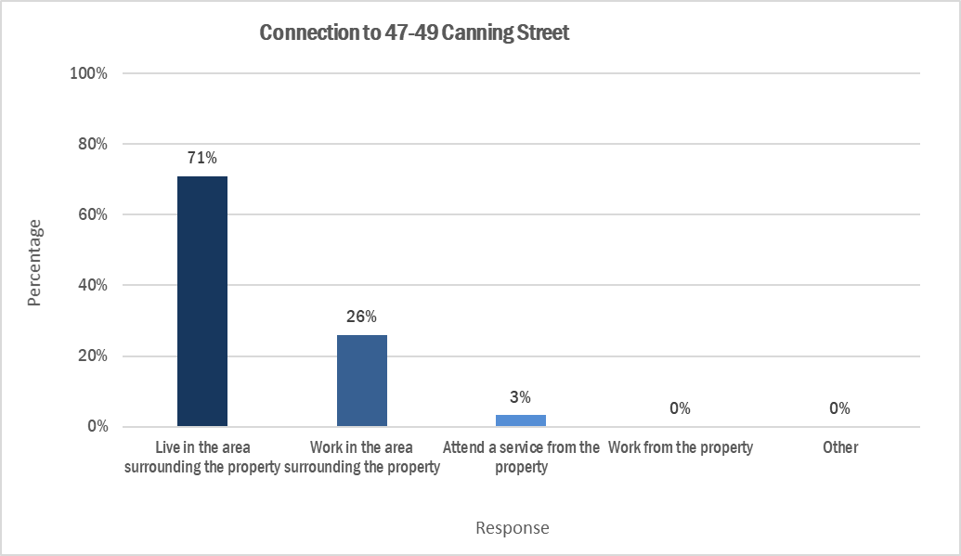
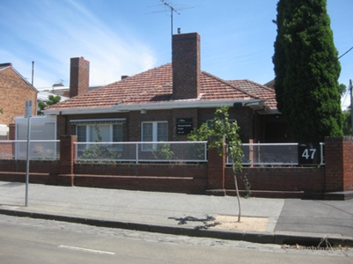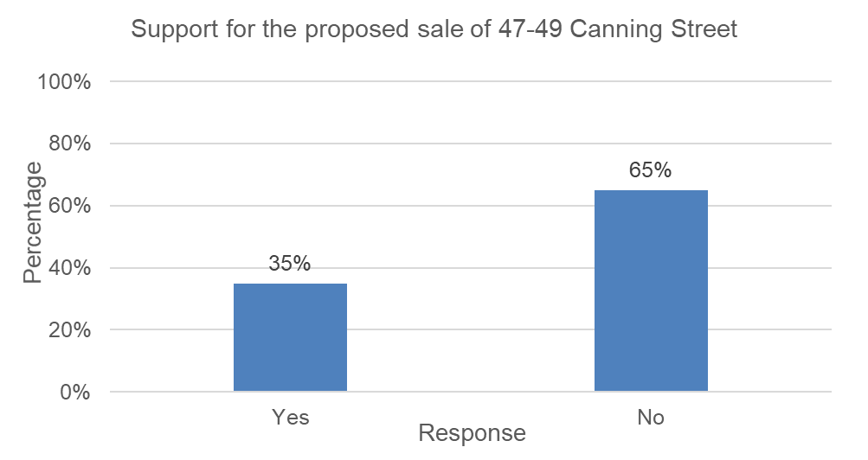
- 35% supported the sale of the property.
- 65% supported the retention of the property.
- 246 (30%) respondents to the campaign commented on this property.
- 71% of the respondents live in the area surrounding the property
- 26% work in the surrounding area.

Summary of Comments
Respondents comments in support of sale | Respondents comments in support of retention
- Property is currently unused or not required (51 comments)  - Support the potential capital gain from the sale (16 comments)  - Support the investment in housing affordability (15 comments)  - Building is run down or lacks aesthetic value (15 comments) | - Support for the property to be used to provide affordable housing (71 comments)  - General support for maintaining community ownership, the property could be used for something that will benefit the community (87 comments)  - Oppose private development (21 comments)  - Support heritage building protection (11 comments)

100-104 A’Beckett Street, Melbourne
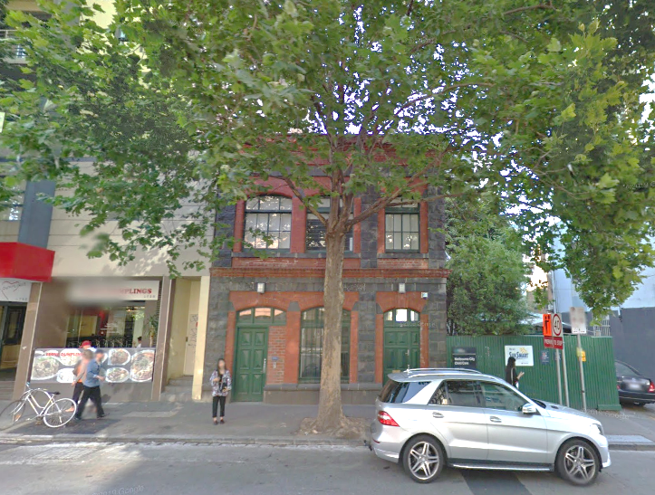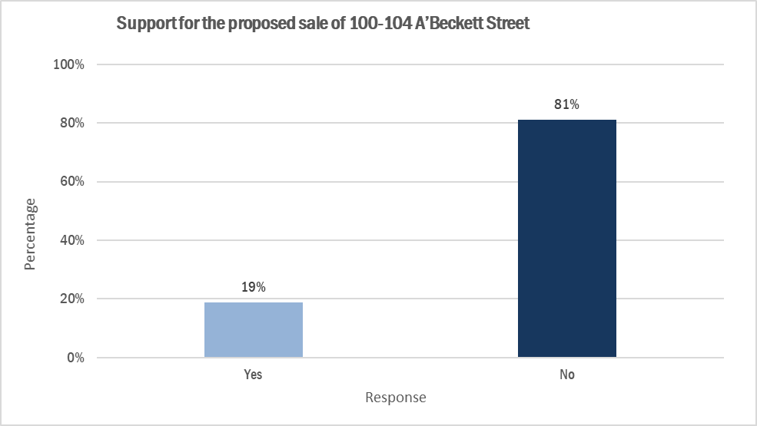
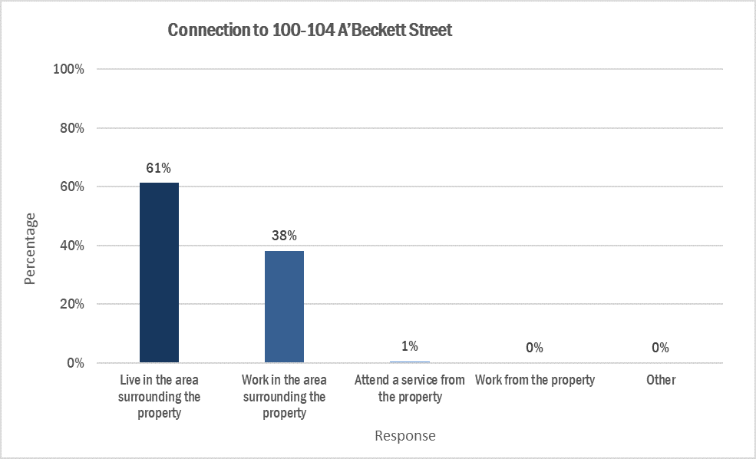
- 19% supported the sale of the property.
- 81% supported the retention of the property.
- 250 (31%) respondents to the campaign commented on this property.
- 61% of the respondents live in the area surrounding the property
- 38% work in the surrounding area.

Summary of Comments
Respondents comments in support of sale | Respondents comments in support of retention
- Property is currently underutilised (17 comments)  - Support for selling the property to allow Council to invest in other things that would benefit the community and to focus on revitalizing the area (9 comments)  - Support for the proceeds from the sale of the property to be invested in community, affordable housing or sell to the State Government to be turned into affordable housing (25 comments) | - Support for the property to be used as affordable housing for those in need (55 comments)  - Support heritage protection (55 comments)  - Oppose private development on this site (29 comments)  - Support for community ownership (52 comments)  - Need for community services, childcare or other community use (68 comments)

505-513 Abbotsford Street, North Melbourne
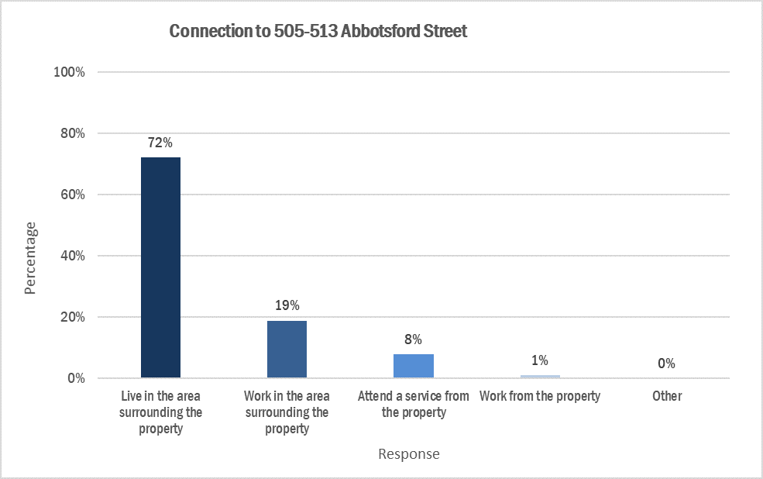
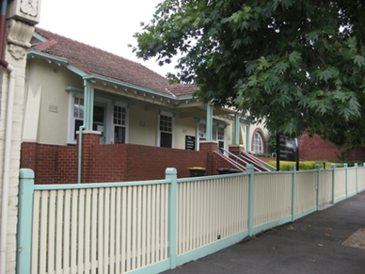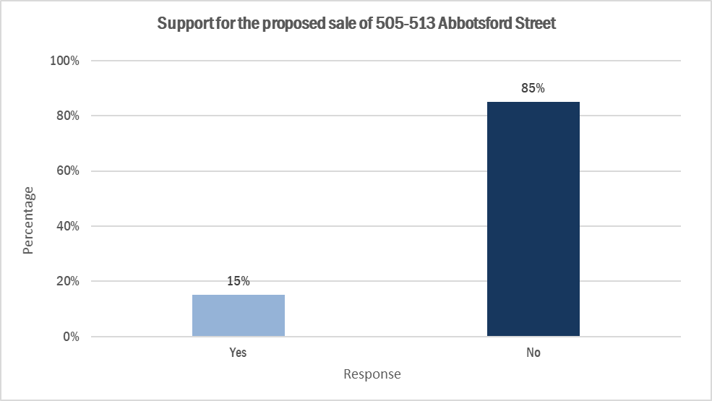
- 15% supported the sale of the property.
- 85% supported the retention of the property.
- 259 (31%) respondents to the campaign commented on this property.
- 72% of the respondents live in the area surrounding the property
- 19% work in the surrounding area.

Summary of Comments
Respondents comments in support of sale | Respondents comments in support of retention
- The property could be put to better use and is not important enough to justify keeping, especially if it is expensive to upgrade (18 comments)  - The sale could secure capital to invest in other areas that would be more beneficial to the community than the property is currently (17 comments)  - The site could be sold and either turning into affordable housing or the profits could be invested into affordable housing (22 comments) | - The site should be used for affordable housing (51 comments)  - The building should be preserved for its heritage value (32 comments)  - The property should be retained for community use or services (60 comments)  - Retain for health services (55 comments)  - Retaining community assets (43 comments)  - Oppose private development (27 comments)

30-38 Gatehouse Drive, Kensington
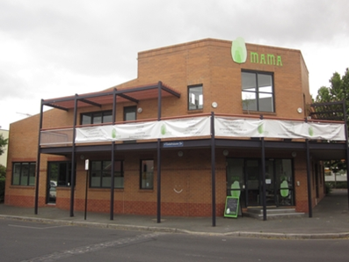
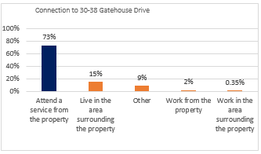
- 8% supported the sale of the property.
- 92% supported the retention of the property.
- 628 (84%) respondents to the campaign commented on this property.
- 15% live in the area surrounding the property
- 2% work in the surrounding area.
- 73% accessed a service at the property

Summary of Comments
Respondents comments in support of sale | Respondents comments in support of retention
- The property could be used in other ways to benefit the community such as cafes, sporting or yoga facilities, a library or community centre (13 comments)  - Selling the property would free up capital for the council to then invest in other projects to benefit the community (12 comments)  - Property is not required (12 comments)  - The building has minimal heritage or aesthetic value (7 comments) | - Substantial support for MAMA’s “unique and distinct services” supporting maternal and infant health were seen as invaluable to the community (730 comments)  - The property could be used for other community services or facilities (41 comments)  - Site should be used for affordable housing (50 comments)  - Private development is not wanted on this site (35 comments)  - Community services should be prioritised for the site (49 comments)  - Building is significant (11 comments)

Next steps
The community engagement findings have been shared with Council to inform the decision to sell or retain the four properties. Council will be reviewing this at the November 2022 Council meeting.

