The Greenline Project
Informing Overall Precinct Planning and
Birrarung Marr Precinct Site One: Draft Concept Design Response
The City of Melbourne, October 2022

engagement findings report

Consultation
Unless otherwise stated, all feedback documented by Capire Consulting Group and any person(s) acting on our behalf is written and/or recorded during our program/consultation activities.
Capire staff and associates take great care while transcribing participant feedback but unfortunately cannot guarantee the accuracy of all notes. We are however confident that we capture the full range of ideas, concerns and views expressed during our consultation activities.
Unless otherwise noted, the views expressed in our work represent those of the participants and not necessarily those of our consultants or our clients.

Definitions
The following lists the key definitions for common terms used in the design and delivery of community engagement as stated in the City of Melbourne’s Community Engagement Policy, 2021.

Community
An individual or a group of people united by at least one common characteristic such as geography, shared interests, values, experiences, or tradition.

Community engagement
A planned process with the specific purpose of working with individuals and groups to encourage active involvement in decisions that affect them or are of interest to them.

Stakeholder
An individual or group that has an interest in any Council decision or activity, including Traditional Custodians and Aboriginal communities, other tiers of government and government agencies, businesses, educational institutes, not-for-profits and philanthropic organisations, visitors, residents, advocacy groups, children, ratepayers and renters, emergency services, culturally and linguistically diverse people and many more.

Privacy
Capire Consulting Group and any person(s) acting on our behalf is committed to protecting privacy and personally identifiable information by meeting our responsibilities under the Victorian Privacy Act 1988 and the Australian Privacy Principles 2014 as well as relevant industry codes of ethics and conduct.
For the purpose of program delivery, and on behalf of our clients, we collect personal information from individuals, such as e-mail addresses, contact details, demographic data and program feedback to enable us to facilitate participation in consultation activities. We follow a strict procedure for the collection, use, disclosure, storage and destruction of personal information. Any information we collect is stored securely on our server for the duration of the program and only disclosed to our client or the program team. Written notes from consultation activities are manually transferred to our server and disposed of securely.
Comments recorded during any consultation activities are faithfully transcribed however not attributed to individuals. Diligence is taken to ensure that any comments or sensitive information does not become personally identifiable in our reporting, or at any stage of the program.
Capire operates an in-office server with security measures that include, but are not limited to, password protected access, restrictions to sensitive data and the encrypted transfer of data.
For more information about the way we collect information, how we use, store and disclose information as well as our complaints procedure, please see www.capire.com.au or telephone (03) 9285 9000.

1 Introduction 2
1.1 Project background 2
1.2 Report purpose 3
2 Engagement approach 4
2.1 Engagement objectives 4
2.2 Methodology 4
2.3 Limitations 8
3 Summary of participants 10
3.1 Gender 10
3.2 Age 10
3.3 Representativeness 10
3.4 Connection to City of Melbourne 11
4 Findings: The Greenline Project 13
4.1 Summary of key themes 14
4.2 Understanding of The Greenline Project 20
4.3 Experiences and activities 20
4.4 Amenities 23
4.5 Connections, safety, and access 26
4.6 Concept Design Response: Birrarung Marr Precinct Site One 31
5 Conclusion 33
5.1 Project reflections 33
5.2 Next steps 33
Appendices 34
Appendix A: Draft Concept Design Renders 34
Appendix B: Survey questions 36

- Introduction
  - Project background
The Greenline Project is an initiative by the City of Melbourne (Council) to revitalise the north bank of the Yarra River – Birrarung into a reinvigorated and inspiring public waterfront. The initiative is guided by four overarching themes – Environment, Culture, Place, and Connection (Figure 1).
These themes were developed through community engagement in 2021 on the draft Greenline Implementation Plan and guide the development of the initiative. Community and stakeholder engagement on the draft Greenline Implementation Plan occurred between September and October 2021. This engagement resulted in the co-development of a Greenline Opportunity Statement. This Statement has informed the brief and draft concept designs for the first project in the Birrarung Marr Precinct, and the principles underpinning the proposed precincts of The Greenline Project. Community and stakeholder engagement was also held for the Yarra River – Birrarung Strategy between April and August 2019.
The Greenline Project identifies five precincts along the Yarra River - Birrarung’s north bank. The precincts reflect land management, activity, and character attributes, as shown in Figure 2. Sites will be identified within these precincts to address local character and context on a finer scale.
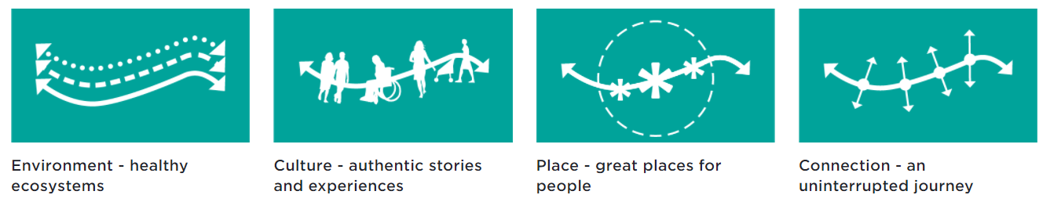
Figure 1. The Greenline Project overarching themes
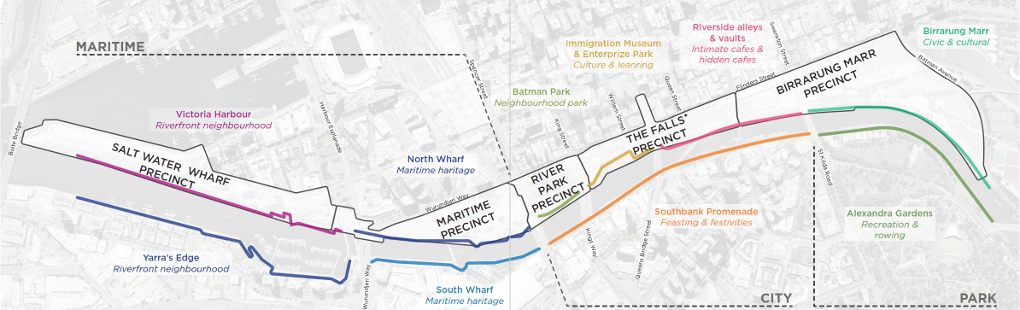
Figure 2. The Greenline Project proposed precincts
Following Future Melbourne Committee’s endorsement of the Greenline Implementation Plan in December 2021, Council is advancing the planning and delivery of the initiative. The progression of one of the precincts’ sites – Birrarung Marr Precinct Site One – has been fast-tracked, and concept designs have been developed for presentation to the community. In this stage of community and stakeholder engagement, feedback was sought on The Greenline Project and the Birrarung Marr Precinct Site One draft concept designs (Appendix A).
  - Report purpose
This report summarises the key findings from engagement on The Greenline Project and Birrarung Marr Precinct Site One draft concept designs.
The feedback gathered through this engagement process will inform the progression of The Greenline Project draft Outline Brief. It will do so by supplementing and enriching the engagement findings from the Draft Greenline Implementation Plan. To achieve this, the engagement scope was expanded to include all community members and stakeholders. Targeted stakeholder engagement also took place during this engagement process.
The feedback received through the engagement process will be used to inform and refine the draft concept designs for the fast-tracked Birrarung Marr Precinct Site One project.

- Engagement approach
This section details the objectives, methodologies, and participation of engagement, including engagement limitations. The engagement occurred for six weeks, commencing on 1 August 2022, and ending on 12 September 2022.

  - Engagement objectives
The engagement was underpinned by a set of objectives below. They guided the planning and design of the engagement program and allowed for effective monitoring and evaluation.
- To inform and consult with community on The Greenline Project, specifically Birrarung Marr Precinct Site One draft concept designs and The Greenline Project precincts.
- To demonstrate design response to priority areas identified in Phase 1 community engagement.
- To demonstrate how The Greenline Project responds to neighbourhood insights gathered, particularly from a diverse range of voices and perspectives.
- To involve key diverse community stakeholders in the development of requirements to be included in The Greenline Project precinct planning.
- To understand the community’s priorities and aspired uses of spaces at the Project sites.
- To gather insights that can bring the City of Melbourne’s diversity and inclusion aims to life in both the Birrarung Marr Precinct Site One concept and The Greenline Project precincts.
- To establish an approach for community engagement to be replicated for individual projects along the lifespan of The Greenline Project.

  - Methodology
A range of communication and engagement tools were used to reach to different stakeholder groups, including community, sports bodies, arts and cultural facilities, education, and learning providers, as well as Aboriginal groups and Traditional Owners. Near neighbours and existing users of the project area were also engaged.

Promotion
Table 1. Tools used to promote the engagement
Tool | Description
Participate Melbourne page | A project webpage for the Greenline Project was set up on Participate Melbourne (https://participate.melbourne.vic.gov.au/greenline-project). The project page contained project information, frequently asked questions, a fly-through video, a project site plan, project timeline and updates. A survey about The Greenline Project and concept designs for Birrarung Marr Precinct Site One were also hosted on the project page.  In total, The Greenline Project Participate Melbourne page received 10,395 views, 5,981 visits and 5,024 visitors.
Email invitations with pre-engagement letter | A pre-engagement letter to 65 key stakeholders was sent via email on 5 August 2022. These stakeholders comprised of people from community groups, developers and construction organisation, local business and commercial stakeholders, resident groups, and government stakeholders.  The letter introduced the project and encouraged participation in the engagement through the online survey and targeted workshops for specific stakeholder groups.
Email promotion | Emails were sent directly to stakeholders to promote and personally invite them to engagement opportunities. A total of 45 emails were sent to stakeholders, including stakeholders and contacts that represent businesses, commercial, and event interests.  Council staff emailed the engagement opportunity to residents, groups, and networks with existing relationships. This included promotion through the Participate Neighbourhood engagement process.
Social media promotion | Council promoted The Greenline Project engagement through social media channels such as Facebook, LinkedIn, Twitter, YouTube, and Instagram. Promotional posts were published on Facebook, Instagram, and Twitter. This resulted in:  - 252,389 impressions  - 3,364 clicks with a 1.33% click through rate  - 4.27% engagement rate  - 10,771 post engagements.
Traditional media | The announcement of the engagement period was promoted by Channel 9 News, Herald Sun, and across hyperlocal publications in the days prior to feedback opening.
On-site promotion | Corflute signage was installed around Birrarung Marr. This included translated text in simplified Chinese and a QR code which was scanned close to 184 times.
Council eDM | eDM to business in City of Melbourne reached 18,000 addressed, with an open rate of 46.4%.
Melbourne Mag | The engagement period was promoted in Melbourne Magazine which reaches 64,000 people.
Postcard | Postcards detailed the core engagement messages and encouraged community members to participate in the community engagement process. This was done by providing website links, Council contact details, and a QR code which linked to the Greenline Project Participate Melbourne page.  A total of 300 graphically designed postcards were printed and distributed at engagement events.

Engagement Activities

Survey
The online survey, accessible via The Greenline Project Participate Melbourne page, served as a principal method of gathering community feedback. The objective of the survey was to provide a wide-reaching opportunity for community members to share their feedback and ideas for The Greenline Project and respond to the draft concept designs for Birrarung Marr Precinct Site One in an accessible and non-committal way.
The survey asked 13 questions relating to The Greenline Project and received 198 responses. The full list of questions asked in the survey can be found in Appendix B.

Pop-ups
Four pop-up events were held throughout the engagement period at different sections of the Greenline Project and were scheduled at varied times and locations to capture different user groups. They were also scheduled to coincide with nearby community events to increase participation. The pop-ups schedule and a map of the pop-up locations are in Table 2.
Pop-up events involved Capire staff being present at strategic locations at or near Birrarung Marr Site One. We shared information about the project, spread awareness of the survey, and recorded conversations and key information including participant’s use of the site.
Approximately 54 conversations were recorded across the four pop-ups. The project team also raised awareness and distributed information, including 300 postcards. The pop-ups aligned with the engagement objectives, they also aimed to:
- direct community members on how to submit their thoughts and find out more, including a strong focus on directing participants to The Greenline Project Participate Melbourne page
- generate excitement for the project, and provide an opportunity for incidental and non-committal community feedback
- listen to feedback in response to the concept designs for the Birrarung Marr Precinct, and for The Greenline Project as a whole.
Table 2. Pop-up schedule
Date | Time | Location | Location on Figure 3
17 August 2022 | 5.00pm – 7.00pm | Tanderrum Bridge | 1
25 August 2022 | 7.00am – 9.00am | Birrarung Marr | 2
1 September 2022 | 10.00am to 12.00pm | Library at the Dock, Docklands | 3
11 September 2022 | 11.00am to 1.00pm | Art of Play, Birrarung Marr | 4
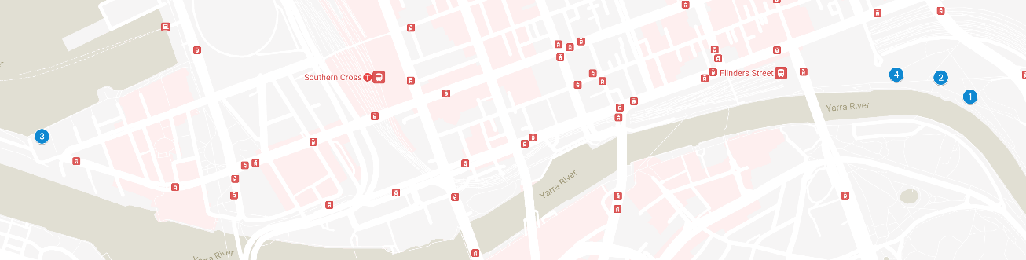
Figure 3. Map of pop-ups locations

Workshops
Four workshops (Table 3) provided a space to share information and for structured discussions to seek feedback, including what stakeholders like and what was missing from the draft concept designs. Registration for the ‘Community’ and ‘Business and Commerce’ workshops was available to all interested through the Greenline Project Participate Melbourne page. Registration for the ‘Events’ workshop was by invitation. Those not invited were welcomed to join the other workshops to fully represent events stakeholder interests. Three participants attended a targeted discussion as they were unable to attend the ‘Events’ workshop.
The workshops aligned with the engagement objectives and aimed to:
- provide an update on The Greenline Project and Birrarung Marr Precinct Site One
- seek feedback on the concept designs for Birrarung Marr Precinct Site One
- understand ideas for activities and experiences; the types of amenities that are needed and ways to improve connection, safety, and access along The Greenline Project.
Table 3. Workshop schedule
Date | Format | Stakeholder group | No. of attendees
1 September 2022 | Online | Community | 13
7 September 2022 | In-person | Community | 26
7 September 2022 | In-person | Events | 19
8 September 2022 | Online | Business and Commerce | 13
Inbound Phone Calls
Fewer than 10 phone calls were received during the engagement period.

E-mails received
A total of 25 emails were received during the engagement period.

Written submissions
Three written submissions were received from Parks Victoria, National Trust, and Tennis Australia. The City of Melbourne conducted additional meetings with these organisations and plans to incorporate their feedback into the final proposed design.

Aboriginal groups and Traditional Owners
Engagement with Traditional Custodians on The Greenline Project commenced in early 2021 with the preparation of the draft Greenline Implementation Plan. The Greenline Branch has been meeting regularly with Wurundjeri Woi Wurrung Cultural Heritage Aboriginal Corporation as the Registered Aboriginal Party for The Greenline Project area since July 2021 and this will continue throughout the life of the project. Input from Wurundjeri Elders has informed the Greenline Implementation Plan and is shaping the planning and priorities for The Greenline Project.
During the development of the concepts for the Birrarung Marr Site One project, several meetings were held with elders and their input has informed the design. The community engagement links were also provided to Wurundjeri Woi Wurrung to share with and invite input from their communities. The Greenline Branch has also met with Koorie Heritage Trust, also sharing information on the engagement community engagement to invite input from their networks.

  - Limitations
The engagement methodology while robust, also had several limitations that should be acknowledged when reading this report. These are outlined below:
- Capire has reported on information documented by participants and interpreted the information to represent the views of participants as closely as possible.
- The engagement program included multiple opportunities for participants to contribute. Some people may have taken part in multiple engagement activities, for example completed the survey and participated in a workshop. Their views may have been captured more than once.
- In some instances, participants did not respond to all questions, thus some questions received fewer responses than others.
- All feedback received through the engagement program and included in this report has been summarised to reflect key themes. Data was analysed and has been presented in this report by key themes and issues that were frequently raised. It does not provide a quantitative analysis of all feedback provided by participants.
- All feedback received through the engagement has been coded to reflect 10 key emerging themes (themes are listed in section 4.1). The coding of data was undertaken by our team of consultants and even with a thorough quality assurance process there may be a small margin of error due to individual interpretation.
- Every effort is made to summarise feedback accurately and comprehensively. Where responses are open-ended, interpretation is required, and assumptions are made in the analysis.
- Participants of the engagement program self-selected to participate. While overall participation was from a broad range of community members, the engagement methods used do not allow for a statistically representative sample of the Melbourne community.
- In some instances, participants used the opportunity to provide feedback that was not related to the project. This feedback has not been included in this report, however all data collected has been provided to the City of Melbourne for consideration.
- Several questions that were asked as part of the engagement program asked multiple questions. As a result, it was hard to differentiate whether feedback that was provided was directed towards the Birrarung Marr Precinct project or The Greenline Project in general. Capire have done our best to interpret the responses.
- Due to wet weather conditions and permit requirements, one of the pop-ups had to be relocated.
- The format and function of the Greenline Project Participate Melbourne page meant that engagement opportunities and information was hard to locate. Participants were required to click through multiple links and navigate to the bottom on the webpage for the survey link and workshop registration.
- While participants had multiple opportunities to participate, the time period for workshop registration was short. Capire addressed this limitation through proactive promotion of direct emails to known stakeholders and flexibly offering an additional engagement session for events stakeholders.
- While demographic data was collected from workshop and survey participants, it was not collected at pop-ups as these conversations focused on seeking feedback on the project. Demographic data was also not collected for the invite-only events targeted at events stakeholders.

- Summary of participants
Feedback was received from 326 participants across all engagement activities. Participant demographic data was collected from workshop and survey participants. The results of this data are reflected below.

  - Gender

Figure 4. Gender of participants (n = 250)
As expressed in Figure 4, just under half of the participants identified as male (48%), while 44% of participants identified as female. Less than 1% of participants identified as non-binary or gender diverse, while 1% used another term to describe their gender.

  - Age

Figure 5. Age of participants (in years) (n = 250)
As expressed in Figure 5, the top four age groups represented through the survey and workshops were the 20-24 years (14%), 30-34 years (12%), 35-39 years (12%) and 45-49 years (12%) age groups. The least represented age groups were those above 70 years (3%) and 19 years or under (2%).

  - Representativeness
Questions were asked to understand who was participating in the engagement process. Across the different representation measures, LGBTIQ+ persons (20%) and those born overseas (23%) were most represented in the engagement.
Participants who were least represented were Aboriginal and Torres Strait Islanders (2%). Additionally, a small percentage of participants who speak a language other than English (9%), who have a disability (5%) and people who are carers (4%) participated in the engagement process.

  - Connection to City of Melbourne
Participants were asked for their suburbs, their relationship to this project and if they had participated in a consultation with City of Melbourne before. This information helped us understand participants’ connection to the City of Melbourne.

Relationship with City of Melbourne

Figure 6. Connection to the City of Melbourne (n = 250)
As expressed in Figure 6, most participants were residents living in the City of Melbourne (44%). Just under a quarter of participants were workers (17%) or visitors to the City of Melbourne (14%). Meanwhile, respondents who owned a business (3%) were less represented.

Suburb

Figure 7. Suburb of participant’s relationship to the City of Melbourne (n = 250)
As expressed in Figure 7, the suburbs most represented through the engagement were the Central Business District (24%) and Docklands (10%). The suburbs least represented were West Melbourne (3%) and Fisherman’s Bend (0%).
Approximately 14% of respondents who said ‘Other’ were outside the City of Melbourne; the suburbs of those participants are listed below.
- Richmond  - Brunswick  - Cremorne  - Burnley  - Sunbury  - Preston  - Coburg  - Caulfield | - St Kilda  - Geelong  - Strathmore  - Fawkner  - Carlton North  - Toorak  - Aspendale Gardens  - Camberwell | - Hawthorn  - Mount Macedon  - Oakleigh  - City of Stonnington  - Sydney, NSW  - Collingwood  - Carlton North  - Malvern

Previous engagement experience

Figure 8. Previous engagement experience of participants (n = 250)
Just under half (44%) of participants who engaged with The Greenline Project engagement program had previously participated in other City of Melbourne engagement activities (once or twice, or regularly) (Figure 8). Just over a third of participants (35%) responded that this is the first time they have been involved in a City of Melbourne engagement.

- Findings: The Greenline Project
The following findings summarise the feedback and ideas collected through the engagement process. The feedback is presented under headings that correspond to priority themes that will inform the direction of The Greenline Project. These themes were extrapolated on during the engagement process through key questions, which were asked consistently across the survey and workshops (see Appendix B).
Open-ended feedback received as part of the engagement process has been coded under key themes. Prevalent and recurring themes have been specified under the relevant headings. Quotes from participants have been included to illustrate sentiment.
Participants were shown draft concept designs for Birrarung Marr Precinct Site One. Participants were asked to reflect on their current use of the site, and how the designs respond to environmental and ecological sustainability. Participants were also prompted to provide additional feedback on each of Birrarung Marr Precinct Site One’s spaces. These proposed spaces are illustrated in Figure 9, and include:
- The River Edge
- The Billabong
- The Lookout
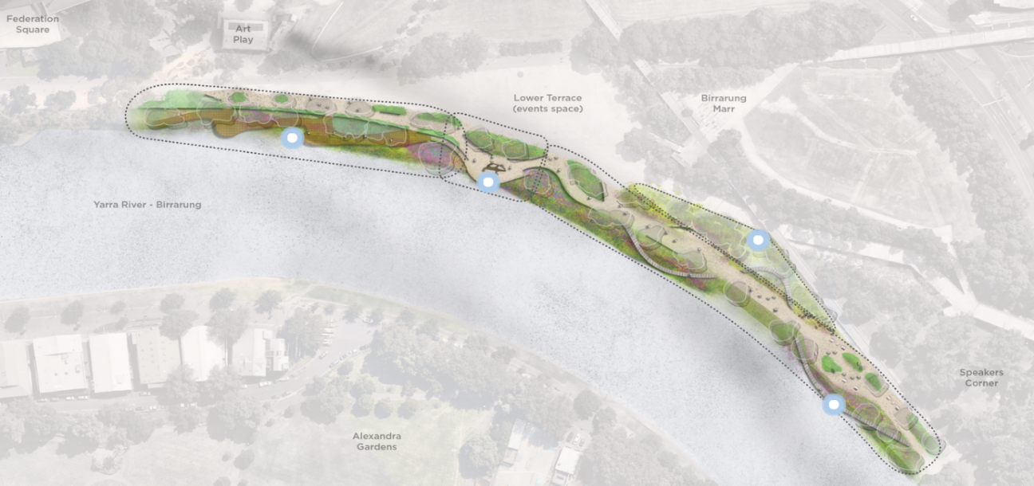
- Fig Tree Boardwalk
1
2
3
4
Figure 9. Birrarung Marr Precinct Site One and spaces
The findings highlight a strong degree of support for the ecological orientation of the Birrarung Marr Precinct Site One draft concept designs, and a high awareness of climate resilience, and diverse and inclusive uses of the space.
  - Summary of key themes
All feedback received through the engagement and presented in this report has been summarised to reflect 10 key themes. The percentage of feedback under each key theme is shown in Figure 10. This is followed by a summary of the key feedback received along with quotes to illustrate sentiment.

Figure 10. Percentage of feedback related to each of the 10 key themes

Implementation and maintenance
A key theme under this topic focused on rubbish collection, and issues with maintaining the Greenline's features. Participants were concerned with littering issues specifically in the river, planted areas, and in playgrounds. Participants suggested the provision of adequate permanent waste and recycling bins, and temporary bins during events.
The overall maintenance and cleanliness of the precincts were highlighted by participants. Ideas included having permanent onsite managers and cleaners for regular maintenance of facilities and amenities. It was thought that this would create an attractive environment for all visitors.
There were suggestions to use durable materials to ensure long term use of infrastructure.
- ‘Make sure to keep up maintenance and keep it clean.’ – survey respondent
- ‘Waste and recycling bins should be adequately provided to discourage littering.’ – survey respondent
- ‘I'm concerned there will be more rubbish entering the river - how will waste be managed? In some of the images the boardwalk looks to be made from wood - how often will it have to be sealed to keep from rotting and will the sealant contaminate the water?’ – survey respondent

Environment and Ecology
Central to the environment and ecology theme were statements about the impacts and considerations on the waterway and connected ecosystem. Participants expressed high level of support for increased ecological focus along the whole Greenline Project.
It was stressed that the new design should support health of the Yarra River – Birrarung and enhance environmental and ecological sustainability of the site. It was highlighted that this can be done by reintroducing native plants to create habitats for the urban wildlife and incorporate natural water retention measures to improve water quality of the river.
Participants emphasised the importance of climate mitigation and adaptation designs in response to climate change impacts. Flooding and urban heat island effect were the main concerns expressed. Suggestions include planting vegetation along the riverbank to regulate river flow, selecting appropriate construction materials to improve water permeability of ground surfaces, and increasing natural shading to filter sunlight during summer days.
- ‘It's pleasing to see the revegetation along the river's edge, which will both improve amenity and the health of the river... We would like to see the use of initiatives such as floating wetlands to improve water quality and provide habitat for birds, insects, and wildlife.’ – survey respondent
- ‘Diverse plants that can help the Yarra be healthy and provide food for the fish and birds.’ – survey respondent
- ‘I have very great concerns regarding the "transformed river edge" proposal where the boardwalks appear to curve out over the existing bank and intrude into the river proper. There appears to be an increased amount of proposed water vegetation which will narrow the river itself and with the vegetation in place will slow the flow of the river.’ – survey respondent
- ‘The plants grown to preserve the ecology should be symbiotic with the surrounding area and Melbourne weather while adding beauty to our city.’ – survey respondent

Active transport
Feedback was received about the management of active transport such as pedestrians, cyclists, and people on scooters, along the whole Greenline Project. Participants identified potential for conflicts of space between cyclists and pedestrians and between scooters.
There were also a number of comments about having dedicated infrastructure for cyclists. Less frequently, participants suggested a bicycle and scooter ban across project area.
Participants who activate the space and host events raised concerns around conflict of space between event participants and other recreational users at the site. Specific suggestions included conducting further research on pedestrian movement to inform connectivity design at sites along the Greenline.
- ‘A separated space for cycling slowly through to enjoy the space that must not resemble Southbank Promenade shared space.’ – survey respondent
- ‘There is no provision is made for bikes. This reduces space overall and risks putting bikes in conflict with those walking. Given this is at the city end of an extremely popular bike route, having shared space for bikes and pedestrians is a missed opportunity.’ – survey respondent
- ‘Need to balance use of space by commercial operators and recreational users to avoid conflict.’ – workshop participant

Safety and security
Regarding safety and security along The Greenline Project, respondents gave suggestions to increase the overall perception of safety and to have measures to deter anti-social behaviour. Participants suggested installing more lighting and CCTV cameras, providing multiple unobstructed pedestrian access points, and allocating ‘safe zones’ where visitors can contact security staff or police for assistance.
Linked to this theme was a desire to for more opportunities for night-time economy activation. It was thought that this will attract visitors during different times and create natural surveillance along the site. There were suggestions for designs to minimise public safety risks, including the installation of balustrades or railings to prevent people from falling into the river and providing smooth surfaces for pedestrians to walk on.
Participants highlighted the need for pedestrian networks to be carefully planned to ensure effective crowd management and operation during major events.
- ‘Better lighting including for safer use at night.’– survey respondent
- ‘This is an excellent proposal that would activate the area. However, my concern is with activation brings all kinds of people good and not so good. Security should be a major concern; the increased tree cover could promote an environment for crime with low visibility within the promenade. Forward thinking on public safety and security should be a high priority and considered in the design.’ – survey respondent
- ‘The safety bollards have made it more complex. Allow people to spill out. In major events there is a risk for people fall into the river and this has triggered need for safety measures. We need an integrated emergency system.’ – workshop participant

Playground and recreational areas
Playground and recreation requests included more recreational areas and playgrounds along the Greenline Project. Participants aspired for additional recreational areas that can be enjoyed by different age groups in all seasons. Common suggestions for active recreation were for nature play areas, a swimming pool, and spaces for activities like skating and parkour. Frequently heard ideas for passive recreation area centred on spaces to gather, rest, and relax.
Consistently with feedback received in other themes, participants would like to see the design of playground and recreational areas to focus on environmental sustainability principles. It was thought that would encourage the connection between nature and visitors. Colours and materials should be sensitively selected and sensitive to the features of the surrounding environment.
- ‘Birrarung Marr would be a great spot for a water play area next to Art Play’ – survey respondent
- ‘More kid stuff like playgrounds or just areas to play. Cool kid art/statues? Pop up kid events? Library pop up?’ – survey respondent
- ‘This area is used extensively by parkour practitioners and other movement disciplines. It would be amazing to see engagement with those communities in design, as simple and unobtrusive things can make the space much more usable, for those communities and for all people’ – survey respondent

Accessibility and Inclusion
Suggestions were received from participants about measures to improve accessibility and amenities to support inclusion along the Greenline Project. Participants frequently mentioned the need to improve connectivity of pedestrian and cycling network to surrounding locations of interest in the City. Participants would like to have multiple points of access, supported by clear wayfinding instructions along the site. More specifically, frequent feedback expressed a desire for a new footbridge connecting Birrarung Marr and Alexandra Gardens.
Participants identified a range of amenities that would support inclusion of different uses of the space. For example, it was thought that amenities should consider and provide for all user needs. These considerations included designs that support people with disability, COVID health and hygiene concerns, and general safety concerns. Often cited ideas were cafes, water refill stations, free WIFI connection, charging stations, and first-aid stations. Other design features often mentioned were ramps, railings, and smooth footpath surfaces for wheelchair and stroller access.
- ‘Please ensure the design is inclusive of people with disability who are so often not involved in the design process.’ – survey respondent
- ‘To ensure concept is connected at multiple points of access and egress both to river activities but more important to major points of the adjoining city.’ – survey respondent
- ‘Consider the diversity of people's age, gender, might be different, accessible for all ages.’ – workshop participant

Tree cover and landscaping
Frequent comments and ideas were received about species of plantings and landscaping along the Greenline Project. Participants expressed strong preference for the design to support visitors to connect with nature. Specific ideas frequently raised included increasing the tree canopy and including a range of landscaping features that are visually engaging for visitors. Other suggestions included trees that provide shade in the warmer months, grassed areas to sit next to the river and keeping the walking surfaces natural.
Participants also indicated the kinds of trees and greenery they would like to see in The Greenline Project and Birrarung Marr Precinct Site One. These suggestions ranged from deciduous to blossoming trees to help create an attraction for The Greenline Project. There was also commentary on ensuring there is enough space for movement between the paths, landscaping, and trees.
- ‘A variety of tree species that provide shade in summer (natives don't do this), colour in autumn and let the light in winter. There are climate resistant deciduous trees that do this.’ – survey respondent
- ‘Grasses in water which would catch rubbish must be considered.’ – survey respondent
- ‘It would be great to have some trees with blossoms, so Melbourne looks even more gorgeous, cherry blossoms, magnolias, etc.’ – survey respondent

Design
The theme of design referred to sentiments about the design concepts for Birrarung Marr Precinct Site One and the inclusion of lighting as a feature and/or art element. In general, positive feedback was received on the proposed design for Birrarung Marr Precinct Site One. Most feedback welcomed the design focus on environmental sustainability and inclusion of different user types. Participants who activate the space and host events commented that the design of Birrarung Marr Precinct Site One should maintain and expand its capacity for event hosting. Feedback highlighted a desire for more design consideration for crowd management and event setup needs such as utility vehicle access and power access.
There were specific suggestions to install feature lighting as an art element. Of the participants that indicated this, they would like to see creative lighting with the ability to coordinate with art installations and events. It was mentioned that varied lighting effects would help engage different visitors and enhance the site’s atmosphere.
- ‘I like the site one design plan; it changes a relatively uninteresting area into a vista!’ – workshop participant
- ‘Lighting which enhances the atmosphere of the area should be used. Make it fun, enchanting, romantic and interesting!’ – survey respondent
- ‘Is it a purpose-built event space? How to activate the space meaningfully?’ – workshop participant

Aboriginal Culture and Storytelling
The theme of Aboriginal culture and storytelling includes ideas to celebrate local culture and history through design and activities. Participants emphasised that the Greenline Project should celebrate and highlight the rich history of the site including Aboriginal culture and history and local stories. There is a desire by respondents to participate in more history and Aboriginal culture related events and activities.
To enrich user experience, there was strong feedback to have more education opportunities to learn about local history through interpretive signage or digital self-guided tours. Feedback indicated that they should be suited for all ages and available in multiple languages.
There was a clear desire for the new design to have direct input from Aboriginal groups and feature design elements that would elevate the presence of Aboriginal culture and history. Frequent suggestions were the installation of more Aboriginal artwork and adopting Aboriginal skills and knowledge to landscaping.
- ‘The history/stories of the Yarra from the traditional owners, pictures of what early settlement looked like around the Yarra’ – survey respondent
- ‘Educational space for community to learn more about the indigenous culture, fauna & flora and gardens’ – survey respondent
- ‘I think there could be a stronger aboriginal presence? maybe through art or installations?’ – workshop participant

Community events and activities
Feedback was received about community events and activities participants would like to see along The Greenline Project. In general, participants aspired the site to be open and flexible to encourage creative use of the space. It was thought that the new design should accommodate users who would like to enjoy both active and passive recreation activities including exercising, children’s play, and quiet relaxing.
There were also comments stating that the site should enhance its role as an events space. Events and activities frequently mentioned by participants ranged from large-scale free events such as music festivals, Moomba festival, and New Year’s Eve fireworks to smaller-scale events such as charity events and street performances. There were repeated comments that expressed the need for the site to balance events management with other regular users’ needs.
- ‘I’d like to [see] more of other events such as charity events.’ – workshop participant
- ‘Seating, Gathering Areas, perhaps spaces that lend themselves to impromptu performances or group meals.’ – survey respondent
- ‘Dedicated spots for street entertainment/buskers’ – workshop participant

Other
Feedback under ‘other’ was for feedback that didn’t fit under the 10 themes above. It includes feedback from respondents who are against The Greenline Project, general support for the project, and out of scope comments such those relating to boating along the river and other Council projects and initiatives.

  - Understanding of The Greenline Project

Figure 11. Understanding of the Greenline Project (n = 198)
Participants were asked to indicate their level of understanding about The Greenline Project. While most participants had a good knowledge of The Greenline Project (46%), a sizeable group of people had a limited knowledge of the project (38%). As shown in Figure 11, a minority of participants either had very good knowledge, full knowledge, or no knowledge of the project.

  - Experiences and activities
Participants were asked ‘What type of activities/experiences would you like to see more of or added in this and future sites along The Greenline Project?’ (Figure 12). They were able to select multiple options as their response. A summary of responses is detailed below. Where possible, feedback corresponding to specific spaces is detailed.

Figure 12. Types of activities/experiences along The Greenline Project (n = 198)
Over half of respondents wanted to see more art and music events (52%), as well as Aboriginal culture events and ceremonies (51%). Just under half (47%) of respondents said they’d like to see more cultural festivals occurring within the Greenline precincts. Approximately 14% of respondents answered ‘Other’ to this question.
There was an aspiration for the spaces to be used for diverse uses and activities. Participants stated that the space should not be overengineered with events and expressed a desire to see the space utilised for different activities such as parkour, nature play, performances, activities on the river including swimming and boating. It was suggested the design could consider ways to commemorate and celebrate the history of the area and have food and beverage options through trucks and carts.
- ‘Independent led exploration e.g., reflection time encouraged. Where you can be without needing to be actively participating in the above.’ – survey respondent
- ‘Suggest do not over-engineer the space/activities, let people develop how they use the space themselves.’ – survey respondent
- ‘Food trucks and Melbourne-authentic food carts all around. Be bold and create an amazing space.’ – survey respondent

Sites along The Greenline
Feedback was received on the activities and experiences participants would like to see along the whole Greenline Project. This included a variety of feedback about what should and should not be included in the project.
Many participants would like to see a wide range of activities and events for all ages along the Greenline. Activities cited most were opportunities for nature and water play for children, as well as opportunities to integrate Aboriginal and Torres Strait Islander culture and maritime heritage into the project. Participants also suggested the inclusion of varied events such as the Moomba festival, New Year’s Eve celebration, and Christmas celebrations. Participants positively responded to and encouraged more places to dwell and engage in passive recreation.
Participants who activate the space and host events provided consistent feedback on the activities and experiences they would like to see along the Greenline Project. Additional feedback included allowing space for smaller community-based events and installing viewing platforms for New Year’s Eve fireworks.
Multiple participants asked for opportunities to interact with the river at sites along the Greenline. This includes activities such as swimming and fishing, either in the Yarra River – Birrarung, or in pools within The Greenline Project area. This was also echoed by business and commerce stakeholders. Participants who activate the space and host events would like to see increased promotion of recreational boating. These participants shared challenges with access to recreational boating that may arise from the concept designs.
- ‘I would like there to be available a welcome to Wurundjeri Country sign. I would like to be able to hear indigenous voices upon pressing a button or similar reciting local words or stories or other to really feel immersed in the culture.’ – survey respondent
- ‘Recreational activities, boat rides, speed boats or other activities that generate excitement on the Yarra River.’ – survey respondent
- ‘We would like to see the introduction of recreational swimming through interventions like floating pools and saunas, to further connect locals and visitors to the river, with a long-term goal of a swimmable Birrarung.’ – survey respondent

The River Edge
A key message in the feedback was that this space needs to balance different user need and demands. Comments around experiences and activities people wanted to see in ‘The River Edge’ precinct focused on amenities or concerns surrounding connection, safety, and access.
Broadly, these comments focused on ensuring that specific stakeholders are considered when events are planned such as existing users and people with disability. Feedback also suggested to limit the number of events and disruptions in the space as well as indicated the types of events they want to see.
- ‘This area is used extensively by parkour practitioners and other movement disciplines (including dance, fitness etc.) It would be amazing to see engagement with those communities in design, as simple and unobtrusive things can make the space much more usable.’ – survey respondent
- ‘A seniors exercise park would be a great inclusion.’ – survey respondent
- Please be careful in planning too many events in this space that limit daily use of the area. Pre-covid often pedestrian and cycle access was limited by events at Birrarung Marr. Including events themselves as well as bump in / bump out activities.’ – survey respondent
- ‘Have a café along the River Edge.’ – workshop participant

The Billabong
The proposal to include a billabong (wetland) in the lower terrace east was included as an optional element. Most comments about activities and experiences regarding ‘The Billabong’ focused on positive sentiments about the Billabong’s design. Specifically, the positive sentiments covered the addition of greenery and trees to this space, and the potential for attraction, education, and quiet reflection.
We heard comments about ensuring this space can continue to be used for events, as well as potential for specific events. Participants of the events targeted discussion raised their concerns that the proposed plans for the Billabong will interrupt or interfere with operations of events. Concerns raised included space and width of pathways, and location of events infrastructures, including tree driplines, storage, and waste.
- ‘Doesn't get used for smaller community events, so we may not see them in the space’ – workshop participant
- ‘I love the idea of using water in new (or rather old) ways and creating a water feature that may have useful biodiversity benefits but also will help the public engage more with the river.’ – survey respondent
- ‘Looks like this removes the available open air event space.’ – survey respondent

The Lookout
Feedback for the Lookout focused on how the design and landscaping should complement events use of the space. Comments about activities and experiences mainly focused on the design. Most participants had positive sentiments on the design and how the viewpoint offered can be maintained. Others mentioned that not much is being changed through the concept designs. Feedback noted the need for more trees and to ensure this location provides opportunities for people to dwell, take photographs and relax.
Participants highlighted the need for the designs to not impede existing events in the location and on the river, such as recreational boating activities, AFL Grand Final events, and Moomba, and sought to work with City of Melbourne to finalise the designs.
- It’s a great vantage point of the city. Enhancing that is key. The mirror of water created by the river when it’s calmed is fantastic there!’ – survey respondent
- ‘Based on the proposed site improvements, there would need to be a significant shift in the Moomba site layout. To facilitate a workable Moomba footprint, we would need to consider activating the Middle Terrace and Upper Terrace precincts for elements of the event program.’ – survey respondent
- ‘The Lookout is currently used for one of our key AFL Grand Final Events - Fox Footy Longest Kick. The proposed "landscape design" in the current plan will limit the ability for this event to continue moving forward.’ – survey respondent
- ‘What activities are being considered here when there are no markets?’ – workshop participant

Fig Tree Boardwalk
Aligned with the other locations in the Birrarung Marr Precinct Site One, most comments highlighted positive sentiments about the location’s design. Specifically, comments applauded the use of greenery in this area, and how the design provides ‘direction’ to the site.
Less frequently, participants asked for more greenery in the area or providing educational and cultural experiences. There was mixed feedback about the benefit and issues of the proposed meandering paths, with some asking for them to be straightened, while others complemented the meandering paths. Infrequently, there were concerns that this area may be over-designed, taking away from the natural characteristics of the location.
- ‘The space could be improved by including more available space along [the] river’s edge with face towards the city.’ – workshop participant
- ‘Interpretive signage relating to the historic Morgue, the former swimming pools and Watts Punt/Balbirnie's Bridge should be seized.’ – survey respondent
- ‘I would like to hear Wurundjeri music/language/words emanating from a button on activation or similar. I wish for the vibe to very much be like a "mild temperate" Kakadu or the essence of elements of the scene before the first colonial settlers. What noises did they hear/music/birds they encountered etc...’ – survey respondent

  - Amenities
Participants were asked, ‘Which of the following amenities would you like to see added or upgraded in this and future sites along The Greenline Project?’ (Figure 13). Respondents were able to select multiple options as their response. A summary of responses to this question is detailed below. Feedback corresponding to specific spaces is also detailed under this theme.

Figure 13. Amenities along The Greenline Project (n = 198)
Approximately three-quarters of respondents (74%) would like to see more lighting at night throughout The Greenline Project. Over half of respondents wanted to see more benches and seating (59%), shade (54%), and more water refill stations (50%). Just over a quarter of respondents (26%) would like to see other amenities including:
- connecting the Greenline Project precincts via multiple ingress and egress points
- increased maintenance of public toilets and community spaces
- spaces for seating and gathering with areas protected from wind
- more mature trees to provide shade and rain protection
- more rubbish and recycling bins
- more Aboriginal artwork, as well as signs explaining the meaning and significance of Aboriginal artwork in the precincts
- Wi-Fi along the Greenline Project precincts
- consideration that lighting does not contribute to light and pollution problems.

Sites along The Greenline
During the engagement program, we heard feedback and ideas about The Greenline Project covering multiple topics. We heard that amenities should support diverse user demands. Participants suggested a range of amenities to be installed along the Greenline to support use and activities. Prevailing themes focused on providing water features across the Greenline area. In addition, participants proposed that food and beverage opportunities should be provided along the Greenline area. There were also multiple comments about providing shade, either by using trees and greenery, or artificial shade.
Other specific amenities suggested by participants who activate the space and host events were to install lighting that can be adjusted during events and accessible power outlets at appropriate locations.
- ‘Install temporary toilets at appropriate locations during events.’ – workshop participant
- ‘We need to have the ability to control the lighting with design of events.’ – workshop participant
- ‘Coffee shops and other interesting specialty shops or information centres or better constructed ticket offices instead of the portable ones which are embarrassing. Or other interesting things like stand-up wine bars like they have in Italy. No reason why a bit of commerce can’t take place there.’ – survey respondent

The River Edge
Most comments about ‘The River Edge’ focused on providing more shade for the area. Multiple participants would like to see increased tree canopy as natural sun shading. Other comments included providing more rubbish bins and ensuring the River Edge does not collect rubbish flowing through the river. At the same time, there were also comments about having additional toilets in the area.
- ‘More bins and toilets. Having covered areas with natural or artificial for shading and avoiding rain’ – workshop participant
- ‘Should be going with trees that provide shade in summer and drop their leaves in winter to let light in.’ – survey respondent
- ‘Better public bathrooms, water refill and shade areas as long area with closest being Fed square which takes you to Flinders and Russell streets rather than in the area by the river.’ – survey respondent

The Billabong
Participants provided positive feedback about the intent and design of 'The Billabong’. A key message was that the design should be flexible, and amenities should be able to cater for different occasions. Comments emphasised the need to maintain and improve the capacity of The Billabong for both event and non-event uses. There were desires for water features to be included as part of the design, particularly in pools and ponds. Comments focused on reducing littering, with suggestions to have certain plantings to capture rubbish.
There were concerns that the design on this space would limit and impact events. Feedback reiterated that this space needs to continue to be used for events.
- ‘Benches or seating may impede access and flow. Prefer removable seating.’ – workshop participant
- ‘This looks like a great oasis. Some seating should be included in the billabong to sit and relax.’ – survey respondent
- ‘I love the idea of introducing large and diverse banks of native plantings as a point of interest, education and environmental benefit.’ – survey respondent
- ‘Love the transformation from vast expanses of granitic sand into a lush, shady, and vegetated environment. The boardwalk treatment will make it an inviting and engaging place to wander through.’ – survey respondent

The Lookout
Overall, amenity comments for ‘The Lookout’ were complementary, with a specific focus on appropriate lighting and seating. There were suggestions to use feature lighting to complement the existing sculpture in this location.
- ‘I like the added meadow and the idea of more seating to make this a destination.’ – survey respondent
- ‘This area needs some upgraded surface treatments, seating, and feature lighting. It’s good as a focal point, but as a main touch point, further attention is needed to make it a great place to dwell and spend time.’ – survey respondent
- ‘Provide the right type of lighting in the right location. Creative lighting.’ – workshop participant

Fig Tree Boardwalk
Key messages for ‘Fig Tree Boardwalk’ focused on providing natural shading for pedestrians and passive recreation opportunities, including installing lighting. Participants generally appreciated the planned improvements of this site, valuing its city vistas. Multiple participants preferred having more natural shading while others stressed that existing trees at the site should be retained.
There were some questions about the maintenance of plantings to prevent overgrowth, especially those close to the river edge. Related to this point, several comments noted that native plantings may accumulate rubbish flowing through the river, emphasising the need for regular maintenance.
- ‘You should definitely keep the fig trees and provide lots of seating.’ – survey respondent
- ‘Integrated lighting strategy along Federation Square to the Boardwalk.’ – workshop participant
- ‘Love this. Looks so inviting and can tell it will be on tourist brochures of Melbourne in years to come! The boardwalk with integrated lighting and casual bench seating is a great touch and looks well-designed.’ – survey respondent

  - Connections, safety, and access
Participants were asked ‘Which of the following would enhance the connection, safety and access to this and other sites for future development along The Greenline Project?’ (Figure 14). Respondents were able to select multiple options as their response. A summary of responses to this question is detailed below. Feedback corresponding to specific spaces is also detailed under this theme.

Figure 14. Connection, safety, and access amenities people would like to see added or upgraded (n = 198)
The top three desired connections, safety and access enhancements were better lighting (76%), accessible pathways from street level (54%), and amenities for people with accessibility needs (47%). Some respondents who answered ‘Other’ to this question, their responses included:
- reiterating the need for CCTVs, help buttons and regular police patrols
- a well-lit and separated cycling path
- footpaths that are wide enough to handle high foot traffic
- facilities for cyclists, such as bicycle maintenance stations
- a pedestrian bridge to connect Birrarung Marr to Alexandra Gardens
- facilities for pets, such as water stations
- access for scooters
- signage design and implementation suggestions, such as Aboriginal language signage.

Sites along The Greenline
Feedback highlighted the need for wayfinding to distinguish between pedestrian and cyclist path, reflecting on notions of conflict between cyclists and pedestrians.
Improve connectivity to and from the Greenline
In terms of accessibility, participants asked for improved links between surrounding parks and locations of interest to the Greenline Project. Participants emphasised that improved pedestrian connection with surrounding sites and public transport network will help attract more diverse users to the site. This should be supported by clear and updated wayfinding signages. The idea of a pedestrian footbridge between the north and south banks of the Yarra River – Birrarung was also frequently raised.
- ‘Need better wayfinding to and from the Flinders Station.’ – workshop participant
- ‘There's a desperate need for a new pedestrian bridge across the river between Princes Bridge and Swan Street Bridge - the round trip is too long for many walkers.’ – survey respondent
- ‘Improved bike infrastructure and potential pedestrian bridge where suit will bring more people to the area. This will bring life to the area and enables vibrant, popular events to the area which it has great potential for.’ – survey respondent
- ‘Good connection into street network that are clear, and not private.’ – workshop participant
- 'Prioritise pedestrian access at key intersections of main roads.’ – workshop participant
Encourage safe environments
Public safety was a common theme with participants suggesting that passive surveillance be introduced through coffee and food stations. It was proposed that activating ‘dead zones’, or less visited areas will bring increased pedestrian flow during different times of the day and increase perception of safety along the sites. Lighting and CCTV was proposed to be introduced to reduce anti-social behaviour across The Greenline Project.
- ‘For me a big one was the lighting. Walking along the water bank at night, always felt a little scary, when the space and place with the right lighting would be amazing.’ – survey respondent
- ‘Make sure it is bright and well-lit with CCTV cameras across the Greenline.’ – survey respondent
- ‘Look at the different spaces and have the ability to create different scales of activation.’ – workshop participant
- ‘What makes a space feel safe: a diverse crowd, lighting.’ – workshop participant
Accommodate event participation
Participants who activate the space and host events highlighted that there should be sufficient capacity to manage large volumes of crowds during events. There were suggestions to have multiple access points to the Greenline with wide footpaths for pedestrians. Additionally, separate access was proposed for utility vehicles along with signage was to provide updated wayfinding information for both event participants and other users.
- ‘Accessible pathways from street level - with running events balancing the public movement and event.’ – workshop participant
- ‘It's important to strike a balance between Greenline as a shared user path and a series of destinations to stop and dwell.’ – survey respondent
- ‘It's well designed but knowing how busy the area gets when I am at an event or passing through to the MCG or to Rod Laver it feels like it would add congestion and maybe a safety issue by narrowing the path.’ – survey respondent

The River Edge
A key message was to both manage and encourage active transport. Most comments about The River Edge highlighted concerns around poor interactions between cyclists and pedestrians. Specifically, participants were concerned that no provisions had been made for cyclists to ride through this location. A contention exists as to how issues arising from poor cyclist-pedestrian interactions can be addressed. Several comments highlighted how shared footpaths do not work because the proposed paths are not wide enough, and the need for dedicated paths for bicycles and scooters. Other frequent comments highlighted the need for a footbridge connection between the north and south banks of the Yarra River – Birrarung, and the need to reduce anti-social behaviour in this location.
- ‘Will there be a proposal for bridge/crosswalk connection from the River Edge to Alexandra Gardens?’ – workshop participant
- ‘Would love to see a footbridge connection to the other side of the river.’ – survey respondent
- ‘A pedestrian bridge over the river between Birrarung Mar and Alexandra Gardens is essential to connect up these two great recreation precincts, as the distance between the Princes Bridge and Swan St Bridge is quite significant.’ – survey respondent

The Billabong
A frequent theme was to separate users by having separate cycling and pedestrian paths. As raised in The River Edge, the primary connections, safety, and access comment raised regarding The Billabong was about retaining bicycle access to this location. There is concern that there has been no provision for bicycles in this location, and participants are requesting for separated bicycle lanes or wider paths to accommodate all users of Birrarung Marr. Related to comments about narrow paths in this location, there is a public safety concern where the narrow paths may not be able to cater for mass events at the nearby sports precincts in Richmond.
- ‘Maintaining flexibility and the capacity for events of the Billabong area.’ – workshop participant
- ‘Sounds great as long as there is wide path available for bike pedestrians and wheelchair/ pram users.’ – survey respondent
- ‘Good idea for quieter slower reflection (especially if allows for seats to watch and some steppingstones through for 'littler ones' to explore but make sure you also provide bikers/e-bikes and scooters/joggers/faster walkers alternative travel so it's not only/competitive thoroughfare.’ – survey respondent

The Lookout
The main themes of comments for this location focused on the need for a pedestrian bridge between this location and the south bank of the Yarra River – Birrarung. This was often cited as a way of improving accessibility for this area.
Like the comments raised in other Site One locations, there was contention about permitting cyclists and scooters in this location. Less frequently, participants asked for outright bans on cyclists and scooters. There were concerns about whether The Lookout would impact accessibility to events in and around Birrarung Marr. Specifically, there were questions about whether current events that use this location could continue to use this location for events. There were also questions about whether access to activities on the river are impacted.
Less frequently, some accessibility suggestions were raised, including ensuring there is enough seating and providing safe surface treatments for paths.
- ‘Is there scope to safeguard the future delivery of a pedestrian bridge from this point to the southern bank of the Yarra River-Birrarung?’ – survey respondent
- ‘Ensure there is enough space given for both pedestrian flow and to stop and admire/take photos of the view.’ – survey respondent
- ‘Consideration given to mass ingress and egress of event patrons on the Yarra bank, avoiding pinch points and better connecting the pathway to the event site with signage and lighting.’ – survey respondent

Fig Tree Boardwalk
There were consistent comments regarding active transport for The Fig Tree Boardwalk and other sites along the Greenline. This includes issues around cyclists accessing this location. There were multiple comments about banning cyclists, while some asked for separated cycling spaces as alternative access.
Other suggestions for connection, safety and access included providing lighting and ensuring the location is safe to access for everyone. There was also a suggestion to ensure walkways are not slippery after adverse weather and providing handrails. There were mixed reviews about the meandering paths for this location. One the one hand, people were appreciative of the paths to encourage people to dwell and relax. Others wanted to see the paths straightened for practicality reasons.
- ‘Looks great. Ensure it is safe for all pedestrians by keeping cyclists and scooters out.’ – survey respondent
- ‘Provide enough width for pedestrian flow’ – survey respondent
- ‘I think this looks great - there is something about the present space that is so open you feel like you lack direction. Having a meandering path defined will help recreational enjoyment of the river’s edge.’ – survey respondent
- ‘Be better to keep paths with as few curves and turns as possible. They look nice and organic in a render, but the practical use I think straighter lines/less curves the better.’ – survey respondent
- ‘Activating Fig Tree Boardwalk with lighting is a good idea’ – workshop participant
  - Concept Design Response: Birrarung Marr Precinct Site One
The following section details feedback received in response to Birrarung Marr Precinct Site One, including participants’ relationship to and use of the site, and its response to environmental and ecological sustainability.

Relationship to the site
Participants were asked ‘How often do you use the site in and around Birrarung Marr?’. As shown in Figure 15, most use the site a few times a year (40%), followed by monthly (26%). A total of 28% use the site weekly, multiple times a week, or daily.
Participants were also asked, ‘How would you describe your use of the site in and around Birrarung Marr?’ (Figure 16). The primary uses for the site include passing through on the way to events (64%), active recreation (57%) and when the space is activated for events (53%).

Figure 15. Frequency of site use in and around Birrarung Marr (n = 198)

Figure 16. How participants use the site in and around Birrarung Marr (n = 198)

Design response to Environmental and Ecological Sustainability
Participants were asked:
- How well do you think the ideas in the draft concept design addresses environmental and ecological sustainability? (Figure 17)
- Do you have any additional feedback on how the draft concept design addresses environmental and ecological sustainability?

Figure 17. Rating of the draft concept design’s response to enviromental and ecological sustainability (n = 197)
A total of 56% of participants responded that the draft concept design addresses environmental and ecological sustainability favourably, with most participants rating it as ‘very good’ (43%), while 13% rated the design response as ‘insufficient’ or ‘somewhat adequate’. Additional comments below about how the draft concept design addresses environmental and ecological sustainability covers these main themes.
Most participants noted the positive impacts of the plan on the waterway and ecosystem. Participants highlighted how the plantings could support native species to return to the Yarra River – Birrarung. However, a few participants had concerns that the plantings on the river edge may increase sedimentation, narrow the waterway, or reduce the oxygenation of the waterway. Concern was also raised about how the plantings could create unwanted swampy areas. Concerns were raised about waste management throughout The Greenline Project. Specifically, participants were concerned about littering, as well as river-edge plantings trapping litter within the Yarra River – Birrarung.
There were positive reflections and questions about the climate resiliency and sustainability of materials used to construct the Birrarung Marr Precinct Site One concept designs. Positive sentiments focused on the use of additional greenery as part of the concept designs. Questions focused on providing more greenery, whether greenery can withstand extreme weather events, whether any provision for ‘blue infrastructure’ has been made in the concept designs, as well as the use of sustainable and durable materials during construction.
- ‘Reduce the additional vegetation right on the very edge of the riverbank. Many residents enjoy more manicured gardens around the CBD and if they wanted wilderness would travel to regional Victoria. In the CBD, there is a risk of this becoming overgrown and full of litter and look neglected.’ – survey respondent
- ‘The Yarra River is not a floodplain river and the narrowing of the river, and the planting of water vegetation could increase the risk of slower water flow, depositing of silt and sedimentary material and also increase the risk of flooding.’ – survey respondent
- ‘I love any and all efforts to activate the river's edge making it more environmentally friendly to wildlife and fauna.’ – survey respondent
- Conclusion
The following section details the reflection on the engagement, the next steps planned for The Greenline Project and the submission of this report.

  - Project reflections
The engagement findings illustrate a high level of civic responsibility of community and key stakeholders. Responses were strongly focused on the various facets of safety, access, inclusion, and climate responsibility.
This engagement program successfully generated interest and awareness around the Birrarung Marr Precinct Site One and The Greenline Project. The Greenline Project Participate Melbourne page generated a significant amount of in-bound traffic, and consultants observed that participants were deeply engaged or interested in the project across all engagement activities.
Informal conversations at pop-ups indicated a high level of support for the increased greenery and the report findings illustrate a high level of support for Birrarung Marr’s ecological focus. These informal conversations were substantiated by the feedback gathered via workshops and the survey. Conversations indicated a positive response towards the draft concept designs and support for The Greenline Project as a whole.
Most participants wanted to see more Aboriginal culture events and activities, art, and music events, as well as cultural festivals. Participants were also concerned about whether existing events happening on Birrarung Marr can continue to be held, or if access to existing experiences and activities such as recreational boating would be hindered.

  - Next steps
The feedback collected from this phase of engagement will be considered during the next design phase for Birrarung Marr Precinct Site One. It will also be used to form one body of evidence in the approval process for the draft concept designs.
The views and values heard throughout the engagement will inform the overall Greenline Project, including ongoing Precinct Planning.

Appendices

Appendix A: Draft Concept Design Renders
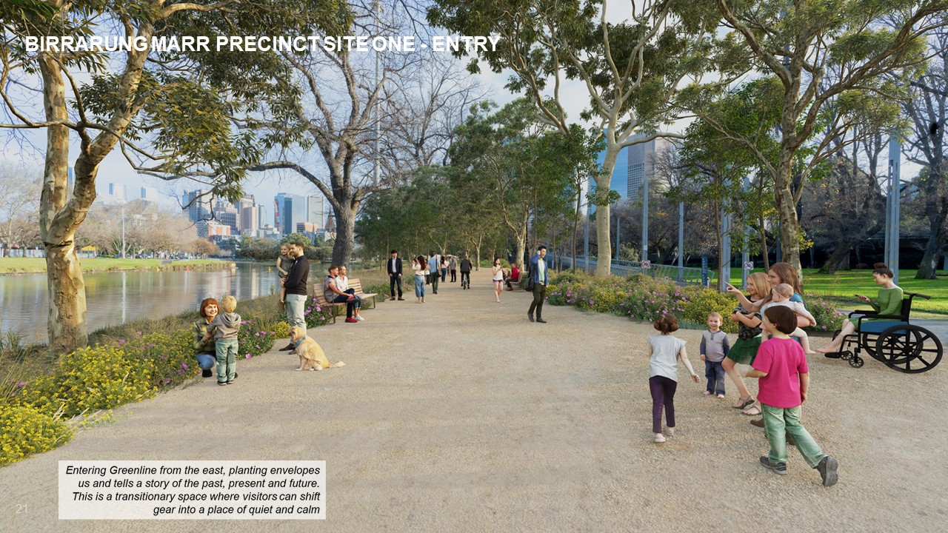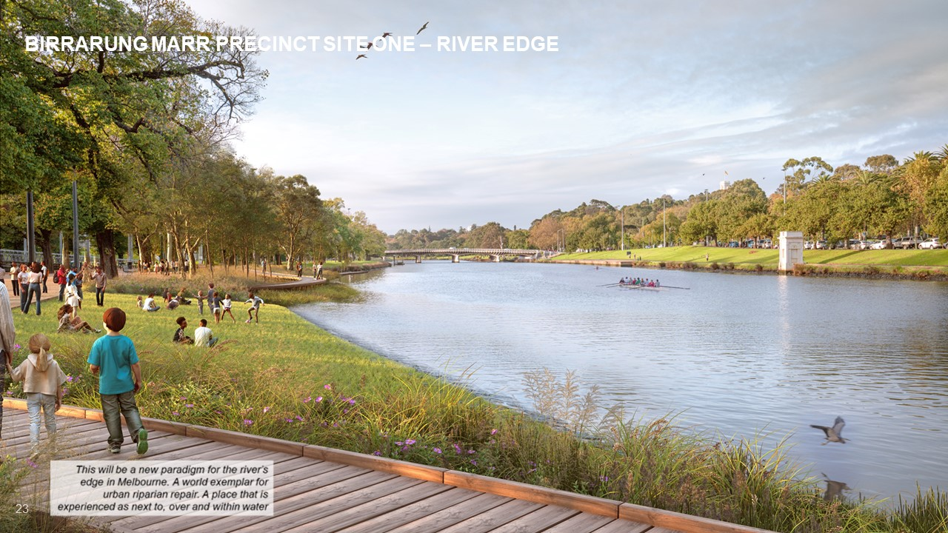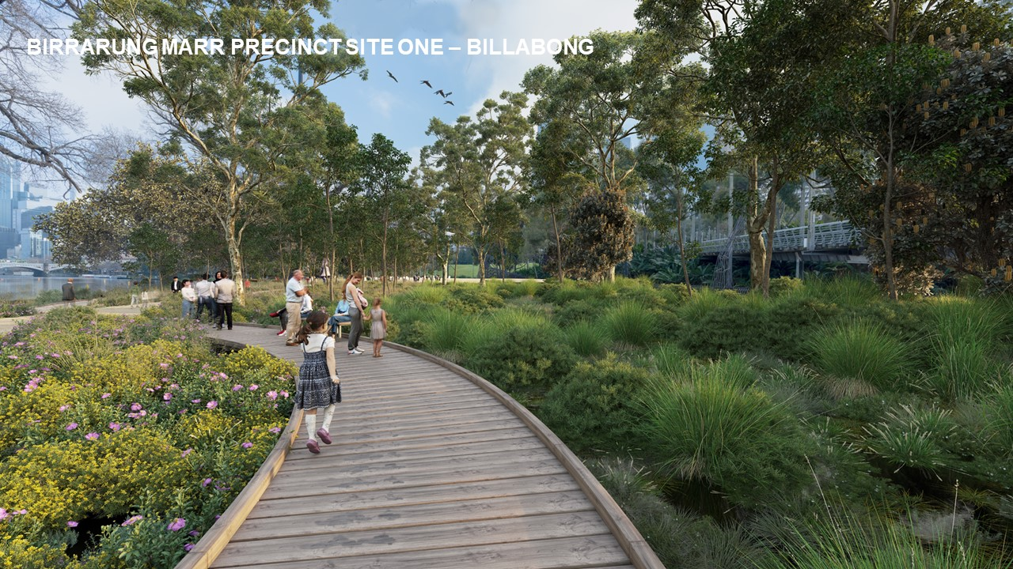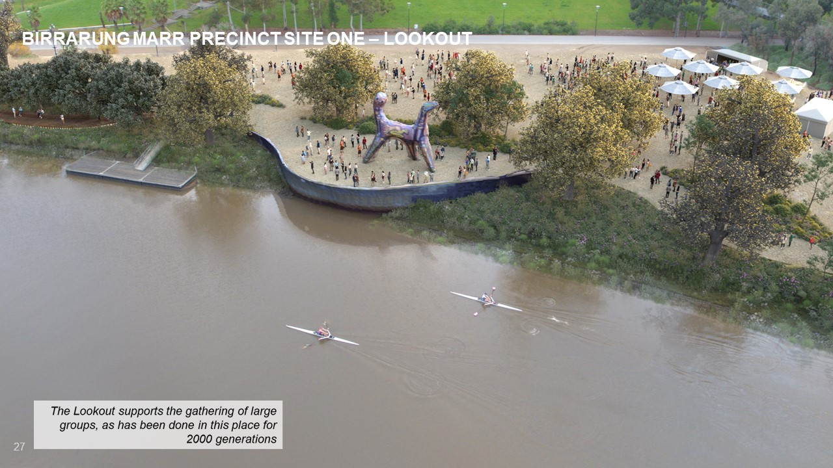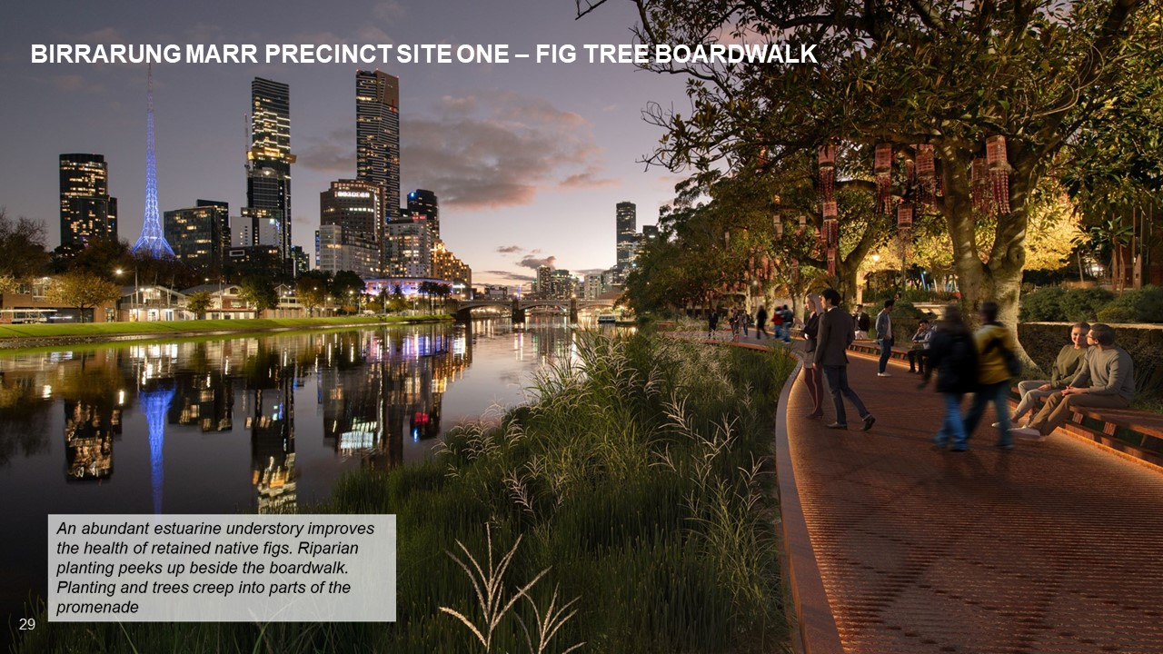

Appendix B: Survey questions
How often do you use the site in and around Birrarung Marr?
- Yearly or less
- A few times a year
- Monthly
- Weekly
- More than once a week
- Daily
How would you describe your use of the site in and around Birrarung Marr?
You may select more than one option.
- When the space is activated (programs, events, festivals)
- To participate in events, festivals, programs etc
- Passing through (on the way to public transport, to work, or Melbourne and Olympic Park Sports Precinct)
- For quiet recreation (reading, eating lunch)
- For active recreation (exercise, kayaking, cycling, running, walking)
- Family activities (playground, BBQ areas)
- For respite or refuge (from crowds and city noise)
- Other (please specify)
During the previous consultation we heard through community feedback that environment and ecological sustainability is highly important for Birrarung Marr’s river edge. How well do you think the ideas in the draft concept design address environmental and ecological sustainability?
- Insufficient
- Somewhat adequate
- Adequate
- Very good
- Excellent
Do you have any additional feedback on how the draft concept design addresses environmental and ecological sustainability?
What is your level of understanding about The Greenline Project?
- No knowledge
- Limited knowledge
- Good knowledge
- Very good knowledge
- Full knowledge
What type of activities/experiences would you like to see more of or added in this and future sites along The Greenline Project?
You may select more than one option.
- Art and music events
- Aboriginal culture events and ceremonies
- Cultural festivals
- Sport and wellness (marathons, yoga, boating, tai chi)
- Food
- Music
- Family friendly events or festivals
- Education programs
- Other (please specify)
Which of the following amenities would you like to see added or upgraded in this and future sites along The Greenline Project?
You may select more than one option.
- Lighting for use at night
- More public toilets
- More recreational areas for families (playgrounds, picnic/BBQ facilities)
- Handrails
- Benches/seating
- Water refill stations
- Charge stations
- Shade
- Other (please specify)
Which of the following would enhance the connection, safety and access to this and other sites for future development along The Greenline Project?
You may select more than one option.
- Amenities for people with accessibility requirements (handrails, benches, ramps, lifts)
- Better lighting (including for safer use at night)
- Emergency help line buttons across the area
- Safe zones
- Installation of security cameras
- Improved and accessible pathways from street level
- Easier access to public transport
- Easier access to car and bike parking
- Better signage and wayfinding (including in a range of languages)
- Other (please specify)
Please provide specific comments you may have on The River Edge.
Please provide specific comments you may have on The Billabong.
Please provide specific comments you may have on The Lookout.
Please provide specific comments you may have on Fig Tree Boardwalk.
What else would like to see as part of The Greenline Project?
Demographic
What is your age?
- Under 15 years
- 15-19 years
- 20-24 years
- 25-29 years
- 30-34 years
- 35-39 years
- 40-44 years
- 45-49 years
- 50-54 years
- 55-59 years
- 60-64 years
- 65-69 years
- 70-74 years
- 75+ years
- Prefer not to say
How do you describe your gender?
- Female
- Male
- Non-binary/gender diverse
- Prefer not to say
- I use a different term (please specify)
Do you identify with any of the following?
- None of these
- Prefer not to say
- Aboriginal
- Torres Strait Islander
- Person with disability
- Carer
- LGBTIQ+
- Speak a language other than English at home*
- Born overseas
- International student
*What language do you speak at home?
Which of the following best describes your connection to this City of Melbourne project?
- I am a resident
- I am a worker
- I own a business
- I am a student
- I am a visitor
- Prefer not to say
- Other (please specify)
Based on your connection to this project, where do you live/work/own a business/study/visit?
Please use the map below to help identify your neighbourhood.
- Carlton (3053)
- CBD Hoddle Grid (3000)
- Docklands (3008)
- East Melbourne (3002)
- Kensington (3031)
- North Melbourne (3051)
- Parkville (3052)
- Southbank (3006)
- South Yarra (3141)
- West Melbourne (3003)
- Fisherman's Bend
- Prefer not to answer
- Other/outside the City of Melbourne (please specify)
Have you participated in a consultation with City of Melbourne before?
- No, this is my first City of Melbourne consultation
- Yes, I have participated in a City of Melbourne consultation once or twice before today
- Yes, and I participate in City of Melbourne consultations regularly
- Not sure
- Prefer not to say

Environmental and ecological sustainability was identified as highly important for Birrarung Marr’s river edge through previous community feedback.
Blue infrastructure refers to water sensitive urban design (WSUD), water retention facilities, drainage areas (Planning a Green-Blue City, Department of Environment, Land, Water and Planning, 2017)

