Design and Construction Standards
For public infrastructure works in the City of Melbourne

Acknowledgement of Traditional Owners
City of Melbourne respectfully acknowledges the Traditional Owners of the land we govern, the Wurundjeri Woi Wurrung and Bunurong Boon Wurrung peoples of the Eastern Kulin and pays respect to their Elders past, present and emerging.
We acknowledge and honour the unbroken spiritual, cultural and political connection the Wurundjeri, Bunurong, Dja Dja Wurrung, Taungurung and Wadawurrung peoples of the Eastern Kulin have to this unique place for more than 2000 generations.
We are committed to our reconciliation journey, because at its heart, reconciliation is about strengthening relationships between Aboriginal and non-Aboriginal peoples, for the benefit of all Victorians.
Note: current versions
This version was last updated in September 2022.
As a whole, the standards described in this document are expected to remain current for many years. However, individual details may need to be updated to reflect evolving best practices. New versions of this document are likely to be issued. Users must ensure they are referring to the current version.

Contents
Message from the Lord Mayor and Deputy Lord Mayor of Melbourne 7
Executive summary 8
Part A - Introduction 10
A.1 Role of the Standards 10
A.1.1 Extent of application 10
A.1.2 When the standards apply 10
A.1.3 Statutory basis 10
A.1.4 Document audience 12
A.1.5 Related documents 12
Part B - Design approach 13
B.1 Using Standards in Design 13
B.1.1 Why use standards? 13
B.1.2 How to use the Standards 13
B.2 Public Realm Design Principles 15
B.2.1 Objectives 15
B.2.2 Guidelines 16
B.2.3 Modular systems 17
B.2.4 Selecting materials and details 18
B.2.5 Conserving heritage and character 19
B.2.6 Provision for change 19
B.3 Place-based Design Standards 20
Part C - Approval Process 26
C.1 Introduction 26
C.2 Overview – Submission and Approval Process 27
C.3 Development Plan 28
C.4 Planning Permit 30
C.5 Subdivision 30
C.6 City of Melbourne Design Approval 30
C.6.1 Briefs and designs for the public realm 32
C.6.2 City of Melbourne design approval submission requirements 34
C.7 Consent for Works 42
C.7.1 Consent for works submission requirements 43
C.7.2 Construction management plan 43
C.7.3 Tree protection management plan 44
C.7.4 Other authority approvals 44
C.7.5 Certifications and third-party audits 44
C.8 Construction 44
C.8.1 Hold points, progress inspections and approvals 44
C.8.2 Site minutes and records 45
C.9 Practical Completion and Handover 46
C.9.1 Pre-handover cleaning 46
C.9.2 Practical completion inspection 46
C.9.3 Defects rectification and bonding of works 46
C.9.4 Practical completion submission requirements 46
C.10 Defects Liability and Final Completion 52
C.10.1 Defects liability periods 52
C.10.2 Final completion 53
Part D - Standards for materials, construction and elements 55
D.1 Groundwater and Geotechnical Conditions 56
D.1.1 Saline water 56
D.1.2 Groundwater monitoring wells 56
D.1.3 Ground settlement 56
D.2 Stormwater Management 56
D.2.1 Water quality and pollution control 57
D.2.2 Design methodology and levels 58
D.2.3 Design for flood-prone areas 60
D.2.4 Drainage elements design 61
D.3 Streets and Routes 63
D.3.1 Footpaths and walking routes 63
D.3.2 Provision for universal access 65
D.3.3 Bike paths and on-street bike lanes 68
D.3.4 Vehicular traffic lanes 71
D.3.5 Vehicular crossings of footpaths 73
D.3.6 On-street vehicle parking 75
D.3.7 Shared zones 75
D.3.8 Parks and waterfront promenades 77
D.4 Paving and Surface Materials 78
D.4.1 Pavement design 78
D.4.2 Kerb and channel 82
D.4.3 Channels and spoon drains 84
D.4.4 Flush edges 85
D.5 Furniture 86
D.5.1 Supply and installation 86
D.5.2 Seats 87
D.5.3 Litter bins 90
D.5.4 Fountains, barbecues and tables 92
D.5.5 Bollards and fences 94
D.5.6 Bicycle parking 98
D.5.7 Skateboarding management 99
D.5.8 Public amenities and street trading 101
D.6 Signs 102
D.6.1 Directional and regulatory signs 104
D.6.2 Interpretive and commemorative signs 104
D.6.3 Temporary and events signs 106
D.7 Public Lighting 106
D.7.1 Light poles and fittings 108
D.7.2 Power supply and operation 112
D.8 Utilities Provision 114
D.8.1 Accommodation of utilities 114
D.8.2 Impacts of utilities 115
D.9 Planting and Irrigation 116
D.9.1 Placing trees in the public realm 116
D.9.2 Tree planting plot details 120
D.9.3 Other plantings 124
D.9.4 Mulches 125
D.9.5 Irrigation and drainage 126
D.9.6 Implementation and establishment 127
D.9.7 Planting over structures and in containers 128
D.10 Maritime Works 130
D.10.1 Functional criteria 132
D.10.2 Structural criteria 134
GLOSSARY AND ABBREVIATIONS 135
APPENDICES 139
Appendix C1: Developer Contribution Plan and Works in Kind 139
Appendix C2: City of Melbourne Submission Drawing Standards 141
Appendix C3: Public Realm Design Plan 142
Appendix C4: Typical Public Realm Construction Hold Points 148
Appendix C5: Typical Elements of Pre-Handover Cleaning 149
Appendix C6: Typical Asset Categories 150
Appendix C7: Typical Operation and Maintenance Manual Scope 152
Appendix D1: Current and Superseded Design Standards 153
Design and construction standards 153

Disclaimer
This report is provided for information and it does not purport to be complete. While care has been taken to ensure the content in the report is accurate, we cannot guarantee it is without flaw of any kind. There may be errors and omissions or it may not be wholly appropriate for your particular purposes. In addition, the publication is a snapshot in time based on historic information which is liable to change. The City of Melbourne accepts no responsibility and disclaims all liability for any error, loss or other consequence which may arise from you relying on any information contained in this report.
To find out how you can participate in the decision-making process for City of Melbourne’s current and future initiatives, visit melbourne.vic.gov.au/participate

Message from the Lord Mayor and Deputy Lord Mayor of Melbourne
Melbourne’s public realm is admired around the world. Our well-designed streetscapes, enduring street furniture and materials shape the city’s character and experiences.
A distinctive public realm relies on consistency, and these standards provide more clarity for land owners, developers, designers and the broader construction sector.
This document follows the full life cycle of a project – from inception to design and delivery. While these standards were originally developed for the Docklands area, we’ve amended them to apply to the whole municipality. Key changes include expanded guidance for environmental sustainability and furniture layout and updated information about design construction and approvals.
We’re confident these revised Design and Construction Standards will be highly useful to all involved in the planning, design, review, delivery and handover of public infrastructure. Developers, contractors and council staff all benefit from increasing their knowledge of Melbourne’s accepted design principles and standards. We value not just the aesthetic appeal of our city’s public realm, but its functionality, inclusivity, safety, durability and adaptability.
In creating a document for the whole municipality, we consulted the community – including council’s Design Excellence Advisory Committee – and have acted on the feedback we received. More clarity on planning processes, heritage guidelines and continuous footpath treatments have been included in response to the feedback.
All Melburnians can take great pride in our public realm. So many well-loved areas in our city contribute to Melbourne’s world-leading liveability and design excellence. Our new Design and Construction Standards set a high benchmark for maintaining this quality, and we commend them to you.
Sally Capp, Lord Mayor
Cr Nicholas Reece, Deputy Lord Mayor

Executive summary
The municipality of Melbourne has achieved a distinctive and high-quality public realm that is typified by aesthetic appeal, functionality and maintenance efficiency.
The Design and Construction Standards for Public Infrastructure Works in the City of Melbourne (Standards) apply to the public realm, including streets, lanes, parks, squares and waterfront promenades. The Standards assist City of Melbourne, developers, residents and other landowners with associated design, approval, construction and handover processes.
The process of public realm design and construction is complex, so this document aims to clarify needs and expectations and help enhance public realm works.
Part A is a general introduction; Part B describes general design principles that underpin the Standards; and Part C sets out the approvals, design, construction and handover process and the required documentation. Part D sets out dimensional standards, and standard materials and elements to be used in Melbourne’s public realm.
These Standards apply to the whole municipality of Melbourne except where equivalent standards exist in formal agreements linked to development approvals. Examples are the Docklands and the Metro Tunnel Project sites.
This document extends and updates those previous documents so as to apply to the entire municipality but maintains the same approach and structure.
The Standards defer to town planning and similar statutory requirements and focus on the processes, requirements and submissions following any development approvals.
The Standards include references to relevant City of Melbourne policies, strategies and individual design and technical standards, and other documents such as Australian Standards. However, users must ensure they are referring to the most current versions of these publications.

Figure 1: The area of application of the Standards, City of Melbourne municipal boundary and neighbourhoods.
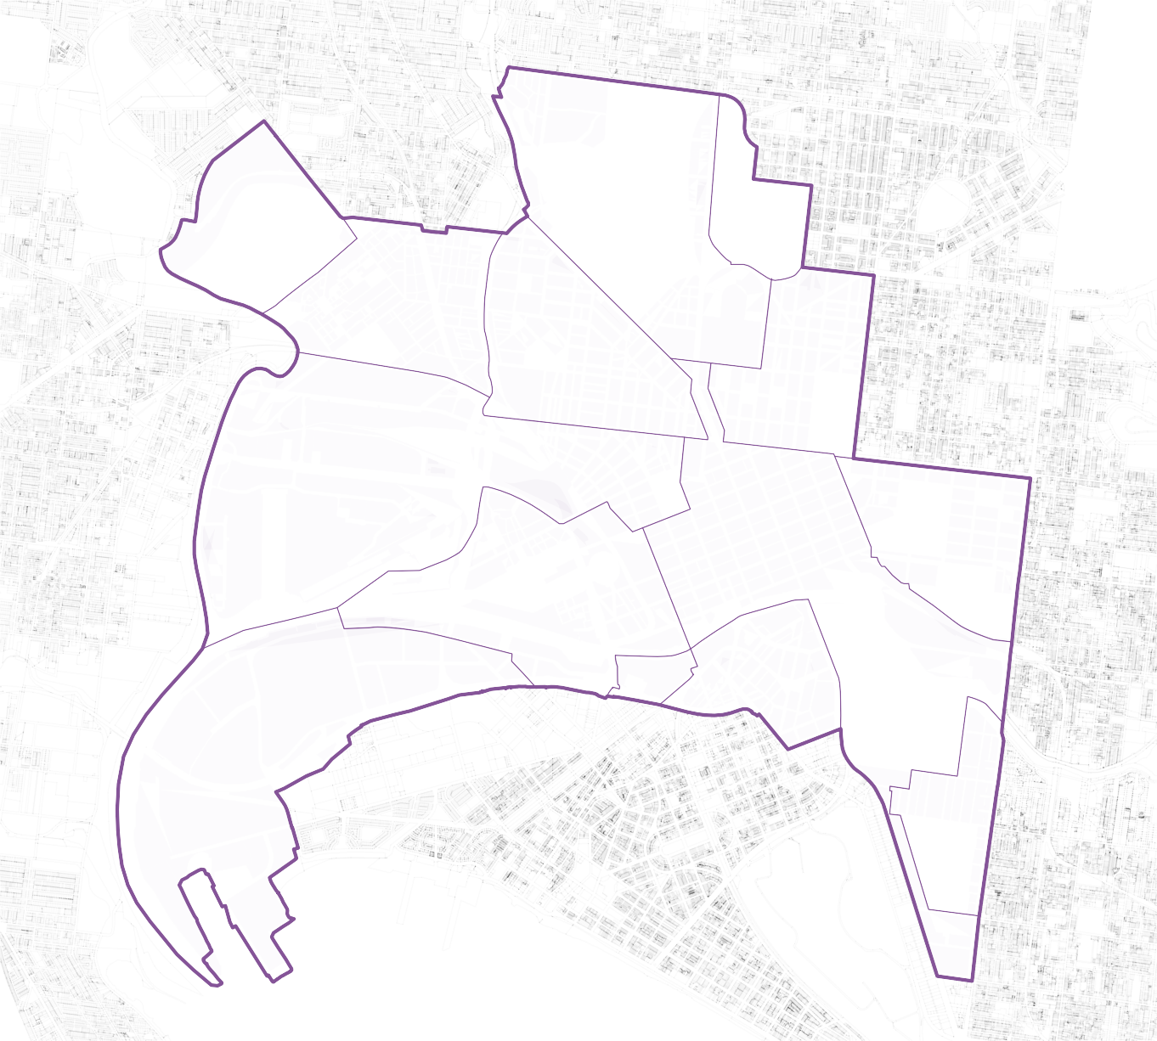
Parkville
Flemington
Kensington
North Melbourne
Carlton
West Melbourne
Melbourne
East Melbourne
Docklands
Southbank
Port Melbourne
South Yarra

Introduction

Role of the Standards
These Standards for Public Infrastructure Works in the City of Melbourne (the Standards) set out approval processes and technical requirements for all civil, landscape and infrastructure works in the public realm. They draw on City of Melbourne’s field research and observation of products and materials over decades. They balance aesthetic appeal, functionality, compliance with Australian Standards, efficient maintenance and sustainability across the municipality.
Appropriate use of these Standards helps to ensure that:
- works meet the demanding functional and safety standards required for public spaces
- works support community and City of Melbourne aspirations
- the resulting places and infrastructure can be well-maintained without unreasonable expense.
The use of design standards across multiple projects also helps to ensure that incremental development contributes to a cohesive vision identified in strategic plans and masterplans. The Standards therefore act as an important strategic tool guiding development of the city’s public realm and complement other strategies we use to direct planning, projects and works.

Extent of application
The Standards apply to the whole municipality of Melbourne except where equivalent standards exist in contractual agreements linked to development approvals, such as Docklands and the Metro Tunnel Project.
The Docklands and Metro Tunnel documents will become obsolete when relevant contracts conclude, at which point we envisage that a single design and construction standard will apply everywhere. In some cases, individual standards for detailed elements referred to in the above documents have already been updated or renamed, as listed in Appendix D1: Current and Superseded Design Standards.
The Standards apply to all of the public realm that is or will be owned by or vested in the City of Melbourne, where we are the Committee of Management. They may also apply by agreement and can inform design considerations for publically accessible private space.
The Standards apply to all public realm works, whether undertaken by City of Melbourne, the Victorian Government and its agencies, or developers (and their contractors and consultants) who deliver improvements to public spaces.
The Standards apply to reinstatement, for example, after underground services works and to new designs for spaces.

When the standards apply
It is essential to consider the Standards at the outset of project planning to understand expectations for quality, allow for appropriate budget allocations, and inform a design approach using standard elements rather than relying on extensive customisation.
We use the Standards as the basis for approval of all public realm works. Various types and levels of approval are required at each stage of a project and requirements for approvals are outlined in Part C.

Statutory basis
Compliance with the Standards is a statutory requirement under the Melbourne City Council Activities Local Law 2019.
If you submit non-compliant public realm works or elements, you risk refusal of practical completion and handover, prolonging developer insurance, liability and maintenance until satisfactory rectification.

Document audience
The Standards are intended to assist people involved in the design and construction of the public realm. This includes three key groups:
- developers of the municipality’s public realm, including their consultants and contractors
- City of Melbourne staff responsible for assessing stages within the approval process
- City of Melbourne staff involved in planning, designing, developing and managing the public realm.
In this document:
- “we” and “us” refer to City of Melbourne or any member of staff who has been delegated power by an Act of parliament or other law, for example, the Local Government Act 2020 (Vic) as reviewers and approvers of works in the public realm.
- “you” refers to the person applying for approval, permit or consent for design and construction, and all other people involved in the design and construction of the public realm. This includes developers, project managers, designers or other consultant or officers, contractors or works managers, acting as a delegated representative of the entity name that appears on any application, approval, permit or consent. This also includes City of Melbourne staff involved in projects we design and deliver.

Related documents
The Standards should not be read in isolation. They apply in conjunction with applicable legislation, related strategic and technical documentation issued by City of Melbourne, and standards and guidelines issued by Victorian Government agencies, service providers and authorities.
Within this document, we refer to City of Melbourne’s individual design standards, which explain how individual elements should be used in the public realm. Those standards include additional references to engineering standard drawings, fabrication drawings and technical specifications for more detailed information.
Please refer to our website or contact our City Infrastructure Branch on 9658 9658 to obtain a copy of any City of Melbourne standard detail or fabrication drawing.

Design approach

Using Standards in Design
This section describes design principles that underpin City of Melbourne’s approach to the design and management of the public realm. It identifies a strategic and philosophical approach to the delivery of an enduring, high-quality, high-amenity public realm that supports our capacity to provide for equitable community wellbeing, environmental sustainability and the long-term economic prosperity of our city.
Objectives stated here must be followed in all works.
Guidelines stated here should be followed in most works, although site-specific situations may require an alternative approach. Any alternative must be approved and support all objectives.

Why use standards?
People using the city contribute to the sense of place, as do artworks, architecture and window displays. Standard materials and elements in the public realm complement these characteristics and highlight genuinely distinctive features that give places their identity.
Design standards are useful in public realm design for many reasons:
- Locally-based design standards promote a cohesive character and a strong sense of place that help meet the long-term strategic vision for the municipality’s physical environment.
- Consistent use of the same details in similar situations makes the city easier to read, supporting wayfinding and safety.
- Consistency supports efficient management and maintenance, preservation of original designs, and economies of scale in the supply and replacement of parts. Tried and tested standards reduce risks of failure.
- Clear standards support appropriate project budget allocations and informed design.

How to use the Standards

When do Standards apply?
Standard materials and elements must be used for all new works and reconstruction.
The municipality has a mix of street furniture and civil construction details, resulting from varied influences at different times. The site context should be considered when choosing details.
For minor works and repairs, match existing materials and elements at and adjoining the works. If two or more materials or elements exist, use the one most typical of the site and its surroundings. For conservation of significant features, maintain intact historic features unless they cause an unsafe or dysfunctional situation.
Why use standards?
- Locally-based design standards promote a strong sense of place
- Consistent use of the same details in similar situations makes the city easier to read
- Tried and tested standards reduce risks of failure
- Clear standards support project budget allocations and informed design

When are non-standard items justified?
Standard materials and elements are to be used in all standard situations. Departure from standard materials and elements requires approval from City of Melbourne, and may be supported if:
- the site will never be managed and maintained by City of Melbourne
- functional requirements are not met by existing standard materials or elements
- the conservation of significant heritage features requires special treatments
- unusually durable materials and protection from the risk of damage ensures maintenance requirements will be minimal
- in rare cases, it is important that a particular space has a distinct identity.
Artworks are also not standardised. We have separate guidelines for commissions, acquisitions and transfers of artworks. For any artwork to be considered for our collection, our Creative Urban Places Branch (including the public art program and art and heritage collection) must be involved at the onset of the commissioning process, including participation in the selection panel.
We seek to provide diverse play opportunities addressing the developmental needs of different age groups and demographics. This frequently requires custom-designed facilities, although standard furniture elements are often appropriate as part of many play spaces. We require early consultation when you are planning and designing for play. Our Parks and City Greening Branch will assess approval, in association with City Design.

Approval for non-standard details
City of Melbourne Design Approval is required for the use of all non-standard materials and elements. Approval is also required for any non-standard use of standard materials or elements – that is, for functions other than those intended or in locations other than those specified.
As general guidance, to gain approval for non-standard items:
- materials used must be able to be sourced in the future to enable maintenance and repair
- asset maintenance requirements and issues must be detailed as part of the submission for approval
- materials must provide an asset life that is equivalent to, or greater than, materials normally used and must be durable in a coastal marine environment
- materials must contribute towards strategic objectives to support sustainable development. We prefer materials from renewable sources that reduce waste and inputs for maintenance, that can be readily repaired to extend their useful life and that can be managed as part of a circular economy.

Public Realm Design Principles

Objectives
The following objectives are fundamental to the design of the municipality’s public realm. They need to be supported at all levels, from broad-scale planning to design detail, and through all approaches, from engineering works to community engagement programs.
Designs must be functional, well planned and built with appropriate materials and technology that works well for all users. They must be:
- legible, understandable, safe, secure and appealing to the users of the space, with good visual links and strong passive surveillance
- seamless, with a cohesive and linked network that is easy to understand and navigate, and that integrates different transport modes, providing direct connections and easy transitions
- universally inclusive, with access routes, space and facilities that are obvious and accessible to all members of the community without barriers or differentiation
- walkable, with supporting pathways and useable public space that prioritises pedestrian connections across and between transport corridors and links into local streets and networks.
Designs must support the community and promote social, environmental, cultural and economic values. They must be:
- socially responsive, supporting community aspirations for the place
- economically enabling, supporting and being activated by adjoining land uses
- conducive to community health through the provision of comfortable places and active lifestyles
- respectful and supportive of biodiversity values.
Designs must be enduring and sustainable, relevant across the lifespans of many generations, representative of their time and of a high quality. They must assess long-term life cycle implications and future renewal opportunities. They must be:
- responsible, minimising the use of energy and resources, emissions and generation of waste
- durable and easy to maintain so they age gracefully and support capacity for future adaptation.
Designs must be enjoyable, creating a desire to experience the journey rather than just pass through. They must be:
- engaging, reflective and responsive to diverse community values, and encouraging positive interaction
- delightful, authentic, sensitive and intelligent in the design of form, space, proportion, craft and detail
- site responsive, reflecting specific local conditions including landscape, built form and other features
- valuing heritage, responding to history and memory, and showing understanding of, and continuity with, the past.
Objectives
- Designs must be functional, well planned and built with materials that work well for all users
- Designs must support the community and promote social, environmental, cultural, and economic values
- Designs must be enduring, sustainable, representative of their time and of high quality
- Designs must be enjoyable, creating a desire to experience the journey

Guidelines
Melbourne’s streets generally have a particular look. This is not a house design style. It reflects how streets function, how they are built and maintained, and the use of materials that are characteristic of the area (especially bluestone). These factors apply consistently throughout the municipality.
Consistency in design, including use of materials and details, is also essential to the safe functioning of streets. Design consistency helps people to develop a shared understanding of how to behave in busy spaces when inevitable conflicts occur between different modes and directions of traffic.
In the design of public spaces and infrastructure for Melbourne, the following approaches are therefore encouraged.
Make the setting, not the feature
Most urban spaces should be designed primarily as a setting – for travel, trading, socialising, recreation, art and architecture. In combination, these things can be chaotic. A good design ties them together with an orderly and relatively neutral treatment.
Design the space, not the plan
Plans emphasise ground surfaces, and can inadvertently encourage the use of decorative paving to make appealing drawings. However, three-dimensional features are more obvious than paving in real life views, and more important as a focus of design detail.
Make spaces work
Avoid an exclusive focus on a single use. Support diverse uses, at once and over time. Ensure these multiple uses coexist safely. Check for required and expected clearances. Consider functions that may not be obvious, like cleaning and water sensitive urban design.
Fit in
Support the place’s character. Match existing details unless there are plans for extensive change in the area. Ensure the project site extends widely enough to include related features. Extend plans to logical boundaries, like the next intersection or driveway along a street and the opposite building line.
Line things up
Maintain the area’s characteristic layout and geometry to protect its visual character and support legibility. Maintain regular kerb alignments and setbacks. Keep things predictable to enable access by people with visual impairments, especially on major routes and busy thoroughfares.
Keep it simple
If alternative standards are suitable, use the simplest. Introduce complexity only to increase the usability of a space. Minimise visual and physical clutter. Avoid an unnecessary variety of materials and detailing, especially in large formal spaces. More complex designs may be better suited to intimate spaces.
Work to a long-term plan
Look at the broader context and think strategically. Avoid ad hoc changes. If current priorities affect a limited site, consider how likely future changes around it would be designed. If a change in the area’s character is called for, work consistently towards this new character on an incremental basis.

Modular systems
Many of our standard design elements use modular components or systems. This approach:
- enables a diversity of design options while using only a limited range of parts
- facilitates the replacement of damaged or worn-out parts without wholesale reconstruction, thereby reducing costs, waste, and carbon footprint, minimising disruption to the public amenity
- when designing public spaces, knowing in advance what these modules are allows the layout to be set up so elements can be placed easily, without conflict, and without requiring customisation during detailed design phases.
Examples of this modular approach in the standards include:
Kerbs
Standardised kerb radials have been used in Melbourne for generations, enabling costly stonework to be reclaimed and reused when street layouts are altered.
Paving
Standard paving modules are in nominal dimensions of 500 mm x 250, 500, 750, or 1000 mm (allowing for joints). These are typically laid in a simple stretcher bond pattern, but the sizes allow for other patterns such as herringbone and even mixtures of sizes to add interest in special areas.
Lights
The range of standard light poles, brackets and luminaires developed over the past several years has been rationalised to a limited range, which can be combined in various ways. For example, the same 5.5 m tapered aluminium pole is used for the park light and promenade light, while the 10 m tapered aluminium pole works for the capital city light, neighbourhood light, plaza light, and the tall version of the promenade light.
Seats
The stainless-steel capital city seat, originally used in Bourke Street Mall, has been used in various lengths over recent years. This has been rationalised into a modular system using 2 m long straight or curved sections, with or without backs that can be used separately or linked together to create longer seats.
Litter bins
We have rationalised the range of litter bins we use to a standardised body with varied tops to suit requirements for ordinary litter and recycling bins.

Selecting materials and details
These Standards minimise decisions about the materials or details to use in a project. If an applicable standard has been established, it should be used. Areas for the appropriate use of standard items are explained in the following sections.
However, there are situations where site-specific details are appropriate.
Understanding the rationale behind standards helps you use them appropriately. Criteria for selecting the standards, which also apply if site-specific details are required, include:
Functionality
Streets are the city’s most essential public spaces and must support universal public access and many varied activities. They require provision for safety, physical comfort, and high aesthetic quality. Spaces must be dimensioned to suit priorities for use, generously or meagrely as appropriate to encourage or merely allow particular functions. Materials and their form of use must be suited to the broad functions for which they are employed.
Sustainability
Public spaces need to support the activities that comprise a sustainable urban system, especially walking. Relatively high-impact treatments may be justified in specific places to create a more efficient whole. Otherwise, select details to minimise energy and materials used in construction, operation and maintenance, working as much as possible to support the objectives of a circular economy.
Robustness and durability
Materials and fixtures should be proven in local conditions. They must withstand heavy traffic and other pressures inherent in streets to ensure their longevity and ongoing safety. This principle relates to the materials and the details of how they are used.
Ease of maintenance and replacement
Management, maintenance, replacement, replication and installation must be easy to achieve without compromising the finish of nearby pavements, programs or other features.
Respect for context
Details should be suited to and supportive of their context. They should be in harmony with their setting, helping to maintain and enrich its distinctive urban character.

Integration of the public realm
There should be a clear relationship between the site and its context to contribute to the cohesiveness of the public realm. Special areas may be distinct from their surroundings but should not be incongruous or disjointed from them; they should be experienced as part of the whole rather than separate from it.

Conserving heritage and character
Large areas in the municipality are protected by the Victorian Heritage Register and Heritage Overlays in the Melbourne Planning Scheme. Design standards are intended, in part, to protect urban character, but this is not the same as conserving cultural significance. Conservation aims to protect significance by minimising change. Design standards aim to protect character even while facilitating change.
In areas affected by heritage overlays, principles for public space design include:
- Consult any relevant statement of significance to determine what the overlay is intended to protect.
- Minimise change of significant fabric. Avoid removing, altering or relocating significant or contributory features.
- Where uses or safety issues demand change, the option that interferes least with the significant fabric is generally best. Consider what interferes least with regard to the maintenance needs of the feature. For example, many paving materials must be periodically replaced or reset to maintain a smooth, trafficable surface. Wholesale lifting and resetting of pavers as part of a functional adaptation may therefore be preferable to piecemeal changes that affect less of the fabric in the short term but disrupt its overall pattern.
- Reconstruct original details that have been removed if this makes a safe and functional arrangement and if evidence exists to guide accurate reconstruction. However, this must be seen in context: for example, details from an old house would not be reinstated into a modern house on the same site; nor should obsolete details be reinstated into a modern street design.
- For new works, we encourage contemporary designs that complement a heritage place. New work should reflect the rhythm and spatial characteristics of its surroundings but should not mimic heritage features.
Heritage overlays are typically based on buildings’ intactness, not the integrity of public spaces. Old buildings along a street often support the application of a heritage overlay to a precinct, even though pavements and other features of the public realm have been extensively changed. The converse situation rarely applies, although there are sometimes elements that merit retention in a public space that is not subject to heritage controls. Heritage overlays are therefore only a partial guide to where sensitive conservation is appropriate in streetscape works. Any design project should commence with a careful assessment of existing site conditions and features.

Provision for change
In areas where new development is anticipated, the size of spaces to suit long-term needs may seem excessive in the short term. In such situations, temporary or reversible measures can be used to reduce the perceived scale to suit existing levels of use, while allowing for future adaptation to suit increased use.
Temporary measures can include plantings (especially using relatively fast-growing and short-lived species), street furniture and screen structures. Temporary art installations may also be appropriate. On streets and other areas open to vehicular access, car parking may be appropriate as an interim measure.
Any temporary treatment should be accompanied by a plan for its future removal or conversion.
Unlike the basic size and layouts of spaces, furniture provision should reflect current demands, with spaces being designed to allow for future additions of furniture as and when appropriate.

Place-based Design Standards
More than one standard exists for some elements because some have been developed to suit particular areas or situations. The map and table below provide an overview of what to use where. Further guidance is also provided in the following sections of this document, and in the Design Standards.
Figure 2: Where different standards apply within the municipality
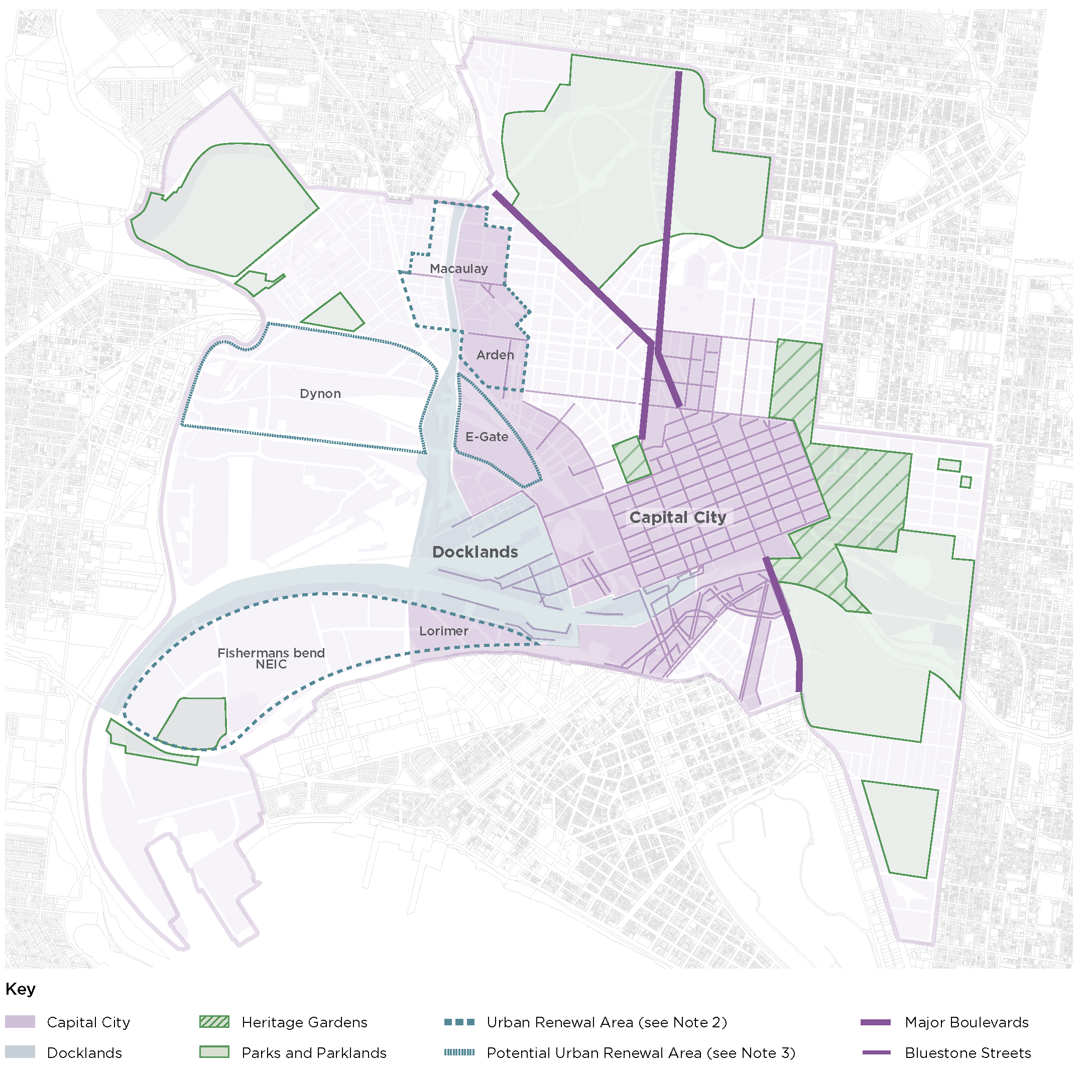

Table 1: Elements and preferred styles in different areas
Area: Capital City
- Hoddle Grid
- key parts of major growth areas* including Southbank
- City North
- Carlton South,
- Arden Macaulay
- Lorimer Street Precinct of Fishermans Bend (away from the riverfront)
Element | Preferred Styles (Exceptions May Apply)
Bluestone paving | Yes, but avoid use in areas subject to subsidence  - Standard  - Trafficable  - Sawn-top Pitcher  - Shared Zone
Lights for streets without trams | - Capital city light
Lights for streets with trams | - City joint use pole
Lights for pedestrian spaces | - Promenade light
Lights for little streets and laneways | - Capital city light – wall mounted  - Catenary lighting
Seats | - Stainless steel seats
Litter bins | - Standard bin, stainless steel finish  - Solar compactor bins
Bollards | - Fin bollards  - HVM bollard  - Heritage style bollard, charcoal finish
Fences | Steel safety rail fence

Area: Docklands Precincts
- Docklands
- riverfront areas of Fishermans Bend (between the Yarra and Lorimer Street)
Element | Preferred Styles (Exceptions May Apply)
Bluestone paving | Yes, but only east of Bolte Bridge and avoid use in areas subject to subsidence  - Standard  - Trafficable  - Sawn-top Pitcher  - Shared Zone
Lights for streets without trams | - Capital city light
Lights for streets with trams | - City joint use pole
Lights for pedestrian spaces | - Waterways light
Lights for little streets | - Capital city light – wall mounted
and laneways | - Catenary lighting
Seats | - Stainless steel seats
Litter bins | - Standard bin, stainless steel finish
Bollards | - Fin bollard  - HVM bollard  - Heritage style bollard, charcoal finish
Fences | - Steel safety rail fence

Area: Heritage Gardens Precincts
Large public gardens and associated spaces near the Hoddle grid: Flagstaff, Fitzroy, Treasury, Parliament and Carlton Gardens, Gordon Reserve, College of Surgeons
Element | Preferred Styles (Exceptions May Apply)
Bluestone paving | No
Lights for streets without trams | - Capital city light
Lights for streets with trams | - City joint use pole
Lights for pedestrian areas | - Park light, green finish to pole  - Plaza light
Seats | - Park seat, green finish to frame
Litter bins | - Standard bin, green finish  - Possum proof
Bollards | - Heritage style bollard, green finish
Fences | - Steel hoop fence, green finish  - Steel safety rail fence (in streets)
Area: Parkland Precincts
Royal, Princes, Westgate, and Yarra Park, Birrarung Marr, and smaller parks outside Capital City area including Argyle Square, Powlett Reserve, Darling Square, Clayton Reserve, Gardiner Reserve
Element | Preferred Styles (Exceptions May Apply)
Bluestone paving | No
Lights for streets without trams | - Neighbourhood light (10m)
Lights for streets with trams | - City joint use pole
Lights for pedestrian areas | - Park light, charcoal finish to pole  - Plaza light
Seats | - Park seat, charcoal finish to frame
Litter bins | - Standard bin, charcoal finish  - Bin corral in key picnic areas  - Dog waste  - Possum proof
Bollards | - Square timber
Fence | - Square timber post and rail  - Steel hoop fence, galvanised finish  - Steel safety rail fence (in streets)
Area: Neighbourhoods
Neighbourhoods under heritage overlays*, other areas expecting only limited new development, transitional areas at edges of growth areas
Element | Preferred Styles (Exceptions May Apply)
Bluestone paving | Footpaths along identified priority streets only  - Standard  - Heritage Laneways  - Pitcher  - Sawn-top Pitcher
Lights for streets without trams | - Neighbourhood light (10 m)
Lights for streets with trams | - City joint use pole
Lights for pedestrian spaces | - Neighbourhood light
Seats | - Park seat, charcoal finish to frame
Litter bins | - Standard bin, charcoal finish
Bollards | - Heritage style bollard, charcoal finish  - Square timber
Fences | - Square timber post and rail  - Steel safety rail fence (in streets)

Area: Major Boulevards
Royal Parade, Flemington Road, Elizabeth Street, Victoria Parade, Wellington Parade North, St Kilda Road, Peel Street
Element | Preferred Styles (Exceptions May Apply)
Bluestone paving | - Match adjoining zone
Lights for joint use tram poles | - City joint use pole
Lights without tram supports | - Neighbourhood light (10 m)
Seats, litter bins, bollards, fences | - Match adjoining zone

* Note that these area designations do not entirely correspond with land use zones or local areas in the Melbourne Planning Scheme, which have similar names. Boundaries for renewal precincts and heritage overlays are also rationalised to physical boundaries that help to create appropriate separation between areas using different materials or details so that awkward transitions do not occur. The application of design standards within renewal areas will be guided by current policy in the Melbourne Planning Scheme.

Approval Process

Introduction
This section outlines the approval process, providing a brief overview of the different stages of project development. We recommend you seek our guidance before making a submission.
- Public realm works are delivered to the City of Melbourne by a variety of mechanisms:
- by developers as a statutory or regulatory requirement
- by the City of Melbourne capital works program
- by City of Melbourne service contractors or
- as assets gifted by public or private bodies.
Design and implementation of public realm works may also span several stages, each requiring approval by the relevant responsible authority. These stages are typically as follows, the first three stages of which are discussed in outline only in this document:
- Development Plan
- Planning Permit
- Subdivision
- City of Melbourne Approval of Public Realm Works
- Consent for Works
- Construction
- Practical Completion and Handover
- Defects Liability and Final Completion.
This section summarises the intent of these stages, the level of design resolution required to support the intent, and the documentation required to explain the proposed designs. It focuses exclusively on City of Melbourne’s requirements for the public realm.
Each stage has different permit and documentation requirements. Complying with the requirements of this document will assist in avoiding delays in obtaining approvals. Compliance with the Standards is a statutory requirement under the Activities Local Law 2019.
This document does not address:
- general planning permit and subdivision application requirements (refer to the Melbourne Planning Scheme and the Subdivision Act)
- the competitive tendering process
- documentation and approval requirements of other stakeholders, agencies and authorities (for example, Department of Transport, VicRoads, Melbourne Water and Parks Victoria).

Overview – Submission and Approval Process
The public realm design and construction process is supported by and responds to our design context and the mandatory approvals and submission requirements that govern the development of the municipality’s fabric.
City of Melbourne requires that any public realm works appropriately reflect its:
- strategic vision and policy framework
- technical processes and standards
- continuing improvement evaluations and recommendations.
City of Melbourne must also ensure that:
- relevant statutory and regulatory requirements are satisfied in the design and construction of public realm components
- permits, approvals and consents are issued progressively and complied with, and contractual obligations are satisfied
- works in kind projects by developers meet the requirements of the Melbourne Planning Scheme.
Building on this submission and design context, the Standards also set out a more detailed staged approach to public realm design, construction, handover and subsequent management and maintenance.
The diagram below shows the relationships between:
- strategic and technical guidance for the design of the public realm
- various levels of approval required for works
- stages of project design and development.

Figure 3: Relationships in public realm design, approval and construction
Funding for works
The costs of public realm works are subject to agreements outside the scope of the Standards.
Development within renewal areas is expected. Further detail on developer contributions and works in kind is provided in Appendix C1: Developer Contribution Plan and Works in Kind.
Community engagement
Some stages of the approval process may require community engagement as deemed appropriate by City of Melbourne or the responsible planning authority. If so, we will determine the engagement scope and program, and the developer of the public realm must as directed:
- undertake or permit community engagement as approved
- provide presentation materials to support the community engagement process
- attend community engagement meetings, as appropriate.
General documentation and drawing standards
All documentation submitted to us during the approval process must be prepared by suitably qualified individuals or companies. It must be coordinated, accurate and comply with specific project requirements and checked. We will reject submissions that do not meet our standards, and require resubmission.
The list below provides an overview of the level of design resolution required at key project stages:
- development plan or master plan – concept design resolved to an extent that further design can occur on a site-by-site basis without affecting the functionality of the precinct as a whole
- subdivision approval – plan of subdivision completed with boundaries accurately resolved and representing the ownership responsibilities of future landowners and easement rights of others
- planning permit – schematic design resolved to an extent that further design work is focused on details and construction, with no change in off-site impacts and with no significant functional or visual change
- City of Melbourne design approval – fully detailed design documentation required to support construction
- practical completion and handover – construction hold points must be satisfied and accurate, and complete documentation of works completed as actually constructed.
Detailed documentation requirements for submissions at each stage are provided in Appendix C3: Public Realm Design Plan.

Development Plan
Sites that are large and significant, or located in an urban renewal area, require development plans. In other cases, any public realm provision may be dealt with directly by the planning permit or equivalent site-specific incorporated document.
Development plans include consideration of public realm issues. They provide an overview of approved land use, built form, public realm, transport and access, drainage and other infrastructure requirements and support the staged delivery of development within the area they apply to. Development plans may be required to be prepared and approved by the relevant responsible authority under the Melbourne Planning Scheme. They will contain relevant public realm objectives, locations, descriptions and references to strategic and policy documents.
A planning permit is still required for the further development of all or individual portions of the development plan area, which must be consistent with the relevant approved plan and its particular public realm provisions.
Detailed documentation is provided in Appendix C1: Developer Contribution Plan and Works in Kind.

Planning Permit
Details of the planning process are beyond the scope of this document. In summary, planning permits are issued by the relevant responsible authority and are required prior to the commencement of any works. City of Melbourne is the responsible authority for developments with a gross floor area of less than 25,000 m2. The Victorian Minister for Planning is the responsible authority for consideration and decision on all planning applications for developments with a gross floor area exceeding 25,000 m2 and for other sites by specific designation. In this case City of Melbourne is typically a referral authority.
Planning permit conditions often require the submission of detailed information for further approval, including details of public realm works, access, waste management, drainage and public lighting. The planning permit might also specify governance matters such as public accessibility and maintenance responsibilities.
Sometimes an incorporated document replaces a planning permit, to provide specific controls that vary the adopted Melbourne Planning Scheme provisions. These site-specific provisions may include public realm matters like a planning permit.
The pre-application and application process will define the extent of new or reinstated public realm that is to be part of the development and confirm responsibilities for the funding and organisation of works. Public realm areas, costs and responsibilities will be described by the conditions in any subsequent permit. Public realm design briefs and designs are not normally prepared at this stage and are dealt with below, in section C.6.1.1.

Subdivision
City of Melbourne is the responsible authority for assessing land subdivision applications and any public realm matters associated with the application.
There are three potential types of plans and approval:
- transfer of land to commence construction – the start of the process (staged release)
- subdivision of land for sale by the developer – sale of land
- re-subdivision at the end of development – this may include the redefinition of the public realm.
To receive subdivision approval, all referral authorities’ requirements must be completed to the satisfaction of our Planning and Building Branch (Land Survey) under Victoria’s Subdivision Act 1988. All issues, including any public realm issues, must be resolved to the satisfaction of the City of Melbourne’s Planning and Building Branch (Statutory Planning) prior to the issue of the statement of compliance.

City of Melbourne Design Approval
City of Melbourne design approval ensures that the design aims for public realm works are clear and that the final construction is fit for purpose, appropriate to the location, consistent with all relevant standards and supported by necessary supplementary information.
Our City Infrastructure Branch coordinates the review and approval of all public realm design and implementation works in consultation with the other relevant branches.
They also review the consistency of the design in relation to any approved development plan or planning permit.
All applications for approval must be directed to the City Infrastructure Branch.
Several steps are involved, requiring staged submission and approvals, including:
- public realm design brief
- public realm design plan – schematic design stage
- public realm design plan – design development stage
- public realm design plan – construction documentation stage.
For each of these steps, the scope, complexity and extent of integration of submissions will reflect the works required. Submissions must address the following as relevant to the project:
- property titles and ownership plan
- traffic management plan
- stormwater drainage management plan and design
- public realm lighting plan
- tree management plan
- planting over structures and in containers
- place naming
- wayfinding (pedestrian) signs
- public art drawings and documentation
- non-standard materials and elements documentation
- durability plan for maritime works
- certifications and third-party audits.
Although the above may be individually named on development approval documents or may originate from different sources, the information they contain must be checked and coordinated to ensure a satisfactory, integrated public realm. It is therefore preferable that submissions are made at the same time.
Incomplete, uncoordinated or inconsistent submissions are likely to result in delays as a result of requests for further information or resubmission.
Permission is required before undertaking any construction works that may impact City of Melbourne’s public areas or assets. As a minimum, permission will require that any of our assets affected by the works are returned to their original condition in accordance with these standards. The purpose of the consent for works process is to ensure that works are carried out in a safe and logical manner, with minimal disruption to other activities in the public realm and without damage to other assets.

Briefs and designs for the public realm

The public realm design brief
For most works, we prepare a public realm design brief specific to the project, in consultation with the developer for the agreement of all relevant parties. This applies to projects undertaken by City of Melbourne and those undertaken by other parties.
The extent of the brief should reflect:
- any planning permit conditions that must be met
- the size and complexity of the site
- the extent to which works entail renewal of existing conditions, new works, or a combination of both.
Projects of small scale or low complexity will only require a short, simple brief. However, briefs should integrate all relevant aspects of road, streetscape and open space design, construction and planting. They should include relevant engineering, building, horticultural, servicing, management and maintenance considerations.
The design brief will typically confirm all or a selection of the following, as determined by City of Melbourne and as directly relevant to the extent and types of public realm involved:
- site area, location and description
- strategic, statutory and planning permit requirements
- the design process, design and technical skills required, key participants and roles
- design context, vision, objectives, key elements required, opportunities and challenges
- background considerations and available or required information
- form, functional and design criteria requirements
- exclusions – what is not required or desired
- required inputs from City of Melbourne
- expected design outputs
- community engagement requirements and responsibilities
- any cost criteria, steering committee, reference group or reporting arrangements particular to the design process for the public realm in consideration.

Public realm design plan
The public realm design plan deals with the functional and aesthetic aspects of the public realm and may have several components. Unless otherwise agreed, the design plan must be completed and approved in three stages.
Schematic design
The schematic design stage reflects the public realm design brief and produces the first high-level but comprehensive design, sufficient for review and approval to proceed to the next stage. It responds to the strategic, functional and qualitative aspects of the brief and provides a design vision, its major components, their descriptions and their relationships in physical terms.
City of Melbourne approval of the schematic design is required before progressing to the design development stage.
Design development
This stage develops the approved schematic design into a final, costed design solution of sufficient scope and detail for review and approval by all required parties. It provides confidence to all parties that it is the appropriate basis for full documentation for procurement and construction. The goal is to demonstrate that the issues of planning, design, materials selection, services, construction and constructability, staging, management, maintenance and coordination of specialist skills have been addressed and integrated into the proposal and will ensure an effective project outcome.
City of Melbourne approval of the design development is required before progressing to the construction documentation stage.
Construction documentation
This stage incorporates any agreed design amendments resulting from the design development stage and cost plan. It is focused on the production of fully dimensioned and annotated digital drawings, written specifications, material schedules, material samples and any required pre-ordering necessary to tender the works or implement the desired design to an agreed budget and program.
City of Melbourne approval of the public realm construction documentation is required before proceeding to the implementation stage.
These stages and expected outputs are described fully in Appendix C3: Public Realm Design Plan.

City of Melbourne design approval submission requirements

Property titles and ownership plan
A plan for property titles and ownership must be submitted when required. Drawings must show current and proposed title boundaries for the public realm areas and any easements or other legal constraints.

Traffic management plan
A draft and a final traffic management plan must be submitted as required and appropriately integrated with other public realm plans and designs.
In addition, as relevant, submit:
- a functional layout plan and schedules with details of all road line markings and traffic signal designs
- plans and schedule with details of traffic, parking and any other regulatory signage in accordance with VicRoads standards
- plans and schedule with details of all signage including:
  - street name plates for public roads
  - street name plates for private routes
  - street name plates for promenades
  - building or property address numbers
  - pedestrian directional signage
  - interpretive signs or plaques if appropriate
- details of how Disability Discrimination Act 1992 requirements are met.

Stormwater drainage management plan and design
A stormwater drainage management plan must be submitted for the approval of our City Infrastructure Branch.
Following approval of the management plan, submit relevant detailed designs, including a report, plans, drawing details and computations explaining stormwater management objectives, proposed treatments, integration with other public realm plans and designs. This submission typically includes:
- the approach to integrated water management and water sensitive urban design
- types and quantities of pollutants that will be generated on the site (pollutant load)
- drainage – legal points of discharge
- environmental plan showing gross pollutant traps
- the design flow for pollutant capture or containment
- stormwater treatment design to specifically target identified pollutants
- effects of tides on the effectiveness of proposed treatments
- required maintenance including the method, frequency and costs of pollutant removal
- a spill management plan (including the dangerous goods manifest) for areas where chemicals or oils will be stored or transferred (such as loading docks) including an on-site spill management system to prevent spills from leaving the site.

Public lighting plan
Where a public lighting plan is required, it should be integrated into the overall public realm design and include details of lighting levels. Typically, a lux level plan is required, certified by a qualified lighting consultant, with a dimensioned site plan and cross sections showing locations of conduits, cables, pits, lights, construction details and specifications.
A copy of the power supply responsible authority’s approval for any functional lighting, including cabling and associated works, should also be submitted.
The public lighting plan must be approved by our City Infrastructure Branch before advancing to the implementation stage.

Tree management plan
Where relevant, submit a tree management plan in accordance with City of Melbourne requirements.

Planting over structures and in containers
Design details must be documented for our approval, including:
- independently certified structural design
- soil profile and relevant specifications
- irrigation system
- plant species
- waterproofing and drainage systems, including protection from backflows of saline water
- demonstration that the design allows for easy removal and replanting
- demonstration of access for cleaning drains and irrigation pipes from top surface through inspection pits or pipes.
Provide a management plan linked to our maintenance contract requirements, addressing:
- maintenance requirements for all aspects of the containerised planting including irrigation systems
- maintenance practices to prevent damage to any underlying structure, waterproofing
- membranes, drainage system or other services
- predicted lifespans of all plants and a replacement strategy for each.

Place naming
All new streets, lanes and public open spaces (including parks) must be legally named to provide for proper addressing and for identification in emergencies. Applications should be made early through our Planning and Building Branch, which requires ultimate approval from Geographic Names Victoria (Land Victoria). All names must comply with the published naming rules and Victoria’s Geographic Place Names Act 1998.

Wayfinding (pedestrian) signs
City of Melbourne must review and approve all wayfinding signs to be located on sites we control. We assess whether signs are:
- the most appropriate sign type
- appropriately placed
- designed to display appropriate messages.

Non-standard materials and elements documentation
Deviation from the use of standard materials and elements requires City of Melbourne approval. Alternatives must be discussed prior to submitting drawings for our approval.
For proposed non-standard materials or elements, the following must be submitted:
- details of maintenance requirements
- certification that the item or material will have an asset life equivalent to, or longer than, an appropriate existing standard, including documentation of tests and technical assessments
- supply sources (more than one if available) to facilitate maintenance and replacement.
Our City Infrastructure Branch will determine which of the following tests are required in relation to the use of non-standard materials or elements:
- road safety audit
- audit of compliance with the Disability Discrimination Act or the impact on the compliance of the place of use
- risk assessment
- geotechnical investigation and service proving
- other safety tests, such as slip resistance for paving materials.
If approved, non-standard materials and elements documentation must be integrated into the public realm design at all stages.

Public art drawings and documentation
For any artworks to be installed in a road reserve or any other public space owned or managed by City of Melbourne, submit the following:
- evidence of an approved and current planning permit, if required, and compliance with all conditions placed on that permit by the responsible authority
- detailed design drawings that show integration with the surrounding public realm
- specifications of materials, finishes, and relevant engineering calculations (for example, for footings or structural members) including material codes and supplier contact details.
- a durability plan describing:
  - the expected lifespan and defects liability period (handover date – usually one year from completion)
  - assumptions regarding environmental conditions (for example, salt spray)
- a maintenance manual indicating the appropriate maintenance regime including methods, costs and specialist contractors in at least two-year intervals
- details of the commissioning agreement for the artwork, including any commitment to maintain the artwork for any period, made by the commissioner of the artwork and agreed to in writing by City of Melbourne.
- maquettes, for public artworks, to the City of Melbourne Art and Heritage Collection.

Maritime works – durability designer and plan
An expert in planning the durability of structures with exposure to marine environments must be retained throughout the project to ensure all durability issues are addressed. The durability designer must undertake a detailed review of design documentation for each of the following phases:
- development of a durability plan
- durability review of preliminary design
- review of 50 per cent complete detailed design
- review of the final design.
Until the durability designer has reviewed and provided input at each of these project phases, a hold point must be in place.
For the final design, this hold point will only be released once the durability designer provides evidence that all requested modifications have been fully incorporated into the design documentation.
The durability designer must have an ongoing role during the construction phase to ensure all site works are constructed in a durable manner. This role must encompass the development of a comprehensive range of trial mixes and the supervision of all durability aspects of a project to be included in a durability plan.
The durability plan
A durability plan considering the design and construction process of a marine structure is required for all maritime works to ensure the required service life is achieved. The plan must detail maintenance requirements during the first 25 years, and an extended period from 25 to 50 years. The plan must address all structural elements (for example, piles or wharf deck) and fixtures (such as fenders, bollards, ladders, safety equipment). Details of modelling assumptions must be stated (for example, chloride diffusion coefficients for concrete elements and assumed reinforcement construction tolerances).
Environment
Environmental conditions have a significant impact on deterioration of marine structures. The assumed environment of each element must be defined in detail, along with the suggested deterioration control mechanisms.
Environmental conditions must be drawn from site investigations and test data wherever possible. Assumptions must be clearly identified and supported by current literature. Possible environmental changes such as sea level rises, or increased water body aeration, must be outlined and include wave studies.
Structural elements
The durability plan must subdivide structures into element types and define:
- proposed uses and assumed design loadings, berthing characteristics and maximum berthing reaction allowed into the wharf
- details of the components of each element, such as concrete mix design, grade of steel or stainless steel
- the proposed construction method and measures to address durability concerns
- contamination risks during construction from storage of materials, containment during fabrication, and contamination during construction and at early ages post-construction
- accessibility of each structural member for inspection, repair or replacement
- the results of condition surveys for any existing structural member to be re-used.
Maintenance and lifecycle costs
Costs and scheduling for all planned maintenance activities during the minimal maintenance period must be provided, as well as details of projected maintenance work beyond the first 25 years to maintain the integrity of the structure. Details of lifecycle ownership, maintenance regimes and responsibilities, and minimum standards of asset condition must also be provided.
Construction management
A sustainability action plan must be submitted before starting the construction of any element. It must identify risks and hazards to durability, including but not limited to:
- action, such as cover to reinforcement
- responsibility, such as the site representative responsible for the construction of this element
- methodology or timing, such as inspection and measurements to cover reinforcement prior to concrete pour
- records produced, including listing steps taken to mitigate risks and hazards that can be audited by the durability designer
- possible remedial measures in case of deficiencies.
The durability designer must assess any non-conformances that reduce the durability of the structure. Proposed remediation actions must be supported by durability modelling and achieve the required service life without increased maintenance compared with the requirements of the original design.
At the completion of construction, the durability designer must compile a durability completion report, detailing the outcomes of the design, construction and post-construction phases.
It must include:
- the durability plan and modelling details
- design review reports
- construction durability action plans
- trial mix results
- construction test results and measurements of concrete properties
- site measurements, such as cover to reinforcement
- non-conformance reports affecting durability and associated correspondence or recommendations
- any other relevant testing or correspondence.

Certifications and third-party audits
Depending on the location and nature of the proposed works, and at the discretion of the director of City Infrastructure, the following information may be required as part of our approval for the public realm design:
- fire brigade report
- access audit
- public realm safety audit
- road safety audit
- independent structural certification
- playground safety and standards compliance audit
- crime prevention through environmental design (CPTED) audit.
These must be prepared by an independent person with recognised technical expertise relevant to the assessment and submitted with a signed declaration stating the designs comply with all relevant standards.

Fees
We will charge fees for checking drawings and construction supervision in accordance with the Subdivision Act.
At the submission of plans for approval of public realm works, the developer must provide an estimated cost of construction of public realm works proposed to transfer to City of Melbourne. We will provide confirmation of all fees when assessing the construction plans and then invoice the developer for fees.
If the developer chooses not to provide the estimated construction cost, we will determine the appropriate construction cost, for an additional fee of 0.25 per cent of the estimated construction cost.
Fees are as follows:
- checking engineering plans – payment of 0.75 per cent of the estimated construction cost for City of Melbourne approval of public realm works checking of plans
- supervision of works – payment of 2.5 per cent of the estimated construction cost for municipal construction surveillance (if City of Melbourne is undertaking surveillance).
If City of Melbourne is not undertaking municipal construction surveillance, we will apply an administration fee of up to $5,000. This fee includes approving the developers’ proposed surveillance plan and a final audit of surveillance reports.
If approved plans require alteration during construction then further approval will be required before construction of that portion commences.

Consent for Works
Permission is required before undertaking any construction works that may impact on City of Melbourne’s public areas or assets. As a minimum, permission requires that any City of Melbourne assets affected by the works are returned to their original condition in accordance with our standards. The purpose of the consent for works process is to ensure that works are carried out in a safe and logical manner, with minimal disruption to other activities in the public realm and without damage to other assets.
Consent is not required when works occur solely on private land.
City of Melbourne’s Infrastructure Branch is responsible for granting consent under delegation.
We will only consider an application for consent to undertake works after the design of those works has been approved by our City Infrastructure Branch. The consent to undertake works focuses on construction methodology and management and does not re-examine the design unless insoluble problems with the construction process are identified that arise because of the design.
Regardless of any prior approval of the design, consent must be obtained to undertake works on existing public assets, such as roads, drains, lighting or street furniture, before construction can commence.

Consent for works submission requirements
The requirements to apply for consent for works are available on our online application site.

Construction management plan
Requirements for the submission of a construction management plan are available on our website and refer to our code of practice for building and construction sites. The plan will include measures to manage, protect, retain and reinstate the public realm.

Tree protection management plan
All development works near public trees must abide by the protection and retention requirements of our Tree Policy 2021. A tree protection management plan is required where any demolition or construction activity encroaches into a tree protection zone. All plans are accompanied by a bond or bank guarantee. The plan must be approved by a City of Melbourne arborist.
Details are available on our website including the following or as updated:
- tree protection website, City of Melbourne.
- City of Melbourne Tree Policy 2021.

Other authority approvals
The developer must obtain approvals from all affected service authorities and agencies. This includes, but is not limited to:
- VicRoads approval if any construction procedures, deliveries and crane operations require temporary closure of a VicRoads road, works on an arterial road or at signalised intersections.
- Yarra Trams approval if any construction procedures, deliveries and crane operations affect tramway operations
- Melbourne Water approval if the works involve any alteration to Melbourne Water drains. For any application to alter a Melbourne Water drain, plans must be prepared in accordance with their standard drawings and construction specifications.
See also:
- Melbourne Water Land Development Manual (2013).

Certifications and third-party audits
Depending on the location and the nature of the proposed works, and at the discretion of our Planning and Building Branch, you may be required to submit a public realm safety and or road safety review of the proposed construction management plan.

Construction
City of Melbourne provides assistance to developers during the construction of the public realm. With prior arrangement, the following branches may be required to inspect during the works, at agreed hold points:
- Infrastructure
- Planning and Building
- City Design
- Parks and City Greening.

Hold points, progress inspections and approvals
The construction process requires a variety of hold points beyond which work must not proceed without our authorisation. The hold points normally apply to critical aspects of the work that cannot be inspected or corrected at a later stage because they will no longer be accessible.
City of Melbourne must verify the quality of the work at each hold point and release the hold before work recommences.
A variety of witness points are also required when the City Infrastructure Branch may review, witness, inspect or undertake tests on any component, method or process of work, although these do not require a hold on further works.
Hold points and witness points are typically nominated in the technical specifications in the design documentation. Those required specifically by City of Melbourne will be provided for incorporation into the technical specifications used for any construction contracts.
The developer must arrange for appropriate site inspections to support approvals at all hold and witness points. The developer must provide three days’ notice for a hold point inspection.
Typical hold points are listed in Appendix C4: Typical Public Realm Construction Hold Points.

Site minutes and records
The developer is responsible for recording all hold point inspections during the construction process.

Practical Completion and Handover
The City Infrastructure Branch oversees our interests in the construction, practical completion and final completion processes of a public realm project, in accordance with the conditions in the project approval. We also refer to practical completion as handover – both terms are used throughout this section.
Inspections of work during this period will involve the City of Melbourne branches that will take responsibility for the assets when they are completed. Other organisations, such as the responsible power supply authority, will be involved if their assets are affected.
Practical completion indicates that the site is safe and usable for its intended purpose. Roads, walkways and parks can only be opened to the public once we issue a certificate of practical completion, either for the whole site or a particular construction stage.
In the interest of opening a site for use, minor finishing works and rectification of defects or omissions may occur after we issue practical completion.
After practical completion, the City of Melbourne accept responsibility for the day-to-day maintenance of designated assets, which normally includes waste collection, street sweeping and cleaning street and park furniture. The developer is normally responsible for maintaining soft landscape elements for a stated period after practical completion.

Pre-handover cleaning
A pre-handover clean is required to ensure a public realm project is presented to its highest standard. Building and construction projects require a thorough clean prior to the practical completion inspection.
We may charge for cleaning works to achieve the required standard.
Pre-handover cleaning elements are listed in Appendix C5: Typical Elements of Pre-Handover Cleaning.

Practical completion inspection
The developer must provide two weeks’ notice for a City of Melbourne practical completion inspection.
At the inspection, in consultation with the developer and its contractors, we will prepare a defects list covering all defects and minor omissions to be rectified by the developer.

Defects rectification and bonding of works
We may require any or all defects to be rectified before practical completion. The developer must rectify any defects or omissions in the work existing at practical completion as soon as possible.
At the request of the developer, and at the sole discretion of the City Infrastructure Branch, it may be agreed that works deemed unnecessary to complete before practical completion may be bonded. In this instance, the developer must provide an electronic funds transfer, unconditional bank guarantee or bank undertaking from a recognised bank for an amount set by the manager of Infrastructure (insurance bonds are not acceptable). We will return the bond to the developer when the City Infrastructure Branch determines that the works have been completed.

Practical completion submission requirements
We will not issue a practical completion certificate until all as-built drawings, asset inventory spreadsheets, reports and manuals have been accepted by the director of City Infrastructure.
Submission requirements at practical completion include:
- as-built drawings
- asset inventory, including GIS data
- design reports
- construction reports
- operation and maintenance manuals
- lighting requirements
- other agency inspections and approvals
- certifications and third-party approvals.

As-built drawings
Full documentation of all as-built assets must be submitted to the Infrastructure and Assets Branch before we will issue a certificate of practical completion. As-built drawings are to be provided to our current CAD drawing standards. See:
- City of Melbourne As-built Special Standards – Streetscapes – Open Space July 2015
- City of Melbourne Design and Drafting Guideline
As-built drawings must update the complete set of City of Melbourne approved construction drawings, showing all changes since approval was given. The submission of only a feature and level survey plan of as-built conditions is not an acceptable response to this requirement.

Asset inventories
An inventory of as-built asset data is to be provided in Microsoft Excel spreadsheet format for all areas of the public realm as constructed. The data must list all assets constructed as part of the contract by location, with quantities and construction costs for each asset, defined by type, and listed under the relevant asset categories.
The asset inventory must comply with the CAD layering standard document provided in the data table format identified in that document. Further, each record should be linked to an object in a CAD drawing by use of a unique ID for each object in both the drawing and data table.
Refer to Appendix C6: Typical Asset Categories.

Design reports
A design report must be provided for each element of the works and must include:
- design drawings
- drawing numbers
- design standards, assumptions and inputs
- details of coordination and integration with other design elements
- construction specifications
- description of proposed operation and maintenance
- documented design approvals
- copies of all statements and certificates required under the contract to demonstrate compliance.

Construction reports
A construction report must be provided for each element of the works, including:
- certification by an independent verifier that the works have been built and tested as required by the drawings and specifications
- details of all non-conformances and defects detected during construction
- details of all rectification and repair works undertaken prior to practical completion
- details of all deviations of the constructed works from the design
- closed-circuit television surveys of the new line of all drains.

Operation and maintenance manuals
Operation and maintenance manuals must be provided before we issue a certificate of practical completion. Manuals are required for all types of work including civil works, landscape and artwork. Manuals must be of sufficient detail to enable the works to be operated and maintained as intended.
Maintenance specifications must be in a format suitable for incorporation into City of Melbourne’s asset maintenance contracts – consult with the City Infrastructure Branch for details. Where necessary, training may need to be undertaken for our maintenance crews and contractors.
A draft of the manual must be prepared and submitted to the City Infrastructure Branch 14 working days before the proposed date of practical completion. Any alterations to the manual required by the Infrastructure Branch must be made and resubmitted prior to completion of the work.
Refer to Appendix C7: Typical Operation and Maintenance Manual Scope

Lighting requirements
Public lighting – unmetered
The developer must ensure that all power supply authority requirements are met to enable the power supply authority to take ownership of the poles, cabling and luminaires at completion of works. We prefer lighting for public open spaces to have a metered supply with poles and cables owned by City of Melbourne.
The developer must arrange for all site inspections by the power supply authority for it to accurately record horizontal and vertical locations of public lighting conduits prior to backfilling trenches.
Public lighting – metered
The developer must ensure all requirements are met to enable us to take ownership of the poles, conduits, cabling, luminaires and other accessories at completion of works, including:
- make arrangements for site inspections by City of Melbourne before backfilling trenches, at the commissioning of electricity and at practical completion and final completion
- ensure compliance with the Electrical Safety Act 1998 (section 76) and provide the records of all underground electricity lines installed by the developer to City of Melbourne in accordance with the provisions of the Act
- provide a copy of the certificate of electrical safety to City of Melbourne
- provide warranty documents for poles, brackets, luminaires, lamps, control gear, cabinets, switchboards and all fittings to City of Melbourne
- provide as-built electrical drawings to City of Melbourne complete with locations of meters, cabinets, electrical pits, underground conduits including offsets and depths, poles and luminaires, general purpose outlet (GPOs) for all electrical circuits, in accordance with the Act
- place a laminated copy of the as-built drawing permanently fixed in the meter cabinet or the switchboard cabinet where the circuit originates.
Feature or decorative lighting
When part of an approved design, this should be treated in the same way as public lighting – metered (refer above).

Other agency inspections and approvals
Where works alter or affect assets of another agency or authority, a copy of written confirmation that the work has been inspected and approved by that agency must be provided to our director of City Infrastructure before practical completion will be issued. This includes:
- any work affecting a Melbourne Water drain
- any work altering or creating a VicRoads asset (after practical completion, traffic signals are handed over to VicRoads for management and maintenance at its cost). The developer must arrange for sufficient and timely site inspections by VicRoads, particularly for underground conduits.

Certifications and third-party audits
Depending on the location and type of works, and at the discretion of the manager of Infrastructure, the developer’s design consultant may be required to certify that as-built work complies with:
- the planning permit
- the development contributions plan design and costings
- the public realm design brief
- the approved design
- their professional design intent.
The developer must accept liability for omissions, errors or misrepresentations in this certification.
At the discretion of the director of City Infrastructure, third-party audits may also be required at practical completion, in accordance with our policy and including:
- fire brigade report
- Disability Discrimination Act audit
- public realm safety audit
- road safety audit
- independent structural certification
- playground safety assessment.

Defects Liability and Final Completion
Defects liability periods commence at when we issue practical completion. These vary in length depending on the type of work. Different periods may apply to different elements of the same project.
Although a site may be handed over for management by City of Melbourne at the time of practical completion, the developer may be required to continue to undertake the maintenance of specified elements throughout the applicable defects liability period. Soft landscape works typically have a maintenance period of 12 months following practical completion.
Final inspection of work involves other stakeholders and authorities who will take over responsibility for the assets (for example CitiPower).
At the end of each defects liability period, the City Infrastructure Branch will inspect relevant aspects of the work and, if satisfactory, will issue a record of approval for those elements. At the end of each defects liability period, City of Melbourne will undertake a final inspection. If all work is satisfactory, we will issue a final completion certificate for each relevant element of the project.
At any time prior to the 14th day after the end of the defects liability period, City of Melbourne may direct the developer to rectify any defect or omission in the work. The direction may set a date by which it must be rectified and may also require a separate defects liability period to apply for the rectification work, commencing on the date the rectification is complete.
If a defect or omission is not rectified by the date specified, City of Melbourne may have the rectification carried out at the developer’s expense.
The developer must maintain the asset in good condition throughout the defects liability period. We will not issue certificates of final completion under any circumstances until all as-built information is provided.

Defects liability periods
Typical defects liability period
The minimum defects liability period for public realm works is 12 months unless noted otherwise. This applies to:
- typical civil infrastructure works
- street and open space hard and soft landscape works including furniture, structures, play areas, planting and accompanying irrigation works
- public lighting.
Artworks defects liability period
The minimum defects liability period for artworks is 12 months. During this time the developer is responsible for any construction defects and insurances associated with the artwork.
After practical completion, City of Melbourne is responsible for basic maintenance which includes graffiti removal, cyclical cleaning and regular inspections. Programmed maintenance detailed within the artwork’s maintenance manual and rectification works remain the responsibility of the developer until final completion
Final completion is issued at the end of the 12-month defects liability period. At this point, City of Melbourne takes full ownership and responsibility for all defects and ongoing programmed maintenance.
Maritime works defects liability period
The minimum defects liability period for public realm wharves and other maritime structures is 36 months.

Final completion
Once we issue a certificate of final completion for the public realm works, we accept full ownership and responsibility for ongoing maintenance of the works.
Developers, residents, businesses and visitors are encouraged to contact the Customer Service Centre to report any maintenance requirements (telephone 03 9658 9658).

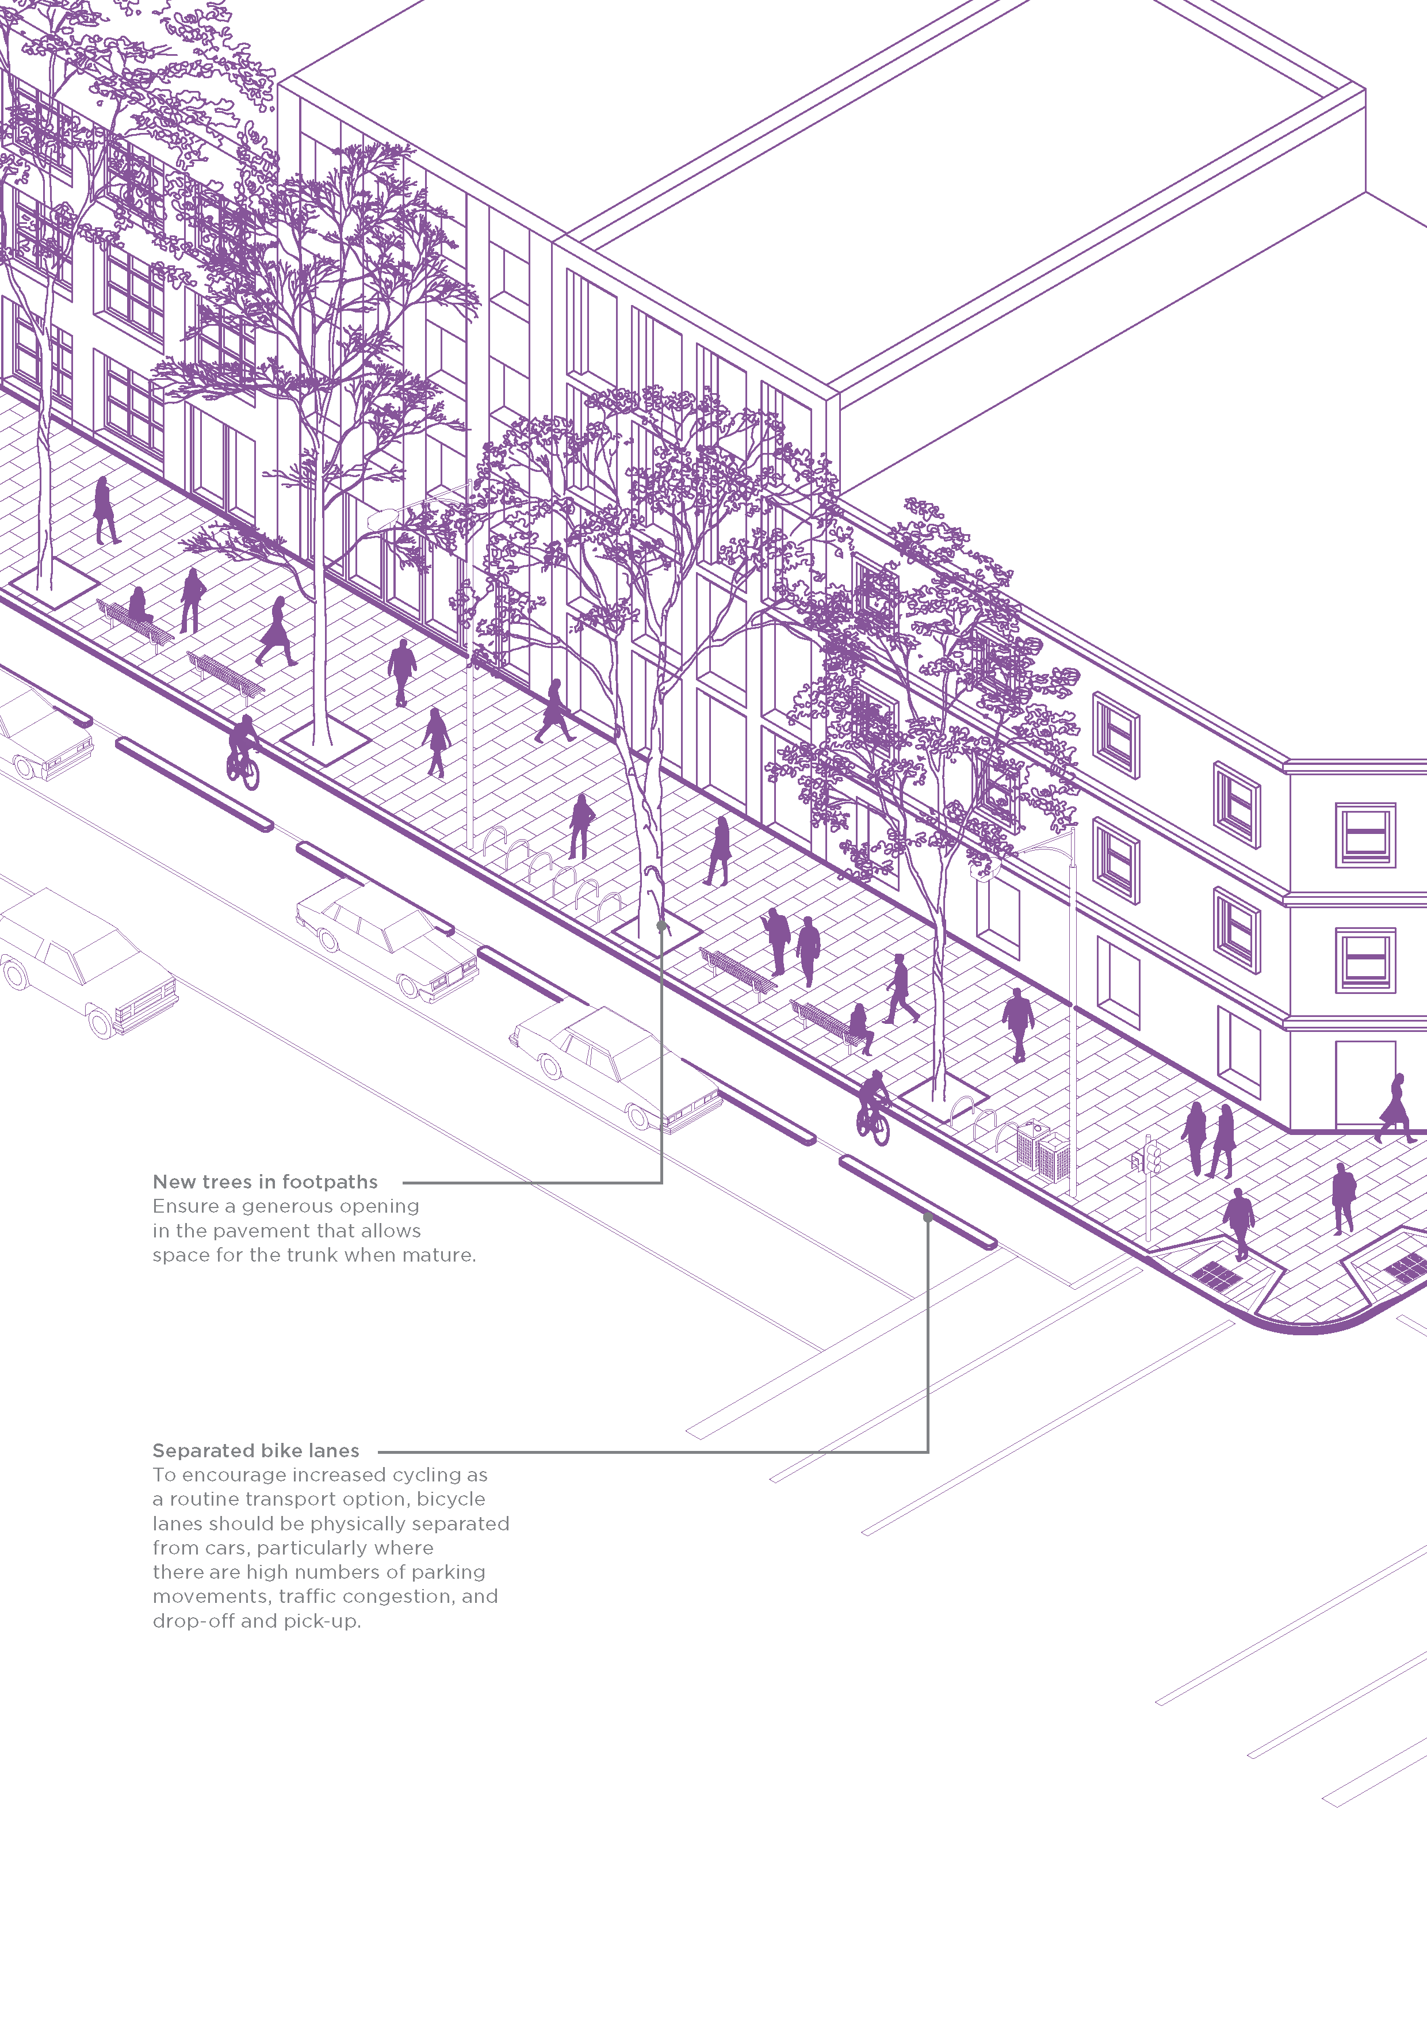

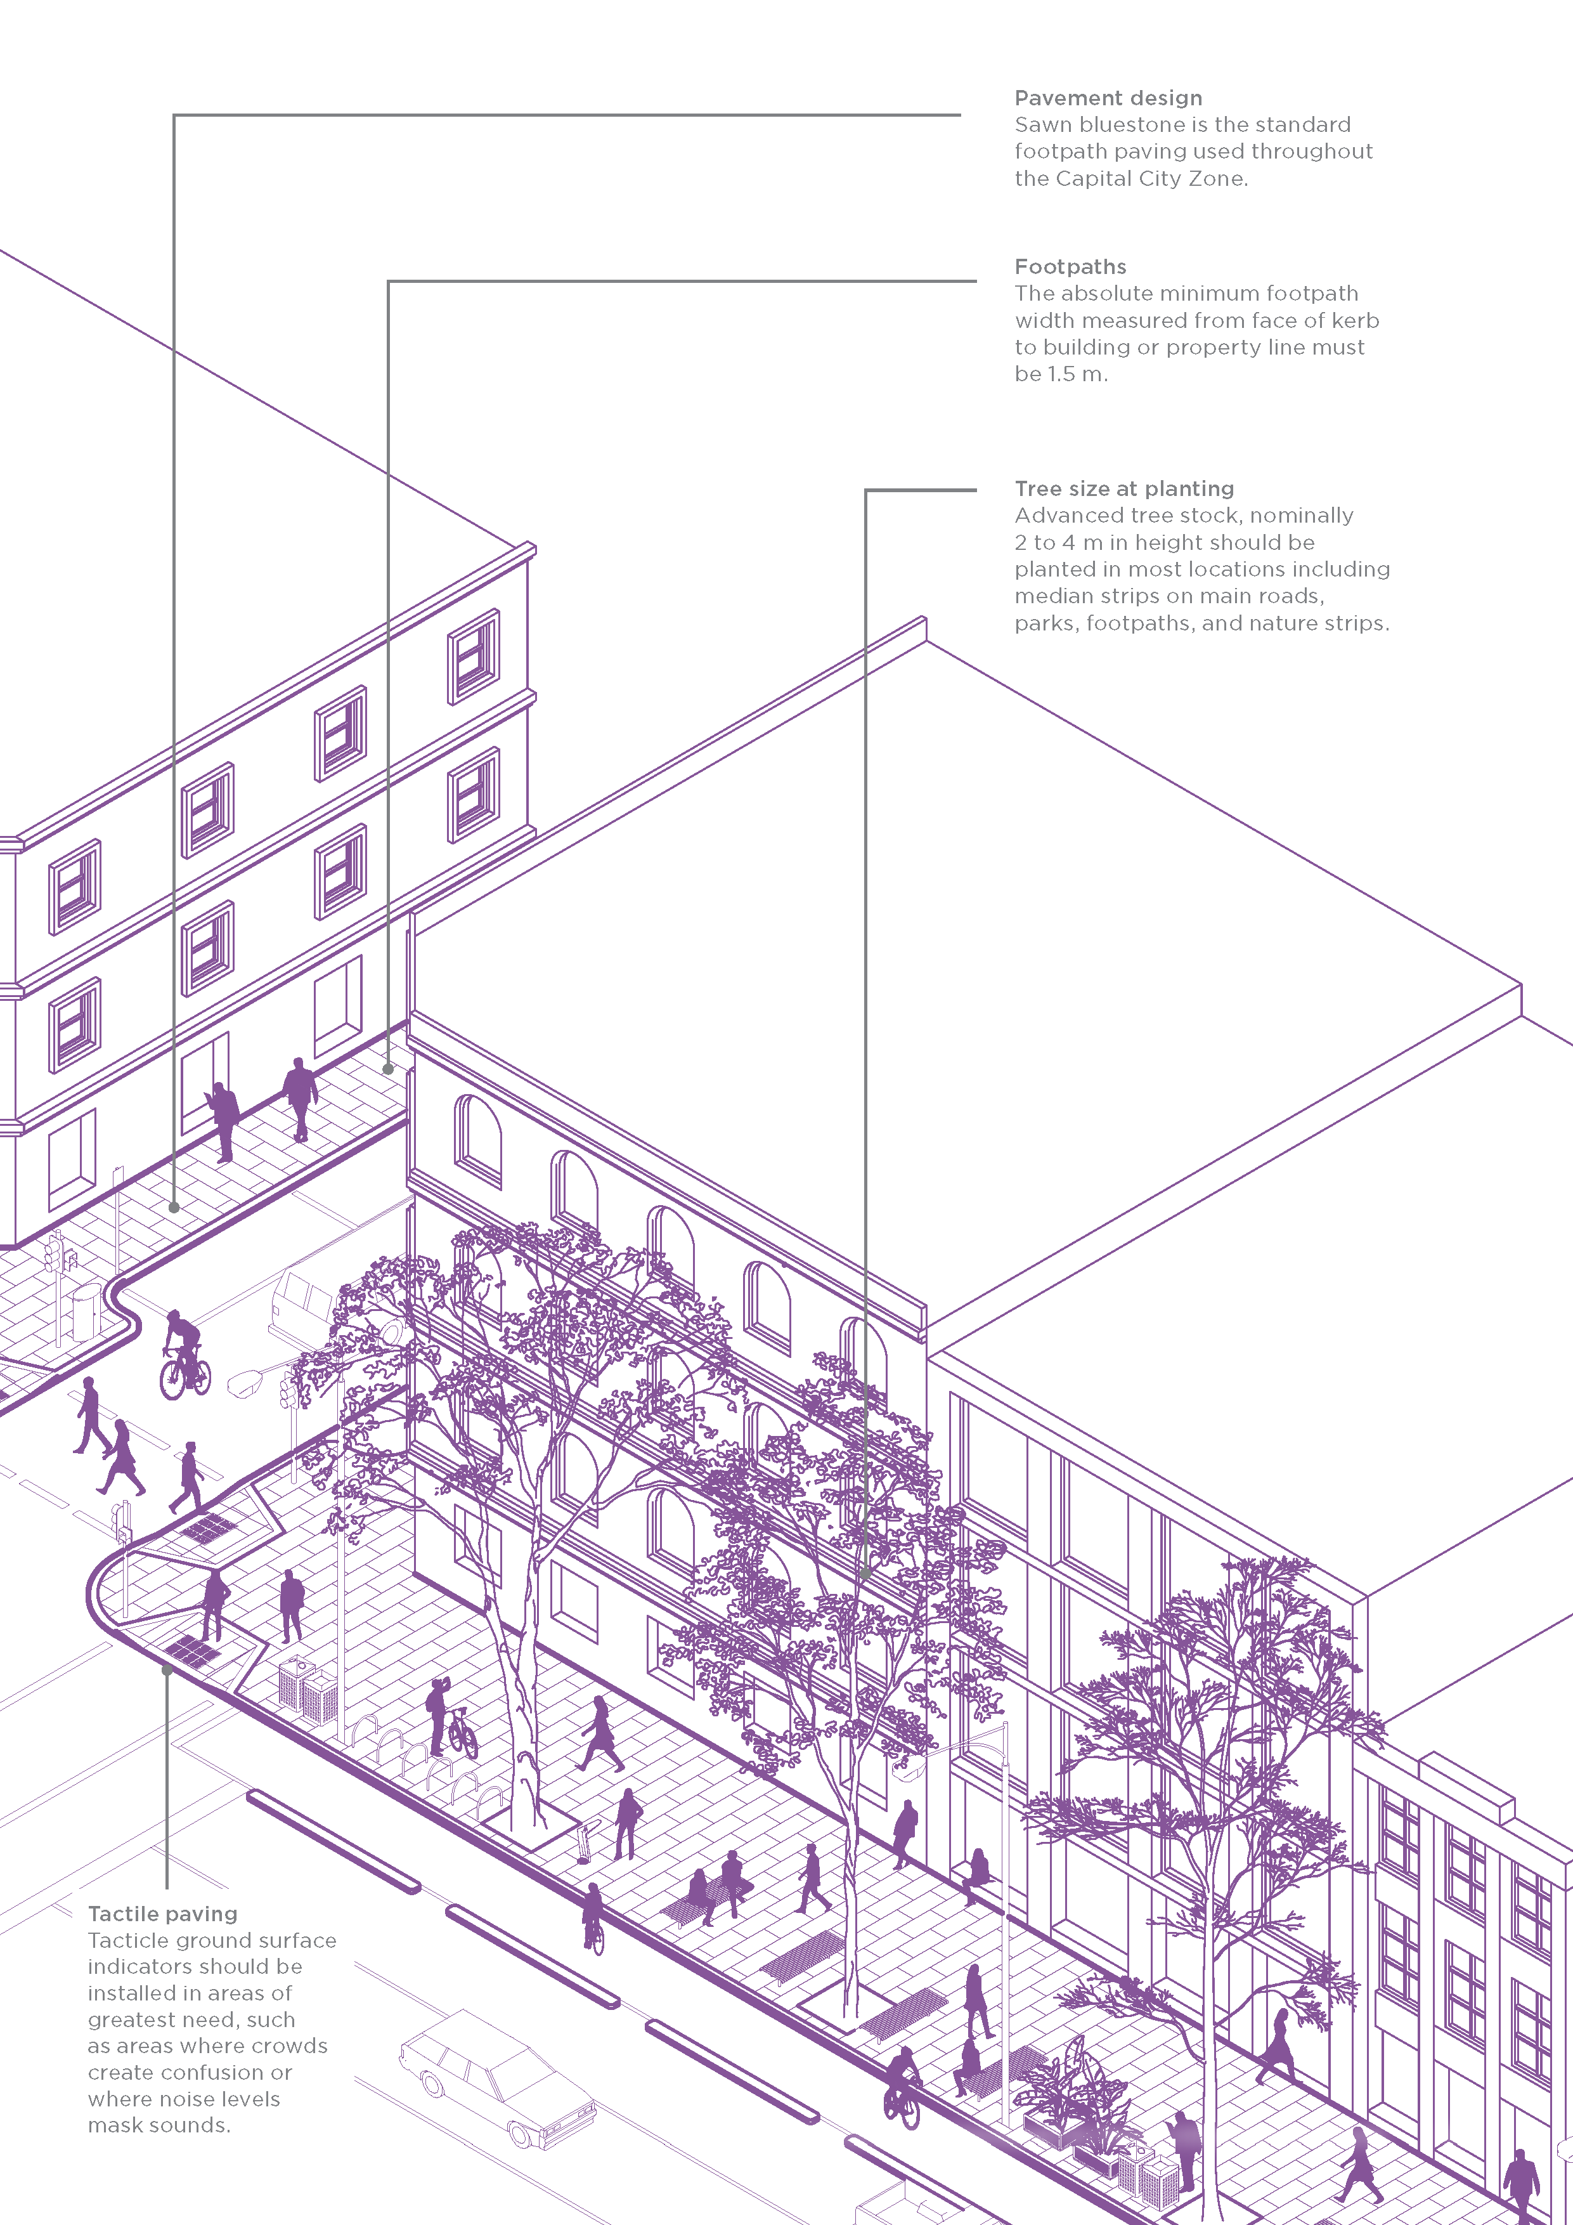

New trees in footpaths
Ensure a generous opening in the pavement that allows space for the trunk when mature.
Separated bike lanes
To encourage increased cycling as a routine transport option, bicycle lanes should be physically separated from cars, particularly where there are high numbers of parking movements, traffic congestion, and drop-off and pick-up.
Pavement design
Sawn bluestone is the standard footpath paving used throughout the Capital City Zone.
Footpaths
The absolute minimum footpath width measured from face of kerb to building or property line must be 1.5 m.
Tree size at planting
Advanced tree stock, nominally 2 to 4 m in height should be planted in most locations including median strips on main roads, parks, footpaths, and nature strips.
Tactile paving
Tacticle ground surface indicators should be installed in areas of greatest need, such as areas where crowds create confusion or where noise levels mask sounds.

Standards for materials, construction and elements
This section stipulates design standards, and standard materials and elements to be applied in the development of the City of Melbourne’s public realm. It outlines options applicable in typical situations.
We refer to our design standards, which detail and illustrate how public realm elements must be built and include links to relevant engineering standard drawings and fabrication drawings for City of Melbourne furniture items.
Please refer to our website or contact the City Infrastructure Branch on 9658 9658 to obtain copies of any standard detail or fabrication drawing.
Some detailed elements referred to in this section have been updated from previous publications of our design standards, some have been made obsolete and replaced, and some have been renamed. The practice of naming elements after the project where they were first used, as with King Street lights, became confusing when that detail was used elsewhere. A table explaining how old details are replaced by new ones is attached as Appendix D1: Current and Superseded Design Standards.

Groundwater and Geotechnical Conditions
This section sets out groundwater and geotechnical management for the municipality. It applies to all development applications in the public realm including public streets and parks.

Saline water
Stormwater collection and storage systems must be designed and built to prevent infiltration of saline water via percolation through subsoils, or via flows along service trenches or disused pipes.
Drains from water storage tanks and planters must be fitted with one-way valves to prevent the backwash of saline water from the Yarra River Birrarung, Maribyrnong River, Moonee Ponds Creek, and Victoria Dock at high tides.

Groundwater monitoring wells
When EPA Victoria requires groundwater monitoring wells for a project, details are to be provided to City of Melbourne, including the location and operational requirements. When a groundwater monitoring well is to be located within the public realm the relevant party must obtain consent from our manager of Infrastructure or appropriate delegate for installation of the monitoring well.
It is always preferred that groundwater wells are located within private property. If this is not possible, we may allow groundwater wells to be located in an adjoining footpath. However, the responsibility for groundwater monitoring wells remains with the building owner.
Groundwater wells must be decommissioned and removed at such time that monitoring is no longer required. The building owner is responsible for rectifying any asset affected by the removal of the groundwater well.

Ground settlement
Parts of Melbourne, especially areas along the waterways, overlie deposits of Coode Island silt at varying depths and thicknesses, and it is therefore expected that gradual ground settlement will occur. Because many buildings, wharves, bridges and other structures in these areas are founded on deep piles, while pavements and public space treatments are not, differential settlement occurs between adjoining structures and surfaces. This settlement can be noticeable even within relatively short periods and will continue over the very long term.
An estimate of likely settlement and potential differential settlement of pavements and adjacent structures must be provided, detailing the accuracy or confidence limits of this estimate, as the basis for designs in these areas. The design of roads, footpaths and underground services must consider and allow for the predicted differential settlement. A range of considerations and approaches may be appropriate, including:
- piled footings
- hinged bridging structures between structures on piles and areas liable to subsidence to avoid the development of trip hazards and barriers
- planning for frequent renewal of levels and surfaces and designing in a way that facilitates this renewal.

Stormwater Management
This section sets out stormwater drainage design requirements. It applies to all trunk drainage infrastructure and local drains, including those within road reserves and other public spaces. It does not apply to building roof drainage.
For roads under VicRoads control, refer to VicRoads requirements.

Water quality and pollution control
EPA Victoria regulates environmental aspects of water management in Victoria within the framework of the Environment Protection Act 2017. The associated environment protection policies identify beneficial uses (environmental values) of the water environment at any particular location and establish environmental quality objectives to ensure their protection.
The Waters of Victoria policy contains catchment- specific schedules, including 'F7 Waters of the Yarra Catchment', which is relevant to the City of Melbourne. It recognises the cumulative effects of different activities on water quality and the need to coordinate the planning and management of land, water and waterways.
Water quality in urban waterways largely depends on the control of pollutants carried by stormwater. Waters of Victoria requires that urban runoff does not compromise identified beneficial uses of receiving waters. It refers to stormwater pollution and requires measures be undertaken to control the environmental impact of stormwater.
CSIRO’s Urban Stormwater (2006) guidelines identify the following principles for managing stormwater runoff:
- Preservation – preserve valuable elements of the stormwater system, such as natural channels, wetlands and vegetation.
- Source control – limit changes to the quantity and quality of stormwater near the source.
- Structural control – use structural measures, treatment or detention basins to improve water quality and control discharge rates.
Suitable measures to control runoff are required to manage water quality draining into waterways. This involves structures to reduce or delay stormwater flow or to intercept or remove pollutants.
Treatment measures must be installed for all discharges to receiving waters as appropriate to ensure compliance with:
- Yarra River Protection (Wilip-Gin Birrarun Murron) Act 2017
- Environment Protection Act 2017, Variation of the State Environment Protection Policy (Waters of Victoria) – Schedule F7, Waters of the Yarra Catchment.
- Urban Stormwater: best practice environmental management guidelines (CSIRO)
- Stormwater Quality Management Guidelines for Wharf Areas in Victoria Harbour.

Design methodology and levels
Design must be carried out using methods described in Australian Rainfall and Runoff: a guide to flood estimation (1987), by Engineers Australia. Attention should be focused on volume 1, book 8, Urban Stormwater Management. Where this guide does not specify applicable criteria, one of the following documents may be used and their reference included in the computations:
- Melbourne Water’s Land Development Manual (2013), volume 2, part 3 – technical guidelines and requirements
- VicRoads Road Design Guidelines (2003) part 7 – drainage.
In calculating runoff, it must be assumed that all catchment areas including currently pervious areas are fully developed and a runoff coefficient of 0.9 is applicable. This allows for drainage to cope with future development.
Effects on upstream and downstream catchments must be allowed for and must not be adversely affected by new works. This may require information about designated flood paths from our Infrastructure Branch.

Major and Minor Flow
Design must address major and minor flows. Both are generated through rainfall directly on the local catchment area. Floods caused by king tides are treated separately.
Major flow used in calculations must be that resulting from an Average Recurrence Interval (ARI) 100-year storm. Major flows may drain overland along streets, through parks or through private property where floodway easements are created. Major flow depth and velocity must be in accordance with Australian Rainfall and Runoff section 1.10.4, Safety, which states that the product of velocity and depth should not exceed 0.4 m² per second. Flow depths on streets should not exceed 200 mm above channel invert. Flow is to be contained within the road reserve.
Minor flow is to be the ARI 10-year storm or as per the VicRoads Road Design Guidelines, whichever is greater. Minor flow must be fully contained in an underground piped system. This applies to all areas including roads, public spaces, residential, commercial, retail and industrial development.
Downpipes from buildings and drainage from paved or landscaped areas must connect to the underground system, except where runoff into a bioretention system or other water sensitive urban design measure is approved. Under no circumstances will minor flow be permitted to sheet flow over public reservations including roads.

Discharge into trunk drains and receiving waters
City of Melbourne’s manager of Infrastructure or appropriate delegate will stipulate the point of discharge into trunk drains or receiving waters. Piped systems will discharge to the Yarra River, Moonee Ponds Creek or a trunk drain.
All receiving waters must be protected at each outlet by means of an approved gross pollutant trap. The piped system must be designed for the hydraulic grade line at the discharge point. The design flow for pollutant capture or containment (the treatable flow rate) shall be the ARI 3-month storm.
No discharge is allowed into Victoria Harbour except from rainfall events greater than the minor storm event. If it is demonstrated to be impractical to avoid flow into Victoria Harbour, this must be approved by the manager of Infrastructure or appropriate delegate who will stipulate any applicable conditions. If discharge into Victoria Harbour is approved, the design must be in accordance with the Stormwater Quality Management Guidelines for Wharf Areas in Victoria Harbour (Places Victoria, 2012).

Receiving water level
The receiving water level of the Yarra River and Moonee Ponds Creek for both minor and major flow must be the mean higher high water of 0.42 m AHD, as per the Victorian Tide Tables for Williamstown, by the Victorian Regional Channels Authority.

Design for flood-prone areas
Two categories of flooding are addressed through controls in the Melbourne Planning Scheme: overland flows during major storms exceeding the capacity of the underground drain system and raised water levels along waterways resulting from heavy rain in upstream catchments or from tidal storm surges.
Overland flows often constrain the design of public realm projects, because overland flow paths must not be obstructed such that flooding will be caused in upstream areas. Furthermore, the water-carrying capacity of overland flow paths must not be restricted so that flows are displaced into nearby properties.
Designs should ensure that flood impacts on critical uses are minimised:
- Important through routes should be set at levels where they will not be compromised by frequent flooding.
- In areas subject to potential inundation, road levels must be above the Designated Flood Level unless approved by the manager of Infrastructure or appropriate delegate.
- If any path is subject to flooding, an alternative route above flood level should be available nearby, without a requirement for extensive backtracking to reach it.
- Any paths on floating structures that pass below bridges should be designed to ensure safe overhead clearances at times of flood or high tide.
Any structure that intrudes into a river, creek, drain or floodway below a 1 in 100-year flood level must not adversely affect its ability to convey flood flows:
- Structures should be located and designed to minimise interference with flood flows.
- Structures should be designed to deflect rather than entrap litter and debris. New piles should be spaced at least 6 m apart to minimise the risk that snagged debris might bridge across multiple piles and dam the flow of water.
- Design to minimise increased siltation in the channel and allow for dredging of the nearby channel where appropriate.
- Design to withstand impact by drifting vessels or debris and incorporate navigation warning lights where appropriate.
Development in flood-prone areas presents challenges for maintaining accessibility and capacity for stormwater drainage. Developments must consider flood requirements in early planning stages. Individual building projects may be able to do little more than protect the property involved by setting floor levels at appropriate heights. However, in areas undergoing widespread redevelopment, a precinct-wide approach can help to ensure maintenance of access to and through the area during floods.
Please refer to the Good Design Guide for Buildings in Flood Affected Areas in Fishermans Bend, Arden and Macaulay (Melbourne Water, City of Melbourne and City of Port Phillip, 2021).
Please refer to Melbourne Water for flood level information for the particular site.

Drainage elements design

Pits, covers and grates
Design Standards – 304 Series
The following pipe design and construction standards apply:
- The grate detail must be coordinated with the kerb and channel it is used with.
- Locate pits clear of pedestrian crossings and on the uphill side of crossings, where possible.
- All pit covers in the road reserve, including footpaths, nature strips and medians, must be Class D, capable of taking highway-type loadings and must provide skid resistance equivalent to the adjacent pavement
- Pit dimensions must allow for mechanical and manual cleaning methods and satisfy Occupational Health and Safety rules regarding access.
- Pit covers with infills located in bluestone or asphalt paved areas must be filled in with charcoal-coloured concrete. Concrete surrounds to pits must be charcoal coloured.
- All steel parts must be hot dipped galvanised and must conform to Australian Standard
- AS 3996 Metal Access Covers, Road Grates and Frames.

Pipe design and construction
The following pipe design and construction standards apply:
- All pipes in road reserves must be VicRoads approved pipe material and rubber ring jointed.
- Pipes must be 300 mm diameter minimum and backfilled in accordance with City of Melbourne’s specification.
- Pit, pipe bedding, pipe cover etc. must be to the standards stipulated by City of Melbourne or VicRoads, if not stated. Cement stabilised backfill around pipes will not be accepted.
- Minimum drop through pits is to be 50 mm. Pit bases to be shaped. No sump pits are allowed without the approval of the manager of Infrastructure or appropriate delegate.
- Minimum pipe cover 400 mm in easements not subject to vehicular loads, and 600 mm in roads.
- Stormwater drains must incorporate a method to prevent siltation from upstream catchment areas, and from the receiving water resulting from tidal flows back up the pipe, which may deposit silt.
- A minimum pipe flow velocity of 0.6 m/s is to be achieved for ARI 1 year for self-cleansing maintenance. Check for partial flow velocity.
- Maximum pipe flow velocity to be 6 m/s and maximum velocity into receiving water 3 m/s.
- Minimum pipe slope determined by meeting minimum pipe flow velocity and construction tolerance. Roughness coefficient of n = 0.013 applies.
- Pumped stormwater discharge will not be approved unless it can be demonstrated that alternatives are not feasible and requires the approval of the manager of Infrastructure or appropriate delegate.

Melbourne Water main drains
No buildings may be located over or immediately adjacent to Melbourne Water main drains and sufficient lateral space adjacent to main drains must be provided to enable maintenance and future refurbishment.

Design Standards: Examples of pits, covers and grates
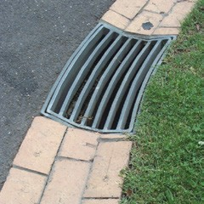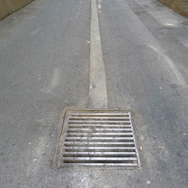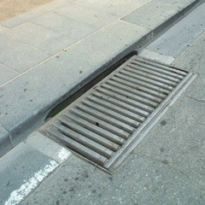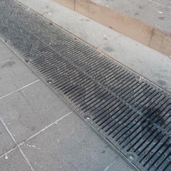

Streets and Routes
This section provides design guidelines for street, traffic management and road design, including the design of walking and cycling routes where they extend through parks and other public spaces. The focus of this section is on the functional layout of circulation spaces. Materials and furniture are addressed in following sections.
City of Melbourne’s Transport Strategy 2030 (2019) provides higher-level strategic guidance, setting out priorities for various transport modes in key areas and routes. Consideration of all transport modes in relation to the uses of public spaces and private development is required to ensure an integrated design of the movement network as a whole. Designs must be in accordance with predicted volumes and must provide for connectivity between precincts and major destinations.
Designs must respond to the hierarchy of streets and lanes that define the municipality, respecting their varied priorities in relation to transport functions and interfaces with development sites such as key public frontages or service access areas.
Walking and cycling should be the primary means of local transport via safe, generous and attractive routes that interlink the city. Particular regard must be given to the needs of people with disabilities and for non-ambulant modes of movement (prams or wheelchairs). The use of public transport must also be prioritised and access for emergency services is essential.
Public access on foot and by bicycle to and along waterfront areas is a key feature of the city’s waterways and Docklands and must be prioritised. Vehicle traffic near waterfronts should be limited, except for emergency, maintenance and delivery access.
Provisions for vehicular traffic must allow for:
- expected present and future traffic volumes and staged construction issues as the precinct develops over time
- connection to trunk roads and between precincts such that traffic flow is not unduly impeded, and future development is not stifled
- discouragement of unnecessary through traffic ‘rat running’
- use of public transport, cycling and walking
- emergency vehicle access
- future construction vehicle activity
- access for delivery trucks, couriers, taxis and garbage trucks
- pedestrian safety and access.
All waste storage and collection for private properties must be accommodated within the site. Placement of bins in streets for rubbish collection will not be permitted.
Designers must consult with our City Infrastructure Branch during the design phase of all projects that propose new or revised traffic management arrangements. The branch can provide advice on parking layouts, sign locations, time restrictions and requirements for fee parking including the type and location of meters or ticket machines.

Footpaths and walking routes

Path widths
The appropriate footpath width in any location depends on anticipated pedestrian volumes and must also allow for street furniture, and for outside eating areas, etc. where appropriate. The provision of space should be as generous as possible to support access and accommodate associated pedestrian activities.
As a rule of thumb for new and redesigned streets, the proportion of the road reserve width allocated to pedestrian uses should be:
- at least one-third throughout Capital City and Mixed Use Zones
- at least half in pedestrian priority areas as in Swanston Street.
The absolute minimum footpath width measured from face of kerb to building or property line must be 1.5 m. Significantly greater widths are appropriate in most streets. Some areas, especially near major transport nodes, suffer from chronic congestion and additional space may be requested. Guidance should be sought from City of Melbourne with respect to footpath capacity requirements.
If an adequate footpath cannot be provided – as in some laneways – the entire space must be treated as a shared zone.

Slopes and cross-falls
Footpath cross-falls:
- 1.25 per cent (1 in 80) minimum
- 2.5 per cent (1 in 40) maximum.
Minimise cross-falls for user comfort and to support kerbside cafes and other areas of outdoor seating. However, absolute minimum slopes are only appropriate with paving materials that can be laid in smooth, even slopes.

Minimum clear circulation space
An absolute minimum 1.5 m wide unobstructed pedestrian pathway must be maintained on all footpaths, adjoining the building or property line. Greater widths are appropriate in most streets.
No public realm elements, including steps, street furniture, signs, poles, service cabinets or plantings are to be installed along the building line that would obstruct pedestrian movement or visibility along this path. This ensures that the city can be more easily navigated by people with visual impairments.
Where footpath widths are minimal, any impediments on the path should be minimised, for example by:
- mounting streetlights on buildings
- placing furniture in localised kerb extensions
- planting trees in the parking lane.

Provision for universal access
The Disability Discrimination Act provides protection for everyone against discrimination based on disability. It encourages everyone to be involved in implementing the Act and to share in the benefits to the community and the economy that flow from participation by the widest range of people.
The Act makes it illegal for public places to be inaccessible to people with a disability. This applies to existing and newly built places. Existing places must be modified to be accessible, except where this would involve unjustifiable hardship.
Every area open to the public must be open to and usable by people with a disability:
- Places must be accessible at the entrance and inside.
- Facilities must be accessible, including wheelchair-accessible toilets, lift buttons within reach, tactile and audible lift signals for people with vision impairments.
- People with a disability should not be confined to a segregated space or the worst seats; rather, all areas in places used by the public should be accessible.
- Location of on-street disabled parking spaces should consider access to and along the adjacent footpath.
- Signalised pedestrian crossings must have automatic call-up and all traffic signals must include audio tactile features. All pedestrian crossings must have audio tactile devices.
Complying with the Building Code of Australia, or the Melbourne Planning Scheme, does not necessarily mean the public realm will comply with the requirements of the Act.

Kerb access ramps
Design Standards – 401 Series
Kerb access ramps enable access for all people by providing ramped access from the footpath at a road crossing.
Where conventional kerb ramps are required, the following principles apply:
- Ramps should align with the direction of travel to cross the street and with a path of travel along the building line.
- Minimise slopes – a 1:20 (5 per cent) maximum slope is preferred, with the absolute maximum being 1:8 (12.5 per cent). Create gentle transitions between surfaces at different angles to avoid trip hazards.
- If necessary to achieve recommended slopes, the entire width of the footpath may be used if the resulting slope is less than 5 per cent (1 in 20).
- If recommended slopes cannot be achieved by manipulating the footpath surface, it will be necessary to raise the road level.
- Side slopes must be no steeper than the ramp itself, so these are set out at 45° angles.
- The absolute minimum width is 1200 mm, and the preferred minimum is 1500 mm. Even the preferred minimum should generally be exceeded unless a wider ramp is impossible.
- Do not provide ramps if they do not link with accessible crossings, unless for access to disabled parking or for delivery trolleys.
- The ramp pavement, kerb and channel should match adjoining details.
- Where unit pavers are used, the ramp size should be rounded up to fit the paver module. Align the paving pattern with the ramp edges to minimise the cutting of tiles.
Design Standards: Examples of kerb access ramps
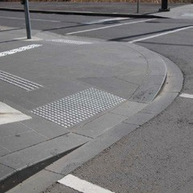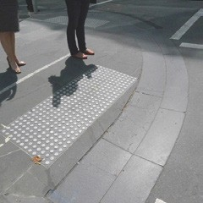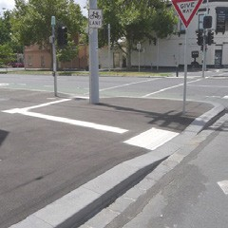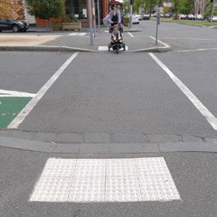

Tactile paving
Design Standards – 201 Series
Tactile ground surface indicators (TGSIs) are used to inform vision-impaired people as they move through a place. Not all vision-impaired people are totally blind, so TGSIs also use luminance contrast with surrounding pavements for their effect. Compliance with the Act requires their installation where appropriate in new or upgraded works. However, while TGSIs are useful for the vision- impaired, they can hinder access for people with other disabilities and can trip anybody, so their use requires careful consideration.
General principles for the use of TGSIs include:
- Provide TGSIs as per the relevant Australian Standard, AS/NZS 1428.4.1:2009, to comply with the Act at all pedestrian ramps, crossings and wide vehicle crossovers.
- TGSIs should be installed in areas of greatest need. They are important to mark unusual hazards such as stairs, in areas where crowds create confusion, or where noise levels mask sounds that people usually use to navigate (such as at busy public transport facilities).
- Use of TGSIs should be minimised through careful site design. A plan that needs many TGSIs probably has basic faults that should be addressed before they are added to the design. Footpaths and other spaces should be intrinsically easy to navigate, and intersections and crossings should be designed with simple alignments and direct lines of travel. Remove hazards, if possible, rather than mark them with TGSIs.
- Be consistent in the use of TGSIs within a given area.
- Use TGSIs only to indicate safe routes and street crossings. Do not mark street crossings with TGSIs if they duplicate or are close to existing signalised crossings or zebra crossings.
- Use the minimum necessary quantity of TGSIs.
- TGSIs at door entries and ramps should be located within the property line, not on the public footpath. New stairs and ramps at entries must be designed with a landing and TGSIs located within the property boundary.
- TGSIs on costly stone pavements should be of a high-quality material commensurate with the paving. They must be an integral part of paving projects and may therefore be a factor limiting the use of special pavements.
Design Standards: Examples of tactile paving
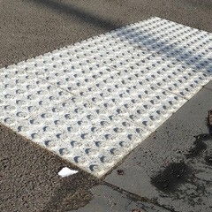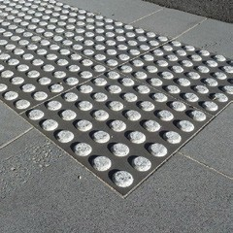

Bike paths and on-street bike lanes
City of Melbourne is committed to supporting a significant increase in bicycling as part of an increased role of active transport and public transport for access into and through the city. This entails not only a support for more cyclists, but also more diverse cyclists including women, children and families and people with varied levels of confidence for riding in traffic. A less homogeneous group of cyclists means people travel at different speeds on different styles of bikes. Bike lanes need to accommodate this mix.
Bike paths should be provided in accordance with the City of Melbourne Transport Strategy, the Austroads Guide to Road Design and any other applicable plans that identify priority routes. VicRoads’ Traffic Engineering Manual, Volume 3 – Design Guidance for strategically important cycling corridors (Edition 1, December 2016) provides more detailed guidance on bicycle lane design.

Path separation
It is the City of Melbourne’s position that to encourage increased cycling as a routine transport option, bicycle lanes should be physically separated from cars, as a priority,
Separation is particularly important where:
- there are high numbers of parking movements
- traffic congestion encourages drivers to drive use unseparated bike lanes as a traffic lane.
- there is limited parking or a strong desire for drop-off and pick-up.
Different uses of kerbside parking and loading spaces raise unique issues that need to be considered in bicycle lane design. High turnover at short-stay loading bays increases the desirability of locating the bicycle lane behind the parking or loading bays, to minimise conflicts.
Bus stops and taxi ranks require designs to find a balance between interactions involving bicycles and buses or taxis and bicycles and passengers. The frequency, intensity and stopping pattern of buses is a key consideration. On routes with very infrequent services, bicyclists could be required to stop behind buses rather than having separated lanes. On routes with relatively low bicycle volumes, waiting pedestrians could be expected to cross the bike path when buses arrive, as per Southbank Boulevard, but on busy cycling routes a waiting area next to the stop is likely to be more appropriate, as per Grattan Street.
- Bicycle path surfaces and other features
- Ensure bike paths have smooth, well-draining surfaces.
- Provide safe setbacks from hazards and clear views at intersections and curves.
- Ensure that gravel or other loose materials do not wash onto the bike path from adjoining areas.
- Provide lighting for safety, with particular attention to intersections and conflict points.
- Support wayfinding with consistent signage and line marking.
- Consider provision of complementary facilities such as bicycle parking and bicycle maintenance stations in locations that relate logically to cyclists’ travel routes and destinations.

Dedicated on-street bicycle lane positions and widths
Bicycle lanes to be delivered within the municipality must be one of the following designs, listed in order of preference. There should be continuity and consistency in the path design along each route.
Kerb-separated bike lane – for example, La Trobe Street, Melbourne
- bike lane adjoining kerb – width excludes pitcher channels
- separator – width differs based on adjacent roadway uses
- car parking lane or bays – width determined by traffic conditions.
This design is preferred on most key cycling routes.
Raised separated bike lane – or example, Southbank Boulevard Southbank
- provide offset to street furniture – 0.5 m min
- bike lane – width specific to location requirements.
- door and car exit zone (footpath paving) – 0.8 m
- kerb
- car parking lane or bays – width determined by traffic conditions.
This option can be provided where space doesn’t allow for a kerb-separated lane, but may not be appropriate if:
- heavy pedestrian traffic directly adjoins the bike lane
- only a short length of the route will be designed to this standard.
Double chevron bike lane markings – for example, Clarendon Street, East Melbourne
- car parking lane or bays adjoining kerb – width determined by traffic requirements
- painted chevron – as per bike lane design guidelines
- bike lane – width specific to location requirements
- painted chevron – as per bike lane design guidelines
- traffic lane.
This option may be preferred in situations with:
- high number of driveways or un-signalised local road crossings
- steep downhill gradients.
Absolute minimum bike lane – for example, Queensberry Street, Carlton South
- car parking lane or bays adjoining kerb – width determined by traffic requirements
- painted chevron – as per bike lane design guidelines
- bike lane – width specific to location requirements
- vibraline (textured line marking rumble strip) – as per bike lane design guidelines
- traffic lane.
This is to be applied as a last resort in exceptional circumstances, as in local streets with low traffic volumes and 40 km/h speed limits or where justification is made that space does not allow.
No bike lane
In very rare occasions on streets with low speed and extremely low traffic volume and where traffic congestion does not exist, bicycles can share a lane with other traffic. This may be acceptable on streets where traffic and bicycle movements are separated in time or where conditions provide a low-stress riding environment.
For construction stages wide kerbside lanes or clearway bicycle lanes may be acceptable and should be 4 to 4.8 m wide.
Kerb-separated bike lane
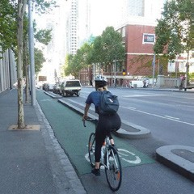
Raised separated bike lane
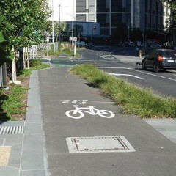
Double chevron bike lane markings
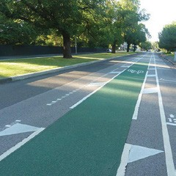
Absolute minimum bike lane provision
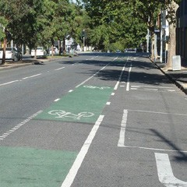

Bicycle lanes at intersections
Intersection designs need to consider capacity, conflicts with other transport modes and connections to intersecting paths:
- Ensure bicycle lanes connect to and through intersections.
- Remove slip lanes where possible.
- Provide green pavement in areas of conflict such as turning movements, substandard lane widths and transitions from separated to non-separated facilities.
- Provide space and facilities for cyclists waiting at signals, including bike boxes and holding rails.
- Provide early start signals and controlled right turns for cyclists.
- Prioritise signal phase time at intersections relative to the throughput of people, not vehicles.
- Ensure that neither bicycle nor pedestrian waiting areas at signals block cross traffic.
- Clearly indicate priority movements at crossing points.

Shared bicycle and pedestrian paths
Shared bicycle and pedestrian paths are typical in parks and along waterfronts. The preferred minimum width on major routes is 6 m for two-way traffic and 3 m for one-way. The absolute minimum width for two-way traffic is 4 m, or 2 m for one-way bicycle travel. Austroads’ minimum of 2 m for two-way cycling is inadequate in most parts of the municipality due to high pedestrian and cyclist volumes.
Separated cycling and walking paths may be desirable for greater capacity and safety along commuter cycling routes.

Bicycling in pedestrian-priority shared zones
Pedestrian-priority shared zones where cycling is permitted but cyclists are to ride at slow speeds and give way to pedestrians, as along Southbank Promenade, should be understood and designed as a different type of bicycling environment from shared paths. In shared zones, the design should reinforce appropriate cycling behaviour through:
- consistent use of materials and details that are characteristic of pedestrian spaces, while avoiding or minimising line markings, traffic signs and other elements that suggest a conventional roadway environment
- layouts that encourage cyclists away from the most sensitive areas of potential conflicts, such as near building entries
- use of relatively low tree canopies or other elements to give a sense of an intimate space, while maintaining ample breadth for people to move about.

Vehicular traffic lanes

Lane widths
Appropriate traffic lane widths vary depending on context. Minimise the number and width of traffic lanes to leave more space for pedestrians, cyclists and public transport, and encourage slower driving. However, lane widths must be adequate to cater for anticipated vehicular movements, including buses, garbage trucks and removalist vans as appropriate to each location. Lane widths must allow vehicle access to properties, taking into consideration all on-street parking requirements.

Kerb radials at corners and intersections
Kerb radials at corners must be adequate to cater for all anticipated vehicular movements.
At a minimum, all intersections should cater for:
- garbage trucks (minimum 8.8 m long)
- fire trucks (minimum 8.8 to 12.5 m long)
- removalist vans (minimum 12.5 m long).
Provision for larger vehicles (long rigid buses, semi-trailers etc.) is required in some streets. Obtain advice from City of Melbourne’s Infrastructure Branch (Traffic Engineering) to confirm requirements.
Designs must be checked to confirm accommodation for swept paths to Austroads standards.

Slopes and cross-falls
Minimise cross-falls to reduce the risks of trucks striking projecting signs and building canopies.
Channel grade:
- 0.5 per cent (1 in 200) desirable minimum
- 0.33 per cent (1 in 300) absolute minimum.
Cross-fall – running lanes and parking lanes:
- 1.67 per cent (1 in 60) minimum
- 5.0 per cent (1 in 20) maximum.

Setbacks of public realm elements from kerbs
Elements should be set back from the kerb for traffic safety and access to parked vehicles and to prevent damage. Minimum acceptable setbacks, measured from the face of the kerb to the edge of the relevant item closest to the kerb, are:
- furniture – 500 mm absolute minimum
- parking meters, light poles and small services cabinets – 750 mm minimum
- items more than 1000 mm wide – 800 mm minimum – for example, seats, cafe screens, rows of bike parking hoops
- at loading zones – 700 mm minimum for all objects except light poles and parking signs
- at disabled parking bays – 1500 mm minimum for all objects except light poles and parking signs.
These minimum setbacks should be increased in locations where there is an unusually steep cross-fall on the street, so that trucks tilting sideways do not strike signs, light poles or other furniture.

Vehicular crossings of footpaths
Design Standards – 402 Series
Locations where vehicles drive across footpaths create potential conflicts with pedestrians. They are also subject to much more serious structural loads than other footpath areas. Standard footpath paving materials must not be used in these areas and site-specific details need to be taken into account.
A visible indication that there may be conflicts between pedestrians, cyclists and vehicles should be provided by a change in paving material. Typical crossover details return the kerb to the building line to demarcate the crossover.
Extreme durability is required for paving on crossovers as stopping and turning vehicles exert lateral and twisting pressures. Therefore, paving tiles of standard thickness, such as bluestone, are not durable on crossovers and are not acceptable. Crossovers must typically be paved with asphalt or a higher-quality pavement material, as approved. Specifically engineered pavement surfaces, like bluestone, may be used to provide a continuous footpath surface treatment over laneways and driveways provided they adequately support the necessary vehicle loads.
Standard widths for driveways and crossovers are:
- single residence: 2.75 m minimum width
- other land uses: 3 m minimum width
- 7.6 m maximum width.
Kerbs and channels at crossovers are to match adjoining details. Similar details are used for entries to minor laneways as for entries to private driveways and car parks.
We are trialling continuous footpath treatments in the municipality. We expect to update this standard as the evidence base is built for continuous footpaths that can withstand the rigours of high foot traffic, vehicle use and inundation.
Design Standards: Examples of vehicle crossovers
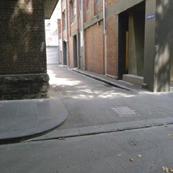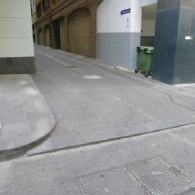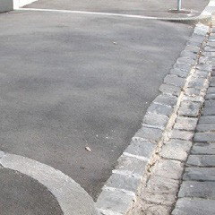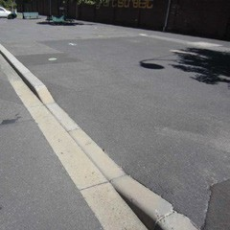

On-street vehicle parking
Short-term on-street parking, loading zones and taxi ranks can be important for the functioning of streets to support local land uses. Kerbside parking can also provide a buffer between traffic and pedestrians by creating friction that slows traffic.
On-street parking space in an area should relate to local uses and consider the following, as appropriate:
- short-term customer parking
- patron drop-off areas
- disabled persons
- taxi ranks and bus zones
- loading zones and postal service
- clearways to facilitate traffic flow
- motorbike and bicycle parking
- visitor parking
- special uses such as work zones.
Appropriate parking lane widths vary depending on context, but typical ranges include 2.2 to 2.3 m to accommodate cars only, and 2.6 m to accommodate bus stops.
Long-term parking and all parking requirements for new developments will be off-street.
Parking is to be in accordance with Australian Standard AS 2890.5 Parking Facilities Part 5, On-Street Parking.

Parking locations and arrangements
Loading zones and five-minute parking zones should be located at the downstream side of intersections to allow ease of access and sight distance for the intersecting street.
Substantial loading facilities should be located off-street and should not compromise other street uses.
Separate bike paths from parking bays, if possible, to avoid conflicts between cyclists, car doors and alighting passengers.

Motorcycle parking
There are some free on-street motorcycle parking bays in the central city. In some areas, motorcycle parking on footpaths has been prohibited and signed accordingly; otherwise, it is legal in Victoria to park motorcycles and scooters on footpaths and pedestrian areas if they do not block access to doorways, public transport, delivery vehicles, parking metres or other street furniture.
In practice, motorcycle parking can create significant obstructions that reduce footpath capacity. Managing motorcycle parking to avoid impacts on other uses should be addressed as part of the public realm design.
Consider proactive provision of motorcycle parking bays, placed conveniently near entries to pedestrian zones and promenades, without blocking pedestrian desire lines. Street design should consider formal motorcycle parking bays.

Shared zones
Pedestrian priority areas typically include waterfront promenades and shared zones. Shared zones are streets and laneways with either part or full closure to vehicle traffic, or low vehicle speed restrictions as part of a dedicated shared traffic zone arrangement. Shared zones remove the presumption that the vehicle has the right of way. Shared zones are designed to prioritise pedestrians and public life. This must be clearly expressed through a design that signals to drivers that they are not in a conventional street situation.
- Use spatial changes as critical primary signals, including level changes, minimised lane widths and overhead clearances.
- Employ secondary signals, such as using pavements to strongly differentiate from traditional streets and avoid distinct carriageways that may be interpreted by drivers as a conventional road space.
- Minimise the presence of vehicles, including parked vehicles, as they become visually dominant and affect perceptions of the street regardless of the design. Routes with high traffic volumes are therefore unsuitable as shared zones.
- Use durable paving materials under vehicular traffic.
- Locate buffer kerbs or bollards to prevent vehicles from bumping into buildings or other features.
Shared zones may be temporary for peak usage times, such as weekday lunchtimes or during special events.

Parks and waterfront promenades
Melbourne’s parks and waterfront promenades are valued as recreation spaces, and are integral to the walking and cycling network. Vehicle traffic should be discouraged or prevented from accessing waterfronts and parks, except for emergencies, maintenance or deliveries. Where vehicle access is required, these areas should be designed as shared zones. We do not support vehicle through traffic along waterfronts.
Design local streets around parks and waterfronts to minimise conflicts between vehicles, pedestrians and cyclists.
Safety principles must be included to effectively manage risks associated with activities along the waterfront. Undertake a water safety risk assessment, and implement recommendations in accordance with the Guidelines for Water Safety in the Melbourne Docklands.

Space allocation along waterfronts
The design of public spaces along waterfront promenades should consider establishing distinct zones in appropriate locations that respond to the location, nearby land and water uses, and a wider strategy for public space use and activation.
These include:
- active circulation zones for main pedestrian and bicycle traffic
- passive recreational zones for seating and respite
- event zones, where programmed activities may occur.
Prioritise waterfront spaces for recreational uses, walking and slow-speed cycling. If separate paths are required, set bikes away from the water. Where possible, direct high-speed commuter cycling routes away from waterfronts.
Minimum clear path widths along building lines facing onto waterfronts should be as for footpaths in streets.
Provide vehicle access for emergencies, rubbish collection, services and events. Routes should be nominally 3 m wide and allow for swept paths at turns. Maintain generous clearances around features that may be damaged by vehicles and provide protection using bollards or kerbs as appropriate.
Any vehicle access should be very short-term, and no parking provision should be made along waterfronts.

Levels
Where feasible, create an overall fall towards the water to maximise water views.
Do not create raised spaces or features that visually isolate parts of the promenade from the water. Avoid abrupt level changes high enough to block views, considering balustrades and other features that exaggerate the visual impacts of surface level changes.
Minimise cross-falls in most areas for ease of walking. However, steeper slopes may be appropriate in places to enhance water views and for activities such as sitting on grass.

Paving and Surface Materials
This section provides guidelines for paving and surface materials. It should be read in conjunction with subsequent sections on streets and routes. It does not address materials for waterfront promenades on wharf structures – see section D.10 Maritime Works.

Pavement design
Design Standards – 201 Series
Adhere to the following construction standards, in order of legal requirement:
- VicRoads’ Traffic Engineering Manual, the Austroads Guide to Road Design and VicRoads’ Supplements to the Austroads Guide to Road Design
- Relevant Australian Standards.
In addition:
- Road pavement design life must be 30 years.
- Designers must submit assumptions on vehicle loadings to allow for growth in traffic volumes and vehicle types.
- Pavement design must take into account the strength and stiffness of the foundation material.
- As a basis, pavement design requires a geotechnical report by a laboratory approved by the National Association of Testing Authorities.
- Asphalt must be a minimum depth of 100 mm and must have a minimum 10-year design life with no maintenance during that time, while the subsequent maintenance cycles are to be within the normal maintenance regime acceptable to VicRoads.
- Road and bridge construction, including material supply, must be in accordance with VicRoads specifications.
- Refer to VicRoads for roads under its control.
The extent of paving in the city means that even small increases in material costs or maintenance complications have huge cumulative impacts.
Principles for the selection and use of paving include:
- Ensure the paving suits likely vehicle loadings.
- Paving must be easy to repair, replace and replicate.
- Design for extreme durability where stopping and turning vehicles exert lateral and twisting pressures. Crossovers must therefore be asphalt even if a higher-quality pavement like bluestone is used for the rest of the footpath.
- Minimise the variety of materials and details in a given area.
- Relate changes in paving to changes in functions and clearly delineated boundaries, for example, at kerbs or drainage channels.
- Adopt a consistent modular system with 250 mm, 500 mm, and 1000 mm (nominal) dimensions.
- Avoid mixtures of rigid paving (concrete or stone) and flexible paving (gravel or asphalt) to minimise trip hazard risks as different materials wear and move over time.
- Consider ways to reduce the prominence of paving rather than using costly materials. For example, if flat areas are paved and slopes planted, greenery will tend to dominate in most views. Trees can break up views of paving, while shaded surfaces are less obvious than those in sun. Dappled shade can make plain surfaces more attractive.
Design Standards: Examples of paving
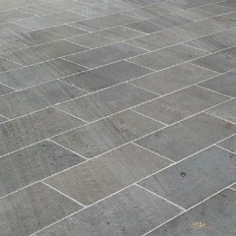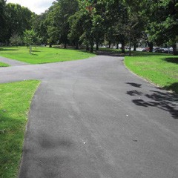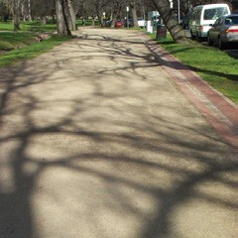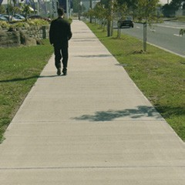

Standard paving
Two main paving treatments are to be used in the municipality.
- Sawn bluestone is the standard footpath paving used throughout the Capital City zone and other identified priority streets and spaces. It must be used for designated high-use areas including primary streets, pedestrian-only streets, laneways and shared zones. The size and thickness of standard bluestone pavers are related to vehicle loading requirements.
- Asphalt is the standard paving for all other areas, all road and laneway surfaces, and all driveway crossovers. Various construction standards apply for asphalt, in relation to likely vehicle loadings or pedestrian-only use.

Other paving types
Granitic gravel
Gravel may be appropriate in large level spaces subject to intensive use, where lawn is not sustainable, but a hard paved finish is unwanted. It is also useful where paving materials are likely to be routinely damaged by events.
However, gravel requires regular maintenance. On slopes, it is liable to erosion. It is easily tracked onto surrounding pavements. Use it with care, paying close attention to drainage, erosion control and interfaces with adjoining pavements. Large expanses of gravel may require constructed drainage channels across them to minimise sheet erosion and gullying.
Special stone paving types
Bluestone pitcher paving is a traditional detail in Melbourne’s laneways and creates an attractive texture, but its uneven surface creates trip hazards and limits access for people with disabilities. It should generally be used only where reinstatement is required for conservation reasons, and then only for vehicular areas. Pitchers must not be used on footpaths, bike paths or pedestrian crossings.
A detail with flat sawn-topped pitchers is available where pitchers are historically appropriate but pedestrian access is required.
Where stone paving in carriageways is appropriate – exclusively in formally designated shared zones – a robust trafficable detail is required with relatively small, thick blocks.
Textured, split-face bluestone pavers are also used in limited areas away from main paths of travel on footpaths where a visual accent or a deterrent to skateboarding is wanted.
Concrete
Concrete paving is used only in limited areas. City of Melbourne does not encourage the use of an exposed aggregate concrete finish on paved or vertical surfaces as the finish is extremely difficult to match for repairs and can be difficult to clean.
Other materials
With specific approval, other paving materials may be appropriate in situations such as:
- where a flexible material is needed around the base of trees (see section D.9.2 Tree planting plot details).
- where permeability to increase air and rainwater infiltration into soil is a high priority and cannot be achieved using standard paving. Permeable asphalt may be appropriate in footpaths and parking lanes with light vehicular traffic loads. Maintenance requirements for permeable surfaces must be clearly defined and agreed to prior to approval by the City Infrastructure Branch.
Design Standards: Examples of paving
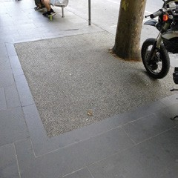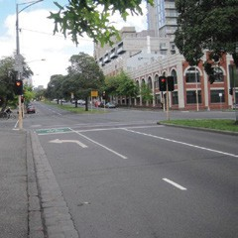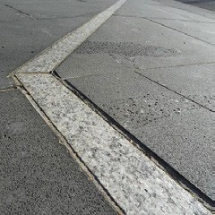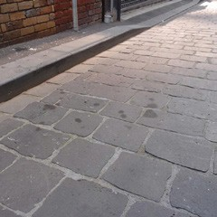

Kerb and channel
Design Standards – 301 Series
Kerbs block vehicles but create only minor impediments for pedestrians and can withstand vehicle impacts, so they are usually preferred over other barriers such as bollards.
Bluestone kerbs are traditional and preferred throughout the municipality.
Precast concrete kerbs are also used in certain areas, in particular for medians and traffic islands (which are physically separated from any bluestone kerbs at the sides of streets) in neighbourhoods outside the Capital City zones and Docklands. In-situ concrete kerbs are only used to form radials where standard precast units are not of the necessary dimensions.
Gutter stones are typically used in combination with kerbs to define the drainage channel and may also be used separately.
Principles for use of kerb and channels are:
- Minimise kerb heights to provide easy access onto the footpaths and to minimise the size of ramped kerb crossings.
- Re-use old bluestone kerbstones but avoid mixing recycled and new stonework.
- Do not use bluestone pitchers for kerbs.
- Where unit pavers are planned for a footpath, do not use recycled kerbstones due to the difficulty of making a neat joint between the pavers and irregular kerbstones.
- Where bike lanes are located adjacent to the kerb, use a channel of minimal width.
- Tightly butt-joint pitchers without mortar, except as necessary at pedestrian crossings to ensure an even surface.
Wide bluestone pitcher channels exist in some parts of the municipality. They should be retained and repaired if damaged if they are of heritage significance. However, they are not acceptable for new work.

Standard kerb and radial dimensions
The standard bluestone kerb width is 300 mm. Narrow kerbs (200 mm) have been used in some areas in the past but must only be used for repairs or minor modifications where they now exist.
Lengths should be 450 mm minimum, and average at least 1 m.
Radial kerbs must be used for exposed corners and internal angles. Sharp square corners and mitred joints are not acceptable in roadways.
Use standard kerb radial dimensions and curves in simple arcs rather than using compound curves, to facilitate replacement of damaged sections and recycling if works are altered. This applies at all locations including intersections, driveway crossovers and kerb outstands.
- For curves, use standard radii:
  - - 610, 1220, 1830, 2440, 3660 and 4270 mm
  - 5, 6, 7, 8 m through to 18 m
  - make curves greater than 18 m radius out of straight segments.
- With 300 mm wide kerbs, the ends of each stone should be trimmed to create tight butt joints in curves between 18 m and 30 m radius
- With 200 mm kerbs, ends should be trimmed for curves between 18 m and 20 m radius
- Larger radii can be formed using untrimmed butt jointed straight segments.
Design Standards: Examples of kerb and channel
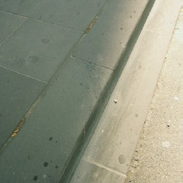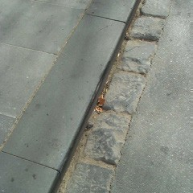

Channels and spoon drains
Design Standards – 303 Series
Gutters, channels or spoon drains with or without kerbs are used at path edges where no barrier is needed. They are also used to define drainage lines across paved surfaces, such as where a laneway drains to a central channel.
General principles for use of channel details are:
- Use sawn bluestone for all channels except where matching adjoining pitcher channels in minor works, or where reinstating historic details in areas under Heritage Overlays.
- If drainage lines are required over pedestrian areas, integrate these with any ornamental paving pattern
- Ensure surface drains do not create trip hazards or interfere with universal access
- Do not use bluestone pitchers to construct channels.
A variety of channel details are used to suit various contexts in the municipality.
- Sawn bluestone channels are preferred in most streets unless conservation objectives call for retention or reinstatement of pitcher channels.
- Brick channels are a traditional detail used in some parks and gardens.
Drain grates must be matched to the channel they are used with.
Design Standards: Examples of channels and drains
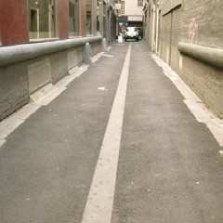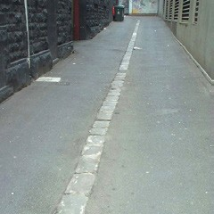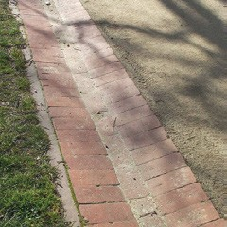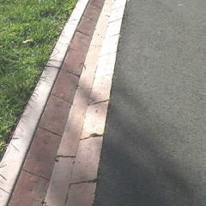

Flush edges
Design standards – 305 series
Edging materials are often required for paths in parks, between garden beds and lawns, and between different pavement materials. They stabilise flexible materials such as asphalt and gravel, and contain loose mulch in play areas and garden beds.
General principles for the selection and use of edging materials include:
- Edging should typically be used at junctions between garden beds and lawn areas or lawn and gravel path interfaces.
- Rather than being decorative only, edge details should serve as drainage channels or have a practical relationship to the construction of the pavement (such as serving as formwork for laying concrete or asphalt, or as a permanent retaining edge for loose materials).
- Lawn edging should have a smooth face along the grass side to facilitate maintenance. Materials should resist damage from trimming tools. If it is difficult to keep neat turf edges along irregular materials, or grass grows into joints, maintenance staff may resort to using herbicides, which is undesirable.
- For lawns of Kikuyu or similar invasive species, the edging should have tight joints and be deep enough to prevent the grass from spreading.
- Edging details should generally be in proportion to the width of the surface. Avoid using wide borders on narrow paths.
Design Standards: Examples of flush edging
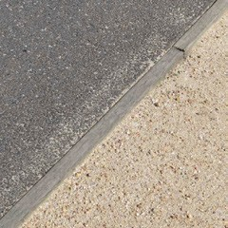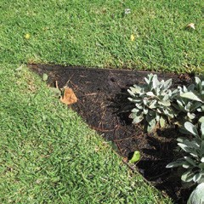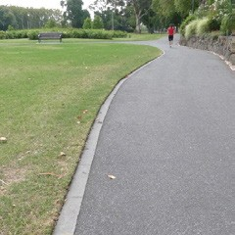

Furniture
This chapter contains design guidelines and standards for furniture in the City of Melbourne’s streets, parks and waterfronts.

Supply and installation

Supply and manufacture of furniture
All new street and park furniture must be manufactured in accordance with the requirements of City of Melbourne’s Infrastructure Branch. Only furniture approved by the City Design Branch and endorsed by the manager of Infrastructure or appropriate delegate may be used.
Our standard furniture pallet is managed by the City Design Branch. Contact City Design for current fabrication drawings and relevant installation details.

Footings and installation of furniture
All new furniture must be installed in accordance with our requirements.
An installation system used for many of City of Melbourne’s standard furniture elements uses gib key sockets – steel tubes cast into a concrete footing. Signposts or seat legs are inserted and locked in place using a wedge-like key.
Construction details for gib key sockets are typically provided as part of the documentation for each furniture element.
Where possible, install gib key sockets and other items such as bollards and bike hoops that install directly into concrete footings by coring a neat hole in the finished pavement rather than using other means of excavation.
On structures such as wharves and waterfront promenades, or where there are shallow underground services, furniture is installed using base plates and chem-set bolts.
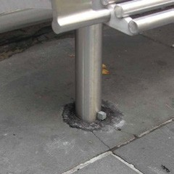
A seat installed into a gib key socket.

Seats
Design standards – 701 series
Seating is one of the most crucial elements for encouraging and supporting the use of public spaces. It is also relevant to universal access and promotes inclusion, by providing frequent resting places and ensuring that seat types cater to all people, of varying abilities and needs.
- The location and type of seating should be physically and socially comfortable.
- At least 10 per cent of seating should have backrests
- At least 5 per cent of seating should have armrests.

Selection of seat types
The various styles of standard seats should be used in precincts and contexts as directed (refer also to section B.3 Place-based Design Standards).
Within many of these styles, there are options for types of seats:
- with or without backs
- with or without armrests
- single facing or back-to-back
- varied lengths
- fixed, fold-up and swivelling seats.
Design Standards: Examples of seats
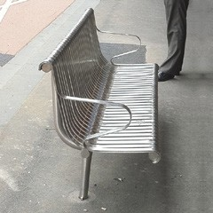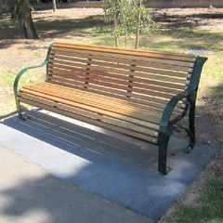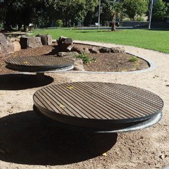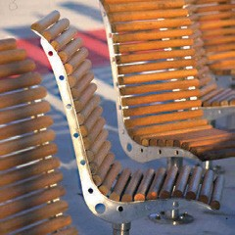

Factors to consider in using these options include:
- Bench seats without backs create trip hazards for people with vision impairments or in crowded conditions. They should not be used on narrow footpaths and should preferably be located where a taller and more conspicuous element nearby prevents people from attempting to walk through them.
- Seats with backs are preferred for the elderly and people with disabilities, and in locations where people are expected to sit for lengthy periods. Bench seats without backs should be used only where people are expected to sit for periods shorter than 15 minutes.
- Where space is available and in locations that are conducive to social interaction (where ambient noise doesn’t make conversation difficult), it is desirable to arrange some seats to allow groups of people to talk to each other.

Quantities and locations of seating
Provide a seat at regular intervals along important pedestrian routes to provide resting places. Provide more seats on hills, with increasing frequency as the slope increases.
In plazas, provide at least 100 mm of seating per square metre of open space (measured along the front edge of seats and sitting ledges). This should be public seating, additional to any seating in outdoor cafes. A substantial portion can be provided using built-in elements rather than standard furniture.
Consider seating locations carefully to take account of factors that make a place desirable or undesirable to sit, including:
- exposure to wind, sun or shade at various seasons
- clearance from extremely busy thoroughfares that may make it seem that passers-by will step on toes of people in the seats
- proximity to traffic, other sources of noise, or litter bins
- attractive vantage points.

Built-in seating
In most streets, standard seats are the only appropriate type of seating. However, in plazas, waterfront promenades and other places where space permits, some seating should often be built into the design using ledges, plinths and steps, to maximise seating without making spaces look like an auditorium or furniture shop. In these situations:
- The aim is to provide seating opportunities that complement the use of standard seats in the space. It is not an excuse to design customised alternatives to standard seats.
- Seating should be nominally 420 mm above pavement level.
- Where seat heights vary due to sloping sites, surfaces between 300 mm and 900 mm above pavement level may be usable, but at least 50 per cent should be between 350 mm and 600 mm.
- Bench seating should be at least 400 mm deep. Seating with a back should be at least 350 mm deep, and the backrest at least 300 mm high.
- Back-to-back seating should be no less than 750 mm deep and preferably at least 1000 mm deep.
- Seating surfaces should be level, smooth and well-draining.
- A variety of seating arrangements provides flexibility and choice for individuals, groups, strangers or friends.
- Exposed aggregate concrete is not generally supported.
- All timber surfaces are to be treated with natural oils and included within a regular maintenance program to protect and improve the presentation of the timber.
The front edges of seating elements are often used and damaged by skateboarders. If skating is not appropriate for the location, the design must integrate deterrents. If skating is supported, edges must be designed to withstand this use.
See section D.5.7 Skateboarding management, for more details.
Design Standards: Examples of built-in seating
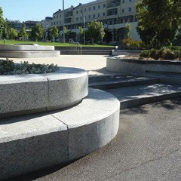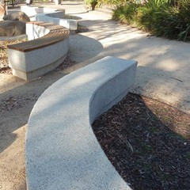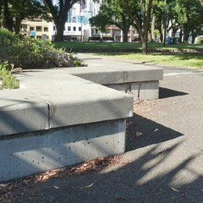

Litter bins
Design standards – 702 series

Standard litter bins and variations
The standard litter bin holds a wheeled plastic liner designed for a mechanical lifter attached to garbage trucks. The stainless-steel surround secures the liner and improves its appearance. The basic bin body can be used with a range of tops and accessories to provide for special functions.
Finish options:
- Stainless steel is the preferred finish for most areas.
- Brunswick Green powder coat finish is for use in heritage garden precincts.
- Charcoal powder coat finish is for use in parks and parkland precincts.
Tops and specialist functions:
- standard bins – for general use
- recycling – generally installed as part of a pair with a standard litter bin, although recycling bins may not be installed with every standard bin. They should be provided along major pedestrian thoroughfares and in parks near barbecues and sports clubs
- glass bottle recycling – for use in designated park areas near major barbecue facilities
- solar compacting bins – for use in central city streets where large litter volumes are generated, as directed by the manager of Infrastructure or appropriate delegate
- dog-poo bag dispenser – for use in designated park areas
- anti-possum – for use in designated park areas.

Bin corrals
Use bin corrals at picnic areas where large litter volumes are generated, and multiple bins are needed at one location.

Locations for bins
General principles for placing bins include:
- Bins should be placed at regular intervals along paths with high pedestrian traffic, at intersections and mid-block crossings.
- They should be convenient to seating areas, especially where people are likely to sit and consume food and drinks but placed so they do not detract from the amenity of the seats.
- Bins should be near a road or path traversable by garbage trucks. Preferred positions are near corners where there are no standing zones to ensure easy access.
- Bins should not impede pedestrian access. Do not place bins in defined pedestrian paths, along the property boundary, inside shelters at tram or bus stops, or in alignment with doorways.
- Bins must have a clear distance of 500 mm from the face of the kerb and should be located at the rear end of a parking space to keep clear of car door swings.
- Do not place bins where they may block drivers’ views. Bins should be at least 15 m away from an intersection on the vehicle approach side, at least 1 metre away from the traffic signal pole on the departure side of an intersection and at least 5 m from driveways.
- Bins should be located at least 1 m away from other assets such as light poles, pits or cabinets and 2 m from a bicycle hoop.
- Consider the potential impact of pest populations when placing bins near seats, picnic furniture or playgrounds.
- The siting of litter bins is often contentious. Try to keep bins in their existing locations if feasible.
Design Standards: Examples of bins
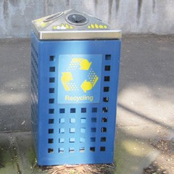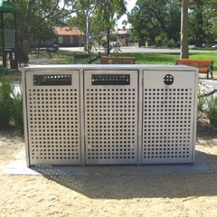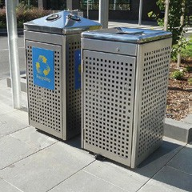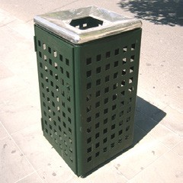

Fountains, barbecues and tables

Drinking fountains
Design standards – 703 series
Providing drinking fountains throughout the city’s public realm is important to the health and wellbeing of the community, but they are high maintenance. Ease of maintenance using standard parts is vital. Non-standard fountains will not be approved.
Given the limited number of drinking fountains installed in the municipality, they should be placed consistently in similar types of locations so people can find them.
Appropriate sites for drinking fountains include positions near or within clear view of:
- tram and bus stops and railway station entries
- entries to public or civic buildings
- public toilets
- sports facilities and picnic sites in parks.
Drinking fountains should be installed parallel to the kerb when installed on footpaths. They must be installed so that a person in a wheelchair can use them with ease. Our standard drinking fountains provide access for users of mobility aids, but their placement needs to be carefully considered to ensure space is available for access.
All fountains have an integrated bottle refill tap and a dog bowl.
Drinking fountains should preferably drain into sewers. If this is not possible, they can sometimes be installed to drain into a soaker pit and planting areas. This detail needs to be carefully considered to avoid creating boggy spots near the fountain.

Barbecues and picnic tables
Design standards – 707 series
The standard barbecues are electrical and operate with timer-controlled switches, so power connections are required. The single, double and extended barbecues are of similar design but offer sizes to suit different contexts. Consider access around double barbecues to allow for two groups to use at once.
Picnic tables are also available in extended lengths to support use by large groups or communal dining. A USB charger can be added to tables as an option in appropriate areas, such as where outdoor study is being encouraged.
Picnic tables may be appropriate in areas without barbecues, but barbecues are always used in areas with tables. If possible, picnic tables should be placed where they receive shade from midday through to early afternoon during summer yet receive some sun in winter.
Tables and barbecues must be installed on a concrete paving slab if located in areas of grass or gravel. Tables should also be installed to provide access for users of mobility aids.
In addition to their visual impact, picnic facilities can significantly change how a space is used. New installations should therefore be supported by an appropriate consultation process or an approved master plan for the site.
When replacing existing barbecues and tables, use the current standard design. If there is more than one barbecue at a site and they are of an older style, replace all at once.
Design Standards: Examples of drinking fountains, barbecues and picnic tables
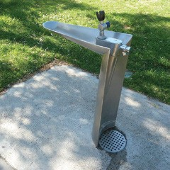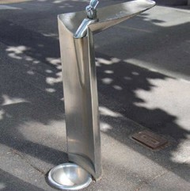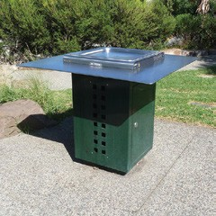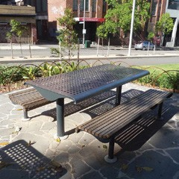

Bollards and fences
Design standards – 704 and 706 series
Bollards restrict vehicle access without impeding pedestrian and bicycle access or rainwater drainage, so they may be desirable instead of kerbs in some situations. They are a simple way to protect individual trees or other features or protect paved areas that may be accessible to vehicles.
Bollards are often used to protect other features where they are likely to be struck by vehicles and damaged. As such bollards must be simple to replace without great expense.
Bollards should not be used as a barrier instead of kerbs where vehicles are likely to strike the barrier regularly, unless:
- the bollard is placed as a sacrificial protector of a more valuable feature
- kerbs would create unworkable problems with drainage, disability access or trip hazards
- retention of existing kerbs is important for some reason, such as heritage, but a barrier is needed beyond the existing kerb line.
General principles relating to the use of bollards include:
- Finishes should be easy to restore when scratched or marked.
- Bollards must incorporate a reflective panel to ensure visibility for vehicular traffic.
- In rows of bollards, there should be clear gaps of at least 1 m, but gaps should be no greater than
- 1.5 m to prevent vehicular access
- If a mixture of removable and fixed bollards is needed at a site, all should be the same style.
Design Standards: Examples of bollards
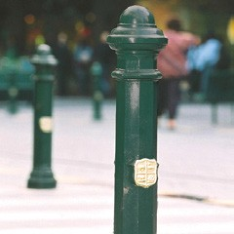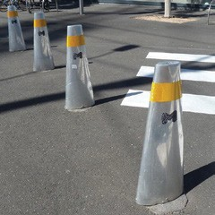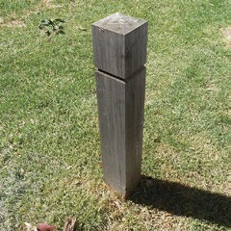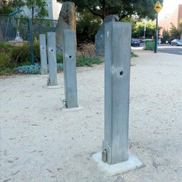

Management of removable bollards
All removable bollards throughout the municipality are on a key system. Refer to the relevant design standard for details. Developers must provide all keys at Practical Completion to the satisfaction of the manager of Infrastructure or appropriate delegate.

Public space protective measures
In addition to routine operational considerations to manage vehicle access, managers of crowded places must assess their vulnerability to ‘vehicle as a weapon’ threats and, where appropriate, take proportionate measures to manage or reduce risks.
Based on the findings from a risk assessment, mitigation measures should be developed and implemented in consultation with City of Melbourne and other relevant stakeholders, including police and other emergency services agencies.
Depending on the location, measures can include street furniture, low walls and level changes, stone blocks and other features integrated into the public realm design. However, bollards are often the only workable solution since the need for protection is greatest in some busy pedestrian areas where other options would obstruct access.
All vehicle mitigation measures should be consistent with similar measures and standards implemented within the municipality.
Any protection required for buildings or spaces not managed by City of Melbourne must be provided on the site, not in the adjoining public realm.
Refer to our Public Space Protection Framework for guidance on the vulnerability assessment requirements and process and consult with the manager of Infrastructure and City Design Branch for details of preferred bollards where applicable.

Fences in streets
Fences and other pedestrian barriers should only be used in situations where they are absolutely necessary, because:
- freedom of pedestrian movement is generally desirable
- there is little data proving that fences in streets enhance pedestrian safety
- barriers can create hazards by trapping people in dangerous situations
- fences are often subject to accidental damage and can therefore be relatively maintenance-intensive
- many people resent barriers, making fences targets for vandalism.
An apparent need for fences in streets usually indicates inadequate footpath widths, a lack of convenient crossings, excessive distances between crossings, traffic signal cycles that inadequately cater to pedestrian needs, or other problems.
These should be rectified where possible, rather than installing a fence.

Park fences
Many of the problems with fences in streets also apply in other public spaces, so they should only be used when there are clear reasons to do so. Park designs should minimise the need for fencing. Generally, we do not support fences enclosing play spaces.
The standard park fences use 150 mm x 150 mm timber posts with a pyramidal top (30° slopes) and chamfered detail to define a cap. This applies to timber post and rail fences and timber bollards (fixed and removable).
Timber fence posts located within 3 m of a roadway with a 50 km/h or greater speed limit must be made frangible with a 35 mm diameter hole, 50 mm above the finished surface level, drilled perpendicular to the direction of traffic.
Pipe fences must not be used along roads with speed limits greater than 40 km/h, as they create a risk of impalement in accidents.

Garden bed fencing
Low steel hoop fencing can be used to protect garden beds and exposed lawn areas from pedestrian cross traffic. The low height is intended to create a deterrent rather than as a security measure.
A temporary option is used to allow new plantings to become established where the plantings themselves are expected to create an effective barrier in the longer term.
Finish options include:
- green powder coat for selected heritage gardens precincts
- galvanised for other areas
- unfinished mild steel for temporary fencing.
Design Standards: Examples of fences
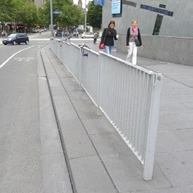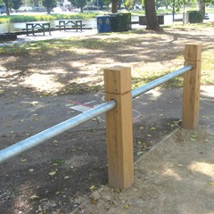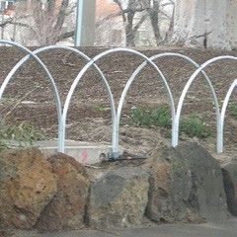

Bicycle parking
Design standards – 706 series
The standard bicycle parking hoop can be used singly or, more commonly, with two or more set parallel to each other, depending on the demand and available space. They can be placed perpendicular or parallel to the kerb or at another angle appropriate to the space to maintain required setbacks.
The demand for bicycle parking in a given area can sometimes be assessed by observing where people lock their bicycles to fences, poles and other street furniture. The use of existing furniture for bicycle parking is not undesirable unless it interferes with other activities or damages the furniture involved. Therefore, it is not necessary to provide bicycle parking hoops to meet all demand.
Placement criteria for bicycle hoops include:
- Bicycle hoops are generally located along cycling routes, destination points or public attractions.
- They should be placed where they are clearly visible, not hidden where bikes are more vulnerable to vandalism or theft.
- Minimum offsets from kerbs and building lines should allow for a 2000 mm x 600 mm zone, centred on the hoop, to keep bikes as well as the hoops themselves clear of traffic, car doors and pedestrian travel paths.
- When placing multiple bicycle hoops in a group, parallel hoops should be spaced 1000 mm apart (measure perpendicular to the centre lines of the hoops).
- They should be offset a minimum of 800 mm from the face of the kerb.
- The absolute minimum footpath width for placing bicycle hoops is 2000 mm. The preferred minimum is 3500 mm and hoops must be set parallel to the kerb at or below this width.
- Try to place bicycle hoops so that more can be added in the future if demand increases.
Bicycle hoops should be fixed securely to footings rather than installed with gib key sockets, due to the risk of theft.
When adding or replacing existing non-standard bike hoops use the current standard design. If there is more than one at a site and they are of an older style, replace all at once.
Design Standards: Examples of bicycle parking
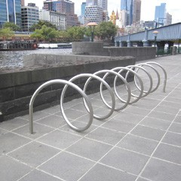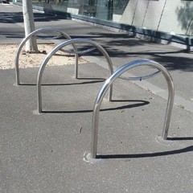

Skateboarding management
Design standards – 705 series
The Skate Melbourne Plan (2017) guides the provision and management of skateboarding in the City of Melbourne. Skating is recognised as a popular activity, an important form of physical exercise, a valuable focus for social and civic interaction among many age groups, and part of the spectacle of urban activity that is enjoyed even by non-skaters.

Design to support skating
The plan identifies locations where skating is encouraged. Where these are part of the wider public realm – as distinct from special-purpose skate parks – this requires careful design to ensure that skating co-exists harmoniously with other uses, as well as ensuring that materials and surfaces enable and withstand the impacts of skating. The plan sets out principles and guidelines for skateable spaces.

Design to deter skating
In places where there is no specific provision for skateboarding, it often causes damage to stonework and furniture. In addition, the risk of skateboarders colliding with pedestrians or unexpectedly entering roadways is a safety concern and can intimidate other users of a space. Noise can also be a problem near residential buildings.
Physical measures are therefore often required to deter skating, even in parts of spaces where skating is encouraged. These should, in the first instance, consider how to minimise reliance on obvious skate deterrent elements. For example:
- Integrate textured pavements along or near walls and steps into the design, while ensuring Disability Discrimination Act requirements are met.
- Design seats, walls and ledges to incorporate rough textures, heavily jointed masonry, and broadly rounded or angled edges rather than square edges, small bevels or bullnoses.
- Place furniture and other features to impede clear runs up to edges and slopes that may be used for skateboarding jumps.
- Consider the need for tactile ground surface indicators (TGIS) and their impact before installing other deterrents, but never use them as skateboarding deterrents if they are not needed to assist people with vision impairments.
Regardless of these measures, protruding fins and buttons are often required, especially when retrofitting existing masonry. Their use must consider the following factors:
- Protruding fins and buttons can create tripping hazards and are prone to vandalism.
- Installation of projecting fins or buttons must be subject to a risk assessment, and a heritage impact assessment where relevant
- A range of options are available that should be carefully matched to the details of the elements and the character of the space being protected.
- When replacing damaged or missing skateboarding deterrents, match the surrounding detail.
Design Standards: Examples of skate deterrents
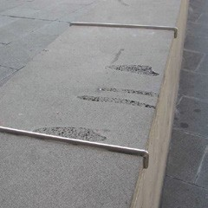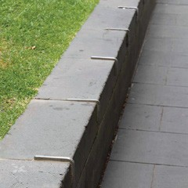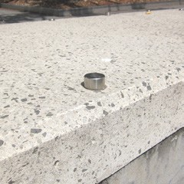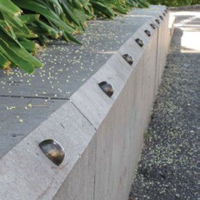

Public amenities and street trading
Design standards – 710 series

Passenger shelters
Most passenger shelters are provided at tram and bus stops by the public transport authority. Site designs must allow space for appropriate shelters including clearances for access around them and for service connections.

Other structures for weather protection
Provision of weather protection to footpaths with canopies, verandas or awnings is required through the Melbourne Planning Scheme for building frontages along major central city streets. These canopies should always be cantilevered from the building facade, not supported by columns within the road reserve (except where a building is set back from the title boundary at ground level and support columns may be acceptable). As such, they affect the design of the public space only indirectly, by preventing trees or light poles from being located within the extent of the canopy.
Wind impacts from tall buildings should be mitigated through building design, where possible. However, there are situations where structures may be required to reduce the impact of wind in public spaces.
- The design and location of wind abatement structures must be approved by the manager of Infrastructure in accordance with planning requirements.
- Any structure must not obstruct pedestrian desire lines or key views.
- Typically, section 173 agreements are required for the ongoing maintenance and care of wind abatement structures and remain the responsibility of building owners.
Tree planting in the public realm must not be relied upon to abate wind impacts resulting from new buildings.

Street trading facilities
City of Melbourne issues all street trading permits. Detailed guidance for kerbside cafes is provided in our Outdoor Cafe Guide, which addresses:
- access and design guidelines
- operation and management
- education and compliance
- application information.
The guide, application forms and additional street trading information are available on our website.
Design Standards: Examples of shelters
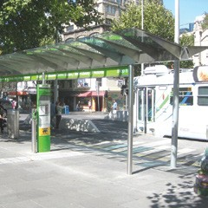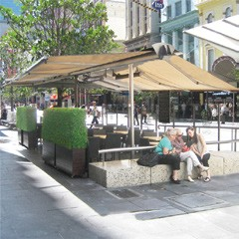

Public toilets
The provision of public toilets is usually planned in response to community demand across a neighbourhood, rather than on a project-by- project basis.
If a project involves a site with an existing toilet that needs to be moved, or the design will significantly change its context, the following factors should be considered:
- Proximity should be maintained to pedestrian paths and other facilities or areas where toilets should be located.
- Toilets must be visible so they can be found when needed.
- Exposure to good natural surveillance is important for security; locations at park edges and in streets are preferred to sites within parks.
- The location should avoid obtrusive visual impacts.
- Underground service connections must be available.
- Access for all must be ensured, including multi- gender considerations for safe access to toilets without fear of discrimination or harassment.
City of Melbourne has adopted standard automated public toilet designs that aim to provide a well-presented interior that is robust and easy to clean, an external shell that blends with the streetscape, and has provisions for people with special needs. This should be used in all locations, except in rare situations where larger structures are required for sports facilities or event spaces. Appropriate details will be supplied by City of Melbourne when needed, upon request.
A typical self-cleaning toilet
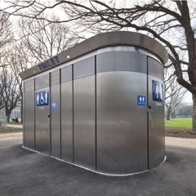

Signs
Signs must be provided in streets and spaces to provide safety, regulatory, directional and interpretive information. While various types of signs are subject to different guidelines, there are some general principles for all sign types:
- Provide information where it is most required.
- Place directional signs where people make decisions about their route of travel (for example, at intersections and railway station entries).
- Complement existing signage systems such as those in train stations and tram stops.
- Ensure sign type, size and content suit viewing conditions.
- Keep signs addressed to motorists simple, especially in complex traffic situations, and avoid unnecessary signs at busy intersections.
- Minimise the number of signs and only include information appropriate to a site.
- If existing signs are inadequate, replace them rather than add new ones.
- All directional signs should use a consistent design and graphic style to ensure the legibility of the system as a whole.
- Sign graphics – including text size, style, colour and contrast with the background – should maximise legibility for all people (refer to AS 1428 for detailed guidance).
- International standard pictograms should be used to provide concise and universally recognisable information.
- Illuminated signs must comply with all standards relating to lighting including the control of obtrusive lighting.
- Information about events should be provided using separate temporary signs rather than by complicating permanent directional signs.
Naming geographical places and roads
Guidelines, principles and procedures for naming, renaming and adjusting boundaries of geographic features, localities and roads are set out by the Victorian Government’s Geographic Place Names Act and the Department of Environment, Land, Water and Planning’s Naming Rules for Places in Victoria (2016).
The policy for naming geographical places, including roads in City of Melbourne is set out in the Activities Local Law – Policy Operating Statement Naming of Geographical Places (Including Roads). Any new place name must be used in accordance with City of Melbourne’s policy operating statement. The naming of roads is handled by City of Melbourne’s Planning and Building Branch (Land Survey). The naming of public parks and reserves will be guided by City of Melbourne.

Directional and regulatory signs

Traffic, street and property signs
Traffic and parking signs and line markings must be in accordance with VicRoads standards. Parking signs should be placed on buildings, where possible, or on a footpath adjacent to the car parking space.
Every intersection must have street name signs. Where a street is to remain privately owned, the words Private Road must be displayed on the street nameplate.

Property address numbers
Every building must clearly display its street address at the main entrance, at a minimum. The use of standard signs makes these easier for people to find and is strongly recommended.
When not done as part of the subdivision approval process, allocation of street address numbers to properties is handled by our City Property Branch.

Wayfinding (pedestrian) signs
Guidelines for wayfinding signage are provided in Wayfound Victoria (2020) by the Melbourne Visitor Signage Committee.
We will supply specifications for sign composition, graphics, colours, finishes, fabrication and installation. When we approve final sign locations and types, we will also supply graphic contents including three- and two-dimensional maps and naming for directional information.
Park signs
Signage within the city’s parklands and open spaces must be consistent with City of Melbourne’s suite of standard park signage. These support a mix of regulatory, directional and wayfinding information along with interpretive material where applicable. The provision and use, and content of park signage will in guided by an subject to City of Melbourne approval specific to each location and project.

Waterways signs
Signs are used on land and on berthing infrastructure to indicate navigational hazards, locations of safety equipment and berths, and to direct boat traffic and pedestrians accessing marine facilities. This includes:
- ferry signage pylon (pedestrian-oriented, on land)
- waterfront regulatory and information pylon (pedestrian-oriented, on land)
- waterway regulatory signs (water-oriented, mounted on wharf faces)
- lifebuoy marker signs (on land)
- pile caps (colour coded to indicate commercial, public and reserved/private berths)
- pile-mounted marina signs.
All wayfinding signage associated with waterways is to be consistent with the broader wayfinding system described above.
Water-based navigation requirements are the responsibility of Parks Victoria, acting as waterways manager under the Marine Act (1998).

Interpretive and commemorative signs
This section concerns signage commemorating a person or event or providing information of general interest about a place – as distinct from directional, safety or regulatory information.
Interpretive and commemorative signage should only be installed if directly relevant to the place and if consistent with an approved master plan. It should avoid providing information that can be provided more effectively through other media.
The number of existing nearby plaques, artworks and other objects may be a reason not to install more, even if another sign seems relevant.
This type of signage is usually fixed to a building or pavement, rather than freestanding. Proposals for plaques that incorporate sculptural relief, three- dimensional sculptures or artistic works in other respects should be considered through procedures relating to public art acquisition rather than design standards.

Memorial plaques
All memorial plaques are to be informed by City of Melbourne’s Plaques and Memorials Policy (2016). They are subject to an application process and must be referred to the Plaques and Memorials Committee for approval.

Interpretive signs
Interpretive signs differ from directional signs. They can suggest, evoke and arouse curiosity, not just state facts. Convenient walking routes do not determine the best locations. Things other than conventional signs can also be used to interpret a place. Interpretive signs should avoid stating the obvious and encourage people to develop their own personal understanding of a place.
Interpretive signage is an expression of a place’s cultural dimensions. Public places are valued for the opportunities they provide for people to interact in public, thereby making their own contributions to the significance of the place. Official statements of meaning may undermine this value. Any interpretive signage should unobtrusively enhance the experience of a place so that the space itself and its public activity remain the focus of people’s attention.
Avoid using signs to provide information that can be communicated more effectively using other media such as brochures or a website.

Temporary and events signs

Construction signage
Guidelines and requirements for signage associated with construction sites are provided in our Construction Management Plan Guidelines (2005).

Banner poles
In key locations across the municipality, banner poles hold changeable banners that promote public events and major civic occasions.
Any future installation of banner poles will be based on a city-wide rationalisation to support wider strategic objectives. Designers of individual projects should not propose new banner poles unless we request you to do so.
If a project requires existing banner poles to be relocated, or where their context will be significantly changed, you must consult with us to determine whether they should be re-accommodated within the project boundary. If relocation is required, banners:
- must be in highly visible locations
- should be placed in groups to maximise their impact
- must not conflict with existing trees, limit tree planting opportunities or the growth of trees around them
- should not be placed near activities that are sensitive to the noise of halyards banging against the poles.
Detailed drawings will be supplied on request, as appropriate.

Public Lighting
Good public lighting makes responsible use of energy to enhance people’s experience of the city. It improves amenity, wayfinding, visual comfort, road safety and personal security. Illumination and light fittings contribute to the city’s identity and reveal or exaggerate other features.
Our Public Lighting Strategy (2021) sets out principles and guidelines for public lighting and should be referred to for guidance in relation to all projects. This includes general approaches to what should be illuminated, where and when, as well as performance standards for lighting levels, control of light spill and glare.
This section focuses on light poles, fittings, and associated infrastructure and how these are used to achieve the objectives set out in the strategy.
Illumination standards
Functional lighting must be designed to meet or exceed the minimum illumination standards required by the strategy, or as otherwise informed by the City Infrastructure Branch and AS 1158.
All lighting must be designed to minimise adverse impacts including glare, sky glow, obtrusive impacts on sensitive uses, and impacts on native fauna.
Luminaire details and lamp wattage must be resolved in consultation with a specialist lighting engineer to suit the site conditions and the appropriate lighting standard.
In areas of staged development of major growth areas, supplementary lighting may be appropriate to compensate for the absence of lighting that is usually provided from adjoining buildings in developed areas.
Pole locations and spacing
Light poles are typically located at the back of kerb on both sides of streets, or on one side only in narrow streets. They can also sometimes be placed in a median strip and in this situation may have brackets with luminaires on two sides.
Pole locations and spacing must be resolved in consultation with a specialist lighting engineer to meet the appropriate lighting standard and coordinate with all other features in the space:
- Poles must not obstruct paths of travel, passenger access to on-street parked vehicles, and other activities.
- Pole placement should minimise risks of damage by vehicles.
- On streets with steep cross-falls, standard setbacks from kerbs may need to be increased.
- In narrow streets and laneways accessed by trucks, building-mounted or catenary lights are preferred.
Indicative typical spacing for different light and pole types is provided in the design standards.

Light poles and fittings
Design standards – 601 series
One of the principles set out in the Public Lighting Strategy is to use a limited range of light types to add cohesion to the urban landscape and to articulate hierarchies of major and minor routes. Each type should be matched to a specific situation and used consistently wherever that situation occurs.
Select light poles and fittings in two key stages. First, identify the appropriate light pole height and mounting system in relation to the space’s functional priorities and scale. Second, identify the appropriate style to fit with the preferred precinct or neighbourhood character.

Support spaces’ functional priorities
Typical streets with mixed traffic
In most streets with mixed vehicular traffic, typical light pole heights are about 10 m. Shorter poles are not adequate to illuminate the width of wide carriageways without causing glare.
Pedestrian-only and pedestrian-priority streets and spaces
Shorter poles may be suitable in narrow streets, in wide pedestrian-priority streets where carriageways are narrow, along paths in parks, and for pedestrian-only routes. Our standard styles include:
- promenade light
- waterways light
- park light.
Consistent use of a distinctive lighting style for pedestrian-priority spaces helps signal this priority to drivers and bicyclists and is especially important in shared zones. They should not be used in streets with typical mixed traffic, as it will compromise their effectiveness as a signal of pedestrian priority.
Design Standards: Examples of light poles and fittings
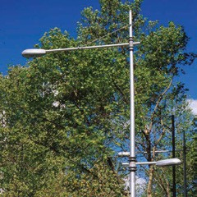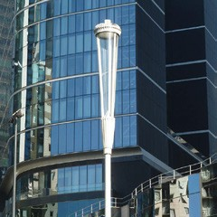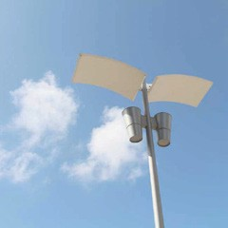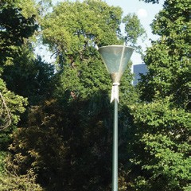
Catenary lighting, especially if suspended at a low height to create a sense of an intimate ceiling, can also be useful to signal a shared zone.
Little streets and laneways
Wall-mounted and suspended catenary lights should be used where footpath widths are minimal, in narrow laneways where poles are vulnerable to damage by manoeuvring trucks, or where a clear ground area is important for other reasons.
Plazas and sports grounds
Where a large space needs to be lit while remaining relatively clear of poles, tall poles (more than 10 m) can be used to help achieve an even spread of light and to avoid glare.
Streets with tramways
Joint-use poles for lights and tram wire supports minimise clutter along tram routes. Structural requirements for these poles require much heavier steel poles than standard streetlights. These poles can also support catenary lights if mounting points on buildings are not available.
Small parks
In very small parks, most lighting will be provided by streetlights around the park perimeter. In these situations, it is generally preferable to use light fittings that match those in the street rather than introducing only one or a few lights in a different style.
Design Standards: Examples of light poles and fittings
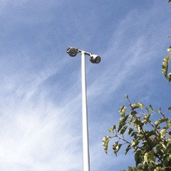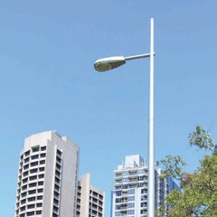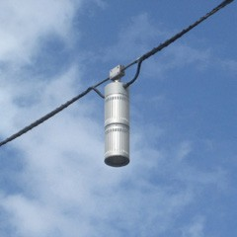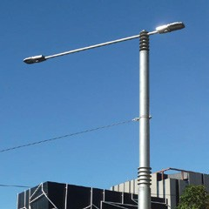

Enhance precinct character
The selection of light styles should reinforce a consistent character for the municipality’s various precincts and neighbourhoods, as explained in section B.3 Place-based Design Standards, where light-fitting styles for streets, pedestrian spaces and parks are nominated for precincts or areas including:
- capital city
- Docklands waterfronts
- other neighbourhoods
- heritage gardens precincts
- parkland precincts
- major boulevards.
Light pole and luminaire styles should be used consistently within each of these areas. Do not mix different styles in one area – for example, do not use park lights and promenade lights together.
Finishes and colours
Pole finish and colour options are based on the location:
- Brunswick green is used in heritage gardens precincts.
- For other areas, poles are finished in a silver colour.
- The black painted finish used in Docklands is to be phased out, and any new or replacement poles are to be silver.
Detailed specifications for paints and colours are provided with the fabrication drawings.

Modular elements
We have rationalised our standard lights into a modular system that uses a limited range of pole heights, brackets and luminaires that can be combined in different ways for a tailored response to functional lighting requirements in different types of spaces and character objectives and precincts. Most poles that are the same height are the same pole. Most luminaire and bracket styles fit on varied pole heights as described following:
Capital City Lights approved standard combinations for pole heights are 7.5 & 10 meters high with, special combinations acceptable if specifically approved, for pole height of 12 meters high
Neighbourhood Lights approved standard combinations for pole heights are 7.5 & 10 meters high, with special combinations acceptable if specifically approved, for pole height of 12 & 18 meters high.
Promenade Lights approved standard combination for pole height is 5.5 meters high, with special combinations acceptable if specifically approved, for pole height of 10 meters high.
Park Lights approved standard combination for pole heights is 5.5 meters high.
Waterways Lights approved standard combination for pole height is 6 meters high.
Plaza Lights approved standard combinations for pole heights are 7.5, 10 & 12 meters high, with special combinations acceptable if specifically approved, for pole height of 10 & 18 meters high.
City Joint Use Poles approved standard combination for pole heights is 10 meters high.
Combinations not described above are not approved.
Notes
Typical poles are tapered aluminium.
*Heavy-walled straight or stepped steel poles are required for joint use poles that support overhead wires for tramways or catenary lighting systems.
**The 18 m pole is tapered steel and should only be used in special situations due to complications of servicing very tall poles.
Some of our standard lights were originally named after the project where they were first used but have now been renamed.
- The former King Street light is now the capital city light, reflecting its intended use for streets in capital city zones.
- The former suburb light is now merged with the neighbourhood light as a single design.
- The former Swanston Street cone light is now the promenade light reflecting its use in pedestrian priority spaces.
- The former Docklands light, now the waterways light, is for waterfronts in Docklands and along the Yarra downstream of Queens Bridge.
- The former Argyle Square light, now the plaza light, is for pedestrian areas that need relatively tall poles to achieve large, uncluttered spaces.
Some older light fittings have been discontinued as standards and their use will be limited to existing locations or they will be phased out. Where these exist and individual lights need to be maintained or replaced until the whole area is changed to a new standard, details are available on request.

Power supply and operation
In practice, public lighting involves coordination between City of Melbourne and the power distribution company (CitiPower or Powercor) charged with operating lighting systems in the area.

Functional public lighting – unmetered
Much of the standard functional street lighting in the municipality is connected to CitiPower or Powercor circuits and is unmetered. All poles, luminaires, conduits and wiring are owned and operated by the distribution company once commissioned. These must be a current CitiPower or Powercor approved standard or must gain specific approval as a non-standard.

Functional public lighting – metered
Many poles and luminaires are not accepted by CitiPower or Powercor and are retained as City of Melbourne assets. These are connected to metered supplies. Maintenance is organised through separate contracts.
We prefer lighting of parks, plazas and other non- street public spaces to have a metered supply, with City of Melbourne ownership of poles and cabling. This allows us to manage lighting to suit activities and events and facilitates designs that are not supported by CitiPower or Powercor.

Decorative lighting
CitiPower and Powercor carry no responsibility for decorative lighting, which must be on separate metered circuits with maintenance organised through separate contracts by City of Melbourne.
The use of decorative lighting and all aspects of its design is subject to the approval of the director of City Infrastructure. Criteria for approval of decorative lighting include:
- The performance of fittings, quality of light and glare control must meet performance requirements for functional lighting.
- The number of different fittings in use should be minimised within a given site and across the municipality.
- Vulnerability to vandalism must be minimised.
- Ease of maintenance and replacement must be considered, including accessibility and the ease of opening and servicing components (for example, moisture-proof fittings that cannot be re-sealed on site when lamps are replaced are not acceptable).
- Operating costs must be minimised.
- Energy use must be minimised.
- All lamps and fittings must have a verifiable minimum life of 3 years with manufacturer guarantees.
- It should be possible to decommission decorative lighting without rebuilding or replacing other assets.
- Decorative lighting must be designed in accordance with relevant Australian Standards, the Victorian Service and Installation Rules and the requirements of the relevant distribution company.
- All control gear and switches must be located in public spaces that are easily accessible by our contractors. Electrical industry standard locking devices must be used.
The following lighting elements will not be approved:
- in-ground up-lights onto trees
- light fittings attached to trees
- control gear under wharf structures.

Power supplies to other features
Power supply to items such as irrigation pumps, water storage tanks and associated switchboards must be on a metered supply.

Solar-powered lighting
We are committed to ambitious sustainability and carbon emissions reduction targets using renewable energy. However, few sites in the municipality are far from a reticulated electricity supply and the most efficient way to generate solar power is not through small photovoltaic panels on lights. Solar-powered lights are only supported in unusual situations where extensive new electrical supply cables would be required to connect to the grid.

Cabinets, conduits and wiring
Design standards – 710 series
Cabinets for electrical switchboards and meters must be to our standards. They must be fitted with a power industry standard lock with key number 811A unless you have obtained our written approval to use another type.
A photoelectric cell should be mounted on the exterior of the cabinet to control the operation of lighting.
Cabinets should be located carefully to avoid limiting the potential use of a space and to minimise visual impacts. In streets and small parks, cabinets should be installed parallel to the kerb.
Overhead wiring is not permitted except where part of an approved catenary-supported lighting system.
Use CitiPower– and Powercor–approved orange colour standard conduits of a minimum 40 mm diameter for underground cabling.
All electrical cabling for metered circuits should comply with the current version of AS 3000 and the Electricity Safety Act (1998). For unmetered lighting, follow CitiPower and Powercor and Victorian Electricity Supply Industry standards.

Controls
All new lighting systems must optimise energy management through the following functions:
- trimming – allowing lights to be dimmed in small increments – to accurately meet output requirements
- dimming – allowing lights to be adjusted in response to changes in use (for example, very late at night when traffic volumes are lower)
- constant light output controls to counterbalance luminaires’ diminishing output as they age.
Design Standards: Example of an electrical cabinet
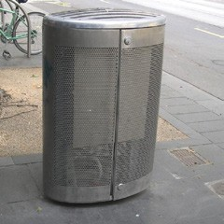

Utilities Provision
This section addresses issues relating to services provided by third-party utility operators or service authorities only as they affect the public realm and the assets within it. This section does not duplicate or supersede standards or requirements set out by other service authorities. Refer to those authorities whenever work is to be undertaken near or affecting their assets.

Accommodation of utilities
Provision of space for services
- Road reserve widths and levels must allow for existing and future services.
- Third-party utility operators and service authorities will be notified of upcoming significant streetscape works. City Infrastructure Branch maintains a Utilities Register that can be accessed to notify third-party utility operators and service authorities of our annual works program and significant works projects.
- Utilities’ locations must accord with industry standards.
- Cement-stabilised backfill around underground service conduits is not approved.
- Pit covers in the road reserve (including footpaths, nature strips and medians) must be capable of taking highway-type loadings.
- Pit covers with infills in bluestone or asphalt paved areas must be filled in with charcoal-coloured concrete. Any concrete surrounding pits must be constructed with charcoal-coloured concrete.
- Pits and pit covers for third-party utilities and service authority assets are subject to those organisations’ standards. Alterations to these assets are subject to the approval of the relevant third-party utility operator or service authority.
  - The provision of services must be undertaken by accredited providers in accordance with designs approved by the relevant third-party utility operator or service authority.
- Public realm designs must consider our requirements to include City of Melbourne- owned future services through the installation of extra conduits. This is especially important where a relatively high-cost paving design is used.
- Typically, City of Melbourne-owned conduits are for our CCTV and data services. You must consult with our Security Services and Smart City teams.
- Public realm designs must consider the need to install an additional 90 mm PVC conduit at a nominal 400 mm depth, located centrally along the pavement. All conduit details must be included in as-built plans and must form part of any handover package.
- Public realm designers are recommended to consult with service providers to locate and identify third-party utility operators and service authority conduits.

Impacts of utilities
Install utility-related infrastructure in street and other public spaces with care to minimise impacts on the uses of those spaces and minimise any encumbrances to future public realm changes.
Utility-related infrastructure includes telecommunication cabinets, electrical pillars, electric vehicle charging stations, payphones, various antennae and associated hardware for 5G networks. It also includes VicRoads signals and signal control boxes, power poles and substations, and tramway infrastructure.
The following should be noted:
- Locate utility elements in streets and other public spaces to avoid detrimental impacts on other assets, including trees.
- Pedestrian, bicycle and vehicular circulation routes must be unimpeded. Utility-related infrastructure setbacks must be maintained near intersections and crossings to maintain safety. Setbacks from intersections and back of the kerb must be maintained as set out in section D.3, Streets and routes. Contact our City Infrastructure Branch to confirm standard setback requirements.
- Above-ground elements should generally be located in alignment with other features in streets, so they do not create obstructions or squeeze points in busy footpaths.
- Utility elements must not block views of buildings, entries, shopfronts, paths of travel or infrastructure within streets, such as passenger shelters at public transport stops.
  - Utility elements should carry discrete identification of the owning authority but must not be used as a vehicle for advertising unless advised otherwise through the Melbourne Planning Scheme. The scale, location and form of all elements must be carefully considered to minimise visual impacts. This objective is incompatible with any advertising.
- Utility cabinets including meter boxes, valves, booster pumps and fire services for private developments must be located on private land. They must not be located in public streets or spaces.
- The location of utility cabinets for private development should minimise detrimental impacts on the public realm and be located to minimise disruption of active frontages.
- Routine access for meter reading or other servicing activities must not require vehicular intrusion into pedestrian zones.

Planting and Irrigation
Guidance for planting, including species selection, is also provided by other City of Melbourne strategic documents including:
- Urban Forest Strategy
- Urban forest precinct plans
- Nature in the City Strategy (2017)
- Climate Change Mitigation Strategy to 2050 (2018)
- Park master plans and conservation plans.
The section below addresses design considerations when delivering the above strategies, with a particular focus on the placement and planting of trees in streetscape conditions.

Placing trees in the public realm

General guidelines
Maximise the benefits of planting
Our Urban Forest and Nature in the City strategies are ambitious, while planting opportunities in many city spaces are limited. Planting is not feasible at all in some spaces. In others, decorative greening is an option but significant contributions to canopy cover targets and habitat values are impossible. In the context of our declaration of a climate and biodiversity emergency, investment in merely decorative planting is a low priority.
It is therefore important to make the most of opportunities for significant greening where they exist. Designs should:
- Contribute to increased tree canopy cover across the city. Achieving the Urban Forest Strategy’s overall target of 40 per cent canopy cover relies on exceeding that target in many areas, especially in off-street spaces.
- Prioritise shading paved areas exposed to the sun, to help combat the urban heat island effect. If possible, locate trees towards the centre of roadways, in parking lanes or medians rather than near the building line.
- Space trees to maximise canopy cover while allowing for healthy growth, for example:
  - large canopy trees at 10 to 12 m centres along streets
  - small and medium trees at 6 to 10 m centres.
- Use plantings in parks and small reserves to create impacts beyond the immediate site, complimenting existing plantings and compensating for any lack of planting opportunities in surrounding streets.
- Where significant planting opportunities exist, invest in soil improvement, passive and active irrigation, and maintenance that will support robust growth and long-term tree health.
- Select species to complement and extend ecological values of nearby plantings to create more extensive and interconnected habitat for native plants and animals.
Minimise conflicts with uses of streets
Locate trees of appropriate species and scale to maintain safe sight-lines and overhead clearances for pedestrians, cyclists and vehicles. Trees in parking lanes, medians and near the back of the kerb in footpaths should generally be:
- 10 m from the face of the kerb of an intersecting street at an unsignalised intersection
- 20 m from the face of the kerb of an intersecting street on the approach-side of traffic signals
- 10 m from the departure side of traffic signals
- 2.4 m from driveways
- 3 m from power and light poles
- 2 m from fire hydrants.
In streets, it is generally preferable to use fewer large trees rather than many small ones, to maximise their beneficial impacts while minimising interruptions to the footpath surface.
Clear footpath space for circulation should take into account the potential impact on accessibility of the full size of the tree trunk, tree guards, and tree pits (see section D.3.1.1 Path widths).
Trees in footpaths must be tall enough at maturity that branches are above head height. Species with pendulous branches must be maintained to provide adequate overhead clearances.
Protect trees from damage
Protection of trees must include consideration of the below:
- Comply with AS4970 Protection of Trees on Development Sites.
- Avoid works within root zones, but, if necessary, ensure works are guided by the advice of a qualified arboriculturist.
- Provide tree guards as appropriate.
- Direct trucks and other large vehicles away from areas with low tree branches overhanging carriageways.
- Use planting details and surface finishes to limit soil compaction in root zones.
See also our Tree Policy (2021) and Urban Forest Tree Protection Fact Sheet.
Minimise risks of damage to assets by trees
The location, selection and planting methods for trees should be considered to minimise the likelihood of damage to other assets.
- Use planting details scaled to allow for the growth of trees (and roots) to their anticipated size at maturity.
- Maintain adequate clearance from underground and overhead services and from canopies.
- Consider vulnerable nearby structures and pavements when locating large tree plots in footpaths. Large trees in the parking lane and medians present less of a risk than trees in footpaths.
- Where the above options are not viable, consider alternate solutions such as engineered measures, root barriers and the like.

Integration of Water Sensitive Urban Design (WSUD) features and passive irrigation
Consider options to support WSUD objectives. However, any option that collects ground surface rainwater runoff will also collect litter, debris and dust, and is liable to become clogged in a short period. Soil areas that are consistently moist will also attract tree roots and may be clogged or damaged by them.
Rainwater collection directly into tree pits has been trialled extensively in Melbourne and has been effective in boosting short-term tree growth. However, WSUD tree pits can become silted up over time and tree roots outgrow the system. This will ultimately restrict the WSUD functions of the pit and transition to a more traditional tree planting pit.
Designs for WSUD features must consider the incorporation of litter and silt traps, maintenance systems, and the isolation of trees and other permanent plantings from areas that may need to be dug out and renovated periodically.
Key approaches to consider include:
- Rainwater soaker pits are encouraged and should be within the tree’s anticipated drip line, but physically isolated from tree planting pits and outside of the tree’s structural root zone.
- Raingardens or bioswales are specially designed garden beds that filter runoff from surrounding areas or stormwater pipes. Water is expected to pass through the raingarden in a cleaner state than it entered so by definition they will accumulate contaminants and debris and must be periodically renewed.
- Passive irrigation, where the planting collects runoff from relatively small areas. This does not require the complex filtration systems used in raingardens, so it is encouraged on a more widespread basis.
- Subsoil drains should be installed where passive irrigation, rain gardens and bioswales are used to avoid water-logging, unless the plants used are suited to periodic wet conditions (this can include trees as well as wetland vegetation types).

Soils
Soil volumes and quality
Available soil volumes supporting healthy root growth are to be maximised for all new planting. Deep soil zones to accommodate canopy trees should be at least 1 m deep (excluding drainage layers) and provided in all areas where planting occurs over structures. It is desirable that soil volumes substantially exceed the minimal volumes defined using our Urban Forests calculation methods for containerised plantings. Greater volumes provide soil moisture reserves and stabilise soil temperatures. Deep soil zones should correspond approximately to the full area of anticipated tree canopy cover within a site. Where possible, they should be even more extensive and interconnected to allow long-term design flexibility and the potential to plant in new areas.
Soil type and quality should complement local soil conditions, support selected vegetation types, and support any specialist functions such as raingardens or intensively used grass areas.
Use of structural soil and structural soil cells
Structural soils may be desirable when trees are planted in footpaths and parking lanes (areas subject to significant compaction) and where the area is disrupted by underground services or likely to be disrupted by future services works.
Structural soil cell systems are generally only acceptable in areas where future excavation is unlikely and where large clear soil volumes (without crossing services) allow for installation of the modular structure. These situations are very rare in streets.
Liaise with our Parks and City Greening Branch to ensure that you provide the most appropriate soil conditions.
Design Standards: Examples of WSUD features
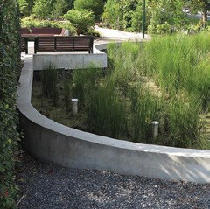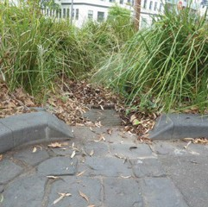

Tree planting plot details
Design standards – 501 series

Trees in roadways
Trees planted in parking lanes and medians should be canopy trees as large as practical, with low branches pruned to be clear of vehicles.
Trees planted in parking lanes should be spaced to maximise canopy cover along streets while allowing for efficient kerbside parking layouts (for example, with clear parking bay lengths of two to four cars).
Depending on context and the size of the planting area, tree plots in roadways should be designed as follows:
- Raised tree islands or medians, defined by kerbs – these generally need to be large enough that the distance from the tree to the kerb is greater than the front and rear overhang of vehicles (beyond their tyres) to avoid damage to tree trunks during parking manoeuvres.
- Flush with the surrounding paving – this requires the use of bollards, tree protection hoops or other elements to prevent vehicles from driving into the planting zone.
- Sunken below the surrounding paving to collect rainwater – this requires the use of bollards, tree protection hoops or other elements to prevent vehicles from driving into the planting zone. The risk of trip hazards also needs to be considered with this option.
Tree pits in roadways are typically finished with a lightly rolled granitic gravel mulch, not a compacted gravel pavement.

Finishes around existing trees in footpaths
Granitic gravel is often used to finish tree plots in footpaths and is acceptable in many relatively quiet residential streets. However, in busy central- city areas, people walk across tree pits and track gravel onto surrounding pavements and into shops. Gravel also erodes easily on slopes. Within the Capital City Zones, Docklands and in other locations with steep slopes, tree pits need to be finished with a more stable material.
Our standard material for this stabilised tree pit finish is a layer of permeable pebble-epoxy paving. Depending on the growth habit of the trees, this surface is likely to be relatively short-lived due
to the expansion of roots near the base of the tree. New trees in tree plots are to be finished with a granitic gravel surface until the tree is established (approximately 2 to 3 years). Once the tree is established, the granitic gravel surface can be removed, and the permeable pebble-epoxy surface installed. As pebble-epoxy finish requires more complicated maintenance than the simple topping up of granitic gravel, it should not be used where granitic gravel is adequate.
Tree pits around existing trees typically need to be scaled in response to a combination of factors including:
- tree trunk size
- the extent of shallow structural roots
- footpath clearance requirements.
Design Standards: Examples of tree pits
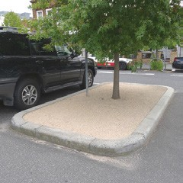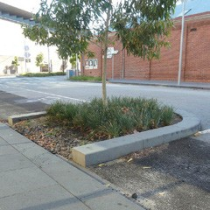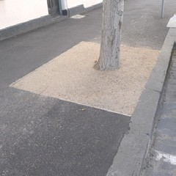

New trees in footpaths
Over the past several decades, typical tree pits used in the municipality have been 1200 x 1200 mm. They have proven inadequate for mature canopy trees. Maintaining a safe surface on tree pits, and pavement heave around trees, have become widespread problems.
To avoid these problems, tree planting details in footpaths, plazas and other paved pedestrian areas must provide:
- a generous opening in the pavement that allows space for the trunk when mature and for any flared base of the trunk, and that is also large enough to allow for removal of a dead tree, and replanting with a new specimen
- an adjustable grate over the opening with the soil level set down to allow for anticipated root growth without exerting pressure on the surrounding paving
- If a grated option is not feasible, provide a flexible surface near the tree to allow for root growth.
Tree pit sizes
Tree pit sizes are typically a compromise between the best outcomes for tree growth (usually calling for a larger opening) and access requirements along footpaths.
- The absolute minimum tree pit size should be 1500 x 1500 mm, and this should generally only be used for small species.
- The preferred minimum is 2 x 2 m for a large canopy tree.
- The preferred standard is a 2.5 x 2.5 m overall grate.
Pits may need to be rectangular or off-centre to the tree trunk to work within constraints of narrow footpaths or to protect existing shallow tree roots. In such cases, the total area of the tree pit should be no less than for an equivalent square pit.
Grate and other surface finish options
Standard options for the surface finish of tree pits include steel grates and fibre-reinforced polymer grates. The latter are more economical than steel for large-scale grates and also allow for trimming around tree trunks as they grow.
If for some reason a grated pit and set-down planting level is not possible, a flush finish with granitic gravel or pebble-epoxy paving can be used, as for existing trees.
Tree guards
The protection required varies in relation to the tree’s location and adjacent influences. Trees in some locations are especially likely to be targeted by vandals, while those in other areas are vulnerable to vehicles.
Our standard tree guard options relate specifically to the type of tree pit they are used with. Do not use unnecessary permanent tree guards. Most permanent tree guards should be able to be removed when trees have grown enough to be safe from damage without them.

Trees in lawn or garden areas
Protect trees from damage by mowers and string trimmers. In areas of closely spaced trees, use a mulch surface or ground cover planting other than lawn.
Design Standards: Examples of tree plots and park installations
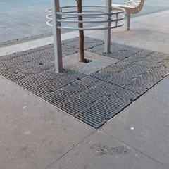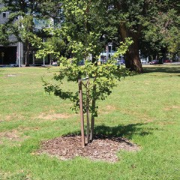

Other plantings

Lawn
In most cases and unless otherwise agreed all turfed areas should be warm season Kikuyu.
As Kikuyu can spread invasively, careful attention must be given to the delineation of the edge of the lawn where it adjoins other planting areas. Ideally, paved pathways will be used to separate grassed areas from garden beds to ensure a complete barrier. The appropriate detail for other types of barriers depends on the context, including maintenance regimes and soil type – Kikuyu runners spread at greater depth in sandy soil than in clay.

Planting beds and understorey
The guidelines below apply primarily to streets and other busy urban spaces. Parks offer more flexibility and planting is often a focus of their design; refer to relevant master plans for guidance.
Prioritise tree planting in most areas
- Understorey planting should not limit the opportunities to plant trees.
- Avoid planting ground covers below small to medium-sized trees, where ground covers will compete with the trees when young and fail when major tree roots later dominate the space.
- Use areas with substandard tree soil volumes for understorey.
- Consider the use of climbers where above- ground space for canopy trees is lacking, but there is soil to plant in.
Design to support functional values
- Understorey plantings may be useful as a part of pedestrian barriers, in some situations to reduce the hostile appearance of barrier fencing.
- Raingardens may be appropriate for stormwater treatment.
- Where appropriate, provide for extended and enhanced habitat for native fauna. The priority for implementation of the Nature in the City Strategy is to extend and complement existing significant habitat areas; however, small, fragmented areas of understory plantings should also be improved, created and connected.
Minimise potential conflicts with other uses
- Locate understorey plantings or provide protection to avoid damage from trampling.
- Use planting to support rather than displace use of public spaces.
Ensure safety
- Ensure that vegetation will not create places of concealment or obstruct sight lines for circulation safety or wayfinding.
Design to enable maintenance
Plantings must be selected and designed so they can be well-maintained without unreasonable expense.
- Limit high maintenance plantings to areas with agreed strategic importance.
- Avoid plantings in sites that are dangerous to work in, for example, because of exposure to vehicular traffic.
- Avoid plantings that require types of maintenance that are not supported by existing City of Melbourne procedures.

Mulches
All planted areas must be adequately mulched. The type of mulch used must suit the planting type and situation – for example, organic mulches that float are inappropriate in biofiltration beds.

Irrigation and drainage
We aim to balance the use of finite water resources against community expectations for public spaces. This requires irrigation to make spaces more usable for recreation, provide shade during hot weather, and meet aesthetic ideals connected with historic landscapes. Where possible:
- Design landscapes to be irrigated efficiently, with access to both potable and stormwater where practicable.
- Use passive irrigation, directing rainwater runoff from paved areas into planted areas.
- Maximise the extent of permeable surfaces to let air and water into the soil, especially within trees’ anticipated drip zone, and in low-lying parts of the street where water collects.
- Incorporate stormwater collection and re-use systems.
- Use subsoil drains in combination with bioretention areas and passive irrigation to avoid waterlogging of soils.
All design and documentation, materials, and work carried out should meet relevant Australian Standards, as well as the criteria set out below.
Give consideration to rainwater collection tanks and other WSUD systems. City of Melbourne must be engaged to discuss the use and design of these systems for public realm works. The following provides general guidance.

Irrigation zones and system types
Irrigation zones should be classified by vegetation type:
- turf grass
- tree
- garden bed.
No single irrigation valve should water more than one zone. Multiple valves per zone may be acceptable for specific design requirements.
High-profile turf areas should be irrigated with pop-up sprinklers.
All high-profile garden beds should be irrigated with pop-up sprinklers or risers and spray heads as needed, based on the plant selection and anticipated irrigation requirements.
No dedicated tree irrigation systems should be provided for trees that we plant and maintain, unless the trees are containerised and not in a natural soil profile.

Irrigation control systems
All irrigation controllers must be compatible with our Irrinet control system, which allows for remote operation through a central computer.
All irrigation control infrastructure must be operated by the developer’s maintenance representative until final handover is given. Then, the developer will arrange for the new controllers to be connected to City of Melbourne’s system.
Power must be on a metered supply to items that are part of the public realm, such as irrigation controllers, garden and lawn sprinkler pumps, water storage tanks and associated switchboards.
To ensure compliance with our standard irrigation specifications, irrigation system design must be confirmed with the Parks and City Greening Branch prior to municipal design approval.

Implementation and establishment

Tree supply and planting
Tree quality should meet the Australian Standard for Tree Stock for Landscape Use, AS 2303:2018. See also NATSPEC’s Specifying Trees: A Guide to Assessment of Tree Quality (2003) by Ross Clark.

Tree size at planting
Advanced tree stock, nominally 2 to 4 m in height, should be planted in most locations including median strips on main roads, parks, footpaths, and nature strips.
Only consider super-advanced stock (200 L and greater) where an extended maintenance regime (2 years plus) can be implemented.
Typical planting sizes should be as follows:
- 2 to 3 m high, 45 L or 50 cm container
- 3 to 4 m high, 100 L container.

Support for tree establishment
Watering
Turf or generalised garden irrigation systems are unlikely to provide the necessary water requirements for healthy tree establishment. Unless a dedicated tree irrigation system is provided, targeted hand watering to the root zone will be required during the establishment period after planting. The operation of dedicated tree irrigation systems should be informed by regular soil moisture analysis within and surrounding the tree root ball.
Staking
Provide temporary staking to trees to protect from vandalism:
- Two timber stakes should be installed for all trees.
- Only tie trees in exceptional circumstances.
- Stakes should be 50 x 50 mm hardwood, 1800 or 2400 mm long.
- Drive stakes straight into the ground to a depth of approximately 800 mm.
- Stakes must not be driven through the root ball.
- Install to ensure that the trunk or branches do not rub against stakes.
Trees installed within pavements and incorporating City of Melbourne steel tree guards do not require additional timber stakes.
Ensure stakes, ties and other temporary protective measures are fully removable at the appropriate time.

Planting over structures and in containers

Planting over structures
There are significant issues with containerised plants and planting over structures which make these options of last resort for greening the public realm:
- Due to limited soil volumes, containerised trees rarely grow to a large size, which means they can be ineffective at providing shade or a human scale in relation to large buildings.
- Containerised plants often have a reduced lifespan.
- Replacement planting is often difficult without damaging structures, waterproofing membranes and drainage systems.
- It may be impossible to redesign plantings to respond to new expectations if constrained by below-ground structures.
- Containerised plants are vulnerable to heat and drought, as they lack the surrounding mass of natural ground conditions which helps stabilise soil moisture and temperatures.
- Irrigation is critical for containerised plants in Melbourne’s climate, and the failure of irrigation systems is often catastrophic.
Public spaces should be planned and designed to minimise any demand for planting over structures. Ways to do this include:
- Maximise plantings where there is natural ground.
- Use spaces on structures for buildings or for activities and facilities that suit open, treeless sites.
- Where effective soil volumes on natural ground are limited by a high water table, contaminated subsoils or other factors, build up the level to increase the available soil depth.
If planting over structures is deemed to be appropriate:
- Create a few large planters rather than many small ones. This helps to minimise their surface area and exposure to heat, reduces the risks associated with localised failures of irrigation systems – for example, if an individual dripper outlet becomes clogged – and provides greater flexibility in replanting.
- If all tree planting possibilities have been exhausted, the use of lawns, ground covers or shrubs can be considered
- Use species that are likely to tolerate drought, high temperatures, wind and a changing climate.
- Ensure sub-structures have the capacity to support at least 1 m depth of saturated soil, drainage provisions and associated live loadings, including maintenance vehicle access.
- Ensure soil media meets Australian Standards for containerised soils, and that drainage and irrigation systems are robust and proven in other instances.

Movable planters
Movable planter boxes or potted plants are inappropriate in most public landscapes except as temporary decorations. When applicable movable planters are strongly preferred over temporary in-ground plantings at the base of trees, as irrigation for the latter is likely to encourage shallow tree root growth that exaggerates later problems with pavement heave.
Planters are to be considered for non-permeable paved areas only. Do not use containers that are likely to have more visual impact than the planting they support.
Moveable planter boxes may also be permitted as part of the furniture and screening provided by a kerbside cafe operator. These cafe planters are supplied, installed and maintained at the expense of the cafe operator. The design, placement and maintenance of such planters must conform to the requirements detailed in City of Melbourne’s Outdoor Cafe Guide.

Maritime Works
This section describes standards for wharves and floating infrastructure intended to become public assets. It pertains to works in, or adjacent to, the Yarra River, Victoria Harbour and Moonee Ponds Creek. Except for a portion of Moonee Ponds Creek, all of these are tidal zones within City of Melbourne’s municipal boundaries.
Several organisations share responsibility for coordinating waterways development, providing infrastructure, and improving recreation, leisure, tourism and water transport.
- City of Melbourne’s Recreation and Waterways Branch is the committee of management for Docklands waterways under the Crown Land (Reserves) Act 1978. Our responsibilities include allocation and licensing of berths for vessels, direct management of Melbourne City and Yarra’s Edge Marina, day-to-day operations of the waterways, managing contracts and marina leases.
- City of Melbourne is responsible for the lower and upper promenades along Southbank, leasing rowing sheds, and tourist signage on the lower Yarra River.
- Melbourne Water is responsible for the environmental management of all waterways, including the bed and banks of the lower Yarra River. This includes drainage and sewage systems, treating and supplying drinking and recycled water and flood protection.
- Parks Victoria is responsible for recreational activities on the Yarra and Maribyrnong Rivers. It manages facilities for navigational safety and port infrastructure for commercial activities. This includes tour operators and fishing charters, as well as recreational activities such as boating and boating zones, pier promenading and fishing.
- DELWP provides policy advice on marine conservation, coastal issues and local ports.
Strategic guidance for the public realm along waterways is provided by:
- Yarra River Protection (Wilip-Gin Birrarung Murron) Act
- City of Melbourne’s Yarra River – Birrarung Strategy (2019)
- City of Melbourne’s Moonee Ponds Creek Strategic Opportunities Plan (2019)
- Docklands Waterways Strategic Plan (2009–2018).
The section below sets out design standards that should be applied when delivering the above policies and strategies.

Functional criteria

Essential access and navigation
Wharves and marinas must provide universal access. Gangways should typically be provided for vessel access. Where gangways are not provided the vessel or landing gap should not exceed 100 mm. All surfaces must be non-slip.
Emergency vehicle access and any other emergency authority requirements must be provided to all wharves and marinas. Developers will be required to provide evidence in the form of a letter from emergency service agencies that the design meets their operational requirements.
The navigation requirements of Parks Victoria, as Waterways Manager under the Marine Act 1988, must be met.

Safety equipment
Design standards – 708 series
Lifebuoys and ladders must be installed as per the Guidelines for Water Safety at the Melbourne Docklands. Generally, lifebuoys should be installed at 150 m intervals and ladders at 50 m intervals.
Ladders are required when freeboard exceeds 0.5 m, such as a wharf or commercial pontoon, and should be:
- in line of sight from the water’s surface
- located to allow clear access to the ladder when berths are occupied
- clear of edge protection.

Servicing functions
Servicing functions (such as boat refuelling or waste disposal) should be kept as far away from pedestrian activities as feasible.
During the planning process, consider locating servicing functions adjacent to the buildings and land-based functions they are associated with. For example, make an arrangement to share compactor bins for waste disposal in an adjacent building.

Utilities provision
Where a maritime structure is to provide support for services or utilities, the developer must obtain written approval from the relevant authorities and certification of the design. The design must consider the following elements:
- mooring points
- firefighting equipment
- service pedestal equipment detail
- waste management (sewer, rubbish, recycling and general waste)
- lighting
- electricity
- signage.

Maintenance
Design all maritime components for minimum or easy maintenance. Design structures to minimise debris and litter mat formation. Allow for access to all structural members for inspection, repair or replacement.
Design Standards: Examples of marine safety equipment
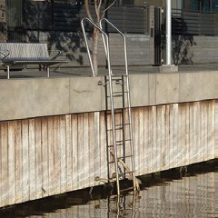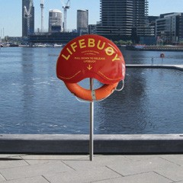

Structural criteria

Structural loads
The maximum tonnage limit for vessels mooring adjacent to a public maritime structure must be defined, having regard to the proposed use.
Structures must be able to withstand current, log strike, debris and litter mat forces associated with flood velocities up to and including those associated with a 1 in 100-year flood.

Structural isolation
Maritime structures must be designed to act as independent structures:
- If ownership of the structure is to be transferred to City of Melbourne, the developer must demonstrate structural support is not required for adjacent structures. They must also provide evidence to satisfy our City Infrastructure Branch that it has been achieved.
- If complete structural independence cannot be economically achieved, the developer will retain ownership of the structure and transfer the area above the structure to City of Melbourne for ongoing care and maintenance.
- The structure must not compromise the integrity of adjacent structures. It must be designed to withstand lateral impact from marine vessels without affecting adjacent structures.

Design life
The minimum design life for all structural maritime elements must be 50 years. The infrastructure in total, including all piles, decking, pontoons and associated elements, must be designed to last a minimum of 25 years with minimal maintenance.
Design life requirements will be fulfilled if all structural, functional and safety requirements are met throughout and at the end of the stated period, although there may be a need for major maintenance to prolong the service life beyond this. For design purposes it must be assumed that only preventative and isolated maintenance will be necessary during the design life.
For concrete elements, it will be assumed that the end of the service life will be reached after a maximum of 8 years from corrosion initiation.
The condition of any existing member that is to be re-used must be investigated by means of a thorough condition and material testing survey. Condition surveys and inspections will continue to be an important part of the lifetime maintenance regime.
See also:
- Loading Information for Wharves and Marinas (2011), City of Melbourne
- Cleaner Marinas – EPA Guidelines for Protecting Victoria’s Marinas (1998), Environment Protection Authority
- Design Guideline for Floating Assets Including Marinas and Walkways (2011), City of Melbourne,
- Public Safety on Wharves (no date), P.D Cummings and J.A. Imrie of Kinhill Pty Ltd.

GLOSSARY AND ABBREVIATIONS
Active frontage | Building frontages onto a public space that allow for movement in and out, and an active visual engagement between people in the street and people on the ground and upper floors of buildings. Active frontages are important to enhance amenity, interest and personal safety in the public realm.
Active transport | The movement of people or goods through human physical activity rather than via motorised means.
AHD | Australian Height Datum, the height above mean sea level as standardised for Australia
AS | Australian Standard
CAD | Computer Aided Design
Capital City Zone | The Capital City Zones as defined by the Melbourne Planning Scheme cover areas of existing intensive mixed-use activity as well as areas of projected major new development, including:  - CCZ1 Outside the Retail Core (within the traditional Central Business District or Hoddle grid)  - CCZ2 the Retail Core (of the CBD)  - CCZ3 Southbank  - CCZ4 Fishermans Bend  - CCZ5 City north  - CCZ6 Carlton Connect site  - CCZ7 Arts Precinct.
DCP | Developer contributions plan is a document that sets out the contributions expected from each individual landowner to fund infrastructure and services. Refer to Part 3B of the Planning and Environment Act 1987.
DELWP | Department of Environment, Land Water and Planning (Victorian Government)
Design standards | City of Melbourne documents that explain how standard elements are to be used in designs for the public realm. They do not provide complete construction or fabrication details and are not suitable for use as construction contract documentation (see also Engineering standard drawing).
Developer | The entity responsible for building the public realm, be they a public or private agency.
Development Victoria | The urban renewal authority of the Victorian Government (successor to VicUrban and Places Victoria)
DM# | City of Melbourne document management system reference number
Docklands Design and Construction Standards | Design and Construction Standards for Public Infrastructure Works in the Docklands Area
Docklands zone | The Docklands zone, as legislated in the Docklands Act 1991, includes all Docklands precincts from Yarra’s Edge in the south, stadium precinct to the east, Waterfront City in the north and Moonee Ponds Creek to the west, and is also defined in the Melbourne Planning Scheme.
Drip zone | The area extending from a tree’s trunk to the edge its canopy, notionally the limit of rainwater dripping off its foliage, which is used as a rough indication of the tree’s major root zone.
Engineering standard drawing | City of Melbourne documents that detail construction of particular elements for use in the public realm. Depending upon the project context, they may be useable as construction contract documentation.
EPA Victoria | Environment Protection Authority Victoria
Final completion | Formal acknowledgement that the defects liability period is complete, and all outstanding works have been rectified to City of Melbourne’s satisfaction. At this point, City of Melbourne accepts all responsibility for the site.
Fishermans Bend | The urban renewal area encompassing, in the City of Melbourne, the area between Lorimer Street and the Westgate Freeway which is divided into the Lorimer Precinct east of the Bolte Bridge and the employment precinct to the west (in addition to areas south of the freeway within the City of Port Phillip)
GIS | Geographic Information System
Handover | Refer to practical completion
Head start storage areas | Areas on-road provided for cyclists at signalled intersections, using line markings on the pavement
Incorporated document | A generally site-specific Melbourne Planning Scheme amendment which exempts a development from some or all the planning provisions and applies alternative controls
Passive irrigation | The direction of rainwater runoff from roof and paved areas into planted areas to increase the effective natural rainfall supporting vegetation
Practical completion | Practical completion is commonly referred to as handover. It is formal acknowledgement from City of Melbourne that works are complete and the defects liability period may commence. The site is typically open to public access, even though minor finishing works and rectification of defects of omissions may occur. At this point, City of Melbourne accepts day-to-day responsibility for maintenance.
Public realm | All publicly accessible areas including public spaces, streets and routes
Public space | A component of the public realm that includes waterways, public marinas, parks, squares, forecourts, promenades and creek corridors
Public streets and routes | Components of the public realm that include roads, lanes, arcades, bridges and overpasses
Section 173 agreements | A legal contract between the responsible authority and the owner of land setting out conditions or restrictions on the use or development of the land, or to achieve other planning objectives in relation to the land, registered over the title to the land so that the owner’s obligations under the agreement bind future owners and occupiers of the land.
Standards | The Design and Construction Standards for Public Infrastructure Works in the City of Melbourne
Structural soil | A medium that can be compacted to pavement design and installation requirements while permitting root growth. It is a mixture of coarse gravels with soil (approximately 80 and 20 per cent respectively).
Structural soil cells | A modular structure, usually manufactured from plastic, which supports pavements by bridging down through an uncompacted soil layer to a compacted base. The system allows a volume of soil that can be specified primarily to meet horticultural, rather than structural standards, and is structurally isolated from the paving above.
TGSIs | Tactile Ground Surface Indicators are paving tiles with raised patterns of bars and dots that are used to inform vision-impaired people of safe routes and hazards as they move through a place.
Urban heat island effect | Urban heat islands occur when natural land cover is replaced with concentrations of pavement, buildings and other surfaces that absorb and retain heat, resulting in hotter climates in urban areas compared to their surroundings. This effect increases energy costs (for air conditioning), air pollution levels, and heat- related illness and mortality for people as well as for other animals and plants.
Works in kind | Works (or the provision of land) City of Melbourne may permit development proponents to undertake (or provide) in lieu of cash payments, providing that the works or land constitute projects funded by the development contributions plan and City of Melbourne agrees that the timing of the works or land would be consistent with priorities in a development contributions plan.
WSUD | Water Sensitive Urban Design – design aiming to minimise the impact of development on the surrounding environment and waterways, involving treating and reducing stormwater flows, increasing soil moisture, urban greening and providing an alternative water source. Contributing to an Integrated Water Management (IWM) co-ordinated approach for the City of Melbourne.

APPENDICES

Appendix C1: Developer Contribution Plan and Works in Kind
Developer contributions plan (DCP)
In most cases, the process of subdivision will trigger a requirement to pay development contributions.
As collecting agency, City of Melbourne may accept the provision of land, works, services or facilities by the applicant to partly or fully satisfy the DCP levy payment.
This can be agreed with City of Melbourne before or after the application for the permit is made or before the development is carried out.
To enable coordinated infrastructure in precincts subject to DCPs, developers applying for subdivision must also submit a public infrastructure plan to the satisfaction of the responsible authority.
The public infrastructure plan must include the location, type, staging and timing of infrastructure on the land, as identified in the structure plan and DCP, or reasonably required as a result of the subdivision or development of the land. It must address the following:
- stormwater drainage and water quality works
- street works internal or external to the land consistent with any relevant traffic report or assessment
- the reservation or encumbrance of land for infrastructure, including for public open space and community facilities
- any infrastructure works an applicant proposes to provide in lieu of development contributions in accordance with
- a DCP
- the effects of the provision of infrastructure on the land or surroundings
- any other relevant matter related to the provision of infrastructure as required by the responsible authority.
Works in kind
City of Melbourne may permit development proponents to undertake works in lieu of DCP cash payments, providing that:
- the works constitute projects funded by the DCP
- we agree that the timing of the works is consistent with priorities in the DCP
- the developer complies with appropriate tendering, documentation, supervision and related provisions
- works are provided to a standard that generally accords with the DCP, unless an alternative is agreed with City of Melbourne and relevant Victorian Government agency
- detailed designs are approved by City of Melbourne and the development agency and generally accord with the standards outlined in the DCP unless an alternative is agreed
- the construction of works is completed to the satisfaction of City of Melbourne and the development agency
- there is no negative financial impact on the DCP, to the satisfaction of City of Melbourne.
The works will only be accepted in lieu of a financial contribution required by the DCP to the extent that they constitute part or all of the design of the infrastructure item and reduce the cost to complete that design, to City of Melbourne’s satisfaction. Temporary works will not be accepted as works in kind.
Where City of Melbourne agrees that a developer is to provide works in lieu of cash contribution (subject to the arrangements specified above):
- The credit for the works provided shall equal the final cost of the works to the maximum identified in the DCP, taking into account the impact of indexation,
- or an alternative figure we approve (unless we agree to an alternative approach).
- The value of works will be offset against the development contributions liable to be paid by the development proponent
- No further financial contributions will be required until the agreed value of any credits is used.

Appendix C2: City of Melbourne Submission Drawing Standards
All plans and drawings must:
- be drawn to scale, with the size of the drawing original indicated
- show north point and maintain consistent drawing orientation within the drawing set
- provide accurate and complete annotations and dimensions
- display an appropriate drawing title, number and date for reference
- show all levels to Australian Height Datum and all coordinates to Geocentric Datum of Australia 2020.
Data format requirements include:
- CAD files must comply with City of Melbourne’s CAD standard (refer to Part A, Chapter 7: Practical completion).
- GIS electronic files must include descriptive documentation, spatial data and metadata.
- PDF files must include embedded fonts for all text and symbols used.
- Electronic copies of reports, maintenance manuals and other text documents must be in either Microsoft Office or PDF format.
- GIS, PDF and CAD files must be provided.
The documentation of any proposed works must, to an extent appropriate to the purpose of the documents:
- be comprehensive
- be concise and well-ordered, with minimal duplication
- present a fully coordinated design that integrates proposals for underground services, sub-structures and geotechnical elements with all above ground elements
- be consistent and fully coordinated with other drawings in the set and professional inputs, to avoid contradictions, omissions or ambiguities (for example, civil engineering drawings coordinated with landscape architectural drawings and with services drawings)
- include a plan showing the current and proposed title boundaries in relation to the proposed public realm works
- include handing over maquettes for public artworks to the City of Melbourne Art and Heritage Collection.
Typical scale for drawings:
- set out plans at 1:100
- set out longitudinal and cross sections at 1:20 vertical and 1:200 horizontal
- include details as appropriate for construction purposes.
Unless otherwise indicated, submit multiple complete copies of all documentation including:
- two full size hard copy drawing sets
- three A3 size hard copy drawing sets
- electronic files (PDF format) of all documents.

Appendix C3: Public Realm Design Plan
Unless otherwise agreed on a project specific basis, the developer must prepare and submit the integrated public realm design plan in accordance with the project brief, seeking approval in stages as described below.
Public realm design plan – schematic design stage
The schematic design stage reflects the public realm design brief and produces the first high-level, comprehensive design sufficient for review and approval. This stage responds to the strategic, functional and qualitative aspects of the brief and provides a design vision and major components, with descriptions and relationships in physical terms.
The design should integrate construction and management considerations relevant to the scope, size and complexity of the site and the extent to which works are new or renewing existing conditions.
If required by the brief, this stage also provides information to further develop a construction budget, its break down and a preferred procurement method. Responses to regulatory requirements also become clear.
Typically, required outputs at this stage are:
- a project design program
- a feature, level and services plan appropriate to design requirements
- geotechnical and horticultural soils reports as appropriate
- site and context analysis as relevant
- preliminary illustrative options, plans, sections, and elevations of key elements, buildings and structures as necessary to convey the functional, spatial and material aspects of the project
- design presentations and discussions
- secondary digital outputs such as plans, sections, elevations where appropriate
- outputs to assist internal and external stakeholder input, as determined by the brief and likely to include community engagement
- acknowledgement of the horticultural, built form, traffic, waste, stormwater, lighting and public art considerations particular to the project
- responses to City of Melbourne cultural, heritage, sustainability and public safety policies and practices and obligations
- preferred options and selected precedent images of settings, hard and soft materials
- a draft and final costed schematic design proposal package, if required
- identification of further specialist inputs, opportunities or further investigations needed, and provision of advice on briefs for these services.
City of Melbourne approval of the schematic design is required before the design development stage.
Design development stage
This stage reflects the public realm design brief and develops the approved schematic design into a final, costed design solution of sufficient scope and detail for review and approval by all required parties. It provides confidence to all parties that it is the appropriate basis for full documentation for construction. The goal of the stage is to demonstrate that the issues of planning, design, materials selection, construction and constructability, staging, management, services and coordination of specialist skills have been addressed and integrated into the proposal and will ensure an effective project outcome.
The stage addresses the following:
- What agreed changes may be needed to the schematic design due to design considerations, cost and specialist inputs?
- What are the agreed materials and finishes and the resolutions or refinements to any design issues not resolved in the schematic design stage?
- What outputs best assist internal and external stakeholder input, as determined by the brief and likely to include community engagement material?
- What specific outputs are required for approvals and referrals (for example, planning permits)?
- Is the final design development documentation clearly traceable to the approved schematic design?
- Are all horticultural, built form, traffic, waste, stormwater, lighting and public art considerations understood and reflected in the design?
- Are City of Melbourne’s cultural, heritage, sustainability and public safety policies and practices addressed?
- Does the final design development documentation, including the cost plan, enable formal approval and progression to the next stage?
Typically, required outputs at this stage are:
- design studies for components or areas of the public realm to further confirm practicality, appearance, cost or similar parameters, while retaining the agreed design approach of the schematic design
- ongoing development and refinement of the approved design by all consultants and our stakeholders, including the incorporation of all authority requirements
- resolution of all outstanding design issues and responses to servicing, management and maintenance
- clarification of power and water supply, metering, sewer connections, monitoring and control systems, waste management and wayfinding signage.
- additional planning authority or other authority submission drawings (where relevant)
- scale digital plans, sections, elevations, photo simulations, material samples, preliminary audits (play, accessibility, building surveyor, safety and crime prevention through environmental design) sufficient to provide confidence in the preliminary design development proposal
- outputs to assist internal and external stakeholder input, as determined by the brief and likely to include community engagement outputs
- a draft and a final design development cost plan, if required.
Information on elements proposed must respond to the brief and typically include:
- location and intended materials of buildings, other structures, road and pedestrian paving, park or street furniture, planting and play equipment
- the specific management approach for any areas where subsoil contamination has been identified
- typical plants and turf types
- required soil preparation
- for any containerised planting, a description of required maintenance, management and replanting and confirmation of life expectancy drainage and waterproofing systems
- any arrangements with City of Melbourne for plant supply or supply and installation
- the approach to irrigation layout, water storage
- water sensitive urban design elements as relevant
- responses to City of Melbourne cultural, sustainability and public safety policies and practices
- location and type of public lighting
- public art locations and provision
- management and maintenance aspects.
City of Melbourne approval of the design development is required before progressing to the construction documentation stage.
Construction plan documentation stage
This stage reflects the brief and incorporates any agreed amendments from the design development stage and cost plan. It is focused on the production of fully dimensioned and annotated digital drawings, written specifications, material schedules and material samples. It includes required pre-ordering of materials and equipment necessary to tender the works or produce the desired design on the ground to an agreed budget and program.
The stage addresses the following:
- coordination of documents with relevant documents produced by other consultants
- further discussion with specialist suppliers, contractors and approval bodies as necessary
- advice on tendering and implementation methods
- outputs to assist stakeholder input, as determined by the brief
- design audits (for example, play, access and safety)
- client approval
- production and review of the draft and final construction pre-tender cost plan, if required
- formal design reviews by stakeholders as required for the documented works to proceed to construction.
Elements addressed must reflect the brief and typically include all documents necessary for street and open space construction including plans, cross sections, longitudinal sections, details, specifications and schedules, such as:
- comprehensive and detailed earthworks and grading plans, set-out of kerbs, channels, paving, tree planting pits, grates, buildings, structures, buildings and other features
- for streetscape improvement works – construction notes, legend, site plan, plan showing the location of services, longitudinal and cross-sections, construction details and specification
- accurate locations and details (including types, locations, sizes and cover lid types) of all underground service access points, pits, manholes, traps, outlets and cabinets for all utilities including water, sewer, power, gas, drainage, cathodic protection systems, traffic signals, cabinets, irrigation controls, drainage pumping stations, telecommunications cables, mobile phone towers and gross pollutant traps
- water sensitive urban design elements as relevant
- locations of new utilities including depths and offsets
- proposed spare conduits to allow for possible future services and to eliminate the need to excavate the paving in future
- identification of all construction materials including those for kerbs, channels, pavements and other surfaces, structures and buildings
- maritime works
- construction details including footings, paving substructure and joint details
- street furniture types, materials, locations, quantities and installation details
- all street sign types, locations, materials, quantities and installation details
- all poles, for example, for signs, tramways and lighting
- sub-surface and surface horticultural treatments to the site supported by a horticultural soils analysis report and responses to the recommendations of the report
- irrigation and water storage details
- planting plans for all trees, shrubs and other plants
- confirmed orders and costs for tree planting and maintenance to be undertaken by City of Melbourne
- schedules of numbers, botanical, common names and cultivars of all trees, shrubs and other plants, including supply size and ultimate growth size
- for any containerised planting, a detailed maintenance and management plan, schedule of procedures for replanting and confirmation of the life expectancy of drainage and waterproofing systems
- confirmation of any arrangements with City of Melbourne for plant supply or supply and installation
- location and type of public lighting
- approved public art locations and related documentation
- management, maintenance and handover requirements including a management policy for any areas of soft landscaping where subsoil contamination has been identified.
A geotechnical report for the site must be submitted. It must be prepared by a National Association of Testing Authorities–approved laboratory and supported by calculations and engineering details including:
- pavement design assumptions and calculations
- estimates of likely settlement of road and footpath pavements, adjacent structures and differential settlement, including details of the accuracy or confidence limits of this estimate
- details of design measures to mitigate the impact of ground settlement and to allow for likely differential settlement between roads, footpaths and structures on piles.
City of Melbourne approval of the public realm construction documentation is required before progressing to the implementation stage.

Appendix C4: Typical Public Realm Construction Hold Points
Hold points specifically required by City of Melbourne will be provided for incorporation into the technical specifications used for any construction contracts.
Typical hold points for civil works (carriageway, vehicle and footpath works assessed separately):
- meeting prior to commencement of the works
- sub-grade inspection
- inspection of kerb and channel alignment
- proof rolling of road base
- reinforcement prior to concrete pour
- first 10 m² of bluestone paving, if relevant
- pipe bedding and laying before backfilling
- connection of legal point of discharge.
Typical hold points for lighting works
- City of Melbourne approval of design drawings prior to installation
- submission of details of the electrical contractor to City of Melbourne prior to starting work
- City of Melbourne approval before backfilling or concreting trenches or footings
- City of Melbourne inspection of the lighting system at – the commissioning of electricity, at practical completion, and at final completion.
Typical hold points for soft landscape works
- trees to be removed and protected are marked on site and protection measures inspected by an arborist to ensure compliance with the tree protection plan
- achievement of proposed final levels with preliminary set out of garden beds and paved areas marked on site
- subgrades cultivated or prepared before placing topsoil
- grassing bed prepared before turfing or temporary grassing
- underground irrigation works completed before backfilling
- tree and shrub stock to be inspected at the supplier's nursery before delivery to the site
- tree and shrub stock to be inspected after delivery to the site, before planting
- stages of water sensitive urban design construction as nominated
- soil sample and soil test provided to City of Melbourne before importation to ensure it complies with our standards.
Typical hold points for public realm structures, play elements and buildings
Hold points may apply, depending on the nature of the work. We will provide them on a project-specific basis.

Appendix C5: Typical Elements of Pre-Handover Cleaning
Pre-handover cleaning should include, but is not limited to, the following:
- removing tape and wrapping
- washing down all street furniture, feature walls, architectural features and artworks
- cleaning all light fittings
- cleaning all traffic poles and signal cabinets
- cleaning glass
- removing all grout residue from pavers and fixtures and any cement spray, stains, tyre marks or other stains from roads, pavers and fixtures
- cleaning all grates and side entry pits of silt and litter
- emptying all litter bins
- removing all litter from garden beds.

Appendix C6: Typical Asset Categories
The asset inventory must comply with the CAD layering standard document provided in the data table format identified in that document. Further, each record should be linked to an object in a CAD drawing by use of a unique ID for each object in both the drawing and data table.
For a more complete list including identification of relevant asset managers within City of Melbourne, see Handover Inventory List.
The following is a summary:
- art and heritage
- aviation
- barrier
- bridge
- building component
- buildings and or small structure
- decoration
- electricity
- financial asset
- fire hydrant
- fuel
- furniture and equipment
- gas
- horticulture
- information and communications technology
- land
- lighting
- marine structures
- outdoor furniture and signage
- parking control
- pneumatic systems
- railway
- recreation equipment
- recreational surface
- residential bin
- road
- security infrastructure
- sewerage
- signage
- stormwater
- structural support
- syringe bin
- telecommunications
- traffic systems
- transport assets
- water
- water supply and irrigation system.

Appendix C7: Typical Operation and Maintenance Manual Scope
Typically, manuals must include:
- details of manufacturers and suppliers and all warranty details
- specifications and maintenance requirements for all paint, applied finishes, protective coatings or special finishes, including cleaning procedures, periodic maintenance or renewal, and repairs including retouching after minor damage, graffiti or other vandalism
- details of interim maintenance contracts, such as landscaping
- details of all electrical and mechanical systems, including their purpose, mode of operation, operating instructions, maintenance requirements, suppliers' contact details, and part numbers
- a description of lighting, operation details and recommended life and replacement details
- an inventory of all installed equipment and software with details of type, manufacturer, capacity, size, operating parameters, serial number, supplier name and contact details
- operating procedures including instructions for starting, stopping, and restarting after a power interruption and in case of emergency.
- inspection, testing and life cycle maintenance program in tabular form showing:
  - frequency and level of routine attention required for each component of the work throughout its intended lifespan
  - any special maintenance procedures for structures, including access for inspection and maintenance
  - any other special measures for the conservation and preservation of artworks
- notification procedure in case of claims under the defects liability provisions of the contract
- contact details for designers, artists, and major subcontractors.

Appendix D1: Current and Superseded Design Standards

Design and construction standards

DOCKLANDS (FROM 2013)
200 Series
201.01 – Sawn bluestone paving standard size
201.02 – Sawn bluestone paving small size
201.03 – Asphalt footpath paving
201.04 – Granitic gravel paving
201.06 – Permeable pebble mix paving
201.08 – Asphalt road paving
300 Series
301.01 – Bluestone kerb and gutterstone
301.03 – Bluestone overflow kerb
302.01 – Precast concrete kerb exposed aggregate
302.03 – Cast in situ concrete kerb aggregate finish
303.01 – Sawn bluestone channel
304.01 – Drainage pit side entry with standard steel grate
305.01 – Timber edge
305.02 – Steel edge
305.03 – Cast in situ concrete edge
400 Series
401.01 – Access ramp typical corner bluestone footpath
401.02 – Access ramp joined narrow bluestone footpath
401.03 – Access ramp typical corner asphalt footpath
401.04 – Access ramp for median/island
402.01 – Crossing asphalt paving with bluestone edge
402.02 – Crossing asphalt paving for laneway with side pits
402.05 – Crossing asphalt paving with no edging
500 Series
501.01 – Tree pit in lawn or mulched planter bed
501.02 – Tree pit in asphalt paved area
501.04 – Tree pit standard size in bluestone paved area
501.07 – Tree island in centre of road parking area
501.08 – Tree pit bio-retention type in bluestone paving
501.11 – Tree pit in combination with structural soil
600 Series
601.01 – King Street light – tall pole
601.02 – King Street light – short pole
601.03 – Docklands light
601.05 – Laneway wall-mounted light
601.06 – Neighbourhood light
601.07 – St Kilda Road light
601.09 – Park light
700 Series
701.01 – Stainless steel slatted seat
701.02 – Stainless steel slatted bench
701.03 – Park seat
701.04 – City swivel seat
701.05 – Park swivel seat
702.01 – City litter bin
702.02 – City recycling bin
702.03 – Park bin
702.04 – Park recycling bin
702.07 – Waterways dog waste bin
703.01 – Drinking fountain
703.02 – Drinking fountain with dog bowl
704.03 – Fin bollard – fixed
704.04 – Fin bollard – removable
704.05 – Cattle rail bollard
704.06 – Timber bollard – fixed
704.07 – Timber bollard – removable
705.01 – Skate deterrent long fin
705.02 – Skate deterrent short fin
705.03 – Skate deterrent stainless steel button
705.04 – Skate deterrent bronze button
705.05 – Gib key and socket
706.01 – Post and rail fence
706.02 – Steel hoop fence
706.03 – Tree guard and grate for bio-retention tree pit
706.07 – Steel safety rail fence
706.08 – Bicycle hoop
706.09 – Spiral bicycle hoop
707.01 – Picnic table
707.02 – Barbecue – single
707.03 – Barbecue – double
708.01 – Life buoy holder
708.02 – Marine ladder
710.03 – Tourist bus shelter
710.04 – Tram shelter
710.05 – Outdoor cafe screen
710.06 – Outdoor waiter station
710.07 – Elliptical pillar
710.08 – Park toilet
710.09 – Self-cleaning toilet
710.10 – Banner pole
710.11 – News pillar
710.12 – News kiosk

CITY OF MELBOURNE (FROM 2022 ONWARDS)
200 Series
201.01 – Sawn bluestone paving standard size
201.02 – Sawn bluestone paving small size
201.03 – Asphalt footpath paving
201.04 – Granitic gravel paving
201.05 – Concrete paving
201.06 – Permeable pebble mix paving
201.08 – Asphalt road paving
201.09 – Granite strip inlay in bluestone paving
201.10 – Sawn bluestone pitcher paving
201.11 – Asphalt footpath with bonded aggregate finish
201.12 – Granite tactile ground surface indicators
201.13 – Ceramic tactile ground surface indicators
300 Series
301.01 – Bluestone kerb and gutterstone
301.02 – Bluestone kerb and single pitcher channel
301.03 – Bluestone overflow kerb
302.01 – Precast concrete kerb exposed aggregate
302.03 – Cast in situ concrete kerb aggregate finish
303.01 – Sawn bluestone channel
303.02 – Bluestone pitcher channel
304.01 – Drainage pit side entry with standard steel grate
304.02 – Drainage pit for bluestone channel
305.01 – Timber edge
305.02 – Steel edge
305.03 – Cast in situ concrete edge
305.04 – Stainless steel edge – isolation joint in bluestone
400 Series
401.01 – Access ramp at typical corner bluestone footpath
401.02 – Access ramp in joined narrow bluestone footpath
401.03 – Access ramp at typical corner in asphalt footpath
401.04 – Access ramp for median/island
402.01 – Crossing asphalt paving with bluestone edge
402.02 – Crossing asphalt paving for laneway with side pits
402.03 – Crossing asphalt paving for laneway with central pit
402.04 – Crossing asphalt paving bluestone edge pitcher channel
402.05 – Crossing asphalt paving with no edging
500 Series
501.01 – Tree pit in lawn or mulched planter bed
501.02 – Tree pit in pavement
501.03 – Tree pit in road adjacent kerb
501.07 – Tree island in centre of road parking area
501.08 – Tree pit in pavement bio-retention type ‘Class B’
501.09 – Tree pit in road bio-retention type ‘Class D’
501.11 – Tree pit in combination with structural soil
600 Series
601.01 – Capital city light
601.03 – Waterways light
601.05 – Capital city light - wall-mounted
601.06 – Neighbourhood light
601.07 – City joint use pole
601.08 – Catenary lighting
601.09 – Park light
601.10 – Promenade light
601.12 – Plaza light
601.14 – Northbank light pole
700 Series
701.01 – Stainless steel slatted seat
701.03 – Park seat
701.04 – Swivel seats – City and Park
701.08 – Stainless steel curved rod seats
701.09 – Stainless steel straight rod seats
701.10 – Platform seats
701.11 – Bluestone seating blocks
701.12 – Stainless steel tree pit seat
702.01 – City bins
702.05 – Dog waste bin
702.01 – Three bay bin corral
703.01 – Drinking fountain
704.01 – Heritage bollards – fixed and removable
704.03 – Fin bollards – fixed and removable
704.06 – Timber bollards – fixed and removable
704.11 – Parks bollard steel - removable
704.12 – HVM bollard shroud
705.01 – Skate deterrent fins
705.03 – Skate deterrent buttons
705.05 – Gib key and socket
706.01 – Post and rail fence
706.02 – Steel hoop fence
706.07 – Steel safety rail fence
706.08 – Bicycle hoop
706.09 – Spiral bicycle hoop
706.10 – Stainless steel handrail
707.01 – Picnic table
707.02 – Barbecue - single
707.03 – Barbecue – double
708.01 – Life buoy holder
708.02 – Marine ladder
709.02 – Flower planter box large
709.05 – Flower planter box round
710-02 – Awning shelter
710.03 – Tourist bus shelter
710.04 – Tram shelter
710.09 – Self-cleaning toilet
710.13 – Hub pillar
710.15 – Electrical events pole
7.10.20 – Water meter enclosure
In addition to the above list, specific Design Standards exist for past City of Melbourne works and non standard applications that may be appropriate for use in specific situations subject to City of Melbourne prior approval.

https://participate.melbourne.vic.gov.au/

