Statement of Significance: Fairlie flats (54-60 Anderson Street, South Yarra), February 2023

Heritage Place: | Fairlie flats | PS ref no: | HO1402
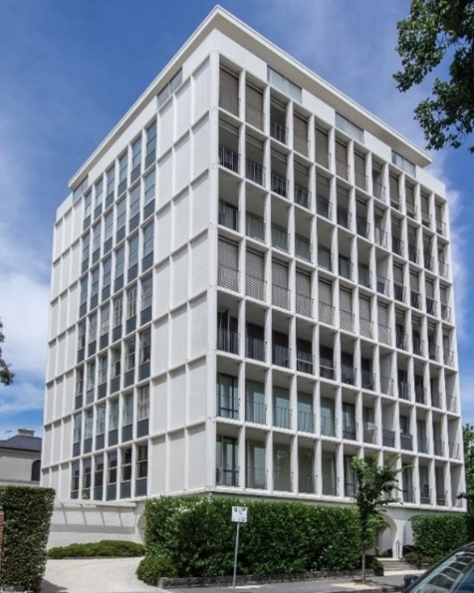  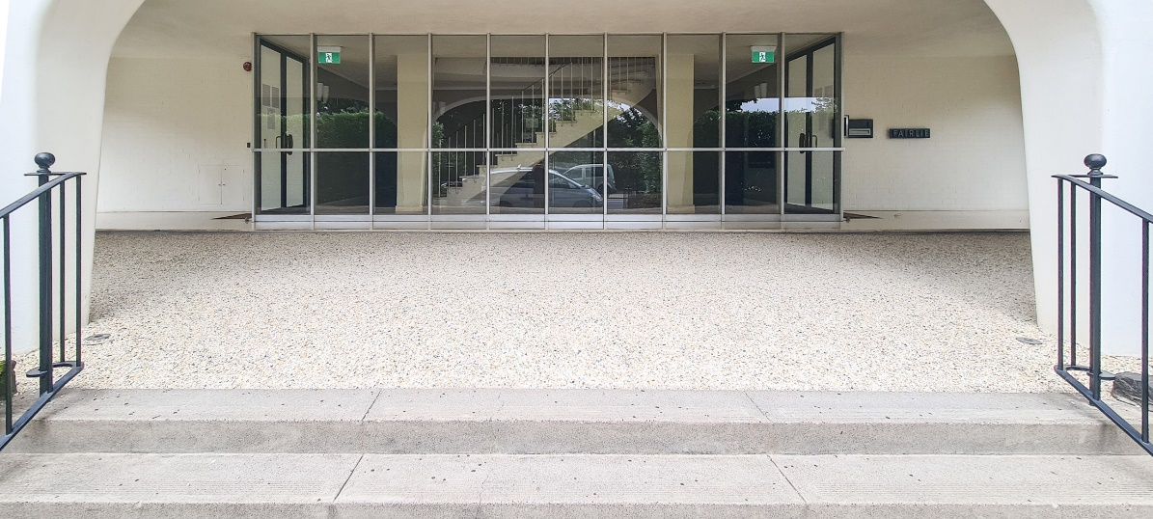  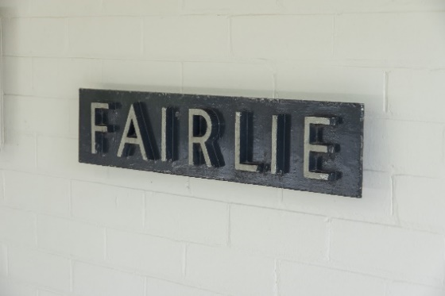 | 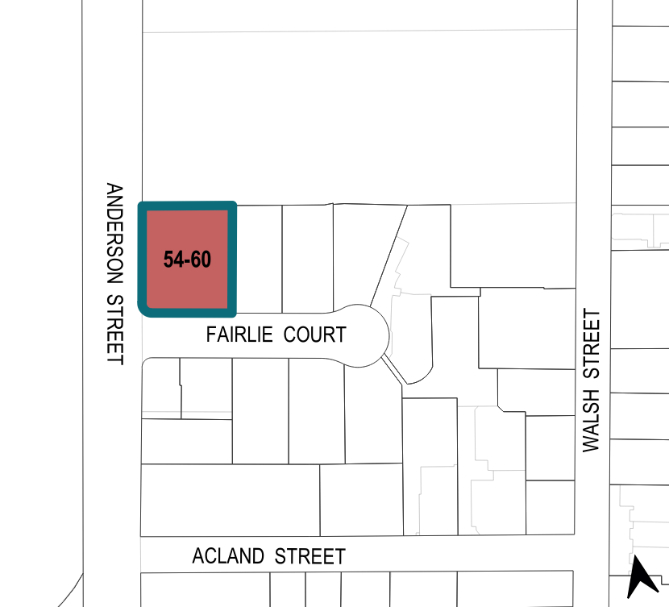

What is significant?
Fairlie at 54–60 Anderson Street, South Yarra, completed in 1961 to a design by Yuncken Freeman Pty Ltd, is significant.
Elements that contribute to the significance of the place include (but are not limited to) the:
- building’s original rectangular form, materials and detailing
- building’s high level of integrity to its original design, including the composition of the primary elevation with its intact fully glazed walls behind the prefabricated concrete frames
- detailing of the exterior including the steel-framed pilotis and non-loadbearing vertical curtain walls and opaque cladding on the side (north and south) and rear (east) elevations, as well as the penthouse with projecting eaves
- pattern and size of original metal frame windows and spandrels
- other original elements including fully glazed lobby, spiral stairwell, brick fence enclosing the original carports and the metal signage reading 'Fairlie' by the lobby.
Original bluestone edging to the garden beds near the entrance also contributes to the significance of the place. More recent alterations and additions are not significant.

How is it significant?
Fairlie at 54–60 Anderson Street, South Yarra, is of local historical, representative and aesthetic significance to the City of Melbourne.

Why is it significant?
Fairlie is historically significant as one of the earliest high-rise blocks of flats built in Melbourne. Completed in 1961, Fairlie predated the introduction of Strata Titles Act 1967. The nine-storey block of flats was designed by Yuncken Freeman Brothers, Griffiths & Simpson, one of the largest architectural practices in Australia. Described in 1961 as the most expensive flats in Australia, it was one of the earliest luxury high-rise blocks in Melbourne when completed. The site’s connection to the Victorian-era mansion Fairlie House, which formerly occupied the site, is of local interest. (Criterion A)
Fairlie is an important early example of a new and distinctive building type that emerged in the 1960s: the high-rise block of flats. The building displays elements influenced by Modernist architecture, characterised by a simplicity of structure and a minimisation of decoration. Its use of prefabricated concrete panels, reinforced concrete construction, and a non-loadbearing curtain wall system are representative of the residential towers built in the City of Melbourne in the 1960s and 1970s. (Criterion D)
Fairlie is aesthetically significant for its demonstration of key elements influenced by Modernist architecture. The rectangular building is raised on arched pilotis, providing a portico with a driveway underneath for covered access to the building from a car. A move away from a traditional loadbearing wall system is evidenced in its use of thin modular prefabricated concrete frames and the use of curtain walls on all elevations. Its lightweight ground-floor treatment is also distinct. Fairlie is distinguished for its delicate design with modular aesthetics, restricted palette, and the interplay of light and shadow. Its visual dominance in the streetscape, as well as the immediate views from the Royal Botanic Gardens, also contribute to the building’s aesthetic significance. (Criterion E)

Primary source
South Yarra Heritage Review 2022 (GML Heritage)

