Statement of Significance: St Thomas Aquinas Catholic Church (chapel of ease) (35-45 Bromby Street, South Yarra), February 2023

Heritage Place: | St Thomas Aquinas Catholic Church (chapel of ease) |  | PS ref no: |  | HO1403
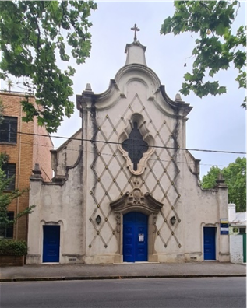 |  |  |  | 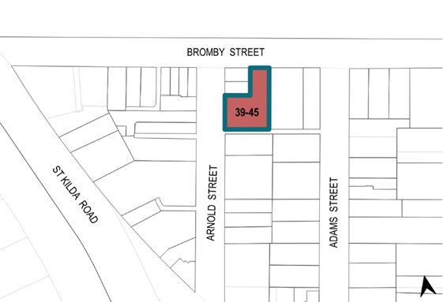

What is significant?
St Thomas Aquinas Catholic Church (chapel of ease) at 39–45 Bromby Street, South Yarra, built in 1915 and remodelled in 1954 for the Roman Catholic Trust Corporation, is significant.
Elements that contribute to the significance of the place include (but are not limited to) the:
- building’s 1915 external form, and 1954 materials and detailing
- building’s high level of integrity to its 1915 and 1954 designs
- northern façade designed by Thomas G Payne, including cement moulded cornices, broken pediment, grooved diaper cross pattern, enamelled tiles, stained glass, buttresses, coping, moulded cornices, pediment, stone reliefs and its crucifixes
- pattern and size of original fenestration
- original hall’s internal layout and timber carpentry
- carved sculptural works including the crucifix sculpture by woodcarver Walter Langcake (1937); the statue of St Thomas Aquinas (circa eighteenth century); and the Stations of the Cross carvings and statues of Our Lady and the Sacred Heart of Jesus by artist Leopoldine Mimovich (dates unknown).
More-recent alterations and additions, including the steel fence, are not significant

How is it significant?
St Thomas Aquinas Catholic Church (chapel of ease) at 39–45 Bromby Street, South Yarra, is of local historical, rarity, aesthetic, social and associative significance to the City of Melbourne.

Why is it significant?
St Thomas Aquinas Catholic Church (chapel of ease) at 39–45 Bromby Street, South Yarra, is of local historical significance to the City of Melbourne as an example of a chapel of ease built in 1915 to serve the needs of the Catholic population in the western end of the parish. Although the number of Catholics within the Parish of South Yarra in the early twentieth century was relatively low, the population was spread thinly across a large area, and it was difficult for some to get to the parish church (St Joseph’s Church), on Fitzgerald Street, South Yarra. The subject building is significant for its demonstration of sociodemographic patterns in the South Yarra area, its purpose being to serve the needs of the servant class in the South Yarra area of the City of Melbourne, many of whom were Catholic domestic servants. (Criterion A)
Architect Thomas G Payne’s 1954 remodelling of the 1915 church hall, designed by Kempson and Conolly, is of historical significance as an example of divergent architectural approaches to religious postwar architecture. The postwar period was marked by a distinct shift away from revivalist style architecture and the growing influence and application of Modernist design principles for religious buildings across suburban Melbourne. Payne’s design for St Thomas Aquinas is a pivotal example of the conservative counterpoint to this architectural debate. It represents the cohort of architects and church organisations that believed traditional or revival styles were the most appropriate styles to use in designing places of worship. Conolly and Payne were prominent architects who, drawing on revival styles, designed many buildings for the Catholic Church in twentieth-century Melbourne. (Criterion A)
St Thomas Aquinas Catholic Church has significance for its demonstration of an uncommon architectural design within the City of Melbourne. The 1954 modified façade and rear additions are an example of the work of Thomas G Payne. The church is a unique example of the Baroque style applied to a postwar church in the City of Melbourne. It is a unique interpretation of the Baroque Revival, a style that is rare within the City of Melbourne and divergent from Modernist-style approaches to postwar religious architecture. It displays key elements of the Baroque style, including the tiled and grooved surfaces, ornate curvilinear parapet, cement mouldings and stained-glass multicurved window. (Criterion B)
The exterior and interior of St Thomas Aquinas Catholic Church have aesthetic significance to the City of Melbourne. The façade has an original composition and style, exhibiting a high degree of craftsmanship and architectural merit. The principal façade is symmetrically composed, with decorative cement mouldings, grooved surface patterns and locally fired glazed tiles with symbolic motifs. Its highly ornate detailing contributes to its unusual and striking character. Internally, the exposed timber queen post truss ceiling with curved supporting brackets and the timber sculptural works exhibit a high level of carpentry and artistic quality. The church contains an important collection of timber sculptural works. These include the near-life-size crucifix sculpture by woodcarver and sculptor Walter Langcake; the statue of St Thomas Aquinas; and the Stations of the Cross carvings and statues of Our Lady and the Sacred Heart of Jesus by artist Leopoldine Mimovich. (Criterion E)
The St Thomas Aquinas Catholic Church is socially significant to the City of Melbourne. It has been used continuously as a place of worship for over 105 years. The congregation of St Thomas Aquinas Catholic Church forms a specific community who use and visit the place regularly and have continuously since its establishment; this suggests that there is some form of community attachment that spans multiple generations. St Thomas Aquinas Church is a publicly accessible building in which a community function (religious worship) is provided. This function is clearly identifiable in the external fabric of the building, evident in the crucifixes and Christogram tiles. St Thomas Aquinas Church is identified as having social significance on the basis that it provides a setting for a defined community to gather and participate in a cultural practice. (Criterion G).
St Thomas Aquinas Catholic Church is significant for its associations with the architects Kempson and Conolly and Thomas G Payne (1906–1983). Conolly and Payne produced designs for several Catholic churches in Melbourne during the twentieth century. Among these, the subject building is a unique and striking example that attracted the attention of architectural critics and the public. Within Payne’s oeuvre, St Thomas Aquinas is one of his best known works, and is an important milestone in his career. (Criterion H)

Primary source
South Yarra Heritage Review 2022 (GML Heritage)

