Statement of Significance: Domain Park (191-201 Domain Road, South Yarra), February 2023

Heritage Place: | Domain Park | PS ref no: | HO1404
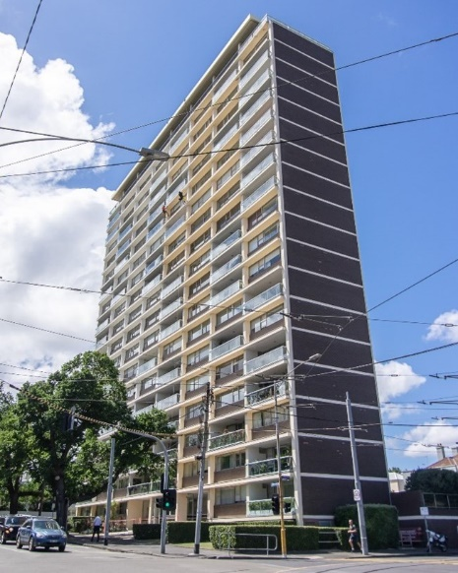  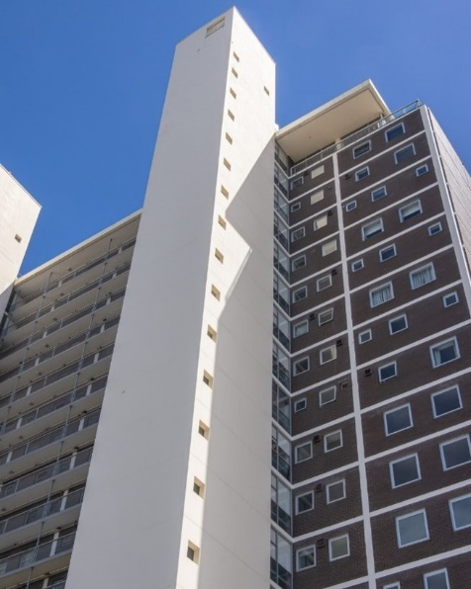 | 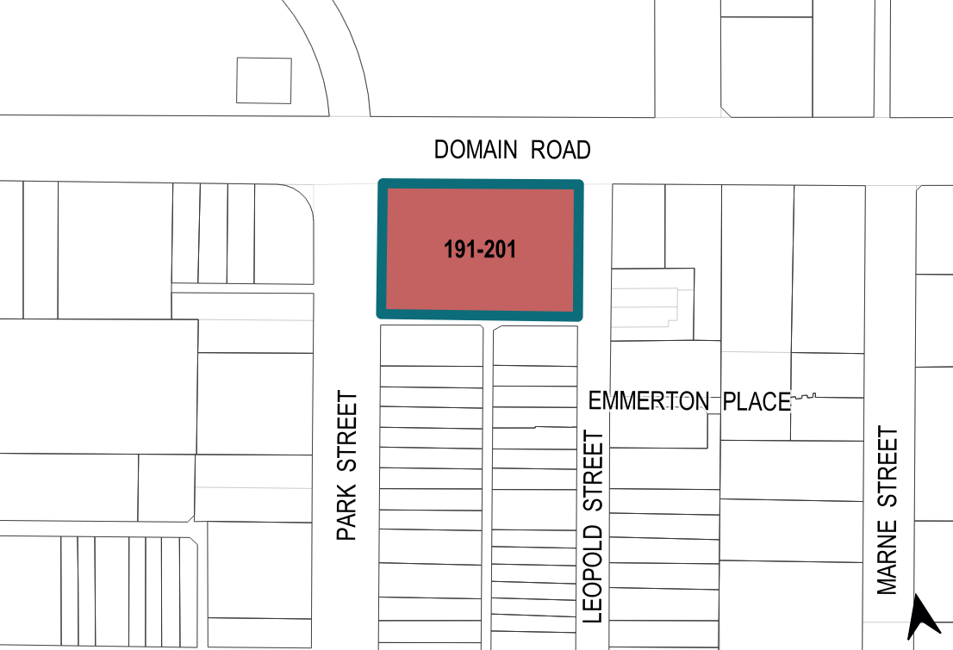

What is significant?
Domain Park at 191–201 Domain Road, South Yarra, built in 1960–62 and designed by Robin Boyd, is significant.
Elements that contribute to the significance of the place include (but are not limited to) the:
- building’s original simple geometric form including the flat roof, narrow rectangular main tower, and two service towers and connecting open balconies to the south
- building’s original materials

- building’s high level of integrity to its original design representative of the Modernist style, including the modular composition of the north elevation incorporating open balconies interposed with recessed windows above dark brown masonry spandrels
- detailing of the exterior including the ‘Domain Park’ lettering, original face brick cladding (manganese brick on side elevations and brown brick on the front and rear elevations) contrasted with bright white concrete walls (currently overpainted in a darker, creamy shade) and expressed concrete floor plates
- pattern and size of original fenestration of the rear elevation, as well as the intact service towers and open service balconies
- other original elements including aluminium window frames, and the walnut fixtures in the lobby.
More recent alterations and additions to the lobby are not significant.

How is it significant?
Domain Park at 191–201 Domain Road, South Yarra, is of local historical, representative, aesthetic and technical significance to the City of Melbourne.

Why is it significant?
Domain Park at 191–201 Domain Road, South Yarra, is historically significant as one of the earliest high-rise residential towers constructed in the inner suburbs in the early 1960s. Designed in 1959 by prominent architect Robin Boyd and constructed in 1960–62, the block of 20-storey own-your-own (OYO) apartments, comprising two 180-feet-high (55m-high) service towers, was the tallest structure in Melbourne’s suburbs and the tallest building of its type for almost a decade. Domain Park was a pioneering example of a Modernist style high-rise residential building that predated other examples in the inner city constructed from the late 1960s and early 1970s. Domain Park is the only example of high-rise residential building that was built to a design by Robin Boyd, who envisioned high-rise development and led the public and professional debate regarding urban density and new forms of residential accommodation. (Criterion A)
Domain Park is of representative significance as a pioneering example of a new typology that emerged in the early 1960s in Melbourne — the modern high-rise residential building. The building displays defining elements of the Modernist high-rise residential apartments, characterised by simplicity of structure and minimisation of decoration. The building’s use of the reinforced concrete frame and non-loadbearing brick-clad walls on side and rear elevations, the mixture of a high level of glazing and open balconies in the primary elevation are representative features of this evolving typology. (Criterion D)
Domain Park is aesthetically significant for its Modernist architectural design characterised by its simple geometric volumes, modular façade patterning, lack or ornament and restricted palette. Inspired by international counterparts, Boyd’s spatial concerns are reflected in the building’s narrow rectangular form with two service towers at the rear and the modular composition of balconies and recessed windows which allowed for various apartment layouts without altering the structural rhythm of the façade. Separation of service towers from the main floor plate aimed at achieving reduced noise transmission to the main living space. The provision of each suite across the north-south depth of the building allowed access to light and views both ways, across the Botanic Gardens to the north and towards Port Phillip Bay to the south. Its visual dominance in the surrounding, as well as the immediate views from the Royal Botanic Gardens also contribute to the building’s aesthetic significance. The outstanding merit of Domain Park was recognised by winning the 2015 Victorian Chapter Enduring Architecture Awards. (Criterion E)
Domain Park is also of technical significance, as the first fully air-conditioned high-rise residential building in Australia. The living areas were equipped with a fan-coil air-conditioning system, serviced by the two towers at the rear. (Criterion F)
Primary source
South Yarra Heritage Review 2022 (GML Heritage)

