Statement of Significance: Former Chevron Hotel (519-539 St Kilda Road, Melbourne), February 2023

Heritage Place: | Former Chevron Hotel | PS ref no: | HO1414
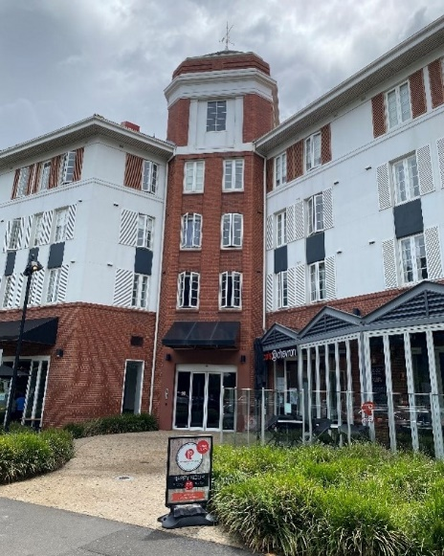 | 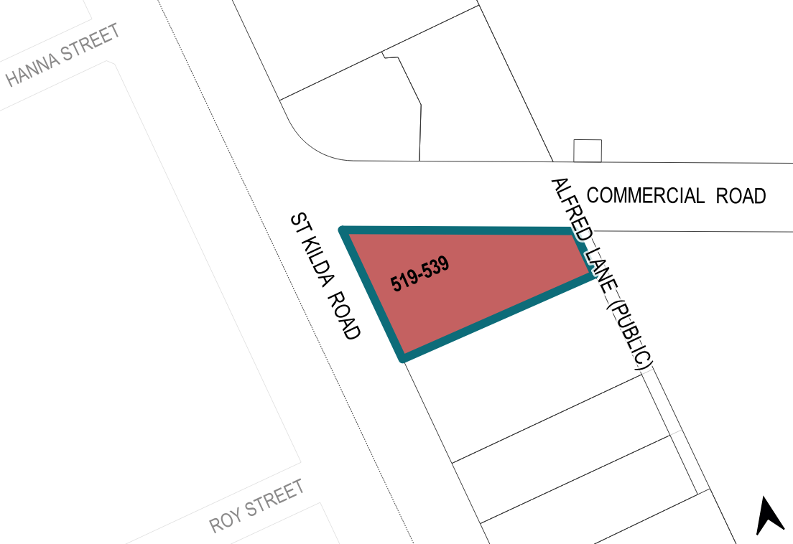

What is significant?
The former Chevron Hotel at part of 519–539 St Kilda Road, Melbourne, built in stages from 1934 to 1939, is significant.
Elements that contribute to the significance of the place include (but are not limited to) the:
- external form and massing of the 1934–39 buildings, including the prominent roofline
- original materiality of the 1934–39 buildings, including face bricks, render and terracotta tile
- alternating light wells on the Commercial Road elevation, including the parapet wall above one projecting wing at the location of a former roof terrace
- brick tower with chamfered corners, tile roof, decorative render and weathervane
- formal entry way on Commercial Road, built as part of the 1939 additions, featuring highly decorative brickwork and a cantilevered, boxed awning
- pattern and size of original fenestration above the ground level, and the louvred shutters
- detailing such as the projecting brick course at the first-floor sill height, and the string courses beneath and above the third level windows

- roof details including the projecting eaves and chimneys
- other decorative details such as the string course beneath the fourth floor
- building’s high level of integrity to its original 1934 and 1939 designs, especially evident on the St Kilda Road and Commercial Road elevations.
More recent alterations and additions, including alterations to the ground floor are not significant.

How is it significant?
The former Chevron Hotel at part of 519–539 St Kilda Road, Melbourne, is of local historical, representative and aesthetic significance to the City of Melbourne.

Why is it significant?
The former Chevron Hotel at part of 519–539 St Kilda Road, Melbourne, is of historical significance as an early and substantial example of a large, private, low-rise luxury hotel that modelled the American style of the 1930s. Large private luxury hotels were uncommon in Melbourne until after World War II. In the interwar period, most visitors to the city relied on the accommodation provided by smaller boarding houses and hotels. Although some private hotels had been established in the City of Melbourne in the preceding decades, the Chevron is a clear example of the transition towards large luxury private hotels designed in the American manner. The Chevron Hotel is possibly the only existing example of such a building from the interwar period in the City of Melbourne. It is of historical interest on account of the many well-known guests who stayed there, including Frank Sinatra, and the Hollywood actors Gregory Peck and Ava Gardner who stayed while filming On the Beach in 1959. (Criterion A)
The former Chevron Hotel is of representative significance as an interwar residential hotel erected in the City of Melbourne. Overall form and planning of the former Chevron Hotel are demonstrative of the residential hotels of the 1930s and 1940s that provided upmarket, modern private suites as well as shared lounges and recreation areas. It also represents influences by commercial architecture of the time, represented by the use of Commercial Palazzo style detailing including the use of vertical bays articulated by pilasters and restrained decorative rendered detailing, pilasters and spandrels. (Criterion D)
The former Chevron Hotel is of aesthetic significance for its country club-style of architecture and site planning that distinguish the subject building within the typology. Designed by architect Leslie M Perrott, the former Chevron Hotel features picturesque massing reminiscent of exotic destinations or the countryside, and integrated recreational facilities (including a swimming pool and tennis courts) across its larger site. The former Chevron Hotel represents how hotel establishments in Melbourne began to provide luxury accommodation on a large scale, influenced by the fashionable hotels in the United States. While drawing on classical architectural roots the former Chevron Hotel plays with the Palazzo form of a three-part façade, creating a more informal version of the style. The picturesque nature of the former Chevron Hotel is highlighted by elements like its low-rise form, diagonal tower, shuttered windows and terracotta roof. (Criteria E)

Primary source
South Yarra Heritage Review 2022 (GML Heritage)

