Statement of Significance: Former Fawkner Club Hotel (2–14 Hope Street, South Yarra), February 2023

Heritage Place: | Former Fawkner Club Hotel | PS ref no: | HO1405
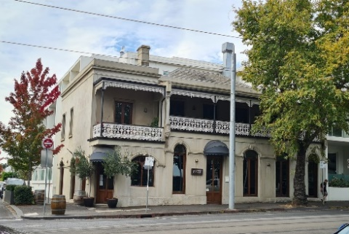 | 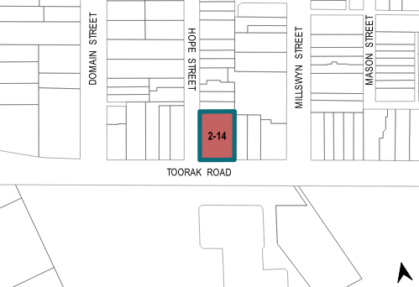

What is significant?
The former Fawkner Club Hotel at 2–14 Hope Street, South Yarra, built c1855, added to in 1882 and altered in 1925, is significant.
Elements that contribute to the significance of the place include (but are not limited to) the:
- 1855 hotel building (Figure 1: Number 1) and its external form, including slate-clad roof and upper-level verandah
- hotel’s ground level extension and façade (Figure 1: Number 2) and 1882 hotel residence building (Figure 1: Number 3) as well as integrity to their 1880s designs
- 1880s parapets, chimney, pattern of fenestration, hood moulds and moulded string course
- 1925 splayed corner entrance and tracery window
- other early decorative details.
More recent alterations and additions, including the new window openings are not significant. The 2002 apartment block (Figure 1: Number 4) abutting the former hotel’s eastern and northern elevations is not significant.

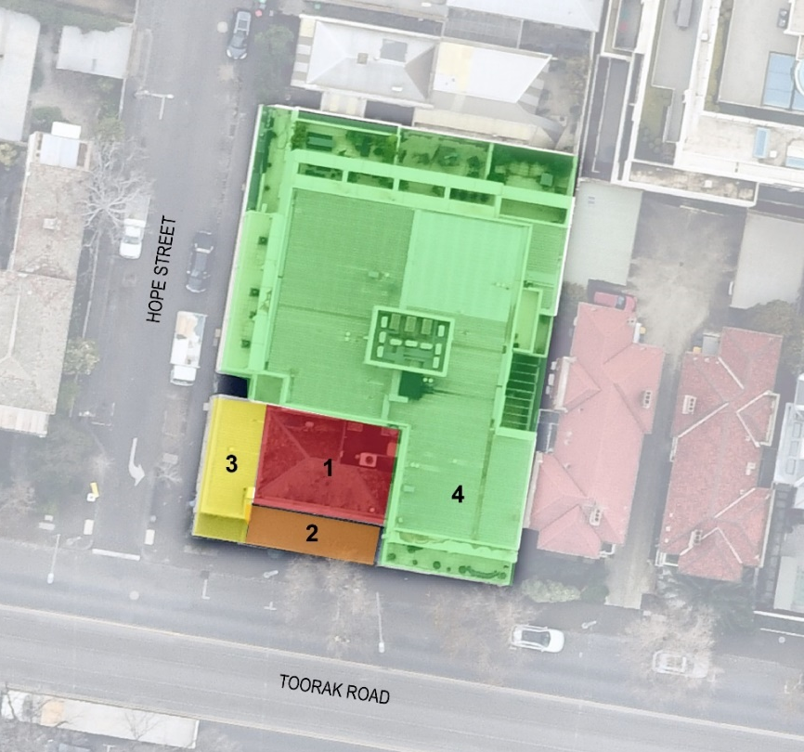
Legend
1 | Original hotel form (c1855–1872) | 3 | Former residence (1882)
2 | Ground floor extensions (1882) | 4 | Apartments (2002)
Figure 1. Aerial photograph of 2–14 Hope Street, South Yarra, showing the elements contribute to the significance (Numbers 1–3). Note the 2002 apartments (Number 4) are not significant. (Source: Nearmap 2020 with GML overlay)

How is it significant?
The former Fawkner Club Hotel at 2–14 Hope Street, South Yarra, is of local historical and representative significance to the City of Melbourne.

Why is it significant?
The former Fawkner Club Hotel is historically significant as an early Victorian-era hotel in the City of Melbourne. It operated continuously as a hotel for over 140 years from c1855 until 1998, initially under the name of the South Melbourne Hotel. The former Fawkner Club Hotel is of historical significance as a demonstration of the establishment of early hotels in Melbourne, which provided refreshment and meeting places. The hotel was one of a handful of early hotels in South Yarra established in the 1850s. The 1925 modifications to the Fawkner Club Hotel reflect changes in liquor licensing regulations that required hotel owners to provide adequate accommodation and facilities for the public. (Criterion A)
The former Fawkner Club Hotel is historically significant as a place that was used by Aboriginal people whose traditional country the building occupied. In the late 1860s, it was frequented by Bunurong Elder Mingaragon (or Mongarra) who was also known as ‘Mr Man’ or ‘Old Mr Man’. (Criterion A)
The former Fawkner Club Hotel is significant as a largely intact example of a Victorian-era hotel building on a corner site. The building façades retain characteristic architectural features of the Victorian Italianate style, typical of the period of its substantial addition in 1882. This is evident in the parapet roofs, hood moulds, verandah ironwork and moulded stringcourse. The 1925 modifications unified the two built forms and the introduction of a splayed corner entrance gave the appearance of a corner hotel. (Criterion D)

Primary source
South Yarra Heritage Review 2022 (GML Heritage)

