Statement of Significance: Christ Church vicarage, and Memorial Hall and school building (663-681 Punt Road, South Yarra), February 2023

Heritage Place: | Christ Church vicarage, and Memorial Hall and school building | PS ref no: | HO1410
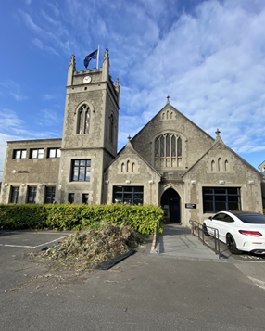  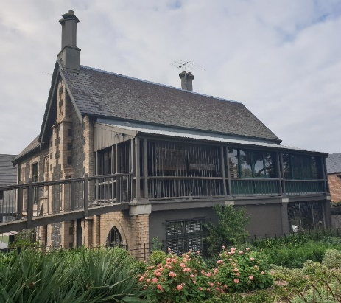 | 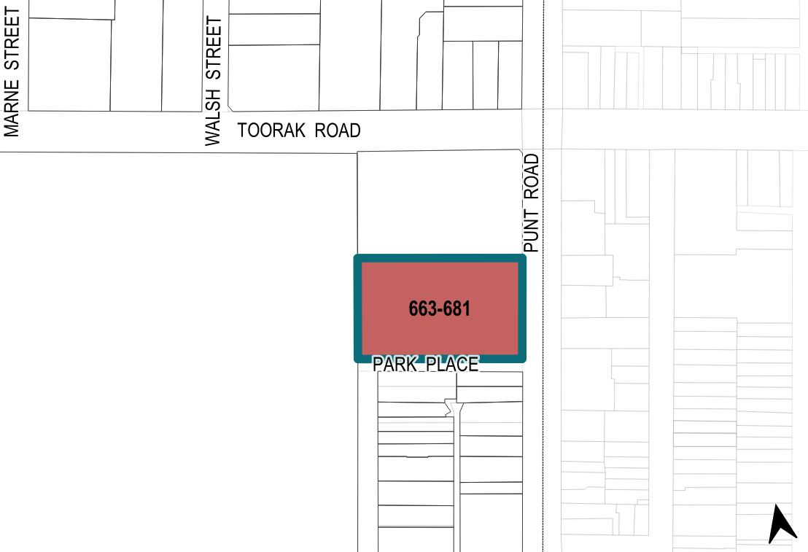

What is significant?
Christ Church vicarage, and Memorial Hall and school building at 663–681 Punt Road, South Yarra, are significant.
Elements that contribute to the significance of the place include (but are not limited to) the:
- 1924 Memorial Hall and school building and 1953 additions (Figure 1: Number 2 and Number 3) and its built form and scale including the tower; materiality (including the exterior concrete render and the concrete tile roof); original pattern and size of fenestration; and decorative elements (including tower pinnacles, Gothic style tracery, gable end details, finials, quoining and clock mounted on the tower)
- the 1860 vicarage (Figure 1: Number 1) and its original form and scale (including the building’s U-shaped roof); materiality (including bluestone, cream brick, concrete render and slate); pattern and size of original fenestration; two-storey verandah on the principal façade overlooking Fawkner Park; decorative details (including bay window, arched entry way, chimney breasts, chimneys and quoining)
- the site’s garden setting.
More recent alterations and additions, including school buildings to the south and west of the 1924 building (Figure 1: Numbers 4–7), are not significant. The new vicarage (Figure 1: Number 6) in the southwest corner of the site is not significant. Later alterations to the 1860 vicarage, including infill glazing to the verandah, are not significant.
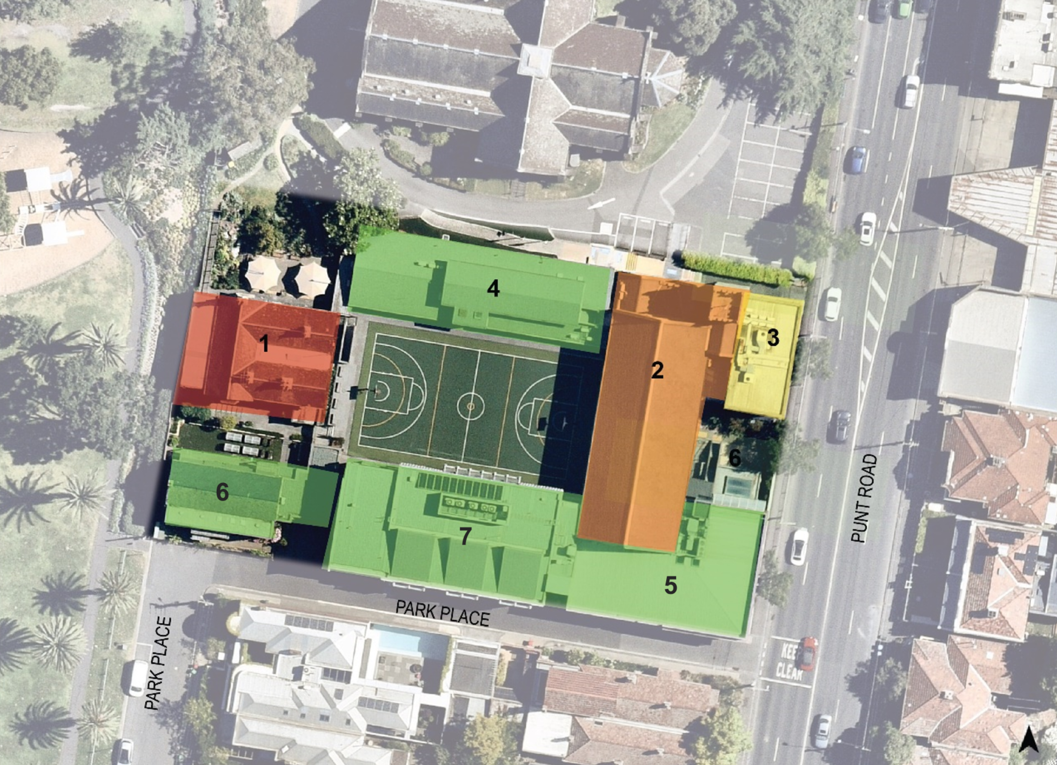
Legend
1 | Vicarage (1860) | 5 | McLardy Music School (1990)
2 | Memorial Hall and school building (1924) | 6 | New vicarage (c2000s)
3 | East wing (1924) with first floor additions (1953) | 7 | Beryl Gregory Resource Centre (2018)
4 | Anne Wardley Wing (1963, 2003)
Figure 1. Aerial photograph of 663–681 Punt Road, South Yarra, showing the key buildings and later structures. Green denotes structures substantially modified or constructed from 1990 that are not significant. (Source: Nearmap 2022 with GML overlay)

How is it significant?
Christ Church vicarage, and Memorial Hall and school building at 663–681 Punt Road, South Yarra, are of local historical, representative, social and associative significance to the City of Melbourne.

Why is it significant?
The Christ Church vicarage, and Memorial Hall and school building at 663–681 Punt Road, South Yarra, are historically significant as part of a complex of church buildings used for Anglican Church purposes since 1854. The 1860 vicarage (Figure 1: Number 1) has been maintained in use by the church for 160 years since its completion. The Christ Church reserve (the subject site and 683–701 Punt Road), developed from 1854, represents the strength and importance of the Anglican Church in South Yarra. The affluence of the local parish community led itself to the development of a substantial church and ancillary church buildings on the site, which were funded in part by private bequests. Christ Church Grammar School, formally established in 1898, continued on from the earlier provision of education at the site, and demonstrates the importance of the Church of England in South Yarra. (Criterion A)
The Christ Church Memorial Hall and school building (Figure 1: Number 2 and Number 3) is of local historical significance for its use as a parish hall since 1924, and its demonstration of the site’s continued educational use to the present day. Education had been provided at the site since 1854 when a schoolhouse was erected. In 1898, Christ Church Grammar School was established, primarily as a school for choirboys, and was closely connected with the music program of Christ Church. Following the first official admission of girls in 1922, the Memorial Hall and school building was erected in 1924. The new building used much of the building materials of the demolished 1876 parish hall, which was also used as a Sunday and day school. The 1924 Memorial Hall (Figure 1: Number 2) accommodated many of the groups and activities associated with the parish community, including dances, charity events and Sunday school. The Memorial Hall is also significant as a war memorial built to honour the local men from the parish who served in World War I. The school wing (originally a single-storey) was added in 1953 with two classrooms on the upper floor (Figure 1: Number 3). The site has since been added to further and continues to be used for the purpose of Christ Church Grammar School. Christ Church Grammar School is notable as the only surviving example of an Anglican parish school in Victoria. (Criterion A)
The Christ Church vicarage, and Memorial Hall and school building (Figure 1: Number 2 and Number 3) at 663–681 Punt Road, South Yarra, are of representative significance for their ability to demonstrate the key characteristics of church complexes in the City of Melbourne. The Memorial Hall and school building and the vicarage represent development in response to the stipulations of the church reserve and remain as legible elements of the wider church complex. Further, the Memorial Hall and school building and the vicarage’s use of Gothic Revival style elements, which had been especially popular in church building in Victoria during the second half of the nineteenth century, is consistent with church complexes that often applied the same architectural detailing to ancillary buildings. (Criterion D)
The 1924 Christ Church Memorial Hall and school building is socially significant to the City of Melbourne. They hold a close association with the Christ Church congregation and the students and alumni community of Christ Church Grammar School. Christ Church has been an integral part of daily life for the members of the local parish from the 1850s, as the primary place of Anglican worship. The Memorial Hall has been and continues to be a place for many community activities and functions, as well as significant events such as christenings, weddings and funerals. The Memorial Hall is also important to the alumni and veteran community and to the families of local men from the parish who served during World War I. (Criterion G)
The site and the 1860 vicarage (Figure 1: Number 1) is of associative significance for its connection to the Anglican pastor and writer Horace Finn Tucker (1849–1911), who was vicar at Christ Church from 1880 until 1909 and lived at the vicarage during this period. Tucker, was integral to establishment of the Christ Church Grammar School in 1898 and as a supporter of the parish’s strong music program, created what may be considered as one of the first music scholarships in Victoria. Tucker later played an influential role in developing a scheme for village settlements in the early 1890s and this work occurred during the period he was vicar at Christ Church. During this time, he also wrote the utopian novel, The New Arcadia (1894), which examined the ideals of co-operative rural settlement. Tucker wrote several other important works during his time at Christ Church, including a book of poetry, After Many Days (1905). (Criterion H)

Primary source
South Yarra Heritage Review 2022 (GML Heritage)

