Statement of Significance: Former Wesleyan Church (431-439 Punt Road, South Yarra), February 2023

Heritage Place: | Former Wesleyan Church | PS ref no: | HO1407
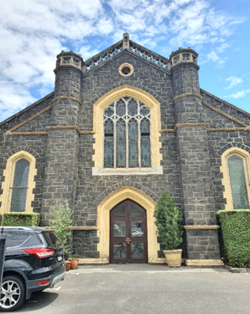 | 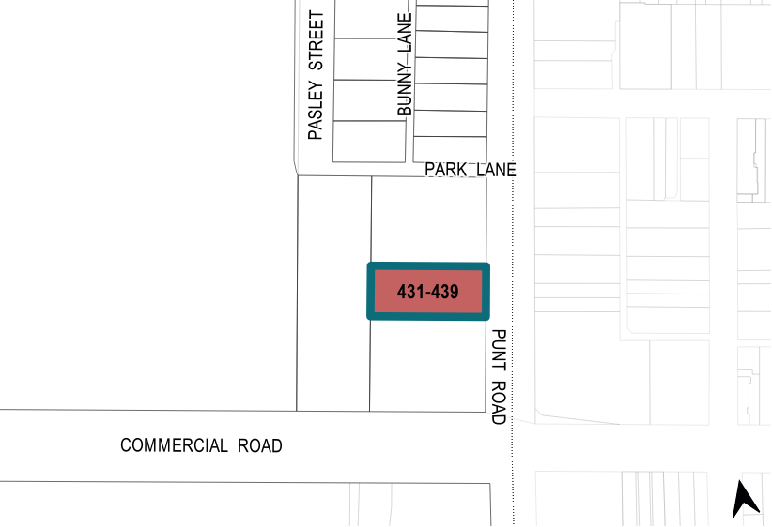

What is significant?
The former Wesleyan Church at 431–437 Punt Road, South Yarra, built in 1864 to a design by Crouch and Wilson, is significant.
Elements that contribute to the significance of the place include (but are not limited to) the:
- building’s original rectangular form with slate gabled roof and twin turrets, and the bluestone external walls with side porches and buttresses
- pattern and size of original fenestration, especially the use of four-centred arches on all elevations
- other original elements such as cement openwork parapet, tracery window with four-part stained glass designed by Ferguson and Urie, quoining and string courses in moulded cream brick, diamond-pattern leadlight glazing.
More recent alterations and additions, including the new side and rear wings and landscaping features, are not significant.
How is it significant?
The former Wesleyan Church at 431–437 Punt Road, South Yarra, is of local historical and representative significance to the City of Melbourne.
Why is it significant?
The former Wesleyan Church at 431–437 Punt Road, South Yarra, built in 1864, is historically significant as an example of a local Wesleyan (Methodist) church built as part of the early suburban development of Melbourne, replacing an earlier church on the site that dated to the mid–1850s. It is also significant as it occupies one of the four Crown reserves granted for use by the four Christian denominations in the 1850s along the same section of Punt Road. The subject church provides important tangible evidence of the development pattern of this early phase of suburban expansion within the City of Melbourne outside of the central city. The building is also evidence of the broad adoption of Gothic Revival style by the Methodists in Victoria in the 1850s and 1860s, which was a significant departure from their preference for a more austere style prior to the 1850s. (Criterion A)
Designed by prominent Melbourne architects Crouch and Wilson, the former Wesleyan Church is of representative significance to the City of Melbourne, as an example of the many smaller-scale churches of the major Christian denominations built in the 1860s and 1870s. Despite the residential conversion in 1994, the building is clearly legible as an example of an early Gothic style church, retaining key stylistic elements that are characteristic of the type, including the use of bluestone with contrasting dressings and detailing, as well as the symmetrical façade composition with gabled roof and twin turrets. The former church building is notable for its uncommon references to Perpendicular Gothic style, exhibited in the vertical emphasis of the design, the use of comparatively wide and flat pointed arches, and its central Perpendicular Gothic tracery window. The stained glass by Ferguson & Urie stained glass is an important part of the window design. (Criterion D)

Primary source
South Yarra Heritage Review 2022 (GML Heritage)

