Statement of Significance: Hoddle Bridge, February 2023

Heritage Place: | Hoddle Bridge | PS ref no: | HO421
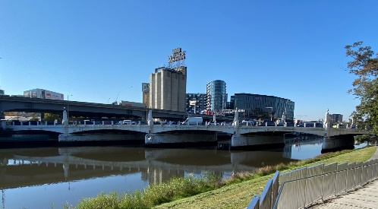 | 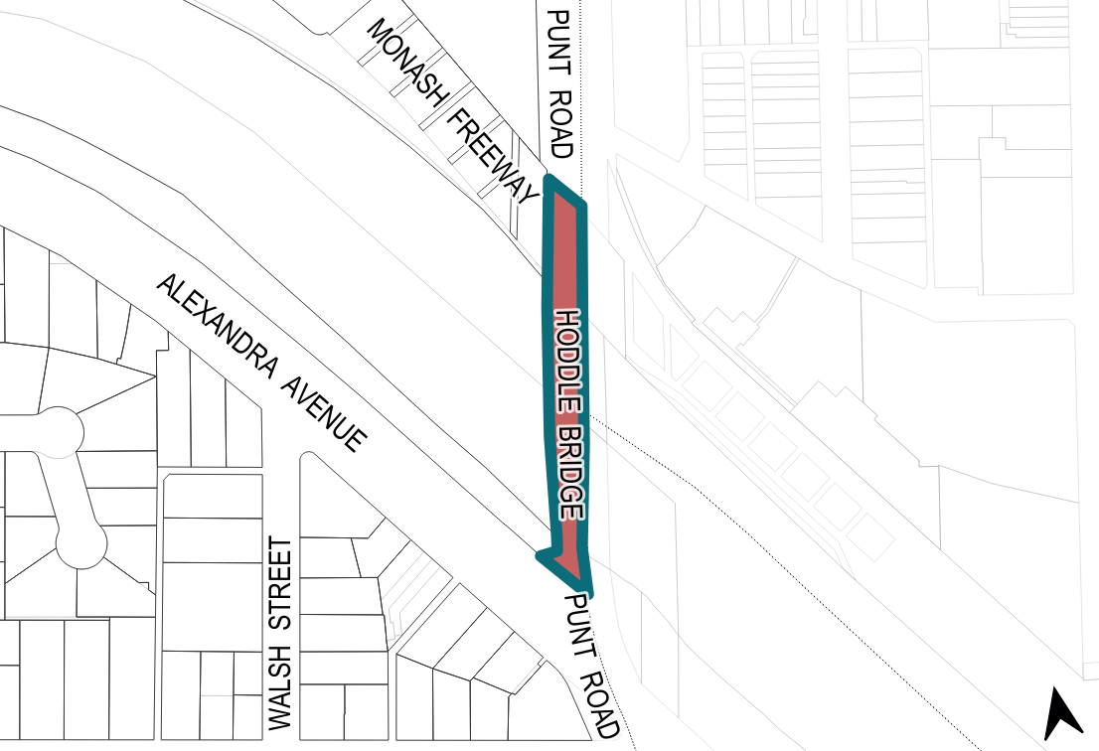

What is significant?
The Hoddle Bridge, Punt Road (at the Yarra River), Melbourne, built in 1938 by the City of Melbourne(engineers), the Country Roads Board (engineers) and Hughes and Orme (consulting architects), is significant.
Elements that contribute to the significance of the place include (but are not limited to) the:
- bridge’s original form of five shallow segmental arched spans supported by transverse piers
- high level of integrity to the original 1938 design
- reinforced concrete construction
- concrete light posts located along both sides of the bridge, including their cast iron fixtures
- metal balustrading with geometric detailing
- curved walls on the southern approach of the bridge

How is it significant?
The Hoddle Bridge, Punt Road (at the Yarra River), Melbourne is of local historical, representative, aesthetic, and technical significance to the City of Melbourne.

Why is it significant?
The Hoddle Bridge is historically significant as it has been the location of an important crossing point over the Yarra River since at least the 1840s. The phases of this crossing included the early punt service at this location, a foot bridge, and the existing Hoddle Bridge, built as part of a program to modernise central Melbourne to cater for increased motorised transport. (Criterion A)
The Hoddle Bridge is a representative example of a concrete bridge built in the late interwar period in

the Art Deco style. Although other examples of Art Deco bridges exist in the City of Melbourne, the Hoddle Bridge is larger in size, and more impressive in its construction and architectural detailing. (Criterion D)
The Hoddle Bridge exhibits strong characteristics of the Art Deco style, demonstrating how the style could be applied to infrastructure projects. Designed by architects Hughes & Orme, the Hoddle Bridge features a coherent and harmonious design that integrated design elements and function. The stylised light posts, geometric steel balustrading and horizontal detailing are a particularly clear characteristics of Art Deco design. (Criterion E)
The Hoddle Bridge is significant for its high degree of technical achievement. When built in 1938, the 85-foot [26 metre] beam spans were considered to be the longest ever constructed in Australia. The beams were cast in one operation that took a total of 190 workers an approximated 117 hours to complete, while working in day and night shifts. The Hoddle Bridge is an early example of the use of large-scale reinforced concrete members that would become integral in later infrastructure projects in Melbourne and Victoria. (Criterion F)

Primary source
South Yarra Heritage Review 2022 (GML Heritage)

